- Problem Name: Installation Ubuntu on Virtual Box.

- Requirements:
- A laptop or desktop
- Operating systems (Linux/Windows)

- Simulation:

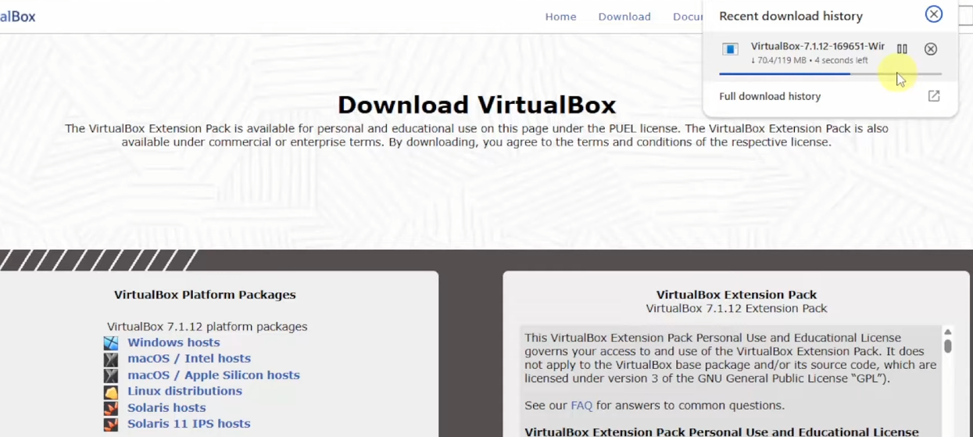
Step 1: Go to the web site and download VirtualBox.exe file.
Figure 1.1: Installing .exe file

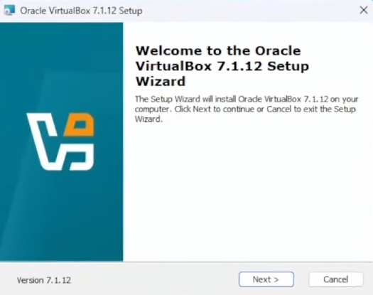
Step 2: Click and open the .exe file and complete the installation process.
Figure 1.2: Complete installation process
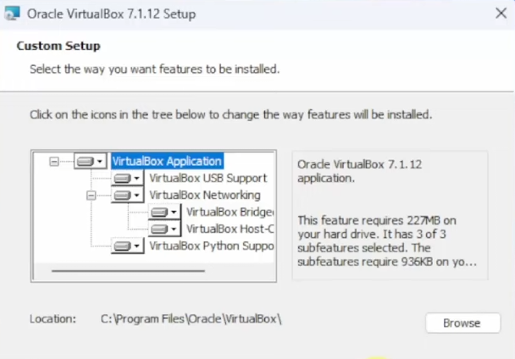
Figure 1.3: Select features
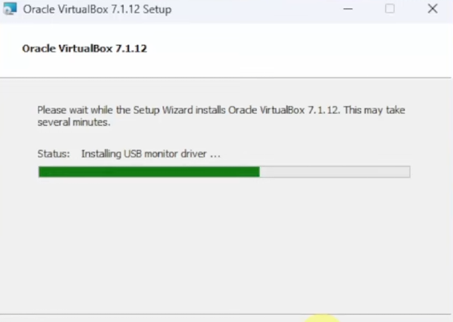
Figure 1.4: Wait for installation.

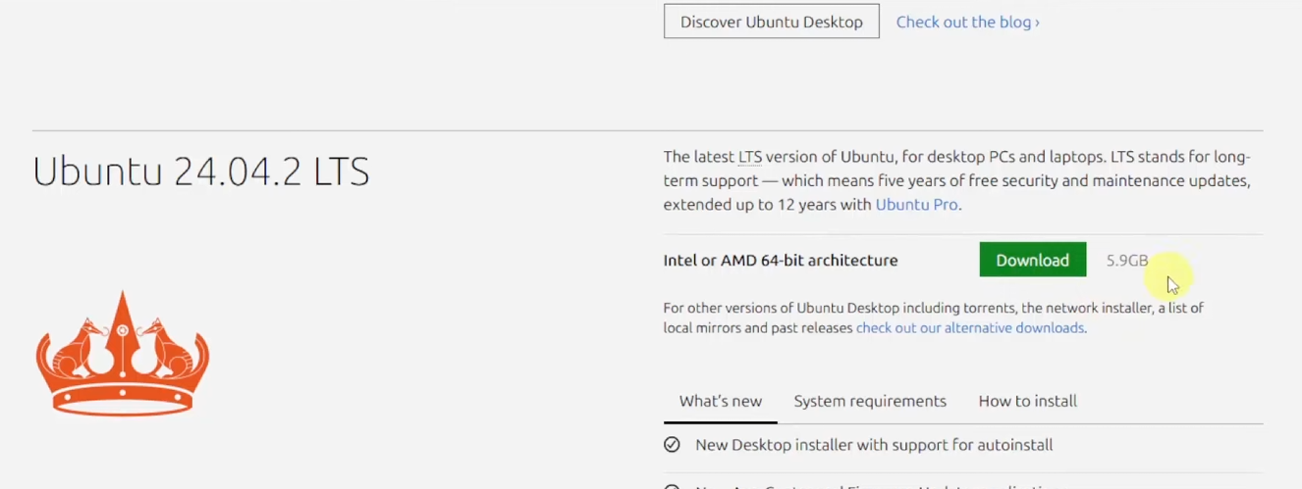
Step 3: Download ubuntu.
Figure 1.5: Download ubuntu

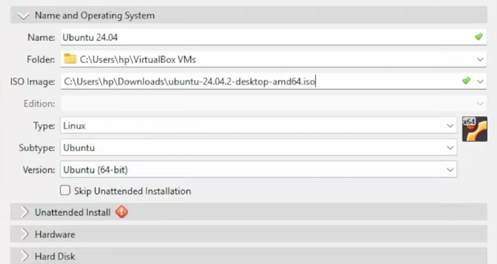
Step 4: Configure VirtualBox.
Figure 1.6: Configure VirtualBox.

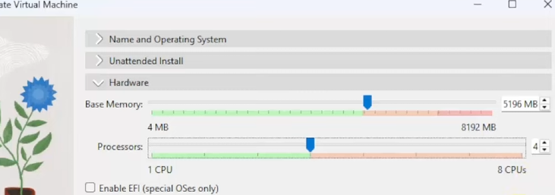
Figure 1.7: Configure VirtualBox.

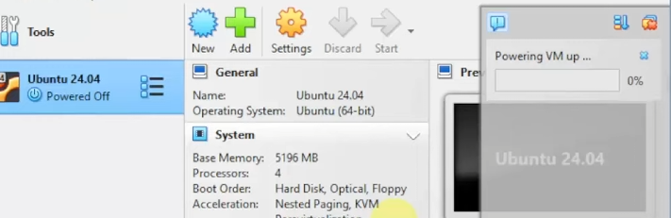
Step 5: Powering up after configuration.
Figure 1.8: Powering up to start ubuntu.

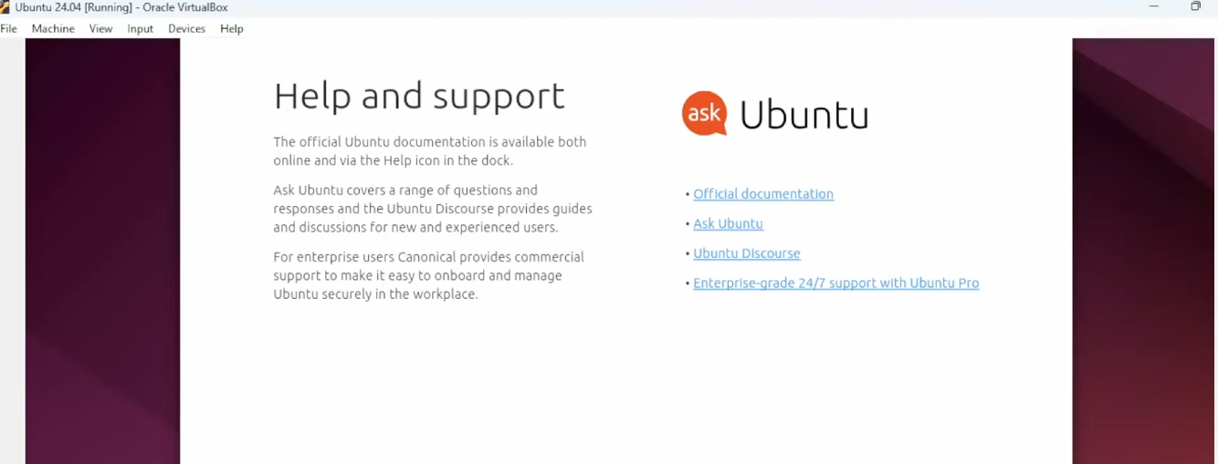
Step 6: Ubuntu installed process completed.
Figure 1.9: Powering up to start ubuntu.

- Conclusion:
In this lab, Ubuntu was successfully installed on a virtual machine. This task helped us understand the process of creating and managing virtual environments. We learned how to configure system resources, install an operating system, and run it without affecting the main system. Virtual machines provide a safe and efficient way to use different operating systems for learning and testing purposes. This experiment improved our practical knowledge of operating systems and virtualization.

