Problem 01: FIFO algorithm.

Source Code:
#pragma GCC optimize("Ofast")
#include <bits/stdc++.h>
using namespace std;
#ifndef ONLINE_JUDGE
#define debug(x) cerr << #x << " = " << x << endl
#else
#define debug(x)
#endif

using ll = long long;

void Solve()
{
ll n, f;
cin >> n >> f;
string s;
cin >> s;

queue<char> q;
unordered_set<char> st;

ll hit = 0, fault = 0;

for (char c : s)
{
if (st.count(c))
{
hit++;
}
else
{
fault++;
if ((ll)q.size() == f)
{
char rem = q.front();
q.pop();
st.erase(rem);
}
q.push(c);
st.insert(c);
}
}

double hit_ratio = (double)hit / n;
double miss_ratio = (double)fault / n;

cout << "Page Faults: " << fault << "\n";
cout << "Page Hits: " << hit << "\n";
cout << fixed << setprecision(6);
cout << "Hit Ratio: " << hit_ratio << "\n";
cout << "Miss Ratio: " << miss_ratio << "\n";
}

int32_t main()
{
ios_base::sync_with_stdio(0), cin.tie(0), cout.tie(0);
ll t = 1;
cin >> t;
while (t--)
Solve();
return 0;
}

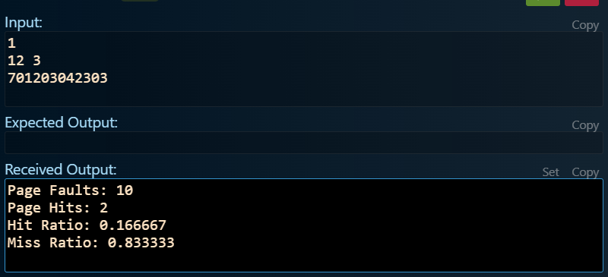
Input and Output :
Figure 6.1: Input and Output of FIFO algorithm.

Problem 02: LRU algorithm.

Source Code:

#pragma GCC optimize("Ofast")
#include <bits/stdc++.h>
using namespace std;
#ifndef ONLINE_JUDGE
#define debug(x) cerr << #x << " = " << x << endl
#else
#define debug(x)
#endif

using ll = long long;

void Solve()
{
ll n, f;
cin >> n >> f;
string s;
cin >> s;

list<char> l;
unordered_map<char, list<char>::iterator> mp;

ll hit = 0, fault = 0;

for (char c : s)
{
if (mp.count(c))
{
hit++;
l.erase(mp[c]);
l.push_front(c);
mp[c] = l.begin();
}
else
{
fault++;
if ((ll)l.size() == f)
{
char rem = l.back();
l.pop_back();
mp.erase(rem);
}
l.push_front(c);
mp[c] = l.begin();
}
}

double hit_ratio = (double)hit / n;
double miss_ratio = (double)fault / n;

cout << "Page Faults: " << fault << "\n";
cout << "Page Hits: " << hit << "\n";
cout << fixed << setprecision(6);
cout << "Hit Ratio: " << hit_ratio << "\n";
cout << "Miss Ratio: " << miss_ratio << "\n";
}

int32_t main()
{
ios_base::sync_with_stdio(0), cin.tie(0), cout.tie(0);
ll t = 1;
cin >> t;
while (t--)
Solve();
return 0;
}

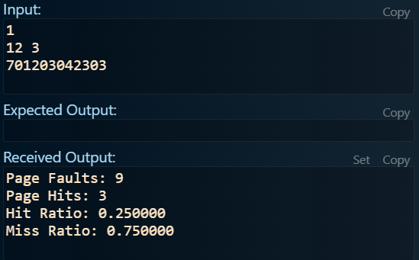
Input and Output:
Figure 6.2: Input and Output of LRU algorithm.

