Problem 1: SJF (Non – Preemptive):
Source Code:
#pragma GCC optimize("Ofast")
#include <bits/stdc++.h>
using namespace std;
#ifndef ONLINE_JUDGE
#define debug(x) cerr << #x << " = " << x << endl
#else
#define debug(x)
#endif
using ll = long long;
void Solve()
{
int n;
cin >> n;
cout << "Total Process: " << n << endl;
deque<pair<int, int>> proc(n);
map<int, int> mp;
for(int i=0; i<n; i++) {
// cout << "\nBurst time of process " << i+1 << ": ";
cin >> proc[i].first;
proc[i].second = i+1;
int x ;
cin >> x;
mp[i+1] = x;
}
vector<int> ans;
int tem = 0;
ans.push_back(proc[0].first);
int p = proc[0].second;
cout << "\nProcess " << proc[0].second << " : ";
cout << "\nWaiting Time: " << tem << endl;
// cout << "Arrival Time: " << mp[proc[0].second] << endl;
tem += ans.back();
int TT = tem - mp[p];
cout << "Turn Around Time: " << TT << endl;
// cout << "WT: " << tem - proc[0].first << endl;
proc.pop_front();
sort(proc.begin(), proc.end());
int piche = proc.back().first;
while(!proc.empty()){
cout << "\nProcess " << proc.front().second << " : " << endl;
cout << "Waiting Time: " << tem << endl;
tem += proc.front().first;
int tt = tem - mp[proc.front().second];
cout << "Turn Around Time: " << tt << endl;
// cout << "WT: " << tem - proc.front().first << endl;
proc.pop_front();
}
int av = tem - piche;
cout << "\nAverage Waiting Time: " << (double)av/n << endl;

}
int32_t main()
{
ios_base::sync_with_stdio(0), cin.tie(0), cout.tie(0);
ll t = 1;
// cin >> t;
while (t--)
Solve();
return 0;
}
Sample Input:
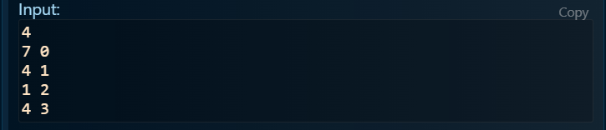
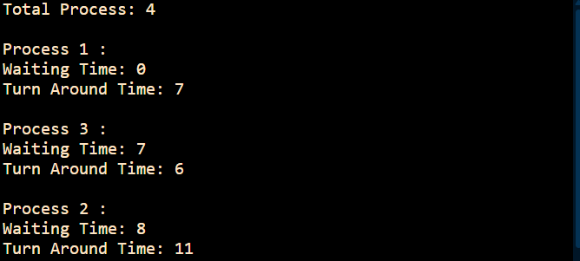
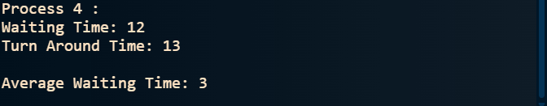
Sample Output:
Problem 2: SJF non-preemptive
Source Code:
#pragma GCC optimize("Ofast")
#include <bits/stdc++.h>
using namespace std;
#ifndef ONLINE_JUDGE
#define debug(x) cerr << #x << " = " << x << endl
#else
#define debug(x)
#endif

using ll = long long;

void Solve()
{
int n;
cin >> n;
deque<pair<int, int>> v(n);
for(int i=0; i<n; i++){
cin >> v[i].first;
v[i].second = i;
}
priority_queue<pair<int, int>, vector<pair<int, int>>, greater<pair<int, int>>> pq;
map<int, int> mp;
map<int, int> arrival;
map<int, int> waiting;
map<int, int> turnaround;

mp[0] = 0;
v.front().first--;
for(auto it : v) pq.push(it);

int time = 0;
for(int i=0; i<n; i++){
arrival[i] = 0;
}

while(!pq.empty()){
auto it = pq.top();
pq.pop();
if(it.first == 0) continue;

time++;
mp[it.second] = time;
it.first--;

if(it.first > 0){
pq.push(it);
}
}

cout << "Process ID | Burst Time | Completion Time | Waiting Time | Turnaround Time\n";
cout << "--------------------------------------------------------------------\n";

int totalWaiting = 0;
int totalTurnaround = 0;

for(int i=0; i<n; i++){
int burstTime = v[i].first;
int completionTime = mp[i];
waiting[i] = completionTime - burstTime - arrival[i];
turnaround[i] = completionTime - arrival[i];

cout << "P" << i << " | " << burstTime << " | " << completionTime
<< " | " << waiting[i] << " | " << turnaround[i] << "\n";

totalWaiting += waiting[i];
totalTurnaround += turnaround[i];
}

cout << "--------------------------------------------------------------------\n";
cout << "Average Waiting Time: " << (double)totalWaiting/n << "\n";
cout << "Average Turnaround Time: " << (double)totalTurnaround/n << "\n";
}

int32_t main()
{
ios_base::sync_with_stdio(0), cin.tie(0), cout.tie(0);
ll t = 1;
while (t--)
Solve();
return 0;
}

Input:
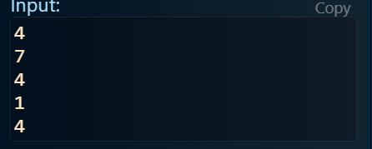
Output:
