- Create a Database called music
- Create a collection called songdetails.
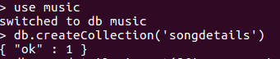

- Create the above 5 song documents
- List all documents created
- List A.R.Rahman’s Songs

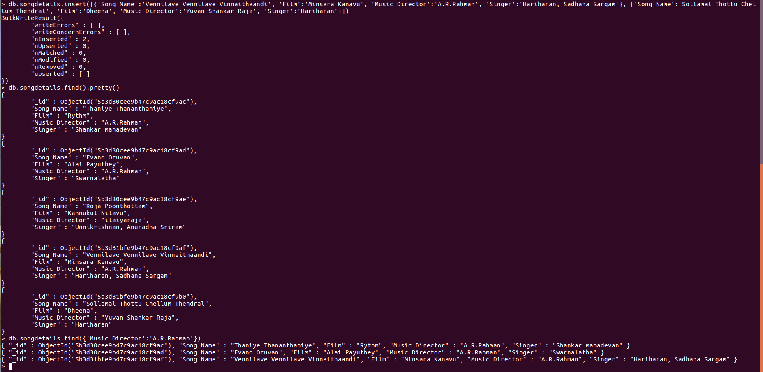
- List A.R.Rahman’s song sung by Unnikrishnan
- Delete the song which you don’t like
- Add new song which is your favorite
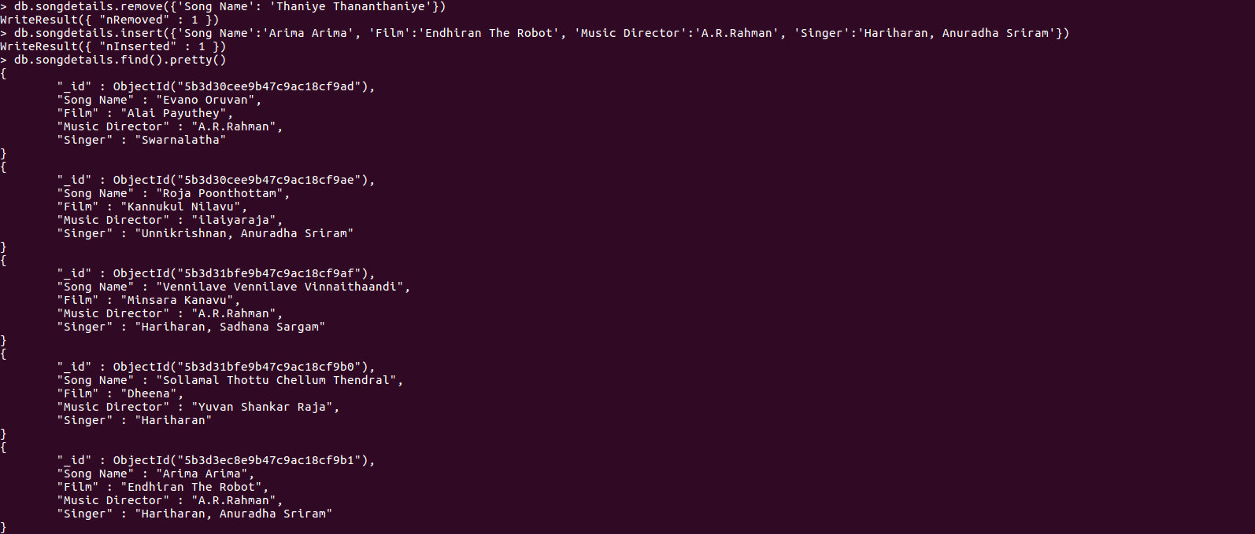
- List Songs sung by Hariharan from Minsara Kanavu film
- List out the singers’ names in your document.
