MongoDB on NODEjs
- Create a Database called student
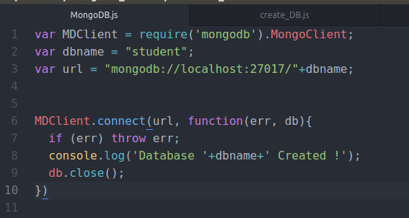
AND OUTPUT
- Create a collection called ​studentmarks
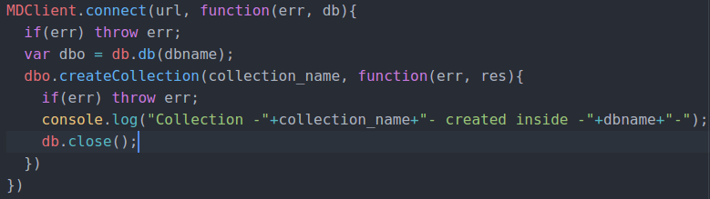
AND OUTPUT
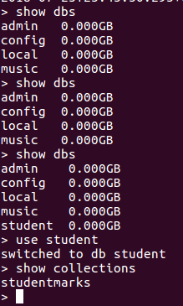
- Create the documents listed in above table.
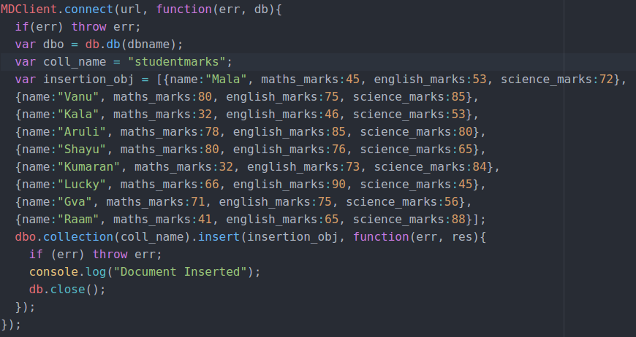
AND OUTPUT
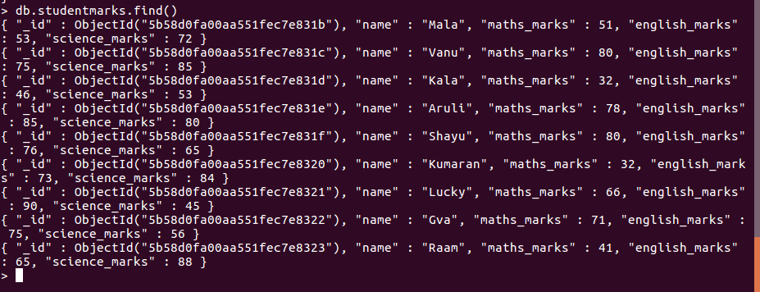
- Increase the maths marks of Mala by 6 marks
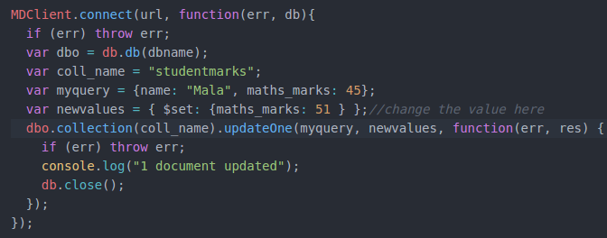
AND OUTPUT
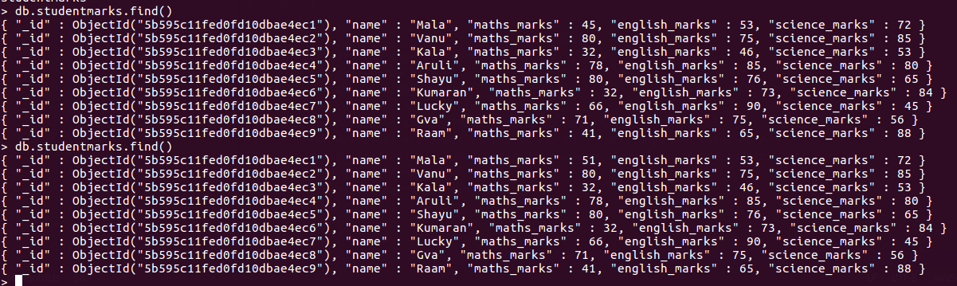

- List the names of students who got more than 50 marks in Maths Subject.
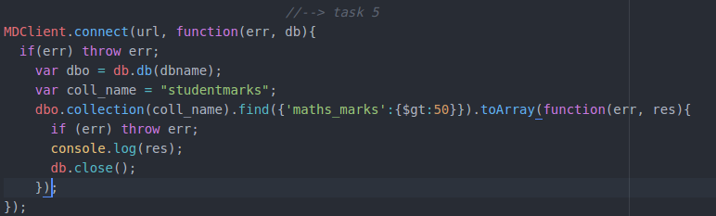
AND OUTPUT
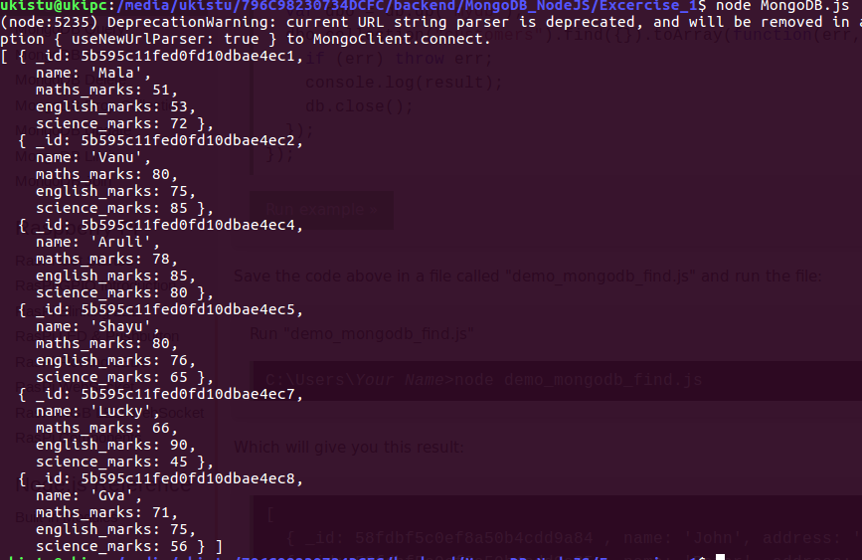
- Add a new column(field) for Average for all students.
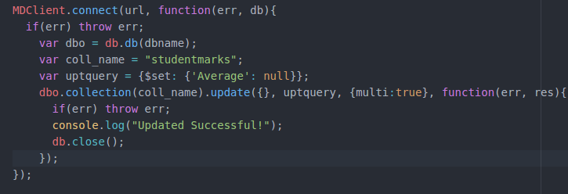
AND OUTPUT
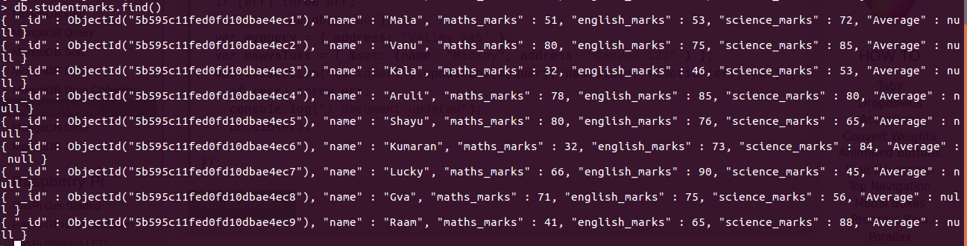
- Update Marks_Science=75 to Lucky .
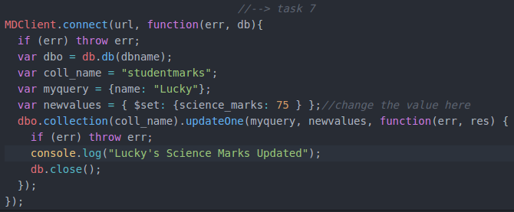

AND OUTPUT
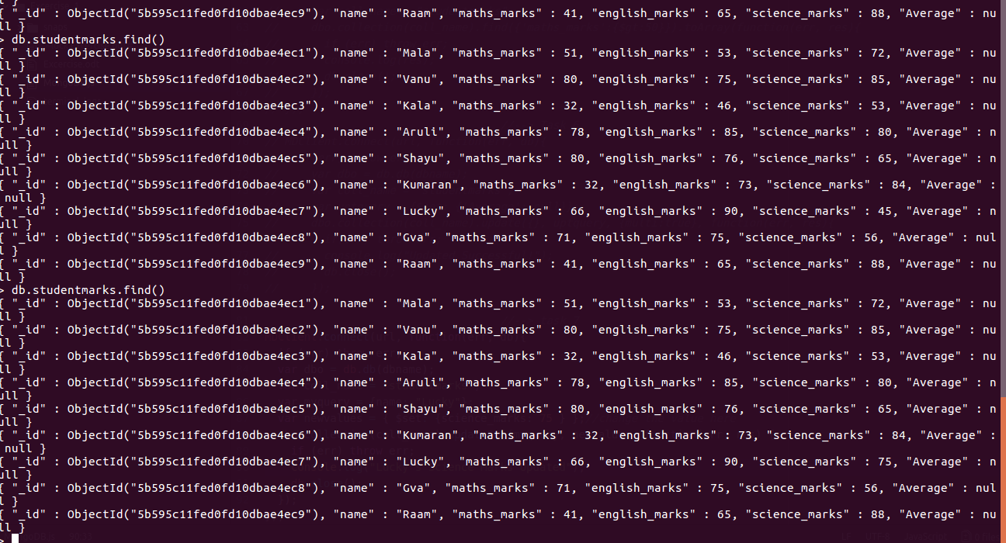
- List the names who got more than 50 marks in all subjects.
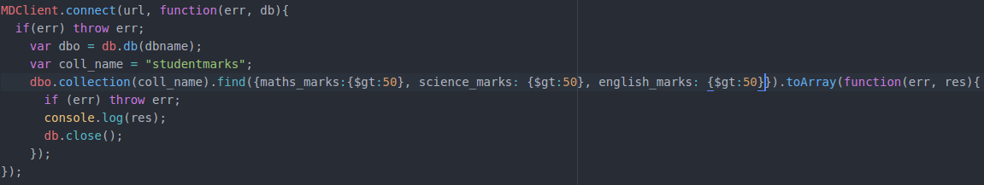
AND OUTPUT
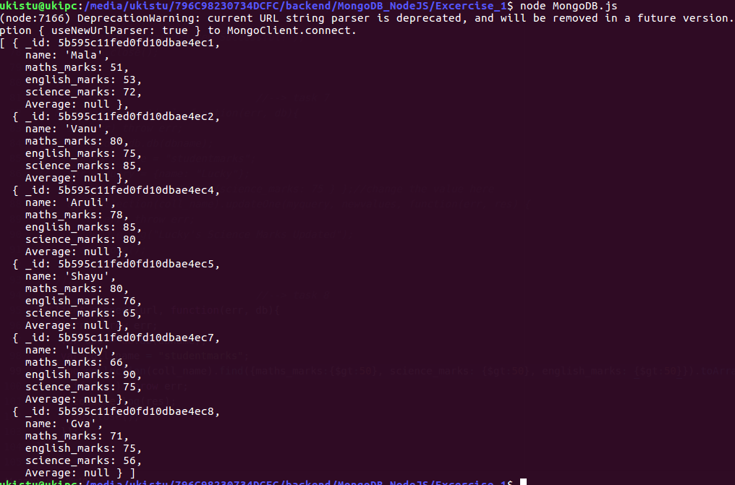

- List the names who got less than 50 marks in Maths subject and more than 50 marks in English
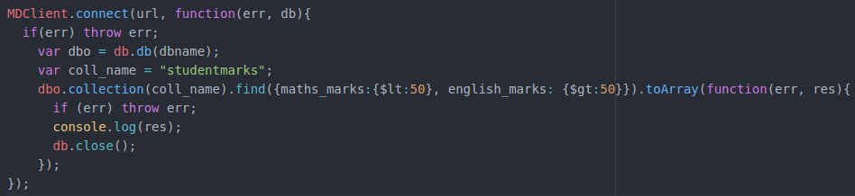
AND OUTPUT
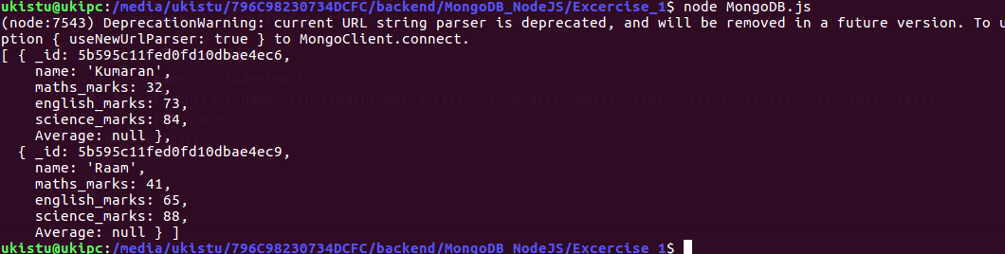
- List the names who got less than 40 in both Maths and Science.
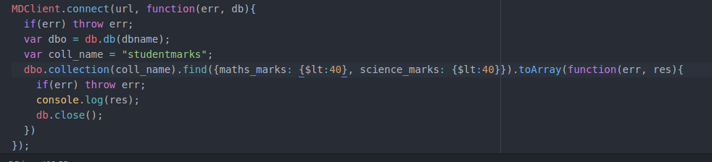
AND OUTPUT
- Remove Science column/field for Raam
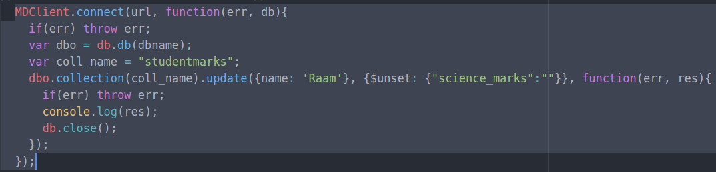
AND OUTPUT
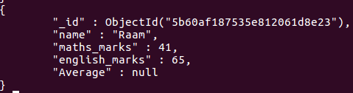
- Update John’s Math mark as 87 and English mark as 23, if john not available upsert.
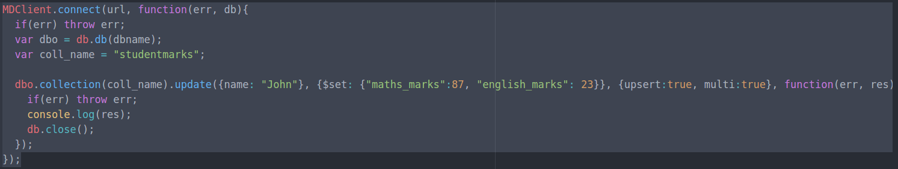
AND OUTPUT
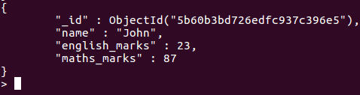

- Rename the english_marks column/field for John to science_marks
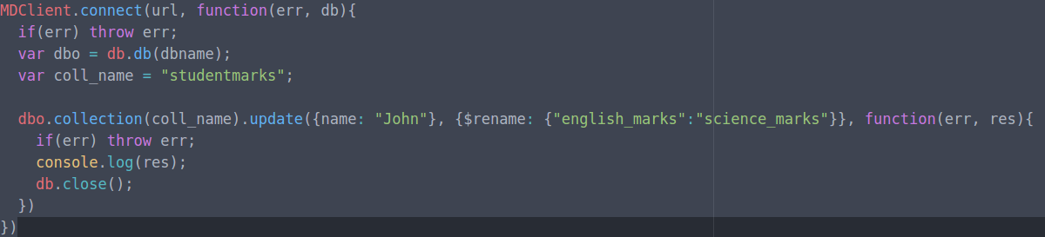
AND OUTPUT
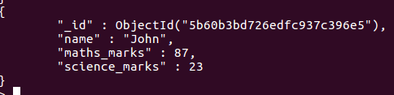

- Remove Kumaran’s document from collection
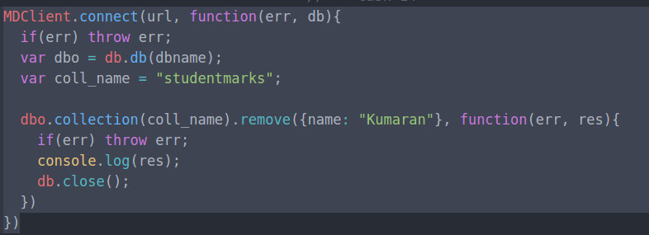
AND OUTPUT
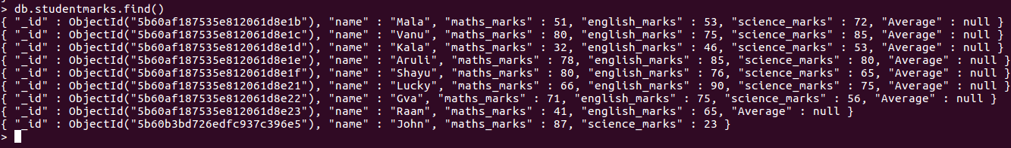
- Find Kala’s or Aruli’s math_marks and science_marks
AND OUTPUT

