
KPR Institute of Engineering and Technology
Department of CSE (Artificial Intelligence and Machine Learning)
Project Report
on
U21AM502
INTERNET AND WEB PROGRAMMING
"Offline Scan-to-Print Workstation with PIN-Based Token System for PITSTOP, KPRIET Boys Hostel, Coimbatore"
Submitted in partial fulfillment of the requirement for the award of the Degree of
BACHELOR OF ENGINEERING
in
COMPUTER SCIENCE AND ENGINEERING
(Specialization in Artificial Intelligence and Machine Learning)
by
SIBISAKTHIVEL K (24AM052)
VIRTHEKESH VIPIN (24AM063)
Under the guidance of
Dr. KARTHICK PANNERSELVAM, Faculty Guide
Department of CSE (Artificial Intelligence and Machine Learning)
NOV 2026-2027

CANDIDATE'S DECLARATION
We hereby declare that the client-based project report titled "Offline Scan-to-Print Workstation with PIN-Based Token System for PITSTOP, KPRIET Boys Hostel, Coimbatore" submitted to the Department of Computer Science and Engineering (Artificial Intelligence and Machine Learning), KPR Institute of Engineering and Technology, in complete fulfillment of the requirements for the award of the Revenue Generation Model for Internet and Web Programming Course-work, is a bonafide record of engineering work carried out by us under the supervision of Dr. KARTHICK PANNERSELVAM, Faculty Guide, Department of CSE (AI & ML).
We further confirm that the client consultation records, technical implementation, testing results, revenue details and deliverables documented herein represent the engagement undertaken with PITSTOP, KPRIET Boys Hostel, Coimbatore. The content of this report has not been submitted previously for the award of any other degree, diploma, or academic certificate.

Student Candidate Name & Register Number | Submission Date
SIBISAKTHIVEL K (Roll No: 24AM052)  Department of CSE (AI & ML) | Date: 02 November 2026
VIRTHEKESH VIPIN (Roll No: 24AM063)  Department of CSE (AI & ML) | Date: 02 November 2026

CLIENT APPRECIATION STATEMENT
I, MOHANKUMAR, Owner of PITSTOP (grocery shop with a printing and binding counter serving hostel students), KPRIET Boys Hostel Block, Avinashi – Coimbatore Road, Arasur, Uthupalayam, Tamil Nadu 641407, India, hereby state that the student team comprising SIBISAKTHIVEL K (24AM052) and VIRTHEKESH VIPIN (24AM063) from KPR Institute of Engineering and Technology, Coimbatore, was engaged to develop an offline scan-to-print system for my shop.
The system turns the shop laptop into a print counter with its own Wi-Fi. Students scan a QR code, upload their files from their phones without internet or any app, choose print settings with a live preview, and receive a 4-digit PIN (token). At the counter, my staff type the PIN to see the exact files, pages and sheets before printing. This removes the need for students to send files over WhatsApp, e-mail or pen drives, keeps their files private, and lets us charge for the exact number of pages printed.
The student team held consultation meetings with me (first meeting on 24 August 2026), incorporated my feedback, installed the system at the shop on 31 October 2026 and trained my staff. The agreed project value of ₹2,000 has been paid in full.

Client Representative Details | Client Endorsement
MOHANKUMAR, Owner  PITSTOP  KPRIET Boys Hostel Block, Arasur,  Coimbatore – 641 407, Tamil Nadu  Mobile: 79047 42326 | Signature: ______________________  Date: 02 November 2026

ACKNOWLEDGEMENT
We take immense pride and honor in presenting this comprehensive project report titled 'Offline Scan-to-Print Workstation with PIN-Based Token System for PITSTOP, KPRIET Boys Hostel, Coimbatore' for Assignment – II (Revenue Generation Model – Client-Based Project Report) under the course U21AM502 Internet and Web Programming.
First and foremost, we express our profound gratitude to our Faculty Guide, Dr. KARTHICK PANNERSELVAM, Department of Computer Science and Engineering (Artificial Intelligence and Machine Learning), for the guidance, continuous technical encouragement and constructive feedback received throughout this project. The reviews and suggestions at every stage helped us carry out a real client engagement to a professional standard.
We convey our deep gratitude to Dr. PANDIYA RAJAN G, Head of the Department of CSE (AI & ML), for the academic support and insightful suggestions during project planning, implementation and documentation.
We express our sincere thanks to Dr. AKILA MUTHURAMALINGAM, Principal, and the Management of KPR Institute of Engineering and Technology, Coimbatore, for providing the infrastructure, laboratory facilities and an environment that encourages students to undertake real-world client engagements. We also express our earnest gratitude to our client, MOHANKUMAR, Owner, PITSTOP, for his trust, the time given for consultation meetings, on-site trials and valuable feedback that shaped this system.
Finally, we express our heartfelt appreciation to our parents, family members, and friends whose enduring patience and unconditional support served as our greatest pillars of strength throughout this project.

ABSTRACT
Small print and binding counters inside college campuses receive dozens of print requests every hour, almost all of them from students' phones. The usual practice is to send files to the shopkeeper's WhatsApp number or e-mail, or to hand over a pen drive. This exposes students' personal documents and phone numbers, depends on mobile data, mixes up whose file is whose during rush hours, and gives the shop no reliable record of how many pages were printed for each customer, which leads to billing disputes, under-charging and petty service fraud.
This report presents the requirement analysis, design, implementation, testing, deployment and commercial documentation of an Offline Scan-to-Print Workstation developed for PITSTOP, a grocery shop with a printing and binding counter in the KPRIET Boys Hostel block, Coimbatore. A Windows laptop at the counter runs its own Wi-Fi hotspot and a local Node.js/Express web server. A customer scans one QR code to join the Wi-Fi; a captive-portal page then opens the print website automatically. The customer enters a name and mobile number, uploads PDF, image, Word, Excel or PowerPoint files, sets colour, sides, orientation, paper size, scaling, page range and copies for each file with a live sheet-by-sheet preview, and receives a unique 4-digit PIN token with the total pages and sheets. Nothing prints until the staff enter that PIN on the counter screen, verify the order and press Print; printing is done silently through SumatraPDF.
The system needs no internet, no app, no database and no cloud hosting. Files never leave the shop laptop and are deleted automatically after printing or expiry; the counter interface answers only the laptop itself. It is engineered for a low-specification laptop through a single prioritised job queue, configurable limits and a JSON order store that survives restarts.
Functional, validation, security and responsive tests were executed on the system (Section 7). The system was installed at the shop on 31 October 2026, the staff were trained and the client accepted the delivery. In line with the institutional Revenue Generation Model mandated by Assignment – II, the agreed project value of ₹2,000 has been received in full.
Keywords: Offline Printing, Scan-to-Print, Captive Portal, Wi-Fi Hotspot, PIN Token, Node.js, Express, pdf.js, SumatraPDF, Revenue Generation Model, PITSTOP, KPRIET.

INDEX / TABLE OF CONTENTS
Section | Chapter / Content Description | Page No.
- | Cover Page | 1
Declaration | Candidate's Declaration | 2
Statement | Client Appreciation Statement | 3
Ack | Acknowledgement | 4
Abstract | Abstract & Keywords | 5
Index | Table of Contents | 6
Section 1 | Project Abstract & Executive Summary | 7
Section 2 | Client Organization Profile & Problem Definition | 8
Section 3 | Requirement Analysis & Software Specification | 9
Section 4 | Project Proposal, Work Breakdown Structure & Quotation | 13
Section 5 | System Design: Architecture, Data Model, UML & UI | 14
Section 6 | Technical Implementation Deep-Dive | 19
Section 7 | Verification, Quality Assurance & Testing | 22
Section 8 | Deployment & On-Premise Installation | 24
Section 9 | Client Interaction, Meeting Records & Change Management | 25
Section 10 | Revenue Generation Model & Payment Details | 26
Section 11 | Client Verification & Authenticity | 27
Section 12 | Project Delivery, Training & Acceptance | 27
Section 13 | Outcomes, Learnings, Future Scope & Conclusion | 28
Section 14 | Evaluation Rubric, Submission Checklist & Approvals | 29
Section 15 | Annexures & References | 31

1. Project Abstract & Executive Summary

1.1 Executive Summary
This client-based project converted the print counter of PITSTOP into a self-contained, offline "scan-to-print" station. The shop laptop runs a Windows Mobile Hotspot and a local web application. Customers connect by scanning a QR code, upload files from their phone's browser, configure each file with a true print preview, and confirm the order to receive a 4-digit PIN. The staff type the PIN on the counter screen, check the customer's name, files, settings and page count, and print with one button.
The solution is a Node.js (Express 5) server with plain HTML, CSS and JavaScript front-ends — no database and no front-end framework — so that it runs smoothly on the shop's low-specification laptop. Office documents are converted to PDF with Microsoft Office (or LibreOffice), page counts are read with pdf-lib, previews are drawn on the phone with pdf.js, and printing is performed silently through SumatraPDF with per-file settings.

1.2 Commercial Revenue Realization
The agreed project value is ₹2,000 (fixed) and the project expenses are ₹0, as all software used is free and the system runs on the shop's existing laptop and printer. The payment has been received in full (details in Section 10 and Annexure C). The system was installed at the shop on 31 October 2026; demonstration, staff training, acceptance and handover are complete.

1.3 Technical Highlights Summary
Technical Specification | Implementation Detail
Target Client | PITSTOP, KPRIET Boys Hostel (MOHANKUMAR – Owner)
Technology Stack | Node.js, Express 5, Multer, pdf-lib, pdfjs-dist, qrcode, dotenv; HTML5, CSS3, vanilla JavaScript; PowerShell
Connectivity | Windows Mobile Hotspot (192.168.137.1); Wi-Fi QR code; captive portal opens the print page automatically
Token System | Unique 4-digit PIN per confirmed order (crypto.randomInt); valid 120 minutes; order prints only after PIN entry at counter
Billing Basis | Exact pages and sheets computed per file from page range, copies and single/double-sided setting
Privacy | Fully offline; files stored only on the laptop, random file names, auto-deleted after printing/expiry; counter API restricted to localhost
Printing | SumatraPDF silent printing: colour/B&W, simplex/duplex, orientation, paper size, scaling, page range, copies
Commercial Terms | ₹2,000 agreed value; received in full
Hosting Approach | On-premise on the shop laptop; no domain, hosting or internet charges

2. Client Organization Profile & Problem Definition

2.1 Client Identity & Business Overview
PITSTOP is a grocery shop located in the KPRIET Boys Hostel block on the Avinashi – Coimbatore Road, Arasur. Along with groceries and daily needs, the shop runs a printing and binding counter used mainly by hostel students for assignments, lab records, notes and forms. The client representative for this engagement is MOHANKUMAR, Owner. The first meeting was held on 24 August 2026.

2.2 Baseline Operational Bottlenecks
- Privacy risk: Students sent files to the shopkeeper's personal WhatsApp or e-mail, sharing their phone numbers and leaving personal documents on the shop phone indefinitely.
- Dependence on internet: Mobile data inside the hostel block is weak; large files often failed to send, and pen drives carried a virus risk to the shop laptop.
- No token or queue: During rush hours (before lab sessions and submissions) files got mixed up between customers, and there was no fair order of service.
- Billing disputes and petty fraud: There was no reliable count of pages, sides and copies for each customer, so charges were estimated by hand; customers sometimes disputed the count, and the owner could not verify what staff had printed.
- Repeated questions: Staff had to ask every customer which pages, how many copies, colour or black & white and single or double-sided, slowing down service.
Business Need | Project Response
Customer privacy | Offline Wi-Fi upload; no phone number sharing over WhatsApp; files auto-deleted
Works without internet | Laptop hotspot + local web server; no app install
Token for each customer | Unique 4-digit PIN issued only after the order is confirmed
Accurate billing | Exact pages and sheets shown to customer and staff before printing
Prevent service fraud | Order prints only through the counter; staff see the exact files and counts; customers see the same totals on their phone
Faster counter service | Customer sets all options and previews before arriving at the counter

2.3 Mandatory Client Business Identification Matrix
Table 2.1 documents the client profile recorded for this engagement:
Field | Details
Client / Company Name | PITSTOP
Nature of Business | Grocery shop with printing & binding counter
Contact Person & Designation | MOHANKUMAR – Owner
Mobile Number | 79047 42326
Official Email | Not available
Complete Business Address | KPRIET Boys Hostel Block, Avinashi – Coimbatore Road, Arasur, Uthupalayam, Tamil Nadu 641407, India
GSTIN (if registered) | Not GST registered
Google Maps Location Link | Inside KPRIET campus (Boys Hostel block) – https://maps.google.com/?q=KPR+Institute+of+Engineering+and+Technology
Existing Website (if any) | None
Date of First Meeting | 24 August 2026
Client Requirement Summary | Offline file transfer from customers' phones with a simple UI/UX, privacy and security; automatic token (PIN) and bill details (pages/sheets) for printing and binding; prevent petty theft and service fraud at the counter.

3. Requirement Analysis & Software Specification

3.1 Objectives & Stakeholders
The objectives are to (1) let customers send print jobs from their phones without internet or an app, (2) protect customer files and contact details, (3) issue a token for every order, (4) give the shop an exact page and sheet count for billing, (5) keep printing under the control of the counter staff, and (6) run reliably on the shop's existing low-specification Windows laptop. Requirements were developed for three user groups: (1) customers — mainly hostel students; (2) counter staff, who verify PINs and print; and (3) the shop owner, who configures the station and monitors capacity.

3.2 Functional Requirements Specification
Req ID | Module Name | Functional Specification
FR-01 | Wi-Fi QR Connect | Counter screen shows a Wi-Fi QR code (SSID + password); scanning it joins the laptop hotspot.
FR-02 | Captive Portal | After joining, the phone's "Sign in to network" window opens a Welcome page; Continue hands over to the full browser.
FR-03 | Customer Details | Customer enters name (2–50 chars) and mobile number (10–15 digits) to open an order.
FR-04 | File Upload | Upload PDF, JPG, PNG, DOC/DOCX, XLS/XLSX, PPT/PPTX; up to 10 files, 20 MB each (configurable).
FR-05 | Document Preparation | Office files converted to PDF; page count read automatically.
FR-06 | Per-file Print Settings | Colour/B&W, single/double-sided (long/short edge), orientation, paper size, scaling, page range and copies for each file; "Use for all files".
FR-07 | Live Print Preview | Sheet-by-sheet preview on the chosen paper, front and back for duplex, greyscale for B&W.
FR-08 | Order Totals | Total pages and sheets of paper computed per file and per order.
FR-09 | PIN Token | Confirming the order issues a unique 4-digit PIN; the customer can edit (PIN withdrawn) or cancel.
FR-10 | Counter PIN Lookup | Staff type the PIN on a keypad and see customer name, mobile, files, settings, pages and sheets.
FR-11 | Print / Reject | Staff preview each file, press Print now or Reject; phone status updates to Printing/Printed.
FR-12 | Station Monitoring | Counter header shows customers in use (e.g. 1/10), waiting orders, printer status, SumatraPDF status and recent orders.

3.3 Use Case Model
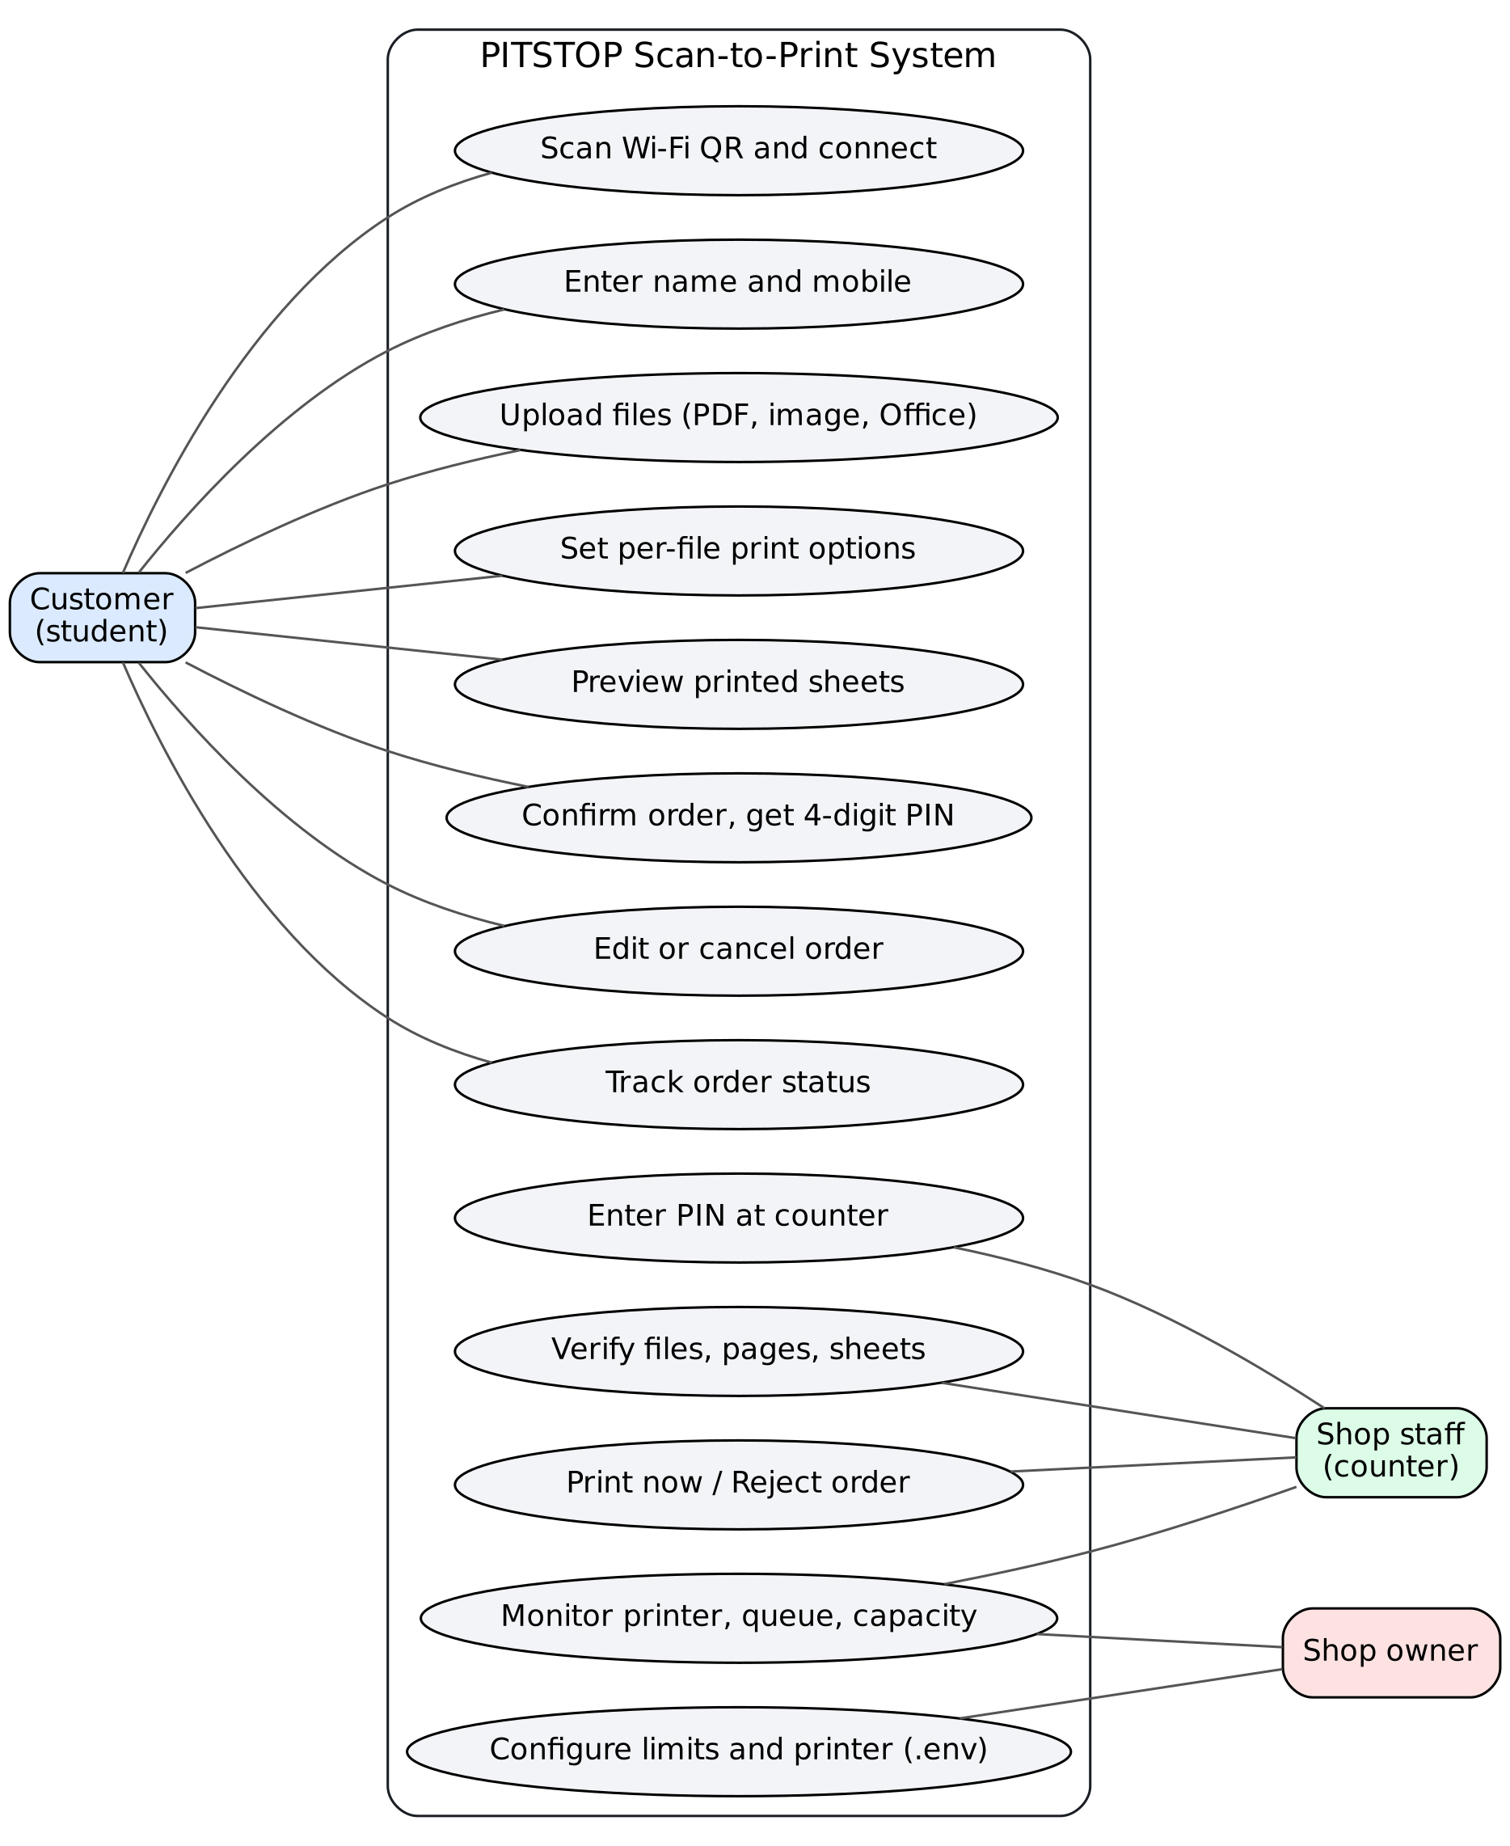
Figure 3.1: Use Case Diagram of the PITSTOP Scan-to-Print System
Use Case ID | Scenario Title | Interaction & Technical Execution Flow
UC-01 | Connect to Station | Customer scans the Wi-Fi QR code; the captive portal opens the Welcome page; tapping Continue opens the print site in the browser.
UC-02 | Create Order & Upload | Customer enters name and mobile; uploads files; the server stores each file under a random name and queues preparation (conversion, page count).
UC-03 | Configure & Preview | Customer taps a file, chooses settings and page range; the preview redraws; totals update.
UC-04 | Confirm & Get PIN | Customer reviews the order summary and confirms; the server validates files and limits, issues a unique PIN and starts the 120-minute validity.
UC-05 | Serve at Counter | Staff type the PIN; verify details; press Print now; the job enters the print lane of the queue and prints through SumatraPDF.
UC-06 | Configure Station | Owner sets shop name, Wi-Fi, printer capabilities and limits in the .env file.

3.4 Non-Functional Requirements
- Offline operation: No internet, cloud service or app installation required.
- Privacy & security: Files stored only on the laptop with random names, deleted automatically; counter pages and admin API accessible only from the laptop itself; per-device rate limiting.
- Performance on low-spec hardware: One job at a time with printing prioritised; previews rendered on the customer's phone, not the laptop.
- Reliability: Orders saved to tmp/orders.json so PINs survive a laptop restart; interrupted print jobs are flagged for the staff.
- Usability: Mobile-first UI in three steps (Upload → Set & preview → Show PIN), large keypad on the counter, keyboard shortcuts; light and dark themes.
- Configurability: Shop name, Wi-Fi, limits, printer capabilities and conversion method set in .env without code changes.

3.5 Acceptance Criteria
- A phone with mobile data turned off can join the station Wi-Fi by QR code and open the print page.
- A customer can upload PDF, image and Office files and see correct page counts and previews.
- Pages and sheets shown on the phone match the counter screen for every combination of range, copies and sides.
- No file prints without the correct PIN being entered at the counter.
- Files are removed from the laptop after printing or expiry.
- The station runs on the shop laptop and starts automatically with Windows.

4. Project Proposal, Work Breakdown Structure & Quotation

4.1 Scope Baseline & Explicit Boundaries
In Scope | Out of Scope
Laptop hotspot and Wi-Fi QR; captive portal; customer web app (details, upload, per-file settings, preview, review, PIN, status); counter web app (PIN keypad, order view, file preview, print, reject, monitoring); Office-to-PDF conversion; silent printing; automatic clean-up; Windows setup and auto-start scripts; testing, installation, training and handover. | Online payment gateway; customer login accounts; cloud storage or remote printing over the internet; Android/iOS native apps; printer hardware purchase or repair; accounting/GST billing software.

Principal risks and mitigations: slow laptop (single job queue, size and page limits, previews drawn on phones); phones refusing captive portal (fallback address printed under the QR code); printer driver errors (clear error messages, retry from counter); laptop restarts (order store persisted to disk); misuse by many requests (per-device rate limit and order limits).

4.2 Work Breakdown Structure & Milestones
Phase | Milestone Activity | Duration | Status
Phase 1 | Client identification and first discussion | 24 Aug 2026 | Completed
Phase 2 | Requirement outline, proposal and client approval | 25 Aug – 05 Sep 2026 | Completed
Phase 3 | System design: architecture, order flow, UI wireframes | 06 – 15 Sep 2026 | Completed
Phase 4 | Core development: server, upload, PIN, counter screen | 16 Sep – 05 Oct 2026 | Completed
Phase 5 | Prototype demo to client; feedback | 26 Sep 2026 | Completed
Phase 6 | Change requests: Office files, per-file settings, preview, capacity limits, captive portal | 06 – 28 Oct 2026 | Completed
Phase 7 | Testing (functional, validation, security, responsive) | 20 – 30 Oct 2026 | Completed
Phase 8 | Installation at shop, staff training, acceptance and handover | 31 October 2026 | Completed
Phase 9 | Report preparation and final submission | 02 November 2026 | Completed

Team Member | Register No. | Responsibility
SIBISAKTHIVEL K | 24AM052 | Client engagement and requirement gathering; server and API (Express), order store, PIN token, job queue, printing and Office conversion; Windows hotspot, captive portal and setup scripts; installation at shop
VIRTHEKESH VIPIN | 24AM063 | UI/UX design of phone and counter screens; print preview (pdf.js); testing; screenshots and documentation; staff training support

4.3 Commercial Quotation Baseline
Table 4.1 presents the commercial quotation and agreed project value:
Item | Service Description | Quoted Value
1 | System design charges (architecture, UI/UX for phone and counter) | ₹600
2 | Development charges (server, customer web app, counter app) | ₹600
3 | Domain and hosting – not applicable (runs offline on shop laptop) | ₹0
4 | Additional features: PIN token, live print preview, Office conversion, captive portal | ₹800
5 | Installation, training and maintenance | ₹0
TOTAL | Total Agreed Project Value (Fixed Fee) | ₹2,000

Deliverable | Status Recorded
Customer phone web app (upload, settings, preview, PIN) | Developed and installed
Counter web app (PIN keypad, order view, print/reject, monitoring) | Developed and installed
Hotspot, captive portal, Windows setup and auto-start scripts | Developed and installed
Source code | Handed over on the shop laptop (D:\…\Pitshop-printer) and to the client
Testing, installation, demonstration, training and handover | Completed (31 October 2026)

5. System Design: Architecture, Data Model, UML & UI

5.1 High-Level Architecture
The system is a single Node.js process on the shop laptop. Customers' phones reach it only through the laptop's own hotspot. The Express server serves the customer site and a counter site, exposes a customer REST API (/api) and a counter API (/api/admin) that answers only requests from the laptop itself. Heavy work — Office conversion, page counting and printing — runs through one queue in which print jobs always go first.
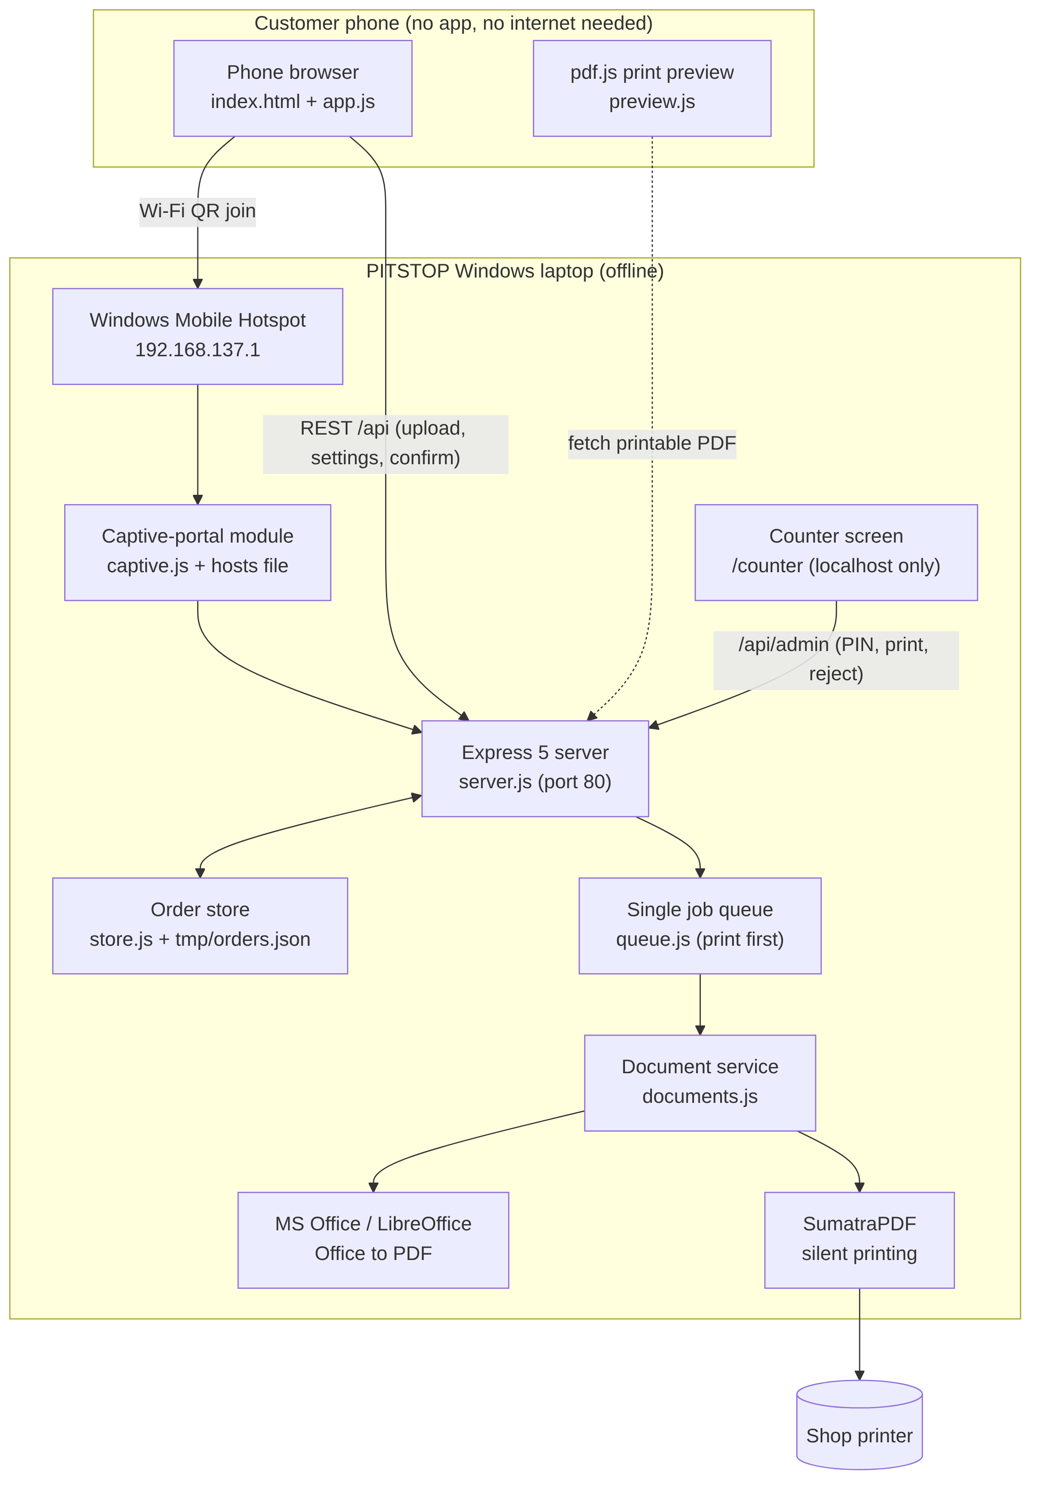
Figure 5.1: System Architecture of the PITSTOP Scan-to-Print Station
Module (file) | Responsibility
server.js | Express app, routing, upload handling (Multer), rate limiting, customer and counter APIs, start-up
store.js | In-memory order store mirrored to tmp/orders.json; PIN generation; settings normalisation; page-range parsing; totals; expiry and clean-up
queue.js | Single job queue with two lanes: print (priority) and prepare
documents.js | File type rules, Office-to-PDF conversion, PDF page counting, SumatraPDF print settings, printer status
captive.js | Captive-portal detection and answers for Android, iOS, Firefox and Linux connectivity checks; localhost-only guard
hotspot.js / hotspot.ps1 | Turns on Windows Mobile Hotspot with the configured SSID and password
config.js | Reads .env settings with safe defaults and limits
public/ (app.js, preview.js) | Customer phone web app and pdf.js-based print preview
counter/ (counter.js) | Counter screen: Wi-Fi QR, PIN keypad, order view, print/reject, status pills

5.2 Data Flow & Logical Data Model
Figure 5.2 models the flow of data. Customer input is validated on the server, stored on the laptop, prepared by the queue and turned into totals and a PIN. The counter looks up the PIN and prints. The system has no database; orders are JavaScript objects kept in memory and saved atomically to tmp/orders.json (written to a temporary file and renamed).
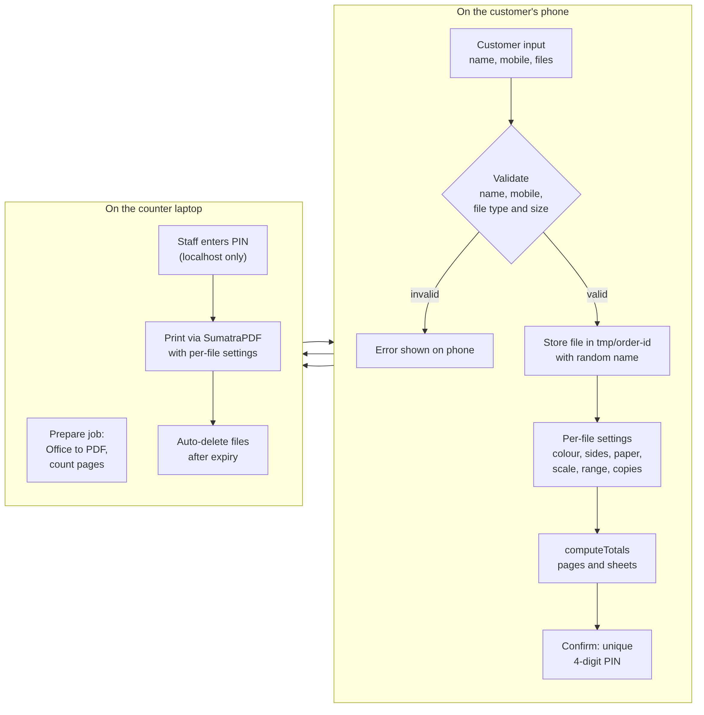
Figure 5.2: Data Flow Diagram
Record | Main Fields and Use
ORDER | id (UUID), name, mobile, ip (device on hotspot), status, pin, createdAt, confirmedAt, doneAt, expiresAt, files[], totals, error
FILE | id (UUID), name, kind (pdf / image / office), size, path (random name), printPath (PDF), pages, range, settings, status (processing / ready / error), error
SETTINGS | copies (1–20), color (bw / color), sides (single / double-long / double-short), orientation (auto / portrait / landscape), paper (A4, A3, A5, Letter, Legal), scale (fit / shrink / noscale)
TOTALS | files, pages = selected pages × copies, sheets = selected (or ⌈selected / 2⌉ for double-sided) × copies
CONFIG (.env) | SHOP_NAME, HOTSPOT_SSID/PASSWORD, SERVER_PORT, MAX_UPLOAD_MB, MAX_FILES_PER_ORDER, MAX_PAGES_PER_ORDER, MAX_ACTIVE_ORDERS, MAX_ORDERS_PER_DEVICE, PIN_TTL_MINUTES, COLOR/DUPLEX_PRINTING, PAPER_SIZES, PRINTER_NAME, CONVERSION_METHOD

5.3 Order Lifecycle (State Diagram)
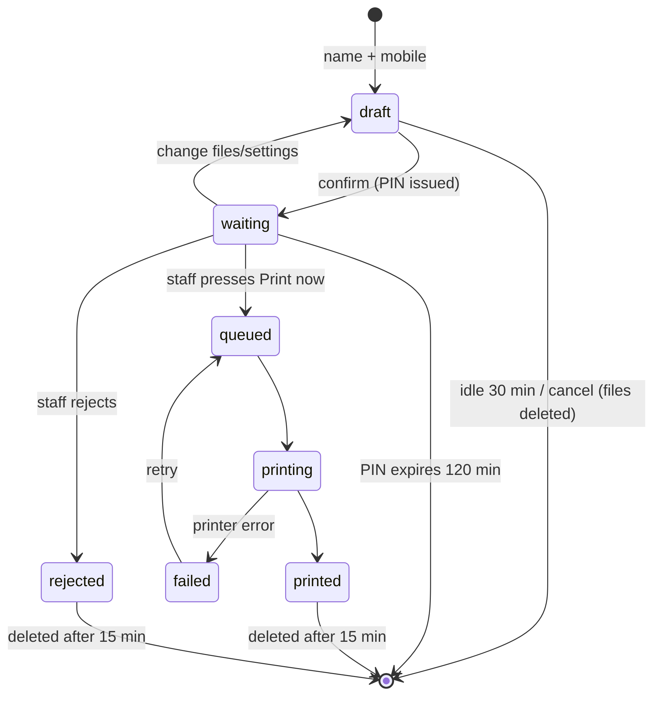
Figure 5.3: Order State Diagram
Status | Meaning | Expiry / Clean-up
draft | Customer is adding files and settings | Deleted after 30 idle minutes
waiting | Confirmed; PIN issued; waiting at counter | PIN valid for 120 minutes
queued / printing | Staff pressed Print now | Never expires while printing
printed / failed / rejected | Finished, printer error, or declined by staff | Files deleted 15 minutes later

5.4 Interaction Design (Sequence Diagram)
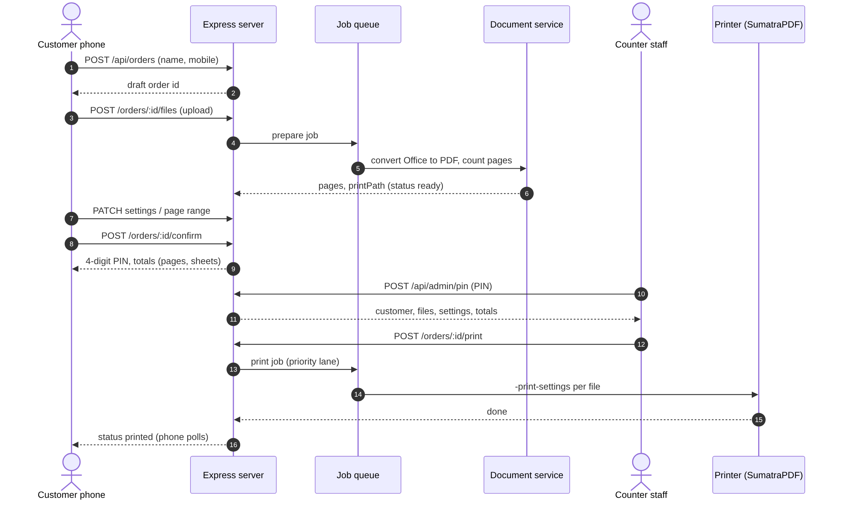
Figure 5.4: Sequence of an Order from Upload to Print

5.5 UI/UX Design & Wireframe
The customer site is a single mobile-first page with three steps shown at the top — Upload files → Set & preview → Show your PIN — and a fixed bottom bar with the running total and a Confirm button. Each file appears as a card with its thumbnail, page count and setting chips; tapping it opens a bottom sheet with the preview above the settings. The counter screen is a two-column landscape layout: the Wi-Fi QR code and connection details on the left, and the PIN keypad (or the order details after a PIN is entered) on the right, with status pills in the header. Screenshots of the delivered screens are in Annexure B.
Design Token | Value | Role
Accent blue | #2950E0 | Primary buttons, links, active choices
Text | #13161B | Headings and body text
Background | #F3F4F7 | Page canvas
Success green | #12804A | "Print now" button, ready/printed states
Warning amber | #A95C00 | Waiting state, notices
Error red | #C4352A | Reject, errors, printer offline
Brand mark | Cyan #12A6D8 · Magenta #D6337F · Yellow #F2B705 | Three-dot printer-ink logo
Typography | System UI font stack; monospace for PIN/addresses | Fast on phones; no font downloads needed offline

5.6 API Design
Method & Endpoint | Purpose | Access
GET /api/info | Shop name, accepted types, limits, printer options | Customer
POST /api/orders | Create order (name, mobile) | Customer
GET /api/orders/mine | Open orders from this phone (resume) | Customer
POST /api/orders/:id/files | Upload one file | Customer
PATCH /api/orders/:id/files/:fileId | Change page range / settings | Customer
PATCH /api/orders/:id/files | "Use for all files" settings | Customer
POST /api/orders/:id/confirm | edit | cancel | Issue PIN / withdraw PIN / cancel order | Customer
GET /api/admin/overview | Wi-Fi QR, printer, queue, capacity, recent orders | Counter (localhost only)
POST /api/admin/pin | Look up order by PIN | Counter (localhost only)
POST /api/admin/orders/:id/print | reject | Print or decline order | Counter (localhost only)

6. Technical Implementation Deep-Dive

6.1 Core Technologies
Component | Technology / Role
Runtime | Node.js (JavaScript ES2022)
Web server | Express 5.3 — routing, static files, JSON APIs
Uploads | Multer 2.5 — disk storage, random file names, UTF-8 file names (Tamil/Hindi names preserved), size and type limits
PDF processing | pdf-lib 1.17.1 — page counting; pdfjs-dist 4.10.38 — previews rendered in the browser
QR code | qrcode 1.5 — WIFI:T:WPA;S:…;P:…; QR for one-scan Wi-Fi join
Office conversion | Microsoft Office COM automation through PowerShell (Word, Excel, PowerPoint → PDF) or LibreOffice headless
Printing | SumatraPDF command line: -print-to-default -silent -print-settings
Windows integration | PowerShell (WinRT tethering API for Mobile Hotspot), hosts file entries for captive portal, startup task
Front-end | HTML5, CSS3 (custom properties, light/dark), vanilla JavaScript — no framework
Package manager / scripts | pnpm / npm; npm start, npm run build (syntax check of all files)
Source code | Handed over on the shop laptop (not published publicly, as requested for client privacy)

6.2 Repository Structure
Path | Purpose
index.js | Loads .env and starts the server
src/ | server.js, store.js, queue.js, documents.js, captive.js, hotspot.js, config.js
public/ | index.html, app.js, preview.js, styles.css, welcome.html (customer site)
counter/ | index.html, counter.js (counter screen)
scripts/ | setup-windows.ps1, hotspot.ps1, convert-office.ps1, captive-hosts.js, install.js, start-kiosk.bat, check.js
.env / .env.example | Shop configuration
tmp/ | Uploaded files per order and orders.json (auto-cleaned)

The code base is about 3,200 lines across 21 source files.

6.3 Key Algorithms
(a) PIN token generation. When an order is confirmed, store.newPin() collects all PINs in use and draws a random 4-digit number with crypto.randomInt(0, 10000) until it finds one not in use. PINs are therefore unique among open orders and cannot be guessed from order sequence.
(b) Pages and sheets (billing basis). For each ready file, the selected pages are parsed from the page range ("all" or a list such as "1-3,5"). Pages printed = selected × copies; sheets = selected × copies for single-sided, or ⌈selected / 2⌉ × copies for double-sided. For example, pages 1–5 double-sided with 2 copies gives 10 pages on 6 sheets (verified in test T08).
(c) Page-range validation. The range text must match ^\d+(-\d+)?(,\d+(-\d+)?)*$ and every number must lie between 1 and the document's page count, otherwise the customer sees "Pages must be between 1 and N".
(d) Settings normalisation. Every incoming setting is clamped to what the shop printer supports: copies between 1 and MAX_COPIES, colour only if COLOR_PRINTING, duplex only if DUPLEX_PRINTING, paper only from PAPER_SIZES. Invalid values fall back to safe defaults, so a tampered request cannot request unsupported printing.
(e) Prioritised job queue. queue.js keeps two lanes; whenever the laptop is free it takes the next print job first, then preparation jobs, one at a time. This keeps a weak laptop responsive and ensures the customer at the counter is never kept waiting behind someone else's Office conversion.
(f) Captive portal. The setup script maps the connectivity-check hosts used by Android, iOS, Firefox and Linux to the laptop in the Windows hosts file. Until a phone has used the print site, these checks are redirected to the Welcome page, so the phone shows "Sign in to network". Once the phone uses the API, the checks get the normal "online" answer, so the phone keeps using the Wi-Fi for uploads instead of switching to mobile data.
(g) Printing. documents.printSettings() builds the SumatraPDF settings string from the file settings, e.g. "1-5,2x,collate,monochrome,duplexlong,paper=A4,fit", and SumatraPDF prints silently to the chosen or default printer. SumatraPDF exit codes are translated into clear messages for the staff.

6.4 Implementation Status & Challenges
Module | Status
Hotspot, Wi-Fi QR and captive portal | Completed
Customer details, upload and file preparation | Completed
Per-file settings, live preview, "Use for all files" | Completed
Totals, review sheet, PIN token, edit/cancel | Completed
Counter keypad, order view, print/reject, monitoring | Completed
Persistence, expiry and automatic clean-up | Completed
Windows setup and auto-start | Completed; installed at shop

Key challenges were making phones open the print page automatically without internet (solved with the captive-portal and "online answer" logic), stopping phones from sending uploads over mobile data, keeping a low-spec laptop responsive while converting Office files (single queue, previews on phones), handling non-English file names correctly, and making the preview match the actual printed output for duplex and black & white.

7. Verification, Quality Assurance & Testing

7.1 Testing Strategy
Testing combined (1) API-level functional and validation tests executed with curl against the running server, (2) end-to-end browser tests automated with Playwright/Chromium at phone (390 × 844 px) and laptop (1366 × 768 px) sizes, (3) security checks on access control and input tampering, and (4) on-site testing with the shop laptop and printer during installation. Results T01–T17 below are the actual responses recorded.

7.2 Functional & Validation Test Cases
ID | Test Case | Expected | Actual Result | Status
T01 | GET /api/info | Shop name, accepted types, limits returned | 200 OK with 10 file types, limits 10 customers / 20 MB / 10 files / 300 pages | Pass
T02 | Create order with 1-letter name | Rejected | 400 "Please enter your name." | Pass
T03 | Create order with mobile "12345" | Rejected | 400 "Please enter a valid mobile number." | Pass
T04 | Upload .exe file | Rejected | 400 "This file type is not supported." | Pass
T05 | Confirm order with no files | Rejected | 400 "Add at least one file." | Pass
T06 | Upload 6-page PDF | Accepted, page count read | 200; file ready, pages = 6 | Pass
T07 | Page range "2-9" on 6-page file | Rejected | 400 "Pages must be between 1 and 6" | Pass
T08 | Range 1-5, double-sided, 2 copies | 10 pages, 6 sheets | totals = 10 pages, 6 sheets | Pass
T09 | Confirm valid order | PIN issued, status waiting | 200; 4-digit PIN, status "waiting" | Pass
T10 | Counter lookup with wrong PIN | Not found | 404 "No order found with this PIN." | Pass
T11 | Counter API from another device on network | Blocked | 403 "only available on the print station" | Pass
T12 | Counter page from another device | Blocked | 403 | Pass
T13 | Tampered settings: 999 copies, paper B5, invalid colour | Clamped to safe values | copies 20, paper A4, B&W | Pass
T14 | 4th open order from the same phone | Rejected (limit 3) | 429 "You already have open orders on this phone…" | Pass
T15 | Change settings after confirmation | Rejected | 409 "This order is already confirmed." | Pass
T16 | Full flow in browser: 2 PDFs → PIN → counter | Phone and counter totals match | 9 pages / 9 sheets on both screens; PIN accepted | Pass
T17 | Syntax check of all JS files (npm run build) | No errors | "Checked 14 files." | Pass

7.3 Responsive & Device Compatibility
Platform | Environment | Result
Customer site | Chromium, 390 × 844 px phone viewport | Pass – all three steps, settings sheet and preview usable
Counter site | Chromium, 1366 × 768 px laptop | Pass – QR, keypad and order view fit without scrolling
Android phones | Chrome via captive portal at the shop | Pass (on-site test at shop)
iPhone | Safari (tap Done, open Safari) | Pass (on-site test at shop)
Shop printer | SumatraPDF silent printing, B&W / colour, duplex | Pass (on-site test at shop)

7.4 Security & Privacy Checks
Check | Implementation | Result
Counter access control | captive.localOnly allows only 127.0.0.1 / ::1 | Pass (T11, T12)
Input validation | Name, mobile, file type, size, range and settings validated on server | Pass (T02–T07, T13)
Abuse limits | 120 requests/min per device; 3 open orders per phone; 10 customers at once | Pass (T14)
File privacy | Random stored names; files deleted on expiry, cancel or 15 min after printing | Pass
HTML injection | Shop name and URLs escaped in the Welcome page | Pass
Header hardening | x-powered-by disabled; JSON body limit 10 KB | Pass

8. Deployment & On-Premise Installation

8.1 Deployment Model
Because the requirement was offline operation and privacy, the system is deployed on-premise on the shop's Windows laptop instead of a public web host. The "live URL" is the station address on the shop Wi-Fi; it is intentionally not reachable from the internet.

8.2 Installation Steps Performed at the Shop
- Installed Node.js, SumatraPDF and the printer driver on the shop laptop (Microsoft Office already present for Word/Excel/PowerPoint conversion).
- Copied the project and created .env with the shop name, Wi-Fi name and password, and the printer's colour, duplex and paper-size capabilities.
- Ran scripts\setup-windows.ps1 as Administrator: installs dependencies, adds captive-portal host entries, registers the Windows startup task and starts the station.
- Opened the counter screen at http://localhost/counter/, tested a phone upload, PIN entry and printing on the shop printer.
- Trained staff on PIN entry, preview, Print now, Reject and printer status.

8.3 Production Deployment Parameters
Parameter | Specification
Start command | npm start (auto-started by scripts\start-kiosk.bat at Windows login)
Hosting platform | On-premise: PITSTOP shop Windows laptop
Customer URL (shop Wi-Fi only) | http://192.168.137.1/
Counter URL (laptop only) | http://localhost/counter/
Deployment date | 31 October 2026
Monthly cost | ₹0 – no domain, hosting or internet charges
Backup & recovery | Orders persisted to tmp/orders.json; project folder copy kept by the team

9. Client Interaction, Meeting Records & Change Management

9.1 Client Meeting and Progress Report
Meeting | Date | Discussion / Work Completed | Client Feedback & Actions
Meeting 1 | 24 Aug 2026 | Business discussion: current WhatsApp/pen-drive printing process, privacy issues, rush-hour mix-ups and billing problems. Proposed offline Windows station + phone web app with tokens and bills. | Proposal accepted; asked for simple UI, offline privacy, tokens and bill details, and fraud prevention.
Meeting 2 | 05 Sep 2026 | Presented requirement outline, screen flow (Upload → Settings → PIN) and quotation. | Approved scope and price; asked to support colour and double-sided printing.
Meeting 3 | 26 Sep 2026 | Prototype demo: phone upload of PDFs, PIN issue and counter print. | Requested Word/Excel/PowerPoint support and a preview so students check pages before printing.
Meeting 4 | 17 Oct 2026 | Trial on shop laptop during evening rush. | Requested separate settings per file, a cap on customers at once (laptop is slow), and the page to open automatically after Wi-Fi join.
Meeting 5 | 31 October 2026 | Final installation, demonstration, staff training and handover. | System accepted; payment completed.

9.2 Client Change Request Log
CR # | Date | Requested Modification | Technical Resolution | Status
CR-01 | 05 Sep 2026 | Colour and double-sided options | COLOR_PRINTING / DUPLEX_PRINTING settings; duplex long/short edge | Incorporated
CR-02 | 26 Sep 2026 | Accept Word, Excel, PowerPoint | Office-to-PDF conversion via Office COM / LibreOffice | Incorporated
CR-03 | 26 Sep 2026 | Preview before printing | pdf.js sheet-by-sheet preview on the phone and at the counter | Incorporated
CR-04 | 17 Oct 2026 | Different settings for each file | Per-file settings with "Use for all files" | Incorporated
CR-05 | 17 Oct 2026 | Limit customers at once on slow laptop | MAX_ACTIVE_ORDERS (10), per-phone limit, single job queue | Incorporated
CR-06 | 17 Oct 2026 | Open the print page automatically after scanning | Captive portal + Wi-Fi QR code | Incorporated

Engagement channels were in-person meetings at the shop and phone calls/WhatsApp with the owner. Detailed minutes of each meeting are given in Annexure D.4.

10. Revenue Generation Model & Payment Details

10.1 Revenue Breakdown
Particulars | Amount (₹)
Website / System Design Charges | ₹600
Website / System Development Charges | ₹600
Domain and Hosting Charges | ₹0 (offline, on-premise)
Additional Features (PIN token, preview, Office conversion, captive portal) | ₹800
Maintenance Charges | ₹0 (free support for 3 months)
Total Agreed Project Value | ₹2,000
Advance Payment Received | ₹0
Final Payment Received | ₹2,000
Total Revenue Collected | ₹2,000
Project Expenses | ₹0
Net Project Earnings | ₹2,000
Balance Payment Pending | -NIL-

10.2 Payment Record
Field | Details
Payment Date | 02-11-2026, 11:18 AM
Payment Method | UPI (Paytm)
UPI Reference No. | 318230380257
Paid To | K P R Charities (institution account, kprcharities.62765784@hdfcbank)
Invoice / Receipt Number | PIT-2026-001
Received By | SIBISAKTHIVEL K / VIRTHEKESH VIPIN

The project revenue of ₹2,000 has been remitted to K P R Charities, the institution account designated for the Revenue Generation Model. Redacted payment confirmation is attached in Annexure C (Figure C.1) with the client's consent. GST has not been charged, as the student team is not a GST-registered entity and the service is not liable for GST.

10.3 Effort & Value
Total effort was about 40 hours per member (80 hours in total) between 24 August and 31 October 2026. Effective value per hour = ₹2,000 ÷ 80 hours = ₹25 per hour. No software, domain or hosting expenses were incurred, as all tools used (Node.js, SumatraPDF, LibreOffice and open-source npm packages) are free.

11. Client Verification & Authenticity

11.1 Business Verification Evidence
Evidence Item | Status / Handling
Business-registration evidence | Not GST registered; business verified through the KPRIET campus location, the CIAT 1 client approval record and the signed consent letter
Location confirmation | KPRIET Boys Hostel Block, Avinashi – Coimbatore Road, Arasur, Uthupalayam, Tamil Nadu 641407, India; located inside the KPRIET campus; shop photograph in Annexure A
Client authorization / consent letter | Signed letter in Annexure D.1
Client acceptance certificate | Signed certificate in Annexure D.2
Stage 1 (CIAT 1) client approval record | Discussion dated 24/08/2026, proposal accepted, payment agreed

11.2 GST Status
The client is not GST registered. No GST has been charged on the project value. Sensitive identifiers in the annexures are masked.

12. Project Delivery, Training & Acceptance

12.1 Deliverables Handover Inventory
Item | Handover Asset | Status
1 | Installed station on shop laptop (auto-start) | Completed
2 | Source code and .env configuration | Handed over
3 | Wi-Fi QR on counter screen (printable copy for the counter) | Completed
4 | Setup and troubleshooting guide (README) | Handed over
5 | Testing results | Section 7
6 | Demonstration and staff training | Completed (31 October 2026)
7 | Client acceptance / signature | Annexure D.2
8 | Payment of ₹2,000 | Received

12.2 Demonstration & Training
The demonstration covered the full flow with a staff member's phone: scanning the QR code, the Welcome page, entering details, uploading a PDF and a Word file, changing settings with the preview, confirming to get a PIN, entering the PIN at the counter, previewing and printing, and rejecting an order. Staff were also shown the header indicators (customers, waiting orders, printer status), what to do when the printer is offline, and how to restart the station.

12.3 Maintenance & Support Terms
- Free support for bug fixes and configuration changes for 3 months from installation.
- Changes to Wi-Fi name/password, limits and printer capabilities are made in .env; no code change is needed.
- New features (e.g. price list and printed bill) to be quoted separately.

13. Outcomes, Learnings, Future Scope & Conclusion

13.1 Student Learning Outcomes
- Client engagement: Turning a shopkeeper's everyday problems into requirements, presenting a proposal and handling change requests.
- Server-side web programming: REST API design with Express, file uploads with Multer, validation, rate limiting and access control.
- Networking: Wi-Fi hotspots, captive-portal detection on Android/iOS, and working fully offline.
- Document processing: PDF page counting, Office-to-PDF automation, browser-side rendering with pdf.js, and command-line printing.
- Engineering for constraints: Job queues, limits and persistence for a low-specification machine.

13.2 Outcomes for the Client
- Students print without sharing phone numbers or files over WhatsApp, and without internet.
- Every order has a token (PIN), so customers are served without mix-ups in any order.
- Exact pages and sheets are known before printing, giving a fair and verifiable basis for billing.
- Only orders confirmed by the customer and entered at the counter are printed.

13.3 Future Scope
- Shop price list (per page for B&W/colour, binding charges) with automatic bill amount and printable bill/receipt.
- Daily and monthly reports of orders, pages and earnings for the owner to detect leakage.
- UPI QR code with amount on the PIN screen.
- Binding and lamination add-ons selected while ordering.
- SMS/WhatsApp-free "ready for pickup" alert on the phone using the existing status updates.

13.4 Conclusion
The project delivered a working, installed offline scan-to-print station for PITSTOP. It replaces WhatsApp and pen-drive file transfer with a private, internet-free upload over the shop's own Wi-Fi, issues a PIN token for every order, gives exact page and sheet counts for billing, and keeps printing under the counter's control. The system was tested, installed on 31 October 2026, accepted by the client, and the agreed value of ₹2,000 has been received.

14. Evaluation Rubric, Submission Checklist & Approvals

14.1 Assignment II Evaluation Rubric
S.No | Evaluation Criterion | Max | Awarded | Evidence / Remarks
1 | Client Identification & Verification | 15 |  | Table 2.1; Section 11; Annexures A, D.1
2 | Requirement Analysis & Proposal | 15 |  | Sections 3–4; WBS; quotation
3 | System Design & Technical Development | 30 |  | Sections 5–6
4 | Testing, Deployment & Demonstration | 15 |  | Sections 7–8; Section 12
5 | Revenue Documentation & Client Acceptance | 15 |  | Section 10; Annexures C, D.2
6 | Report Quality & Viva | 10 |  | Complete report
 | TOTAL | 100 |  | To be awarded by faculty

14.2 Mandatory Submission Checklist
Item | Status
Complete project report (PDF and printed copy) | ✔
Client details and business verification | ✔ (Table 2.1, Annexure A)
Approved requirements and quotation | ✔ (Sections 3–4, Annexure C)
System design and project screenshots | ✔ (Section 5, Annexure B)
GitHub repository and live URL | ✔ Source handed over on shop laptop; on-premise URL http://192.168.137.1/
Client meeting and progress records | ✔ (Section 9, Annexure D.4)
Invoice/receipt | ✔ (Annexure C)
Redacted payment proof | ✔ (Annexure C)
Client feedback and acceptance certificate | ✔ (Annexure D.2, D.3)
Final project demonstration | ✔ (31 October 2026)

14.3 Approval / Verification
Particulars | Student Team | Faculty Guide | Client Representative
Name | SIBISAKTHIVEL K (24AM052)  VIRTHEKESH VIPIN (24AM063) | Dr. KARTHICK PANNERSELVAM | MOHANKUMAR, Owner, PITSTOP
Signature
Date | 02 November 2026

15. Annexures & References

Annexure A: Client Verification
PITSTOP is a grocery shop with a printing and binding counter at the KPRIET Boys Hostel Block, Avinashi – Coimbatore Road, Arasur, Coimbatore – 641 407, Tamil Nadu (Mobile 79047 42326). The client representative is MOHANKUMAR, Owner.
Paste photo of PITSTOP shop front / counter with the station running

Annexure B: Interface Walkthrough & Screenshots
Figures B.1 to B.8 show the delivered interface. Sample files and the names "Arun K" are test data used during testing.
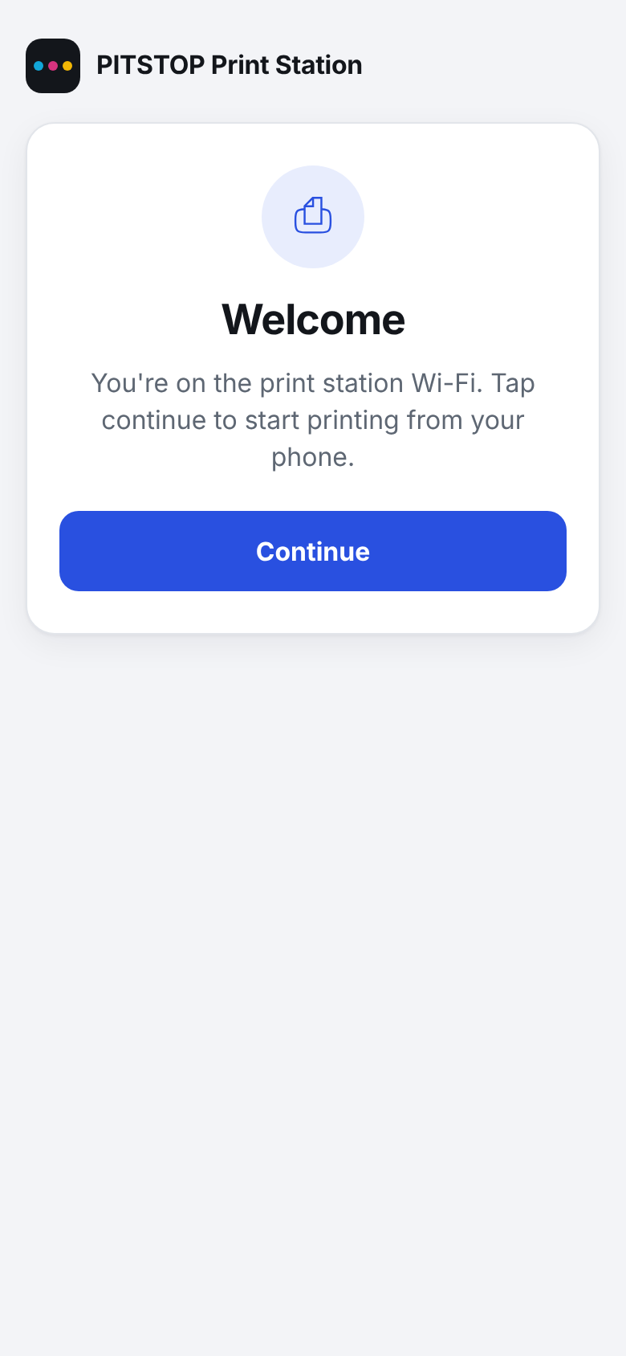  Figure B.1: Captive-portal Welcome page | 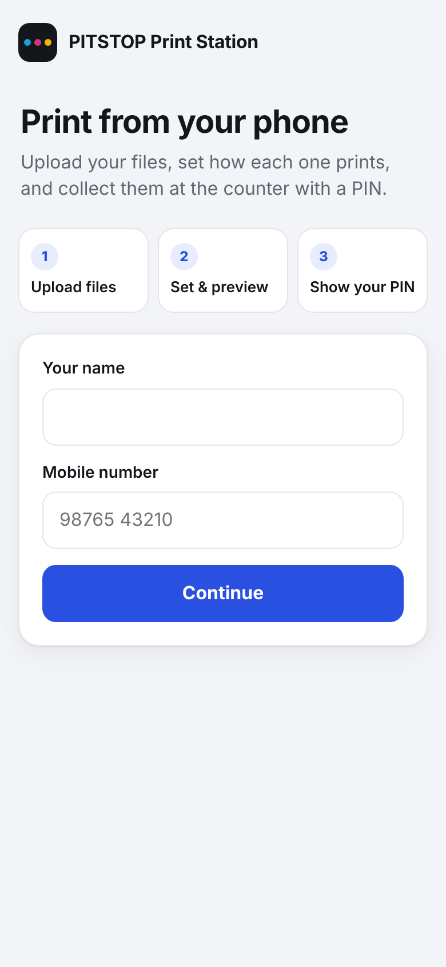  Figure B.2: Start – name and mobile | 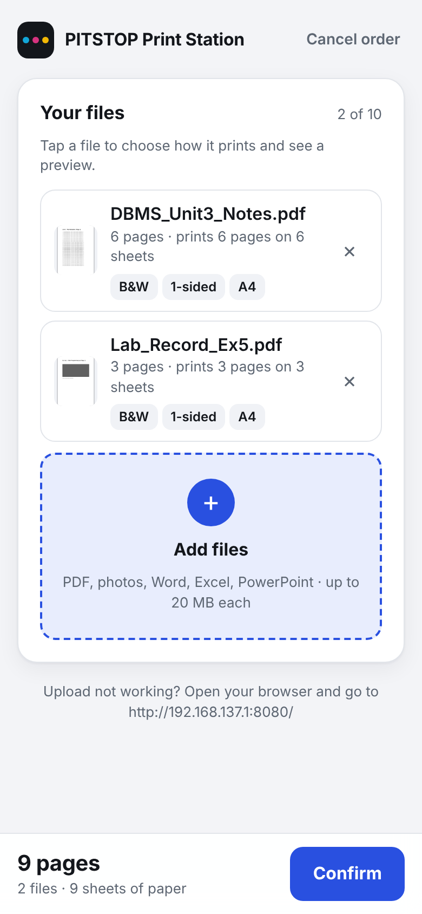  Figure B.3: Uploaded files with page counts

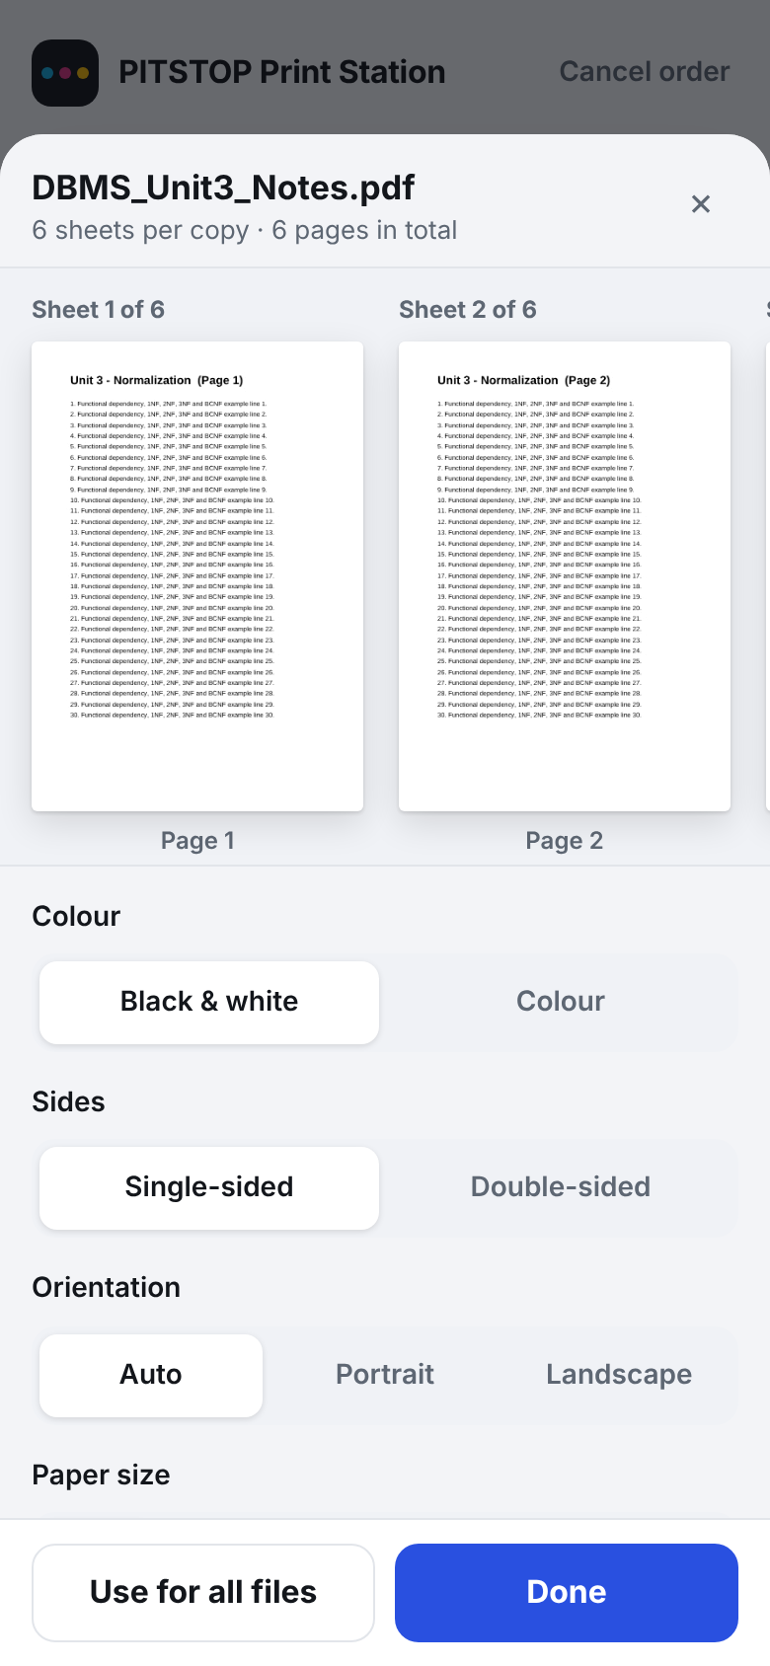  Figure B.4: Per-file settings with live preview | 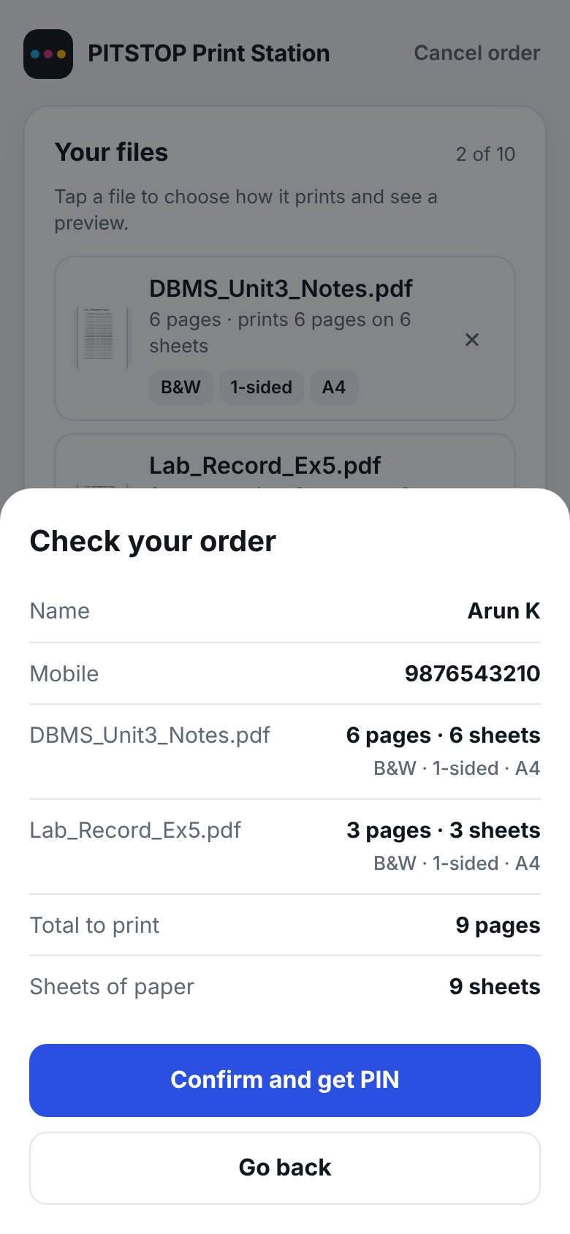  Figure B.5: Check your order | 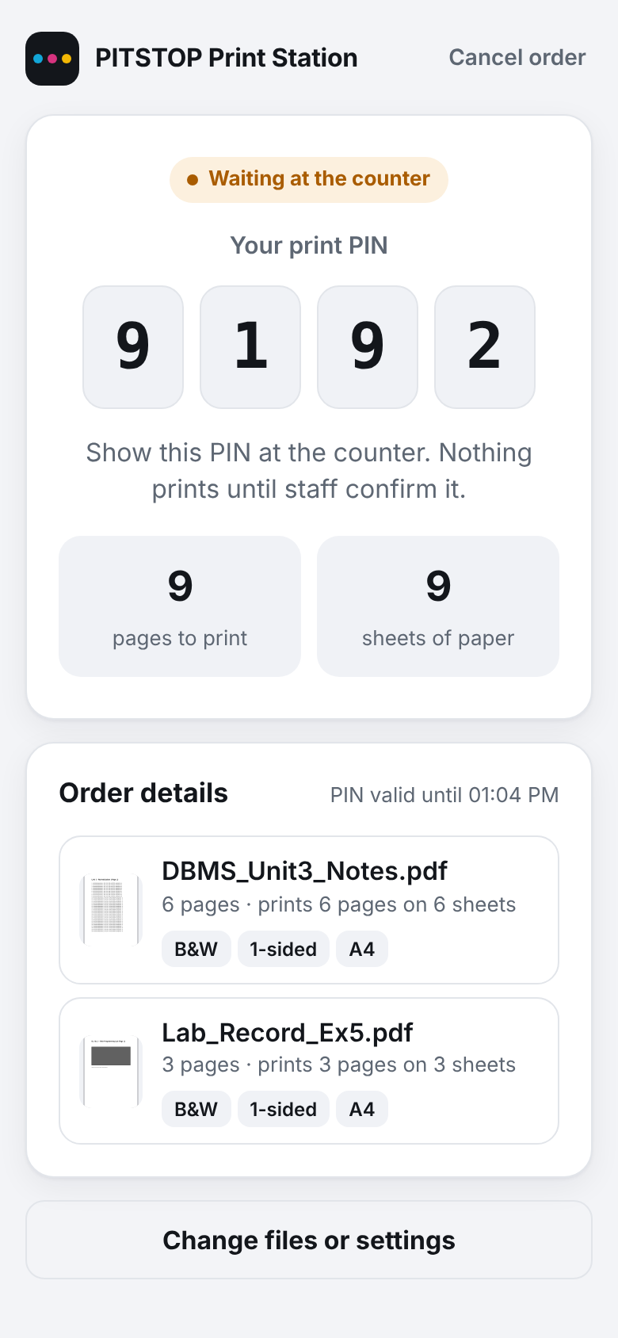  Figure B.6: PIN token with pages and sheets

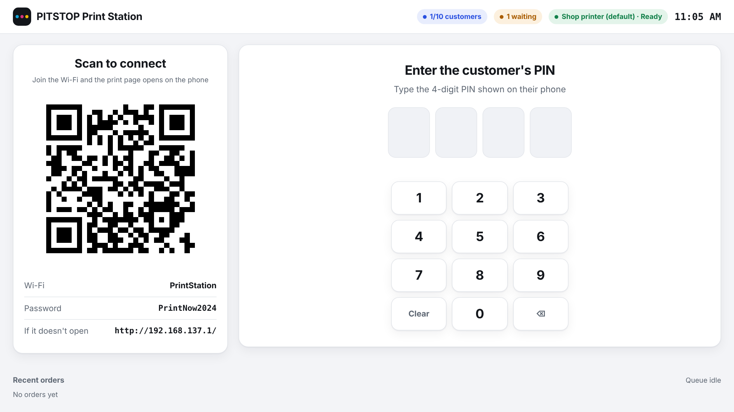
Figure B.7: Counter screen – Wi-Fi QR and PIN keypad
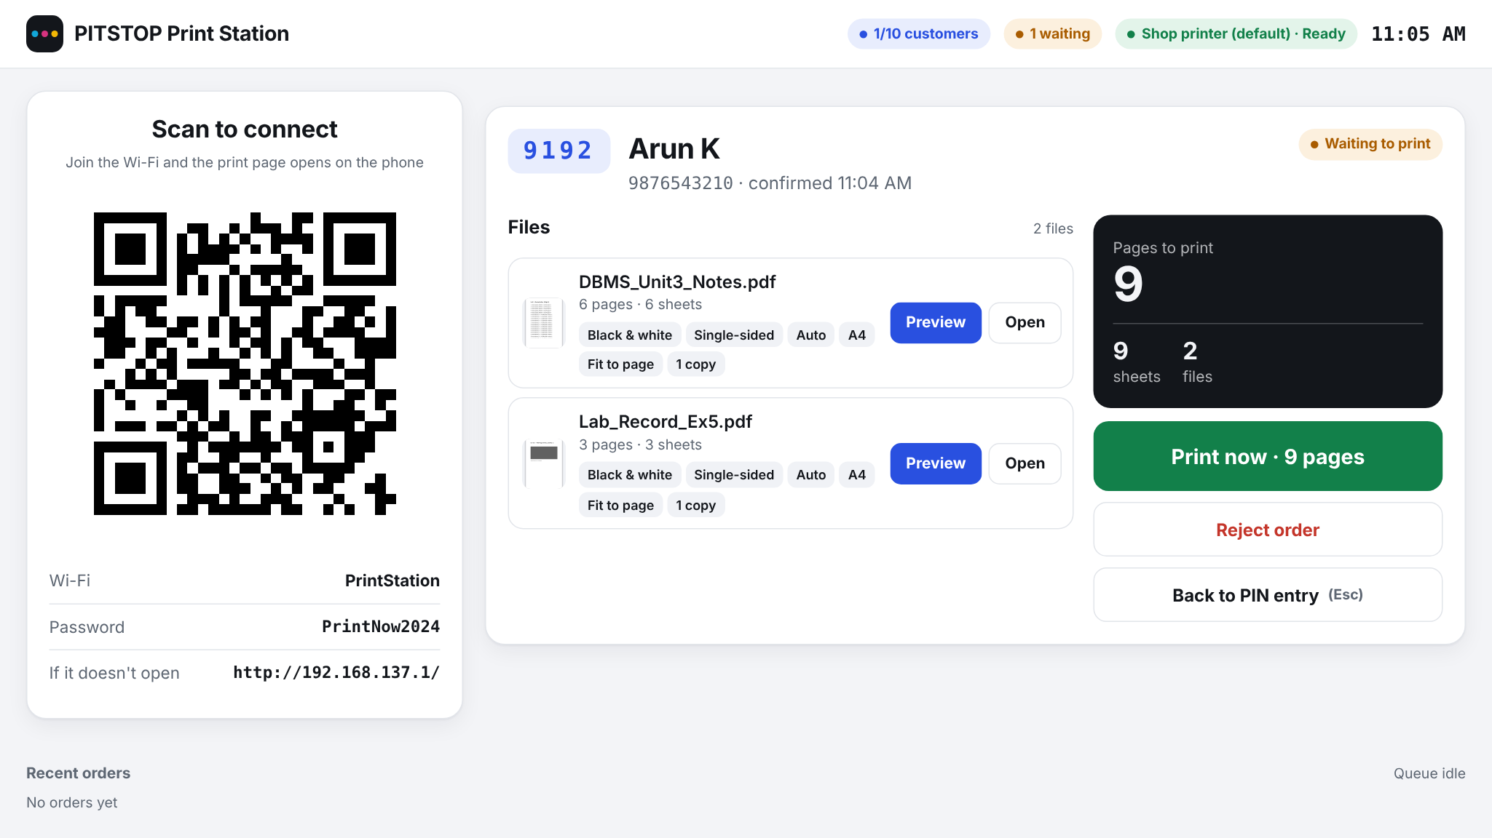
Figure B.8: Counter screen – order verified by PIN, ready to print

Annexure C: Quotation, Invoice / Receipt & Payment Details
C.1 Commercial Quotation
Item | Service Description | Amount | Settlement Status
1 | System design charges | ₹600 | Paid
2 | Development charges | ₹600 | Paid
3 | Domain and hosting (not applicable – offline) | ₹0 | Not applicable
4 | Additional features: PIN token, preview, Office conversion, captive portal | ₹800 | Paid
5 | Installation, training and maintenance | ₹0 | Included
TOTAL | Total Agreed Project Value | ₹2,000 | Paid in full

C.2 Invoice / Receipt
PAYMENT RECEIPT
Receipt No: PIT-2026-001 Date: 02-11-2026
Received from: MOHANKUMAR, PITSTOP, KPRIET Boys Hostel Block, Arasur, Coimbatore – 641 407
The sum of ₹2,000 (Rupees Two Thousand Only) towards design, development, installation and training of the Offline Scan-to-Print Workstation.
Payment mode: UPI (Paytm), remitted to K P R Charities UPI Ref: 318230380257 GST: Not applicable
Received by: SIBISAKTHIVEL K (24AM052) & VIRTHEKESH VIPIN (24AM063), KPR Institute of Engineering and Technology
Signature: ______________________

C.3 Payment Confirmation (redacted)
Field | Details
Client | PITSTOP
Client Representative | Mr. MOHANKUMAR
Total Agreed Project Value | ₹2,000
Amount Received | ₹2,000
Balance Due | ₹0
Payment Method | UPI (Paytm)
Payment Date | 02-11-2026, 11:18 AM
UPI Ref No. | 318230380257
Paid To | K P R Charities

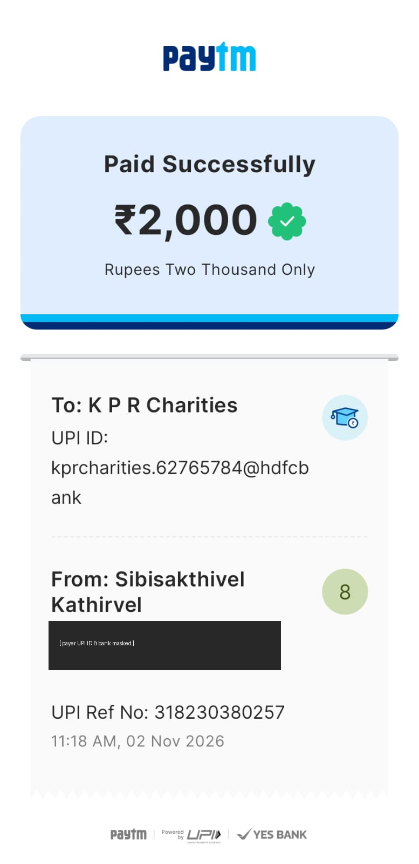
Figure C.1: Payment confirmation for the PITSTOP project (payer UPI ID and bank masked)

Annexure D: Client Documents
D.1 Client Authorization & Consent Letter
CLIENT AUTHORIZATION AND CONSENT LETTER
Date: 02 November 2026
To
The Head of the Department,
Department of CSE (Artificial Intelligence and Machine Learning),
KPR Institute of Engineering and Technology, Coimbatore – 641 407.
Subject: Authorization for client-based project and consent to share project details
Respected Sir/Madam,
I, MOHANKUMAR, Owner of PITSTOP, KPRIET Boys Hostel Block, Avinashi – Coimbatore Road, Arasur, Uthupalayam, Tamil Nadu 641407, India, authorize SIBISAKTHIVEL K (24AM052) and VIRTHEKESH VIPIN (24AM063), students of the Department of CSE (AI & ML), to develop and install an offline scan-to-print system for my shop as part of the course U21AM502 Internet and Web Programming (Revenue Generation Model).
I consent to the students using my shop name, address, contact details, meeting records, screenshots of the system and redacted payment details in their academic project report and viva, and to faculty members contacting me to verify the engagement. I understand that sensitive identifiers will be masked.
Thanking you,

Signature: ______________________
Name: MOHANKUMAR, Owner, PITSTOP
Mobile: 79047 42326

D.2 Client Acceptance Certificate
PROJECT ACCEPTANCE CERTIFICATE
This is to certify that the Offline Scan-to-Print Workstation with PIN-Based Token System developed by SIBISAKTHIVEL K (24AM052) and VIRTHEKESH VIPIN (24AM063) of KPR Institute of Engineering and Technology was demonstrated, installed and handed over at PITSTOP, KPRIET Boys Hostel Block, on 31 October 2026.
I have checked the following and accept the delivered system:
S.No | Item Checked | Accepted (✔)
1 | Phone joins shop Wi-Fi by QR code and the print page opens
2 | Upload of PDF, photos, Word, Excel and PowerPoint files
3 | Print settings and preview for each file
4 | PIN token issued with pages and sheets
5 | PIN entry, preview and printing at the counter
6 | Files removed automatically after printing
7 | Station starts automatically with the laptop
8 | Staff training completed

The agreed project value of ₹2,000 has been paid in full. Free support for 3 months is provided by the students for bug fixes and configuration changes.

Signature: ______________________ Date: 02 November 2026
Name: MOHANKUMAR, Owner, PITSTOP

D.3 Client Testimonial
CLIENT TESTIMONIAL
Client Name: Mr. MOHANKUMAR
Designation: Owner
Organization: PITSTOP, KPRIET Boys Hostel Block, Coimbatore
The scan-to-print system developed by SIBISAKTHIVEL K and VIRTHEKESH VIPIN has changed how our printing counter works. Students now connect to our shop Wi-Fi by scanning a QR code and send their files directly from their phones, without WhatsApp, e-mail or pen drives and without needing internet. Their files and phone numbers stay private.
Each student gets a PIN for their order, and at the counter we can see exactly which files, which pages and how many sheets to print before we press Print. This has reduced confusion during rush hours and made billing clear for both the students and us.
We appreciate the students' effort in understanding our needs, making the changes we asked for, and installing and explaining the system to our staff.

Client Signature: ______________________ Date: 02 November 2026

D.4 Minutes of Client Meetings
Item | Details
Meeting 1 – 24 Aug 2026 (at shop) | Attendees: MOHANKUMAR; SIBISAKTHIVEL K; VIRTHEKESH VIPIN. Discussed current process (WhatsApp/e-mail/pen drive), privacy, poor mobile data in hostel, rush-hour mix-ups, billing disputes and petty service fraud. Proposed Windows station with phone web app, tokens and bills. Decision: proposal accepted; client agreed to pay service charges. Action: prepare requirement outline and quotation.
Meeting 2 – 05 Sep 2026 | Presented requirement outline, screen flow and quotation. Decision: scope and price approved. Feedback: support colour and double-sided printing (CR-01). Action: begin development.
Meeting 3 – 26 Sep 2026 | Demonstrated prototype: phone upload of PDFs, PIN issue, counter printing. Feedback: accept Word, Excel and PowerPoint (CR-02); show preview so students can check pages (CR-03).
Meeting 4 – 17 Oct 2026 | Trial on shop laptop in evening rush. Feedback: separate settings per file (CR-04); limit customers at once as the laptop is slow (CR-05); open the print page automatically after scanning (CR-06).
Meeting 5 – 31 October 2026 | Installed final version with auto-start; demonstration and staff training; client acceptance; payment completed.

D.5 Training & Handover Record
Topic | Trained Person | Signature
Starting / restarting the station; counter screen | MOHANKUMAR
PIN entry, order check, preview, Print now, Reject | MOHANKUMAR
Printer offline / SumatraPDF messages; retry | MOHANKUMAR
Changing Wi-Fi password and limits in .env | MOHANKUMAR

Annexure E: References
- OpenJS Foundation, "Node.js Documentation." [Online]. Available: https://nodejs.org/docs/latest/api/
- Express.js, "Express 5.x API Reference." [Online]. Available: https://expressjs.com/en/5x/api.html
- Express.js, "Multer – Node.js middleware for handling multipart/form-data." [Online]. Available: https://github.com/expressjs/multer
- A. Dworkin, "pdf-lib – Create and modify PDF documents in any JavaScript environment." [Online]. Available: https://pdf-lib.js.org/
- Mozilla, "PDF.js." [Online]. Available: https://mozilla.github.io/pdf.js/
- K. Kowalczyk, "SumatraPDF Command-line Arguments." [Online]. Available: https://www.sumatrapdfreader.org/docs/Command-line-arguments
- Microsoft, "Mobile hotspot / NetworkOperatorTetheringManager class (Windows.Networking.NetworkOperators)." [Online]. Available: https://learn.microsoft.com/
- IETF, "RFC 8910 – Captive-Portal Identification in DHCP and Router Advertisements," 2020.
- Mozilla Developer Network, "Using files from web applications." [Online]. Available: https://developer.mozilla.org/en-US/docs/Web/API/File_API/Using_files_from_web_applications
- W3C, "Web Content Accessibility Guidelines (WCAG) 2.2." [Online]. Available: https://www.w3.org/TR/WCAG22/
- PITSTOP, "Client requirements, feedback and consultation records," KPRIET Boys Hostel, Coimbatore, 2026.
- SIBISAKTHIVEL K and VIRTHEKESH VIPIN, "Offline Scan-to-Print Workstation for PITSTOP," source code, configuration and test records, KPR Institute of Engineering and Technology, 2026.

