For MERIL DIAGNOSTICS PVT. LTD,
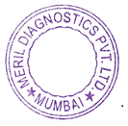
Shaiju Varghese
Additional General Manager - Tender Business

