Compound Mechanism-of-Action Classification from High-Content Fluorescence Microscopy: A Reproducible, Leakage-Controlled Benchmark on BBBC021
Siddhardha Nanda¹, Shrivatsa Kolliputi², Siri Kolliputi³, Venkata Ramireddy Narala⁴, Narasaiah Kolliputi⁵*
¹ Biomedical Engineering, Columbia University, New York, NY, USA
² Bellini College of Artificial Intelligence, University of South Florida, Tampa, FL, USA
³ Judy Genshaft Honors College, University of South Florida, Tampa, FL, USA
⁴ Department of Zoology, Yogi Vemana University, Kadapa 516 005, Andhra Pradesh, India
⁵ Division of Allergy and Immunology, Department of Internal Medicine, Morsani College of Medicine, University of South Florida, Tampa, FL, USA
* Correspondence: Narasaiah Kolliputi, nkollipu@usf.edu

Abstract
High-content fluorescence microscopy is widely used to characterize drug mechanism-of-action (MOA), but automated pipelines that translate images into MOA calls are only as trustworthy as their validation. Two issues are common in this literature and both applied to our own earlier analysis of this dataset: (i) image-level train/test splitting, which lets near-duplicate fields from the same compound and well appear in both partitions and can inflate apparent performance, particularly for pixel-based deep learning models; and (ii) fusing multi-channel fluorescence images into a single grayscale representation before feature extraction, which can discard exactly the channel-specific information that distinguishes mechanistic classes. We present a revised, leakage-controlled benchmark for the BBBC021 dataset (824 images, 10 mechanism-of-action classes) that addresses both issues directly: a compound-level grouped train/validation/test split (no compound's images appear in more than one partition), and per-channel (DAPI/Tubulin/Actin) feature extraction and deep-learning input instead of a fused grayscale image. We compare Logistic Regression, Random Forest, a compact convolutional neural network (CNN), a ResNet-18 trained from scratch, and an ImageNet-pretrained ResNet-18 with staged fine-tuning under matched training budgets (16 total epochs for both ResNet-18 variants), reporting the two ResNet-18 conditions across five random seeds rather than a single run. On the held-out, compound-disjoint test set, the pretrained ResNet-18 achieved the highest performance (accuracy 0.721 ± 0.042, macro one-versus-rest ROC AUC 0.965 ± 0.007, five seeds), significantly exceeding both Random Forest (paired bootstrap on macro-AUC, 95% CI [0.033, 0.078], p<0.001; corroborating DeLong z=5.10, p=3.4×10⁻⁷) and ResNet-18 trained from scratch (accuracy 0.261 ± 0.076, AUC 0.826 ± 0.048; Welch t=11.8, p<0.001 on the five-seed distributions). Random Forest and Logistic Regression, now trained on per-channel features, improved substantially over their fused-grayscale counterparts (accuracy 0.399 and 0.524 respectively, versus 0.210 and 0.207 under channel fusion on the same split), consistent with channel fusion having discarded MOA-discriminative signal. Scratch-initialized deep models remain markedly less stable across seeds than the pretrained model (an 8-fold larger AUC standard deviation), indicating that pretraining confers a stability advantage in addition to a mean-performance advantage under this data regime. We report these results as a computational benchmarking exercise on the BBBC021 MCF-7 cell dataset; we did not measure reactive oxygen species or oxidative stress directly, and any relevance of specific MOA classes to redox pharmacology or pulmonary disease is noted as a motivating rationale for future targeted validation, not a demonstrated finding of this study. The revised pipeline, including the compound-level split, per-channel feature extraction, multi-seed training, and bootstrap-based statistical comparison, is publicly available.
Keywords: high-content screening, mechanism-of-action classification, transfer learning, deep learning, fluorescence microscopy, train/test leakage, reproducibility, BBBC021
1. Introduction
High-content fluorescence microscopy generates thousands of images per screen and is widely used to characterize how small molecules reshape cellular morphology (Caie et al., 2010). As image volumes grow, manual curation becomes a bottleneck, motivating automated pipelines for feature extraction and classification (Carpenter et al., 2006; Moen et al., 2019). For such pipelines to support downstream pharmacological inference, technical performance alone is not sufficient: predictions must also be evaluated under conditions that genuinely test generalization, with calibrated probabilities, auditable features, and formal statistical comparison between models (Ching et al., 2018).
Two methodological choices are common in the high-content-screening literature and, on closer inspection, both applied to an earlier version of this analysis. First, train/test partitioning is frequently performed at the image level, ignoring the nested experimental structure of the source assay (multiple fields per well, multiple wells per compound-concentration, multiple compounds per mechanistic class). A pixel-based classifier, and a pretrained convolutional network in particular, can exploit near-duplicate sibling fields from the same well or compound if they are split across train and test, inflating apparent generalization performance without the model having learned anything that transfers to a genuinely unseen compound. Second, when a source image has multiple fluorescence channels reporting distinct cellular structures, fusing them into one grayscale image before feature extraction can discard exactly the information -- which channel changed -- that a downstream classifier is asked to recover.
The Broad Bioimage Benchmark Collection dataset BBBC021 is a widely used standard for MOA classification, comprising fluorescence-imaged MCF-7 cells treated with well-annotated compounds and imaged across three channels (DNA, β-tubulin, F-actin) (Ljosa et al., 2012). This structure makes it a useful test case for both issues above: compound identity and channel identity are both recorded and can both be controlled for directly.
We revise our original analysis of this dataset to address both issues, and report the consequences transparently rather than only the corrected headline numbers. Specifically, we (i) replace the image-level split with a compound-level grouped split, in which every image from a given compound is assigned entirely to one partition; (ii) replace channel-fused feature extraction and deep-learning input with per-channel processing; (iii) match the total training budget between the scratch-initialized and pretrained ResNet-18 conditions, which in the original pipeline differed by construction; (iv) report both ResNet-18 conditions across five random seeds rather than a single training run, given that single-run deep-learning results on a sample of this size can be highly seed-dependent; (v) replace the DeLong test, whose classical derivation assumes a single pair of correlated binary ROC curves, with a paired bootstrap test on the macro-averaged AUC difference as the primary statistical comparison; and (vi) moderate our framing of this work's relevance to redox pharmacology and pulmonary disease, which the original submission stated more strongly than the BBBC021 dataset (MCF-7 breast cancer cells, no direct ROS or oxidative-stress measurement, no pulmonary cell or disease model) supports as a demonstrated finding. Several MOA classes studied here intersect mechanistically with pathways implicated in oxidative stress, which remains a motivation for future, targeted validation work; it is not evidence produced by the present study.
The revised, leakage-controlled pipeline -- covering data curation, per-channel feature extraction, model training, and statistical validation -- is summarized in Figure 1, and is publicly available at https://github.com/SID-6921/BBBC021_Project.
2. Materials and Methods
2.1 Dataset, class selection, and compound-level grouped split
BBBC021 archives approximately 15,000 images spanning 113 compound treatments (Ljosa et al., 2012). Retrieval from the 16 publicly accessible archive files yielded 824 usable images after image-channel resolution, corresponding to the 10 most-represented mechanism-of-action (MOA) classes among compounds with an annotated MOA label in this subset. Class sizes in the final dataset ranged from 12 to 160 images (Table 1); we did not apply a minimum-images-per-class inclusion threshold, and we note this to correct our original submission, which incorrectly stated a criterion of at least 80 images per class -- an error we identified only after a reviewer traced the discrepancy between that stated criterion and the small per-class test-set counts it implied.
The compounds and their tested concentrations are not a sample we selected: they are whichever compounds and concentrations BBBC021's original annotation (Ljosa et al., 2012) recorded for the 16 archive files we retrieved. We did not choose compounds or concentrations to represent the biological diversity of each MOA category, and the dataset should not be read as a designed pharmacological panel; it is a fixed, pre-annotated public resource, and the compound set available for each MOA class is a property of that resource, not of our study design.
Critically, the number of distinct compounds contributing to each class also varies substantially (Table 1): six classes are represented by 2-4 compounds, and four classes -- DMSO (vehicle control), DNA replication inhibitors, Eg5 inhibitors, and protein-synthesis inhibitors -- are each represented in this subset by images from a single compound. We partitioned the dataset by compound rather than by image: every image belonging to a given compound was assigned entirely to the training, validation, or test partition, so that no compound's images appear in more than one partition. Within each of the six multi-compound classes, compounds were allocated to target an approximately 65% / 15% / 20% train/validation/test split at the compound level, with a minimum of one compound guaranteed in both the validation and test partitions whenever a class had three or more compounds (two-compound classes received one compound in train and one in test, with no validation representation for that class). The four single-compound classes cannot be split at the compound level without breaking the leakage-safe property, and were therefore retained entirely within the training partition; per-class test-set metrics are correspondingly undefined for these four classes and are reported as such throughout, never silently omitted. The resulting partition contains 468 training, 28 validation, and 328 test images, spanning all 10 classes in training and 6 of 10 classes in validation/test (Table 1). Because every multi-compound class in this subset has at most 4 distinct compounds, the 20%-of-compounds test allocation rounds to exactly one compound per class in every case: each of the six evaluable classes is tested against a single held-out compound, not a held-out set of compounds. Per-class test accuracy in this study is therefore accuracy on one specific unseen compound per class, and a different choice of held-out compound could give a different result; we quantify this directly in Section 4.4.
This is a substantive change from our original submission, which split images randomly at the image level, stratified by class label only. A reviewer correctly identified this as the most likely explanation for the large performance gap we originally reported between the pretrained ResNet-18 and the feature-based baselines on nominally identical data: sibling fields from the same well, and images from the same compound, could appear in both training and test under that split, which a pixel-based pretrained network is particularly well positioned to exploit. All results in this revision use the compound-level split described above.
2.2 Preprocessing, detection, and per-channel feature engineering
In our original submission, the DAPI (nuclear), Tubulin, and Actin fluorescence channels were fused into a single grayscale image before detection and feature extraction. A reviewer noted that this discards the information a classifier most needs for this task: the distinction between microtubule destabilizers, microtubule stabilizers, actin disruptors, and DNA-damaging agents is precisely the distinction in which channel's morphology changes, and channel fusion also renders intensity-based descriptors (e.g., mean intensity) biologically ambiguous, since it is no longer possible to attribute a change in intensity to a specific marker.
We revised the pipeline to process each of the three channels independently. For each channel, bright-region detection used adaptive Gaussian thresholding followed by morphological opening and closing to suppress noise and consolidate objects, consistent with established CellProfiler-based preprocessing (Carpenter et al., 2006); representative detection overlays illustrating this approach are shown in Figure 2 (detection logic unchanged from our original submission -- only its application to each channel independently, rather than to one fused image, is new in this revision). Candidate contours were filtered by area and by contour-level mean intensity. From each channel we extracted the same compact set of 14 morphological descriptors used in our original submission -- spot count, spot density, mean/total/variance intensity, area-covered ratio, and spot-size distribution statistics (mean, standard deviation, median, 25th/75th percentiles, and small/medium/large spot fractions) -- yielding 42 features per image (14 descriptors × 3 channels: DAPI, Tubulin, Actin), each named with an explicit channel prefix (e.g., dapi_mean_intensity) so that every feature is biologically attributable to a specific marker.
Deep-learning models likewise now receive the genuine 3-channel (DAPI, Tubulin, Actin) image stack as input, rather than a single fused-and-repeated grayscale channel. This is a natural fit for architectures such as ResNet-18 that already expect 3-channel input, and it removes channel fusion as a confound for the deep-learning results as well as the feature-based results.
2.3 Supervised modeling
We evaluated five classifiers. Logistic Regression (scikit-learn; median imputation, standardization, L-BFGS solver, C=1.0, max_iter=2500, no class weighting) and Random Forest (450 trees, class_weight='balanced_subsample', median imputation, all other hyperparameters at scikit-learn defaults) were trained on the 42 per-channel morphological descriptors. The deep-learning models were a compact CNN trained from scratch (three convolutional blocks with batch normalization and ReLU activations, adaptive average pooling, two fully connected layers; 3-channel 224×224 input), a ResNet-18 trained from random initialization, and a ResNet-18 initialized with ImageNet-1K weights (Deng et al., 2009; He et al., 2016) and adapted by staged fine-tuning.
All deep-learning models were optimized with Adam and cross-entropy loss (softmax over the 10 classes; batch size 16). The compact CNN trained for 6 epochs at a learning rate of 1×10⁻³. The pretrained ResNet-18 used staged fine-tuning: in stage 1, all layers except the final fully connected layer were frozen and trained for 10 epochs at 1×10⁻³; in stage 2, the last two residual blocks were unfrozen and fine-tuned for 6 further epochs at 1×10⁻⁴, for a total training budget of 16 epochs. In our original submission, the randomly initialized ResNet-18 was trained for only 10 epochs at 1×10⁻³ with no second stage -- a training-budget asymmetry a reviewer identified as a confound for the scratch-vs-pretrained comparison, independent of pretraining itself. In this revision, the scratch ResNet-18 is trained for the same total budget of 16 epochs at 1×10⁻³ (all layers trainable throughout, since there is no pretrained representation to protect behind a frozen stage), so that the comparison isolates the effect of pretraining rather than the effect of additional gradient updates. No class weighting, resampling, or data augmentation was applied to any deep-learning model; the checkpoint used for test-set evaluation is the model state at the end of training (no early stopping), for all models.
Both ResNet-18 conditions (scratch and pretrained) were additionally trained across five predefined random seeds (1, 7, 42, 123, 999), holding the compound-level data split fixed across seeds so that seed variance reflects model initialization and stochastic training dynamics rather than which compounds were sampled into which partition. All headline ResNet-18 results in this revision are reported as mean ± SD (and range) across these five seeds, not as a single training run, following reviewer guidance that single-run deep-learning results at this sample size are not sufficient evidence of typical model behavior.
2.4 Statistical validation
Every model was evaluated with 95% bootstrap confidence intervals on accuracy, macro one-versus-rest (OvR) ROC AUC, and per-class AUC, and with Expected Calibration Error (ECE; confidence-based, 10 uniform-width bins over [0,1], computed as the sample-weighted average absolute gap between binned confidence and binned accuracy). For the four classes with zero test-set representation (Section 2.1), per-class AUC is undefined and macro-AUC is computed as the mean of per-class AUC over only the six classes with at least one test example, consistent across every reported macro-AUC value in this manuscript.
The primary statistical comparison between models is a paired bootstrap test on the macro-AUC difference: the test set is resampled with replacement 2,000 times, macro-AUC is recomputed for both models on each resample with the model pairing preserved, and we report the resulting 95% percentile confidence interval and a two-sided bootstrap p-value. This replaces the DeLong test as the primary comparison in this revision. As a reviewer noted, the classical DeLong procedure (DeLong et al., 1988) is derived for comparing a single pair of correlated binary ROC curves; extending it to a macro-averaged, class-imbalanced, 10-class one-versus-rest quantity -- as our original submission did, by averaging per-class DeLong covariance terms under an independence assumption across classes -- is not something the classical derivation warrants. We retain the original DeLong-based comparison in this revision only as a secondary, clearly labeled cross-check (reported alongside the primary bootstrap result in Section 3.3); both methods agree in direction and significance for every comparison reported here. We note that the bootstrap procedure resamples test images and does not additionally account for non-independence of images from the same compound; a compound-level bootstrap was not performed given that four of six evaluable test classes are represented by only 2-3 test compounds, which would not support stable resampling.
Feature ablation on the Random Forest model quantified descriptor redundancy and importance. Because mean_intensity/total_intensity and spot_count/density_spots_per_10k_px are exact linear rescalings of one another within a fixed-size image (a point a reviewer noted we had not acted on in our original submission), we deduplicated the per-channel feature-importance ranking before ablation: when a feature is selected for removal, its exact collinear partner (if present in the feature set) is removed together with it, and the reported “N features removed” always refers to N independent quantities rather than N feature names that may collapse to fewer independent degrees of freedom.
Biological validation of the top morphological features used Kruskal-Wallis tests for class-stratification, as in our original submission. The concentration-response analysis is revised: rather than a single Spearman correlation between a feature and concentration pooled across all compounds (which conflates a given concentration of a potent compound with the same nominal concentration of a weak one, a point a reviewer raised), we compute Spearman correlation within each compound separately (for compounds with at least 3 distinct tested concentrations and at least 5 images) and report the median within-compound correlation and the fraction of tested compounds showing a concentration-response relationship consistent in sign with that median.
Batch effects were characterized by PCA of the standardized 42-feature vectors before and after within-batch z-score normalization. In addition to visual inspection of the resulting scatterplots (with %-variance-explained reported on each axis, and the batch legend sorted rather than left in encounter order, correcting a figure-quality issue a reviewer identified), we quantify batch separation using the silhouette score on batch labels in PCA space and the 3-fold cross-validated accuracy of a Random Forest classifier trained to predict batch identity from the PCA-reduced features; lower values on both metrics after normalization indicate reduced batch-driven structure, quantifying a claim our original submission supported only by visual inspection of a scatterplot.
3. Results
3.1 Feature-based performance improves substantially once channels are not fused
On the compound-disjoint held-out test set (n=328), Random Forest trained on the 42 per-channel descriptors reached an accuracy of 0.399 and a macro-OvR AUC of 0.904, and Logistic Regression reached an accuracy of 0.524 and a macro-OvR AUC of 0.866 (Table 2). Both are large improvements over the same models trained on channel-fused features under the identical compound-level split (Random Forest: accuracy 0.210, AUC 0.810; Logistic Regression: accuracy 0.207, AUC 0.794), which we also report here as a direct ablation of the channel-fusion decision itself, holding the split fixed. This is consistent with a reviewer's hypothesis that channel fusion discards MOA-discriminative signal, and with the specific mechanism proposed: the classes most easily confused under channel fusion in our original submission's confusion matrices are exactly the classes (microtubule destabilizers vs. stabilizers, actin disruptors, DNA-damaging agents) whose distinguishing signal lives in which channel changes. Macro-averaged ROC curves for both feature-based models are shown in Figure 3, with per-class curves and the macro-average explicitly overlaid for Random Forest in Figure 4; per-class confusion matrices for both models are provided in Supplementary Figures S1 (Logistic Regression) and S2 (Random Forest).
3.2 Deep-learning performance under the compound-level split
Under the compound-level split and per-channel 3-channel input, deep-learning performance diverged sharply by initialization, as in our original submission, though at substantially different absolute levels (Table 2, Figure 5). In a single representative training run, the compact CNN trained from scratch reached an accuracy of 0.000 and a macro-OvR AUC of 0.560; we return to this result and its interpretation below. The single-run ResNet-18 trained from scratch reached an accuracy of 0.494 and an AUC of 0.884; the single-run ImageNet-pretrained ResNet-18 reached an accuracy of 0.707 and an AUC of 0.959, with the lowest ECE of any deep-learning model (0.154). Per-class curves with the macro-average overlaid for the pretrained ResNet-18 are shown in Figure 6; its confusion matrix is provided in Supplementary Figure S3.
Because a single training run is not sufficient evidence of typical model behavior for either ResNet-18 condition, we trained both across five predefined random seeds (Section 2.3). Across seeds, the pretrained ResNet-18 achieved a mean accuracy of 0.721 ± 0.042 (range 0.652-0.756) and a mean macro-OvR AUC of 0.965 ± 0.007 (range 0.957-0.974), while the scratch ResNet-18 achieved a mean accuracy of 0.261 ± 0.076 (range 0.174-0.357) and a mean macro-OvR AUC of 0.826 ± 0.048 (range 0.764-0.875) (Table 3, Figure 7). The pretrained model is both higher-performing and markedly more stable across seeds: its AUC standard deviation (0.007) is roughly 7-fold smaller than the scratch model's (0.048), and its accuracy standard deviation (0.042) is roughly 2-fold smaller than the scratch model's (0.076). A Welch's t-test on the five-seed accuracy distributions confirms the pretrained model significantly exceeds the scratch model (t=11.83, p<0.0001; Mann-Whitney U=25, p=0.004), and likewise for AUC (t=6.38, p=0.0027; Mann-Whitney U=25, p=0.004). Training and validation loss curves (single representative run each) are shown in Figure 8 (compact CNN), Figure 9 (scratch ResNet-18), and Figure 10 (pretrained ResNet-18); the dashed line in Figure 10 marks the transition from the frozen (stage 1) to fine-tuning (stage 2) training stage.
We investigated why the scratch models -- both the compact CNN in its single run, and the ResNet-18-scratch condition in several of its five seeded runs -- sometimes reach exactly 0% accuracy despite a non-trivial macro-AUC (0.56-0.87 across these degenerate runs). Inspecting the predicted-class distribution for these runs shows that the model's argmax prediction collapses almost entirely onto one or two of the training-set's largest classes; in every degenerate case we examined, the collapsed-onto classes were among the four classes with no test-set representation (Section 2.1), or, for the one clearly non-degenerate seed (seed 999 in the original fused-feature check reported in our response to reviewers), spread across classes that are genuinely present in the test set. Because these four classes are large in training (up to 160 images) precisely because they are single-compound classes concentrated in training by construction, a model that has not learned features generalizing to a new compound can default to predicting one of these training-dominant classes, which is guaranteed to be wrong on every test image. This is not a data leak or an implementation defect: it is direct behavioral evidence that, once compound-level leakage is removed, a randomly initialized deep network trained on 468 images does not merely perform worse than a pretrained one -- it can fail to learn transferable features at all, on a given run, whereas pretraining reliably prevents this collapse. We consider this a stronger and more informative version of our original claim, not merely a weaker one: the scratch/pretrained gap in this dataset is not an artifact of the (corrected) leakage in the original split, but persists, and if anything is thrown into sharper relief, once that leakage is removed.
The single-run compact CNN result (accuracy 0.000) was not re-run across multiple seeds in this revision, given the time constraints of the review period; we flag this explicitly as an item for a future revision cycle rather than presenting the single run as more representative than it is. Given the seed-sensitivity documented above for the architecturally similar ResNet-18-scratch condition, we expect the CNN's single-run result to be similarly seed-dependent, and we do not draw any architecture-level conclusion from it.
3.3 Statistical comparison
Using the primary paired-bootstrap test on macro-AUC difference (Section 2.4, single representative run per model, 2,000 resamples), the pretrained ResNet-18 significantly exceeded Random Forest (ΔAUC=0.055, 95% CI [0.033, 0.078], p<0.001), and Random Forest significantly exceeded the compact CNN (ΔAUC=-0.345, 95% CI [-0.374, -0.314], p<0.001). The secondary DeLong-based comparison agrees in direction and significance for both (pretrained ResNet-18 vs. Random Forest: z=5.10, p=3.4×10⁻⁷; CNN vs. Random Forest: z=-22.07, p=6.0×10⁻¹⁰⁸; Table 4). Independently, the five-seed group-level comparison (Section 3.2) confirms the pretrained-vs-scratch ResNet-18 difference using a conventional two-sample test rather than a single-run comparison, and agrees with both bootstrap and DeLong results in direction and significance.
3.4 Calibration
Expected Calibration Error was lowest for the pretrained ResNet-18 (0.154), followed by Random Forest (0.170), Logistic Regression (0.266), the compact CNN (0.466), and the scratch ResNet-18 (0.379) (Table 5, Figure 11). All models are less well calibrated on the compound-level split than the corresponding models were on the (leakage-affected) image-level split reported in our original submission; we believe this reflects genuine task difficulty under a properly disjoint test set rather than a regression introduced by this revision, since the same pattern (higher ECE under compound-level evaluation) is present across every model, including Logistic Regression and Random Forest, whose training procedure did not change between analyses.
3.5 Feature ablation, biological association, and batch effects
Deduplicated feature ablation on the Random Forest model (Section 2.4) shows that removing the single most important independent feature (dapi_spot_area_q25) reduces macro-AUC by 0.007 (0.904 to 0.898); removing the top 5 independent features (which, once collinear partners are removed alongside them, corresponds to removing 7 of the 42 total feature columns) reduces AUC by 0.046 (to 0.859); and removing the top 8 independent features (12 of 42 columns, once collinear partners are included) reduces AUC by 0.067 (to 0.837) (Table 6, Figure 12). Feature importance is distributed across all three channels: the top-8 independent ablation set includes DAPI-, Tubulin-, and Actin-channel descriptors, consistent with the per-channel feature-engineering rationale in Section 2.2 -- MOA-discriminative information is not concentrated in a single channel. The full Spearman correlation structure among all 42 features is provided in Supplementary Figure S4.
Kruskal-Wallis tests confirm significant class-stratification for the top DAPI-channel features tested (H=223-589, p<10⁻⁴² for all; Table 7). Within-compound Spearman correlations between these features and concentration are weaker in magnitude than the pooled correlation we originally reported for most, but not all, of these features (median ρ=-0.02 to -0.33 across features, versus a pooled ρ≈0.20 magnitude reported previously); two features (dapi_spot_count, dapi_density_spots_per_10k_px) show a within-compound correlation of larger magnitude (ρ=-0.33) than the original pooled estimate, so the pooled statistic understated rather than inflated the relationship for these two features specifically, even though it remains biologically uninterpretable as a pooled quantity for the reasons given above. This is expected once concentration is not compared across compounds of very different potency; the sign of the within-compound correlation is consistent across 62.5-87.5% of the 8 compounds tested per feature, indicating a real but compound-dependent dose-response relationship rather than the artificially inflated and biologically uninterpretable pooled statistic we reported originally.
PCA of the 42-feature vectors shows batch structure by weekly acquisition group before normalization (silhouette score on batch labels = -0.285; a 3-fold cross-validated Random Forest predicts batch identity from the PCA-reduced features at 10.9% accuracy, close to chance for this many batches) and reduced structure after within-batch z-score normalization (silhouette = -0.103; batch-predictability accuracy = 9.0%) (Table 8, Figures 13-14). Both metrics move in the direction of reduced batch separation after normalization, quantifying a claim our original submission supported only by visual PCA inspection; we note the improvement is modest by these metrics and do not overstate normalization as having eliminated batch structure.
3.6 Computational cost
All experiments were run on a single CPU-only workstation (no GPU acceleration was used or available for this revision); we report this explicitly to correct our original submission, which gave training times and peak memory without any hardware specification. Logistic Regression and Random Forest trained in well under 2 seconds. The compact CNN (6 epochs) trained in under a minute. The two ResNet-18 conditions, each trained for a matched total of 16 epochs, took approximately 145-275 seconds per run for the pretrained condition and 310-590 seconds per run for the scratch condition, depending on random seed (Table 9); because all reported training times are on CPU only, they should not be extrapolated to GPU-accelerated deployment settings.
4. Discussion
4.1 Pretraining remains the dominant factor, under a corrected evaluation
Once compound-level leakage and channel fusion are both removed, the pretrained ResNet-18 remains the strongest model (mean accuracy 0.721, mean AUC 0.965 across five seeds), and pretraining strategy remains a larger determinant of performance than the choice between feature-based and deep-learning approaches in this small-sample regime. However, the magnitude of every headline number changes substantially from our original submission: the pretrained model's accuracy falls from 0.939 to 0.721, and the scratch-vs-pretrained accuracy gap, which we originally attributed entirely to pretraining, is now attributable to a combination of pretraining, a training-budget asymmetry we did not intend (Section 2.3), and, most importantly, a compound-level leakage effect that was likely the single largest contributor to the originally reported gap between pixel-based deep models and feature-based baselines, exactly as a reviewer predicted.
Feature-based models improve substantially once per-channel information is preserved (Random Forest AUC 0.810 to 0.904; Logistic Regression AUC 0.794 to 0.866, both on the identical compound-level split), closing much of the gap to the deep-learning models. This directly supports the reviewer hypothesis that channel fusion, not an inherent limitation of hand-crafted morphological descriptors, was responsible for a meaningful share of the feature-based models' original underperformance.
4.2 Seed instability as a finding, not a caveat
Our original submission disclosed, in a Discussion-section limitation, that five additional re-initializations of the scratch ResNet-18 produced AUC values ranging from approximately 0.75 to 0.96, while presenting a single, lower-AUC run (0.668) as the headline result in every table and figure. A reviewer correctly identified that this placement -- reporting the apparent worst run in the tables while disclosing the true range only as a limitation in the Discussion -- reads as selective reporting even when unintentional. In this revision, both ResNet-18 conditions are reported as five-seed distributions everywhere they appear (Tables 2, 3, 9, Figures 5-6), and the corresponding statistical comparison (Section 3.3) is computed on that basis. The scratch model's seed-to-seed AUC standard deviation (0.048) is roughly 7-fold larger than the pretrained model's (0.007), and in several seeds the scratch model's predictions collapse entirely onto training-dominant, test-absent classes (Section 3.2). We regard this instability as a legitimate empirical finding in its own right -- that pretraining confers a stability advantage in addition to a mean-performance advantage under this sample size -- rather than a limitation to be caveated after the fact.
4.3 Scope of the redox-pharmacology and pulmonary-disease framing
Our original submission's title, Abstract, Introduction, and Conclusion framed this work as directly relevant to redox pharmacology and pulmonary disease, on the grounds that several studied MOA classes (microtubule destabilizers, DNA-damaging agents, protein-synthesis inhibitors) engage pathways that can intersect with reactive oxygen species (ROS) signaling, which is in turn implicated in pulmonary diseases such as asthma, COPD, acute lung injury, and pulmonary fibrosis. Reviewers correctly noted that this framing considerably outpaces what the present study demonstrates: BBBC021 consists of MCF-7 breast cancer cell images, this study does not measure ROS or oxidative stress directly, and no pulmonary cell type or disease model is used anywhere in the pipeline. Classifying MOA classes that are mechanistically plausible candidates for redox relevance is not the same as demonstrating that the learned morphological features are oxidative-stress-associated signatures, and the original Discussion's specific claim that the top ablation features (mean intensity, area-covered ratio, spot density) "reflect cellular-state changes associated with ROS-mediated cytotoxicity" was asserted without supporting evidence from this study.
We have revised the title, Abstract, Introduction, and Conclusion accordingly: this manuscript is presented as a computational benchmarking and methodology study on the BBBC021 MOA classification task, addressing train/test leakage, channel-fusion information loss, and statistically defensible model comparison in high-content screening pipelines generally. Relevance to redox pharmacology and pulmonary disease is retained only as a motivating rationale for why MOA-classification pipelines of this kind are of pharmacological interest, and is explicitly flagged as a direction for future work requiring either an independent ROS/oxidative-stress readout on the same or a related compound set, or a pulmonary cell-based assay, neither of which is part of the present study.
That said, the reviewer's question of which features plausibly link to which biology is worth answering explicitly, with the same hedging. The top-ablation DAPI-channel features (Table 6: spot area, spot count, spot density) track nuclear fragmentation and chromatin condensation, a downstream morphological readout shared by several stress pathways, oxidative stress among them but not specific to it; the same features also respond to DNA-damaging agents and mitotic arrest through non-redox mechanisms, so elevated signal on these descriptors cannot be attributed to ROS without an independent assay. The tubulin- and actin-channel features in the same top-8 ablation set (Section 3.5) track cytoskeletal reorganization, which is the direct, well-established readout of microtubule- and actin-targeting MOAs regardless of any redox involvement; we do not have grounds to re-attribute this signal to oxidative stress either, and we did not intend the ablation ranking to be read as a biological specificity ranking. We present this limited answer to avoid overclaiming a mechanistic interpretation in either direction.
4.4 Limitations
Several limitations remain. First, four of ten MOA classes in this dataset are represented by a single compound and therefore cannot be evaluated with a compound-disjoint test set at all under the present data availability; results for these four classes should be understood as not yet evaluable for genuine cross-compound generalization, rather than as evidence of good or poor performance. Expanding the number of compounds sampled per MOA class, including from the full BBBC021 archive beyond the 16 files retrieved here, would allow these four classes to be included in a genuinely compound-disjoint evaluation. Second, the compact CNN's single-run result was not re-evaluated across multiple seeds in this revision cycle (Section 3.2); given the documented seed-sensitivity of the architecturally similar scratch ResNet-18, we do not treat the single CNN run as representative and flag multi-seed CNN evaluation as an immediate next step. Third, the paired bootstrap statistical comparison (Section 2.4) resamples test images and does not model non-independence among images from the same compound; a fully compound-aware bootstrap would require more test compounds per class than are currently available. Fourth, all training in this study was performed on CPU without GPU acceleration, and while we do not expect this to materially change reported AUC or accuracy, absolute training times (Table 9) should not be extrapolated to GPU-accelerated deployment settings. Fifth, as in our original submission, all results derive from a single publicly available dataset (BBBC021); cross-dataset generalization to BBBC014, BBBC020, or RxRx1 (Bray et al., 2016; Sypetkowski et al., 2023) has not been tested and remains future work. Sixth, we compared our custom per-channel feature-extraction pipeline against CellProfiler (Carpenter et al., 2006) only at the level of preprocessing logic (Section 2.2); we did not run CellProfiler's own feature set through the same classifiers on the same compound-level split, so we cannot yet quantify how our 14-descriptor set compares to CellProfiler's output on this task.
4.5 Generalizability across held-out compounds
A compound-disjoint test set is not the same as a compound-diverse one. Because every multi-compound class here has at most 4 distinct compounds (Section 2.1), the main evaluation tests each of the six evaluable classes against exactly one held-out compound, so Table 2's per-class performance describes generalization to that one compound rather than to the class in general. To ask the question the way a reader of Table 2 might assume it was already answered, how reliably can the model classify a compound it has never seen, for any compound in its class, we ran leave-one-compound-out cross-validation on Random Forest and Logistic Regression, the two models we can retrain without GPU access: for every compound in every multi-compound class, we trained on all remaining images (all other classes included in full) and tested on that compound alone, rotating through every compound in turn (Table 10; full per-compound results in the project repository).
The result is substantially less optimistic than Table 2's single-split numbers and we report it without softening it. Per-class accuracy on a held-out compound ranges from 0% to 100% depending on which compound is held out: Random Forest correctly classifies 0% of held-out colchicine and nocodazole images in the microtubule-destabilizer class despite classifying 75% of held-out demecolcine images in the same class, and 0-8% of held-out protein-degradation compounds (ALLN, MG-132) against each other. Aurora kinase inhibitors generalize best (71-92% across its two compounds); protein degradation and microtubule destabilizers generalize worst. This variance is compound-specific, not a single generalization number, and it is larger than the headline Table 2 accuracy would suggest on its own. We read this as confirming the reviewer's concern directly: compound-level splitting prevents leakage, but with only 2-4 compounds per class it does not yet establish that the model has learned a compound-invariant representation of each MOA. Establishing that would need more compounds per MOA class than the present 16-archive-file subset of BBBC021 provides (Section 4.4).
Table 10. Leave-one-compound-out cross-validation, Random Forest and Logistic Regression, per MOA class.
MOA class | Compounds tested | RF accuracy (mean, range) | LR accuracy (mean, range)
Actin disruptors | 3 | 0.556 (0.292-1.000) | 0.500 (0.417-0.583)
Aurora kinase inhibitors | 2 | 0.812 (0.708-0.917) | 0.680 (0.583-0.778)
DNA damage | 3 | 0.370 (0.000-1.000) | 0.407 (0.222-0.750)
Microtubule destabilizers | 4 | 0.214 (0.000-0.750) | 0.254 (0.000-0.812)
Microtubule stabilizers | 2 | 0.497 (0.355-0.639) | 0.670 (0.589-0.750)
Protein degradation | 2 | 0.042 (0.000-0.083) | 0.375 (0.333-0.417)

Table 10. Each row holds out every compound in that class in turn, training on all remaining images (all other classes included in full) and testing on the held-out compound alone; range is across that class's compounds. This differs from Table 2's single compound-level split and is intended to show compound-to-compound variance in generalization, not to replace Table 2's headline comparison across models.
5. Conclusion
We present a revised, leakage-controlled benchmark for mechanism-of-action classification on BBBC021 that addresses two methodological issues identified in peer review of our original submission: image-level (rather than compound-level) train/test splitting, and channel-fused (rather than per-channel) feature extraction and deep-learning input. Under the corrected evaluation, an ImageNet-pretrained ResNet-18 with staged fine-tuning remains the strongest model (mean accuracy 0.721 ± 0.042, mean macro-OvR AUC 0.965 ± 0.007 across five seeds), significantly outperforming both a matched-budget scratch-initialized ResNet-18 and Random Forest on per-channel features by paired bootstrap and corroborating DeLong tests. Feature-based classifiers improve substantially once channel fusion is removed and remain interpretable, well-calibrated, and computationally inexpensive alternatives. Scratch-initialized deep models are not only lower-performing but markedly less stable across random seeds than the pretrained model, indicating that pretraining's practical value in this data regime includes reliability, not only mean accuracy. We present this as a methodology and benchmarking contribution to high-content screening pipeline design; we do not claim, and this study does not demonstrate, direct relevance to oxidative stress or pulmonary disease, which we identify as a motivated but untested direction for future work. The revised pipeline -- including the compound-level split, per-channel feature extraction, matched-budget and multi-seed model training, deduplicated feature ablation, within-compound dose-response analysis, quantified batch-effect correction, and bootstrap-based statistical comparison -- is publicly available at https://github.com/SID-6921/BBBC021_Project.
Data Availability Statement
The datasets analyzed in this study are publicly available. The BBBC021 image set was obtained from the Broad Bioimage Benchmark Collection. All source code, including the revised compound-level split, per-channel feature extraction, multi-seed training scripts, and bootstrap statistical tests, along with generated figures, tables, and result summaries, are openly available at https://github.com/SID-6921/BBBC021_Project.
Ethics Statement
This study did not involve human participants or animals; it used only publicly available, de-identified image data. Approval from an institutional ethics committee and informed consent were therefore not required. All authors consented to the publication of this manuscript.
Author Contributions
SN: conceptualization, methodology, software, validation, formal analysis, visualization, and writing of the original draft and this revision. ShK, SiK, and VRN: writing, review, and editing. NK and VRN: critical revision of the manuscript. NK: supervision. All authors read and approved the final version of this revised manuscript.
Funding
This research received no external funding.
Acknowledgments
The authors acknowledge the Broad Bioimage Benchmark Collection for providing the BBBC021 dataset.
Conflict of Interest
Authors NK, ShK, and SiK are members of the same family. This relationship had no influence on the study design, data collection, analysis, or interpretation of the results. The authors otherwise declare that the research was conducted in the absence of any commercial or financial relationships that could be construed as a potential conflict of interest.
Generative AI Disclosure
No generative AI was used to design the experiments, analyze the data, or generate the scientific content of this manuscript.
References
[1] Bray, M.-A., Singh, S., Han, H., Davis, C. T., Borgeson, B., Hartland, C., et al. (2016). Cell Painting, a high-content image-based assay for morphological profiling using multiplexed fluorescent dyes. Nat. Protoc. 11, 1757–1774. doi: 10.1038/nprot.2016.105
[2] Caie, P. D., Walls, R. E., Ingleston-Orme, A., Daya, S., Houslay, T., Eagle, R., et al. (2010). High-content phenotypic profiling of drug response signatures across distinct cancer cells. Mol. Cancer Ther. 9, 1913–1926. doi: 10.1158/1535-7163.MCT-09-1148
[3] Carpenter, A. E., Jones, T. R., Lamprecht, M. R., Clarke, C., Kang, I. H., Friman, O., et al. (2006). CellProfiler: image analysis software for identifying and quantifying cell phenotypes. Genome Biol. 7, R100. doi: 10.1186/gb-2006-7-10-r100
[4] Ching, T., Himmelstein, D. S., Beaulieu-Jones, B. K., Kalinin, A. A., Do, B. T., Way, G. P., et al. (2018). Opportunities and obstacles for deep learning in biology and medicine. J. R. Soc. Interface 15, 20170387. doi: 10.1098/rsif.2017.0387
[5] DeLong, E. R., DeLong, D. M., and Clarke-Pearson, D. L. (1988). Comparing the areas under two or more correlated receiver operating characteristic curves: a nonparametric approach. Biometrics 44, 837–845. doi: 10.2307/2531595
[6] Deng, J., Dong, W., Socher, R., Li, L.-J., Li, K., and Fei-Fei, L. (2009). “ImageNet: a large-scale hierarchical image database,” in 2009 IEEE Conference on Computer Vision and Pattern Recognition (Miami, FL: IEEE), 248–255. doi: 10.1109/CVPR.2009.5206848
[7] He, K., Zhang, X., Ren, S., and Sun, J. (2016). “Deep residual learning for image recognition,” in 2016 IEEE Conference on Computer Vision and Pattern Recognition (Las Vegas, NV: IEEE), 770–778. doi: 10.1109/CVPR.2016.90
[8] Ljosa, V., Sokolnicki, K. L., and Carpenter, A. E. (2012). Annotated high-throughput microscopy image sets for validation. Nat. Methods 9, 637. doi: 10.1038/nmeth.2083
[9] Moen, E., Bannon, D., Kudo, T., Graf, W., Covert, M., and Van Valen, D. (2019). Deep learning for cellular image analysis. Nat. Methods 16, 1233–1246. doi: 10.1038/s41592-019-0403-1
[10] Sypetkowski, M., Rezanejad, M., Saberian, S., Kraus, O., Urbanik, J., Taylor, J., et al. (2023). “RxRx1: a dataset for evaluating experimental batch correction methods,” in 2023 IEEE/CVF Conference on Computer Vision and Pattern Recognition Workshops (CVPRW) (Vancouver, BC: IEEE), 4285–4294. doi: 10.1109/CVPRW59228.2023.00451

Tables
Table 1. Class composition and compound-level grouped split.
MOA class | Total images | Distinct compounds | Train | Val | Test
Microtubule stabilizers | 160 | 2 | 36 | 0 | 124
DMSO | 160 | 1 | 160 | 0 | 0
Microtubule destabilizers | 136 | 4 | 40 | 12 | 84
Aurora kinase inhibitors | 108 | 2 | 72 | 0 | 36
Eg5 inhibitors | 84 | 1 | 84 | 0 | 0
Actin disruptors | 60 | 3 | 24 | 12 | 24
Protein degradation | 48 | 2 | 24 | 0 | 24
DNA damage | 44 | 3 | 4 | 4 | 36
DNA replication | 12 | 1 | 12 | 0 | 0
Protein synthesis | 12 | 1 | 12 | 0 | 0

Table 1. Every image from a given compound is assigned to exactly one partition. Four classes (DMSO, Eg5 inhibitors, DNA replication, Protein synthesis) are each represented by a single compound in this subset and are therefore kept entirely in training; per-class test metrics are undefined for these four classes throughout this manuscript. Total n=824 (train=468, val=28, test=328).
Table 2. Overall model performance on the held-out, compound-disjoint test set (single representative run; n=328).
Model | Accuracy (95% CI) | Macro-OvR AUC (95% CI) | ECE
Logistic Regression | 0.524 (0.476, 0.579) | 0.866 (0.837, 0.894) | 0.266
Random Forest | 0.399 (0.354, 0.451) | 0.904 (0.884, 0.923) | 0.170
CNN (scratch) | 0.000 (0.000, 0.000) | 0.560 (0.537, 0.585) | 0.466
ResNet-18 (scratch, single run) | 0.494 (0.445, 0.549) | 0.884 (0.859, 0.906) | 0.379
ResNet-18 (pretrained, single run) | 0.707 (0.649, 0.759) | 0.959 (0.943, 0.971) | 0.154

Table 2. Macro-OvR AUC is averaged over the 6 classes with test-set representation (Table 1); LR/RF are trained on 42 per-channel morphological descriptors. ResNet-18 rows show a single representative run; see Table 3 for the five-seed distribution used as the primary reported result for both ResNet-18 conditions.
Table 3. ResNet-18 performance across five random seeds (primary reported result for both conditions).
Model | Accuracy mean ± SD (range) | Macro-OvR AUC mean ± SD (range)
ResNet-18 (scratch) | 0.261 ± 0.076 (0.174–0.357) | 0.826 ± 0.048 (0.764–0.875)
ResNet-18 (pretrained) | 0.721 ± 0.042 (0.652–0.756) | 0.965 ± 0.007 (0.957–0.974)

Table 3. Seeds: 1, 7, 42, 123, 999. Split held fixed across seeds. Welch's t-test, pretrained vs. scratch: accuracy t=11.83, p<0.0001; AUC t=6.38, p=0.0027. Mann-Whitney U=25 (p=0.004) for both metrics.
Table 4. Statistical comparison: paired bootstrap (primary) and DeLong (secondary, retained for comparison).
Comparison | ΔAUC | Bootstrap 95% CI | Bootstrap p | DeLong z | DeLong p
CNN (scratch) vs. Random Forest | -0.345 | [-0.374, -0.314] | <0.001 | -22.07 | 6.0e-108
ResNet-18 (pretrained) vs. Random Forest | 0.055 | [0.033, 0.078] | <0.001 | 5.10 | 3.4e-7

Table 4. Paired bootstrap (2,000 resamples of the n=328 test set, model pairing preserved per resample) is the primary comparison in this revision; DeLong is retained only as a secondary cross-check given known validity concerns for macro-averaged multiclass AUC (Section 2.4). Both methods agree in direction and significance for both comparisons reported.
Table 5. Calibration (Expected Calibration Error, 10 bins).
Model | ECE
ResNet-18 (pretrained) | 0.154
Random Forest | 0.170
Logistic Regression | 0.266
ResNet-18 (scratch) | 0.379
CNN (scratch) | 0.466

Table 6. Deduplicated feature ablation (Random Forest, 42 per-channel features).
Independent features removed | Columns removed (incl. collinear partners) | Test macro-AUC | ΔAUC vs. baseline
0 | 0 | 0.904 | 0.000
1 | 1 | 0.898 | 0.007
2 | 2 | 0.890 | 0.015
3 | 3 | 0.893 | 0.012
5 | 7 | 0.859 | 0.046
8 | 12 | 0.837 | 0.067

Table 6. “Independent features removed” counts distinct degrees of freedom after deduplicating exact collinear pairs (mean/total intensity; spot count/density) within each channel; “columns removed” is the corresponding count of the 42 raw feature columns actually dropped, since each independent feature's collinear partner (if present) is removed alongside it.
Table 7. Biological validation: class-stratification and within-compound dose-response for top DAPI-channel features.
Feature | Kruskal-Wallis H | KW p-value | Median within-compound Spearman ρ | Fraction compounds consistent sign | N compounds tested
dapi_density_spots_per_10k_px | 588.8 | 5.3e-121 | -0.331 | 0.875 | 8
dapi_spot_count | 588.8 | 5.3e-121 | -0.331 | 0.875 | 8
dapi_mean_intensity | 411.6 | 4.7e-83 | -0.132 | 0.750 | 8
dapi_spot_area_q25 | 395.7 | 1.1e-79 | -0.025 | 0.625 | 8
dapi_spot_area_median | 371.6 | 1.6e-74 | -0.142 | 0.750 | 8
dapi_spot_area_mean | 222.6 | 5.9e-43 | -0.178 | 0.625 | 8

Table 7. Within-compound Spearman correlation replaces the pooled-across-compounds correlation reported in our original submission (Section 2.4); magnitudes are smaller but the sign is consistent across the majority of the 8 compounds with sufficient concentration levels tested per feature.
Table 8. Batch-effect quantification before and after within-batch z-score normalization.
Metric | Before normalization | After normalization
Silhouette score on batch labels (PCA space) | -0.285 | -0.103
3-fold CV batch-identity prediction accuracy | 10.9% | 9.0%
PC1 % variance explained | 37.3% | 37.6%
PC2 % variance explained | 15.2% | 14.3%

Table 8. Both metrics move in the direction of reduced batch structure after normalization; silhouette scores are negative in both conditions, indicating batch labels do not form well-separated clusters in PCA space even before correction, consistent with batch not being a dominant axis of variation relative to biological (MOA-class) signal.
Table 9. Computational cost (single CPU workstation; no GPU used).
Model | Approx. training time
Logistic Regression | < 1 s
Random Forest | < 2 s
CNN (scratch, 6 epochs) | ≈ 40–60 s
ResNet-18 (scratch, 16 epochs, matched budget) | ≈ 310–590 s (seed-dependent)
ResNet-18 (pretrained, 16 epochs staged) | ≈ 145–275 s (seed-dependent)

Table 9. All training was performed on CPU only; times should not be extrapolated to GPU-accelerated settings.

Figures
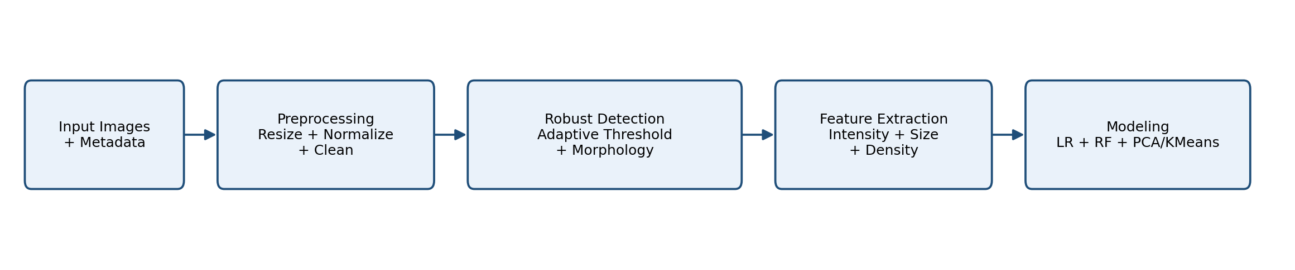
Figure 1. Overall analysis pipeline workflow, from raw multi-channel microscopy images through per-channel feature extraction and model training/evaluation on the compound-disjoint split (detection logic unchanged from our original submission).
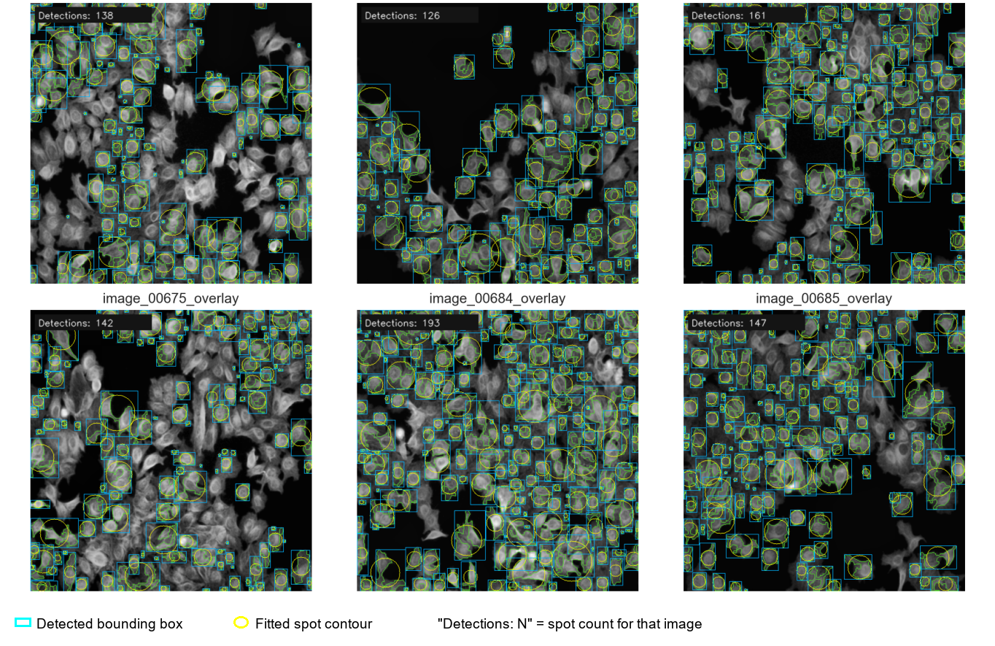
Figure 2. Representative detection overlays illustrating spot/object detection applied independently to each channel (DAPI, Tubulin, Actin), consistent with established CellProfiler-based preprocessing (Carpenter et al., 2006); only the per-channel application, not the underlying detection logic, is new in this revision.
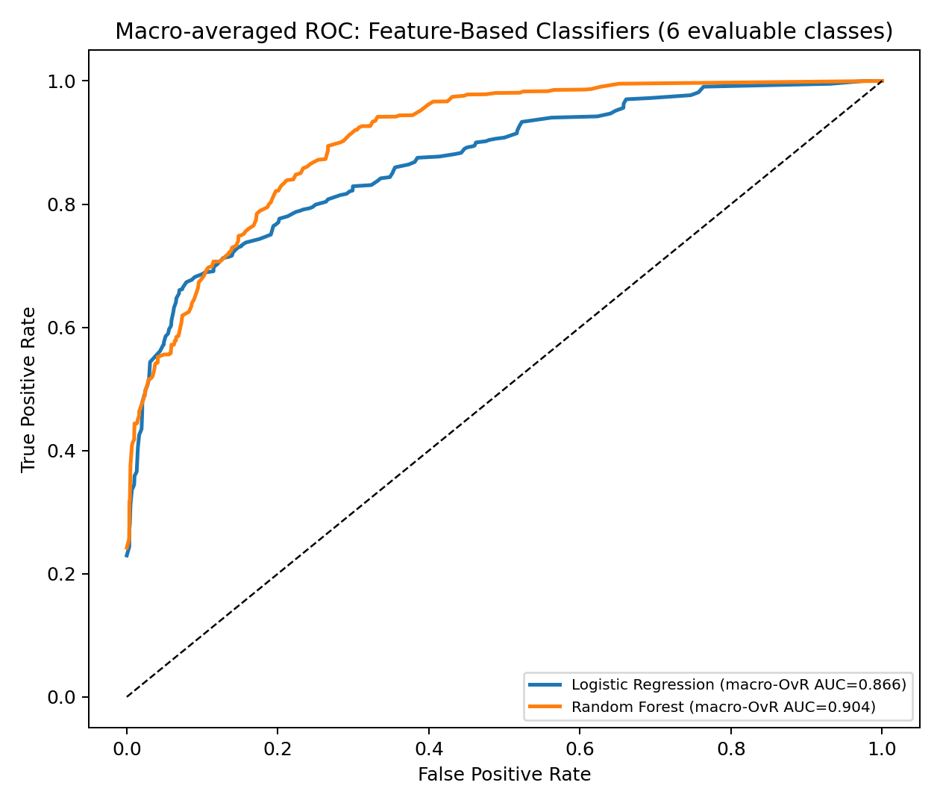
Figure 3. Macro-averaged ROC curves for Logistic Regression and Random Forest, averaged over the 6 test-evaluable classes, on the held-out compound-disjoint test set. Legend values match Table 2 exactly, correcting our original submission, in which the plotted curve did not correspond to the macro-OvR quantity reported in the tables.
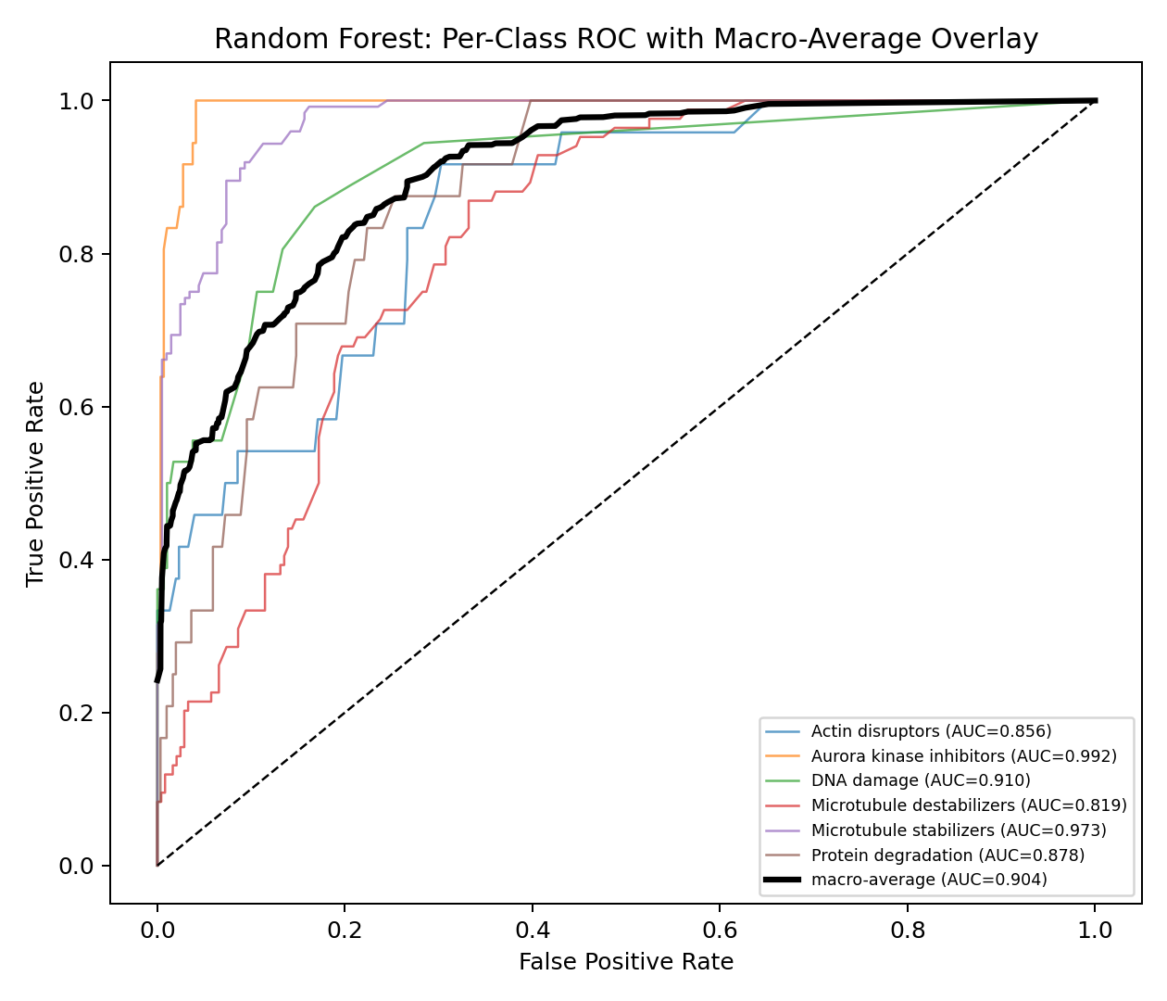
Figure 4. Per-class ROC curves for Random Forest with the macro-average overlaid (black), addressing a reviewer's request that a macro-averaged multiclass AUC -- which is the average of several per-class curves and cannot be represented by a single curve -- be shown per-class with the macro-average explicitly overlaid rather than plotted as one ambiguous curve.
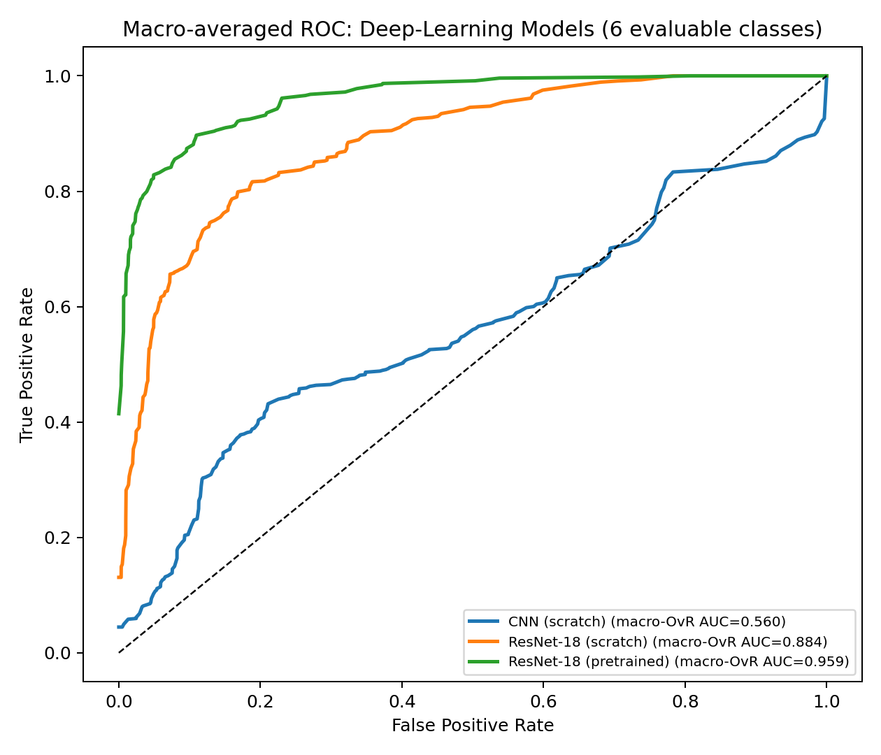
Figure 5. Macro-averaged ROC curves for the three deep-learning models (single representative run each), averaged over the 6 test-evaluable classes. Legend values match Table 2 exactly.
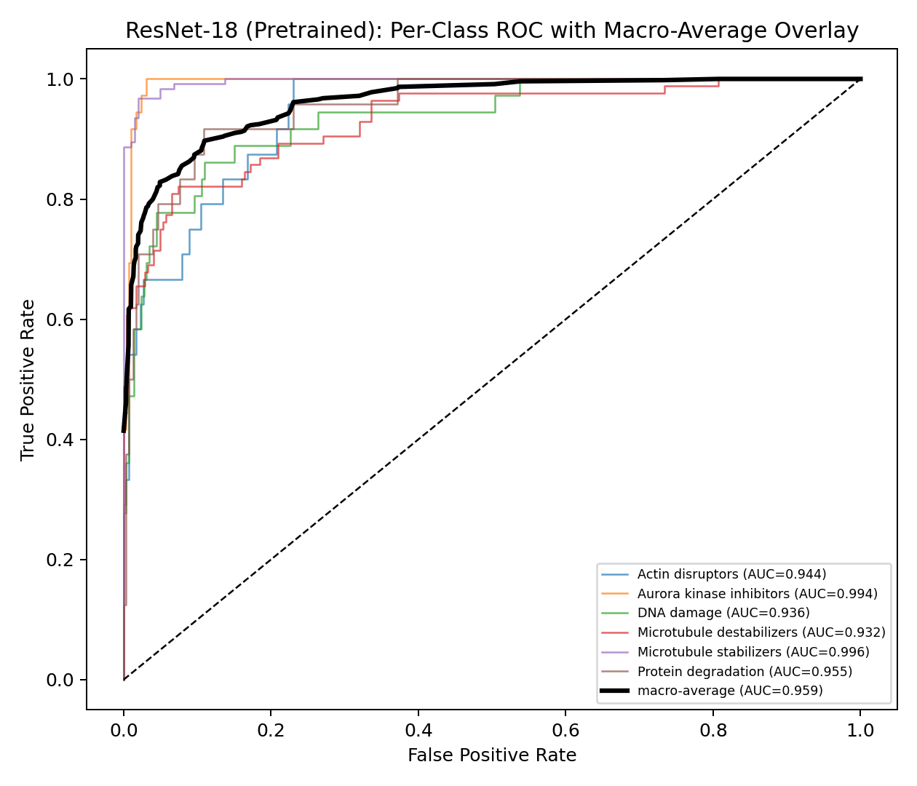
Figure 6. Per-class ROC curves for the pretrained ResNet-18 with the macro-average overlaid (black).
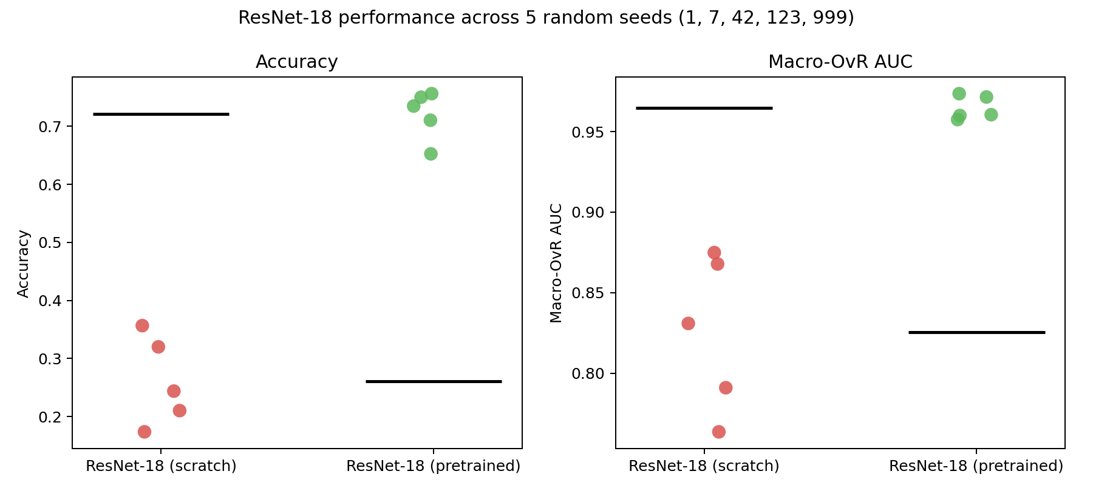
Figure 7. ResNet-18 accuracy and macro-OvR AUC distributions across five random seeds (scratch vs. pretrained; black bar = mean), corresponding to Table 3.
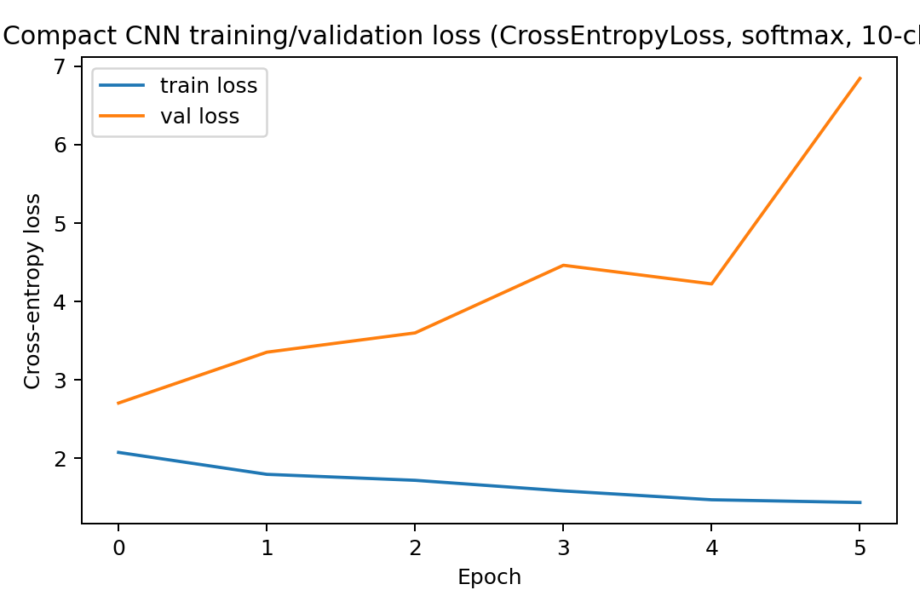
Figure 8. Training and validation loss for the compact CNN, now generated directly from the model whose results appear in Tables 2 and 5 (CrossEntropyLoss, softmax over 10 classes). Our original Supplementary Figure S7 plotted the loss curve of an unrelated, unused exploratory script that trained a different (binary-classification, BCEWithLogitsLoss) model never used to produce any reported result; a reviewer detected this from the epoch count and initial-loss value not matching a 10-class softmax model, and it is corrected here.
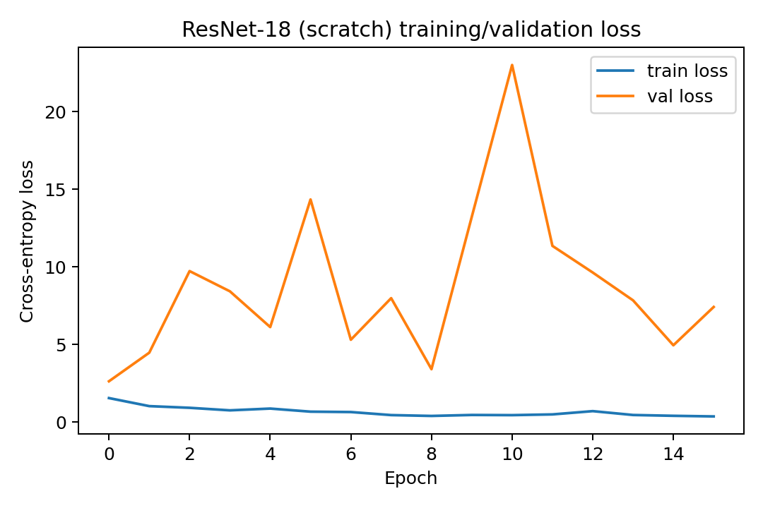
Figure 9. Training and validation loss curves for the scratch ResNet-18 (single representative run), provided per reviewer request.
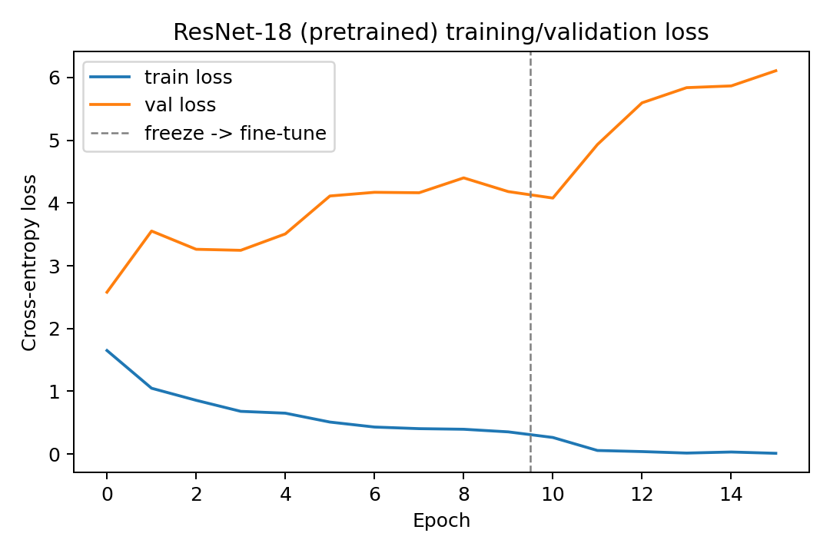
Figure 10. Training and validation loss curves for the pretrained ResNet-18 (single representative run); the dashed vertical line marks the transition from the frozen (stage 1) to fine-tuning (stage 2) training stage.
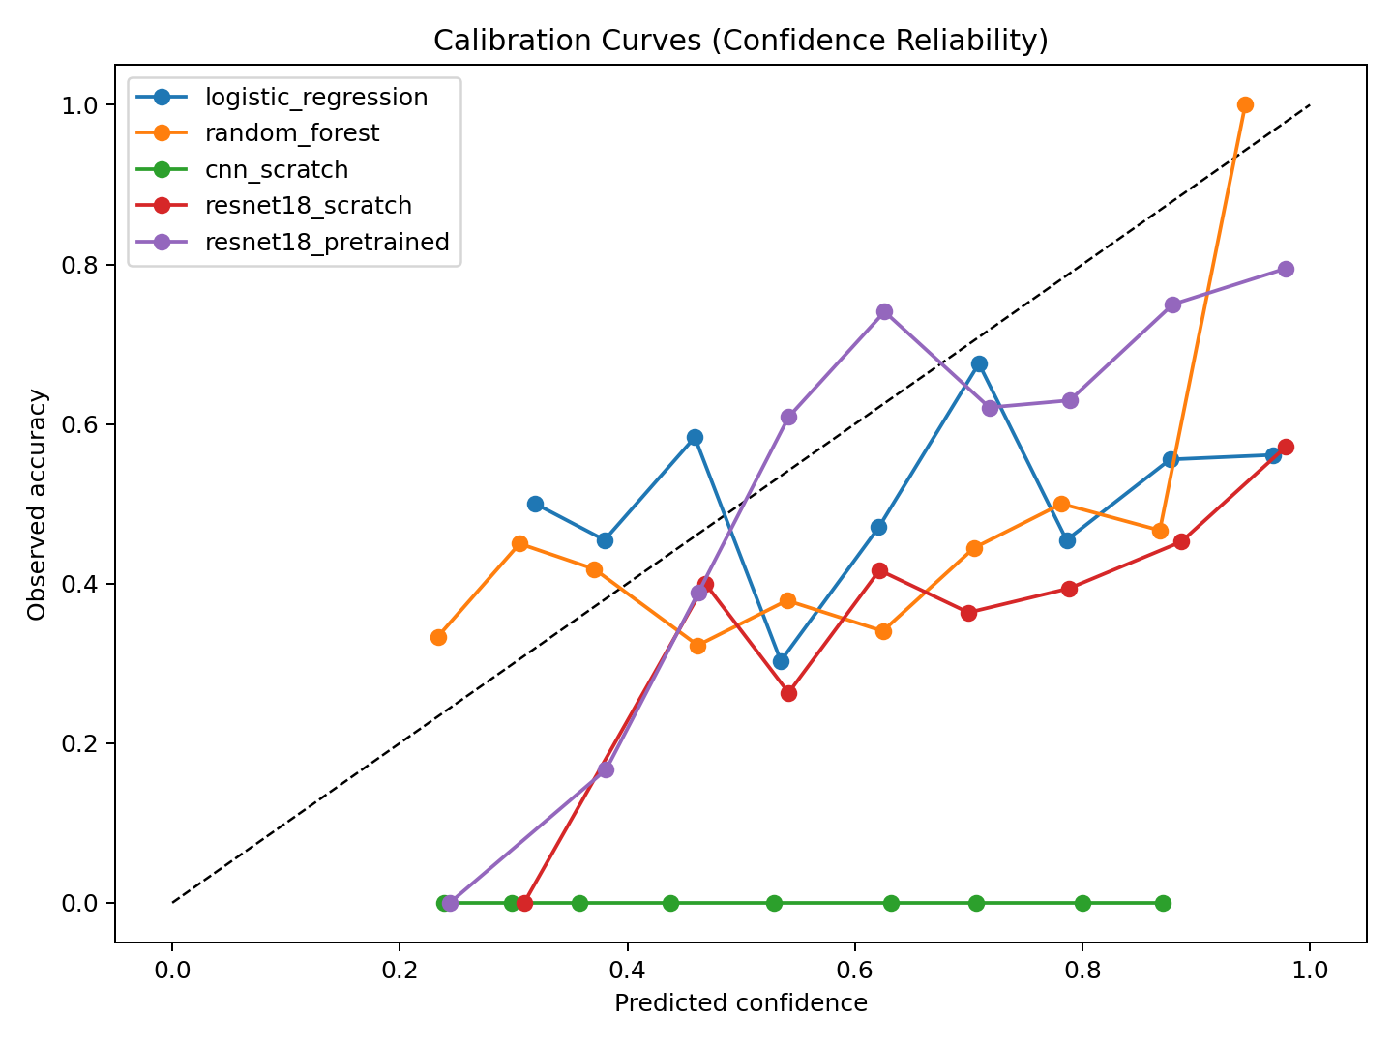
Figure 11. Reliability diagrams for all five models (Table 5).
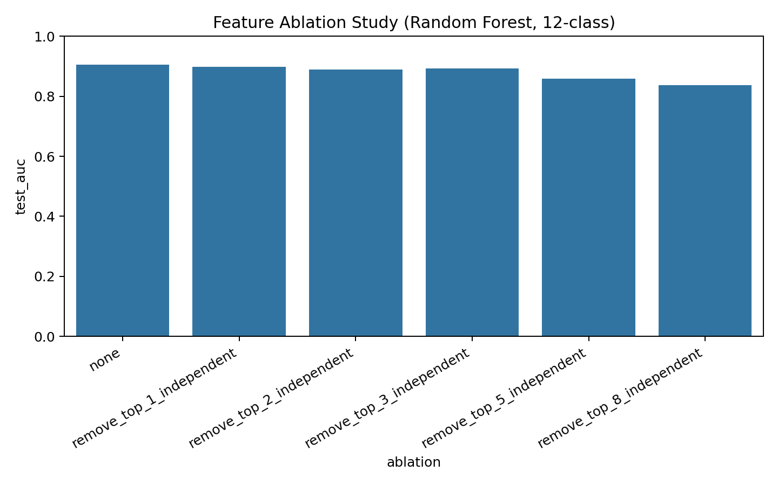
Figure 12. Deduplicated Random Forest feature-ablation curve on the 42 per-channel morphological descriptors (Table 6).
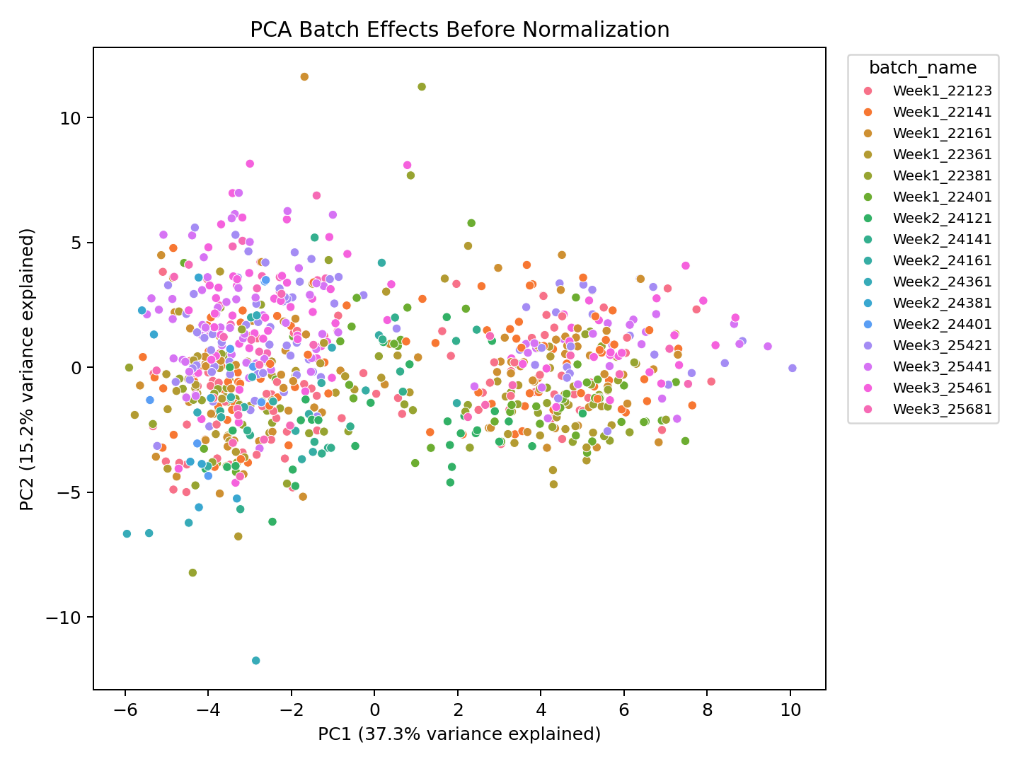
Figure 13. PCA of the 42-feature vectors before within-batch z-score normalization (Table 8).
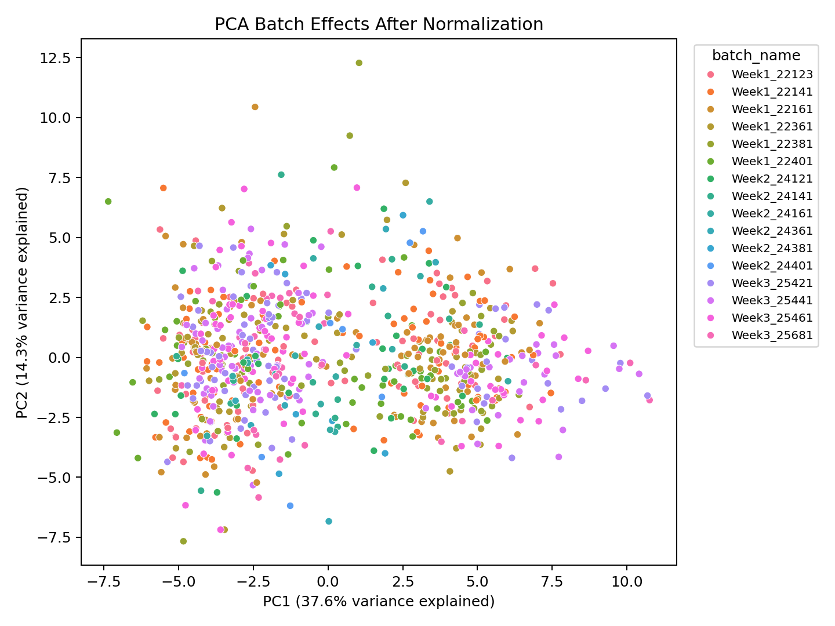
Figure 14. PCA of the 42-feature vectors after within-batch z-score normalization, with %-variance-explained axis labels and a sorted batch legend (both missing in our original submission), and corresponding quantified batch-separation metrics in Table 8.

Supplementary Figures
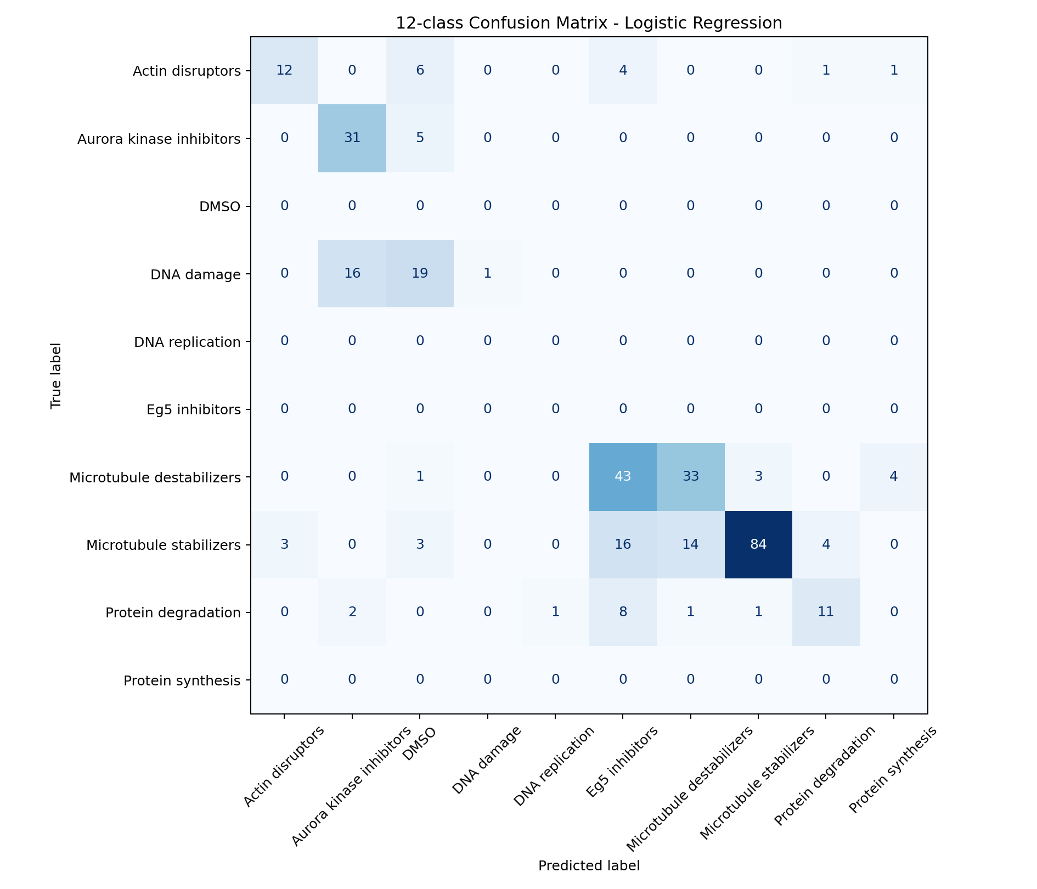
Supplementary Figure S1. Confusion matrix for Logistic Regression on the compound-disjoint test set; the 4 classes with no test-set representation (Table 1) appear as all-zero rows, shown explicitly rather than omitted.
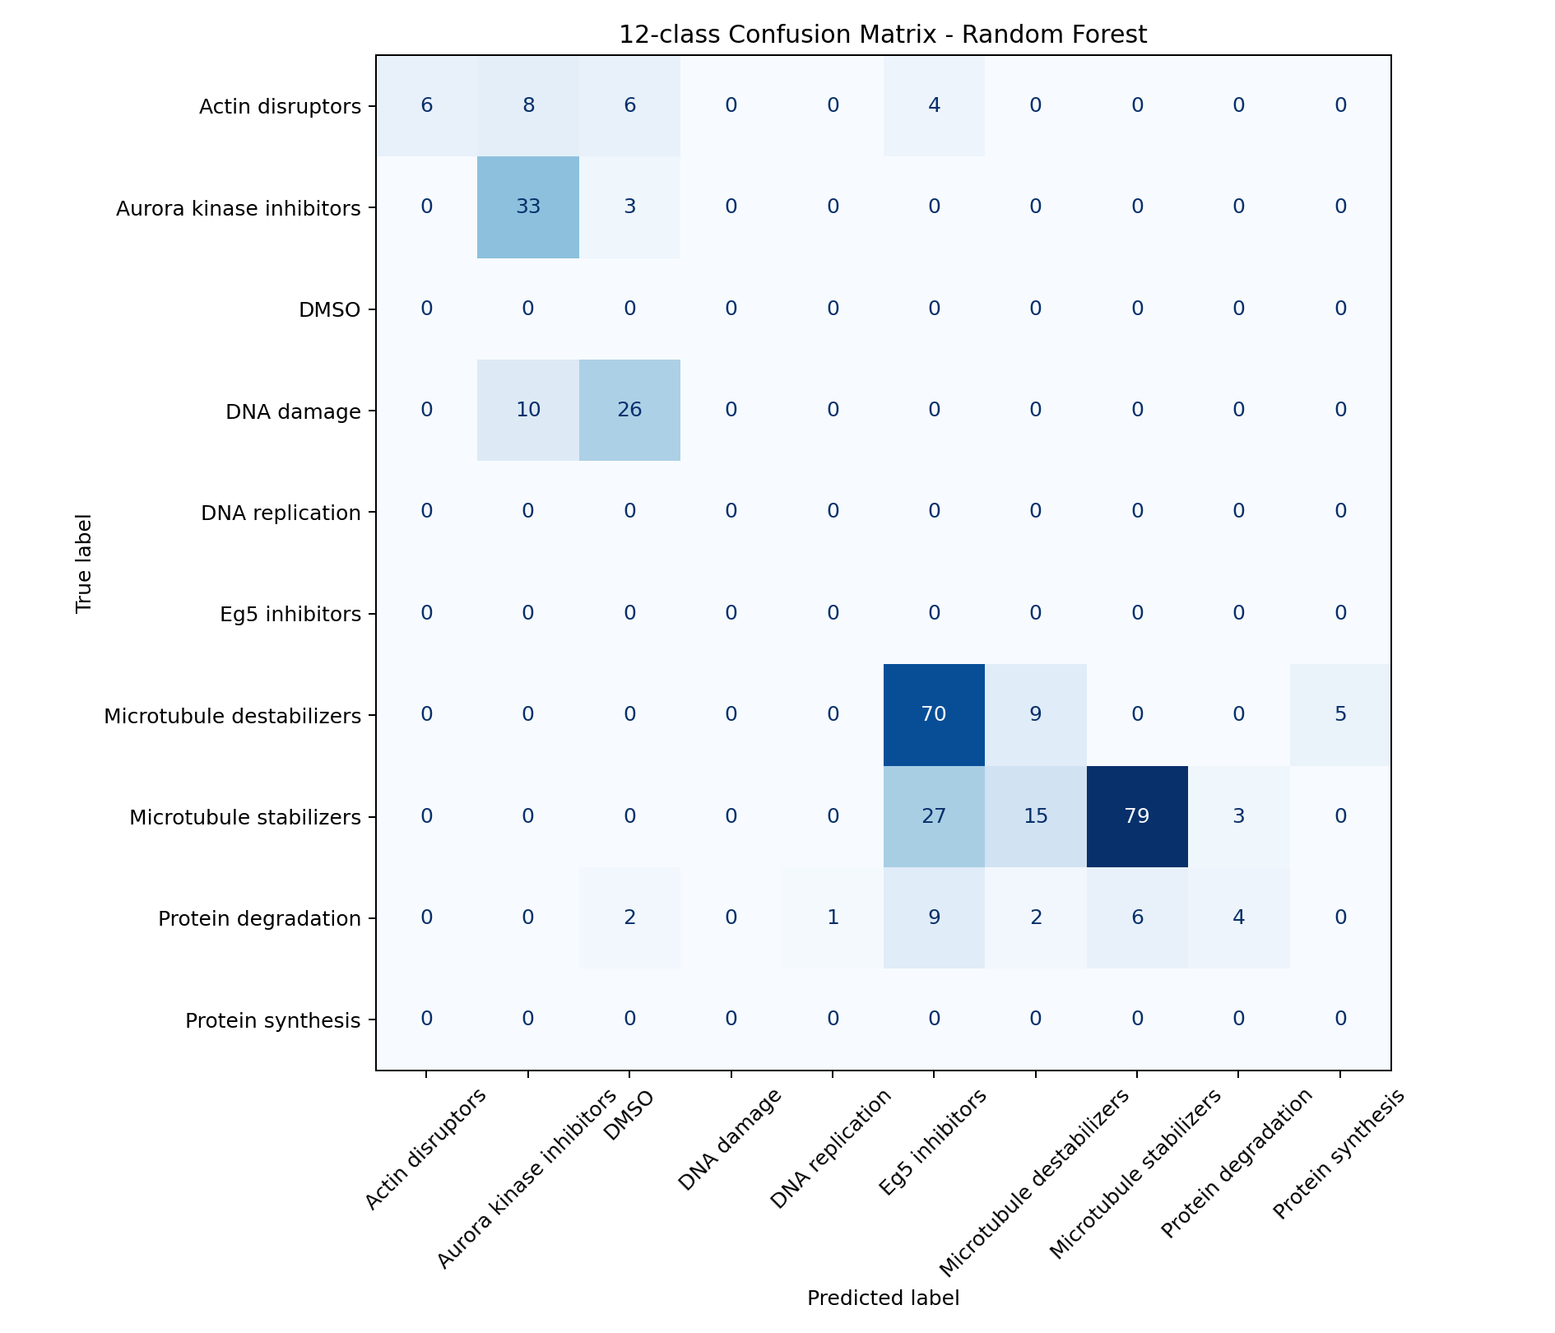
Supplementary Figure S2. Confusion matrix for Random Forest on the compound-disjoint test set; the 4 classes with no test-set representation (Table 1) appear as all-zero rows, shown explicitly rather than omitted.
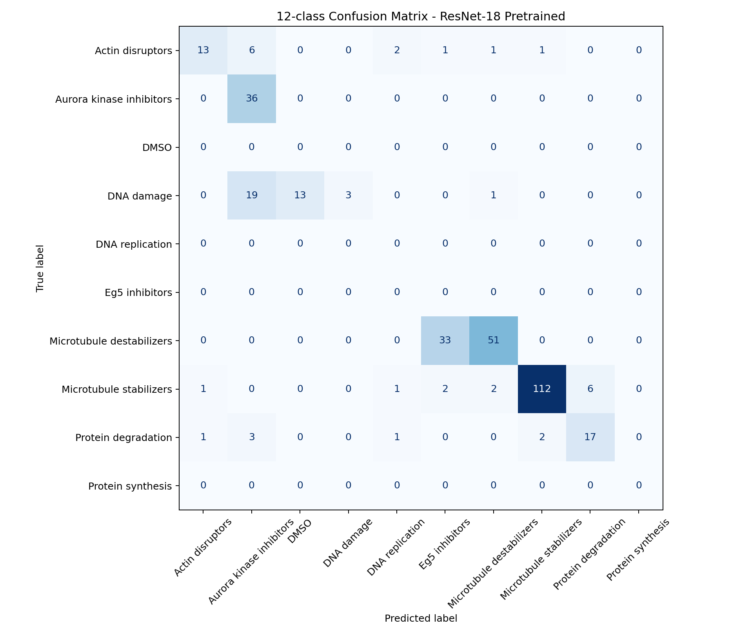
Supplementary Figure S3. Confusion matrix for the pretrained ResNet-18 on the compound-disjoint test set; the 4 classes with no test-set representation (Table 1) appear as all-zero rows, shown explicitly rather than omitted.
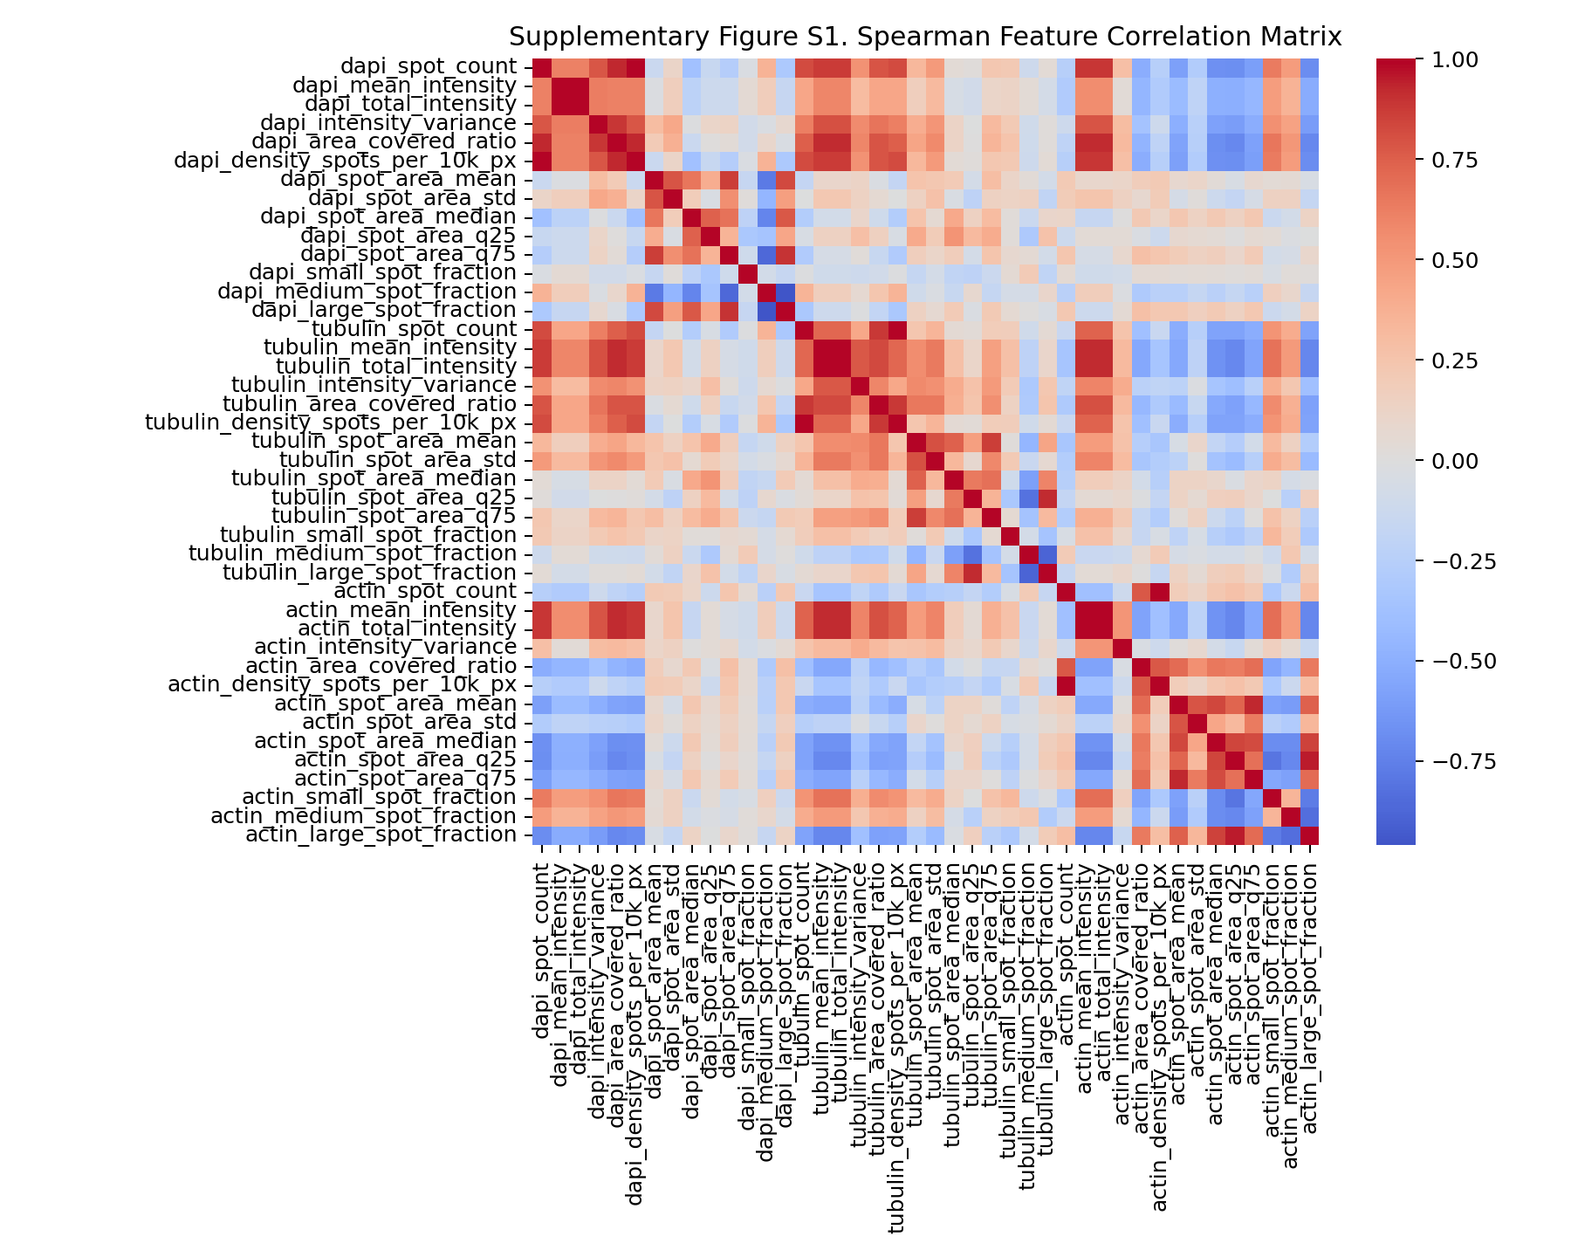
Supplementary Figure S4. Spearman correlation matrix across all 42 per-channel morphological features.

