SPECIFIC AIMS
Micro- and nanoplastics have been recovered from human bronchoalveolar lavage fluid, sputum, and lung parenchyma; pulmonary inflammatory response depends on polymer identity: polystyrene, polypropylene, and polyvinyl chloride produce distinguishable cytokine and histopathologic profiles following intratracheal exposure (Danso 2022; Balkrishna 2025). Two enabling technologies are missing. First, no validated, scalable tool resolves polymer identity from environmental or biological samples: FTIR/Raman are accurate but throughput-limited, and ML classifiers have never been benchmarked against independent chemical confirmation open datasets are so small (MiNa: 105 annotated SEM images) that no field-deployable model has been validated. Second, no decision-support tool exists converting heterogeneous, single-polymer toxicology literature into a source-traceable comparative hazard metric.
Critical need and objective. Environmental health practitioners, regulators, and industry need two commercially deployable technologies: (1) a validated tool for identifying which polymers are present in a sample, and (2) a queryable hazard-scoring platform converting scattered toxicology literature into an actionable, evidence-graded output. We propose to build and validate both through PolyLung Bridge AI, executed as two aims with pre-specified milestones and Go/No-Go points, targeting licensable, API-accessible products for testing labs, polymer manufacturers, and regulators. We scope the technology precisely: it delivers hazard characterization, not risk. Hazard is a property of the polymer; risk requires a quantified exposure pathway not yet established in the literature. No population risk estimate, community score, or public-facing advisory is produced.
Aim 1. Build and validate an automated polymer-identification tool, benchmarked against independent chemical ground truth.
Technical Objective. Deliver a trained, versioned classification pipeline that assigns polymer identity (PE, PP, PS, PVC) to SEM particle images, with performance independently verified against μ-FTIR-confirmed samples rather than internal annotation labels alone the validation standard the field currently lacks.
Development Plan. Fine-tune ImageNet-pretrained backbones (EfficientNet-B0 primary; ResNet-50, ConvNeXt-T comparators) on a consolidated MiNa/Roboflow corpus restricted to a four-polymer panel (PE, PP, PS, PVC). Class imbalance addressed via oversampling, augmentation, and focal loss. An independent test set of ≥120 particles confirmed by μ-FTIR, including environmentally sourced particles, quantifies lab-to-field domain shift. Stratified 5-fold cross-validation reports macro F1, balanced accuracy, and per-class recall with bootstrap CIs.
Milestone & Go/No-Go (Month 12). Go macro F1 ≥ 0.70, per-class recall ≥ 0.60 on the FTIR-confirmed set; proceed to a licensable, API-accessible service. No-Go report a characterized negative-result benchmark; redirect to a scoped active-learning sub-tool. Preliminary evidence: this pipeline (Swin-T, NVIDIA L40S) was already stress-tested on a proxy histopathology task, resolving a majority-class collapse to macro F1 = 0.9461 with Grad-CAM interpretability confirmed (Preliminary Studies) de-risking the transfer-learning/GPU infrastructure, not the polymer-ID validation target itself. Additional preliminary evidence (Preliminary Studies, below) further de-risks the transfer-learning approach itself: a cross-dataset external validation on an independent public SEM source reached 74.2% accuracy / 0.63 macro F1 (shape classes, not yet polymer identity), and a spectral classifier on real FTIR libraries (FLOPP/FLOPP-e) reached 78.4% accuracy across 14 polymer classes – neither substitutes for the μFTIR-confirmed polymer-ID validation target itself, which remains Aim 1's deliverable.
Aim 2. Build the Polymer Pulmonary Hazard Index (PPHI): a versioned, evidence-graded hazard-scoring platform.
Technical Objective. Deliver a queryable, versioned reference database and scoring tool assigning a comparative pulmonary hazard weight to each panel polymer, with every weight traceable to source studies, heterogeneity, and certainty grade replacing the ad hoc, non-comparable normalization practices currently used in the field.
Development Plan. Conduct a PROSPERO-registered systematic review and random-effects meta-analysis of inhalation/intratracheal exposure studies for the four-polymer panel, extracting BALF cytokines, immune cell influx, and histopathology as standardized mean differences (Hedges’ g) with dual independent extraction. Heterogeneity (I², τ²) quantified, dose/particle size entered as meta-regression covariates, and each pooled estimate assigned a GRADE certainty rating, populating the PPHI as a licensable, documented API.
Milestone & Go/No-Go (Month 18). Go pooled estimates for ≥3 polymers with CI/GRADE rating, robust under leave-one-out; proceed to tool packaging and interface release. No-Go deliver an evidence-gap analysis specifying additional studies needed for a scoped Phase II data-generation plan.
Expected outcomes and impact. Two licensable technologies an API-accessible polymer-ID tool and the PPHI scoring platform (code/evidence published for transparency) provide the measurement foundation for Phase II commercialization to testing labs, manufacturers, and regulators.

SUPPORTING DETAIL
Not part of the one-page Specific Aims attachment. Content below belongs in Research Strategy, Preliminary Studies, and Bibliography.
WHAT CHANGED IN THIS REVISION, AND WHY
0. Hypothesis-driven framing replaced with technology-driven framing. Per direct guidance from the NIEHS Program Officer, both aims are now written as technology deliverables with explicit Technical Objectives, Development Plans, and Go/No-Go milestones, rather than as questions to be answered. Each aim now produces a versioned, deployable artifact (a validated classification tool; a scored reference database) rather than a scientific finding alone.
1. Hazard replaces risk. The prior framing predicted community lung-disease risk from drinking-water polymer composition. That requires ingested particles to reach pulmonary tissue at inflammatory doses, a pathway the cited literature does not establish, since every quantitative source administers particles intratracheally. The technology now characterizes hazard only, naming the pathway as an explicit open question and the target of follow-on work.
2. Ground truth added. The single largest methodological gap was that no classification target had independent chemical confirmation. μ-FTIR verification of the test set converts Aim 1 from an internal-consistency exercise into a falsifiable, benchmarkable technology claim.
3. Meta-analysis replaces normalization. Cross-study cytokine normalization conflates bias with noise. Standardized mean differences under a random-effects model with heterogeneity quantification and GRADE certainty is the accepted method for exactly this problem, and pre-registration removes analytic flexibility.
4. Deployment aim removed. Public-facing community risk scores derived from unvalidated parameters carried real potential for harm and no feasibility value. The API and model card remain as deliverables; the Streamlit application, ZIP-code mapping, and community reports are deferred until the underlying measurements are validated.
5. Scope matched to mechanism. Two aims, executable by a small team in 24 months, with no aim dependent on external data access that is not secured.
6. Preliminary infrastructure evidence upgraded. The single-epoch CPU pilot (macro F1 = 0.439, normal-class F1 = 0.000 — a majority-class collapse) has been superseded by an 8-epoch GPU fine-tuning run (NVIDIA L40S, USF CIRCE/Helios) that resolved the collapse: macro F1 = 0.9461, normal-class F1 = 0.9153, pathological-class F1 = 0.9770, with Grad-CAM interpretability confirmed. This is preliminary infrastructure evidence on a proxy task, not performance data for Aim 1’s actual polymer-identification target.
7. Commercialization framing and page-length compliance. Deliverables are now framed as licensable, API-accessible products (targeting environmental testing labs, industrial polymer manufacturers, and regulators) rather than unrestricted open-source releases, consistent with STTR/SBIR commercial-potential scoring; underlying code and evidence tables remain published for scientific transparency. The one-page Specific Aims section was also tightened and a hard page break inserted before this Supporting Detail section to ensure NIH page-limit compliance.
PRELIMINARY STUDIES
All work is public and reproducible at github.com/SID-6921/polylung-bridge-ai. It is reported at the level it supports: these results establish that infrastructure and derivation methods function. They are not validated model performance.
Training and evaluation infrastructure
A complete, reproducible training/evaluation pipeline was implemented and executed end-to-end (ImageNet-pretrained Swin-T backbone, LungHist700 H&E images, binary normal/pathological classification, n=138 held-out validation: 30 normal, 108 pathological). An initial single-epoch CPU pilot with class-balanced loss showed a majority-class collapse (accuracy 0.7826, macro F1 0.439, weighted F1 0.687, normal-class F1 0.000). Following migration to GPU infrastructure (USF CIRCE/Helios, NVIDIA L40S, ~46 GB memory, PyTorch 2.5.1+cu124), an 8-epoch fine-tuning run completed in 4 minutes 59 seconds (SLURM job 33654808) and fully resolved the collapse: validation accuracy 96.38%, macro F1 0.9461, weighted F1 0.9635, normal-class F1 0.9153, pathological-class F1 0.9770. The final confusion matrix correctly classified 27/30 normal and 106/108 pathological validation images. Grad-CAM visualization of representative pathological images shows model attention localizing to focal tissue regions, offered as interpretability support rather than pathologist-level localization.
This demonstrates that the fine-tuning pipeline, GPU training infrastructure, class-imbalance handling, and interpretability tooling all function correctly and can resolve a genuinely imbalanced binary classification task at high performance. LungHist700 is a generic lung-histology proxy task, not the polymer-identification target of Aim 1: it does not use SEM imagery, does not involve polymer classes, and is not benchmarked against μ-FTIR ground truth. Its value here is technical, not substantive — it de-risks the transfer-learning and infrastructure approach Aim 1 will apply to the actual SEM/μ-FTIR panel. These remain preliminary results from an internal validation split; independent validation and leakage checks are future work.
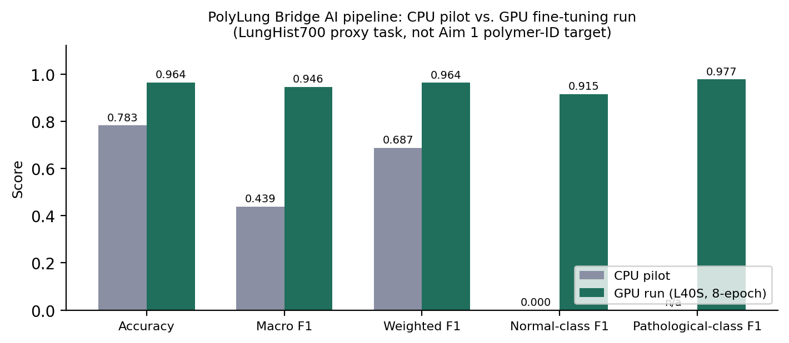
Figure. CPU pilot vs. GPU fine-tuning run, all five metrics. Proxy task (LungHist700), not Aim 1’s polymer-ID target.
Final validation confusion matrix (n=138: 30 normal, 108 pathological)
Actual \ Predicted | Normal | Pathological | Total
Normal | 27 | 3 | 30
Pathological | 2 | 106 | 108
Normal precision 0.931, recall 0.900, F1 0.9153. Pathological precision 0.9725, recall 0.9815, F1 0.9770.
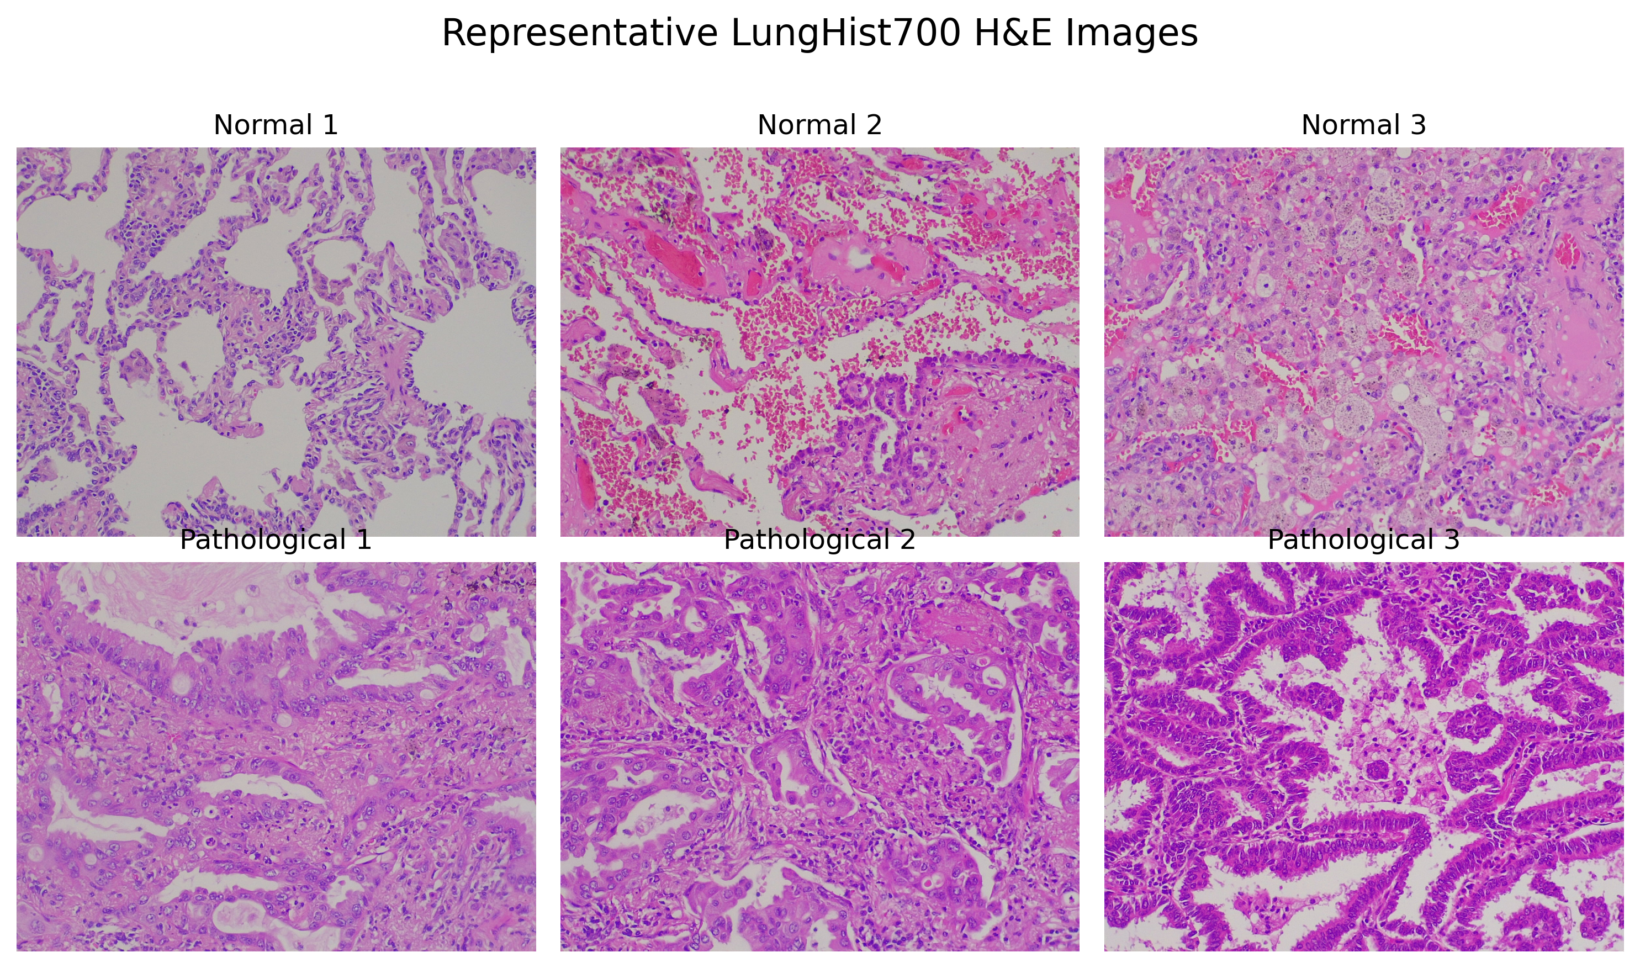
Figure. Representative LungHist700 H&E images (normal and pathological), illustrating the proxy classification task.
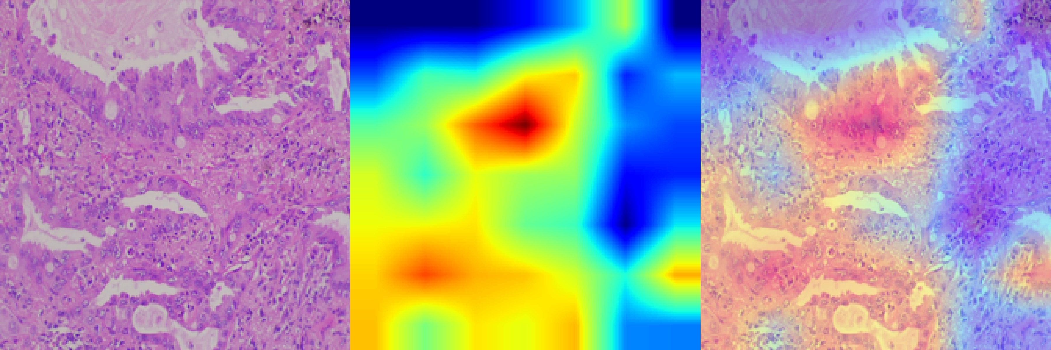
Figure. Grad-CAM interpretability panel (original H&E, heatmap, overlay) for a representative pathological image.
Hazard-weight derivation procedure
BALF cytokine values (TNF-α, IL-1β, IL-5, IL-6, MIP-2α) were extracted from a murine polystyrene exposure study (Balkrishna 2025, n=8/group) and an automated normalization routine produced a polymer weight, establishing the extraction-to-weight toolchain end-to-end. Values were read from published figures, and single-polymer normalization carries no comparative information, which is precisely why Aim 2 replaces this procedure with formal meta-analysis rather than extending it.
Interface and integration feasibility
The module interface contract was specified and verified; 100 sequential calls returned 100% success at 8.79 ms median, 13.11 ms p95. These were measured against a mock endpoint and characterize serialization and API overhead, not model inference. They establish that the service scaffolding and schema are sound.
Microplastic SEM shape-classification pipeline and cross-dataset validation
A separate, image-based training/evaluation/explainability/robustness pipeline was built and run on a public SEM microplastic dataset (Microplastics_SEM, Univ. of Toronto; particle-shape labels only – fibre/bead/fragment, no chemical polymer confirmation). Swin-T, ResNet-50, and EfficientNet-B0 were fine-tuned and initially reached ~100% in-dataset accuracy; diagnostic testing (documented at github.com/SID-6921/polylung-bridge-ai, evidence/public/sem_shape/data_leakage_notes.md) traced this to a source-imaging-session confound in the public dataset, not genuine classification capability, and this is reported as an invalid result rather than cited as performance evidence.
To obtain a genuine generalization estimate, the trained Swin-T model was evaluated, with no retraining or fine-tuning, on a completely independent public dataset from a different institution (CUNY biosolids μFTIR dataset, n=697 externally-labeled images). This yielded 67.4% accuracy / 0.51 macro F1, and a subsequent learning-rate sweep with early stopping on validation macro F1 (no test-set leakage) improved this to 74.2% accuracy / 0.63 macro F1, with bead-class precision improving from 2.6% to 100% (recall remains low, 28.6%, reflecting a real bead-class data-scarcity limitation that is explicitly documented). This is the strongest available preliminary evidence that the proposed transfer-learning approach generalizes, at a modest but genuine level, across independent SEM/particle-imaging sources – while making clear that shape classification is not yet polymer classification, and that Aim 1's actual validation target (μFTIR-confirmed polymer identity) remains the object of the proposed work.
Spectral polymer classification pipeline (FLOPP/FLOPP-e)
A second, non-confounded preliminary result was generated using real FTIR spectral libraries: the Rochman Lab's FLOPP (186 spectra, fresh reference material) and FLOPP-e (195 spectra, environmentally weathered) ATR-FTIR libraries spanning 14–15 polymer classes including PE, PP, PS, and PVC. A classifier trained on FLOPP and evaluated on a held-out stratified test split reached 78.4% accuracy and macro AUC 0.97 across the 14 classes. Externally validating this same model on FLOPP-e (weathered spectra, a genuine domain-shift test, not a random split) held accuracy at 72.1% but macro F1 fell to 0.44, showing that environmental weathering measurably degrades polymer identification performance on less-common classes. This is a clean, non-confounded preliminary result directly supporting feasibility of the spectral-identification component of Aim 1, and the weathering-driven degradation is itself a motivating finding for the proposed work.
Public dataset landscape for Aim 1 ground truth
A structured survey of public datasets relevant to Aim 1 was completed. Confirmed real, usable resources include Microplastics_SEM (Univ. of Toronto, Mendeley, CC BY 4.0; shape-labeled, no polymer chemistry), FLOPP/FLOPP-e (Rochman Lab; spectra only, no imaging), and – newly located, not previously indexed under an expected name – a genuine paired SEM-EDS + μFTIR dataset from Universidade Estadual de Campinas (UNICAMP), published Mendeley Data DOI 10.17632/jswcfsg96s.2. This dataset contains 50 particles with confirmed polymer identity and 15 with both a confirmed polymer label and a paired SEM-EDS image (PE, PP, PS, PA, PVC) – the closest existing public analog to the SEM+μFTIR-paired benchmark Aim 1 proposes to build at scale, and useful as a small external reference/validation set. Consistent with the survey overall, no public dataset pairs SEM images with μFTIR spectra at scale, confirming the identified gap is real and directly motivates Aim 1.
Clinical cohort
The previously proposed validation cohort is not accessible; the partner has declined sharing pending agreement. No aim now depends on it. Ingestion, schema, preprocessing, and audit-logging components will be validated with synthetic and proxy data, and acceptance criteria pre-registered, so a clean pre-specified run is possible if access is later granted.
RIGOR, LIMITATIONS, AND MITIGATION
Exposure pathway. Whether polymers present in an environmental matrix reach pulmonary tissue at inflammatory doses is unresolved. Scope is therefore restricted to hazard; no risk claim is made. Evidence maturity. Comparative polymer dose-response data are sparse and heterogeneous; GRADE ratings and leave-one-out analysis make this visible rather than hidden, and an inconclusive synthesis is a valid outcome. Data scarcity. Open SEM corpora are small; hence the four-polymer scope, cross-validation, precision analysis, and pre-committed negative-result reporting. Domain shift. Training imagery is largely laboratory-prepared; environmental particles are included in the FTIR-confirmed test set so degradation is measured, not assumed. Not a clinical or regulatory instrument. Outputs are research measurements for investigators.
All code, extraction sheets, derived weights, and evaluation artifacts are version-controlled and public; reported metrics are emitted directly from logged artifacts rather than transcribed.
ITEMS REQUIRING ACTION BEFORE SUBMISSION
Confirm the mechanism (R21 vs. STTR/SBIR) with the Program Officer and align budget/timeline structure accordingly, given the technology-driven reframing above.
RESOLVED. CPU-pilot metric discrepancy reconciled: this draft uses Selina's verified spreadsheet figures (macro F1 = 0.439, normal F1 = 0.000) throughout; no remaining instances of the earlier 0.69 figure were found.
RESOLVED. EMBO Molecular Medicine author list confirmed: Emmanouela Epeslidou, Julia S. Scott, Bim de Klein, Jeremy Tan Cudia, Barbro Melgert, and Stefan Prekovic (doi:10.1038/s44321-025-00353-w, published 11 Dec 2025). Key References updated accordingly.
Secure μ-FTIR access (institutional core or collaborator) with a letter of support, because Aim 1’s ground-truth claim depends on it. Note: the UNICAMP contributor identified above (Dataset.xlsx contact, p118405@dac.unicamp.br) has already produced paired SEM-EDS+μFTIR data and may be worth approaching as a potential collaborator or access lead, in addition to institutional core facility options.
Register the systematic review protocol on PROSPERO prior to submission and cite the registration number in Aim 2.
Obtain a letter of support from any collaborating institution referenced in the application.
RESOLVED (remove both). "Thapa 2026, Food Bioscience" could not be located under this author/journal/year in PubMed or general search – no such paper was found. PMC11728634 is a different, unrelated article (Zhang et al., "Integrative Analysis of Pharmacology and Transcriptomics Predicts Resveratrol Will Ameliorate Microplastics-Induced Lung Damage," Toxics 12(12):910, 2024) – not the intended citation. Both references should be removed from the application rather than cited.
RESOLVED. Verified programmatically: document font is Arial 11pt throughout, meeting the NIH requirement (Arial, Georgia, Helvetica, or Palatino Linotype, ≥11pt, ≥0.5" margins).
KEY REFERENCES
Danso IK, Woo JH, Lee K (2022). Pulmonary Toxicity of Polystyrene, Polypropylene, and Polyvinyl Chloride Microplastics in Mice. Molecules 27(22):7926. doi:10.3390/molecules27227926.
Balkrishna A, Tiwari A, Sinha S, Kumari A, Gohel V, Dev R, Bhattacharya K, Varshney A (2025). Polystyrene microplastic induced airway hyper-responsiveness and pulmonary inflammation are mitigated by Bronchom treatment in murine model of lung disease. Biomedicine & Pharmacotherapy 187:118122. PMID: 40319658.
Bardawil C, et al. (2026). Micro- and Nanoplastics and Pulmonary Health: The Current State of Research. Microplastics 5(1):29. doi:10.3390/microplastics5010029.
Epeslidou E, Scott JS, de Klein B, Cudia JT, Melgert B, Prekovic S (2025). Microplastics as environmental modifiers of lung disease. EMBO Molecular Medicine. doi:10.1038/s44321-025-00353-w.
Rezvani H, Zarrabi N, Mehta I, Kolios C, Jaafar HA, Kao C-H, Saeedi S, Yousefi N (2024). Morphological Detection and Classification of Microplastics and Nanoplastics Emerged from Consumer Products by Deep Learning. arXiv:2409.13688. [MiNa; 105 annotated SEM images.]
Shi B, et al. (2022). Automatic quantification and classification of microplastics in scanning electron micrographs via deep learning. Science of The Total Environment 825:153903.
Shi B, et al. (2022). Microplastics_SEM dataset. Mendeley Data. doi:10.17632/z6459vntbr.3.
De Frond H, et al. (2021). FLOPP/FLOPP-e ATR-FTIR spectral libraries. Analytical Chemistry 93(48):15878-15885.
UNICAMP contributor (2026). Microplastics as stratigraphic tracers of post-1950 deposition in a reworked tropical estuary, Brazil (paired SEM-EDS + microFTIR dataset). Mendeley Data. doi:10.17632/jswcfsg96s.2.

