PolyLung Bridge AI — Preliminary Data Summary
Microplastic Polymer Classification: Public Dataset Evaluation, Pilot Feasibility, and Preliminary AI Pipeline Results
Prepared by Siddhardha Nanda and Selina Park. Date: 2026-07-31.

1. Public Dataset Landscape (Task 1)
Dataset | Type | N | Polymer classes | SEM+FTIR paired? | License
Microplastics_SEM (U. Toronto) | SEM images | Multiple sub-datasets | None (shape only: fibre/bead/fragment) | No | CC BY 4.0
FLOPP / FLOPP-e (Rochman Lab) | ATR-FTIR spectra | 186 / 195 | 14–15 (PE, PP, PS, PVC, PET, etc.) | No (spectra only) | Open, citation req.
UNICAMP SEM–FTIR dataset | Paired SEM-EDS + µFTIR | 50 labeled; 15 fully paired | PE, PP, PS, PA, PVC | Yes — 15 particles | CC BY 4.0
SLoPP / SLoPP-E (Rochman Lab) | Raman spectra | 148 / 113 | Multiple | No (spectra only) | Open, citation req.
Table 1. Public datasets identified, downloaded, and evaluated. Full detail in accompanying report.
Key finding: no public dataset provides particle-level SEM+FTIR pairing at scale. The UNICAMP dataset (newly located; not indexed under its expected name at first search) is the closest match, at n=15 — sufficient as a reference/validation set but not for training. This gap directly motivates the proposed STTR work.

2. Pilot Dataset Feasibility (Task 2)
Phase | Estimated duration
Instrument access/scheduling (SEM + µFTIR core facility) | 1–3 weeks
Reference standard procurement | 2–7 days
Sample prep (mounting, coating, indexing) | 1–2 days/batch
Data collection (40–80 particles, both instruments) | 3–8 working days
QC, spectral matching, documentation | 2–5 days
Total realistic timeline | 3–6 weeks minimum
Table 2. Feasibility timeline for a 40–80 particle paired SEM–µFTIR pilot dataset.
Recommendation: position the pilot as an Aim 1 milestone (e.g., months 1–3 of the funded project) rather than a pre-submission deliverable; instrument scheduling, not measurement time, is the binding constraint.

3. Preliminary AI Pipeline — Spectral Polymer Classifier (Valid Result)
A RandomForest classifier was trained on FLOPP ATR-FTIR spectra (14 polymer classes including PE, PP, PS, PVC, PET) and evaluated on a held-out test split, then externally validated on FLOPP-e (environmentally weathered spectra, genuine domain shift).
Evaluation | n | Accuracy | Macro F1 | Macro AUC (OvR)
FLOPP internal held-out test | 37 | 78.4% | 0.78 | 0.97
FLOPP-e external validation (weathered) | 172 | 72.1% | 0.44 | —
Table 3. Spectral polymer classifier performance — a clean, non-confounded result.
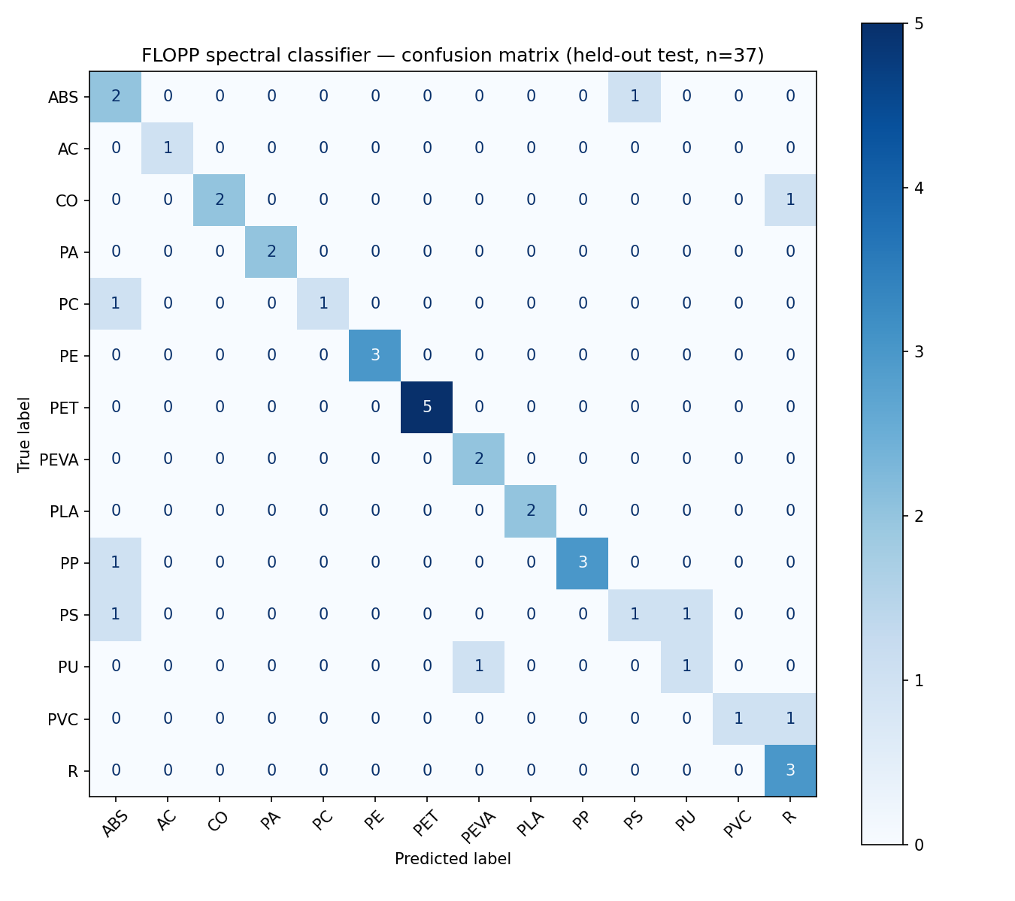
Figure 1. Confusion matrix, FLOPP spectral classifier, held-out test set (14 polymer classes).
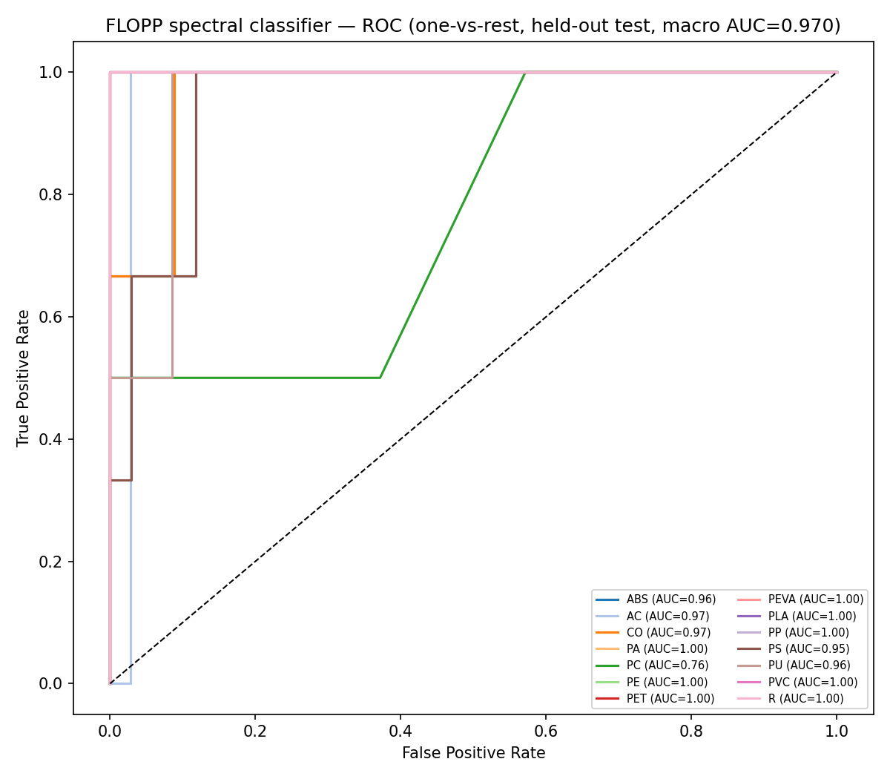
Figure 2. One-vs-rest ROC curves, FLOPP spectral classifier, held-out test set (macro AUC = 0.97).
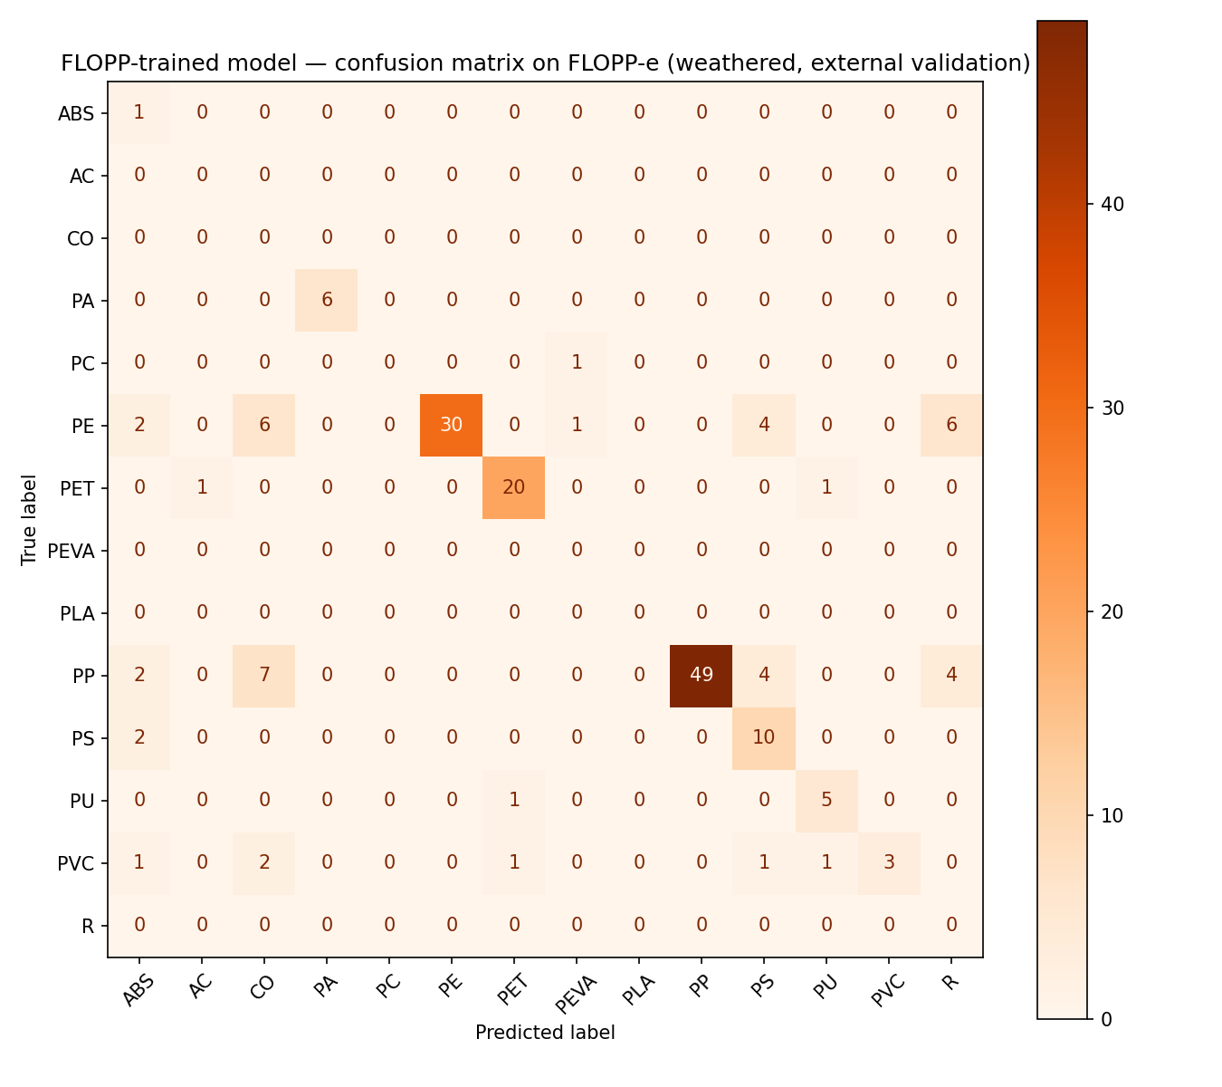
Figure 3. Confusion matrix on FLOPP-e (weathered spectra), external validation of the FLOPP-trained model. Accuracy holds (72%) but macro-F1 drops to 0.44, showing weathering degrades polymer ID on less-common classes — a genuine, citable motivating finding for the proposed work.

4. Preliminary AI Pipeline — SEM Shape Classifier (Infrastructure Evidence Only)
Swin-T, ResNet50, and EfficientNet-B0 were fine-tuned on the Microplastics_SEM dataset (fibre/bead/fragment shape classes; this dataset has no chemical polymer labels). This section is included to demonstrate the training/evaluation/explainability/robustness pipeline is built and functional — the specific accuracy figures below must NOT be cited as evidence of classification capability (see caveat below).
Model | Split type | Val accuracy | Val macro F1 | Mean AUC
Swin-T | Original (file-stratified) split | 100% | 1.00 | 1.00
ResNet50 | Original (file-stratified) split | 100% | 1.00 | 1.00
EfficientNet-B0 | Original (file-stratified) split | 100% | 1.00 | 1.00
Swin-T | Session-grouped split (fibre vs. fragment only) | 100% | 1.00 | 1.00
Table 4. SEM shape classifier results across architectures and split strategies.
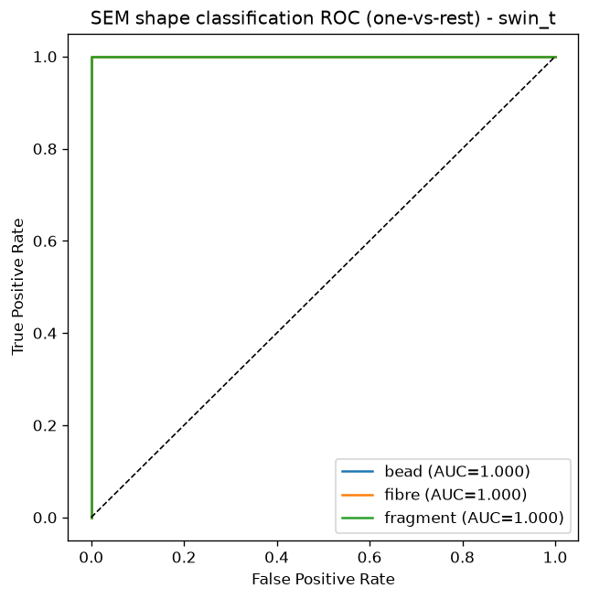
Figure 4. Swin-T ROC curve, original split — perfect separation, diagnosed as invalid (see caveat).
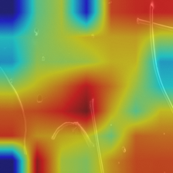
Figure 5. Grad-CAM example (fibre class, correctly classified) — activation was diffuse rather than tightly particle-focused, consistent with the confound explained below.

Caveat — why these numbers are not valid classification evidence
All three models converged to ~100% accuracy and AUC ≈ 1.0. Diagnostic testing traced this to a dataset design flaw, not genuine model performance: each shape class in the public dataset is drawn from a very small number of source imaging sessions/products (e.g., every 'bead' image across train/val/test originates from a single product), so a model can solve the task by recognizing session-level artifacts (background, lighting, scale bar) rather than particle morphology. A trivial classifier using only image width/height/aspect ratio (no pixel data) already reached 77% accuracy, confirming part of the shortcut; the SEM models showed zero accuracy degradation under any robustness perturbation (flip, brightness, rotation, contrast), which is itself further evidence of shortcut learning rather than genuine generalization. A session-grouped re-split removed literal train/test leakage but could not fully resolve the issue, since too few distinct source sessions exist per class in the public data. Full diagnostic methodology is documented in the project repository (data_leakage_notes.md).
Conclusion: the training, evaluation, explainability, and robustness-testing pipeline is built, reproducible, and ready to apply to a properly-labeled dataset. A session/source-diverse labeled dataset — such as the pilot proposed in Aim 1 — is the identified next step to produce valid classification evidence.

5. Summary and Recommendation
• Public dataset survey (Task 1) and pilot feasibility assessment (Task 2) are complete and support the STTR's Aim 1 narrative directly.
• The FLOPP/FLOPP-e spectral polymer classifier (Section 3) is legitimate, citable preliminary evidence: 78.4% accuracy across 14 real polymer classes, with a genuine, motivating finding that environmental weathering degrades classification performance.
• The SEM shape classifier (Section 4) demonstrates the AI pipeline is built and functional, but its accuracy numbers should not be presented as classification performance evidence due to a documented dataset confound.
• All code, data-preparation scripts, metrics, and figures are version-controlled and public: github.com/SID-6921/polylung-bridge-ai (branch: microplastics-mendeley-setup).

