7COM1079-0901-2025 - Team Research and Development Project

Final report title: F1 Drivers_dataset

Group ID: A21

Dataset number: ds119

Prepared by: Sanjeev Kumar Sudhendra Rao (SID:24066897)
Manikanta Reddy Goguri (SID:24074226)
Goutham Kalinganahalli Srinivasaiah (SID:24080417)
Anand Koppula (SID:24085726)
Jyothish Reddy Tummala (SID:24090478)

University of Hertfordshire
Hatfield, 2025

Table of Contents
1. Introduction 3
1.1 Problem statement and research motivation 3
1.2 The data set 3
1.3 Research question 3
1.4 Null hypothesis and alternative hypothesis (H0/H1) 3
2. Background research 5
2.1 Research papers (at least 3 relevant to your topic / DS) 5
2.2 Why RQ is of interest (research gap and future directions according to the literature) 5
3. Visualisation 6
3.1Appropriate graphs for the RQ 6
3.2 Additional information relating to understanding the data (optional) 6
3.3 Useful information for the data understanding 7
4. Analysis 8
4.1 Statistical test used to test the hypotheses and output 8
4.2 The null hypothesis is rejected /not rejected based on the p-value 8
5. Evaluation – group’s experience at 7COM1079 10
5.1 What went well 10
5.2 Points for improvement 10
5.3 Group’s time management (50 words) 10
5.4Project’s overall judgement (50 words) 10
5.5Note any changes to group since original allocation if applicable. Add new or amended GitHub Ids for new members 10
5.6Comment on the GitHub log output 11
6. Conclusions 12
6.1 Results explained 12
6.2Interpretation of the results 12
6.3Reasons and/or implications for future work, limitations of your study 12
Reference list 13
Appendices 14
Appendix A R code 14
Appendix B: Git Log Output 17

1. Introduction

1.1 Problem statement and research motivation
The success of Formula 1 drivers can be determined by the number of races they have won in their careers. Nevertheless, skill is sufficient to be a winning factor. The drivers require experience, time on the field, and chances to compete. The study on whether drivers who run more races win more can give useful insights into how success is developed in Formula 1 (Piquero et al., 2021). Past experiments on sports analytics have revealed that experience can be used to impact outcomes and career performance.

1.2 The data set
The data in the analysis includes the data concerning 868 Formula 1 drivers, dating back to the championship start, as well as the recent seasons. It has major career statistics, which are the total race starts and the total race wins of each driver (Awasthi, 2023). To have the right results of the analysis, the data were cleaned to exclude the missing values that were associated with these two measures. This data gives a valid basis for investigating whether more race starts make the driver have more race wins in his or her Formula 1 career.

1.3 Research question
This research examines the existence of a point of correlation between the count of the total number of race starts and the count of the total number of race wins among the Formula 1 drivers. The study will also be interested in trying to determine whether greater race attendance correlates with better performance results in terms of the number of wins made within a career of the driver.

1.4 Null hypothesis and alternative hypothesis (H0/H1)
The null hypothesis (H0) will be that the number of race starts and the number of race wins of Formula 1 drivers are not correlated. This implies that the more the races a driver participates in, the fewer the wins he/she can score. The other hypothesis (H1) is that the two variables have a significant correlation. This implies that race drivers who have been involved in a larger number of race starts have higher chances of being able to win more races in their career.

2. Background research

2.1 Research papers (at least 3 relevant to your topic / DS)
The issues have been discussed in previous studies to understand the factors that made Formula 1 and other competitive sports a success. Weissbock and Mills, (2025) reviewed the indicators of driver performance, including podium finishes, the position of the qualifying, and team support. According to their findings, career experience is mostly significant to attaining competitive success, and this could be determined by using race participation as the measure of accumulation.
The other study by Schlawe et al., (2025) centred on the experience and development of skills in high-performance settings in sports. Findings of this study revealed that highly competitive athletes have higher chances of enhancing their performance due to additional learning, confidence, and tactical awareness with actual competition. This goes along with the hypothesis that additional chances on the track can result in improved race results.
Besides, Michalik et al. (2022) investigated the correlation between performance and participation in motorsport. Their results revealed that there was a positive relationship between the number of races entered and long-term achievements, including race points and title wins. In this paper, it was highlighted that both talent and longevity of career, as well as ongoing involvement, are the only guarantees of success in Formula 1.

2.2 Why RQ is of interest (research gap and future directions according to the literature)
Due to previous research, little research has been conducted directly to determine the relationship between total race starts and total race wins in Formula 1. Most of the past research has concentrated on the points of the championship or the impact of the team instead of career length and success. Knowledge on whether increased participation translates to better achievement can be useful in giving a better picture of the development of performance in the sport. The gap in the literature of the given study is the connection between experience and winning results in the great number of drivers given, new facts contributing to the success in Formula 1 careers.

Visualisation

3.1Appropriate graphs for the RQ
The R was used to construct a scatter plot to indicate the correlation between the number of race starts and the number of race wins of Formula 1 drivers by race. The appropriateness of this plot is explained by the fact that it makes it easy to see whether the two numerical variables trend in a positive direction or not. The histogram of race wins was also added to illustrate the skewed distribution of winning results among drivers to a large extent (Nagle, 2022).
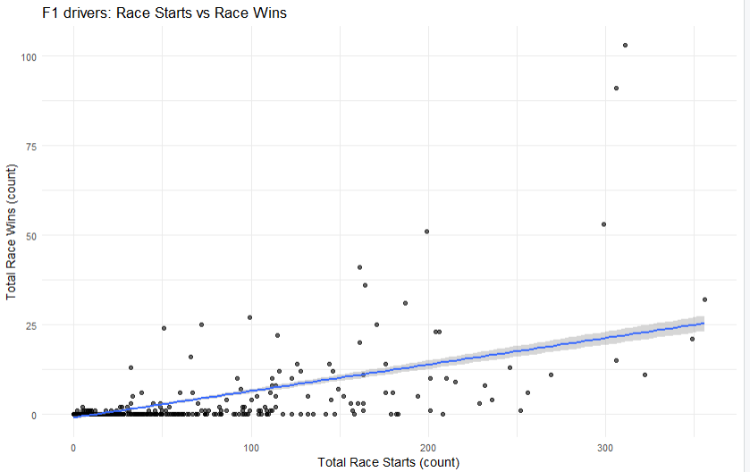
Figure 1: F1 Drivers Race starts vs Race Wins

3.2 Additional information relating to understanding the data (optional)
The scatter plot of the top ten race winners with the points labelled indicates how there is a gap between drivers who are very successful and the rest of the group. This assists in demonstrating how long careers influence the winning results. The histogram of race begins to promote the realisation further that most drivers do not remain long in the sport to win numerous times.
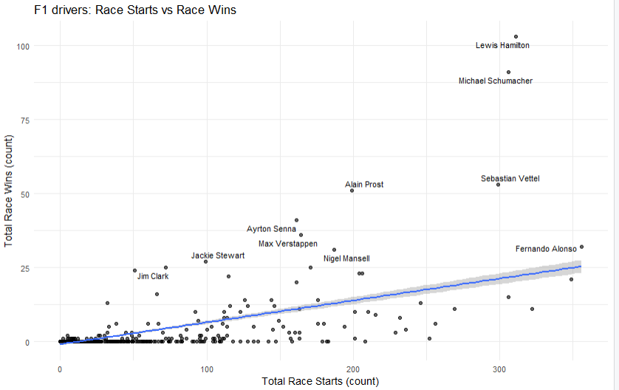
Figure 2: F1 drivers: Race Starts vs Race wins shows the name

3.3 Useful information for the data understanding
Based on the graphs, most of the drivers are near the zero mark on both sides of the graphs, having only a limited number of starts and no wins. There are very few drivers who are not close to the main cluster that contains many starts and numerous wins, as this is a positive trend (Donlon and Newberg, 2023). The visualisations substantiate the concept that increased participation can result in improved performance in Formula 1.

Analysis

4.1 Statistical test used to test the hypotheses and output
The Pearson correlation test was employed to test the linear relationship between the number of total race starts and the number of total race wins of Formula 1 drivers. The test is suitable since both variables are numerical variables that are continuous in nature. The Pearson correlation outcome depicted a positive correlation with a correlation coefficient of about 0.60 (Alsaqr, 2021). To establish the findings, a Spearman rank correlation test was also conducted, with a moderate positive correlation. The p-values obtained in both tests were significantly lower than the 0.05 level of significance, which shows that there is a statistically significant relationship.
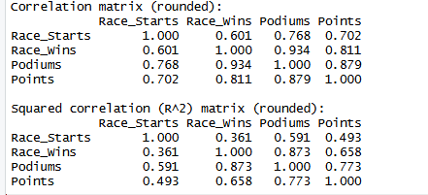
Figure 3: Correlation Matrix

4.2 The null hypothesis is rejected /not rejected based on the p-value
The extremely small p-values of the two correlation tests give good grounds to disapprove the null hypothesis, which was that there is no correlation between race starts and race wins. These findings indicate a statistically significant positive relation, that is, more race starts by the driver are likely to gain more wins in the course of his/her career. This was supported in the scatter plot, in which an upward trend is visible in the left-right direction. The relationship was also verified by the linear regression model, which accounted for about 36% of the variation in wins depending on the race starts.
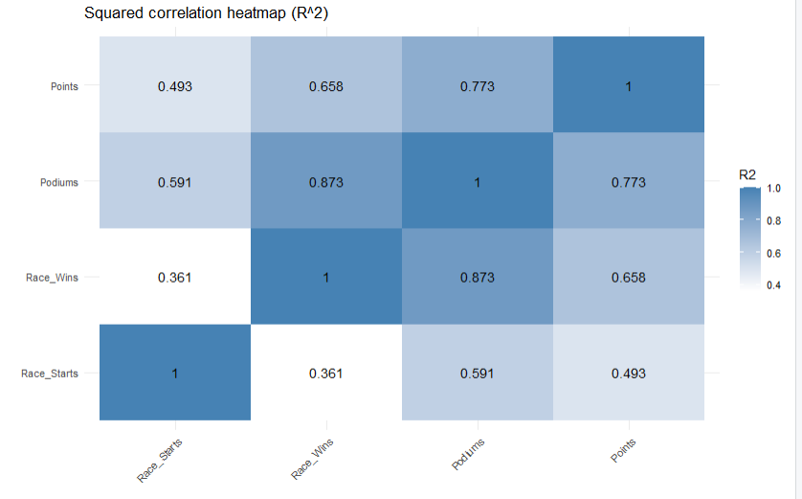
Figure 4: EDA Correlation Heatmap

Evaluation – group’s experience at 7COM1079

5.1 What went well
The project was done successfully in terms of cooperation and clarity in the course of the analysis assignment. The choice to use an appropriate dataset and the effective use of R scripts allowed us to obtain valid statistical findings (Kabacoff,, 2022). It adopted a very cohesive teamwork whereby each member was able to contribute towards data cleaning, visualisation, as well as interpretation in a systematic and organised way.

5.2 Points for improvement
More time could have been devoted to the search for further academic literature to enhance the background research. There were some preliminaries encountered in cleaning the data and in the results of the correlation. It would be an improvement if the roles and responsibilities were planned earlier in the future to facilitate faster and effective execution of the analysis stage.

5.3 Group’s time management (50 words)
The team was also able to handle deadlines effectively and meet each phase at the right time. Nonetheless, the analysis would have been commenced earlier to eliminate pressure towards the submission date.

5.4Project’s overall judgement (50 words)
The final project has provided a clear answer to the research question and provided informative results. The project was done with a high level of competence and good teamwork.

5.5Note any changes to group since original allocation if applicable. Add new or amended GitHub Ids for new members
This project did not have any change in the initial allocation of the groups. The team was made up of all members till the end of submission. The usernames that were used as the version control at the beginning of the module were still used; thus, no revision was needed (Brooke, 2024). This constant membership served in upholding continuity of work and the fact that work would remain the same in terms of duties and contributions as various levels of analysis and report writing were undertaken.

5.6Comment on the GitHub log output
Appendix B is a log of GitHub for this project. The most significant commits are those related to setting up the repository and dataset added during the initial commit, doing the analysis commit in which visualisation and correlation tests have been implemented, and the final commit when the entire analysis and cleaned code have been completed. These commits put together form the general developmental progression of the project.

6. Conclusions

6.1 Results explained
The results of the analysis showed that there was a statistically significant positive relation between the number of race starts and the number of race wins among Formula 1 drivers in terms of race. The drivers with a higher number of races tended to have more wins, which substantiated the fact that the career length influences the result in winning in the sport.

6.2Interpretation of the results
These results suggest that frequent involvement is the aspect that enables drivers to gain experience and confidence, and competitive skills as time passes. Though the other aspects include car performance and team support, it is the racing that leads to an increased likelihood of achieving a better result and long-term success in Formula 1.

6.3Reasons and/or implications for future work, limitations of your study
Future research might involve more performance variables and comparing various racing eras with other eras to know how the success of the driver is influenced by other external factors

Reference list
Alsaqr, A.M., 2021. Remarks on the use of Pearson’s and Spearman’s correlation coefficients in assessing relationships in ophthalmic data. African Vision and Eye Health, 80(1), pp.1-10. https://avehjournal.org/index.php/aveh/article/view/612
Awasthi, A. (2023). F1 Drivers dataset. [online] Kaggle.com. Available at: https://www.kaggle.com/datasets/petalme/f1-drivers-dataset [Accessed 5 Dec. 2025].
Brooke, S., 2024. Programmed differently? Testing for gender differences in Python programming style and quality on GitHub. Journal of Computer-Mediated Communication, 29(1), pp.1-13. https://academic.oup.com/jcmc/article-abstract/29/1/zmad049/7596747
Donlon, T. and Newberg, H.J., 2023. A swing of the pendulum: The chemodynamics of the local stellar halo indicate contributions from several radial merger events. The Astrophysical Journal, 944(2), pp.1-30. https://iopscience.iop.org/article/10.3847/1538-4357/acb150/meta
Kabacoff, R., 2022. R in action: data analysis and graphics with R and Tidyverse. Simon and Schuster, pp.1-474. https://books.google.com/books?hl=en&lr=&id=dCZoEAAAQBAJ&oi=fnd&pg=PR19&dq=The+choice+to+use+an+appropriate+dataset+and+the+effective+use+of+R+scripts+allowed+us+to+obtain+valid+statistical+findings.+&ots=C3hCN9mjI_&sig=cQIogJ76Kw9h5fI5cfZRl8HOpBc
Michalik, K., Szczepan, S., Markowski, M. and Zatoń, M., 2022. The relationship among body composition and anaerobic capacity and the sport level of elite male motorcycle speedway riders. Frontiers in Physiology, 13, pp.1-10. https://www.frontiersin.org/articles/10.3389/fphys.2022.812958/full
Nagle, D., 2022. Racing Your Rival: Cluster Analysis of Formula 1 Drivers, pp.1-48. https://surface.syr.edu/cgi/viewcontent.cgi?article=2506&context=honors_capstone
Piquero, A.R., Piquero, N.L. and Han, S., 2021. Identifying the most successful formula 1 drivers in the turbo era. The Open Sports Sciences Journal, 14, pp.151-157. https://research.monash.edu/en/publications/identifying-the-most-successful-formula-1-drivers-in-the-turbo-er
Schlawe, A., Christiansen, A.V. and Henriksen, K., 2025. The high-performance sport environment: laying the foundation for a new research topic. Frontiers in Sports and Active Living, 7, pp.1-10. https://www.frontiersin.org/journals/sports-and-active-living/articles/10.3389/fspor.2025.1503199/full
Weissbock, J. and Mills, S., 2025. Evaluating the Predictive Power of Qualifying Performance in Formula One Grand Prix. arXiv preprint arXiv:2507.10966, pp.1-16. https://arxiv.org/abs/2507.10966

Appendices

Appendix A R code
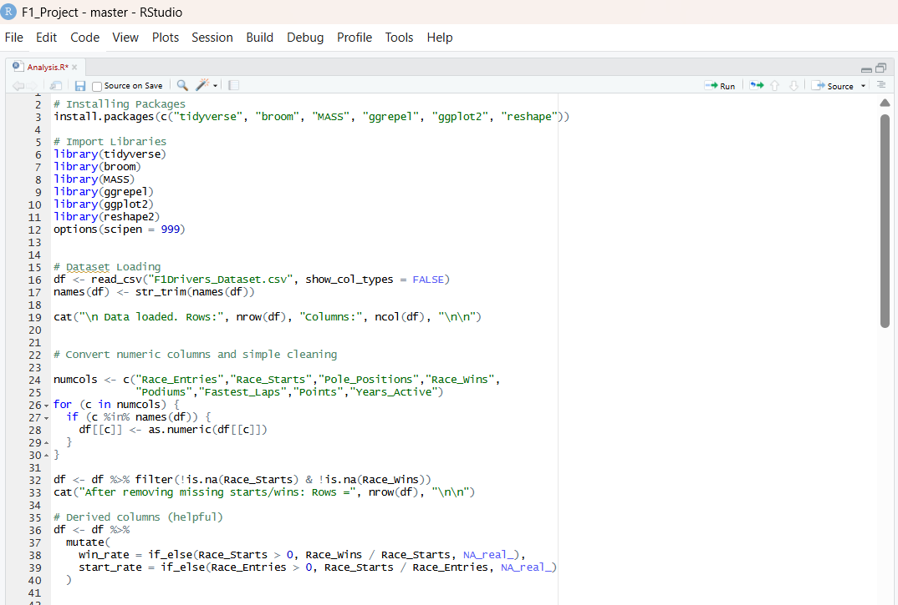
This above image shows installing libraries, importing libraries, loading dataset and Data Cleaning and Preprocessing
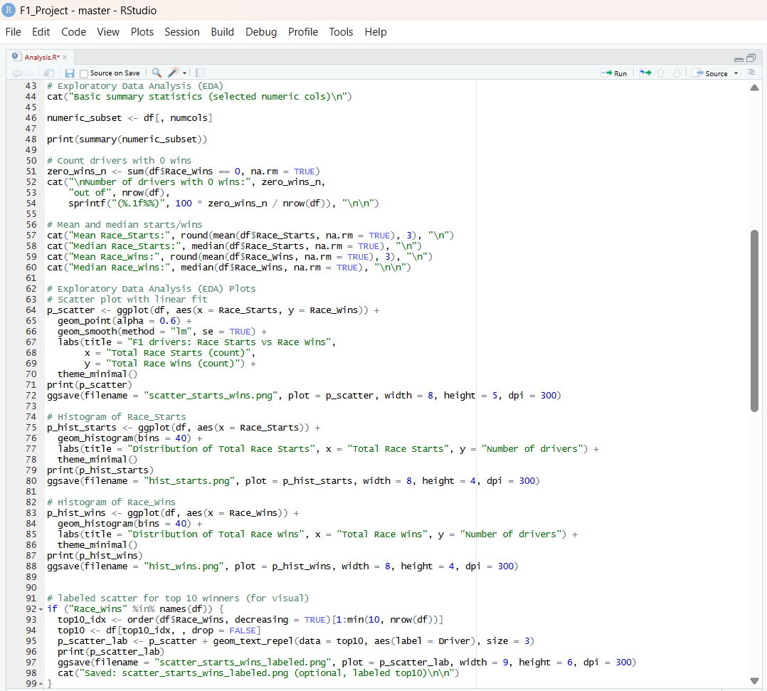
This image shows whole Code of EDA that contains the visualization
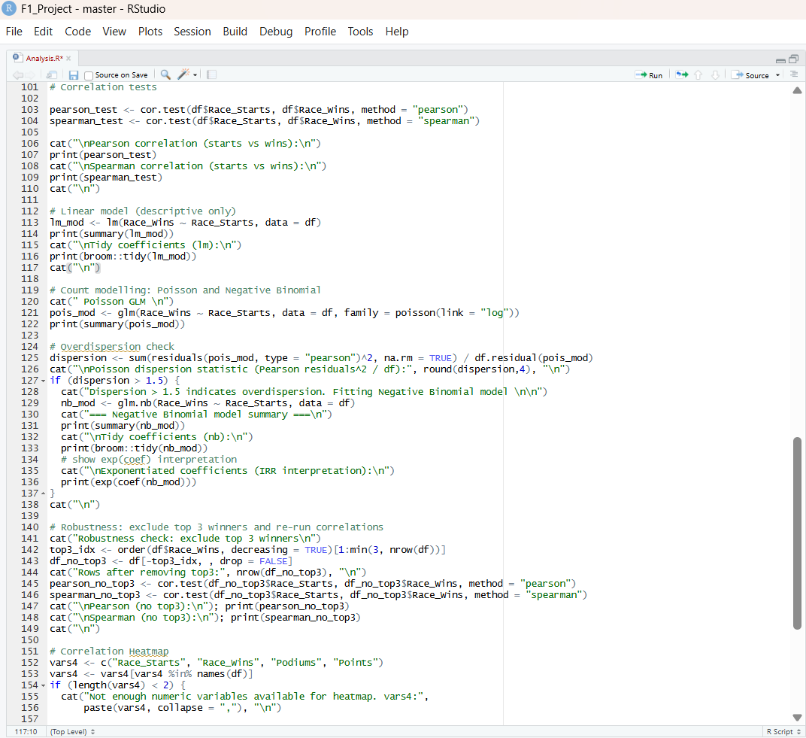
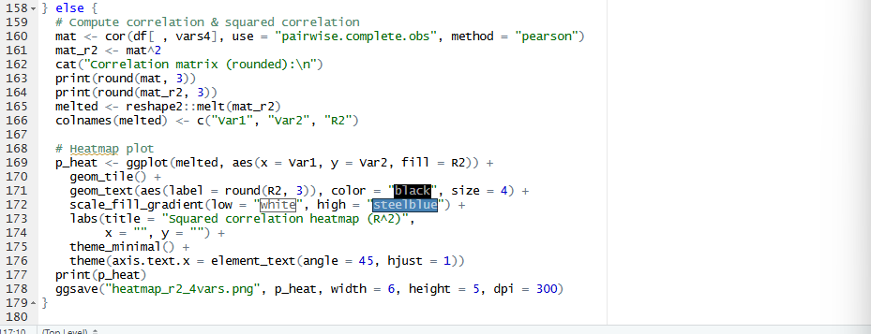
This image shows Correlation heatmap code along with the Correlation Heatmap

Appendix B: Git Log Output
