**DATE:09-02-2021**

**Contribution:**

1. **SIDDHANT KUMAR(PES2201800129):**IDENTIFICATION OF THE LIFE CYCLE AND EFFORT CALCULATION.
2. **SKANDAN KA(PES2201800064):**IDENTIFICATION OF THE TOOLS AND DETERMINING THE DELIVERABLES AND CATEGORISING THEM TO BUILD COMPONENTS.
3. **SAMEER PRASAD SUBEDHAR(PES2201800323):**WBS CREATION AND GANTT CHART SCHEDULING.

**PROJECT PLAN**

1: Identify the lifecycle to be followed for the execution of your project and justify why u have chosen the model.

**ITERATIVE MODEL:**We can make use of the iterative model for the implementation of our project **“LIBRARY MANAGEMENT SYSTEM”.**

**THE REASON TO CHOOSE THE ITERATIVE MODEL ARE AS FOLLOWS:**

* The requirements are defined clearly and easy to understand.
* There may be a requirement of changes in the future.
* Testing and debugging during smaller iteration is easy.
* A Parallel development can plan.
* It is easily acceptable to ever-changing needs of the project.
* Risks are identified and resolved during iteration.
* Limited time spent on documentation and extra time on designing.

2: Identify the tools which you want to use throughout the lifecycle like planning tool, design tool, version control, development tool, bug tracking, testing tool.

**Planning Tools:**Pert chart

**Version Control :** As Github is feasible for handling many documents among the members, We are using the same.

**Development Tools:**

* **Source Control** : Github
* **IDE :** VS Code

**Design Tools:**

* **Diagram :** Creately

3: Determine all the deliverables and categorise them as reuse/build components and justify the same.

**Deliverables:**

1. Providing a GUI in CMD for users and admins (build)
2. Simple UI for easy management (build)
3. Profile viewing (reuse)
4. Adding resources/books (reuse)
5. Viewing all members (reuse)
6. Issuing resources/books (reuse)
7. Return resources (reuse)
8. Remove members (reuse)

4: Create a WBS for the entire functionalities in detail.

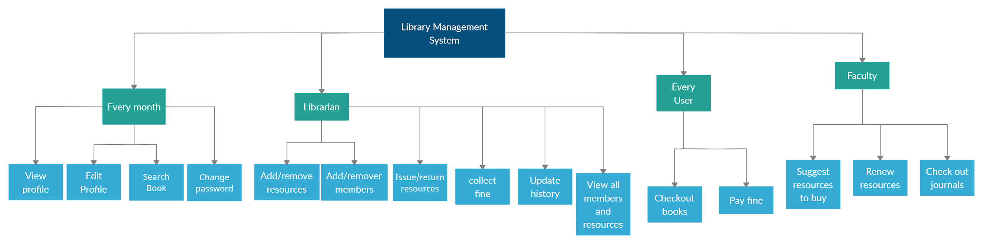

5: Do a rough estimate of effort required to accomplish each task in terms of person months.

**Effort(persons/month)=a ${KLO{C^{}}^{b}}^{}$

\***

Since our model,falls under the “**ORGANIC**” model,

a=2.4

b=1.05

Estimated KLOC=4.9

Therefore,

Effort=2.4*(4.9)^1.05=12.7326

6: Create the Gantt Chart for scheduling.

