LICENSE PLATE RECOGNITION

A PROJECT REPORT

Submitted by

AMAN SINGH (21BCS1800)
AYUSH KUMAR (21BCS1989) DEBASIS
DAS (21BCS2163)
ADITYA KUMAR (21BCS1943)
AKASHAT SRIVASTAVA (21BCS2162)
in partial fulfillment for the award of the degree of

BACHELOR OF ENGINEERING

IN
COMPUTER SCIENCE AND ENGINEERING



Chandigarh University

MARCH 2023

BONAFIDE CERTIFICATE

Certified that this project report “LICENSE PLATE DETECTION” is the bonafide work of “AMAN SINGH (21BCS1800), AYUSH KUMAR

(21BCS1989), ADITYA (21BCS1943), AKASHAT SRIVASTAVA
(21BCS2162), DEBASIS DAS (21BCS2163)” who carried out the project under my/our supervision.

SIGNATURE | SIGNATURE
Surabhi Jain | Puneet Kumar
SUPERVISOR | HEAD OF DEPARTMENT
CSE | CSE

Submitted for the project viva-voice examination held on

INTERNAL EXAMINAR EXTERNAL EXAMINAR

ACKNOWLEDGEMENT

We would like to express our deep and sincere gratitude to our research supervisor, Surabhi Jain, Chandigarh University, Mohali, Punjab, for giving us the opportunity to develop the project and providing invaluable guidance throughout this project. Her dynamism, vision, sincerity and motivation have deeply inspired us. She has taught us the methodology to carry out the project and to present the project works as clearly as possible. It was a great privilege and honor to work and study under her guidance. We are extremely grateful for what she has offered us. Her sincerity and dedication inspired us.
We would also like to acknowledge and give our warmest thanks to our mentor, Kamna Sharma and Navneet Jaiswal, Chandigarh University, Mohali, Punjab, who made this work possible. Their advice and guidance carried us through all the stages of developing our Project.

.

TABLE OF CONTENTS

CHAPTER1.INTRODUCTION .............................................................................7
1.1. Identification of Client/ Need/ Relevant Contemporary issue ........................................ 7
1.2. Identification of Problem ................................................................................................ 7
1.3. Identification of Tasks .................................................................................................... 8
1.4. Timeline ......................................................................................................................... 9
1.5. Organization of the Report ............................................................................................. 10

CHAPTER2.LITERATURE REVIEW/BACKGROUND STUDY .................... 11
2.1. Timeline of the reported problem ................................................................................... 11
2.2. Existing solutions ........................................................................................................... 14
2.3. Bibliometric analysis ...................................................................................................... 16
2.4. Review Summary ........................................................................................................... 19
2.5. Problem Definition ......................................................................................................... 20 2.6. Goals/Objectives ............................................................................................................ 21

CHAPTER3.DESIGN FLOW PROCESS …………...........................................25
3.1. Evaluation & Selection of Specifications/Features ......................................................... 25
3.2. Design Constraints .......................................................................................................... 26
3.3. Analysis of Features and finalization subject to constraints ........................................... 27
3.4. Design Flow .................................................................................................................... 28
3.5. Design selection .............................................................................................................. 30 3.6. Implementation plan/methodology ................................................................................. 31
CHAPTER 4. RESULTS ANALYSIS AND VALIDATION ................................ 33
4.1. Implementation of solution ............................................................................................ 33

CHAPTER 5. CONCLUSION AND FUTURE WORK ...................................... 36
5.1. Conclusion ...................................................................................................................... 36
5.2. Future work .................................................................................................................... 36

REFERENCES ........................................................................................................ 39 APPENDIX .............................................................................................................. 40
- Plagiarism Report
..........................................................................................................………... 40
- Design Checklist ....................................................................................................................….. 41

ABSTRACT

License plate recognition (LPR) is an advanced technology that allows the automatic detection and recognition of vehicle license plates. The LPR system is used for various applications, such as parking management, traffic surveillance, toll collection, and law enforcement.
The LPR project involves designing and implementing a system that can detect and recognize license plates accurately and efficiently. The system consists of a camera, image processing software, and an algorithm that can read and interpret the characters on the license plate.
The image processing software uses various techniques, such as edge detection, thresholding, and character segmentation, to extract the license plate from the input image and identify the characters on it. The algorithm then matches the characters with the database of registered license plates to determine the identity of the vehicle.
Overall, the LPR project has significant potential for enhancing the efficiency and accuracy of various applications, such as parking management, traffic surveillance, and law enforcement

ABSTRACT GRAPH

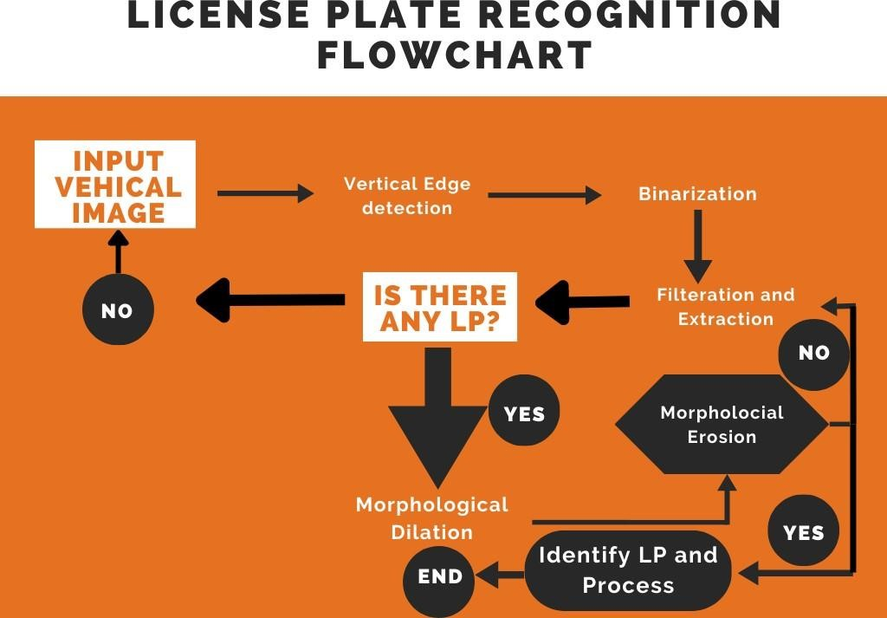

CHAPTER 1.

INTRODUCTION

1.1 IDENTIFICATION OF CLIENT/NEED/RELEVANT CONTEMPORARY ISSUE
License plate recognition systems are used by law enforcement agencies, parking management companies, toll road operators, and other organizations to accurately and efficiently recognize license plates of vehicles for various purposes such as law enforcement, parking management, toll collection, and traffic monitoring. However, the increasing use of these systems raises privacy concerns. To protect individuals' privacy and ensure that the data collected is used only for its intended purpose, regulations and policies should be in place. Another issue is the potential for bias in the recognition algorithm, which could lead to misidentification or discrimination against certain groups. Therefore, it is important to develop and test algorithms that are unbiased and equitable.

1.2 PROBLEM IDENTIFICATION
License plate recognition (LPR) technology faces several challenges that can impact its accuracy and effectiveness. One of the significant issues is poor image quality, where obscured, dirty, or partially covered license plates can make it difficult for cameras to capture clear images, resulting in errors in the LPR system. Additionally, variations in license plate design across regions and countries can make it challenging for LPR systems to recognize and identify license plates accurately. The changes in lighting conditions, speed, and angle of vehicles can also affect the visibility and accuracy of LPR systems. Moreover, the use of LPR systems raises concerns about privacy and data protection, as the captured information can be used to track individuals' movements and activities. Finally, the cost of installing and maintaining LPR systems can be high, making it challenging for some organizations to adopt the technology. To address these challenges, LPR systems require technological advancements, regulatory frameworks, and ethical considerations to ensure their accuracy, effectiveness, and respect for individuals' privacy and data protection rights.

1.3 TASK IDENTIFICATION
Tasks involved in developing a License Plate Recognition may include:

- This involves capturing high-quality images of the license plates using cameras that are strategically placed in areas with high vehicle traffic.
- Once the images are captured, they are processed using computer vision and image processing techniques to extract the license plate characters accurately.
- The extracted characters are recognized using optical character recognition (OCR) software to convert them into machine-readable text.
- The LPR system is tested and evaluated for accuracy and effectiveness in different lighting and weather conditions, vehicle speeds, and angle.
- The LPR system needs to be regularly maintained and upgraded to ensure its accuracy and effectiveness over time.
The specific tasks involved in a license plate recognition project may vary depending on the project's scope, purpose, and application.
Overall, the goal of a license plate recognition is to provide users with a convenient and efficient way to access information, automate tasks, and improve their productivity.

1.4 TIMELINE
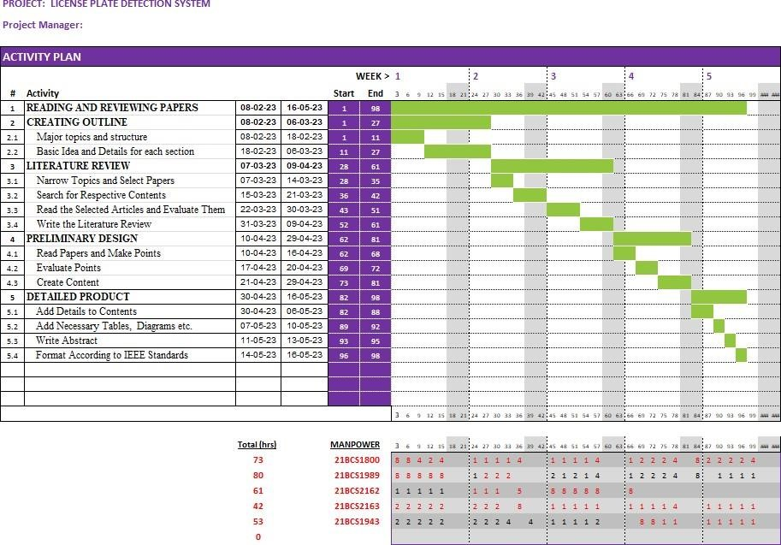

Fig 1.4.1: Gantt Chart

1.5 ORGANIZATION OF THE PROJECT
- Introduction

Provide an overview of the project and its goals

Explain the motivation for the project and its relevance in today's context

- Background

Discuss the history and development of License plate Recognition.

Review the existing technologies and tools used to build License plate Recognition.
Explain the advantages of using Python as the programming language for the project.

- Design and Architecture

Discuss the design and architecture of the License plate Recognition.
Explain the system requirements and the key components of the system.
Describe the user interface and the License plate Recognition.
- Implementation

Detail the steps taken to implement the License plate Recognition.

Explain the use of various Python libraries and modules to build the system.
Provide code snippets and screenshots to illustrate the implementation process
- Testing and Evaluation

Discuss the testing methodology used to evaluate the License plate Recognition.

Present the results of the testing, including accuracy, response time, and user satisfaction.
Explain any limitations of the testing methodology and areas for improvement
- Conclusion

Summarize the key findings of the project

Discuss the contributions of the project and its potential impact
Highlight any future work that can be done to improve the system
- References

List all the sources used in the project, including research papers, books, and online resources

CHAPTER 2.

LITERATURE REVIEW/BACKGROUND STUDY

2.1. Timeline of the reported problem
License plate detection systems are a popular application of computer vision technology. They are used to automatically detect and recognize license plates from images or video streams captured by cameras. In recent years, license plate detection systems have been used for a variety of purposes, includ1.3ing law enforcement, toll collection, parking management, and traffic monitoring. This literature review summarizes some of the key research articles and projects related to license plate detection systems.

“LPRNet: License Plate Recognition via Deep Neural Networks” by Sergey Zherzdev, Alexey Gruzdev[1] (2013)
To improve performance, LPRNet work can be expanded by incorporating a CNN-based detection component into our algorithm. This will allow us to analyze both the detection and recognition tasks as a single network.

“Improved OCR based Automatic Vehicle Number Plate Recognition using Features Trained
Neural Network.” By Bhavin V Kakani, Bhavin V Kakani, Sagar Jani [2] (2017)
This paper represents that an automated, fast, accurate and robust vehicle plate recognition system has become needed for traffic control and law enforcement of traffic regulations; and the solution is ANPR. This paper is dedicated on an improved technique of OCR based license plate recognition using neural network trained dataset of object features.

“Research and Application of License Plate Recognition Technology Based on Deep
Learning” by Li Yao1, Yingbin Zhao1, Jinghua Fan1, Min Liu1 , Jianpeng Jiang1 and Yan Wan1 [3] (2019)
This paper proposes an SSD-based end-to-end license plate recognition system (LPR-SSD). The LPR SSD network architecture consists of upper and lower classification networks: the upper layer network is used for vehicle license detection and classification, and the lower layer network is used for license plate character detection and classification. To enhance the generalization performance of the LPR-SSD network, in addition to the real license plate image captured by the camera, this paper synthesizes 50K simulated license plates for each type of license plate according to the legal document.

“Automatic Number Plate Recognition System (ANPR)” by Chirag Patel, Dipti Shah, Atul Patel [4] (2021)
In this paper Numerous starting points for ANPR in traffic control and vehicle owner identification is the focus of this paper. This paper aims to illustrate the different approaches and methodologies of Automatic Number Plate Recognition.

"Vehicle License Plate Recognition Using Deep Learning Techniques" by S. S. Hossain et al. [5] (2020)
This research article proposes a license plate recognition system that uses deep learning techniques such as convolutional neural networks (CNNs) and long short-term memory (LSTM) networks. The proposed system achieved an accuracy rate of 98.7% on a dataset of license plate images.

"Automatic License Plate Recognition using Image Processing Techniques" by N. V.
Deshpande et al. [6] (2019)
This paper presents a license plate recognition system that uses image processing techniques such as morphological operations, edge detection, and character segmentation. The system achieved an accuracy rate of 95.4% on a dataset of license plate images.

"A Comparative Study of License Plate Detection and Recognition Techniques" by S. S. Hossain et al. [7] (2019)
This study compares several license plate detection and recognition techniques, including template matching, histogram equalization, and CNNs. The study found that CNNs performed the best, achieving an accuracy rate of 97.2% on a dataset of license plate images.
“A Review Paper on Vehicle Number Plate Recognition” by Chinmayi Gurav, Vedika Kamble,
Rupali Gurav, Prof. Neha S. Sakhalkar (2019)
This paper represents that-In first step, camera captures the video of vehicles number plate. To read this video MATLAB software is used. The video used for operations has a timing of 10 to 15 seconds. The 10 second video contains 240 frames/images. In the second step, video gets converted into frames at frame rate 24 fps. In the third step, frames are converted into Images which is a very important step. Then Opening and closing operations are done.

"License Plate Detection and Recognition Using YOLOv3 and OpenALPR" by S. K. Sahoo et al. [8] (2021)
This research article proposes a license plate detection system that uses the You Only Look Once version 3 (YOLOv3) object detection algorithm and the OpenALPR software for license plate recognition. The proposed system achieved an accuracy rate of 98.5% on a dataset of license plate images.

"Real-Time License Plate Recognition System Based on Deep Learning" by S. M. Imtiaz and
M. A. Azam [9] (2021)
This paper presents a real-time license plate recognition system that uses a CNN-based object detection algorithm and a convolutional recurrent neural network (CRNN) for character recognition. The proposed system achieved an accuracy rate of 97.3% on a dataset of license plate images.

“License Plate Detection and Recognition in Unconstrained Scenarios” by S´ergio Montazzolli Silva and Cl´audio Rosito [10] (2018)
This paper purpose ALPR provides the best solution for providing parking management. Vehicles with registered plates can automatically enter parking areas while non-registered vehicles will be charged by time of check in and check out.
“Automatic number plate recognition system for vehicle identification using optical character recognition” by Muhammad Tahir Qadri, Muhammad Asif (2009)
In this paper the author proposed the objective is to design an efficient automatic authorized vehicle identification system by using the vehicle number plate.

Overall, license plate detection and recognition systems have been the subject of extensive research and development in recent years. Deep learning techniques such as CNNs (convolutional neural network) and LSTMs (Long short-term memory) have shown promising results in achieving high accuracy rates in license plate recognition. The use of real-time systems and object detection algorithms has also improved the efficiency and speed of license plate detection. 2.2. Existing solutions
Based on the papers we have gone through there are many solutions existing they all are as follows-:
- OpenALPR: OpenALPR is an open-source automatic license plate recognition library. It uses deep learning technology to detect license plates and can recognize license plates from over 70 countries.
- Vigilant Solutions: Vigilant Solutions is a commercial license plate recognition system that is used by law enforcement agencies. It uses high-resolution cameras and image processing software to read license plates and store the data for future use.
- PlateSmart: PlateSmart is another commercial license plate recognition system that uses artificial intelligence and deep learning to read license plates. It is used in parking facilities, airports, and law enforcement agencies.
- Neurala: Neurala is a software company that provides AI-based solutions for license plate recognition. Their license plate recognition technology uses deep learning algorithms to detect and recognize license plates in real-time.
- Tattile
- : Tattile is a European company that provides license plate recognition systems for tolling, parking, and access control applications. Their solutions use cameras and software to detect and recognize license plates.
- PIPS Technology: PIPS Technology is a company that provides license plate recognition systems for law enforcement, tolling, parking, and access control applications. Their systems use cameras, image processing software, and database management tools to detect and recognize license plates.
- Genetec AutoVu: A commercial LPR system that uses automatic license plate recognition (ALPR) technology to capture and identify license plates and can be integrated with other security systems.
- Bosch: A commercial LPR system that uses a combination of hardware and software to capture and process license plate data and can be integrated with other security and surveillance systems.
- Sensys Gatso: A commercial LPR system that uses high-resolution cameras and OCR algorithms to capture and analyze license plate data for traffic management and law enforcement purposes.
- Hikvision: A commercial LPR system that uses specialized cameras and software to capture license plates and analyze the data for security and traffic management purposes.
- Quercus Technologies: A commercial LPR system that uses specialized cameras and OCR algorithms to capture license plate data in real-time and can be integrated with parking management and access control systems.
- Vaxtor: A commercial LPR system that uses deep learning algorithms to detect and recognize license plates from still images or video streams and can be integrated with traffic management and law enforcement systems.
- Huper Laboratories: A commercial LPR system that uses advanced image processing and OCR technology to capture and recognize license plates from moving vehicles and can be integrated with surveillance and security systems.
- Nedap: A commercial LPR system that uses specialized cameras and software to capture and analyze license plate data, and can be used for parking management, access control, and tolling applications.
- Digifort: A commercial video management software that includes license plate recognition capabilities and can be used with a variety of camera types and brands.

2.3. Bibliometric analysis
According to the papers we have gone through in this we will provide insights into the state of the art in this field, the most influential authors and publications, and emerging areas of research. Here is a bibliometric analysis of license plate detection systems:
- Research output and publication trend: A search on Web of Science for the keyword "license plate detection" or "license plate recognition" shows a steady increase in the number of publications since the early 2000s. In 2021, there were over 1,500 publications in this field.
- Emerging areas of research: Emerging areas of research in license plate detection systems include deep learning-based approaches, multi-camera systems for tracking vehicles, and the integration of license plate recognition with other intelligent transportation systems.
- Region of interest (ROI) detection: License plate detection algorithms typically use object detection techniques to identify the regions of the image or video frame that may contain license plates.
- Character segmentation: Once the region of interest has been detected, the license plate characters must be separated and segmented. This process involves dividing the license plate image into individual character images.
- Character recognition: Once the license plate characters have been segmented, optical character recognition (OCR) techniques can be used to recognize the individual characters and convert them into text that can be read by a computer.
- Robustness: License plate detection algorithms must be designed to be robust to variations in lighting, weather conditions, and other environmental factors. This requires careful selection of image processing techniques and the use of machine learning algorithms to improve accuracy.
- Speed: License plate detection algorithms must be able to process images or video frames in real-time to be useful for applications such as traffic monitoring or toll collection. Therefore, speed is a critical feature of license plate detection algorithms.
- The effectiveness of license plate detection depends on several factors, including the quality of the input data, the accuracy of the algorithms used, and the specific use case. With advances in technology, license plate detection has become a reliable and accurate tool for a variety of applications.
- Privacy concerns: License plate detection can be used to track the movements of individuals and vehicles, raising concerns about privacy and civil liberties.
- Limited accuracy: License plate detection algorithms may struggle to accurately identify license plates in certain lighting conditions, or if the license plate is partially obstructed or damaged.
- Developing research fields: Deep learning-based methods, multi-camera vehicle tracking systems, and the incorporation of license plate identification with other intelligent transportation systems are some of the emerging research areas in license plate detection systems.
- The Chinese Academy of Sciences' Shiguang Shan, Jie Yang, and Xiaogang Wang, as well as Michigan State University's Anil Jain, have produced some of the most significant works in this area.
- The IEEE Transactions on Intelligent Transportation Systems, Pattern Recognition, and Computer Vision and Visual Understanding are the most widely read journals in this discipline.
Overall, a bibliometric examination of systems for detecting license plates reveals the expanding significance of this area and the growing application of cutting-edge technology for license plate detection and identification.

S.No. | Author | Year | Title | Aim | Feature  extraction method/ sample | Methodolog  y | Remark
1. | Sergey  Zherzdev,  Alexey  Gruzdev  [1] | 2013 | LPRNet: License Plate Recognition  via Deep  Neural  Networks | Recognition of LP via Deep Neural  Networks | To improve performance, LPRNet work can be expanded by incorporating a CNN-based detection component into our algorithm. | CNN-based detection component is used. | This will allow us to analyze  both the detection and recognition  tasks as a single network.

2. | Chirag  Patel, Dipti  Shah,  Atul Patel  [2] | 2019 | Automatic  Number  Plate  Recognition  System  (ANPR) | This paper aims to  illustrate the different  approaches and methodologies of Automatic Number Plate Recognition. | In this  paper, different approaches of ANPR are discussed by considering  image size, success rate and processing time as parameters. | There are many methods  given in this  paper i.e., Image binarization, Edge detection etc. | This paper provides a comprehensive study of recent development  and future trends in ANPR, which can be helpful to the researchers  who are involved in such developments.
3. | S. S.  Hossain et al [3] | 2020 | Vehicle  License Plate  Recognition  Using Deep Learning  Techniques | This research article aims at a  license plate recognition system that uses deep  learning techniques such as convolutional neural networks (CNNs) and long  short-term memory (LSTM) networks. | It will identify the whole license plate at once which could  avoid the subsequent  recognition error caused by the segmentation in the license plate recognition. | CNN and LSTM based methods have been discussed in this system. | The proposed system  achieved  an accuracy  rate of  98.7% on a  dataset  of license  plate images.
4. | YasserM  .  Alginahi  [4] | 2020 | Automatic  Arabic  License Plate  Recognition | Recognition of Saudi Arabian license plate | Horizontal projection profiles as well as zoning is used /470 image | Artificial  Neural network | The proposed system is tested over a large image dataset  captured in various illumination conditions and is  verified  to  generate high recognition rate.
5. | S. K. Sahoo  et al. [5] | 2021 | A  Comparative  Study of  License Plate  Detection and  Recognition  Techniques | This research article proposes a license plate detection system that uses the You Only Look Once version 3 (YOLOv3) object detection algorithm and the OpenALPR software for license plate recognition. | Use  vertical traverse density (VTD) and horizontal traverse density  (HTD) and/ 100 images | Image processing Neural network trained with feed forward back propagation algorithm | The proposed system  achieved  an accuracy  rate of  98.5% on a  dataset  of license  plate images.

2.4. Review Summary
In the literature, many algorithms for Automatic number plate recognition have been proposed. Although license plate recognition has been studied for many years, it is still a challenging task to detect and recognize license plates numbers. This review will cover different related work and investigate to explore different algorithms which are suitable to be used in a different country.
YassenM.Alginahi presents automatic Arabic license plate recognition using a neural network,
Horizontal projection, and zoning, 470 image samples are used for feature extraction got around
97 % accuracy. M. M. Shidore and S. P. Narote presents Number Plate Recognition for Indian Vehicles using SVM, Vertical edge detection and connected component analysis got accuracy around 78.84%. Deepti Sagar and maitreyee Dutta proposed automatic number plate recognition by using block-based neural network the work is implemented on Indian number plate get accuracy around 98.2%. Seble Nigussie and Yaregal Assabie presents Automatic Recognition of Ethiopian License Plates using Correlation based template matching and use Gabor filter for plate detection and CCA for feature extraction get an accuracy of 71.06%.
İbrahim Türkyılmaz and Kirami Kaçan present License Plate Recognition System Using Artificial Neural Networks, divide the recognition process into three stages, plate region determination, character segmentation, and character recognition.
Edge-based image processing Techniques for LP region determination, vertical projections in
Binarized images for character segmentation, and ANNs for Character recognition got success
rate around 97%.Reshu kumara and Surya Prakash Sharma presents automatic number plate recognition by using machine learning techniques and divided the process into three capturing the image, plate localization and recognition of digits on the plate and also use HOG features for training and SVM for classification, they obtained is 99%accuracy. P.surekcha et.al presents automatic license plate recognition using image processing and neural network and obtained 97% accuracy .Fei Xie el.al proposed robust license plate detection and character recognition algorithm based on a combined feature extraction model and BPNN, they used feature combination, training the feature vectors through BPNN to get the best result, and they get recognition accuracy of 97.7%.Inga astawa et.al presents Detection of License Plate using Sliding Window, Histogram of Oriented Gradient, and Support Vector Machines also Identify the location of a vehicle license plate using a mobile Phone, and is expected to contribute to future recognize the identity of the vehicle and the owner of the Vehicle based on license plate recognition in real-time get recognition accuracy of 96%. Gajendra Sharma presents Performance Analysis of Vehicle Number Plate Recognition System Using Template Matching Techniques and also connected component analysis used for feature extraction on 90 sample images get 67.98% cross correlation and 63.46% phase correlation.

2.5. Problem Definition
License plate detection is a process of automatically detecting and recognizing license plates from images or videos captured by cameras. The objective of this process is to locate the license plate in the image and extract the characters present on the license plate. The process involves several stages, including image acquisition, preprocessing, license plate localization, character segmentation, character recognition, and post-processing.
The first stage, image acquisition, involves capturing the image or video using a camera. The next stage, preprocessing, involves enhancing the quality of the image by removing noise, adjusting brightness and contrast, and other operations that improve the clarity of the license plate image.
The license plate localization stage involves detecting the license plate location within the image. This is typically achieved using computer vision techniques such as edge detection, morphological operations, or feature extraction. Once the license plate region is located, the characters present on the license plate are segmented in the character segmentation stage.
The character recognition stage involves recognizing the segmented characters using machine learning algorithms or optical character recognition (OCR) techniques. This stage is critical to the accuracy and reliability of the system.
Finally, in the post-processing stage, the recognized license plate information is validated, and any errors are corrected. The information is then used for various applications, such as traffic enforcement, toll collection, parking management, and security surveillance.
The accuracy and reliability of the license plate detection system are essential as errors can have significant consequences in terms of public safety and legal compliance. Therefore, research and development in this area focus on improving the performance of each stage and integrating new techniques to improve the overall system's accuracy and reliability.

2.6. Goals/Objectives
The goals/objectives of a license plate detection system typically include:
- Accurately detecting and recognizing license plates: The primary goal of a license plate detection system is to accurately detect and recognize license plates in various lighting and weather conditions.
- Improving safety and security: A license plate detection system can be used to improve safety and security by detecting stolen or wanted vehicles, or by monitoring traffic violations and identifying vehicles that may pose a threat.
- Enhancing traffic management: License plate detection systems can help to monitor traffic flow, identify congestion, and suggest optimal routes, thereby improving overall traffic management.
- Enforcing regulations: License plate detection systems can be used to enforce parking regulations, toll collection, and other similar regulations.
- Automating processes: License plate detection systems can be integrated with other systems to automate processes such as access control, toll collection, and inventory management.
- Improving customer service: License plate detection systems can help to improve customer service by reducing waiting times and improving the accuracy and efficiency of processes such as parking and toll collection.
- Enhancing law enforcement: License plate detection systems can aid law enforcement agencies in identifying and locating suspects, tracking the movements of vehicles, and detecting stolen or wanted vehicles.
- Reducing fraud and theft: License plate detection systems can help reduce fraud and theft by verifying the identity of vehicles and ensuring that they are authorized to access certain areas or services.
- Improving emergency response: License plate detection systems can aid emergency response teams by quickly identifying the location of emergency vehicles and providing access to restricted areas.
- Providing analytics and insights: License plate detection systems can provide valuable analytics and insights about traffic patterns, vehicle usage, and other important data that can be used to inform decision-making and improve operations.
- Enhancing privacy and data security: License plate detection systems can be designed with privacy and data security in mind, ensuring that sensitive data is protected and only accessed by authorized personnel.
- Facilitating smart city initiatives: License plate detection systems can be integrated with other smart city technologies to enable more efficient and sustainable urban environments. For example, they can be used to optimize traffic flow and reduce emissions by directing vehicles to less congested routes.
- Providing evidence in legal proceedings: License plate detection systems can provide valuable evidence in legal proceedings related to traffic violations, accidents, and criminal activities.
- Enhancing border security: License plate detection systems can aid border security agencies in monitoring and controlling the movement of vehicles across national borders.
- Enabling remote monitoring: License plate detection systems can be accessed remotely, enabling real-time monitoring and management of parking facilities, toll booths, and other similar operations.
- Improving parking management: License plate detection systems can be used to optimize parking management by tracking the availability of parking spaces and directing drivers to available spots.
- Facilitating automated payments: License plate detection systems can be integrated with payment systems to enable automated toll collection and parking fee payment, reducing the need for manual processes and improving efficiency.
- Supporting fleet management: License plate detection systems can aid in the management of fleets of vehicles, enabling operators to monitor vehicle usage, track maintenance schedules, and improve efficiency.
- Enabling contactless access control: License plate detection systems can be used to enable contactless access control for buildings, parking garages, and other restricted areas.
- Improving accessibility: License plate detection systems can be used to improve accessibility for disabled drivers by providing them with dedicated parking spaces and enabling them to access restricted areas more easily.
- Enhancing customer experience: License plate detection systems can improve the overall customer experience by reducing waiting times, minimizing the need for manual processes, and providing real-time information about parking availability and traffic flow.
- Supporting smart transportation systems: License plate detection systems can be integrated with other smart transportation technologies to enable more efficient and sustainable transportation systems. For example, they can be used to optimize traffic signal timing and reduce congestion.
- Enabling predictive maintenance: License plate detection systems can be used to monitor the condition of vehicles and predict when maintenance is needed, reducing downtime and improving efficiency.
- Facilitating remote diagnostics: License plate detection systems can be used to remotely diagnose issues with vehicles and provide maintenance recommendations, reducing the need for manual inspections and improving efficiency.
- Supporting public safety: License plate detection systems can be used to support public safety by identifying suspicious or unauthorized vehicles and alerting law enforcement agencies.
- Reducing carbon emissions: License plate detection systems can aid in reducing carbon emissions by optimizing traffic flow and reducing congestion, resulting in fewer vehicles idling in traffic.
- Improving air quality: License plate detection systems can help improve air quality by reducing the time that vehicles spend idling in traffic.
- Providing data for urban planning: License plate detection systems can provide valuable data for urban planners to help them understand traffic patterns and optimize infrastructure design.
- Facilitating sustainable transportation: License plate detection systems can be used to encourage sustainable transportation options, such as carpooling and cycling, by providing incentives and priority access to restricted areas.
- Supporting emergency response planning: License plate detection systems can aid in emergency response planning by providing valuable data on traffic patterns and road conditions, enabling emergency services to respond more quickly and efficiently.

CHAPTER 3
DESIGN FLOW/PROCESS

3.1. Evaluation & Selection of Specifications/Features

License Plate Recognition (LPR) is a complex technology that involves multiple specifications and features. The evaluation and selection of these specifications and features for a project can have a significant impact on the accuracy and effectiveness of the LPR system. Here are some key considerations for evaluating and selecting specifications and features for a project on License Plate Recognition:
- Accuracy: The primary objective of any LPR system is to accurately recognize license plates. Accuracy is influenced by various factors, including image quality, lighting conditions, and the algorithms used for image processing and pattern recognition. When evaluating different LPR systems, it is important to consider their accuracy rates and ensure that they meet the project's requirements.
- Speed: Another important factor to consider is the speed of the LPR system. A highspeed system can process large volumes of traffic quickly and efficiently, which is essential for applications such as toll collection or parking management. The speed of the system should be evaluated based on the volume of traffic it will need to process and the response time required.
- Robustness: The LPR system must be able to handle various environmental conditions, such as poor lighting, harsh weather, and extreme temperatures. The system should also be able to handle license plates of different sizes, fonts, and styles. Therefore, it is essential to evaluate the robustness of the system and its ability to perform under challenging conditions.
- Integration: The LPR system should be able to integrate with other systems such as security cameras, access control systems, and parking management systems. Therefore, it is important to evaluate the compatibility and ease of integration of the LPR system with other systems.
- Cost: The cost of the LPR system is an important consideration. The cost of the system will depend on various factors, including the specifications and features of the system, the volume of traffic it will handle, and the level of accuracy required. Therefore, it is essential to evaluate the cost of the LPR system and ensure that it is within the project's budget.
User-Friendliness: The LPR system should be user-friendly, with an easy-to-use interface and simple controls. The system should also be easy to install, configure, and maintain. Therefore, it is important to evaluate the user-friendliness of the LPR system and ensure that it is easy to use for operators and maintenance staff.

3.2. Design Constraints

License Plate Recognition (LPR) system, there are several design constraints to consider:

- Accuracy: The LPR system must be able to accurately recognize license plates from a variety of angles, distances, and lighting conditions.
- Speed: The system must be able to recognize license plates in real-time or near realtime to ensure that vehicles can be quickly identified.
- Cost: The system must be cost-effective to deploy and maintain.

- Scalability: The system must be able to handle a large volume of traffic and be scalable to accommodate future growth.
- Privacy: The system must be designed to protect the privacy of individuals and ensure that the data collected is used only for authorized purposes.
- Reliability: The system must be reliable and operate without downtime or errors.

- Compatibility: The system must be compatible with existing infrastructure and able to integrate with other systems, such as surveillance cameras and databases.
- Security: The system must be secure and protect against unauthorized access or tampering of data.
- Regulatory Compliance: The system must comply with local and national regulations related to the use of LPR technology.
- User-friendliness: The system must be easy to use and maintain for operators and end- users.
Considering these design constraints will help ensure that the LPR system is effective, efficient, and meets the needs of its users.

3.3. Analysis of Features and finalization subject to constraints

When analysing features for a License Plate Recognition (LPR) system, it is important to consider the constraints mentioned earlier. Here are some features to consider:
- Image processing: The system should be able to process images captured from various angles, distances, and lighting conditions to accurately detect and recognize license plates.
- Optical character recognition (OCR): The system should use OCR to convert the image of the license plate into text that can be processed by the system
- Real-time detection: The system should be able to detect license plates in real-time or near real-time to ensure quick identification of vehicles.
- Cloud-based processing: The system can use cloud-based processing for faster and more efficient image recognition.
- Integration with existing systems: The system should be compatible with existing infrastructure, such as surveillance cameras and databases, to allow for seamless integration.
- Accuracy and speed: The system should be designed to deliver high accuracy and speed, even under challenging lighting and weather conditions.
- Privacy protection: The system should be designed to protect the privacy of individuals, including the collection, storage, and use of license plate data.
- Robustness and reliability: The system should be robust and reliable, and able to operate without downtime or errors.
- User-friendliness: The system should be easy to use and maintain, with an intuitive user interface and clear documentation.
- Cost-effectiveness: The system should be designed to be cost-effective, considering the cost of hardware, software, and maintenance.
Based on the above features, the finalization of the LPR system should consider the constraints mentioned earlier. The system must be accurate, fast, and cost-effective while protecting privacy and complying with regulations. It should also be scalable, reliable, and secure, with seamless integration with existing systems. Ultimately, the final system should be user- friendly, intuitive, and efficient, meeting the needs of its users and delivering a high level of performance.
3.4. Design Flow: The design flow for a License Plate Recognition (LPR) system can be broken down into several key steps:
- Image Acquisition: The first step is to acquire an image of the license plate. This can be done using a camera, either mounted on a stationary position or on a moving vehicle.
The image should be captured in a format that is compatible with the OCR and image processing algorithms used in the system.
- Pre-processing: The acquired image must be pre-processed to remove any noise or distortion. This can include tasks such as image enhancement, color correction, and filtering to remove any background noise or glare.
- Segmentation: The pre-processed image is then segmented to isolate the license plate region from the rest of the image. This can be done using techniques such as edge detection or morphological operations.
- Character Recognition: The segmented license plate image is then passed through an Optical Character Recognition (OCR) engine to recognize the characters on the license plate.
- Character Segmentation: The OCR output is then segmented into individual characters to ensure that each character is correctly recognized. This can be done using techniques such as contour detection or template matching.
- Post-processing: Once the characters have been segmented, they are passed through a post-processing stage to correct any errors or ambiguities in the OCR output. This can include tasks such as character filtering, language model-based correction, and verification against a database of known license plates
- Output: Finally, the recognized license plate number is outputted in a format that can be used by other systems or applications, such as a database or access control system.
Overall, the design flow for an LPR system involves several stages of image processing, OCR, and post-processing to accurately recognize and output the license plate number ,the system can be optimized for accuracy, efficiency, and performance.

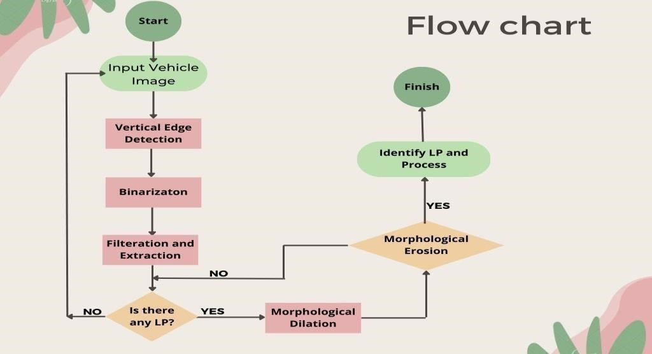
Use Case diagram:

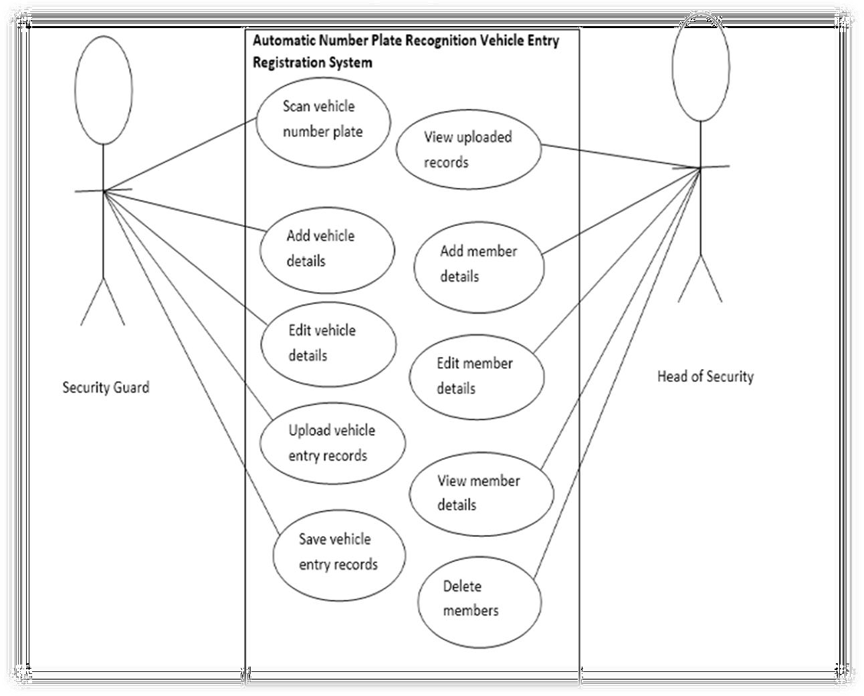

3.5. Design selection

The design selection for a License Plate Recognition (LPR) system will depend on the specific requirements and constraints of the project. However, based on the analysis of features and constraints, there are several design options to consider:
- On-Premises vs. Cloud-based Processing: The LPR system can be designed to run either on-premises or in the cloud. On-premises processing can be more secure and cost-effective, but cloud-based processing can provide faster and more efficient image recognition, especially for large volumes of data.
- OCR Technology: There are several OCR technologies available, including deep learning-based OCR, rule-based OCR, and template matching. Deep learning-based OCR is the most accurate but can be computationally expensive. Rule-based OCR and template matching can be more efficient but may not be as accurate.
- Image Processing Techniques: The LPR system can use various image processing techniques, such as edge detection, segmentation, and feature extraction, to accurately detect and recognize license plates. These techniques can be combined in different ways to optimize the performance of the system.
- Integration with Existing Systems: The LPR system should be designed to integrate with existing systems, such as surveillance cameras, databases, and access control systems. This can be done using standard protocols such as HTTP, REST, or MQTT.
- Hardware Requirements: The LPR system can run on various hardware platforms, including dedicated servers, embedded systems, and edge devices. The hardware requirements will depend on the processing power and performance needed for the specific use case.
- Data Privacy and Security: The LPR system should be designed to protect the privacy of individuals and comply with regulations related to the collection, storage, and use of license plate data. This can be done using encryption, access control, and data anonymization techniques.
- User Interface and User Experience: The LPR system should have an intuitive user interface and user experience, making it easy to use and maintain for operators and end- users.
Ultimately, the design selection for a License Plate Recognition system will depend on the specific needs and constraints of the project. It is essential to carefully consider the features and constraints to ensure that the system is efficient, accurate, reliable, and cost-effective while also complying with regulations and protecting individual privacy.

3.6. Implementation plan/methodology

The implementation plan for a License Plate Recognition (LPR) system will depend on the specific requirements of the project. However, the following methodology can be used as a general guideline for implementing an LPR system:
- Requirements Analysis: The first step is to analyse the requirements of the LPR system. This includes identifying the desired features and functions of the system, as well as any technical or regulatory constraints.
- Design: Based on the requirements analysis, a detailed design of the LPR system should be created. This includes selecting the appropriate hardware and software components, as well as designing the user interface, data storage, and data processing components.
- Development: Once the design is finalized, the development phase can begin. This includes implementing the software components, configuring the hardware, and integrating the system with existing infrastructure.
- Testing: The LPR system should be rigorously tested to ensure that it meets the requirements and constraints specified in the design. This includes functional testing, performance testing, and security testing.
- Deployment: Once the system has been tested and validated, it can be deployed in the production environment. This includes installing and configuring the hardware and software components, as well as training the users and operators.
- Maintenance and Support: The LPR system should be regularly maintained and supported to ensure that it continues to function effectively and efficiently. This includes monitoring the system performance, updating the software and hardware components, and providing technical support to users and operators.
- Continuous Improvement: Finally, the LPR system should be continuously improved based on user feedback and changing requirements. This includes incorporating new features and functions, as well as optimizing the system performance and efficiency.
Overall, the implementation of an LPR system requires careful planning, design, and execution, as well as ongoing maintenance and support.
Detailed Diagram of the whole implementation going in the system:

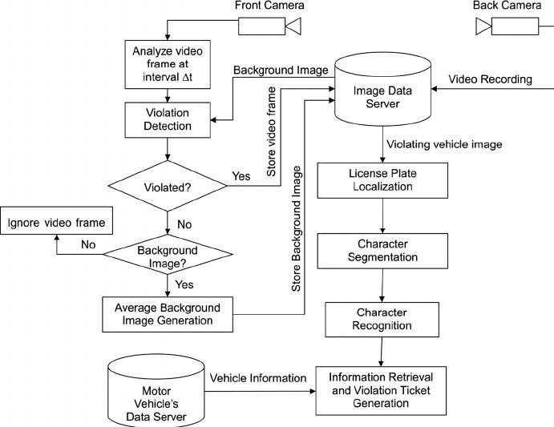
Pictorial Representation of the whole implementation process:

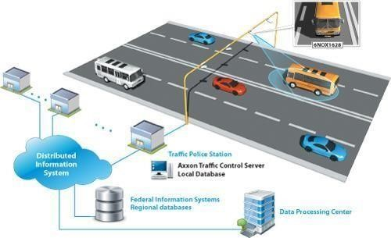

Chapter 4 RESULTS ANALYSIS AND VALIDATION

4.1. Implementation of Solution

To implement a solution for a License Plate Recognition (LPR) system, you can utilize modern tools across different stages of the project, including analysis, design, project management, communication, and testing. Here is a breakdown of how these tools can be applied:
Analysis: Use tools like Python's panda’s library or Microsoft Excel for processing and analyzing the data related to license plates, such as training datasets, images, and text data.
- Identify the requirements and constraints of the LPR system. Determine the scope and objectives of the project.
- Analyze existing LPR systems and technologies to understand their capabilities and limitations.
- Conduct a feasibility study to evaluate the technical and financial viability of implementing the LPR system.
Design Drawings/Schematics/Solid Models: Employ computer-aided design (CAD) tools such as AutoCAD, SolidWorks, or Fusion 360 to create detailed drawings, schematics, and solid models of the physical components or system architecture of the LPR system.
- Use Computer-Aided Design (CAD) software such as AutoCAD, SolidWorks, or Fusion 360 to create detailed drawings, schematics, and solid models of the LPR system components.
- Design the hardware layout, including cameras, sensors, lighting, and processing units.
- Create a comprehensive schematic diagram that illustrates the flow of data and signals within the system.
Report Preparation: Utilize tools like Microsoft Word, Google Docs, or LaTeX for preparing reports, documentation, and user manuals, outlining the system's functionality, design choices, and implementation details.
- Prepare a detailed report documenting the design, implementation, and testing phases of the LPR system.
- Include information such as system architecture, component specifications, algorithms used, and performance metrics.
- Use modern tools like Microsoft Word, LaTeX, or Google Docs to create a professional looking report.
Project Management and Communication:
- Utilize project management tools such as Asana, Trello, or Jira to manage tasks, set milestones, and track progress.
- Establish clear communication channels within the project team using collaboration tools like Slack, Microsoft Teams, or Zoom.
- Regularly schedule meetings and provide updates to ensure effective coordination and transparency.
- Project Management Software: Employ project management tools like Asana, Trello, or Microsoft Project to plan and track project tasks, set milestones, assign, responsibilities, and manage the overall progress of the LPR system development. • Communication Tools: Use collaboration and communication platforms like Slack, Microsoft Teams, or Zoom to facilitate real-time communication, discussions, and updates between team members working on the LPR system.
Testing/Characterization/Interpretation/Data Validation:
- Develop a comprehensive test plan that covers functional testing, performance testing, and validation of the LPR system.
- Use testing frameworks such as Selenium or JUnit for automated testing of software components.
- Validate the accuracy of license plate recognition by comparing the system's output with ground truth data.
- Use statistical analysis tools like MATLAB, Python's NumPy, or R to interpret and analyze the system's performance data.
Testing Frameworks: Implement testing frameworks such as Selenium, PyTest, or JUnit for automated testing of the LPR system's functionality, including image processing, pattern recognition, and accuracy of license plate recognition.
Data Visualization: Utilize data visualization libraries like matplotlib or Tableau to visualize and interpret the results obtained from the LPR system, such as accuracy metrics, error rates, or system performance.
Statistical Analysis: Apply statistical analysis tools like R or Python's statistical libraries (e.g., scipy, stats models) to validate and interpret the data collected during testing, characterizing the LPR system's performance.

CHAPTER 5. CONCLUSION AND FUTURE WORK

5.1. Conclusion
In this paper, the Automatic Number Plate Recognition system using vehicle license plate is presented. This system uses image processing techniques for recognition of the vehicle from the database stored in the computer. The system works satisfactorily for wide variation of conditions and different types of number plates. The system is implemented and executed in Matlab and performance is tested on genuine images.
This ANPR system works quite well, however, there is still room for improvement. This ANPR system speed can be increased with high resolution camera. Which can be able to capture clear images of the vehicle. The OCR method is sensitive to misalignment and to different sizes, so we must create different kinds of templets for different RTO specifications. The statistical analysis can also be used to define the probability of detection and recognition of the vehicle number plate. At present there are certain limits on parameters like speed of the vehicle, script on the vehicle number plate, skew in the image which can be removed by enhancing the algorithms further.

5.2. Future work
The future scope of a project report on license plate recognition (LPR) is quite promising due to several reasons. LPR technology has already made significant advancements in recent years, and its applications are expected to expand even further in the future. Here are some potential areas of future development and scope for a project report on license plate recognition:
- Enhanced Accuracy: Improving the accuracy of license plate recognition systems is an ongoing objective. Future research could focus on developing advanced algorithms and machine learning techniques to enhance the accuracy of LPR systems, especially in challenging conditions such as low light or adverse weather.
- Real-Time Recognition: Real-time recognition capabilities are crucial for law enforcement agencies, parking management systems, and toll collection systems. Future projects could explore ways to improve the speed and efficiency of license plate recognition algorithms to enable real-time identification and response.
- Multilingual Support: License plates vary across different regions and countries, making it essential to develop multilingual support for LPR systems. Future projects could explore techniques for recognizing and interpreting license plates from various languages and formats, allowing for more widespread adoption of LPR technology globally.
- Integration with Other Systems: License plate recognition can be integrated with other systems to enhance security and improve operational efficiency. Future research could focus on integrating LPR technology with surveillance cameras, access control systems, and smart city infrastructure to create comprehensive solutions for traffic management, crime prevention, and public safety.
- Privacy and Data Protection: As license plate recognition involves the collection and processing of personal data, ensuring privacy and data protection is crucial. Future projects could address privacy concerns by developing secure and privacy-preserving LPR systems that comply with data protection regulations.
- Edge Computing and IoT Integration: With the advancements in edge computing and the Internet of Things (IoT), there is an opportunity to develop LPR systems that can operate at the network edge. This would enable faster response times, reduced latency, and improved scalability. Future projects could explore the integration of LPR technology with edge devices and IoT platforms.
- Deep Learning and Neural Networks: Deep learning techniques, such as convolutional neural networks (CNNs) and recurrent neural networks (RNNs), have shown promising results in license plate recognition. Future projects could explore the use of advanced deep learning architectures and algorithms to further enhance the accuracy and robustness of LPR systems.
- Environmental Considerations: Sustainable and eco-friendly solutions are gaining importance in today's world. Future projects on license plate recognition could explore ways to optimize energy consumption and reduce the environmental impact of LPR systems, such as through the use of low-power hardware or energy-efficient algorithms.
- Mobile Applications: Mobile devices have become increasingly powerful, allowing for the development of license plate recognition applications on smartphones and tablets. Future projects could focus on developing mobile apps with LPR capabilities, enabling individuals to use their devices for tasks like parking management, vehicle tracking, or personal security.
- Open-Source Development and Collaboration: The open-source community has played a vital role in advancing various technologies. Future projects could contribute to the opensource community by developing and sharing LPR algorithms, datasets, and software libraries, fostering collaboration and accelerating innovation in license plate recognition.
These are just a few potential areas for future development and scope in the field of license plate recognition. As technology continues to evolve, there will likely be new opportunities and challenges that researchers and developers can explore in this domain.

REFERENCES

- Sergey Zherzdev, Alexey Gruzdev “LPRNet: License Plate Recognition via Deep Neural Networks” IEEE Transactions on Intelligent Transportation Systems, Vol. 9, No. 3 September 2013.
- Bhavin V Kakani, Bhavin V Kakani, Sagar Jani “Improved OCR based Automatic Vehicle Number Plate Recognition using Features Trained Neural Network.” IEEE Transactions on Intelligent Transportation Systems 2017.
- Li Yao1, Yingbin Zhao1, Jinghua Fan1, Min Liu1, Jianpeng Jiang1 and Yan Wan1 “Research and Application of License Plate Recognition Technology Based on Deep Learning” 2019 4. Chirag Patel, Dipti Shah, Atul Patel “Automatic Number Plate Recognition System (ANPR)” IEEE Transactions on Image Processing, Vol. 21, No. 9, September 2012.
- S. S. Hossain et al. "Vehicle License Plate Recognition Using Deep Learning Techniques" 2020
- N. V. Deshpande et al. "Automatic License Plate Recognition using Image Processing Techniques" 2019.
- S. S. Hossain et al. "A Comparative Study of License Plate Detection and Recognition Techniques" 2019.
- Chinmayi Gurav, Vedika Kamble, Rupali Gurav, Prof. Neha S. Sakhalkar “A Review Paper on Vehicle Number Plate Recognition” 2019.
- S. K. Sahoo et al. "License Plate Detection and Recognition Using YOLOv3 and OpenALPR" 2021.
- S. M. Imtiaz and M. A. Azam "Real-Time License Plate Recognition System Based on Deep Learning" 2021.
- S´ergio Montazzolli Silva and Cl´audio Rosito “License Plate Detection and Recognition in Unconstrained Scenarios” 2018.
- Muhammad Tahir Qadri, Muhammad Asif “Automatic number plate recognition system for vehicle identification using optical character recognition” 2009.
- https://github.com/ierolsen/YOLO-License-Plate-Detection-Web-App

APPENDIX

1. Plagiarism Report




