Code Refactoring – Improving Legacy Code with AI
Suggestions
NAME:T SIDDARTHA
ROLL.NO:2503A52389
Task Description #1 (Refactoring – Removing Code
Duplication)
Task: Use AI to refactor a given Python script that contains
multiple repeated code blocks.
Instructions:
o Prompt AI to identify duplicate logic and replace it
with functions or classes.
o Ensure the refactored code maintains the same output.
o Add docstrings to all functions.
Sample Legacy Code:
# Legacy script with repeated logic
print(&quot;Area of Rectangle:&quot;, 5 * 10)
print(&quot;Perimeter of Rectangle:&quot;, 2 * (5 + 10))
print(&quot;Area of Rectangle:&quot;, 7 * 12)
print(&quot;Perimeter of Rectangle:&quot;, 2 * (7 + 12))
print(&quot;Area of Rectangle:&quot;, 10 * 15)
print(&quot;Perimeter of Rectangle:&quot;, 2 * (10 + 15))
Expected Output:
o Refactored code with a reusable function and no
PROMPT:
Analyze the given Python code and identify duplicate logic.
Refactor the code by creating a reusable function.
Add a docstring to the function and ensure that
the output remains exactly the same.
CODE:
def rectangle(length, width):
"""
Calculate and display area and perimeter
of a rectangle.
"""
area = length * width
perimeter = 2 * (length + width)

print("Area of Rectangle:", area)
print("Perimeter of Rectangle:", perimeter)

# Function calls
rectangle(5, 10)
rectangle(7, 12)
rectangle(10, 15)
OUTPUT:
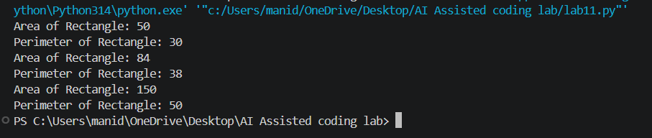
Task Description #2 (Refactoring – Optimizing Loops and
Conditionals)
Task: Use AI to analyze a Python script with nested loops
and complex conditionals.
Instructions:
o Ask AI to suggest algorithmic improvements (e.g.,
replace nested loops with set lookups or
comprehensions).
o Implement changes while keeping logic intact.
o Compare execution time before and after refactoring.
Sample Legacy Code:
# Legacy inefficient code
names = [&quot;Alice&quot;, &quot;Bob&quot;, &quot;Charlie&quot;, &quot;David&quot;]
search_names = [&quot;Charlie&quot;, &quot;Eve&quot;, &quot;Bob&quot;]
for s in search_names:
found = False
for n in names:
if s == n:
found = True
if found:
print(f&quot;{s} is in the list&quot;)
else:
print(f&quot;{s} is not in the list&quot;)
• Expected Output:
o Optimized code using set lookups with performance
comparison table.
PROMPT:
Analyze the given Python code containing nested loops.
Optimize it by replacing nested loops with set lookups.
Compare the execution time before and after refactoring.
Maintain the same output.
CODE:
import time

names = ["Alice", "Bob", "Charlie", "David"]
search_names = ["Charlie", "Eve", "Bob"]

# Original method using nested loops
start = time.perf_counter()

for s in search_names:
found = False

for n in names:
if s == n:
found = True
break

if found:
print(s, "is in the list")
else:
print(s, "is not in the list")

old_time = time.perf_counter() - start

# Optimized method using set
start = time.perf_counter()

name_set = set(names)

for s in search_names:
if s in name_set:
print(s, "is in the list")
else:
print(s, "is not in the list")

new_time = time.perf_counter() - start

# Performance comparison
print("\nPerformance Comparison")
print("Original Time:", old_time)
print("Optimized Time:", new_time)
OUTPUT:
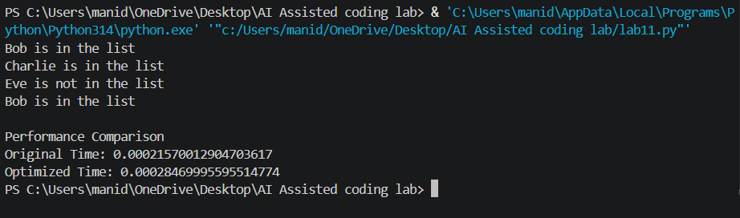
Task Description #3 (Refactoring – Extracting Reusable
Functions)
Task: Use AI to refactor a legacy script where multiple
calculations are embedded directly inside the main code
block.
Instructions:
o Identify repeated or related logic and extract it into
reusable functions.
o Ensure the refactored code is modular, easy to read,
and documented with docstrings.

Sample Legacy Code:
# Legacy script with inline repeated logic
price = 250
tax = price * 0.18
total = price + tax
print(&quot;Total Price:&quot;, total)
price = 500
tax = price * 0.18
total = price + tax
print(&quot;Total Price:&quot;, total)
• Expected Output:
o Code with a function calculate_total(price) that can be
reused for multiple price inputs.
PROMPT:
Refactor the given Python code by extracting repeated
calculations into a reusable function named
calculate_total(price).

Calculate 18% tax and return the total price.
Add a docstring and test multiple inputs.
CODE:
def calculate_total(price):
"""
Calculate total price including 18% tax.
"""
tax = price * 0.18
total = price + tax

return total

# Function calls
print("Total Price:", calculate_total(250))
print("Total Price:", calculate_total(500))
print("Total Price:", calculate_total(1000))
OUTPUT:
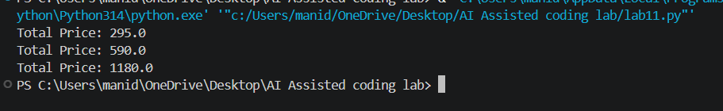
Task Description #4 (Refactoring – Replacing Hardcoded
Values with Constants)
Task: Use AI to identify and replace all hardcoded “magic
numbers” in the code with named constants.
Instructions:
o Create constants at the top of the file.
o Replace all hardcoded occurrences in calculations
with these constants.
o Ensure the code remains functional and is easier to
maintain.
Sample Legacy Code:
# Legacy script with hardcoded values
print(&quot;Area of Circle:&quot;, 3.14159 * (7 ** 2))
print(&quot;Circumference of Circle:&quot;, 2 * 3.14159 * 7)
Expected Output:
o Code with constants like PI = 3.14159 and RADIUS
= 7 used in calculations.
PROMPT:
Analyze the Python code and identify hardcoded values.
Replace them with named constants such as PI and RADIUS.
Improve readability and maintain the same output.
CODE:
# Constants
PI = 3.14159
RADIUS = 7

def calculate_circle():
"""
Calculate area and circumference of a circle.
"""
area = PI * (RADIUS ** 2)
circumference = 2 * PI * RADIUS

print("Area of Circle:", area)
print("Circumference of Circle:", circumference)

calculate_circle()
OUTPUT:
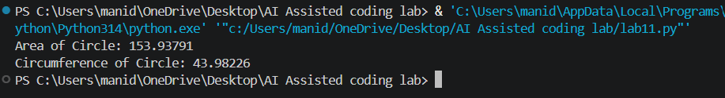
Task Description #5 (Refactoring – Improving Variable
Naming and Readability)
Task: Use AI to improve readability by renaming unclear
variables and adding inline comments.
Instructions:
o Replace vague names with meaningful ones.
o Add comments where logic is not obvious.

o Keep functionality exactly the same.
Sample Legacy Code:
# Legacy script with poor variable names
a = 10
b = 20
c = a * b / 2
print(c)
Expected Output:
o Code with descriptive variable names like base,
height, area_of_triangle, plus explanatory comments.
PROMPT:
Refactor the given Python program by replacing unclear
variable names with meaningful names.
Add explanatory comments without changing the functionality.
CODE:
# Base and height of the triangle
base = 10
height = 20

# Calculate area of triangle
area_of_triangle = (base * height) / 2

# Display the result
print("Area of Triangle:", area_of_triangle)
OUTPUT:
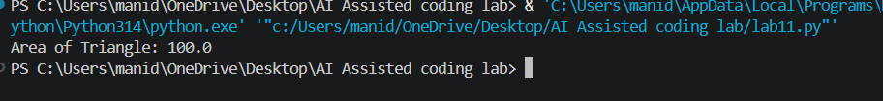
Task Description #6 (Refactoring – Removing Redundant Conditional
Logic)
• Task: Use AI to refactor a Python script that contains repeated if–else
logic for grading students.
• Instructions:
o Ask AI to identify redundant conditional checks.
o Replace them with a reusable function.
o Ensure grading logic remains unchanged.
• Code:
marks = 85
if marks &gt;= 90:
print(&quot;Grade A&quot;)
elif marks &gt;= 75:
print(&quot;Grade B&quot;)
else:
print(&quot;Grade C&quot;)

marks = 72
if marks &gt;= 90:
print(&quot;Grade A&quot;)
elif marks &gt;= 75:

print(&quot;Grade B&quot;)
else:
print(&quot;Grade C&quot;)
• Expected Output:
o A reusable function like calculate_grade(marks) with clean logic and
docstring.
PROMPT:
Analyze the given Python code containing repeated
if-else grading conditions.

Create a reusable function calculate_grade(marks).
Add a docstring and maintain the original grading logic.
Test with multiple marks.
CODE:
def calculate_grade(marks):
"""
Calculate student grade based on marks.
"""
if marks >= 90:
return "Grade A"

elif marks >= 75:
return "Grade B"

else:
return "Grade C"

# Test cases
print(calculate_grade(85))
print(calculate_grade(72))
print(calculate_grade(95))
print(calculate_grade(60))
OUTPUT:


