**Main JFrame(Login)**

**Admin Login**

**Patient Dashboard**

**Doctor Dashboard**

**Lab Dashboard**

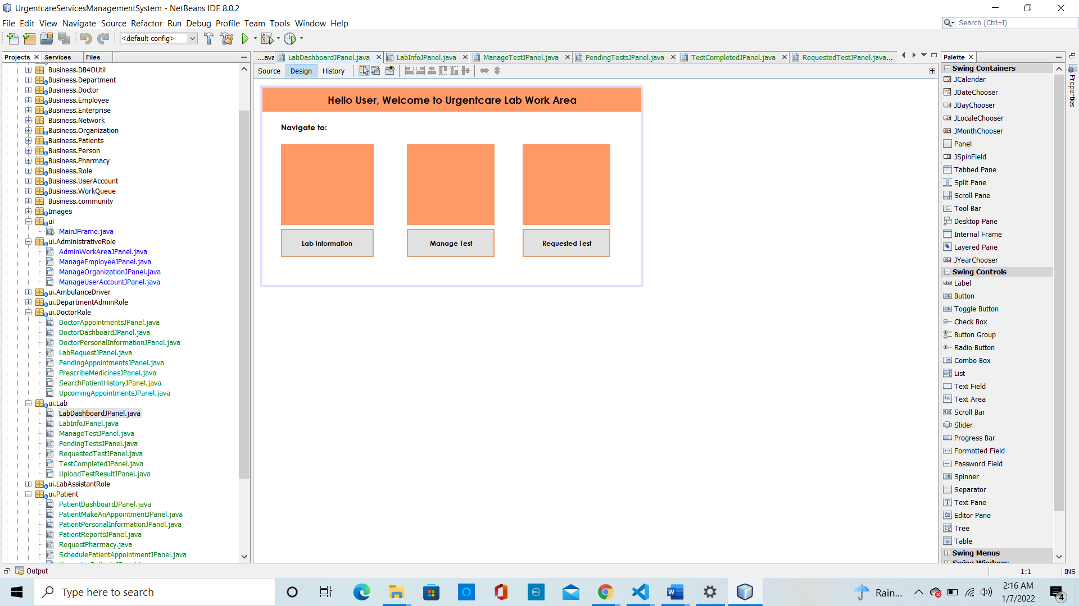

**Ambulance Dashboard**

**Department AdminRole**

**Pharmacy Dashboard**

