Hey, i bought a YDLidar X2L from youyeetoo via amazon.
I am using it for ros noetic (ubuntu 20.04) and it continuously throws me error static this

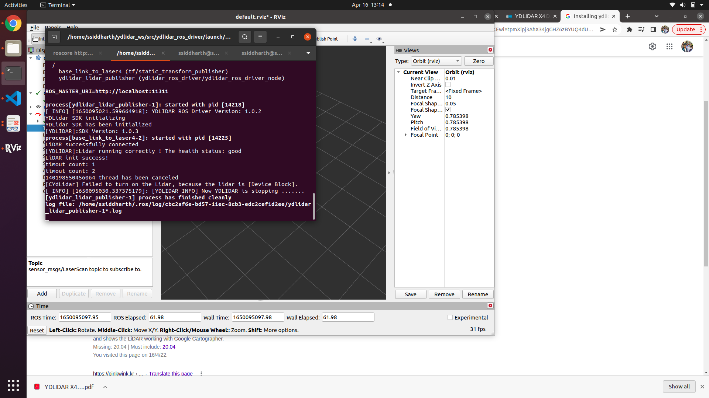
i have checked the USB port, the baud rate and the launch files. Everything seems perfect. Even the installation was perfect inspite of the poor documentation.
Kindly reply me with the solution to this isse.

