Advanced Attendance System
This project modified as per your given requirements which consists of following modules
- Admin Login: admin can login to system using username and password as admin and admin. After login admin can add ‘New Student Details’ and can mark attendance by taking QR code from students. Admin can view attendance for all students from selected date.
- Faculty Login: faculty can login to system using username and password as ‘faculty and faculty’. After login faculty can marked student attendance by taking QR code and can view each student attendance from selected date range.
- Student Login: student can login to system using ID and password iven by admin. During First login system will ask student to registered Face and from next login onwards student has to authenticate face. Upon successful authentication student can generate QR code and can view attendance also.
To run project install python 3.7.2 and then install all packages given in requirements.txt file and then install MYSQL database and then copy content from ‘database.txt’ file and paste in MYSQL console to create database.
Now double click on ‘run.bat’ file to see execution of above modules
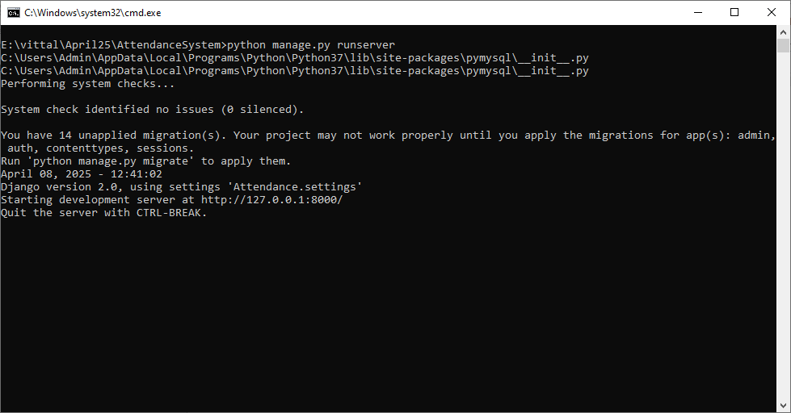
In above screen python server started and now open browser and enter URL as http://127.0.0.1:8000/index.html and then press enter key to get below page
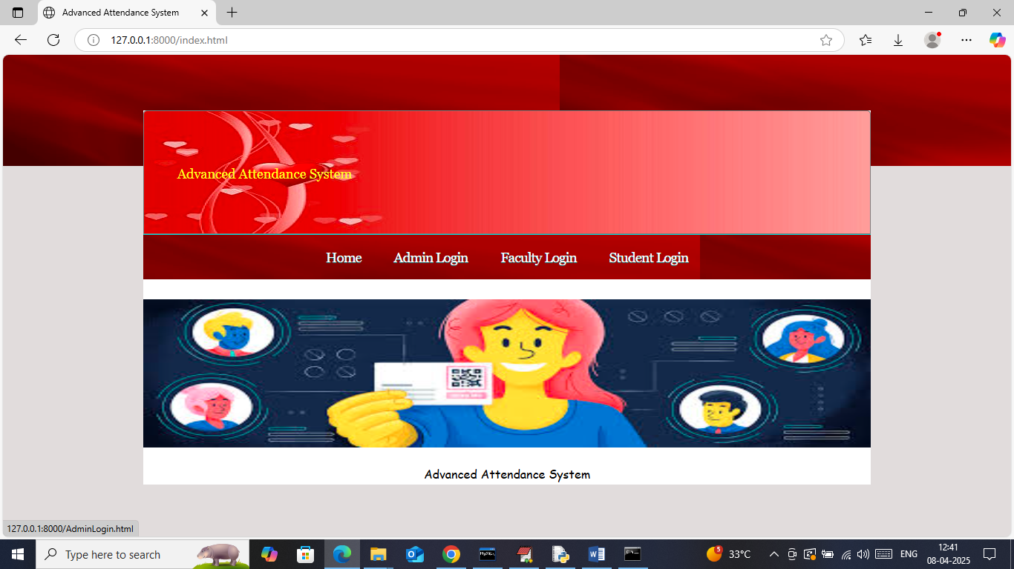
In above screen click on ‘Admin Login’ link to get below page
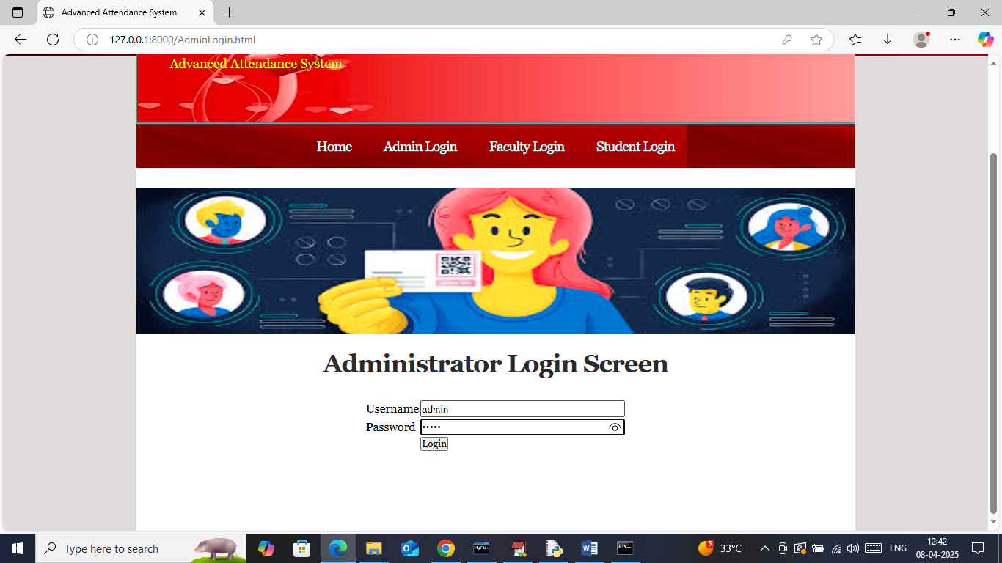
In above screen admin is login and after login will get below page
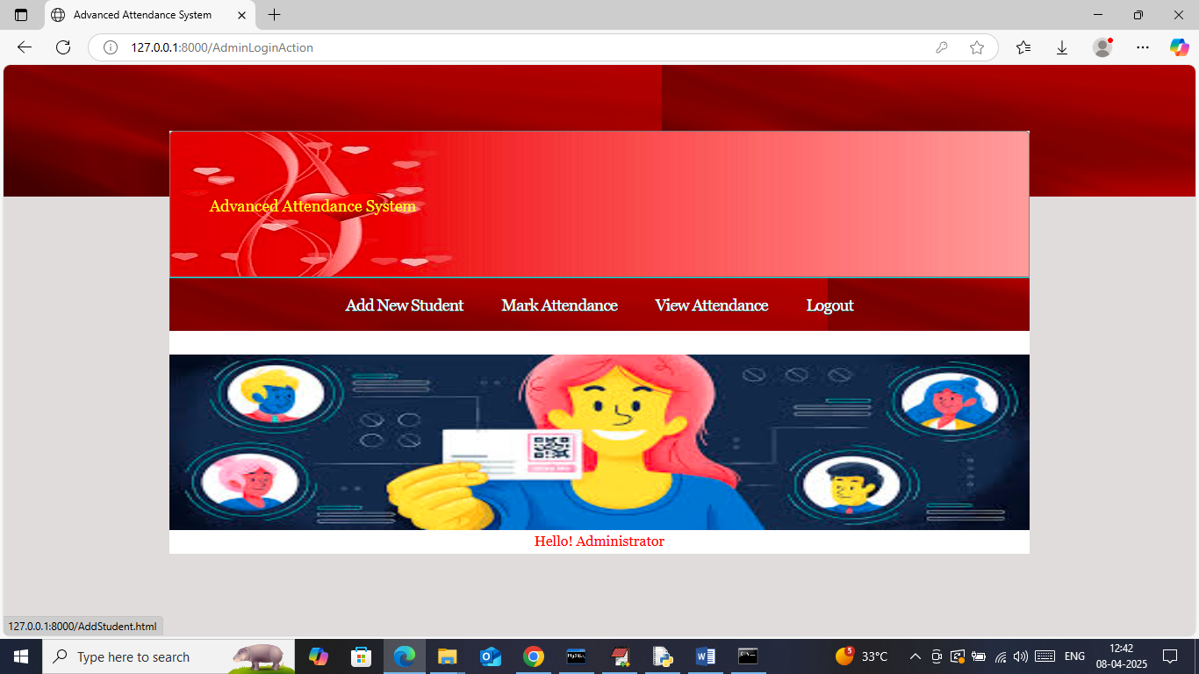
In above screen admin can click on ‘Add New Student’ link to get below page
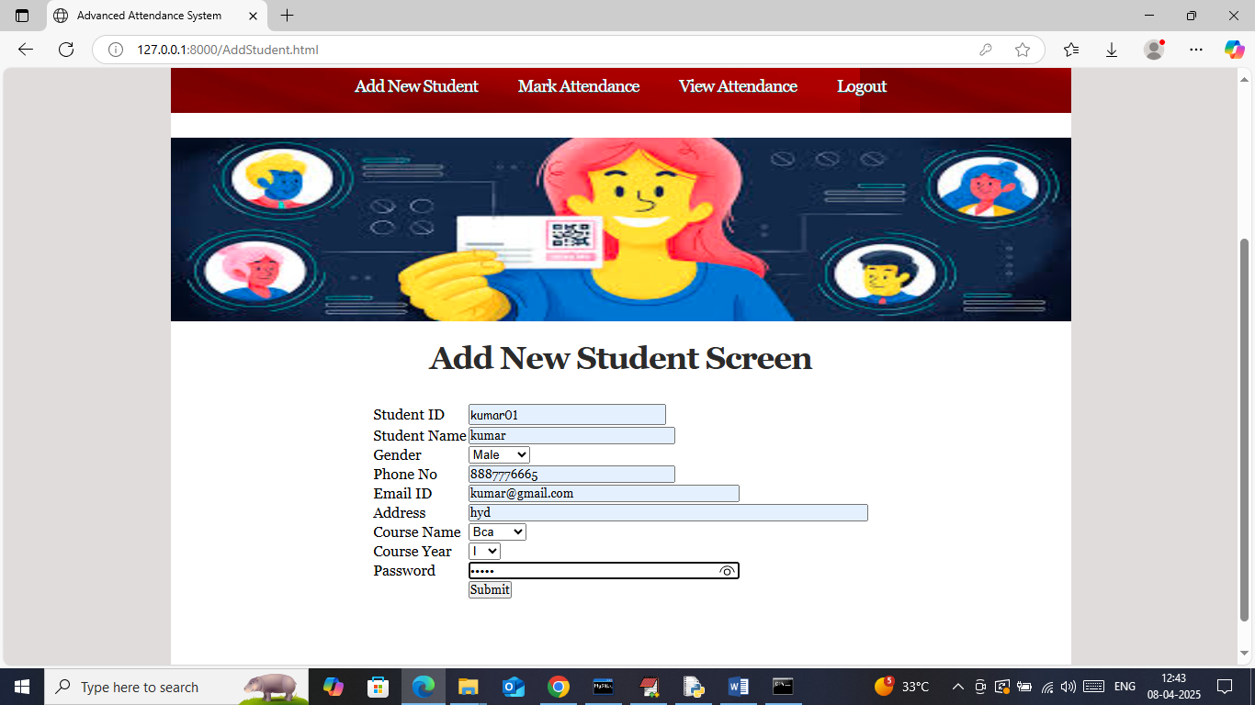
In above screen admin is adding new student details and then press button to get below page
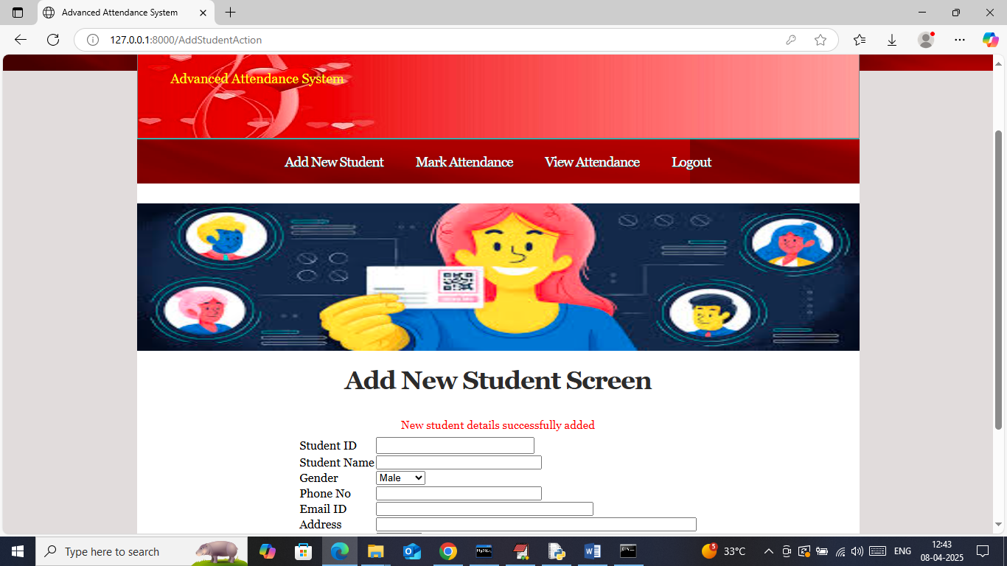
In above screen in red text can see student details added and now logout and login as student to generate QR code and marked attendance
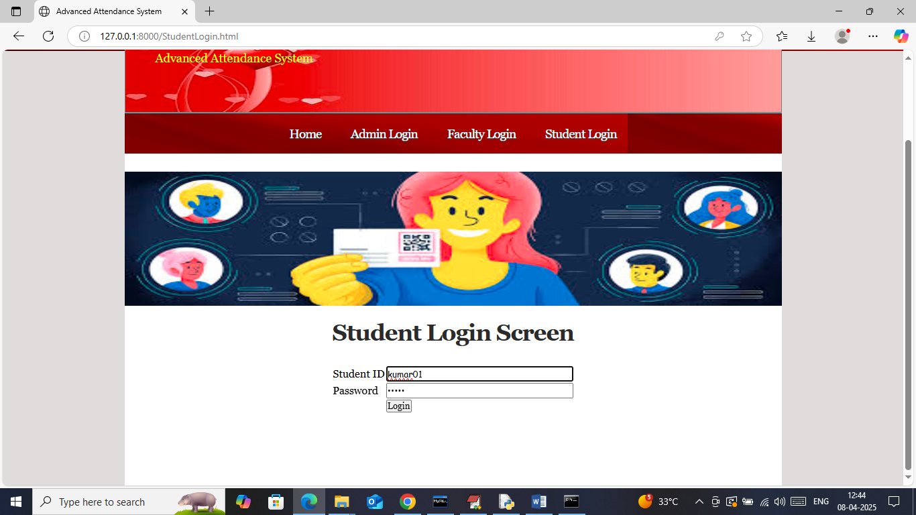
In above screen student is login first time so system will ask user to registered face
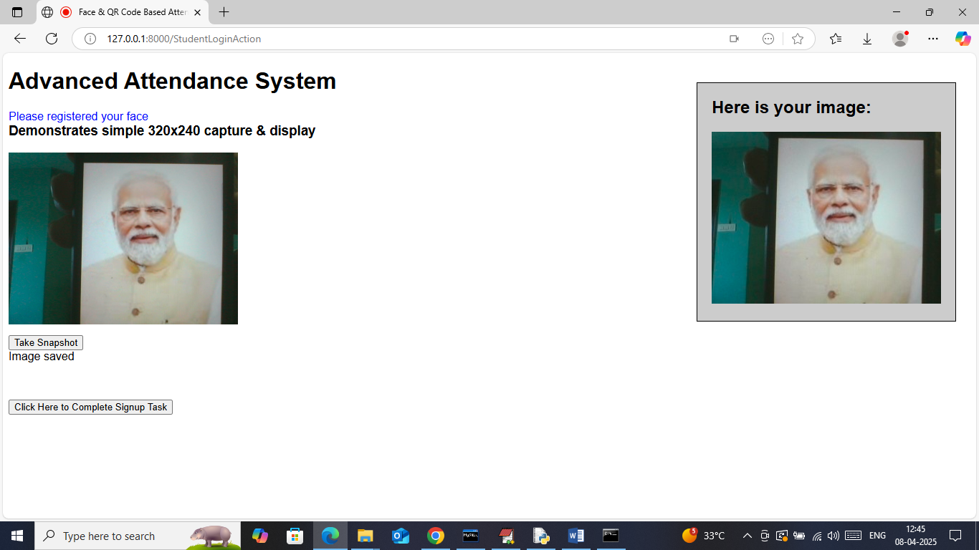
In above screen registering student face and then click on ‘Click Here to Sign up’ button complete face registration and then will get below page
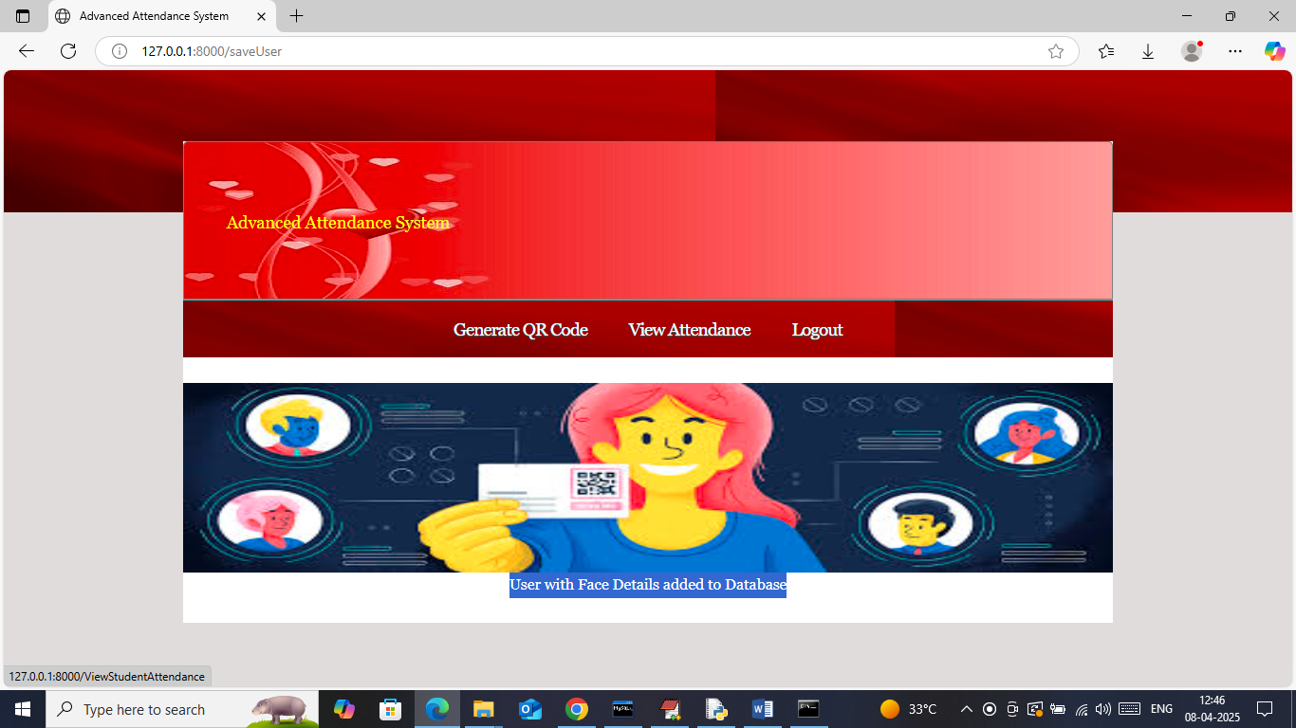
In above screen in blue text can see user with face details added to database and successfully login to system and now once again logout and try to login to get face authenticate page
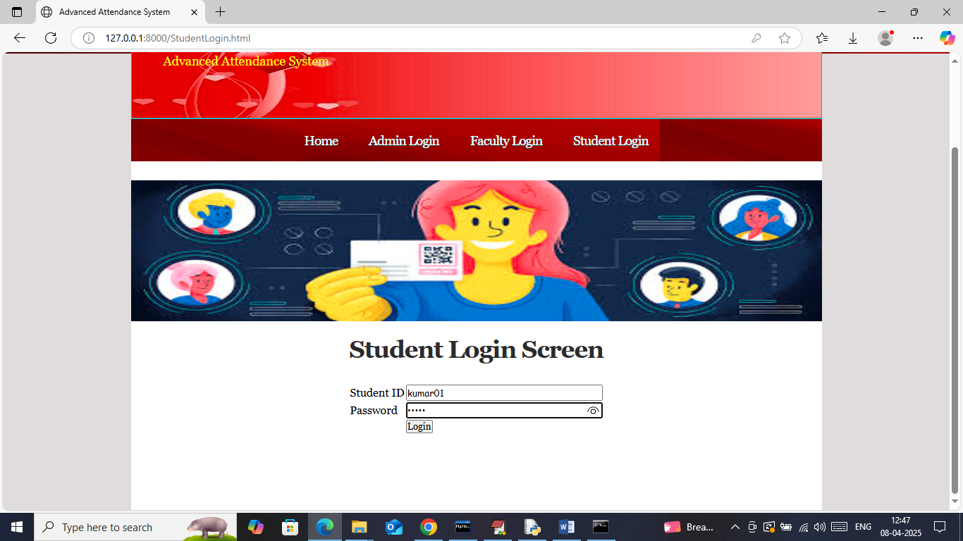
In above screen student is login again
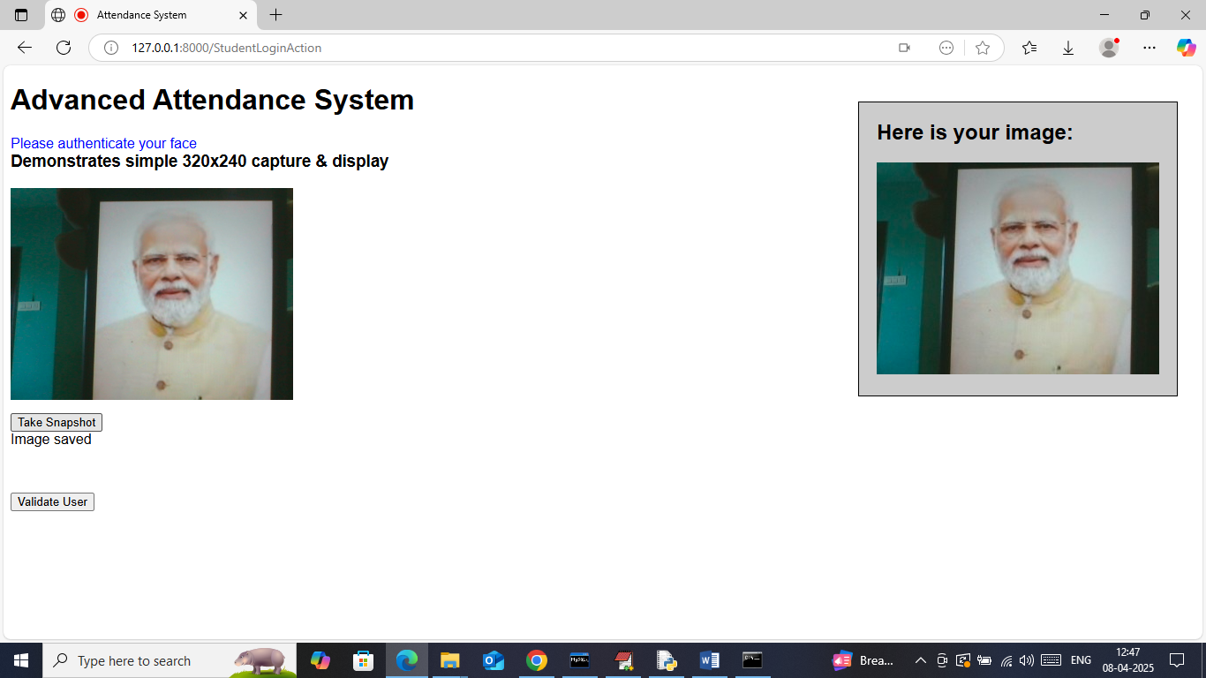
In above screen in blue text can see system asking student to ‘authenticate face’ and now capture face and then click on ‘Validate User’ button to get below page
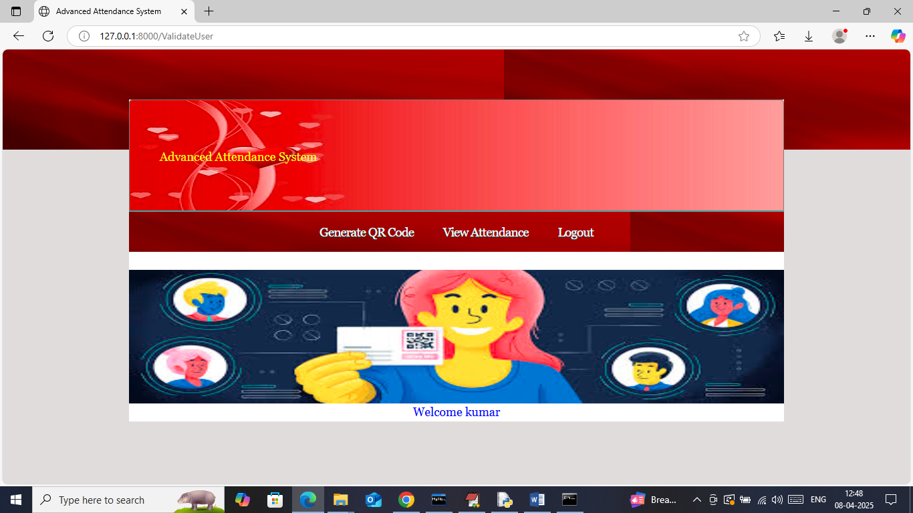
In above screen in blue text can see system authenticate student successfully and greeting with message and now student can click on ‘Generate QR Code’ link to generate and download QR code
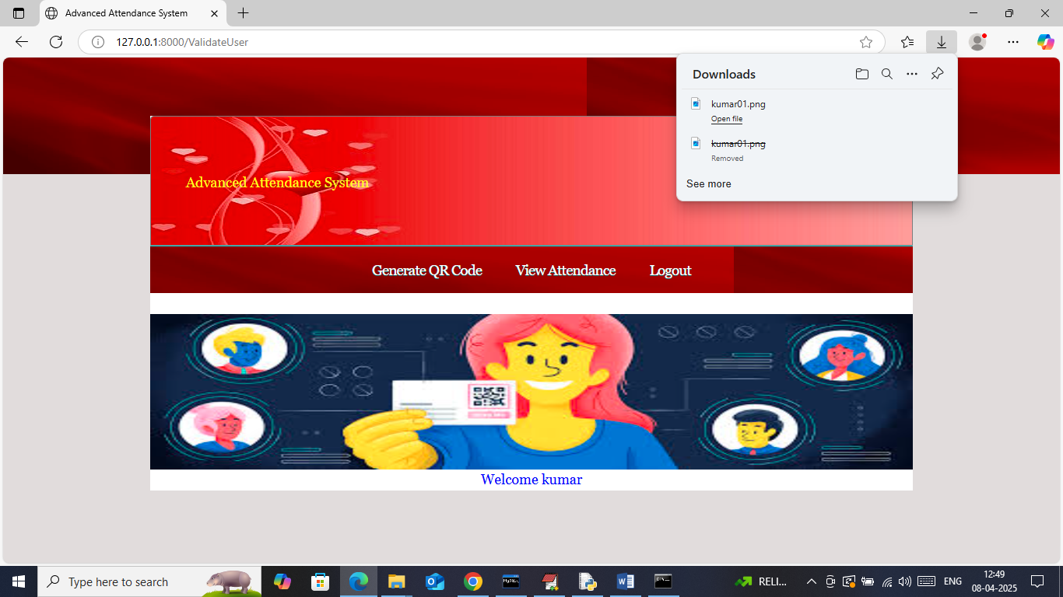
In above screen in browser status bar can see QR code generated and successfully downloaded and now logout and login as faculty to mark attendance
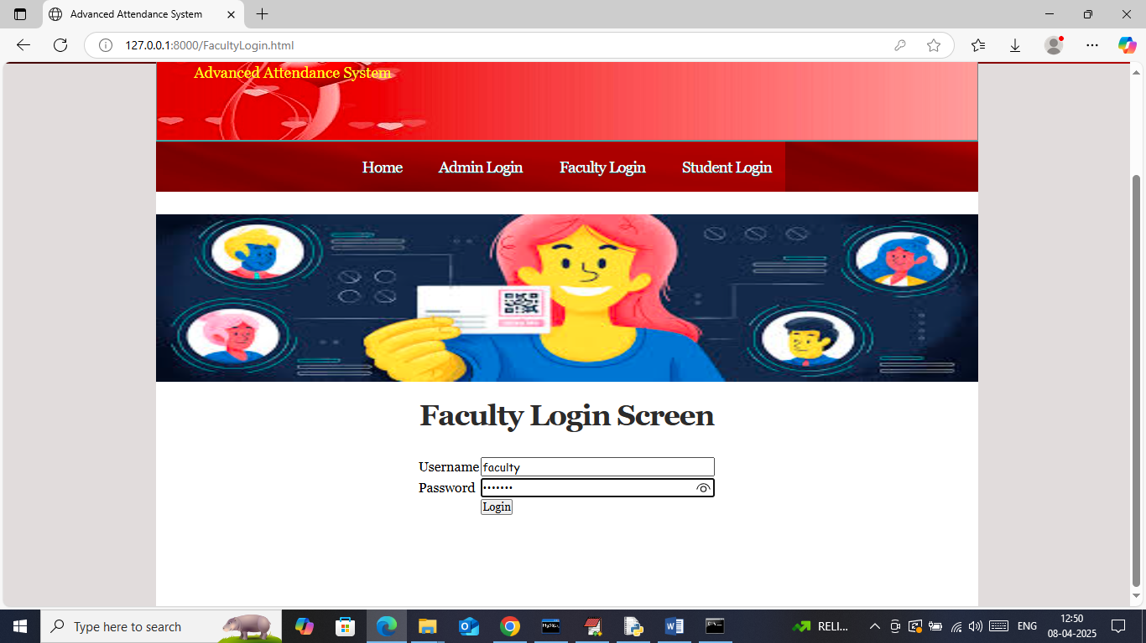
In above screen faculty is login and after login will get below page
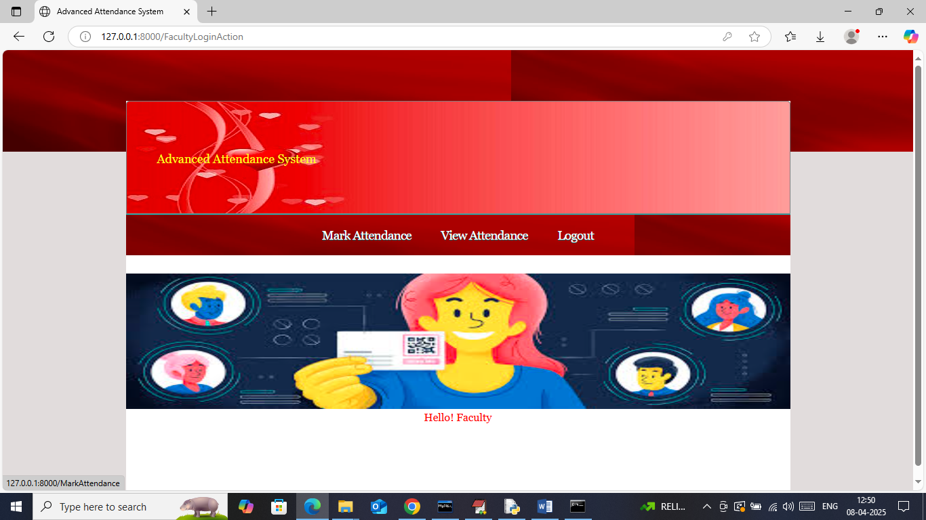
In above screen faculty or admin can click on ‘Mark Attendance’ link to get below page
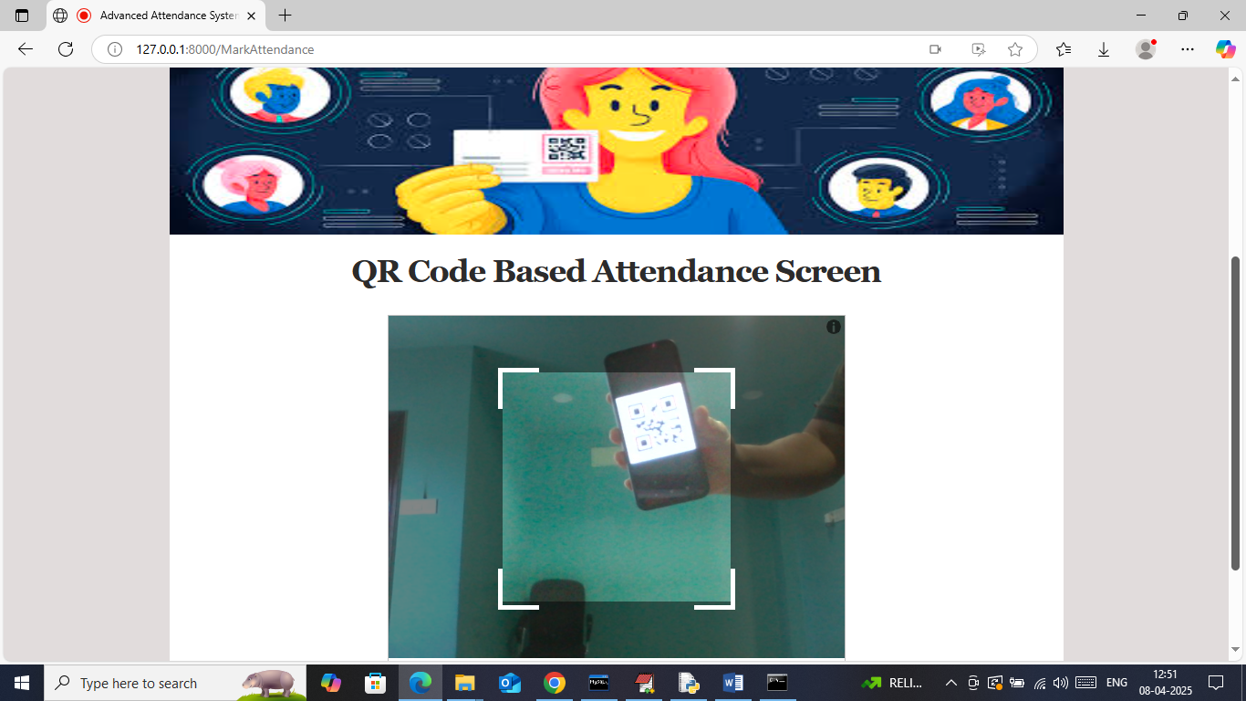
In above screen show generated QR code to get below page
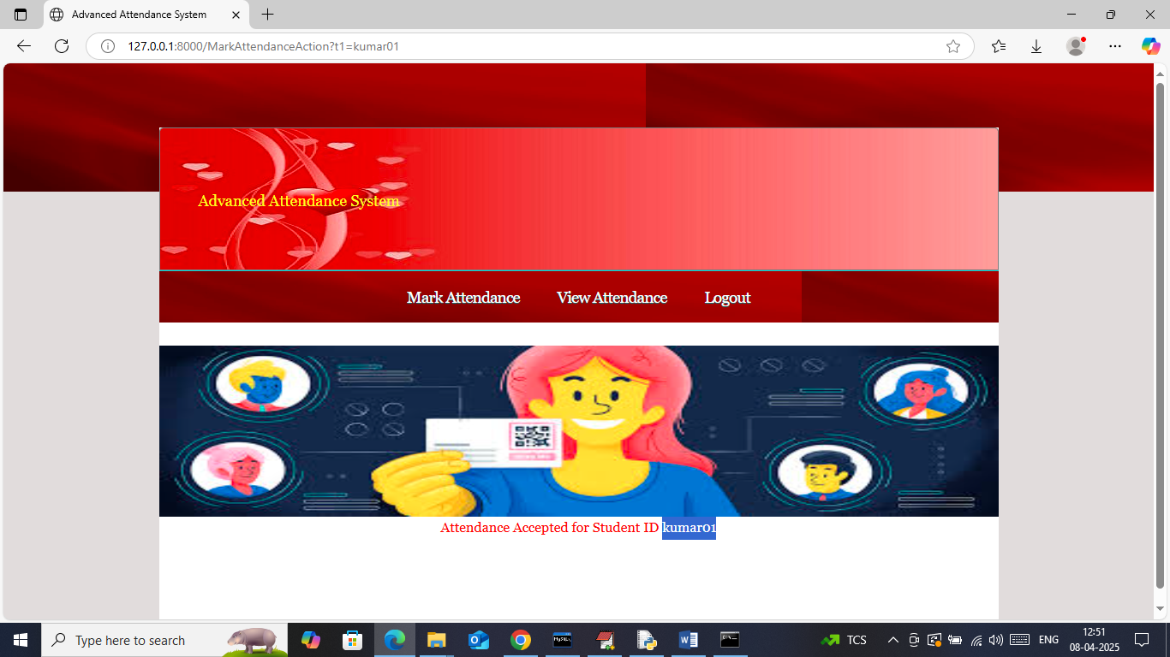
In above screen for student ID kumar01 attendance successfully accepted and faculty can take attendance for as many students as he wants. Now click on ‘View Attendance’ link to get below page
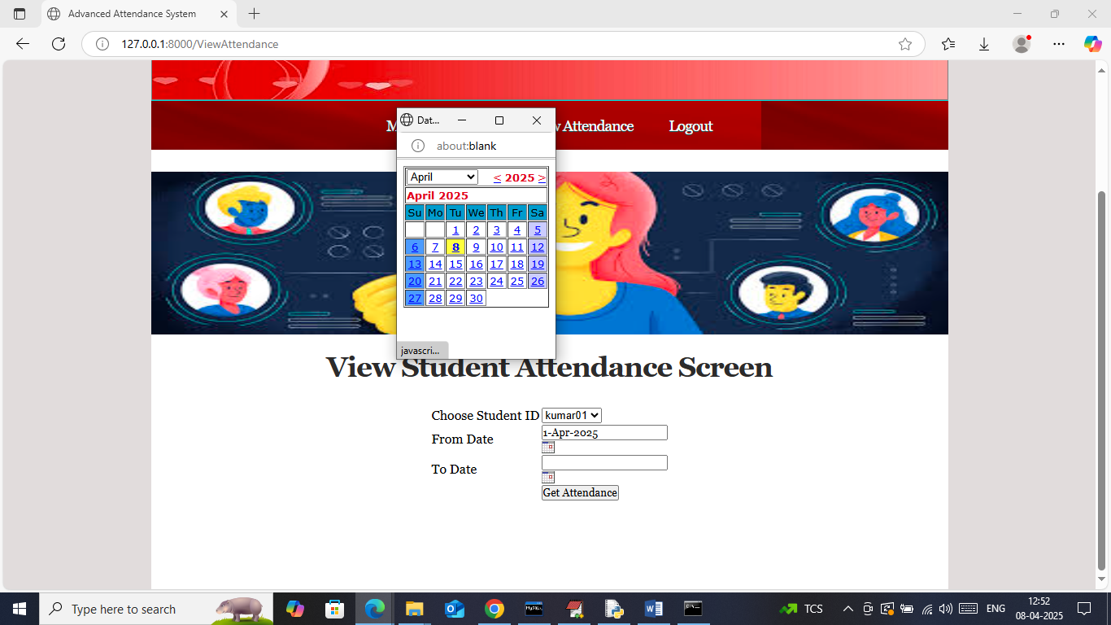
In above screen faculty can select student ID along with from and to date to get below reports
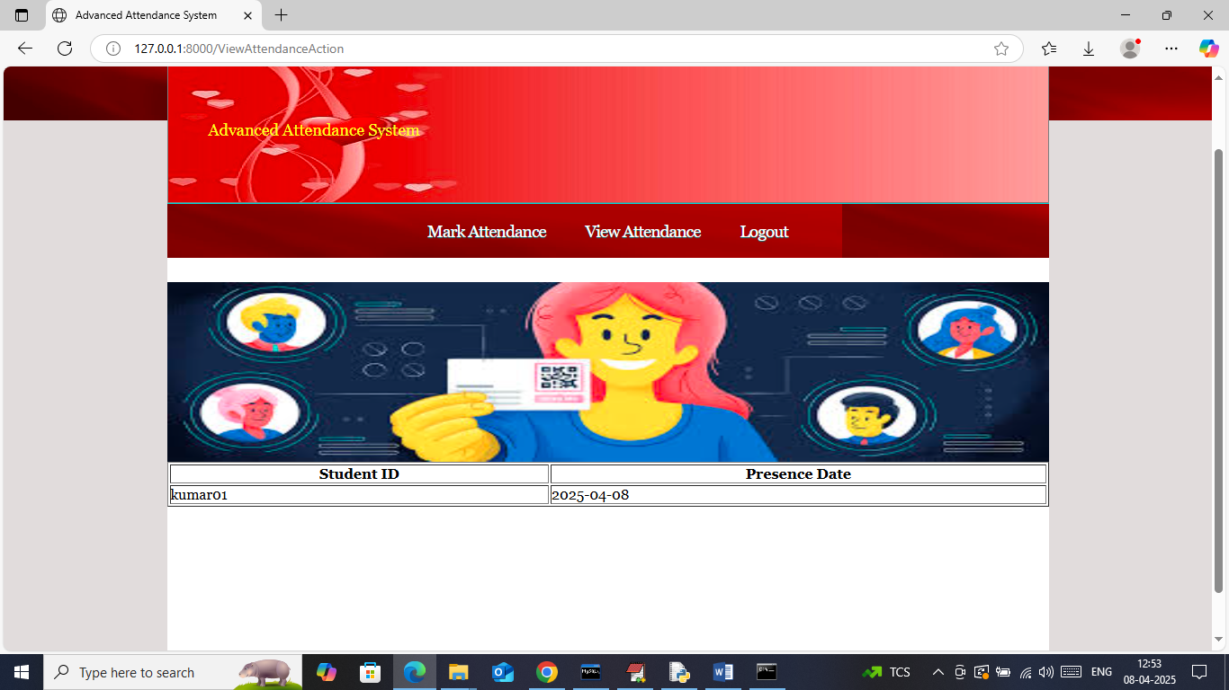
In above screen faculty can see student attendance for all dates and same admin can student can also view.
Note: all possible modules we have added.

