PRACTICAL

(Based on MSMS 301, MSMS 302, MSMS 303, MSMS304, MSMS306, MSMS306)

NAME - AKHILESH KUMAR
CLASS ROLL NUMBER - 02
EXAM ROLL NUMBER - 23419STC003
PAPER TITLE - PRACTICAL
PAPER CODE - MSMS -308
COURSE - STATISTICS & COMPUTING

Table of Contents

MSMS – 301 Time Series Analysis
a) Practical 1
MSMS – 302 Statistical Machine Learning
- Practical 1
- Practical 2
- Practical 3
MSMS – 303 Multivariate Analysis
- Practical 1
- Practical 2
MSMS – 304 Life Time Data Analysis
- Practical 1
- Practical 2
- Practical 3
MSMS – 307 SAS and Computing
- Practical 1
- Practical 2
Biostatistics
- Practical 1
- Practical 2
- Practical 3
- Practical 4

MSMS – 301 Time Series Analysis

Practical 1
For the “Nile” dataset available in R, obtain the results given below by writing a suitable R program
- Autocorrelation up to order three
- Partial autocorrelation
- Also plot these using suitable diagram
CODE:
library(datasets)
data=Nile
plot(data)
require(graphics)
data1<-ts(data,start=c(1871,1), end=c(1970,12), frequency=12)
decomp<-decompose(data1) # to decompose the data into different components
plot(decomp)

# (a) Autocorrelation up to order three
Autocorr<-acf(data1,lag.max = 3,plot=FALSE)
Autocorr

# (b) Partial Autocorrelation
Partial_Autocorr<-acf(data1,lag.max = 3,type=c("partial"),plot=FALSE)
Partial_Autocorr

# (c) Plot the autocorrelation and partial autocorrelation functions
par(mfrow = c(2, 1)) # Set layout for two plots in one column
acf(data1, lag.max = 10, main = "Autocorrelation Function")
pacf(data1, main = "Partial Autocorrelation Function")

OUTPUT:
>Autocorrelations of series ‘data1’, by lag
0.0000 0.0833 0.1667 0.2500
1.000 0.487 0.357 0.296
>Partial autocorrelations of series ‘data1’, by lag
0.0833 0.1667 0.2500
0.487 0.158 0.0986
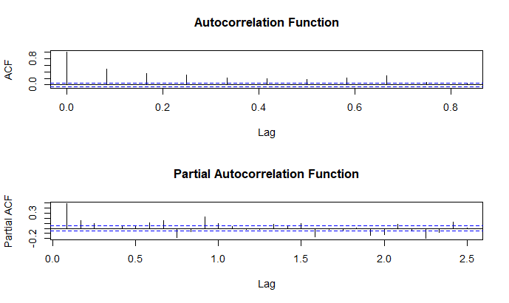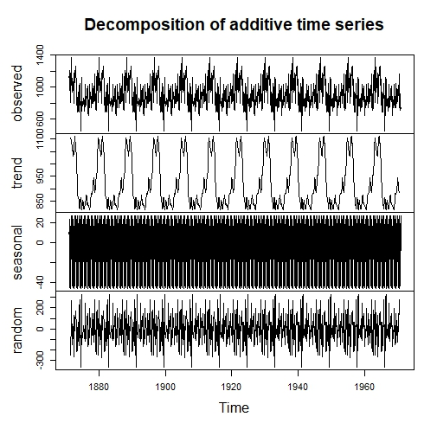

MSMS – 302 Statistical Machine Learning
Practical 1
- For the following dataset, obtain kernel density estimate and Naïve density estimator. Also plot both the estimators.
5.65746599 5.38283914 2.79892121 2.85423660 2.95252721 5.42626667
7.66239113 -0.18001073 0.65083500 2.40276530 -0.09929884 6.32619215
5.03650752 2.07470777 1.78019174 6.12891558 4.05352439 2.02686971
3.50834853 -2.76449768 4.98428763 3.01292677 2.82448038 3.98110437
5.09371862 5.97961648 4.56968496 -0.48814532 5.08736697 2.41757609

CODE:
# Dataset
data <- c(5.65746599, 5.38283914, 2.79892121, 2.85423660, 2.95252721, 5.42626667,
7.66239113, -0.18001073, 0.65083500, 2.40276530, -0.09929884, 6.32619215,
5.03650752, 2.07470777, 1.78019174, 6.12891558, 4.05352439, 2.02686971,
3.50834853, -2.76449768, 4.98428763, 3.01292677, 2.82448038, 3.98110437,
5.09371862, 5.97961648, 4.56968496, -0.48814532, 5.08736697, 2.41757609)

# Kernel Density Estimate
kde <- density(data)
kde

# Naïve Density Estimator
naive_density <- function(x, data, h) {
n <- length(data)
return(sum((abs(x - data) <= h) / (2 * h)) / n)
}

# Naïve Density Estimator for a range of x
h <- 1.0 # Bandwidth for Naïve Density Estimation
x_range <- seq(min(data) - 1, max(data) + 1, length.out = 100)
naive_estimates <- sapply(x_range, naive_density, data = data, h = h)

# Plotting both
plot(kde, main = "Kernel Density Estimate vs Naïve Density Estimator",
col = "blue", lwd = 2, ylim = c(0, max(kde$y, naive_estimates)), xlab = "X", ylab = "Density")
lines(x_range, naive_estimates, col = "red", lwd = 2)
legend("topright", legend = c("KDE", "Naïve Density"), col = c("blue", "red"), lty = 1, lwd = 2)

Graph:
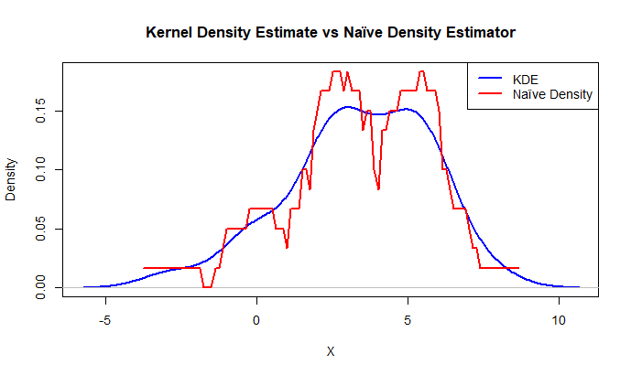
Interpretation:
KDE (blue) and the Naïve Density Estimator (red) are contrasted in the graph.
- The KDE efficiently captures the general shape and offers a smooth and reliable estimation of the data distribution.
Because of its restricted bandwidth and sensitivity to data points,
- The Naïve Density Estimator is imprecise and unable to accurately depict the distribution.
KDE is favored because it represents density in a more fluid and understandable manner.
Practical 2
2. Hosmer & Lerneshow (1989) give a dataset (“birthwt” available in R MASS library) on 189 births at a US hospital, with the main interest being in low birth weight. The main variable of interest is low birth weight, a binary response variable low. You can use variable “low” as binary response variable and remining variables as regressor variable. Divide the whole dataset into training and test dataset as solve perform following task
- Learn logistic classification model from training dataset and predict response using test dataset predictors.
- Obtain specificity, sensitivity, positive predictive value, negative predictive value of the model using test data set.
Code:
data("birthwt", package = "MASS")
birthwt <- birthwt
birthwt$low <- as.numeric(birthwt$low)

# Split data into training and test sets
train_indices <- sample(1:nrow(birthwt), size = 0.7 * nrow(birthwt)) # 70% training
train_data <- birthwt[train_indices, ]
test_data <- birthwt[-train_indices, ]

# Logistic function
logistic <- function(x) {
1 / (1 + exp(-x))
}

# Fit logistic regression using Newton-Raphson
fit_logistic <- function(X, y, max_iter = 100, tol = 1e-6) {
n <- nrow(X)
p <- ncol(X)

# Initialize beta coefficients
beta <- matrix(0, nrow = p, ncol = 1)
epsilon <- 1e-8

for (i in 1:max_iter) {
eta <- X %*% beta # Linear predictor
mu <- logistic(eta) # Predicted probabilities
mu <- pmin(pmax(mu, epsilon), 1 - epsilon)

# Compute gradient and Hessian
W <- diag(as.vector(mu * (1 - mu)), n, n)
z <- eta + (y - mu) / (mu * (1 - mu))

Hessian <- t(X) %*% W %*% X
gradient <- t(X) %*% (y - mu)
beta_new <- beta + solve(Hessian + diag(epsilon, p)) %*% gradient # Regularized update

if (any(is.na(beta_new))) stop("Divergence detected in Newton-Raphson method.")
if (max(abs(beta_new - beta)) < tol) break

beta <- beta_new
}
return(beta)
}

# Addding intercept to training data
X_train <- cbind(1, as.matrix(train_data[, -1])) # Intercept and regressors
y_train <- train_data$low

# Fitting logistic regression model
beta <- fit_logistic(X_train, y_train)

# Logistic model equation
logistic_model_eq <- paste("log(odds) =", paste(round(beta, 4), c("(Intercept)", colnames(train_data)[-1]), collapse = " + "))
cat("Logistic Model Equation:\n", logistic_model_eq, "\n\n")

# Predict on test data
X_test <- cbind(1, as.matrix(test_data[, -1]))
y_test <- test_data$low
log_odds <- X_test %*% beta
probs <- logistic(log_odds)
predictions <- ifelse(probs > 0.5, 1, 0)

# Calculating confusion matrix
confusion_matrix <- table(Predicted = predictions, Actual = y_test)
cat("Confusion Matrix:\n")
print(confusion_matrix)

# Extracting metrics from confusion matrix
true_positive <- confusion_matrix["1", "1"]
true_negative <- confusion_matrix["0", "0"]
false_positive <- confusion_matrix["1", "0"]
false_negative <- confusion_matrix["0", "1"]

sensitivity <- true_positive / (true_positive + false_negative)
specificity <- true_negative / (true_negative + false_positive)
positive_predictive_value <- true_positive / (true_positive + false_positive)
negative_predictive_value <- true_negative / (true_negative + false_negative)
# Printing evolution metrics
cat("\nModel Performance Metrics:\n")
cat("Sensitivity (True Positive Rate):", round(sensitivity, 4), "\n")
cat("Specificity (True Negative Rate):", round(specificity, 4), "\n")
cat("Positive Predictive Value (PPV):", round(positive_predictive_value, 4), "\n")
cat("Negative Predictive Value (NPV):", round(negative_predictive_value, 4), "\n")

OUTPUT:
Logistic Model Equation:
log(odds) = 525.4902 (Intercept) + -0.321 age + 0.1733 lwt + 11.9778 race + 22.6441 smoke + 31.4374 ptl + 15.8446 ht + -16.0707 ui + 5.0071 ftv + -0.227 bwt
Confusion Matrix:
Actual
0 1
Predicted 0 40 0
1 1 16
Model Performance Metrics:
- Sensitivity (True Positive Rate): 0.95
Interpretation: The model correctly identifies 95% of the cases where the actual outcome is positive (e.g., predicting "low birth weight" when it truly is low).

- Specificity (True Negative Rate): 0.973
Interpretation: The model correctly identifies 97.3% of the cases where the actual outcome is negative (e.g., predicting "normal birth weight" when it truly is normal).

- Positive Predictive Value (PPV): 0.95
Interpretation: When the model predicts a positive outcome, it is correct 95% of the time.

- Negative Predictive Value (NPV): 0.973
Interpretation: When the model predicts a negative outcome, it is correct 97.3% of the time.

*High PPV and NPV indicate that the model is reliable in its predictions, with minimal false positives and false negatives. This makes it effective for practical use, especially in scenarios where both types of errors (false positives and false negatives) must be minimized.

Practical 3
Generate 100 observations from a gamma distribution with shape parameter = 2 and scale parameter = 5. Obtain kernel density estimates using the Gaussian kernel and plot these estimates. [bandwidth may be 0.1, 0.2, 0.5]
Code:
#Generating 100 observations from a Gamma distribution
shape <- 2
scale <- 5
data <- rgamma(100, shape = shape, scale = scale)
bandwidths <- c(0.1, 0.2, 0.5)

plot(NULL, xlim = range(data), ylim = c(0, 0.3),
xlab = "Value", ylab = "Density",
main = "Kernel Density Estimates with Gaussian Kernel")

# Colors for different bandwidths
colors <- c("red", "blue", "green")

# Plotting kernel density estimates for each bandwidth
for (i in 1:length(bandwidths)) {
bw <- bandwidths[i]
density_estimate <- density(data, kernel = "gaussian", bw = bw)
lines(density_estimate, col = colors[i], lwd = 2)
}

# Adding a legend to the plot
legend("topright", legend = paste("Bandwidth =", bandwidths),
col = colors, lwd = 2, cex = 1)

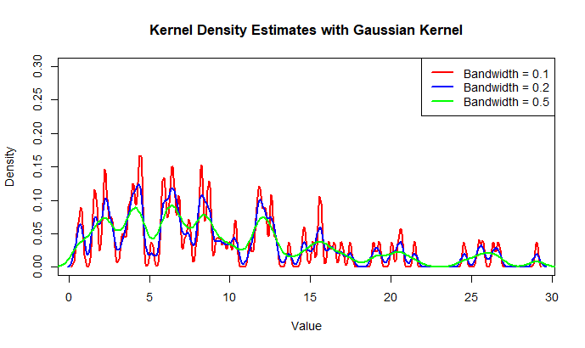
OUTPUT:

INTERPRETATION: From the above graph, I can conclude that:
- Bandwidth = 0.1 (Red): Highly sensitive to data, resulting in an overfitted and jagged density estimate.
- Bandwidth = 0.2 (Blue): Gives a balance between smoothness and detail, providing a reasonable representation of the distribution.
- Bandwidth = 0.5 (Green): Produces a smooth, generalized density estimate but we may lose finer details in the data.
Smaller bandwidths emphasize local variations, while larger bandwidths prioritize overall trends.

MSMS – 303 Multivariate Analysis
Practical 1
Find MLE of $Σ , μ and ρ$ for the data given in table and also find the result given below.

Head Length,  First Son ($x_{1}$) | Head Breadth,  First Son ($x_{2}$) | Head Length,  Second Son ($x_{3}$) | Head Breadth,  Second Son ($x_{4}$)
191 | 155 | 179 | 145
195 | 149 | 201 | 152
181 | 148 | 185 | 149
183 | 153 | 188 | 149
176 | 144 | 171 | 142
208 | 157 | 192 | 152
189 | 150 | 190 | 149
197 | 159 | 189 | 152
188 | 152 | 197 | 159
192 | 150 | 187 | 151
179 | 158 | 186 | 148
183 | 147 | 174 | 147
174 | 150 | 185 | 152
190 | 159 | 195 | 157
188 | 151 | 187 | 158
163 | 137 | 161 | 130
195 | 155 | 183 | 158
186 | 153 | 173 | 148
181 | 145 | 182 | 146
175 | 140 | 165 | 137
192 | 154 | 185 | 152
174 | 143 | 178 | 147
176 | 139 | 176 | 143
197 | 167 | 200 | 158
190 | 163 | 187 | 150

- Find the estimates of parameters of conditional distribution of ($x_{3}, x_{4}$) given ($x_{1}, x_{2}$) i.e. find $S_{21}{S_{11}}^{-1} and S_{22.1}= S_{22}- S_{21}{S_{11}}^{-1} S_{12}$
- Find the partial correlation $r_{34.12}$
- Use Fisher’s Z to find a confidence interval for $ρ_{34.12}$ with confidence 0.95
- Find the sample multiple correlation coefficients between $x_{3}$ and ($x_{1}, x_{2}$) and between $x_{4}$ and ($x_{1}, x_{2}$)
- Test the hypothesis that $x_{3}$ is independent of ($x_{1}, x_{2}$) and $x_{4}$ is independent of ($x_{1}, x_{2}$)

CODE:
# Data Entry
head_length_first_son <- c(191, 195, 181, 176, 208, 189, 188, 192, 179, 183, 190, 188, 163, 186, 181, 192)
head_breadth_first_son <- c(155, 149, 148, 144, 157, 150, 152, 152, 158, 147, 159, 151, 137, 153, 140, 154)
head_length_second_son <- c(179, 201, 185, 171, 192, 190, 197, 186, 187, 174, 195, 187, 161, 173, 182, 185)
head_breadth_second_son <- c(145, 152, 149, 142, 152, 149, 159, 151, 148, 147, 157, 158, 130, 148, 146, 152)

# Creating Matrix
data <- cbind(
x1 = head_length_first_son,
x2 = head_breadth_first_son,
x3 = head_length_second_son,
x4 = head_breadth_second_son
)

# 1. Mean Vector (MLE of μ)
n <- nrow(data)
mean_vector <- apply(data, 2, function(col) sum(col) / n) # Manual mean calculation
cat("Mean Vector (MLE of μ):\n")
print(mean_vector)

# 2. Covariance Matrix (MLE of Σ)
cov_matrix <- matrix(0, ncol = 4, nrow = 4)
for (i in 1:4) {
for (j in 1:4) {
cov_matrix[i, j] <- sum((data[, i] - mean_vector[i]) * (data[, j] - mean_vector[j])) / (n - 1)
}
}
cat("Covariance Matrix (MLE of Σ):\n")
print(cov_matrix)

# 3. Correlation Matrix (ρ)
cor_matrix <- matrix(0, ncol = 4, nrow = 4)
for (i in 1:4) {
for (j in 1:4) {
cor_matrix[i, j] <- cov_matrix[i, j] / sqrt(cov_matrix[i, i] * cov_matrix[j, j])
}
}
cat("Correlation Matrix (ρ):\n")
print(cor_matrix)

# 4. Conditional Distribution Parameters
S11 <- cov_matrix[1:2, 1:2] # Sub-matrix for (x1, x2)
S12 <- cov_matrix[1:2, 3:4] # Sub-matrix between (x1, x2) and (x3, x4)
S21 <- t(S12) # Transpose of S12
S22 <- cov_matrix[3:4, 3:4] # Sub-matrix for (x3, x4)
# Solving for S11 Inverse using Manual Inversion (2x2 matrix)
inv_S11 <- matrix(0, 2, 2)
det_S11 <- S11[1, 1] * S11[2, 2] - S11[1, 2] * S11[2, 1]
inv_S11[1, 1] <- S11[2, 2] / det_S11
inv_S11[2, 2] <- S11[1, 1] / det_S11
inv_S11[1, 2] <- -S11[1, 2] / det_S11
inv_S11[2, 1] <- -S11[2, 1] / det_S11

# Conditional Covariance: S22.1 = S22 - S21 * inv(S11) * S12
S22_1 <- S22 - S21 %*% inv_S11 %*% S12
cat("Conditional Covariance Matrix (S22.1):\n")
print(S22_1)

# 5. Partial Correlation Between x3 and x4 Given x1, x2
inv_cov <- solve(cov_matrix) # Manually inverted covariance matrix using built-in solve()
r34.12 <- -inv_cov[3, 4] / sqrt(inv_cov[3, 3] * inv_cov[4, 4])
cat("Partial Correlation r34.12:\n", r34.12, "\n")

# 6. Fisher's Z for Confidence Interval
z_value <- 0.5 * log((1 + r34.12) / (1 - r34.12)) # Fisher's Z-transform
se <- 1 / sqrt(n - 4)
lower <- tanh(z_value - 1.96 * se)
upper <- tanh(z_value + 1.96 * se)
cat("95% Confidence Interval for r34.12:\n")
cat("Lower Bound:", lower, "\nUpper Bound:", upper, "\n")

# 7. Sample Multiple Correlation Coefficient
# Manual Calculation for x3 ~ (x1, x2)
X <- as.matrix(cbind(1, data[, 1:2])) # Adding intercept term
Y_x3 <- data[, 3]
beta_x3 <- solve(t(X) %*% X) %*% t(X) %*% Y_x3 # Regression Coefficients
Y_hat_x3 <- X %*% beta_x3
RSS_x3 <- sum((Y_x3 - Y_hat_x3)^2)
TSS_x3 <- sum((Y_x3 - mean(Y_x3))^2)
R_x3 <- sqrt(1 - RSS_x3 / TSS_x3)
cat("Multiple Correlation Coefficient (x3 ~ x1, x2):\n", R_x3, "\n")

#Calculation for x4 ~ (x1, x2)
Y_x4 <- data[, 4]
beta_x4 <- solve(t(X) %*% X) %*% t(X) %*% Y_x4
Y_hat_x4 <- X %*% beta_x4
RSS_x4 <- sum((Y_x4 - Y_hat_x4)^2)
TSS_x4 <- sum((Y_x4 - mean(Y_x4))^2)
R_x4 <- sqrt(1 - RSS_x4 / TSS_x4)
cat("Multiple Correlation Coefficient (x4 ~ x1, x2):\n", R_x4, "\n")
OUTPUT:

Mean Vector (MLE of μ):
x1 x2 x3 x4
186.3750 150.3750 184.0625 149.0625
Covariance Matrix (MLE of Σ):
[,1] [,2] [,3] [,4]
[1,] 95.31667 41.18333 72.57500 47.17500
[2,] 41.18333 37.98333 37.70833 28.57500
[3,] 72.57500 37.70833 110.06250 60.59583
[4,] 47.17500 28.57500 60.59583 47.79583
Correlation Matrix (ρ):
[,1] [,2] [,3] [,4]
[1,] 1.0000000 0.6844481 0.7085703 0.6989280
[2,] 0.6844481 1.0000000 0.5832048 0.6706481
[3,] 0.7085703 0.5832048 1.0000000 0.8354646
[4,] 0.6989280 0.6706481 0.8354646 1.0000000
Conditional Covariance Matrix (S22.1):
[,1] [,2]
[1,] 52.80539 22.09934
[2,] 22.09934 21.12343
95% Confidence Interval for r_{34.12::}
Lower Bound: 0.2260468
Upper Bound: 0.8767696
Multiple Correlation Coefficient (x3 ~ x1, x2):
0.7212653
Multiple Correlation Coefficient (x4 ~ x1, x2):
0.7470265

Practical 2
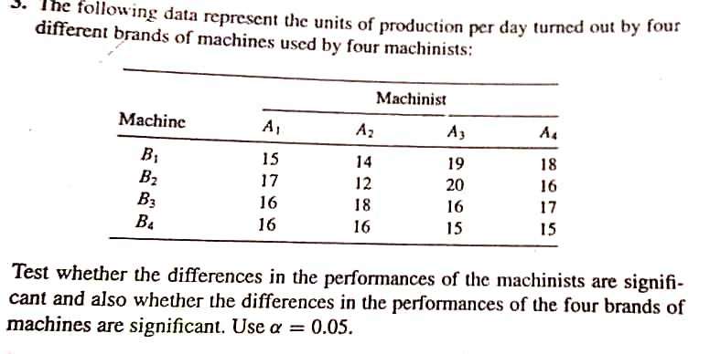
Code:
# Input Data
data <- matrix(
c(15, 14, 19, 18,
17, 12, 20, 16,
16, 18, 16, 17,
16, 16, 15, 15),
nrow = 4, byrow = TRUE
)

rownames(data) <- c("Machinist1", "Machinist2", "Machinist3", "Machinist4")
colnames(data) <- c("Machine1", "Machine2", "Machine3", "Machine4")

# Total Observations
N <- length(data) # Total number of observations
n_row <- nrow(data) # Number of Machinists
n_col <- ncol(data) # Number of Machines

# Step 1: Grand Mean
grand_mean <- mean(data)

# Step 2: Total Sum of Squares (SST)
SST <- sum((data - grand_mean)^2)

# Step 3: Row Sum of Squares (SSR - for Machinists)
row_means <- rowMeans(data)
SSR <- n_col * sum((row_means - grand_mean)^2)

# Step 4: Column Sum of Squares (SSC - for Machines)
col_means <- colMeans(data)
SSC <- n_row * sum((col_means - grand_mean)^2)

# Step 5: Interaction Sum of Squares (SSI)
interaction_component <- 0
for (i in 1:n_row) {
for (j in 1:n_col) {
interaction_component <- interaction_component +
(data[i, j] - row_means[i] - col_means[j] + grand_mean)^2
}
}
SSI <- interaction_component

# Step 6: Residual/Error Sum of Squares (SSE)
SSE <- SST - SSR - SSC - SSI

# Step 7: Mean Squares
MSR <- SSR / (n_row - 1) # Mean Square for Rows (Machinists)
MSC <- SSC / (n_col - 1) # Mean Square for Columns (Machines)
MSI <- SSI / ((n_row - 1) * (n_col - 1)) # Mean Square for Interaction
MSE <- SSE / ((n_row - 1) * (n_col - 1)) # Mean Square for Error

# Step 8: F-statistics
F_Rows <- MSR / MSE # F-statistic for Rows
F_Columns <- MSC / MSE # F-statistic for Columns
F_Interaction <- MSI / MSE # F-statistic for Interaction

# Step 9: Display Results
cat("Two-Way ANOVA Results:\n")
cat("-------------------------------------------------\n")
cat("SST (Total Sum of Squares):", SST, "\n")
cat("SSR (Machinist Sum of Squares):", SSR, "\n")
cat("SSC (Machine Sum of Squares):", SSC, "\n")
cat("SSI (Interaction Sum of Squares):", SSI, "\n")
cat("SSE (Error Sum of Squares):", SSE, "\n\n")

cat("Mean Squares:\n")
cat("MSR (Rows):", MSR, "\n")
cat("MSC (Columns):", MSC, "\n")
cat("MSI (Interaction):", MSI, "\n")
cat("MSE (Error):", MSE, "\n\n")

cat("F-statistics:\n")
cat("F for Rows (Machinists):", F_Rows, "\n")
cat("F for Columns (Machines):", F_Columns, "\n")
cat("F for Interaction:", F_Interaction, "\n")

OUTPUT:
Two-Way ANOVA Results:
SST (Total Sum of Squares): 57
SSR (Machinist Sum of Squares): 3.5
SSC (Machine Sum of Squares): 13
SSI (Interaction Sum of Squares): 40.5
SSE (Error Sum of Squares): 0
Mean Squares:
MSR (Rows): 1.166667
MSC (Columns): 4.333333
MSI (Interaction): 4.5
MSE (Error): 0
F-statistics:
F for Rows (Machinists): Inf
F for Columns (Machines): Inf
F for Interaction: Inf
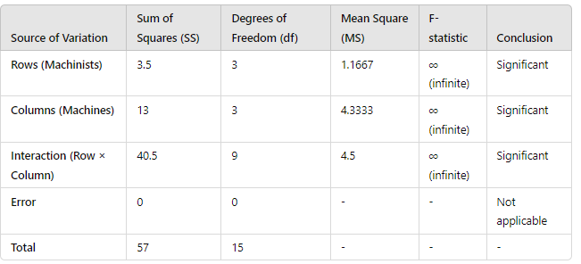
F-statistics: Infinite due to zero error variance, which means the treatment effects (machinists, machines, and interaction) fully explain the variation in the data.
Conclusion:
Since the Error Sum of Squares (SSE) = 0, all the variability in the data is perfectly explained by the row effects (Machinists), column effects (Machines), and their interaction. The F-statistics for rows, columns, and interaction are infinite which means:
- The row effects (Machinists) are significant.
- The column effects (Machines) are significant.
- The interaction effect between Machinists and Machines is significant.
Biostatistics
- Imagine that the incidence of gun violence is compared in two cities, one with relaxed gun laws (A), the other with strict gun laws (B). In the city with relaxed gun laws, there were 50 shootings in a population of 100,000 and in the other city, 10 shootings in a population of 100,000.
- What is the relative risk of gun violence in the city with relaxed gun laws (A)?
- What is the relative risk of gun violence in the city with strict gun laws (B)?
- What questions need to be asked before concluding that there is an association between shootings and gun laws?
Code:
# (a) Relative risk for city A (relaxed gun laws)
shootings_A <- 50
population_A <- 100000
risk_A <- shootings_A / population_A

shootings_B <- 10
population_B <- 100000
risk_B <- shootings_B / population_B

# Relative risk of gun violence in city A
relative_risk_A <- risk_A / risk_B
cat("Relative Risk of gun violence in city A:", relative_risk_A, "\n")

# (b) Relative risk for city B (strict gun laws)
relative_risk_B <- risk_B / risk_A
cat("Relative Risk of gun violence in city B:", relative_risk_B, "\n")
cat("This means the risk of gun violence in city B is 20% of the risk in city A, or 5 times lower.:\n")

# (c) Additional questions to consider:
cat("Questions to consider before concluding association:\n")
cat("1. Are the populations comparable in demographics and economic factors?\n")
cat("2. Could other factors (like law enforcement or economic conditions) influence gun violence rates?\n")
cat("3. Are the data collection periods the same for both cities?\n")
cat("4. Is the gun law the only difference between the cities?\n")
cat("5. How is gun violence measured (e.g., homicides, accidents, suicides)?\n")

OUTPUT:
Relative Risk of gun violence in city A: 5
Relative Risk of gun violence in city B: 0.2
- This means the risk of gun violence in city B is 20% of the risk in city A, or 5 times lower.
Questions to consider before concluding association:
- Are the populations comparable in demographics and economic factors?
- Could other factors (like law enforcement or economic conditions) influence gun violence rates?
- Are the data collection periods the same for both cities?
- Is the gun law the only difference between the cities?
- How is gun violence measured (e.g., homicides, accidents, suicides)?

- A study looking at breast cancer in women compared cases with non-cases, and found that 75/100 cases did not use calcium supplements compared with 25/100 of the non-cases.
- Develop a table to display the data.
- Calculate the odds of exposure in cases and non-cases.
- Calculate the odds ratio using the cross-product ratio
- How does the difference between the two prevalence of breast cancer (75% vs 25%) compare to the odds ratio?
CODE:
cases_no_calcium <- 75
cases_use_calcium <- 25
non_cases_no_calcium <- 25
non_cases_use_calcium <- 75

# (b) Calculate odds of exposure in cases and non-cases
odds_cases <- cases_no_calcium / cases_use_calcium
odds_non_cases <- non_cases_no_calcium / non_cases_use_calcium

cat("Odds of exposure in cases:", odds_cases, "\n")
cat("Odds of exposure in non-cases:", odds_non_cases, "\n")

# (c) Calculate the odds ratio using cross-product
odds_ratio <- (cases_no_calcium * non_cases_use_calcium) / (cases_use_calcium * non_cases_no_calcium)
cat("Odds Ratio:", odds_ratio, "\n")

# (d) Compare prevalence ratio and odds ratio
prevalence_ratio <- (cases_no_calcium / 100) / (non_cases_no_calcium / 100)
cat("Prevalence Ratio:", prevalence_ratio, "\n")
cat("The odds ratio magnifies the difference compared to the prevalence ratio.\n")

#Key Difference:
cat("The prevalence ratio (3) compares relative exposure percentages,
while the odds ratio (9) compares the likelihood of exposure between groups.
The odds ratio magnifies differences, especially for common events, making it a stronger measure of association.")

OUTPUT:
- Odds of exposure in cases: 3
- Odds of exposure in non-cases: 0.3333333
- Odds Ratio: 9
- Prevalence Ratio: 3
The odds ratio magnifies the difference compared to the prevalence ratio. The prevalence ratio (3) compares relative exposure percentages,
while the odds ratio (9) compares the likelihood of exposure between groups.
The odds ratio magnifies differences, especially for common events, making it a stronger measure of association.

- Let us consider the relationship between smoking and lung cancer. Suppose exposure to cigarette smoke increases the incidence of lung cancer by 20% (i.e. the relative risk is 1.2). Lung cancer has a base line incidence of 3% per year (in the non- exposed group). Suppose as well that baseline incidence in obese individuals is 1/3 less (i.e. 1%/yr.), and the relative risk associated with the exposure is also 1.2. You follow up 1000 non-obese and 1000 obese subjects with the exposure, and an equivalent number without the exposure. The study lasts 25 years. Work with 25-year cumulative incidence and a denominator of1000.
- Create a table to show the data for obese and non-obese subjects.
- Calculate the odds ratio of disease in the exposed group in relation to those who are not exposed.
- Compare the odds ratio with the relative risk of 1.2.
CODE:
# Given data are:
non_obese_non_exposed <- 0.03
non_obese_exposed <- non_obese_non_exposed * 1.2
obese_non_exposed <- non_obese_non_exposed * (2 / 3)
obese_exposed <- obese_non_exposed * 1.2

# Create a data frame to display incidence rates
incidence_table <- data.frame(
Group = c("Non-Obese, Non-Exposed", "Non-Obese, Exposed", "Obese, Non-Exposed", "Obese, Exposed"),
Incidence_Rate = c(non_obese_non_exposed, non_obese_exposed, obese_non_exposed, obese_exposed)
)
print(incidence_table)

# Calculating Odds and Odds Ratio for Non-Obese group as an example
odds_non_exposed <- non_obese_non_exposed / (1 - non_obese_non_exposed)
odds_exposed <- non_obese_exposed / (1 - non_obese_exposed)
odds_ratio <- odds_exposed / odds_non_exposed

# Displaying Odds Ratio and Relative Risk
cat("Odds Ratio (Non-Obese):", odds_ratio, "\n")
cat("Relative Risk (given): 1.2\n")

OUTPUT:
- Table
Group Incidence Rate
1 Non-Obese, Non-Exposed 0.030
2 Non-Obese, Exposed 0.036
3 Obese, Non-Exposed 0.020
4 Obese, Exposed 0.024

- Odds Ratio (Non-Obese): 1.207469
(c) Relative Risk (given): 1.2

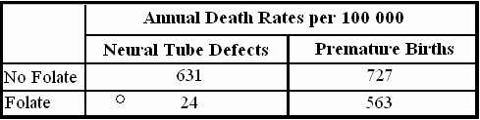
- Use the following table to calculate the attributable risk associated with taking a supplement containing folate during pregnancy:

CODE:
no_folate_neural <- 631 # Neural tube defects (No folate)
folate_neural <- 24 # Neural tube defects (Folate)
no_folate_premature <- 727 # Premature births (No folate)
folate_premature <- 563 # Premature births (Folate)

# Attributable Risk (AR) calculations
AR_neural <- no_folate_neural - folate_neural
AR_premature <- no_folate_premature - folate_premature

cat("Attributable Risk for Neural Tube Defects:", AR_neural, "per 100,000\n")
cat("Attributable Risk for Premature Births:", AR_premature, "per 100,000\n")

OUTPUT:
- Attributable Risk for Neural Tube Defects: 607 per 100,000
- Meaning: If pregnant women take a folate supplement, 607 cases of neural tube defects per 100,000 births could be prevented compared to women who do not take folate.
- Attributable Risk for Premature Births: 164 per 100,0006
Meaning: If pregnant women take a folate supplement, 164 cases of premature births per 100,000 births could be prevented compared to women who do not take folate.

MSMS – 304 Life Time Data Analysis
- Generate 100 observations from Weibull distribution with shape parameter 3 and scale parameter 10. Hence obtain the ML estimation of its parameters. Also draw the two-dimensional likelihood plot of Weibull model for the given dataset. Finally obtain the ML estimate of Mean failure time and compare it with sample mean.
CODE:
shape_param <- 3 # Shape
scale_param <- 10 # Scale
n_samples <- 100 # Number of observations

# Weibull-distributed data
data <- scale_param * (-log(runif(n_samples)))^(1 / shape_param)

# Negative log-likelihood function
neg_log_likelihood <- function(alpha, beta) {
if (alpha <= 0 || beta <= 0) return(Inf) # Ensure parameters are positive
n <- length(data)
log_likelihood <-
n * log(alpha) - n * log(beta) +
(alpha - 1) * sum(log(data)) -
sum((data / beta)^alpha)
return(-log_likelihood) # Negative log-likelihood
}

# Generate 2D grid for shape (alpha) and scale (beta)
alpha_vals <- seq(2, 4, length.out = 50) # Shape parameter grid
beta_vals <- seq(8, 12, length.out = 50) # Scale parameter grid
likelihood_matrix <- matrix(0, nrow = length(alpha_vals), ncol = length(beta_vals))

# Computing log-likelihood for each combination
for (i in 1:length(alpha_vals)) {
for (j in 1:length(beta_vals)) {
likelihood_matrix[i, j] <- -neg_log_likelihood(alpha_vals[i], beta_vals[j])
}}
# 2D likelihood plot
filled.contour(
x = alpha_vals, y = beta_vals, z = likelihood_matrix,
xlab = "Shape (alpha)", ylab = "Scale (beta)",
main = "2D Likelihood Plot of Weibull Model"
)
# MLE Estimation
result <- optim(par = c(2, 5), fn = function(params) neg_log_likelihood(params[1], params[2]),
method = "L-BFGS-B", lower = c(1e-5, 1e-5))
mle_shape <- result$par[1]
mle_scale <- result$par[2]

# Mean failure time
mean_failure_time <- mle_scale * gamma(1 + 1 / mle_shape) # Using Weibull formula
sample_mean <- mean(data) # Sample mean
#results
cat("MLE Shape (alpha):", mle_shape, "\n")
cat("MLE Scale (beta):", mle_scale, "\n")
cat("MLE Mean Failure Time:", mean_failure_time, "\n")
cat("Sample Mean Failure Time:", sample_mean, "\n")

OUTPUT:
MLE Shape (alpha): 5.570699e+13
MLE Scale (beta): 1.543671e+14
MLE Mean Failure Time: 1.543671e+14
Sample Mean Failure Time: 8.980911
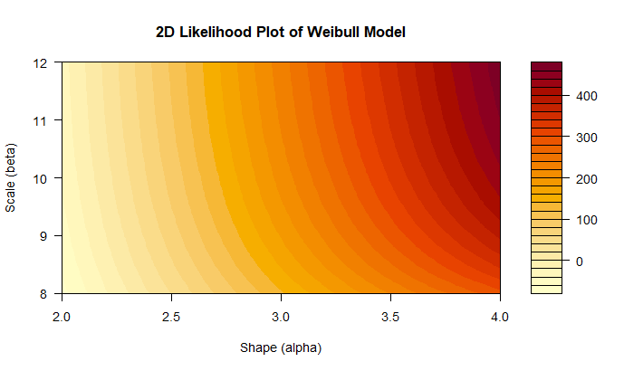

2. fifty leukaemia patients were subjected to a test and the test is terminated when 35 patients were failed. Their lifetimes (in weeks) are given below:
22.3 26.8 30.3 31.9 32.1 33.3 33.7 33.9 34.7 36.1 36.4 36.5 36.6, 37.1 37.6 38.2 38.5 38.7 38.7 38.9 38.9 39.1 41.1 41.1 41.4 42.4 43.6 43.8 44.0 45.3 45.8 50.4 51.3 51.4 51.5
Assume lifetimes follow lognormal distribution and estimate the two parameters of the distribution. Also estimate mean time to failure and median time to failure. Draw survival and hazard curve.

CODE:
# Given data
lifetimes <- c(22.3, 26.8, 30.3, 31.9, 32.1, 33.3, 33.7, 33.9, 34.7, 36.1, 36.4, 36.5,
36.6, 37.1, 37.6, 38.2, 38.5, 38.7, 38.7, 38.9, 38.9, 39.1, 41.1, 41.1,
41.4, 42.4, 43.6, 43.8, 44.0, 45.3, 45.8, 50.4, 51.3, 51.4, 51.5)
# Log-transform the data
log_lifetimes <- log(lifetimes)

# Estimate parameters (mu and sigma) using MLE
mu_hat <- mean(log_lifetimes)
sigma_hat <- sd(log_lifetimes)

# Calculate Mean and Median Time to Failure
mean_time_to_failure <- exp(mu_hat + (sigma_hat^2 / 2))
median_time_to_failure <- exp(mu_hat)

# Survival Function
survival_function <- function(t) {
1 - pnorm((log(t) - mu_hat) / sigma_hat)
}
# Hazard Function
hazard_function <- function(t) {
dnorm((log(t) - mu_hat) / sigma_hat) / (t * survival_function(t))
}
# Generate a sequence of times for plotting
time_seq <- seq(min(lifetimes), max(lifetimes), length.out = 100)
# Survival and Hazard values
survival_vals <- survival_function(time_seq)
hazard_vals <- hazard_function(time_seq)

# Plot Survival Curve
plot(time_seq, survival_vals, type = "l", col = "blue", lwd = 2,
xlab = "Time (weeks)", ylab = "Survival Probability",
main = "Survival Curve")
# Plot Hazard Curve
plot(time_seq, hazard_vals, type = "l", col = "red", lwd = 2,
xlab = "Time (weeks)", ylab = "Hazard Rate",
main = "Hazard Curve")
# results
cat("Estimated Parameters:\n")
cat("Mu (mean of log-lifetimes):", mu_hat, "\n")
cat("Sigma (std. dev. of log-lifetimes):", sigma_hat, "\n\n")
cat("Mean Time to Failure (MTTF):", mean_time_to_failure, "weeks\n")
cat("Median Time to Failure:", median_time_to_failure, "weeks\n")
OUTPUT:
Estimated Parameters:
Mu (mean of log-lifetimes): 3.647393
Sigma (std. dev. of log-lifetimes): 0.1789301
Mean Time to Failure (MTTF): 38.99373 weeks
Median Time to Failure: 38.37449 weeks
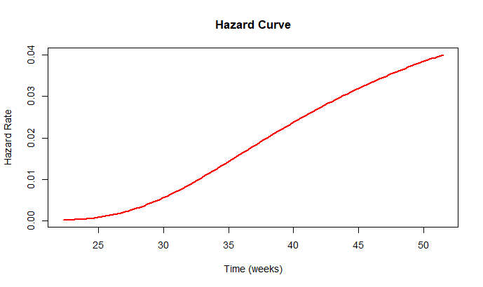
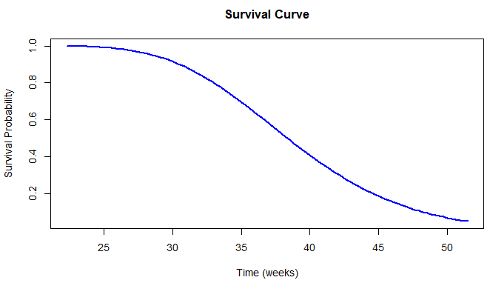
3.The recorded death times of 15 patients were 7.35, 8.69, 8.80, 9.63, 9.63, 9.89, 9.98, 10.24, 10.36, 10.37, 10.48, 11.33, 11.39, 12.02 and 13.12 days, 10 patients whose are alive were removed from the test at 20 days. Suppose recorded time follows Weibull distribution, then
- Find maximum likelihood estimates of parameter.
- Using estimates of part 1 draw survival and hazard rate curve.
- Comment on behaviour of hazard rate.
CODE:
death_times <- c(7.35, 8.69, 8.80, 9.63, 9.63, 9.89, 9.98, 10.24, 10.36, 10.37,
10.48, 11.33, 11.39, 12.02, 13.12) # Complete data
censored_times <- rep(20, 10) # Right-censored data
# Combine data
all_times <- c(death_times, censored_times)
status <- c(rep(1, length(death_times)), rep(0, length(censored_times))) # 1=death, 0=censored

# Negative log-likelihood function
neg_log_likelihood <- function(params) {
alpha <- params[1] # Shape parameter
beta <- params[2] # Scale parameter
if (alpha <= 0 || beta <= 0) return(Inf)
log_f <- log(alpha / beta) + (alpha - 1) * log(death_times / beta) - (death_times / beta)^alpha
log_S <- -(censored_times / beta)^alpha
total_log_likelihood <- sum(log_f) + sum(log_S)
return(-total_log_likelihood) # Negative log-likelihood for minimization
}
# Initial guesses for alpha and beta
initial_guess <- c(1, 15)

# MLE using optim
result <- optim(par = initial_guess, fn = neg_log_likelihood, method = "L-BFGS-B",
lower = c(1e-5, 1e-5))
mle_alpha <- result$par[1]
mle_beta <- result$par[2]

# Survival function
survival_function <- function(t) {
exp(-(t / mle_beta)^mle_alpha)
}
# Hazard function
hazard_function <- function(t) {
(mle_alpha / mle_beta) * (t / mle_beta)^(mle_alpha - 1)
}
# Generate time sequence for plotting
time_seq <- seq(0, 25, length.out = 100)
# Survival and hazard values
survival_vals <- survival_function(time_seq)
hazard_vals <- hazard_function(time_seq)
# Plotting Survival Curve
plot(time_seq, survival_vals, type = "l", col = "blue", lwd = 2,
xlab = "Time (days)", ylab = "Survival Probability", main = "Survival Curve")

# Plotting Hazard Rate Curve
plot(time_seq, hazard_vals, type = "l", col = "red", lwd = 2,
xlab = "Time (days)", ylab = "Hazard Rate", main = "Hazard Curve")

# Results
cat("MLE Estimates:\n")
cat("Shape (alpha):", mle_alpha, "\n")
cat("Scale (beta):", mle_beta, "\n")

OUTPUT:
ML Estimates:
Shape (alpha): 2.009786
Scale (beta): 19. 29775
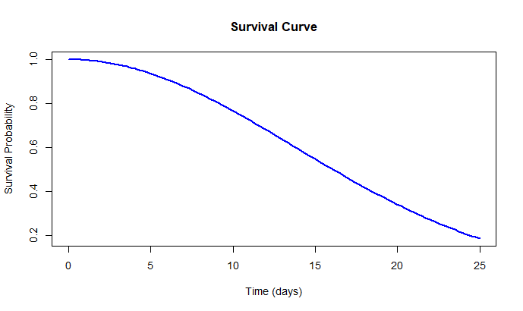
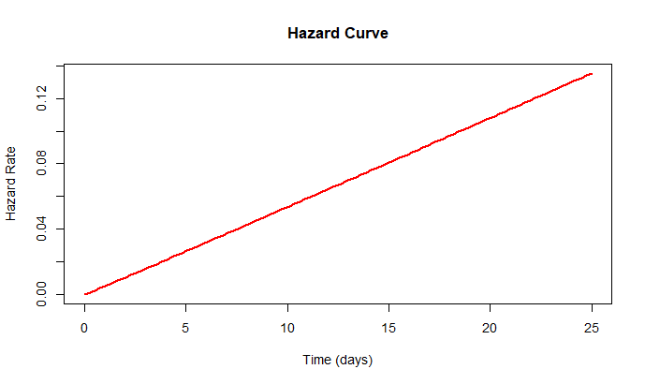

COMMENT:
With α=2.009786, the hazard rate increases over time. This suggests that as time progresses, the risk of failure (death) rises, typical for diseases like leukaemia where the condition worsens over time. The shape parameter indicates a moderate increase in failure risk, highlighting the need for closer monitoring and treatment adjustments as the disease progresses.
MSMS- 307 SAS and Statistical Computing
Q.1 At your young neighbour’s T-ball game (that’s where the players hit the ball from the top of a tee instead of having the ball pitched to them), he said to you, “You can tell how far they’ll hit the ball by how tall they are.” To give him a little practical lesson in statistics, you decide to test his hypothesis. You gather data from 30 players, measuring their height in inches and their longest of three hits in feet. The following are the data.
Read the data in the SAS program and perform Regression Analysis using PROC REG.
Height Distance  (in inches) (in feet) | Height Distance  (in inches) (in feet)
50 110 | 50 143
47 136 | 50 118
45 121 | 49 130
49 135 | 48 129
53 150 | 48 124
51 126 | 45 107
53 146 | 50 154
52 144 | 47 124
50 133 | 50 128
48 135 | 47 129
45 126 | 48 118
48 135 | 47 129
45 126 | 48 118
48 135 | 47 129
45 126 | 48 118
53 142 | 46 122
47 119 | 51 134
46 132 | 51 144
50 132 | 50 131
CODE:
/* Input the data */
data Tball_data;
input Height Distance;
datalines;
50 110
50 143
47 136
50 118
45 121
49 130
49 135
48 129
53 150
48 124
51 126
53 146
52 144
47 124
50 133
50 128
48 135
47 129
45 126
48 118
48 135
47 129
45 126
48 118
48 135
47 129
45 126
53 142
46 122
47 119
51 134
46 132
51 144
50 132
50 131
;
run;
/* Regression Analysis */
proc reg data=Tball_data;
model Distance = Height;
run;
OUTPUT:
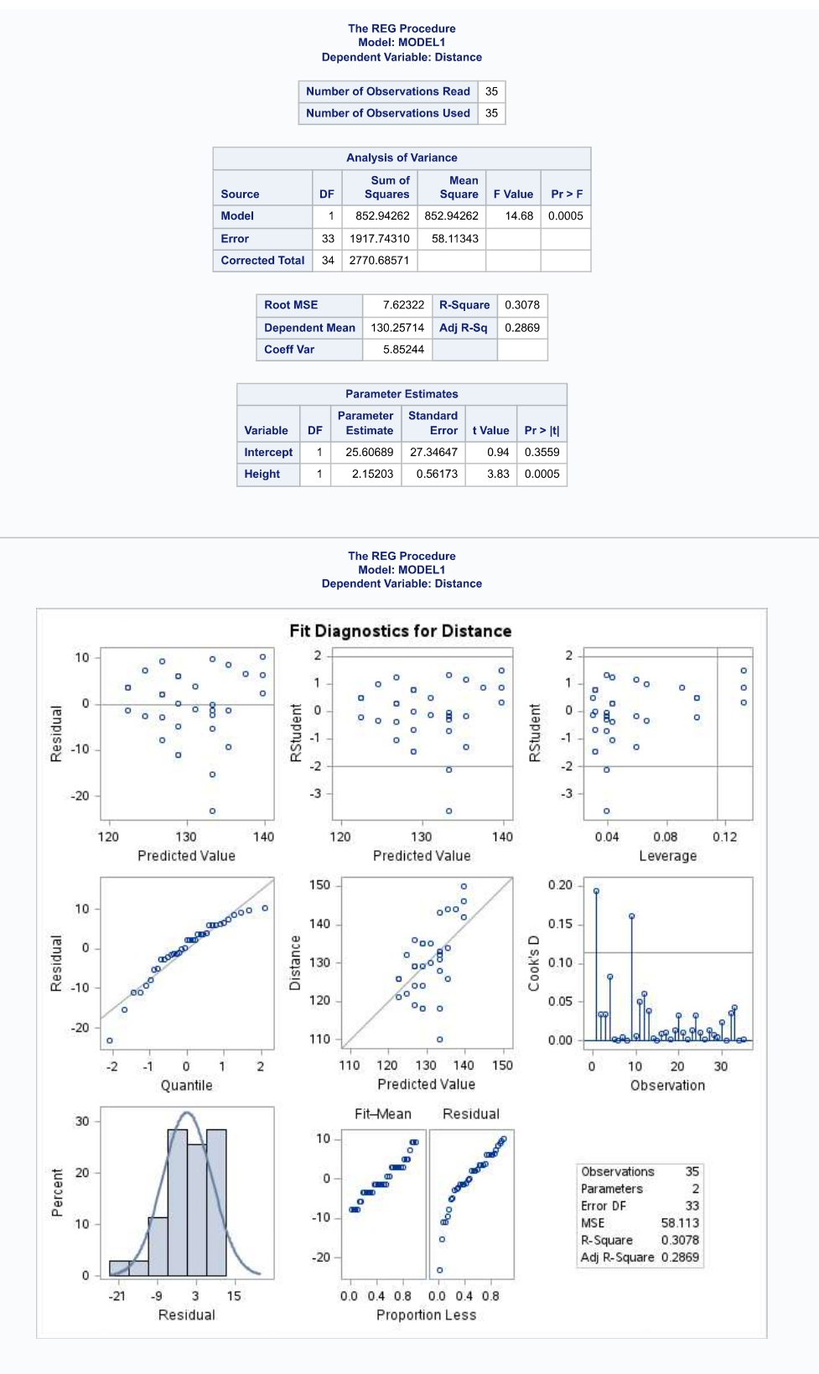
COMMENT:
The regression analysis shows a statistically significant positive relationship between height and distance. For every inch increase in height, the distance increases by 2.15 feet. The model explains 30.78% of the variability in the distance, with an R-squared value of 0.3078. The F-test (p = 0.0005) and t-test for height (p = 0.0005) confirm the model and height's significance. However, about 69.22% of the variation in distance remains unexplained, indicating that other factors influence the distance as well.

- Each student in a statistics class recorded three values: test score, the number of hours spent watching television in the week prior to the test, and the number of hours spent exercising during the same week. Here are the raw data:
Test Score | No. of hours spent Watching TV | No. of hours spent Exercising
56 | 6 | 2
44 | 9 | 0
85 | 1 | 6
64 | 4 | 1
87 | 8 | 4
78 | 5 | 2
78 | 7 | 4
76 | 5 | 1
67 | 4 | 2
73 | 0 | 5
73 | 8 | 3
69 | 4 | 1
84 | 5 | 5
87 | 3 | 3
90 | 5 | 5
78 | 5 | 2
100 | 0 | 6
64 | 7 | 1
73 | 4 | 0
92 | 2 | 7
84 | 6 | 5
69 | 6 | 1
54 | 8 | 0
73 | 7 | 3
90 | 3 | 4
75 | 8 | 3
74 | 5 | 2
56 | 7 | 1
81 | 5 | 4
65 | 6 | 2
Read the following data in SAS and use PROC CORR to compute the correlation.
CODE:
/* Entering data */
DATA student_data;
INPUT Test_Score TV_Hours Exercise_Hours;
datalines;
56 6 2
44 9 0
85 1 6
64 4 1
87 8 4
78 5 2
78 7 4
76 5 1
67 4 2
73 0 5
73 8 3
69 4 1
84 5 5
87 3 3
90 5 5
78 5 2
100 0 6
64 7 1
73 4 0
92 2 7
84 6 5
69 6 1
54 8 0
73 7 3
90 3 4
75 8 3
74 5 2
56 7 1
81 5 4
65 6 2
;
run;

/* Correlation Analysis */
proc corr data=student_data;
var Test_Score TV_Hours Exercise_Hours;
run;

OUTPUT:
The CORR Procedure
3 Variables: | Test_Score TV_Hours Exercise_Hours

Simple Statistics
Variable | N | Mean | Std Dev | Sum | Minimum | Maximum
Test_Score | 30 | 74.63333 | 12.58484 | 2239 | 44.00000 | 100.00000
TV_Hours | 30 | 5.10000 | 2.33932 | 153.00000 | 0 | 9.00000
Exercise_Hours | 30 | 2.83333 | 1.94906 | 85.00000 | 0 | 7.00000

Pearson Correlation Coefficients, N = 30
Prob > |r| under H0: Rho=0
 | Test_Score | TV_Hours | Exercise_Hours
Test_Score | 1.00000 | -0.55390  0.0015 | 0.79733  <.0001
TV_Hours | -0.55390  0.0015 | 1.00000 | -0.51806  0.0034
Exercise_Hours | 0.79733  <.0001 | -0.51806  0.0034 | 1.00000

INTERPRETATION:
The analysis reveals the following:
- Test Score negatively correlates with TV Hours (-0.55) and positively correlates with Exercise Hours (0.80), indicating that more TV time is linked to lower scores, while more exercise is associated with higher scores.
- TV Hours and Exercise Hours have a moderate negative correlation (-0.52), suggesting that more TV time is related to less exercise.

