Dissertation- Mid semester Report

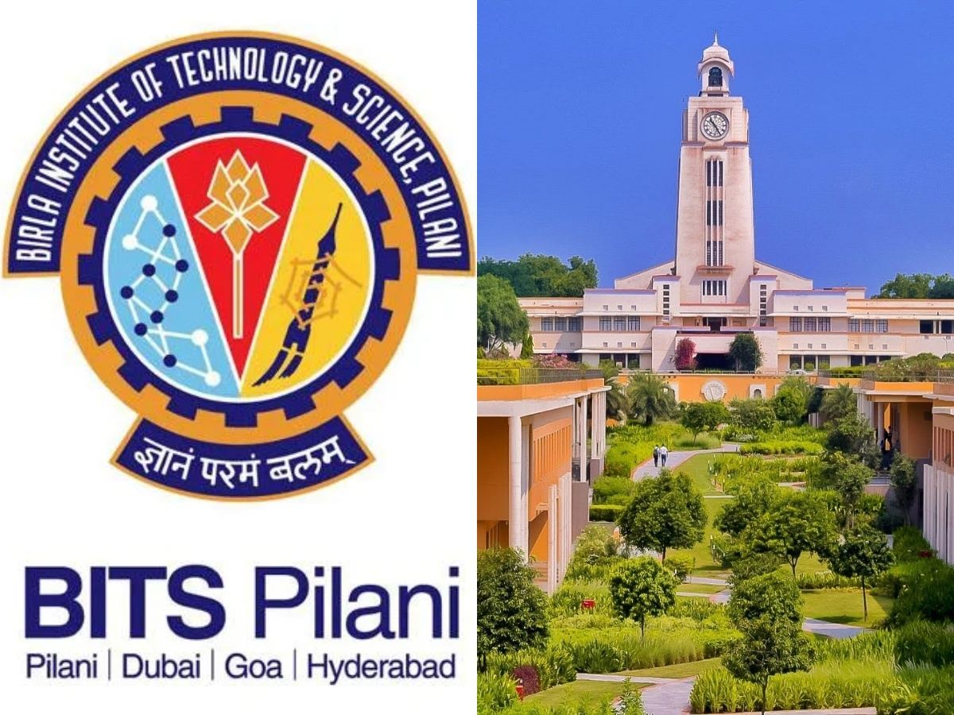

Artificial intelligence Use Cases in Healthcare
- AI-Based Early Detection of Diseases Using Medical Imaging
- Extracting Intelligence from Electronic Health Records
- Predicting Drug Response Using Machine Learning

2023AA05705

Submitted in partial fulfillment of the requirements of the

Degree: MTech in Artificial Intelligence & Machine Learning

By

SIDDHARTHA SANDILYA
2023AA05705

Under the supervision of

Saurabh Gandhi, Senior Manager (MSD Pharmaceuticals Pvt Ltd),
MBA

BIRLA INSTITUTE OF TECHNOLOGY & SCIENCE, PILANI
SECOND SEMESTER 2024-25

(July, 2025)

Table of Contents
- Revision history ..........................................................................................................................................................2

- Acknowledgement ......................................................................................................................................................2

- Certificate from supervisor..........................................................................................................................................2

- Dissertation Abstract...................................................................................................................................................2

- List of Symbols & Abbreviations use.........................................................................................................................2

- List of Tables..............................................................................................................................................................2

- List of Figures…………………………………………
- Chapter 1..................................................................................................................................... 2
- Chapter 2 ..................................................................................................................................... 2
- Chapter 3..................................................................................................................................... 2
- Conclusions / Recommendations (not necessary for mid semester)
- Directions for future work after mid semester
- Bibliography / References
- Appendices (not necessary for mid semester)
- List of Publications/Conference Presentations, if any.

- Revision History:

SL No | Version | Change | Comments
1 | 1.0 | Published version | Initial published version
2 | 1.1 | Amended version | Post review with Sujatha S Mam  - Added Section 6 - Literature review  - Added Section 7 – Proposed enhancements  - Added Section 8 – Data Sources  - Added Section 9 – Acronyms
3 | 1.2 | Details added for the mid-semester report | Amended Sections 8 – Data sources Added Section 9, 10, 11, 12, 14

- Acknowledgement:

I would like to express my sincere gratitude to all those who supported and guided me throughout the course of this dissertation.
First and foremost, I extend my heartfelt thanks to my supervisor, Mr. Saurabh Gandhi, Senior Manager, for his invaluable guidance, encouragement, and insightful feedback at every stage of this project. His expertise and experience have greatly enriched the quality of my work.
I am also thankful to the faculty members and staff at BITS Pilani, who have provided a strong academic foundation and the resources necessary for the successful execution of this research.
I would also like to acknowledge the support of my colleagues and peers for their helpful suggestions and moral support.
Lastly, I am deeply grateful to my family for their unwavering love, patience, and encouragement throughout my academic journey

BIRLA INSTITUTE OF TECHNOLOGY AND SCIENCE, PILANI
II SEMESTER 24-25
DSECLZG628T / AIMLCZG628T DISSERTATION
Dissertation Outline (Abstract)

BITS ID No. 2023AA05705

Name of Student: SIDDHARTHA SANDILYA

Name of Supervisor: SAURABH GANDHI

Designation of Supervisor: SENIOR MANAGER, MSD PHARMACEUTICALS PVT LTD

Qualification and Experience: B. Tech, MBA, 10+ Yrs

Official E- mail ID of Supervisor: saurabh.gandhi@merck.com

Topic of Dissertation: AI Use Cases in Healthcare

AI-Based Early Detection of Diseases Using Medical Imaging

Clinical NLP for Decision Support: Extracting Intelligence from HER

Predicting Drug Response Using Machine Learning for Personalized Medicine

(Signature of Student): 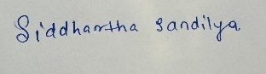 (Signature of Supervisor) 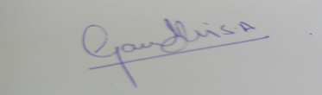
Date: 30th June 2025 Date: 30th June 2025
Abstract
(Contents of the outline /abstract is to be given here)

Abstract (in about 500 words)
(Note: The Outline / Abstract should briefly describe the work done with respect to the goals, in about 500 words).
Artificial Intelligence (AI) is increasingly transforming the healthcare ecosystem by enhancing diagnostic accuracy, enabling data-driven clinical decisions, and facilitating the design of personalized treatment plans. This dissertation explores three core AI applications in healthcare: AI-Based Early Detection of Diseases Using Medical Imaging, Clinical NLP for Decision Support: Extracting Intelligence from Electronic Health Records, and Predicting Drug Response Using Machine Learning for Personalized Medicine. Together, these focus areas represent a comprehensive effort to address some of the most pressing challenges across the healthcare continuum.
The first topic, AI-Based Early Detection of Diseases Using Medical Imaging, investigates the use of deep learning models, particularly Convolutional Neural Networks (CNNs), to detect abnormalities such as pneumonia or tumors in X-ray and MRI scans. By leveraging transfer learning and explainable AI techniques like Grad-CAM, the model highlights regions of interest and supports radiologists in achieving faster and more accurate diagnoses, especially in settings with limited specialist availability.
The second topic, Clinical NLP for Decision Support, focuses on applying advanced Natural Language Processing (NLP) models such as BERT and Clinical BERT to extract meaningful clinical insights from unstructured Electronic Health Records (EHRs). This includes automated identification of diagnoses, procedures, and medications to support clinicians with evidence-based decision-making. Utilizing publicly available datasets like MIMIC-III, the project ensures that sensitive patient information remains protected while still enabling rich data analysis.
The third topic, Predicting Drug Response Using Machine Learning for Personalized Medicine, aims to build predictive models using algorithms like XG-Boost and Random Forests. These models analyze patient-specific factors such as demographics, clinical history, and genomics to forecast how individuals might respond to various medications. The goal is to support precision medicine by optimizing treatment plans, improving efficacy, and minimizing adverse drug reactions.
All three modules of this dissertation will be developed using open-source tools such as TensorFlow, Scikit-learn, Hugging Face Transformers, and evaluated using domain-appropriate metrics like AUC-ROC, F1-score, and BLEU for NLP. Public datasets including ChestX-ray14, LIDC-IDRI, MIMIC-III, and Drug Bank will be used to ensure reproducibility and applicability to real-world scenarios. In essence, this dissertation highlights how integrating AI across diagnostic, decision-making, and therapeutic layers can significantly improve patient care outcomes, reduce clinical burden, and enable a shift toward intelligent, efficient, and personalized healthcare delivery. Keywords: Artificial Intelligence in Healthcare, Deep Learning in Medical Imaging, Clinical Decision Support Systems Healthcare Predictive Modeling

- List of Symbols & Abbreviations use:

- AI – Artificial Intelligence
- CNN – Convolutional Neural Network
- NLP – Natural Language Processing
- EHR – Electronic Health Record
- IC50 – Half maximal inhibitory concentration
- ML – Machine Learning
- DL – Deep Learning
- Grad-CAM – Gradient-weighted Class Activation Mapping
- ViT – Vision Transformer
- AUC – Area Under Curve
- BERT – Bidirectional Encoder Representations from Transformers

- List of tables:

Table no. | Title | Page No.
1 | Dataset Summary for Medical Imaging (Chest X-ray Pneumonia Dataset)
2 | Sample EHR Notes with Annotated Labels
3 | Model Evaluation Metrics for Clinical BERT
4 | Summary of Genomic Features Used from GDSC Dataset
5 | Performance Comparison of Drug Sensitivity Prediction Models
6 | Feature Importance Scores for Top Biomarkers
7
8
9
10

The plan of work should have tangible weekly or fortnightly milestones and deliverables, which can be measured to assess the adherence to the plan and therefore the rate of progress in the work. The plan of work can be specified in the table given below:

- List of figures:

Table no. | Title | Page No.
1 | Architecture of CNN for Pneumonia Detection
2 | Grad-CAM Visualization of Lung Infection Area in Chest X-ray
3 | Model Evaluation Metrics for Clinical BERT
4 | Summary of Genomic Features Used from GDSC Dataset
5 | Performance Comparison of Drug Sensitivity Prediction Models
6 | Feature Importance Scores for Top Biomarkers
7
8
9
10

- Chapter 1:

Literature References
The following literature and datasets have been reviewed to support the research and development of this dissertation across the domains of medical imaging, clinical NLP, and predictive modeling for drug response:
- Medical Imaging Diagnosis
- Wang, X. et al. (2017). ChestX-ray8: Hospital-scale Chest X-ray Database and Benchmarks on Weakly-Supervised Classification and Localization of Common Thorax Diseases. IEEE CVPR.
- Esteva, A. et al. (2017). Dermatologist-level classification of skin cancer with deep neural networks. Nature.
- Litjens, G. et al. (2017). A survey on deep learning in medical image analysis. Medical Image Analysis.
- Clinical Decision Support via NLP
- Alsentzer, E. et al. (2019). Publicly Available Clinical BERT Embeddings. arXiv:1904.03323.
- Johnson, A. E. W. et al. (2016). MIMIC-III, a freely accessible critical care database. Scientific Data.
- Huang, K. et al. (2019). ClinicalXLNet: Modeling Long-term Dependencies in Clinical Text. ACL.
- Drug Response & Personalized Medicine
- Zhang, W. et al. (2015). Predicting drug sensitivity of cancer cells using genomic and chemical properties. Bioinformatics.
- Gao, H. et al. (2015). High-throughput screening using patient-derived tumor xenografts to predict clinical trial drug response. Nature Medicine.
- Yang, M. et al. (2020). Machine Learning for Drug Response Prediction in Cancer Therapy. Frontiers in Pharmacology.
- Datasets and Tools
- ChestX-ray14 Dataset – NIH Clinical Center
- MIMIC-III – Beth Israel Deaconess Medical Center & MIT Lab for Computational Physiology
- DrugBank & PubChem – Public Repositories for Drug and Chemical Data
- Hugging Face Transformers – Open-source NLP model hub
- TensorFlow & Scikit-learn – Python libraries for deep learning and machine learning

Supervisor’s Rating of the Technical Quality of this Dissertation Outline

EXCELLENT / GOOD / FAIR/ POOR (Please specify): EXCELLENT

Supervisor’s suggestions and remarks about the outline (if applicable).

Date 21st May 2025  (Signature of Supervisor)

Name of the supervisor: Saurabh Gandhi

Email Id of Supervisor: Saurabh.Gandhi@merck.com/gandhisaurabh91@gmail.com

