Q4) Task1: Calculating similarity (output will be saved in BioSim-100-predicted.txt)

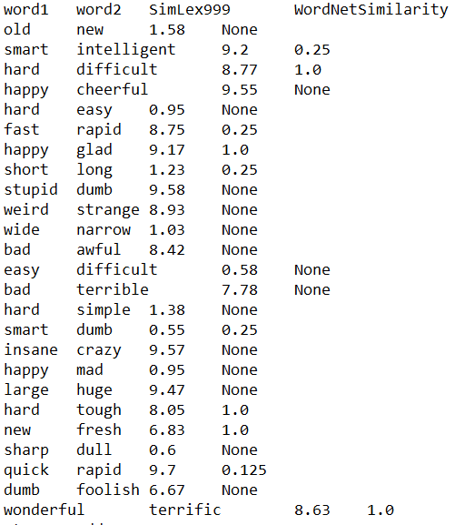

Task2: calculating similarity between words(Output will be saved in original-pairs.txt file)

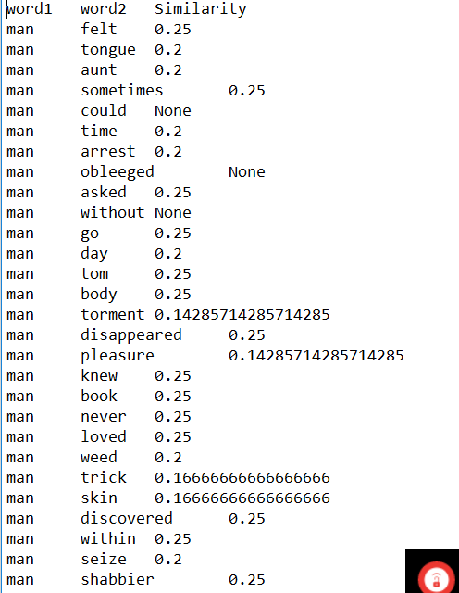

Task3: Calculating hypernyms (Output will be saved in original-pair-hypernyms.txt file)

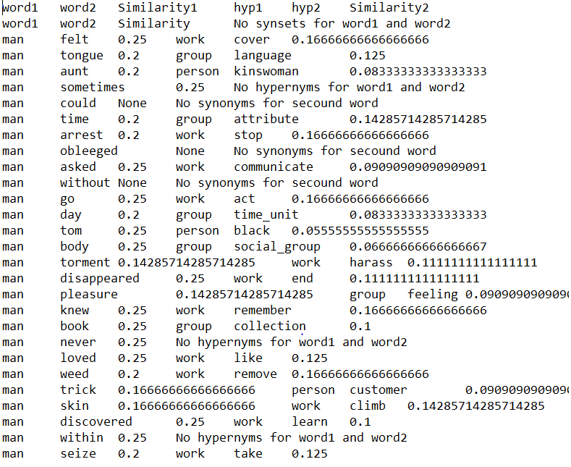

Task4: Top 10 similar pairs (Output will be saved in top.txt file)

