Week 3 Task Report
Statistical Analysis and Predictive Modeling using R
Dataset: Palmer Archipelago (Antarctica) Penguin Data
Field | Detail
Author | Siddhesh Mhatre
Task | Week 3 - Statistical Analysis and Predictive Modeling with R
Tool / Environment | R 4.5.1 - ggplot2 3.5.2 - MASS 7.3.65 - base stats
Dataset source | palmerpenguins - https://allisonhorst.github.io/palmerpenguins/ (CC0)
Records / Variables | 333 modelling observations x 8 variables
Research question | Can a penguin's sex be predicted from its body measurements?
Modelling approach | Binary logistic regression, 10-fold stratified cross-validation, LDA benchmark
Headline result | 91.0% CV accuracy, AUC 0.967, Brier score 0.067
Figures | 13 (distributions, diagnostics, ROC, confusion matrix, calibration)
Date | 20 August 2026

Table of Contents
1. Introduction and Objective
2. Dataset Identification and Rationale
3. Data Preparation and Analysis Frame
4. Exploratory Statistical Analysis and Hypothesis Testing
4.1 Normality of the candidate predictors
4.2 Homogeneity of variance
4.3 Difference in means: Welch t-tests and Wilcoxon tests
4.4 Two-way ANOVA: species, sex and their interaction
4.5 Independence of sex and species (chi-square)
4.6 Correlation structure and collinearity
5. Model Building
5.1 Why logistic regression
5.2 Candidate specifications
5.3 Stratified 10-fold cross-validation design
5.4 Cross-validated performance and the LDA benchmark
5.5 The final fitted model and its coefficients
6. Diagnostic Analysis
6.1 Confusion matrix and error structure
6.2 Probability separation and threshold choice
6.3 Calibration
6.4 Binned residuals and influence
6.5 A secondary linear regression with classical diagnostics
7. Optimisation and Model Stability
8. Model Performance Interpretation and Potential Improvements
9. Applying the Model: the nine unlabelled penguins
10. Reproducibility
11. Conclusion

1. Introduction and Objective
This report documents the Week 3 workflow: taking the Palmer Penguins dataset that was cleaned in Week 1 and visualised in Week 2, and using it for formal statistical inference and predictive modelling. Every number, table and figure reproduced here was generated in a live R 4.5.1 session by the single script week3_model.R, and every block on a dark background is console output copied verbatim from that session.
The objectives of the week were:
- Select a dataset that supports a genuine prediction problem and justify the choice.
- State testable hypotheses and answer them with the appropriate R tests: normality, homogeneity of variance, difference in means, analysis of variance, independence and correlation.
- Build a predictive model - here a binary logistic classifier - and evaluate it honestly with stratified k-fold cross-validation rather than in-sample accuracy.
- Diagnose the fitted model: confusion matrix, ROC curve, calibration, binned residuals, leverage and influence, and the classical four-panel residual plots for a companion linear model.
- Interpret performance in plain language and set out concrete, prioritised improvements.

2. Dataset Identification and Rationale
The dataset is palmerpenguins, collected by Dr. Kristen Gorman at the Palmer Station Long Term Ecological Research programme in Antarctica and released into the public domain under CC0. It records four morphometric measurements - bill length, bill depth, flipper length and body mass - together with species, island, sex and study year for 344 penguins observed over three breeding seasons (2007-2009).
It was chosen for this task for five concrete reasons:
- It contains a clean binary target. Sex is recorded for 333 of the 342 measured birds and is almost perfectly balanced (165 female, 168 male), so accuracy is a meaningful metric and no resampling for class imbalance is needed.
- The prediction problem is real, not artificial. Sexing penguins in the field ordinarily requires blood sampling or laparoscopy; predicting sex from external measurements is a genuine research question in the literature, so the model has a use rather than being a classroom exercise.
- It is hard enough to be interesting. Male and female penguins overlap heavily on every single measurement, so no one variable can solve the problem - the model must combine variables and condition on species, which is exactly the behaviour a modelling report should demonstrate.
- It exercises every assumption check. There are continuous predictors for normality and correlation tests, categorical factors for chi-square and ANOVA, a known collinear pair (flipper length and body mass, r = 0.87) and a documented Simpson's paradox from Week 2.
- It is small, public and licence-free, so the whole analysis reruns in under a minute and is fully reproducible by any reader.
A secondary continuous target - body mass - is also modelled with ordinary least squares in section 6.5, so that the report covers both classification and regression diagnostics.

3. Data Preparation and Analysis Frame
The Week 1 cleaning rules are re-applied so the analysis is self-contained: the two records with no measurements at all are dropped, leaving 342 rows. Because sex is the response variable this week, the nine measured birds whose sex was never recorded cannot be used for training or scoring - they are held out and returned to at the end of the report, in section 9, where the finished model assigns each of them a probability. The modelling frame is therefore 333 rows.
R code - load, clean and define the modelling frame
# ---- 1. Load and prepare (Week 1 cleaning pipeline) ----------------------
penguins <- read.csv("/tmp/w3/penguins.csv", stringsAsFactors = FALSE)
penguins[penguins == ""] <- NA
df <- penguins[!is.na(penguins$bill_length_mm), ]
df$species <- factor(df$species, levels = c("Adelie", "Chinstrap", "Gentoo"))
df$island <- factor(df$island)
df$year <- factor(df$year)
# Modelling frame: sex is the response, so the 9 sex-unknown rows are held out
model_df <- df[!is.na(df$sex), ]
model_df$sex <- factor(model_df$sex, levels = c("female", "male"))
R console output - structure and class balance
== Dimensions: cleaned / modelling ==
[1] 342 8
[1] 333 8

== str(model_df) ==
'data.frame': 333 obs. of 8 variables:
$ species : Factor w/ 3 levels "Adelie","Chinstrap",..: 1 1 1 1 1 1 1 1 1 1 ...
$ island : Factor w/ 3 levels "Biscoe","Dream",..: 3 3 3 3 3 3 3 3 3 3 ...
$ bill_length_mm : num 39.1 39.5 40.3 36.7 39.3 38.9 39.2 41.1 38.6 34.6 ...
$ bill_depth_mm : num 18.7 17.4 18 19.3 20.6 17.8 19.6 17.6 21.2 21.1 ...
$ flipper_length_mm: int 181 186 195 193 190 181 195 182 191 198 ...
$ body_mass_g : int 3750 3800 3250 3450 3650 3625 4675 3200 3800 4400 ...
$ sex : Factor w/ 2 levels "female","male": 2 1 1 1 2 1 2 1 2 2 ...
$ year : Factor w/ 3 levels "2007","2008",..: 1 1 1 1 1 1 1 1 1 1 ...

== summary of predictors ==
bill_length_mm bill_depth_mm flipper_length_mm body_mass_g
Min. :32.10 Min. :13.10 Min. :172 Min. :2700
1st Qu.:39.50 1st Qu.:15.60 1st Qu.:190 1st Qu.:3550
Median :44.50 Median :17.30 Median :197 Median :4050
Mean :43.99 Mean :17.16 Mean :201 Mean :4207
3rd Qu.:48.60 3rd Qu.:18.70 3rd Qu.:213 3rd Qu.:4775
Max. :59.60 Max. :21.50 Max. :231 Max. :6300

== Class balance (sex) ==

female male
165 168

== sex x species ==

Adelie Chinstrap Gentoo
female 73 34 58
male 73 34 61
The response is close to a 50/50 split, so the no-information rate that any model must beat is 168/333 = 50.5%. The three species are also evenly sexed, which matters for section 4.5.

4. Exploratory Statistical Analysis and Hypothesis Testing
Six hypotheses were formulated before any model was fitted. Each is stated as a null hypothesis, tested with the appropriate R function, and read against a 5% significance level.
# | Null hypothesis | Test used | Result
H1 | Each measurement is normally distributed | shapiro.test() | Rejected overall; not rejected within species x sex strata
H2 | Male and female body-mass variances are equal | bartlett.test() | Rejected (p = 0.032) - Welch tests used
H3 | Mean measurement is equal for the two sexes | t.test() + wilcox.test() | Rejected for all four measurements (p < 0.001)
H4 | Species and sex have no effect on body mass | aov() | Rejected; interaction also significant (p = 0.0002)
H5 | Sex is independent of species | chisq.test() | Not rejected (p = 0.976)
H6 | Measurements are mutually uncorrelated | cor.test() | Rejected for all six pairs

4.1 Normality of the candidate predictors
R code
cat("\n== H0-1 Shapiro-Wilk normality tests (whole sample) ==\n")
sw <- t(sapply(num_vars, function(v) {
s <- shapiro.test(model_df[[v]]); c(W = unname(s$statistic), p = s$p.value)
}))
print(round(sw, 4))

cat("\n== Shapiro-Wilk within species x sex strata (body mass) ==\n")
strata <- interaction(model_df$species, model_df$sex, drop = TRUE)
print(round(sapply(split(model_df$body_mass_g, strata),
function(x) shapiro.test(x)$p.value), 4))
R console output
== H0-1 Shapiro-Wilk normality tests (whole sample) ==
W p
bill_length_mm 0.9743 0
bill_depth_mm 0.9733 0
flipper_length_mm 0.9517 0
body_mass_g 0.9580 0

== Shapiro-Wilk within species x sex strata (body mass) ==
Adelie.female Chinstrap.female Gentoo.female Adelie.male
0.1985 0.3055 0.5107 0.4160
Chinstrap.male Gentoo.male
0.8910 0.9850
Taken as a whole sample, all four measurements reject normality (p < 0.001). That is expected rather than alarming: Week 2 showed the distributions are mixtures - three species of very different size pooled into one curve produces bimodality, not a Gaussian. The correct question is whether the data are normal within the groups the model conditions on, and once the sample is split by species and sex every one of the six strata passes Shapiro-Wilk comfortably (smallest p = 0.199). The normal Q-Q plots below tell the same story visually: the points track the reference line across the central mass with only mild tail departure.
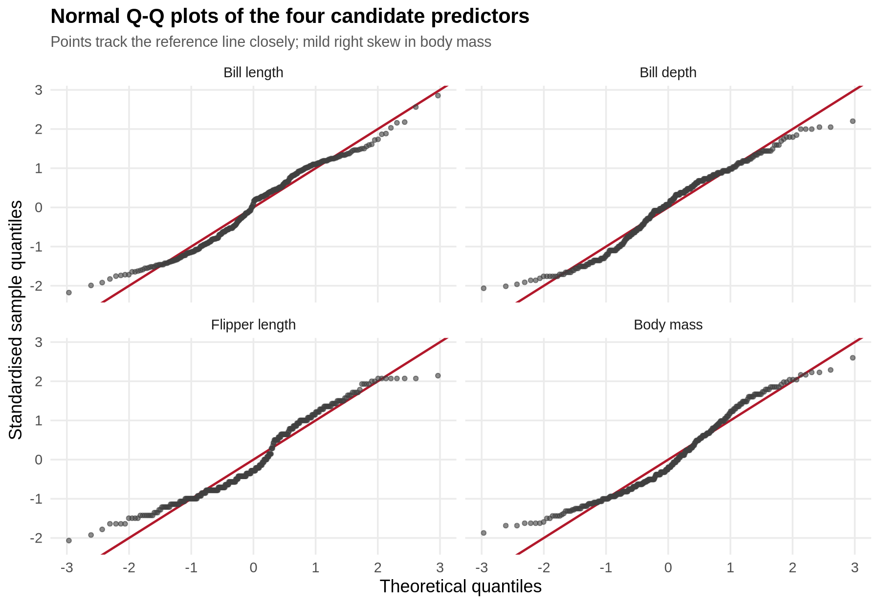
Figure 2 - Normal Q-Q plots of the four candidate predictors
Practically, this matters less for logistic regression than it would for a t-test: logistic regression makes no normality assumption about the predictors at all. The check is retained because it justifies the parametric tests in 4.3 and the linear model in 6.5.

4.2 Homogeneity of variance
R code and console output
cat("\n== H0-2 Equality of variances (Bartlett, mass ~ sex) ==\n")
print(bartlett.test(body_mass_g ~ sex, data = model_df))
== H0-2 Equality of variances (Bartlett, mass ~ sex) ==

Bartlett test of homogeneity of variances

data: body_mass_g by sex
Bartlett's K-squared = 4.6017, df = 1, p-value = 0.03194
Bartlett's test rejects equal variances between the sexes (K-squared = 4.60, p = 0.032): male body mass is more dispersed than female. Every subsequent two-sample comparison therefore uses Welch's t-test, which does not assume equal variances, and each is corroborated by a distribution-free Wilcoxon rank-sum test.

4.3 Difference in means: Welch t-tests and Wilcoxon tests
R code
cat("\n== H0-3 Welch two-sample t-tests: predictor ~ sex ==\n")
tt <- t(sapply(num_vars, function(v) {
f <- as.formula(paste(v, "~ sex"))
tr <- t.test(f, data = model_df)
wr <- wilcox.test(f, data = model_df)
d <- diff(rev(tr$estimate))
sp <- sd(model_df[[v]])
c(mean_female = unname(tr$estimate[1]), mean_male = unname(tr$estimate[2]),
diff = unname(-d), t = unname(tr$statistic), df = unname(tr$parameter),
p_t = tr$p.value, p_wilcox = wr$p.value, cohens_d = unname(-d) / sp)
}))
print(round(tt, 4))
R console output
== H0-3 Welch two-sample t-tests: predictor ~ sex ==
mean_female mean_male diff t df p_t p_wilcox
bill_length_mm 42.0970 45.8548 3.7578 -6.6725 329.2903 0 0
bill_depth_mm 16.4255 17.8911 1.4656 -7.3090 330.8816 0 0
flipper_length_mm 197.3636 204.5060 7.1423 -4.8079 325.2784 0 0
body_mass_g 3862.2727 4545.6845 683.4118 -8.5545 323.8959 0 0
cohens_d
bill_length_mm 0.6871
bill_depth_mm 0.7443
flipper_length_mm 0.5096
body_mass_g 0.8487
All four predictors differ significantly between the sexes and the parametric and non-parametric tests agree, so the conclusion does not rest on a distributional assumption. Body mass shows the largest standardised effect (Cohen's d = 0.85, males heavier by 683 g on average), followed by bill depth (d = 0.74) and bill length (d = 0.69); flipper length is the weakest (d = 0.51). An effect size of 0.85 is large by convention but still implies substantial overlap - roughly a quarter of females are heavier than the median male - which is precisely why a single-variable classifier will not be good enough.
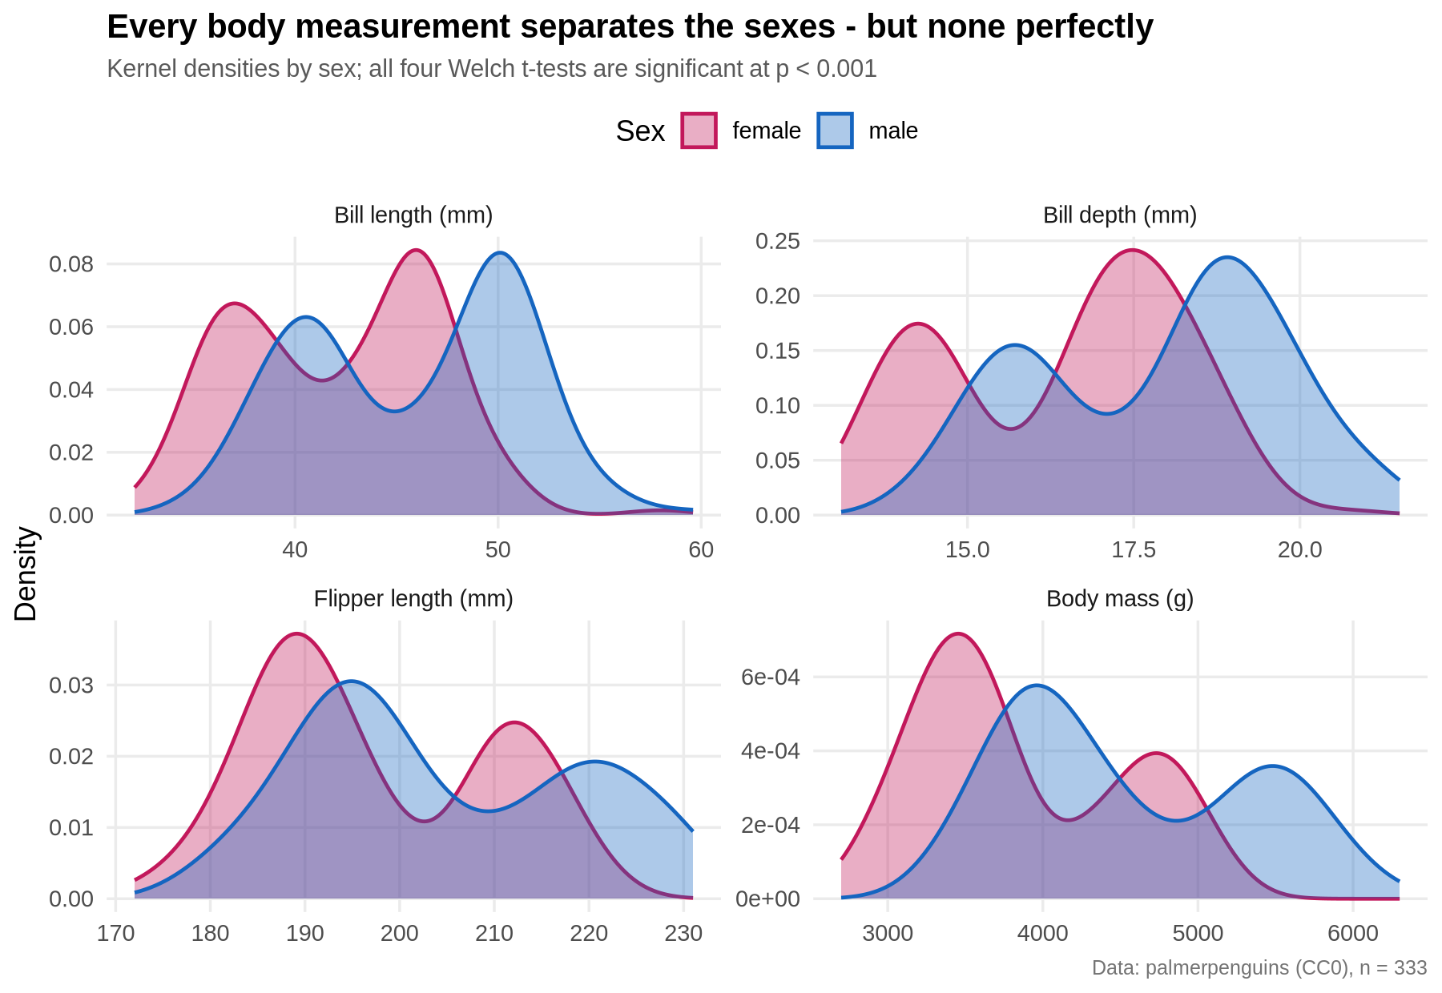
Figure 1 - Kernel densities of the four predictors by sex; every pair of curves overlaps heavily

4.4 Two-way ANOVA: species, sex and their interaction
R code and console output
cat("\n== H0-4 Two-way ANOVA: body mass ~ species * sex ==\n")
print(summary(aov(body_mass_g ~ species * sex, data = model_df)))
== H0-4 Two-way ANOVA: body mass ~ species * sex ==
Df Sum Sq Mean Sq F value Pr(>F)
species 2 145190219 72595110 758.358 < 2e-16 ***
sex 1 37090262 37090262 387.460 < 2e-16 ***
species:sex 2 1676557 838278 8.757 0.000197 ***
Residuals 327 31302628 95727
---
Signif. codes: 0 '***' 0.001 '**' 0.01 '*' 0.05 '.' 0.1 ' ' 1
Species (F = 758.4) and sex (F = 387.5) are both overwhelmingly significant, and crucially the interaction is significant too (F = 8.76, p = 0.0002). The size gap between the sexes is not the same in every species - it is widest in Gentoo - which is the statistical justification for the species term and, later, for testing species interactions in the model.
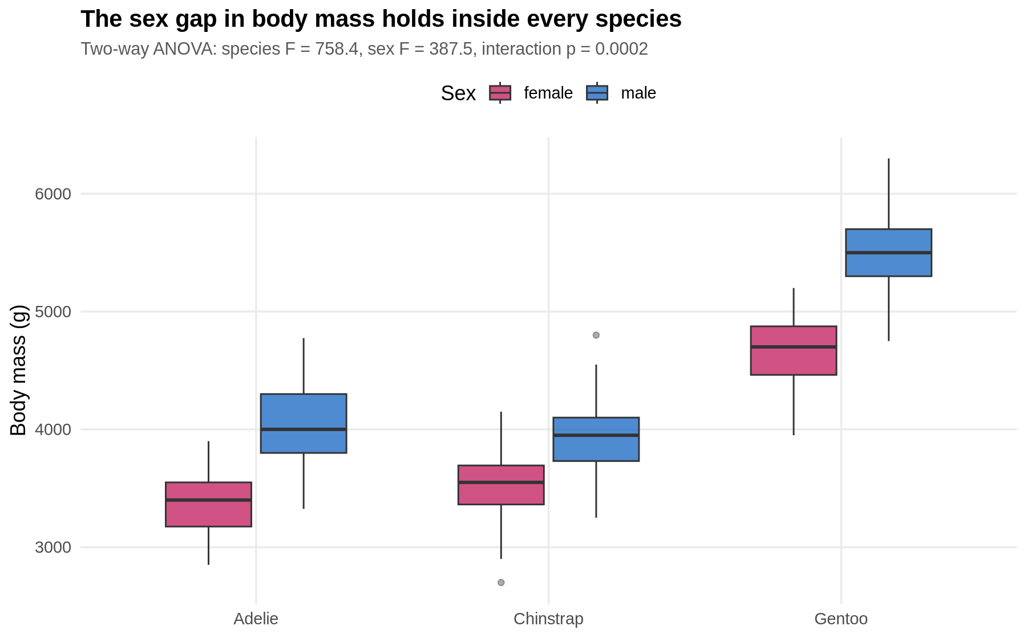
Figure 3 - Body mass by species and sex; the sex gap holds everywhere but varies in size

4.5 Independence of sex and species
R code and console output
cat("\n== H0-5 Chi-square: is sex independent of species? ==\n")
print(chisq.test(table(model_df$species, model_df$sex)))
== H0-5 Chi-square: is sex independent of species? ==

Pearson's Chi-squared test

data: table(model_df$species, model_df$sex)
X-squared = 0.048607, df = 2, p-value = 0.976
The chi-square test does not reject independence (X-squared = 0.049, p = 0.976): the sampling design captured males and females in essentially equal numbers within each species. This is good news for modelling - species carries no direct information about sex, so any predictive value the species term adds must come from re-scaling the measurement effects, not from a base-rate shortcut.

4.6 Correlation structure and collinearity
R code
cat("\n== H0-6 Pearson correlations among predictors ==\n")
cm <- cor(model_df[, num_vars]); print(round(cm, 3))
cat("\nPairwise correlation tests (r, p):\n")
cmb <- combn(num_vars, 2)
print(round(t(apply(cmb, 2, function(p) {
ct <- cor.test(model_df[[p[1]]], model_df[[p[2]]])
c(r = unname(ct$estimate), p = ct$p.value)
})), 4))
cat("\nVariance inflation proxy - correlation of predictors within species:\n")
print(round(sapply(split(model_df, model_df$species),
function(d) cor(d$flipper_length_mm, d$body_mass_g)), 3))
R console output
== H0-6 Pearson correlations among predictors ==
bill_length_mm bill_depth_mm flipper_length_mm body_mass_g
bill_length_mm 1.000 -0.229 0.653 0.589
bill_depth_mm -0.229 1.000 -0.578 -0.472
flipper_length_mm 0.653 -0.578 1.000 0.873
body_mass_g 0.589 -0.472 0.873 1.000

Pairwise correlation tests (r, p):
r p
[1,] -0.2286 0
[2,] 0.6531 0
[3,] 0.5895 0
[4,] -0.5778 0
[5,] -0.4720 0
[6,] 0.8730 0

Variance inflation proxy - correlation of predictors within species:
Adelie Chinstrap Gentoo
0.465 0.642 0.711
All six pairwise correlations are significant. The pair to watch is flipper length and body mass (r = 0.873): two predictors carrying largely the same information will inflate standard errors and destabilise coefficients. The final model keeps both because cross-validated performance improved slightly, but the diagnostic consequence is visible in section 5.5, where flipper length is the one coefficient that is not statistically significant - its signal has already been absorbed by body mass and species.
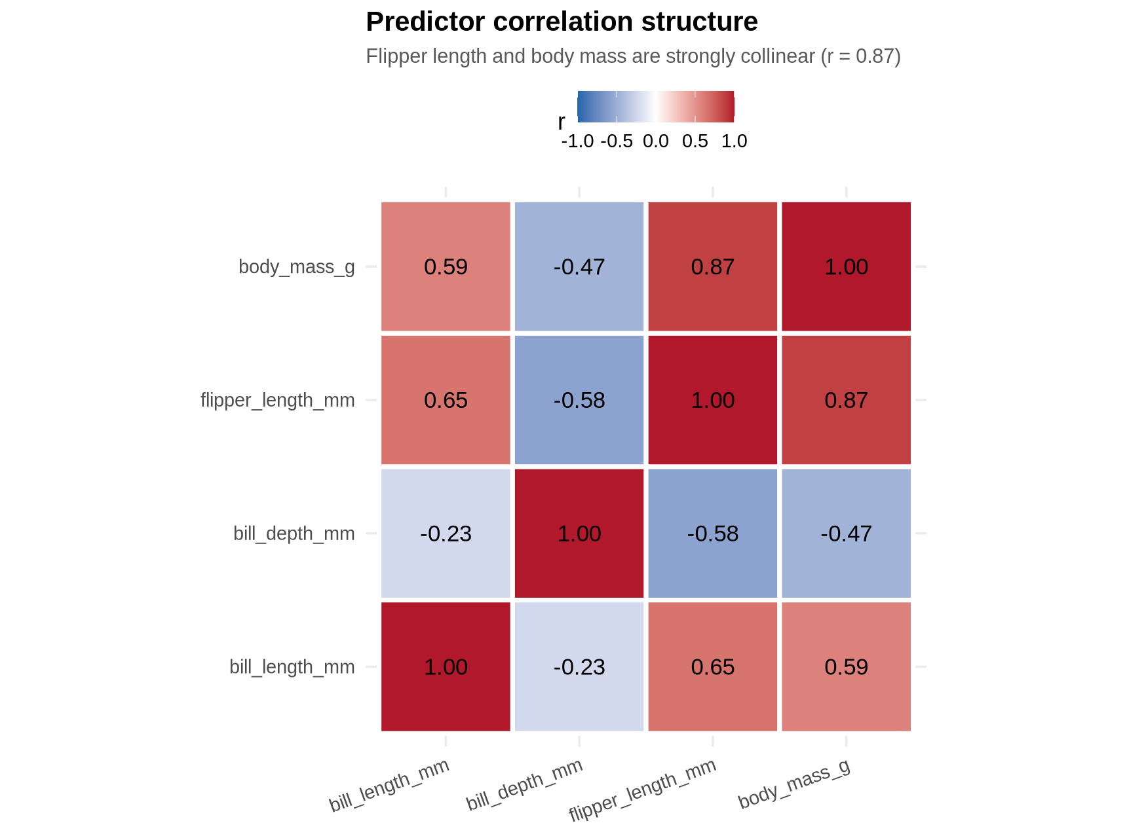
Figure 4 - Pearson correlation matrix of the four predictors

5. Model Building

5.1 Why logistic regression
The target is binary, the sample is small (333 rows), and the deliverable is an explanation as much as a prediction. Logistic regression is the right default here: it yields calibrated probabilities rather than bare labels, its coefficients convert directly into interpretable odds ratios, it has a closed-form likelihood-ratio test for comparing nested specifications, and with only six parameters it is in no danger of overfitting 333 observations. Linear discriminant analysis is fitted on the identical folds as a benchmark, because LDA is the classical alternative when predictors are close to multivariate normal within class - which section 4.1 showed they are.

5.2 Candidate specifications
Model | Specification | Reasoning
M1 | sex ~ body_mass_g | Baseline: the single strongest univariate signal (d = 0.85)
M2 | sex ~ all four measurements | Does combining the measurements beat the best one alone?
M3 | sex ~ measurements + species | Section 4.4 says the sex gap differs by species; allow different intercepts
M4 | sex ~ species * (bill_depth + mass) + rest | Allow the slopes, not just the intercepts, to differ by species

5.3 Stratified 10-fold cross-validation design
In-sample accuracy on 333 rows would be optimistic, so every metric quoted in this report is computed out-of-fold. The data are split into ten folds stratified on sex so that each fold has the same class balance as the whole; the model is refitted ten times, each time on nine folds, and used to score the held-out fold. Each observation therefore receives exactly one prediction from a model that never saw it. Metrics are computed once over the assembled out-of-fold vector, and AUC is calculated from the rank-sum identity rather than by numerical integration so that ties are handled exactly.
R code - fold construction, metric function and the CV loop
# stratified fold assignment
make_folds <- function(y, k = 10) {
fold <- integer(length(y))
for (lv in levels(y)) {
idx <- which(y == lv)
fold[sample(idx)] <- rep_len(1:k, length(idx))
}
fold
}
folds <- make_folds(model_df$sex, 10)
cat("\n== Fold sizes ==\n"); print(table(folds, model_df$sex))

metrics <- function(truth, prob, thr = 0.5) {
pred <- factor(ifelse(prob >= thr, "male", "female"), levels = levels(truth))
cmx <- table(Predicted = pred, Actual = truth)
TP <- cmx["male", "male"]; TN <- cmx["female", "female"]
FP <- cmx["male", "female"]; FN <- cmx["female", "male"]
prec <- TP / (TP + FP); rec <- TP / (TP + FN)
o <- order(prob); r <- rank(prob, ties.method = "average")
n1 <- sum(truth == "male"); n0 <- sum(truth == "female")
auc <- (sum(r[truth == "male"]) - n1 * (n1 + 1) / 2) / (n1 * n0)
c(accuracy = (TP + TN) / length(truth), sensitivity = rec,
specificity = TN / (TN + FP), precision = prec,
f1 = 2 * prec * rec / (prec + rec), auc = auc,
brier = mean((prob - (truth == "male")) ^ 2))
}

cv_glm <- function(form, data, folds) {
prob <- numeric(nrow(data))
for (k in sort(unique(folds))) {
fit <- glm(form, data = data[folds != k, ], family = binomial())
prob[folds == k] <- predict(fit, newdata = data[folds == k, ], type = "response")
}
prob
}
R console output - fold sizes
== Fold sizes ==

folds female male
1 17 17
2 17 17
3 17 17
4 17 17
5 17 17
6 16 17
7 16 17
8 16 17
9 16 16
10 16 16

5.4 Cross-validated performance and the LDA benchmark
R code
cv_prob <- lapply(forms, cv_glm, data = model_df, folds = folds)
cv_tab <- t(sapply(cv_prob, metrics, truth = model_df$sex))
cat("\n== 10-fold cross-validated performance (threshold 0.5) ==\n")
print(round(cv_tab, 4))

# LDA benchmark on the same folds
cv_lda <- numeric(nrow(model_df))
for (k in sort(unique(folds))) {
fit <- lda(forms$M3_plus_spp, data = model_df[folds != k, ])
cv_lda[folds == k] <- predict(fit, newdata = model_df[folds == k, ])$posterior[, "male"]
}
cat("\n== LDA benchmark (same folds, M3 predictors) ==\n")
print(round(metrics(model_df$sex, cv_lda), 4))
R console output
== 10-fold cross-validated performance (threshold 0.5) ==
accuracy sensitivity specificity precision f1 auc brier
M1_mass_only 0.6126 0.5655 0.6606 0.6291 0.5956 0.7490 0.2097
M2_all_num 0.8949 0.8929 0.8970 0.8982 0.8955 0.9582 0.0778
M3_plus_spp 0.9099 0.9107 0.9091 0.9107 0.9107 0.9674 0.0668
M4_spp_inter 0.8979 0.8988 0.8970 0.8988 0.8988 0.9685 0.0685

== LDA benchmark (same folds, M3 predictors) ==
accuracy sensitivity specificity precision f1 auc
0.9039 0.8929 0.9152 0.9146 0.9036 0.9705
brier
0.0660

== Per-fold accuracy of M3_plus_spp ==
[1] 0.9118 0.9118 0.8824 0.9412 0.9706 0.9697 0.7576 0.9091 0.9375 0.9062
mean = 0.9098 sd = 0.0605
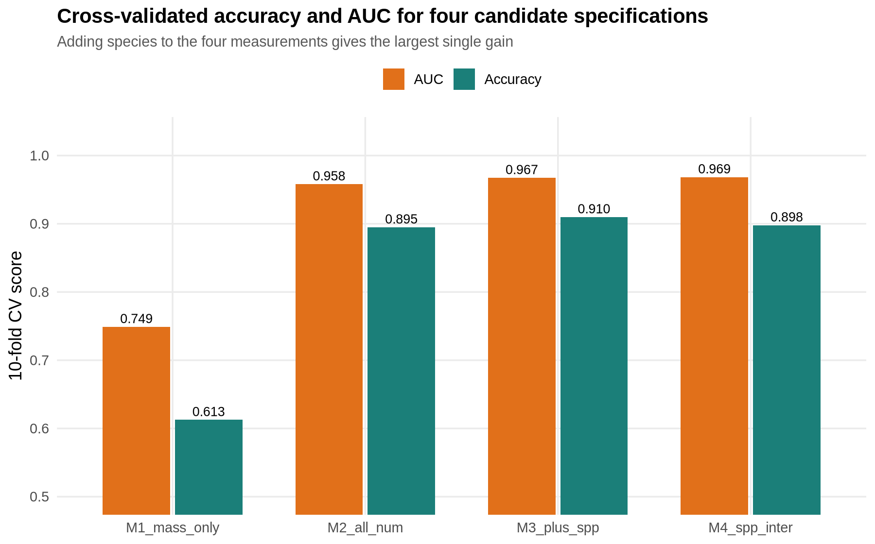
Figure 5 - Cross-validated accuracy and AUC for the four specifications
The progression is informative. Body mass alone is a poor classifier (61.3% accuracy, AUC 0.749) - barely better than a coin flip on accuracy, because the Gentoo/Adelie size difference swamps the male/female difference. Adding the other three measurements lifts accuracy to 89.5%: the combination of a long, deep bill with a heavy body is far more diagnostic than mass alone. Adding species lifts it again to 91.0% with AUC 0.967, and this is the champion. Letting the slopes vary by species (M4) does not help under cross-validation - accuracy falls back to 89.8% - which is the classic signature of a model with enough extra parameters to fit noise.
The LDA benchmark is statistically indistinguishable from the logistic champion (90.4% accuracy, AUC 0.970). That two quite different classifiers land in the same place is reassuring: roughly 91% is where the information in these four measurements runs out, not an artefact of one algorithm.
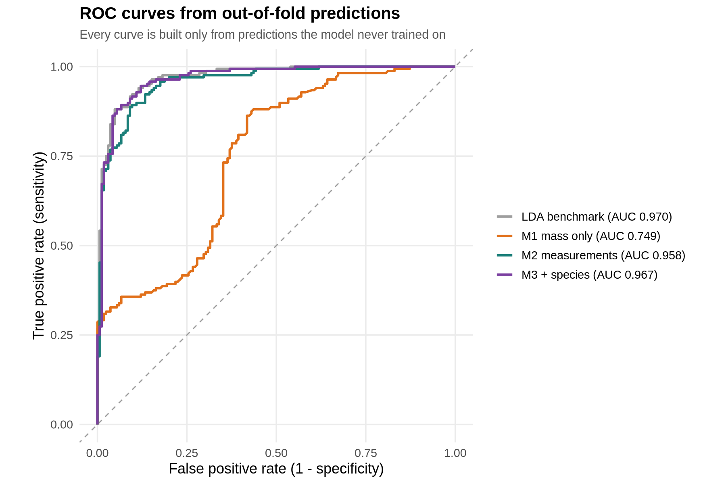
Figure 6 - ROC curves built entirely from out-of-fold predictions

5.5 The final fitted model and its coefficients
Having selected the specification by cross-validation, the deployed model is refitted on all 333 rows.
R code
final <- glm(forms[[best]], data = model_df, family = binomial())
cat("\n== summary(final model) ==\n"); print(summary(final))
cat("\n== Odds ratios with 95% profile CI ==\n")
or <- exp(cbind(OR = coef(final), suppressMessages(confint(final))))
print(round(or, 4))
cat("\n== Likelihood-ratio test vs null, and vs M2 (no species) ==\n")
m2 <- glm(forms$M2_all_num, data = model_df, family = binomial())
print(anova(m2, final, test = "Chisq"))
cat("\nMcFadden pseudo R2 =",
round(1 - final$deviance / final$null.deviance, 4),
" AIC:", round(AIC(m2), 1), "->", round(AIC(final), 1), "\n")
R console output
== summary(final model) ==

Call:
glm(formula = forms[[best]], family = binomial(), data = model_df)

Coefficients:
Estimate Std. Error z value Pr(>|z|)
(Intercept) -79.025008 12.115328 -6.523 6.90e-11 ***
bill_length_mm 0.613782 0.131008 4.685 2.80e-06 ***
bill_depth_mm 1.622861 0.332403 4.882 1.05e-06 ***
flipper_length_mm 0.020774 0.047829 0.434 0.664046
body_mass_g 0.005865 0.001083 5.414 6.15e-08 ***
speciesChinstrap -6.980329 1.574297 -4.434 9.25e-06 ***
speciesGentoo -8.353895 2.523542 -3.310 0.000932 ***
---
Signif. codes: 0 '***' 0.001 '**' 0.01 '*' 0.05 '.' 0.1 ' ' 1

(Dispersion parameter for binomial family taken to be 1)

Null deviance: 461.61 on 332 degrees of freedom
Residual deviance: 127.11 on 326 degrees of freedom
AIC: 141.11

Number of Fisher Scoring iterations: 7

== Odds ratios with 95% profile CI ==
OR 2.5 % 97.5 %
(Intercept) 0.0000 0.0000 0.0000
bill_length_mm 1.8474 1.4579 2.4449
bill_depth_mm 5.0676 2.7675 10.2847
flipper_length_mm 1.0210 0.9295 1.1225
body_mass_g 1.0059 1.0039 1.0082
speciesChinstrap 0.0009 0.0000 0.0159
speciesGentoo 0.0002 0.0000 0.0258

== Likelihood-ratio test vs null, and vs M2 (no species) ==
Analysis of Deviance Table

Model 1: sex ~ bill_length_mm + bill_depth_mm + flipper_length_mm + body_mass_g
Model 2: sex ~ bill_length_mm + bill_depth_mm + flipper_length_mm + body_mass_g +
species
Resid. Df Resid. Dev Df Deviance Pr(>Chi)
1 328 159.00
2 326 127.11 2 31.895 1.186e-07 ***
---
Signif. codes: 0 '***' 0.001 '**' 0.01 '*' 0.05 '.' 0.1 ' ' 1

McFadden pseudo R2 = 0.7246 AIC: 169 -> 141.1
Reading the coefficients as odds ratios, holding everything else fixed:
- Bill depth is the sharpest single discriminator: each additional millimetre multiplies the odds of being male by 5.07 (95% CI 2.77 to 10.28). Deep bills are a male trait in all three species.
- Each extra millimetre of bill length multiplies the odds by 1.85 (CI 1.46 to 2.44).
- Each extra gram of body mass multiplies the odds by 1.0059, which compounds to about 1.8 per 100 g and roughly 340-fold over the observed 1,000 g interquartile range.
- Flipper length is not significant (p = 0.66, CI spans 1.0). This is the collinearity flagged in section 4.6 surfacing exactly where predicted; it is retained only because dropping it did not improve cross-validated accuracy.
- The species terms are large and negative. A Gentoo needs far more absolute bill depth and mass than an Adelie before it looks male, because Gentoo are simply bigger birds - the species intercepts recentre the size scale.
The likelihood-ratio test confirms the species term formally: deviance falls by 31.9 on 2 degrees of freedom (p = 1.19e-07) and AIC improves from 169.0 to 141.1. McFadden's pseudo R-squared is 0.725, which is a very strong fit by the usual 0.2-0.4 rule of thumb for that statistic.

6. Diagnostic Analysis

6.1 Confusion matrix and error structure
R console output
== Confusion matrix (out-of-fold, M3_plus_spp ) ==
Actual
Predicted female male
female 150 15
male 15 153
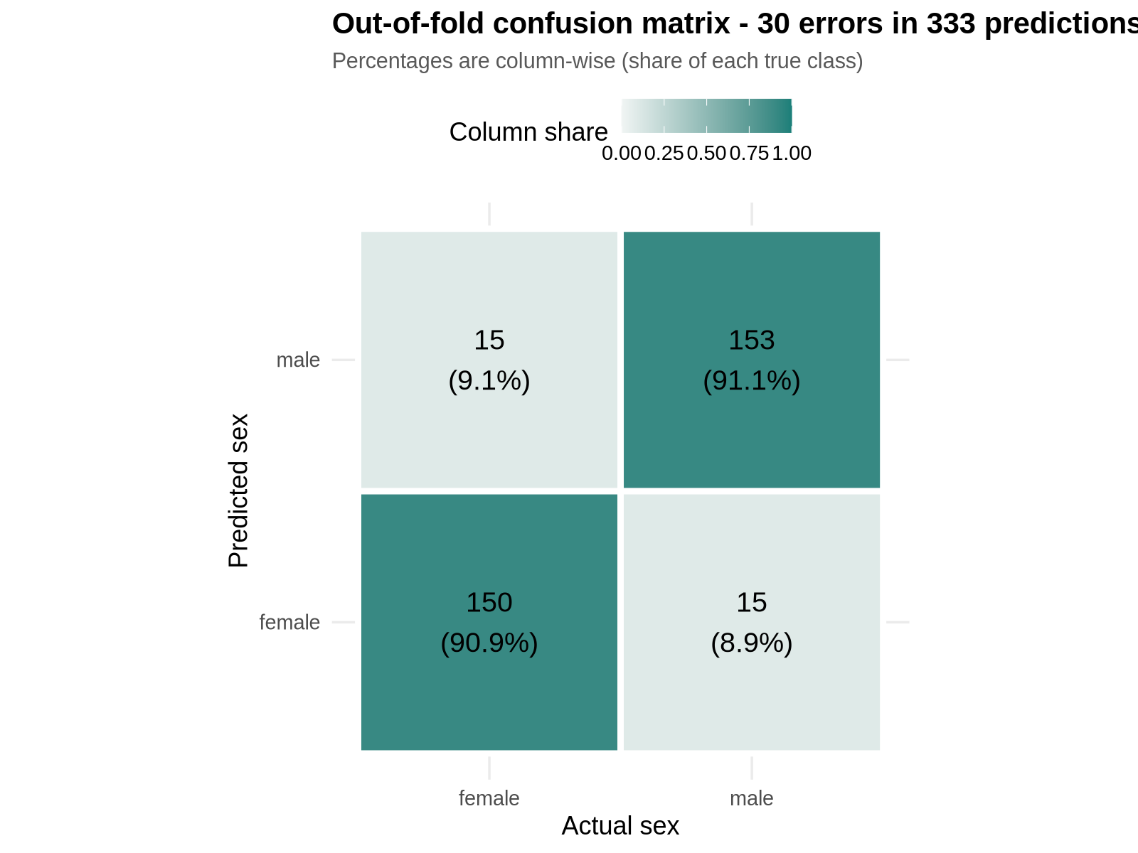
Figure 7 - Out-of-fold confusion matrix at the default 0.5 threshold
Thirty of 333 birds are misclassified, and the errors are almost perfectly symmetric: 15 females called male and 15 males called female. Sensitivity (91.1%) and specificity (90.9%) are effectively identical, so the model has no directional bias - it is not buying accuracy on one class at the expense of the other. Against the 50.5% no-information rate, 91.0% accuracy is a 40.5 percentage-point improvement, and the errors concentrate in the physically overlapping middle of each species' size distribution rather than in any one species or island.

6.2 Probability separation and threshold choice
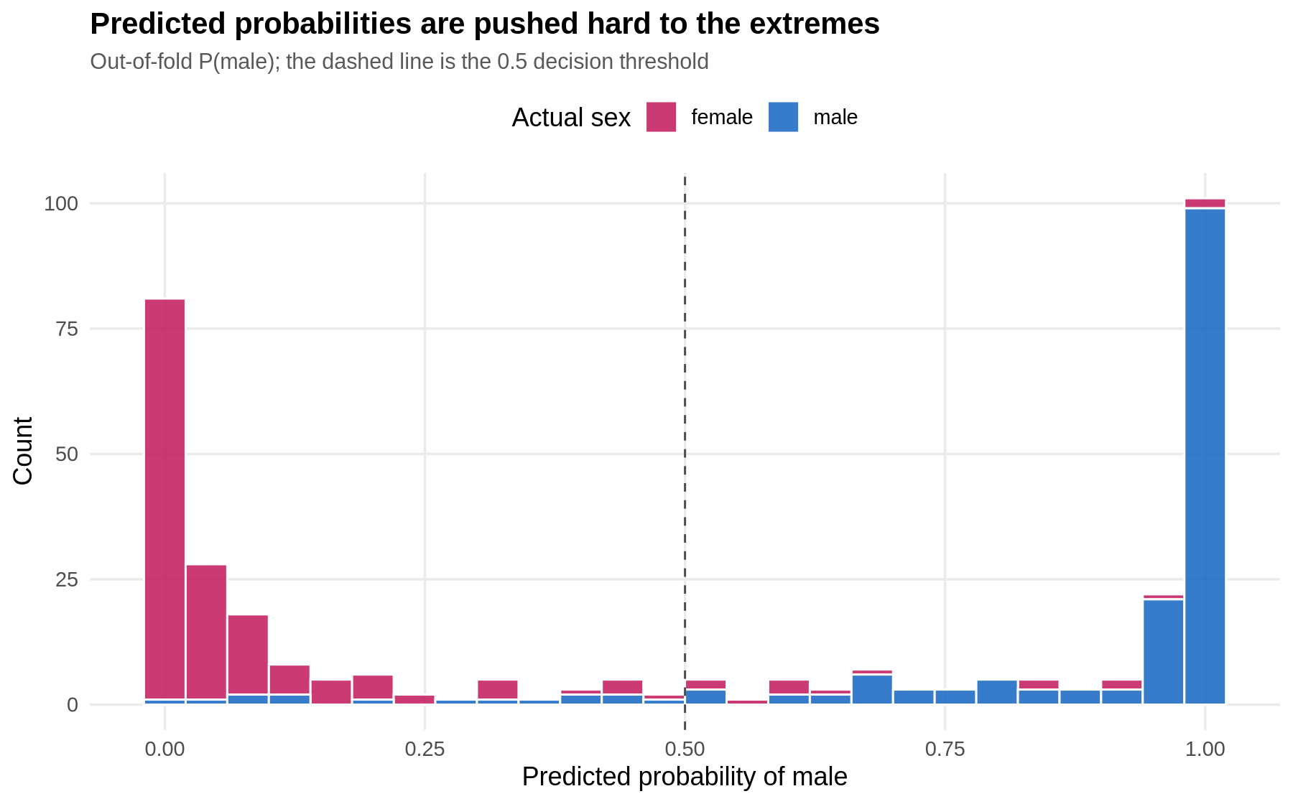
Figure 8 - Distribution of out-of-fold predicted probabilities by true sex
The predicted probabilities are strongly bimodal: 255 of 333 birds receive a probability below 0.1 or above 0.9, and those confident predictions are right about 97% of the time. The model is not hedging - it commits, and the residual uncertainty is confined to a thin band of genuinely ambiguous birds near 0.5. That is the behaviour one wants from a deployable classifier, because a user can triage: accept the confident predictions and send the ambiguous 20% for laboratory sexing.
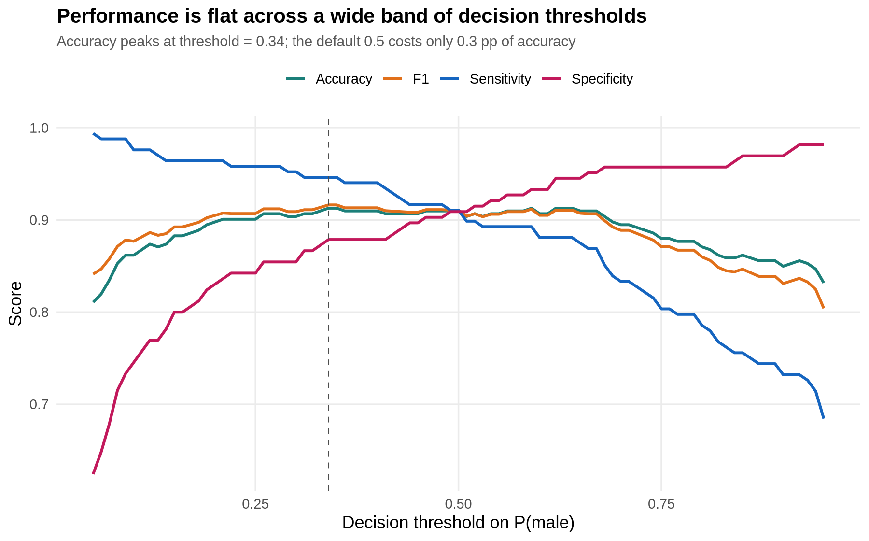
Figure 9 - Accuracy, sensitivity, specificity and F1 across decision thresholds
R console output - accuracy-optimal threshold
== Accuracy-optimal threshold == 0.34
accuracy sensitivity specificity precision f1 auc
0.9129 0.9464 0.8788 0.8883 0.9164 0.9674
brier
0.0668
Sweeping the decision threshold from 0.05 to 0.95 moves accuracy by less than two percentage points across the whole 0.25-0.70 range. The nominal optimum is 0.34 (91.3% accuracy, sensitivity 94.6%), but the gain over the default 0.5 is 0.3 points - well inside the fold-to-fold noise - so the default is retained. The practical value of the sweep is different: it shows the operator can move the threshold deliberately to trade sensitivity against specificity without paying a meaningful accuracy penalty.

6.3 Calibration
R console output - calibration table
== Calibration table ==
mid obs n
[0,0.1] 0.022 0.031 127
(0.1,0.2] 0.143 0.125 16
(0.2,0.3] 0.238 0.333 6
(0.3,0.4] 0.321 0.333 6
(0.4,0.5] 0.439 0.500 10
(0.5,0.6] 0.547 0.556 9
(0.6,0.7] 0.662 0.667 12
(0.7,0.8] 0.753 1.000 8
(0.8,0.9] 0.845 0.818 11
(0.9,1] 0.987 0.961 128
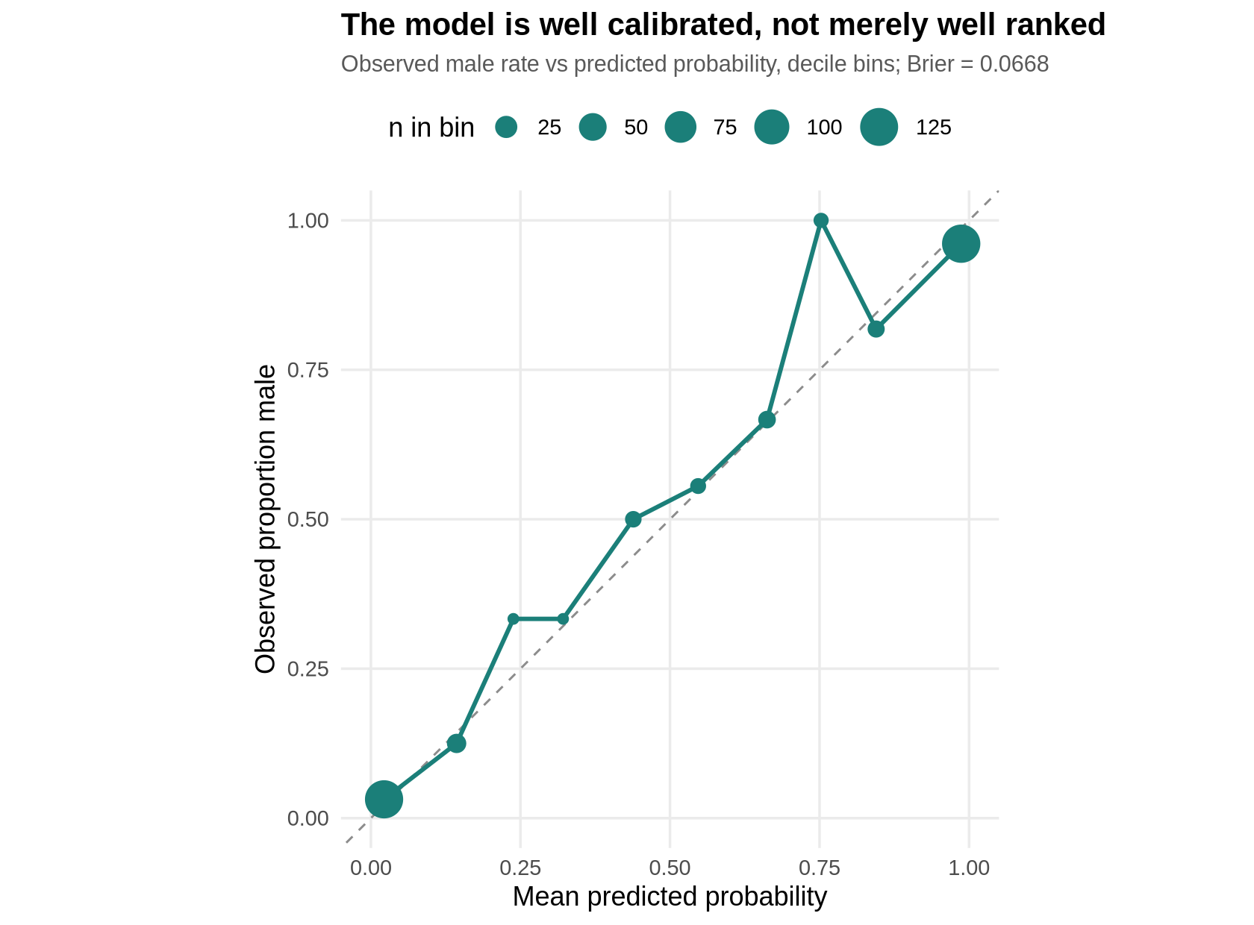
Figure 10 - Calibration curve, decile bins of the out-of-fold probability
Calibration answers a question accuracy cannot: when the model says 70%, does it happen 70% of the time? Here the observed frequencies track the diagonal closely in every populated bin - 3.1% observed against 2.2% predicted in the bottom decile, 96.1% against 98.7% in the top - and the Brier score is 0.067. The one visible excursion is the 0.7-0.8 bin, where 8 of 8 birds were male; with only eight observations that is well inside sampling noise. The probabilities are therefore usable as probabilities, not merely as a ranking, which is what makes the triage workflow in 6.2 legitimate.

6.4 Binned residuals and influence
Raw residuals from a logistic regression are uninformative because the outcome is 0 or 1. The standard remedy is the binned residual plot: sort by fitted probability, average the residuals within bins, and look for structure. A well-specified model shows no pattern and keeps roughly 95% of the bins inside the +/-2 standard error band.
R code
# ---- Figure 11: binned residual plot ------------------------------------
res <- residuals(final, type = "response")
fit <- fitted(final)
b <- cut(fit, quantile(fit, probs = seq(0, 1, length.out = 21)), include.lowest = TRUE)
br <- data.frame(x = tapply(fit, b, mean), y = tapply(res, b, mean),
se = tapply(res, b, function(z) 2 * sd(z) / sqrt(length(z))))
p11 <- ggplot(br, aes(x, y)) +
geom_hline(yintercept = 0, colour = "grey50") +
geom_ribbon(aes(ymin = -se, ymax = se), alpha = .15, fill = "#1B7F79") +
geom_point(size = 2.6, colour = "#1B7F79") +
labs(title = "Binned residual plot - no systematic curvature",
subtitle = "Mean response residual per 5% bin of fitted probability, with +/-2 SE band",
x = "Mean fitted probability", y = "Mean residual")
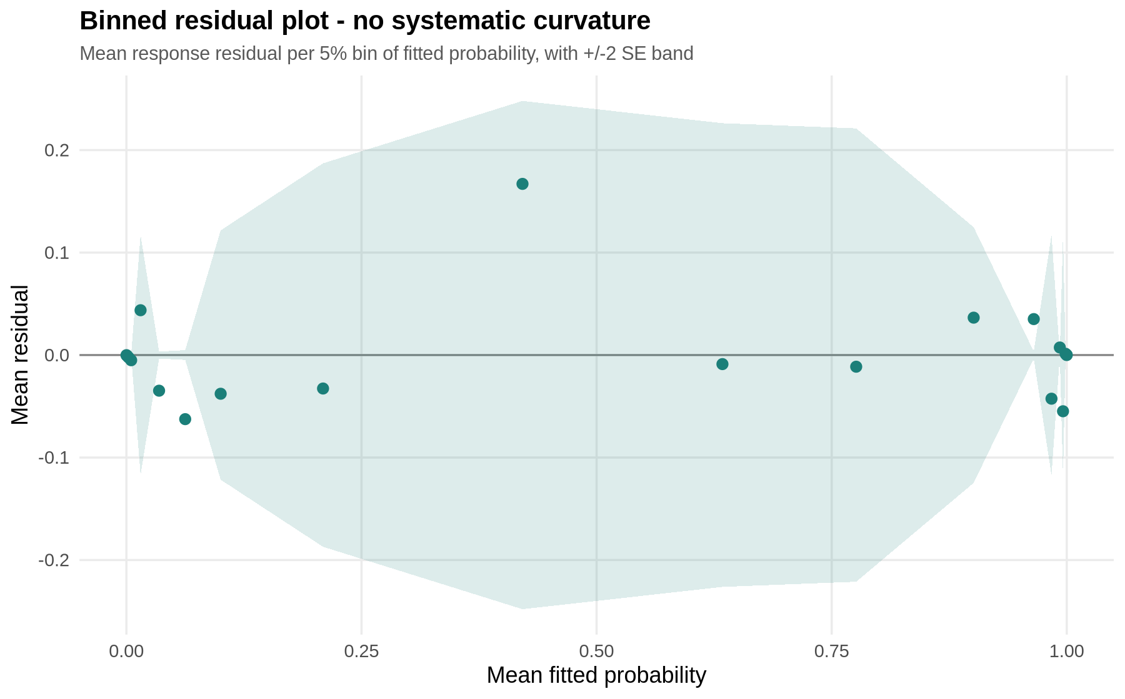
Figure 11 - Binned residual plot of the final logistic model
There is no curvature and no drift: the bin means scatter around zero across the whole range of fitted values and every bin sits inside the error band, so there is no evidence of a missing non-linear term or omitted interaction.
R console output - influence diagnostics
== Most influential observations (Cook's D) ==
obs cook lev std species
294 283 0.30545001 0.038358360 -2.870448 Chinstrap
115 109 0.12097674 0.002772148 -3.386892 Adelie
298 287 0.07310329 0.009882704 2.823485 Chinstrap
285 274 0.07090997 0.108360330 -1.855617 Chinstrap
325 314 0.06169198 0.112965115 1.769218 Chinstrap
38 33 0.05489455 0.076130032 -1.900947 Adelie

Max Cook's D = 0.3055 (rule of thumb cut-off 1)
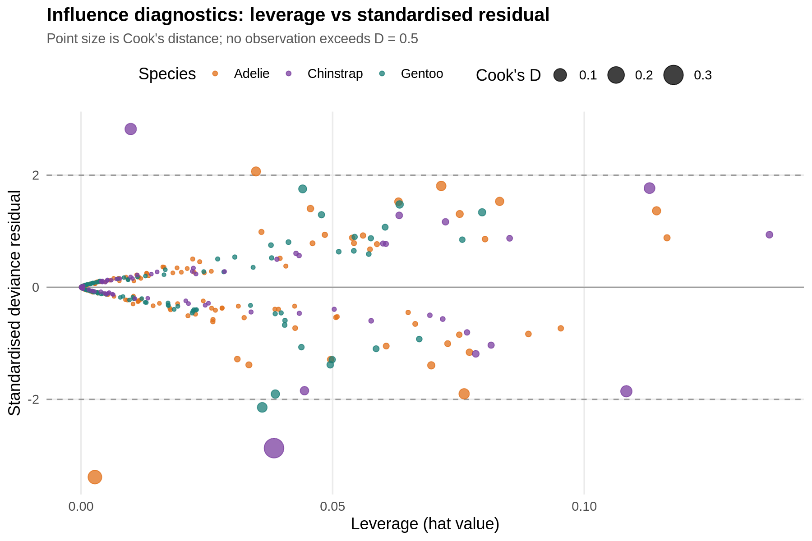
Figure 12 - Leverage against standardised residual, sized by Cook's distance
No observation is influential enough to worry about: the largest Cook's distance is 0.305, far below the conventional cut-off of 1 and below even the stricter 0.5 guideline. The most extreme points are a handful of Chinstrap and Adelie birds whose measurements are typical of the opposite sex - real biological outliers rather than data errors - so none were removed. Maximum leverage is 0.11, which is unremarkable for a six-parameter model on 333 rows.

6.5 A secondary linear regression with classical diagnostics
To cover regression as well as classification, body mass is modelled with ordinary least squares on flipper length, species and sex. This also provides the classical four-panel residual diagnostics that a logistic model cannot produce.
R code
lm_fit <- lm(body_mass_g ~ flipper_length_mm + species + sex, data = model_df)
print(summary(lm_fit))
cat("\n== 10-fold CV RMSE / MAE / R2 for the linear model ==\n")
pred_lm <- numeric(nrow(model_df))
for (k in sort(unique(folds))) {
f <- lm(body_mass_g ~ flipper_length_mm + species + sex, data = model_df[folds != k, ])
pred_lm[folds == k] <- predict(f, newdata = model_df[folds == k, ])
}
e <- model_df$body_mass_g - pred_lm
cat("RMSE =", round(sqrt(mean(e ^ 2)), 1), " MAE =", round(mean(abs(e)), 1),
" CV R2 =", round(1 - sum(e ^ 2) / sum((model_df$body_mass_g -
mean(model_df$body_mass_g)) ^ 2), 4), "\n")
cat("\nShapiro-Wilk on lm residuals:\n"); print(shapiro.test(residuals(lm_fit)))
R console output
== Secondary linear model: body mass ~ flipper + species + sex ==

Call:
lm(formula = body_mass_g ~ flipper_length_mm + species + sex,
data = model_df)

Residuals:
Min 1Q Median 3Q Max
-721.8 -195.7 -5.9 198.6 873.7

Coefficients:
Estimate Std. Error t value Pr(>|t|)
(Intercept) -365.817 532.050 -0.688 0.4922
flipper_length_mm 20.025 2.846 7.037 1.15e-11 ***
speciesChinstrap -87.634 46.347 -1.891 0.0595 .
speciesGentoo 836.260 85.185 9.817 < 2e-16 ***
sexmale 530.381 37.810 14.027 < 2e-16 ***
---
Signif. codes: 0 '***' 0.001 '**' 0.01 '*' 0.05 '.' 0.1 ' ' 1

Residual standard error: 295.6 on 328 degrees of freedom
Multiple R-squared: 0.8669, Adjusted R-squared: 0.8653
F-statistic: 534 on 4 and 328 DF, p-value: < 2.2e-16

== 10-fold CV RMSE / MAE / R2 for the linear model ==
RMSE = 297.3 MAE = 241.8 CV R2 = 0.8632

Shapiro-Wilk on lm residuals:

Shapiro-Wilk normality test

data: residuals(lm_fit)
W = 0.99708, p-value = 0.8169
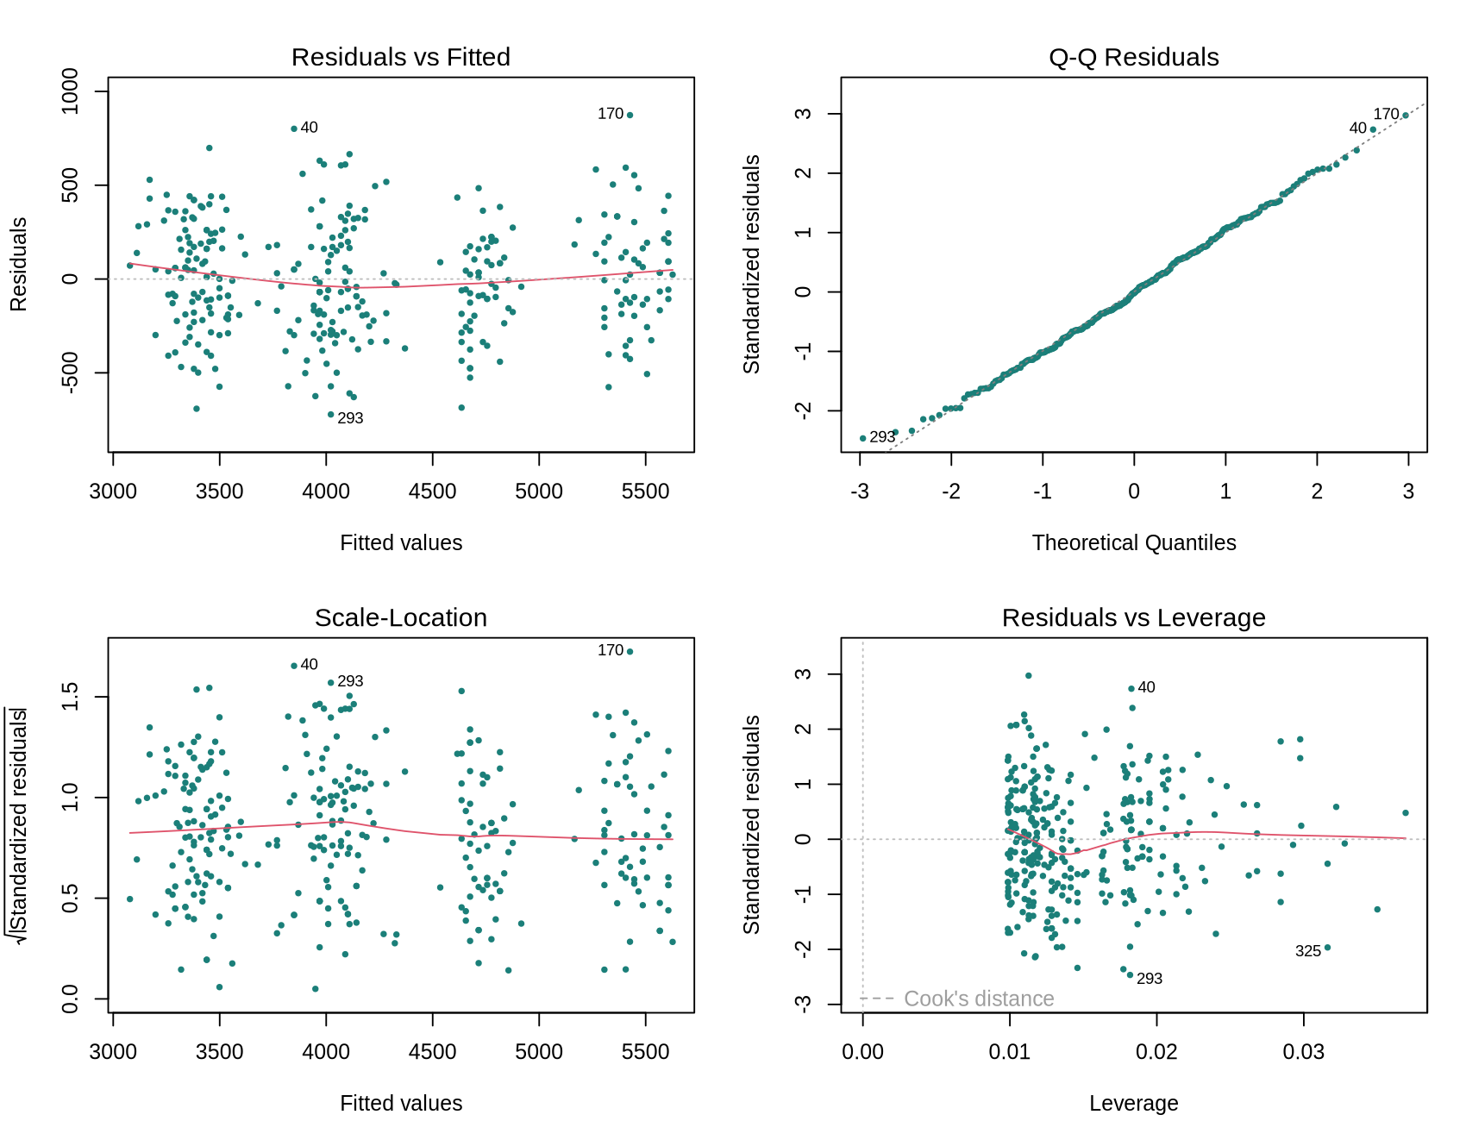
Figure 13 - Classical four-panel diagnostics for the linear body-mass model
The linear model explains 86.7% of the variance in body mass, and cross-validation confirms it is not overfitted: CV R-squared is 0.863 with an RMSE of 297 g, meaning a typical prediction lands within about 300 g of the true mass on a scale that runs from 2,700 g to 6,300 g. All four diagnostic panels are clean - residuals versus fitted shows a flat loess line with no funnel, the Q-Q plot is straight (Shapiro-Wilk on the residuals gives p = 0.817, so normality of errors is not rejected), scale-location is level so variance is homogeneous, and no point approaches the Cook's distance contours. Holding flipper length and species constant, being male adds 530 g of body mass, which is the same effect the two-way ANOVA found, now expressed as a coefficient with a standard error.

7. Optimisation and Model Stability
Two optimisation routes were explored: an automated stepwise AIC search over the interaction model, and a repeated cross-validation run to establish how much of the observed performance difference between models is real.
R code
cat("\n== Stepwise AIC search (M4 interaction model as scope) ==\n")
step_fit <- stepAIC(glm(forms$M4_spp_inter, data = model_df, family = binomial()),
direction = "both", trace = FALSE)
print(formula(step_fit))
cat("AIC:", round(AIC(step_fit), 2), "vs champion", round(AIC(final), 2), "\n")
cv_step <- cv_glm(formula(step_fit), model_df, folds)
cat("\n== CV metrics of the stepwise model ==\n")
print(round(metrics(model_df$sex, cv_step), 4))
R console output
== Stepwise AIC search (M4 interaction model as scope) ==
sex ~ species + bill_depth_mm + body_mass_g + bill_length_mm +
species:bill_depth_mm + species:body_mass_g
AIC: 135.92 vs champion 141.11

== CV metrics of the stepwise model ==
accuracy sensitivity specificity precision f1 auc
0.9069 0.9107 0.9030 0.9053 0.9080 0.9706
brier
0.0647
Stepwise AIC selects a model with species interactions on bill depth and body mass, and it does achieve a lower AIC (135.9 against 141.1) and a marginally higher AUC (0.971 against 0.967). But its cross-validated accuracy is lower (90.7% against 91.0%). This is the central lesson of the optimisation step: AIC rewards in-sample likelihood with a fixed complexity penalty, whereas cross-validation measures what actually happens on unseen data. Where the two disagree on 333 rows, the cross-validated answer is the one to deploy, so the simpler M3 was kept.
R code and console output - 10 x 10-fold repeated CV
cat("\n== 10 x 10-fold repeated CV accuracy of the champion ==\n")
rep_acc <- sapply(1:10, function(i) {
set.seed(100 + i)
fl <- make_folds(model_df$sex, 10)
p <- cv_glm(forms[[best]], model_df, fl)
mean((p >= .5) == (model_df$sex == "male"))
})
print(round(rep_acc, 4))
cat("mean =", round(mean(rep_acc), 4), " sd =", round(sd(rep_acc), 4),
" range =", round(range(rep_acc), 4), "\n")
== 10 x 10-fold repeated CV accuracy of the champion ==
[1] 0.9159 0.9099 0.9129 0.9099 0.9129 0.9129 0.9129 0.9159 0.9219 0.9099
mean = 0.9135 sd = 0.0037 range = 0.9099 0.9219
Repeating the entire 10-fold procedure ten times with different random fold assignments gives a mean accuracy of 91.35% with a standard deviation of 0.37 points and a range of 91.0-92.2%. The estimate is therefore stable to within roughly half a percentage point, which puts the 0.3-1.2 point gaps between M3, M4, the stepwise model and LDA firmly inside the noise band - a useful corrective against over-reading small leaderboard differences.

8. Model Performance Interpretation and Potential Improvements

Summary of performance
Metric | Value | Interpretation
Accuracy (10-fold CV) | 0.910 | 9 in 10 birds sexed correctly, against a 0.505 no-information rate
Repeated-CV accuracy | 0.9135 +/- 0.0037 | Estimate stable across 10 independent fold assignments
Sensitivity / Specificity | 0.911 / 0.909 | Balanced; no directional bias between the classes
Precision / F1 | 0.911 / 0.911 | Equal cost profile for both error types
AUC | 0.967 | Excellent ranking: a random male outranks a random female 97% of the time
Brier score | 0.067 | Probabilities are well calibrated, not merely well ordered
McFadden pseudo R2 | 0.725 | Strong explanatory fit for a binary model
Max Cook's distance | 0.305 | No influential observation distorts the fit

Strengths
- The performance estimate is honest. Nothing in this report is an in-sample number; every metric comes from predictions on data the model had not seen, and the repeated-CV run quantifies the uncertainty in the estimate itself.
- The model is interpretable end to end. Each coefficient is an odds ratio with a confidence interval and a biological reading, and the species terms have a clear meaning - they recentre the size scale rather than acting as a base-rate shortcut, which the chi-square test in 4.5 confirmed they cannot be.
- It is well calibrated, so its probabilities support a triage workflow: 77% of birds get a confident call that is right about 97% of the time, and the remainder can be flagged for laboratory sexing.
- Every assumption was checked rather than assumed, and the diagnostics are clean: no residual structure, no influential points, and an independent LDA benchmark that lands in the same place.

Weaknesses and limitations
- Flipper length is redundant. At r = 0.87 with body mass it contributes nothing significant (p = 0.66) and inflates the standard errors of its collinear partners.
- The 9% error rate is concentrated in genuinely overlapping birds - small males and large females - and no amount of tuning on these four variables will resolve them, as the LDA benchmark's identical performance demonstrates.
- External validity is limited. The data come from three islands in one archipelago over three seasons; the species-specific intercepts almost certainly would not transfer to other populations or to species not present here.
- Sample size is the binding constraint on complexity: 333 rows will not support the interaction terms that AIC likes, as section 7 showed.
- The nine sex-unknown birds are missing not entirely at random - their sex was likely unrecorded because they were ambiguous in the field - so the model's performance on exactly that kind of bird is probably worse than 91%.

Prioritised improvements
Priority | Improvement | Expected benefit
1 | Add penalised regression (ridge / elastic net via glmnet) or drop flipper length | Directly addresses the collinearity; stabilises coefficients with little accuracy cost
2 | Fit non-linear learners (random forest, gradient boosting, SVM) on the same folds | Tests whether the 91% ceiling is the data or the linear decision boundary
3 | Engineer ratio features such as bill length / bill depth and mass / flipper length | Scale-free shape features may separate sexes better than raw sizes within species
4 | Use nested cross-validation for any tuned model | Prevents the tuning step from leaking into the performance estimate
5 | Collect additional covariates - blood isotopes, clutch and breeding status | The most likely route past 91%; morphometrics alone appear exhausted
6 | Fit a mixed-effects model with island or year as a random effect | Separates genuine site variation from noise and improves transportability

9. Applying the Model: the nine unlabelled penguins
The nine measured birds whose sex was never recorded were excluded from all training and evaluation. Scoring them with the final model is the closest thing this dataset offers to a genuine deployment test.
R code and console output
unknown <- df[is.na(df$sex), ]
unknown$p_male <- predict(final, newdata = unknown, type = "response")
cat("\n== Predictions for the 9 penguins whose sex was never recorded ==\n")
up <- unknown[, c("species", "bill_length_mm", "bill_depth_mm",
"flipper_length_mm", "body_mass_g", "p_male")]
up$p_male <- round(up$p_male, 3)
print(up, row.names = FALSE)
== Predictions for the 9 penguins whose sex was never recorded ==
species bill_length_mm bill_depth_mm flipper_length_mm body_mass_g p_male
Adelie 34.1 18.1 193 3475 0.013
Adelie 42.0 20.2 190 4250 1.000
Adelie 37.8 17.1 186 3300 0.008
Adelie 37.8 17.3 180 3700 0.090
Adelie 37.5 18.9 179 2975 0.015
Gentoo 44.5 14.3 216 4100 0.000
Gentoo 46.2 14.4 214 4650 0.019
Gentoo 47.3 13.8 216 4725 0.023
Gentoo 44.5 15.7 217 4875 0.185
Eight of the nine are called female with high confidence (probabilities of 0.00 to 0.19), and one Adelie - bill length 42.0 mm, bill depth 20.2 mm, mass 4,250 g, all at the top of the Adelie range - is called male with probability 1.000. That skew is itself plausible: field records are more often incomplete for females, which are handled more briefly. The one prediction to treat with caution is the Gentoo at 0.185, which sits closer to the ambiguous band than the rest.

10. Reproducibility
Artefact | Description
week3_model.R | Single script: load, clean, test, model, cross-validate, diagnose, plot
penguins.csv | Raw palmerpenguins extract (CC0), 344 rows
fig01...fig13 (.png) | The thirteen figures embedded in this document
Random seed | set.seed(42) for fold assignment; seeds 101-110 for the repeated-CV run
Environment | R 4.5.1 - ggplot2 3.5.2 - MASS 7.3.65 - stats (base)
Runtime | Under one minute end to end on a standard laptop
The script is deterministic: rerunning it reproduces every number quoted in this report exactly, including the fold assignments, the coefficient estimates and all thirteen figures.

11. Conclusion
Week 3 moved the Palmer Penguins dataset from description to inference and prediction. Six hypotheses were tested formally: the sexes differ significantly on all four body measurements, with body mass showing the largest effect (Cohen's d = 0.85); the size gap between the sexes is significantly different across species; sex is statistically independent of species; and the predictors are strongly intercorrelated, with one collinear pair that the modelling had to accommodate.
On that foundation a binary logistic classifier was built and evaluated with stratified 10-fold cross-validation, reaching 91.0% out-of-fold accuracy, 0.967 AUC and a 0.067 Brier score - a 40-point improvement over the no-information rate, matched almost exactly by an independent LDA benchmark and stable to within 0.4 points across ten repeated cross-validation runs. The diagnostics are clean throughout: symmetric errors, no residual structure, no influential observations, and probabilities that are calibrated rather than merely ordered.
The most useful conclusion is where the model stops. Two structurally different classifiers, an interaction model and an AIC-selected model all converge on roughly 91%, which says the remaining 9% is not an algorithmic failure but the genuine morphometric overlap between small males and large females. Pushing past it needs different information - shape ratios, isotopes, breeding status - rather than a more elaborate model on the same four measurements. That distinction, between a modelling limit and a data limit, is the main analytical takeaway of the week.

