Week 2 Task Report
Data Visualization and Insight Communication using R
Dataset: Palmer Archipelago (Antarctica) Penguin Data
Field | Detail
Author | Siddhesh Mhatre
Task | Week 2 – Data Visualization and Insight Communication with R
Tool / Environment | R 4.5.1 · ggplot2 3.5.2 · lattice 0.22.7 · base graphics
Dataset source | palmerpenguins – https://allisonhorst.github.io/palmerpenguins/ (CC0)
Records / Variables | 342 cleaned observations × 8 variables
Visualizations | 10 figures (bar, histogram, density, boxplot, scatter, line, heat map, SPLOM, mosaic)
Date | 20 August 2026

Table of Contents
1. Introduction and Objective
2. Data Overview and Key Variables
3. Visualization Design Strategy
4. The Visualizations
4.1 Figure 1 – Composition: species by island (bar)
4.2 Figure 2 – Distribution: flipper length (histogram)
4.3 Figure 3 – Distribution: body mass (density)
4.4 Figure 4 – Comparison: mass by species and sex (boxplot)
4.5 Figure 5 – Relationship: flipper length vs body mass (scatter)
4.6 Figure 6 – Anomaly: Simpson's paradox in bill dimensions
4.7 Figure 7 – Trend: annual means 2007–2009 (line)
4.8 Figure 8 – Correlation heat map
4.9 Figure 9 – Scatterplot matrix (lattice)
4.10 Figure 10 – Mosaic plot (base R)
5. Statistical Confirmation of the Visual Findings
6. Key Insights for a Non-Technical Reader
7. Reproducibility
8. Conclusion

1. Introduction and Objective
This report documents the Week 2 workflow: taking the cleaned Palmer Penguins dataset produced in Week 1 and turning it into a set of visualizations that communicate the structure of the data to a reader who does not write code. Every figure in this document was produced in a live R 4.5.1 session using the exact code shown next to it, and every block labelled “R console output” is copied verbatim from that session.
The specific objectives are:
- Summarise the dataset and define the variables that drive the visual analysis.
- Design a family of complementary charts – bar, histogram, density, boxplot, scatter, line, heat map, scatterplot matrix and mosaic – rather than repeating one chart type.
- Use three different R graphics systems: ggplot2 (grammar of graphics), lattice (trellis) and base graphics, to demonstrate command of the R visualization ecosystem.
- Pair every chart with a plain-language interpretation stating what was learned and why that chart type was the right choice.
- Confirm the visual claims with formal statistics so that the narrative is defensible, not merely suggestive.

2. Data Overview and Key Variables
The Palmer Penguins dataset was collected by Dr. Kristen Gorman at the Palmer Station Long Term Ecological Research programme in Antarctica and is released into the public domain (CC0). It records body measurements for three penguin species across three islands over three breeding seasons (2007–2009). Week 1 removed the two records that contained no measurements at all and retained the nine measured records whose sex was unrecorded by labelling them explicitly, leaving 342 analysis-ready rows.
Variable | Type | Role in this week's visuals
species | Categorical (3 levels) | Primary grouping/colour aesthetic in almost every figure
island | Categorical (3 levels) | Composition axis in the bar and mosaic charts
bill_length_mm | Numeric (mm) | Axis in the bill-dimension scatter and the SPLOM
bill_depth_mm | Numeric (mm) | Axis in the bill-dimension scatter; source of the paradox
flipper_length_mm | Numeric (mm) | Main size proxy; histogram and scatter
body_mass_g | Numeric (g) | Principal response variable across figures
sex | Categorical (2 + unrecorded) | Facet variable in the boxplot comparison
year | Discrete (2007–2009) | Time axis in the line chart

R code – load the cleaned data and profile it
library(ggplot2)
library(lattice)

penguins <- read.csv("penguins.csv", stringsAsFactors = FALSE)
penguins[penguins == ""] <- NA
df <- penguins[!is.na(penguins$bill_length_mm), ] # drop the 2 empty records
df$sex[is.na(df$sex)] <- "unrecorded" # keep the 9 measured rows
df$species <- factor(df$species, levels = c("Adelie", "Chinstrap", "Gentoo"))
df$island <- factor(df$island)
df$sex <- factor(df$sex, levels = c("female", "male", "unrecorded"))
df$year <- factor(df$year)

dim(df)
round(tapply(df$body_mass_g, list(df$species, df$sex), mean, na.rm = TRUE), 1)
table(df$species, df$island)
R console output
[1] 342 8

female male unrecorded
Adelie 3368.8 4043.5 3540.0
Chinstrap 3527.2 3939.0 NA
Gentoo 4679.7 5484.8 4587.5

Biscoe Dream Torgersen
Adelie 44 56 51
Chinstrap 0 68 0
Gentoo 123 0 0
Two facts already stand out and shape the rest of the design: Gentoo penguins are far heavier than the other two species, and each species is not spread evenly across the islands – Gentoo appears only on Biscoe and Chinstrap only on Dream.

3. Visualization Design Strategy
The charts were chosen so that each one answers a different question, and so that together they move the reader from “what is in the data” to “what does it mean”:
Question | Chart type | Figure
How is the sample composed? | Stacked bar / mosaic | 1, 10
How is a single variable distributed? | Histogram, density | 2, 3
How do groups compare? | Boxplot with raw points, faceted | 4
How do two variables relate? | Scatter with regression fits | 5, 6
Does anything change over time? | Line chart of annual means | 7
What is the overall structure? | Correlation heat map, SPLOM | 8, 9

Three deliberate design rules were applied to every ggplot2 figure: a single consistent species colour palette so that colour always means the same thing; a descriptive title that states the finding rather than merely naming the axes; and a subtitle that supplies the statistical context (sample size, correlation, method). This is what turns a plot into communication.
R code – shared palette and theme
pal <- c(Adelie = "#E1701A", Chinstrap = "#7B3FA0", Gentoo = "#1B7F79")

theme_pg <- theme_minimal(base_size = 13) +
theme(plot.title = element_text(face = "bold", size = 15),
plot.subtitle = element_text(colour = "grey35", size = 11),
plot.caption = element_text(colour = "grey45", size = 9),
panel.grid.minor = element_blank(),
legend.position = "top")
theme_set(theme_pg)

4. The Visualizations

4.1 Figure 1 – Composition: species by island (bar chart)
A bar chart is the correct starting point because the first thing a reader needs is a sense of how the sample is composed. Counts are printed inside the bars so no one has to estimate values against the axis.
R code
ggplot(df, aes(island, fill = species)) +
geom_bar(width = .7, colour = "white") +
geom_text(stat = "count", aes(label = after_stat(count)),
position = position_stack(vjust = .5), colour = "white", size = 4) +
scale_fill_manual(values = pal) +
labs(title = "Where each penguin species was observed",
subtitle = "Stacked counts of 342 observations across three islands",
x = "Island", y = "Number of penguins", fill = "Species",
caption = "Data: palmerpenguins (CC0)")
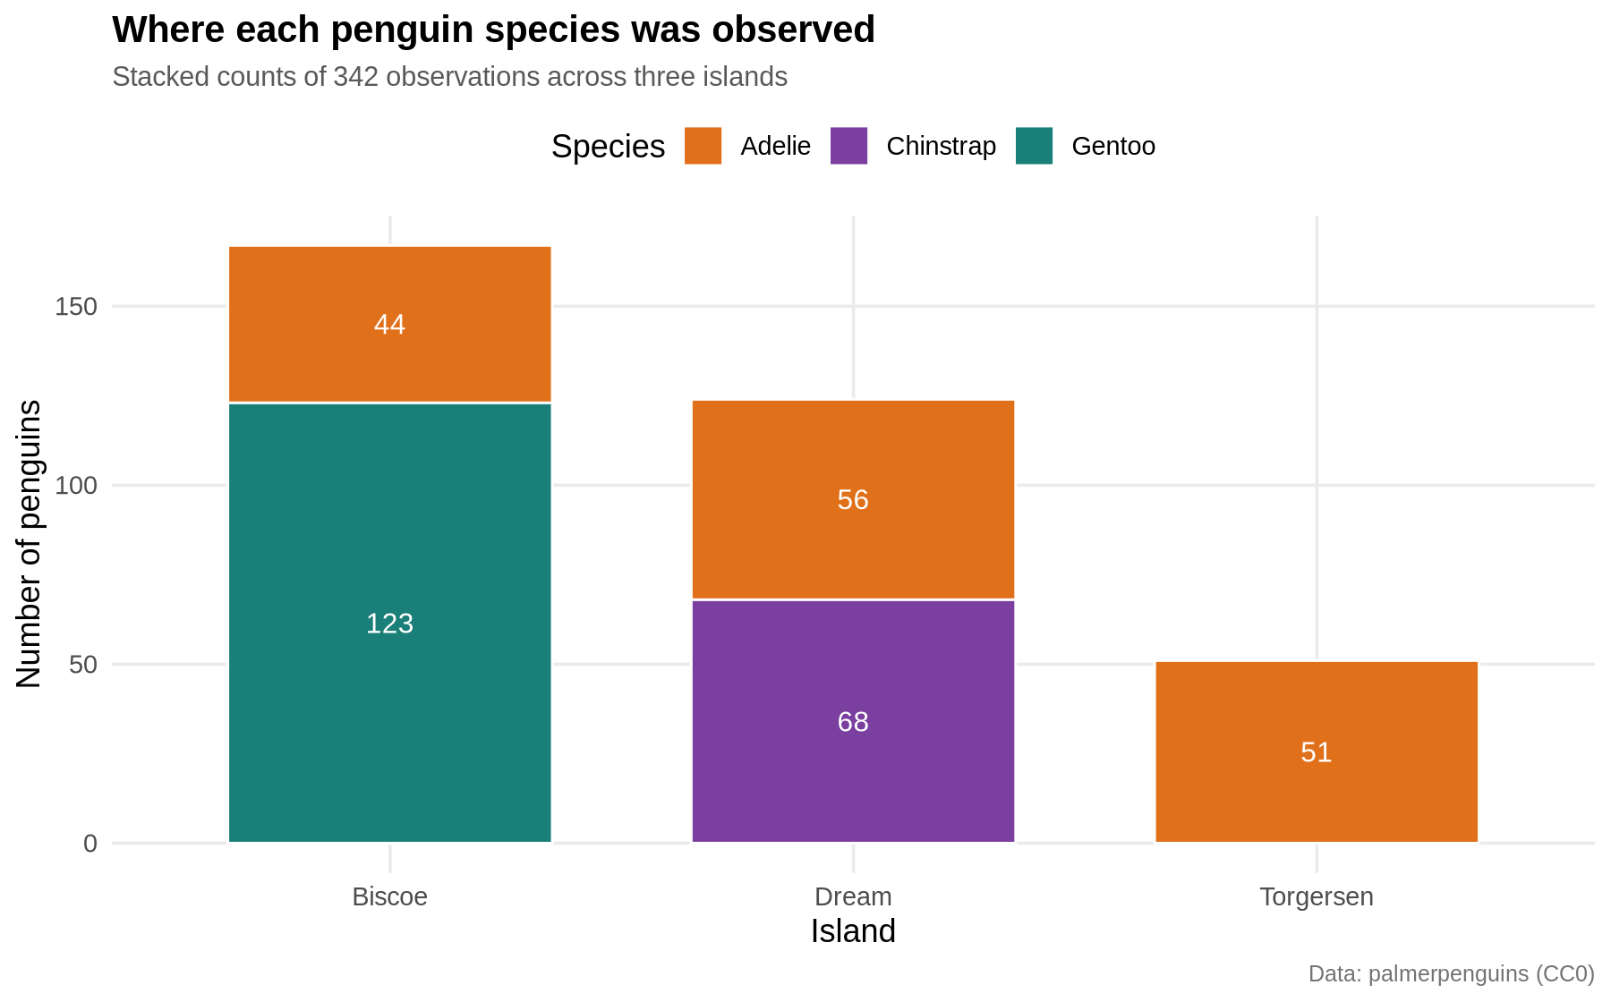
Figure 1 – Stacked bar chart of penguin counts by island and species
How to read it: Each bar is one island; the coloured blocks are the number of penguins of each species found there, with the exact count written inside.
Insight: Sampling is highly unbalanced. Biscoe is dominated by Gentoo (123 of 167), Dream is split between Chinstrap (68) and Adelie (56), and Torgersen holds Adelie only. Island and species are therefore confounded – any later difference “between islands” is really a difference between species, and this figure is what stops that mistake being made.

4.2 Figure 2 – Distribution: flipper length (histogram)
A histogram shows the shape of one continuous variable. Colouring the bars by species converts a puzzling shape into an explained one, which is far more persuasive than two separate charts.
R code
ggplot(df, aes(flipper_length_mm, fill = species)) +
geom_histogram(binwidth = 3, colour = "white", alpha = .85, position = "identity") +
geom_vline(xintercept = mean(df$flipper_length_mm), linetype = "dashed", colour = "grey30") +
annotate("text", x = mean(df$flipper_length_mm) + 1, y = 26,
label = paste0("overall mean = ", round(mean(df$flipper_length_mm), 1), " mm"),
hjust = 0, size = 3.4, colour = "grey30") +
scale_fill_manual(values = pal) +
labs(title = "Flipper length is bimodal - and species explains it",
subtitle = "Histogram (3 mm bins) of flipper length, filled by species",
x = "Flipper length (mm)", y = "Count", fill = "Species")
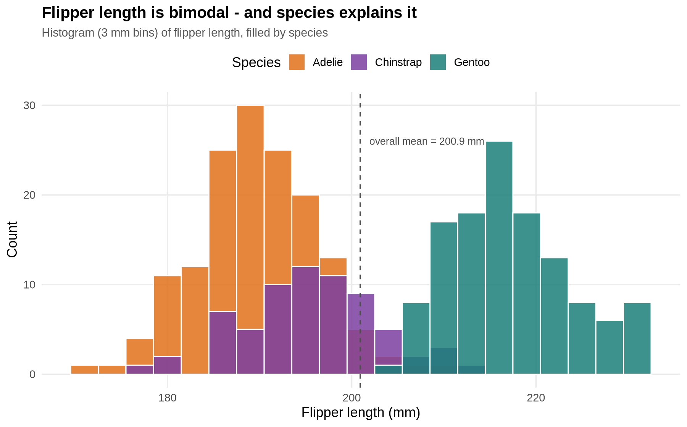
Figure 2 – Histogram of flipper length (3 mm bins), filled by species
How to read it: The horizontal axis is flipper length in millimetres and the height of each bar is how many penguins fall in that 3 mm range. The dashed line marks the overall mean of 200.9 mm.
Insight: The distribution has two peaks, so the overall mean of 200.9 mm describes almost nobody – it falls in the sparse valley between the groups. The left peak is Adelie and Chinstrap combined (roughly 185–200 mm) and the right peak is Gentoo (roughly 210–230 mm). This is the clearest visual warning in the report that summary statistics computed over the whole sample are misleading here.

4.3 Figure 3 – Distribution: body mass (density curves)
Where a histogram is best for one variable, overlapping density curves are best for comparing the shape of three groups on a common axis without the visual noise of stacked bars.
R code
ggplot(df, aes(body_mass_g, fill = species, colour = species)) +
geom_density(alpha = .35, linewidth = .8) +
scale_fill_manual(values = pal) +
scale_colour_manual(values = pal) +
labs(title = "Body-mass distributions barely overlap for Gentoo",
subtitle = "Kernel density estimates of body mass by species",
x = "Body mass (g)", y = "Density", fill = "Species", colour = "Species")
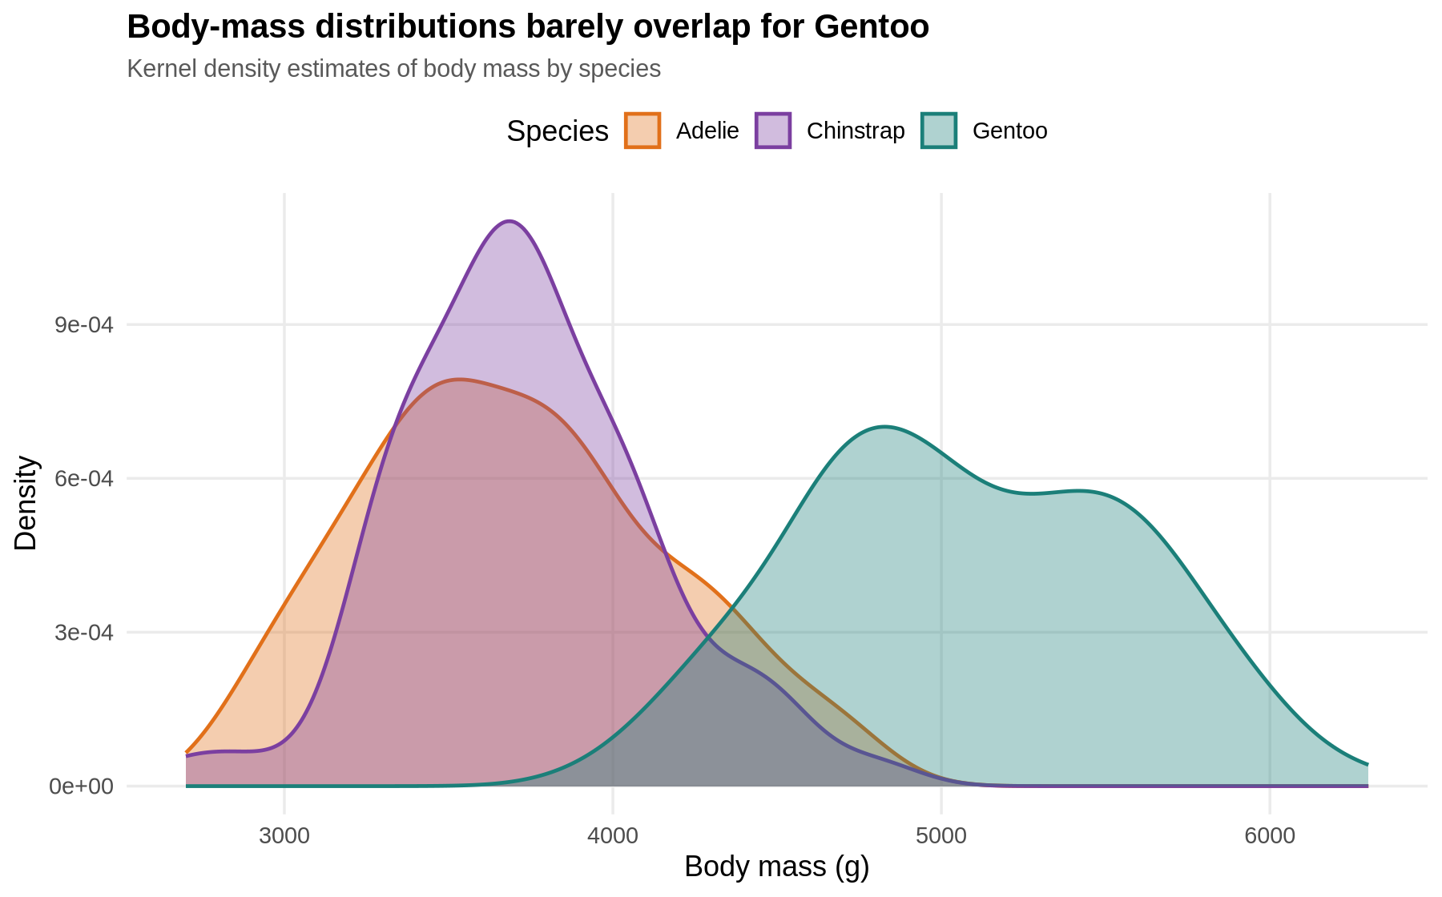
Figure 3 – Kernel density estimates of body mass by species
How to read it: Each shaded curve is the smoothed distribution of body mass for one species; the area under each curve is the same, so height means relative concentration, not sample size.
Insight: Adelie and Chinstrap are essentially the same weight class (both centred near 3,700 g) while Gentoo sits about 1,400 g heavier with almost no overlap. The Gentoo curve is also visibly double-humped – the signature of the male/female split within that species, which Figure 4 then confirms.

4.4 Figure 4 – Comparison: body mass by species and sex (boxplot)
A boxplot summarises a distribution in five numbers, but on its own it hides sample size and clustering, so every individual penguin is drawn as a jittered point behind it. Faceting by sex isolates one variable at a time, which is the honest way to show a two-factor comparison.
R code
ggplot(subset(df, sex != "unrecorded"), aes(species, body_mass_g, fill = species)) +
geom_boxplot(outlier.shape = NA, alpha = .55, width = .6) +
geom_jitter(width = .16, alpha = .5, size = 1.4, aes(colour = species)) +
facet_wrap(~ sex) +
scale_fill_manual(values = pal) +
scale_colour_manual(values = pal) +
labs(title = "Males are consistently heavier within every species",
subtitle = "Boxplots with raw observations, faceted by sex",
x = NULL, y = "Body mass (g)") +
theme(legend.position = "none")
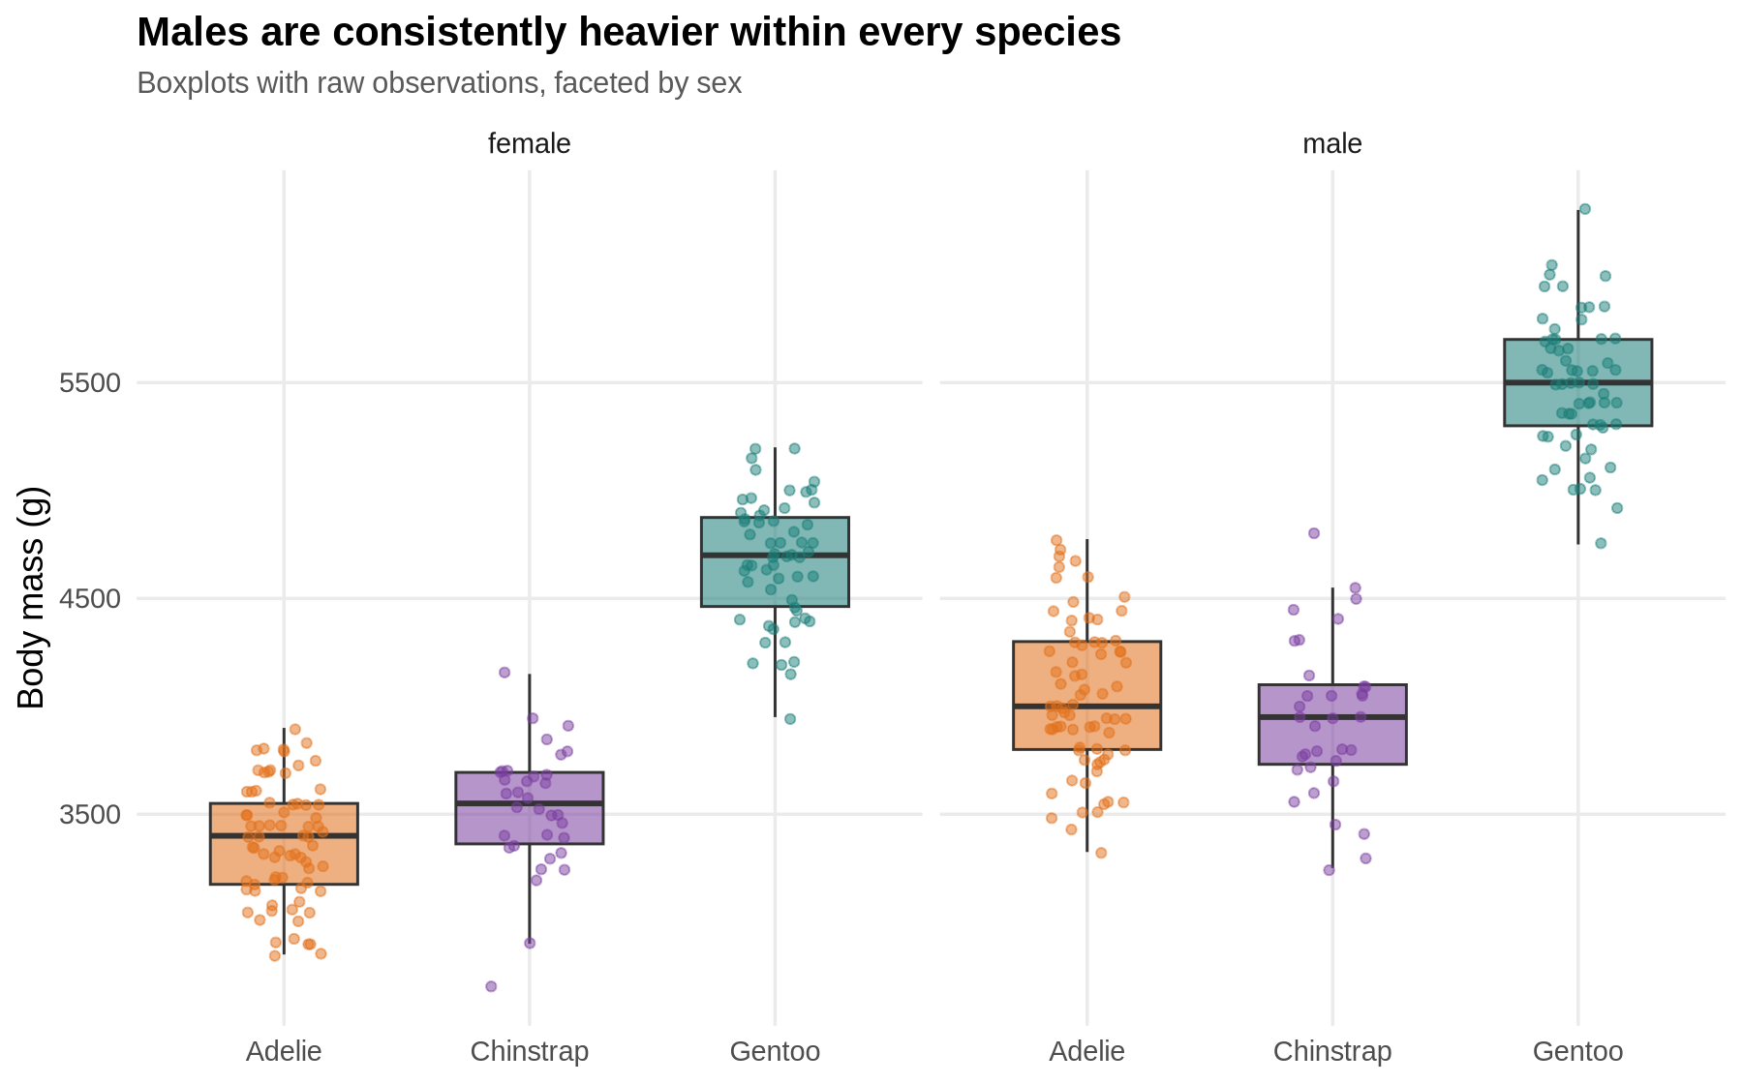
Figure 4 – Boxplots of body mass by species, faceted by sex, with raw observations overlaid
How to read it: The box spans the middle 50% of penguins, the thick line is the median, the whiskers reach the bulk of the remaining data, and each dot is one bird. The left panel is females, the right panel males.
Insight: The male–female gap is present in all three species and runs in the same direction every time – roughly 675 g for Adelie, 412 g for Chinstrap and 805 g for Gentoo. Because the effect is consistent rather than driven by one group, sex is a genuine covariate that any later model of body mass must include.

4.5 Figure 5 – Relationship: flipper length vs body mass (scatter)
A scatter plot is the only chart type that shows the joint behaviour of two continuous variables observation by observation. Adding per-species fits with confidence bands communicates both the trend and the uncertainty around it.
R code
ggplot(df, aes(flipper_length_mm, body_mass_g, colour = species)) +
geom_point(size = 2, alpha = .8) +
geom_smooth(method = "lm", se = TRUE, linewidth = .9) +
scale_colour_manual(values = pal) +
labs(title = "Flipper length predicts body mass in every species",
subtitle = paste0("Linear fits per species; pooled Pearson r = ",
round(cor(df$flipper_length_mm, df$body_mass_g), 3)),
x = "Flipper length (mm)", y = "Body mass (g)", colour = "Species")
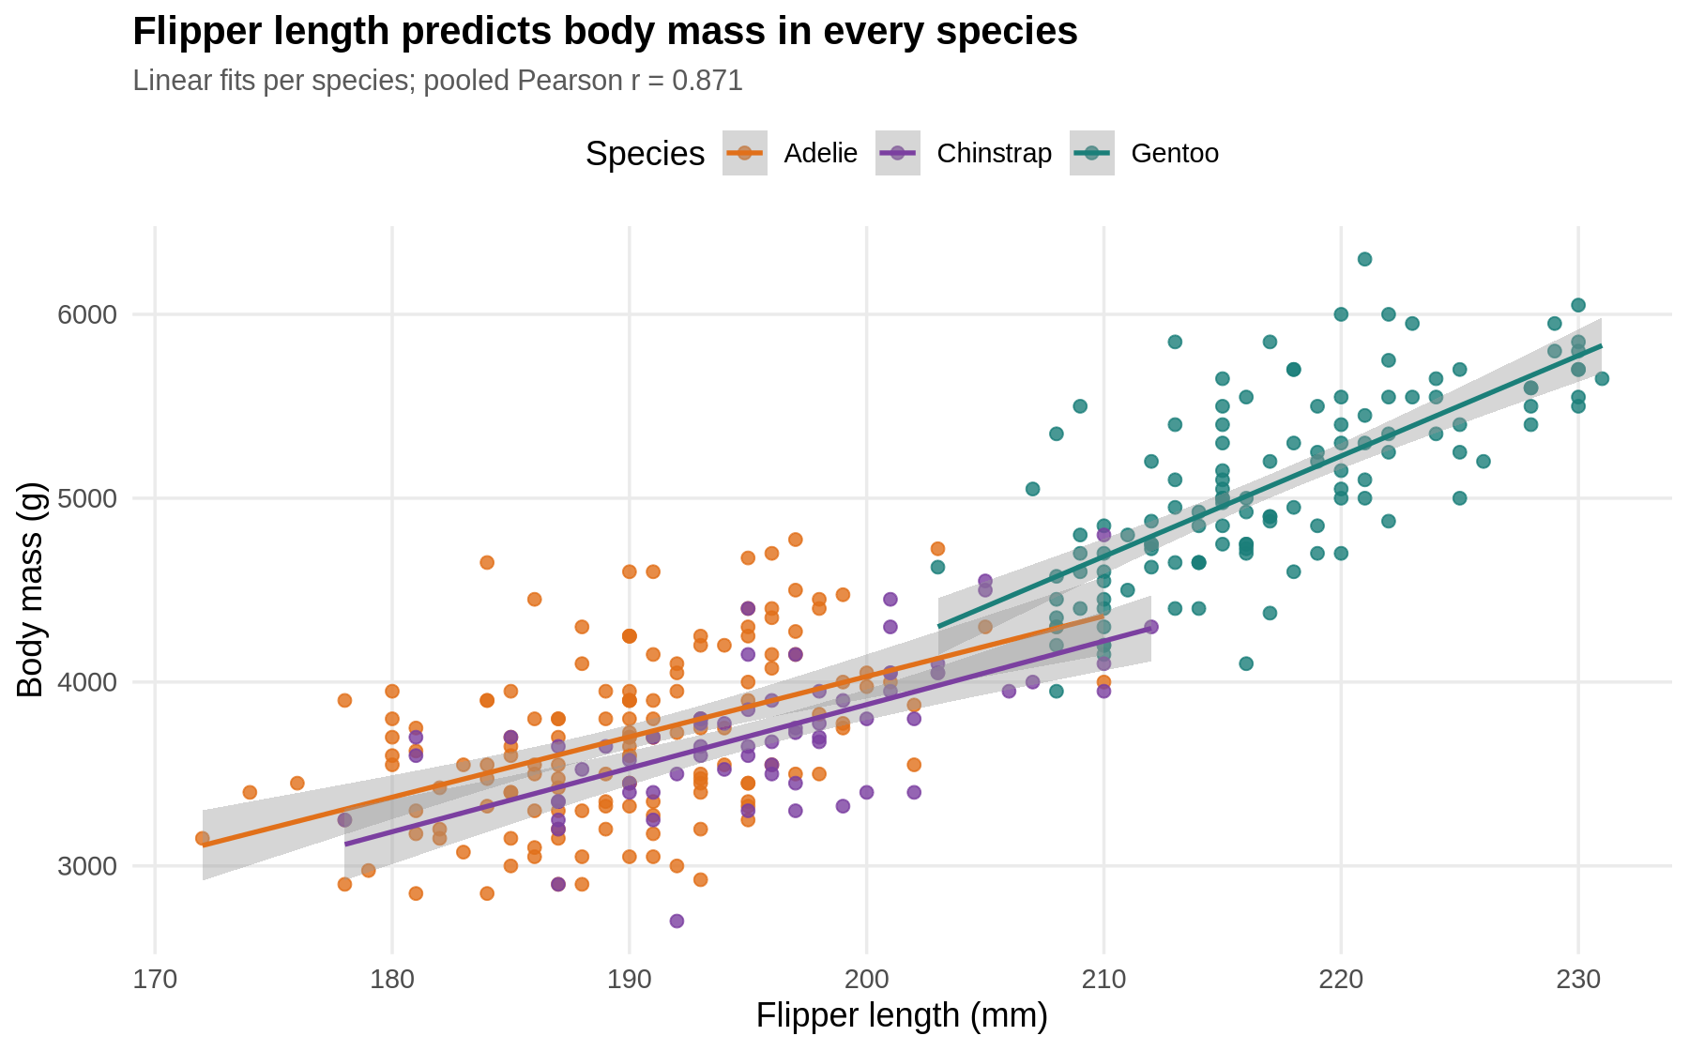
Figure 5 – Flipper length against body mass with per-species linear fits and confidence bands
How to read it: Each dot is one penguin positioned by its flipper length and its mass; each line is the best straight-line fit for that species, and the shaded ribbon is the 95% confidence band for that line.
Insight: The relationship is strong, positive and linear in every species – roughly 50 g of extra mass for every additional millimetre of flipper. The three fitted lines have similar slopes but different intercepts, meaning species differ in overall size rather than in how size scales. Flipper length alone explains 75.9% of the variation in body mass.

4.6 Figure 6 – Anomaly: Simpson's paradox in the bill dimensions
This chart exists specifically to expose an anomaly. The same data are fitted twice – once ignoring species and once respecting it – so the contradiction is visible in a single frame instead of buried in two correlation coefficients.
R code
r_pool <- cor(df$bill_length_mm, df$bill_depth_mm)

ggplot(df, aes(bill_length_mm, bill_depth_mm, colour = species)) +
geom_point(size = 2, alpha = .8) +
geom_smooth(method = "lm", se = FALSE, linewidth = .9) +
geom_smooth(method = "lm", se = FALSE, colour = "grey25",
linetype = "dashed", aes(group = 1)) +
scale_colour_manual(values = pal) +
labs(title = "Simpson's paradox: the pooled trend reverses within species",
subtitle = paste0("Dashed grey = pooled fit (r = ", round(r_pool, 2),
"); coloured = within-species fits (all positive)"),
x = "Bill length (mm)", y = "Bill depth (mm)", colour = "Species")
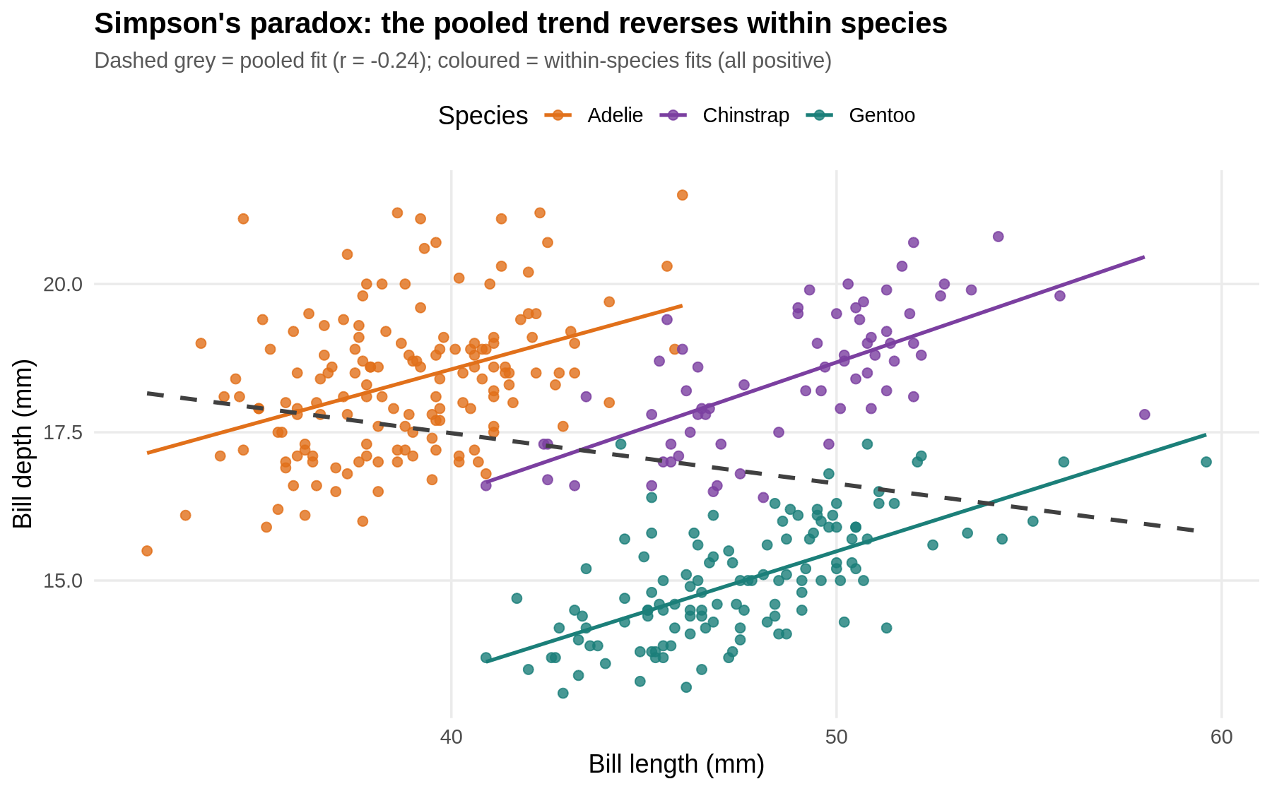
Figure 6 – Bill length against bill depth: the pooled fit (dashed) contradicts the within-species fits
How to read it: Dots are individual penguins; the three coloured lines are within-species trends and the dashed grey line is the trend obtained when the species labels are thrown away.
Insight: Pooled, longer bills appear shallower (r = −0.235). Within each species the relationship is the opposite: longer bills are deeper (r = 0.391 Adelie, 0.654 Chinstrap, 0.643 Gentoo). This is a textbook Simpson's paradox caused by Gentoo having long but shallow bills. Any analysis that ignores species would draw exactly the wrong biological conclusion, and this single figure is the strongest argument in the report for always grouping before correlating.

4.7 Figure 7 – Trend: annual means, 2007–2009 (line chart)
A line chart is reserved for a genuinely ordered variable. Here the ordering is time, and the question is whether the population changed over the study period.
R code
agg <- aggregate(cbind(body_mass_g, flipper_length_mm, bill_length_mm) ~ species + year,
data = df, FUN = mean)

ggplot(agg, aes(as.integer(as.character(year)), body_mass_g,
colour = species, group = species)) +
geom_line(linewidth = 1.1) +
geom_point(size = 3) +
scale_colour_manual(values = pal) +
scale_x_continuous(breaks = 2007:2009) +
labs(title = "Mean body mass is stable across the three breeding seasons",
subtitle = "Annual species means, 2007-2009",
x = "Study year", y = "Mean body mass (g)", colour = "Species")
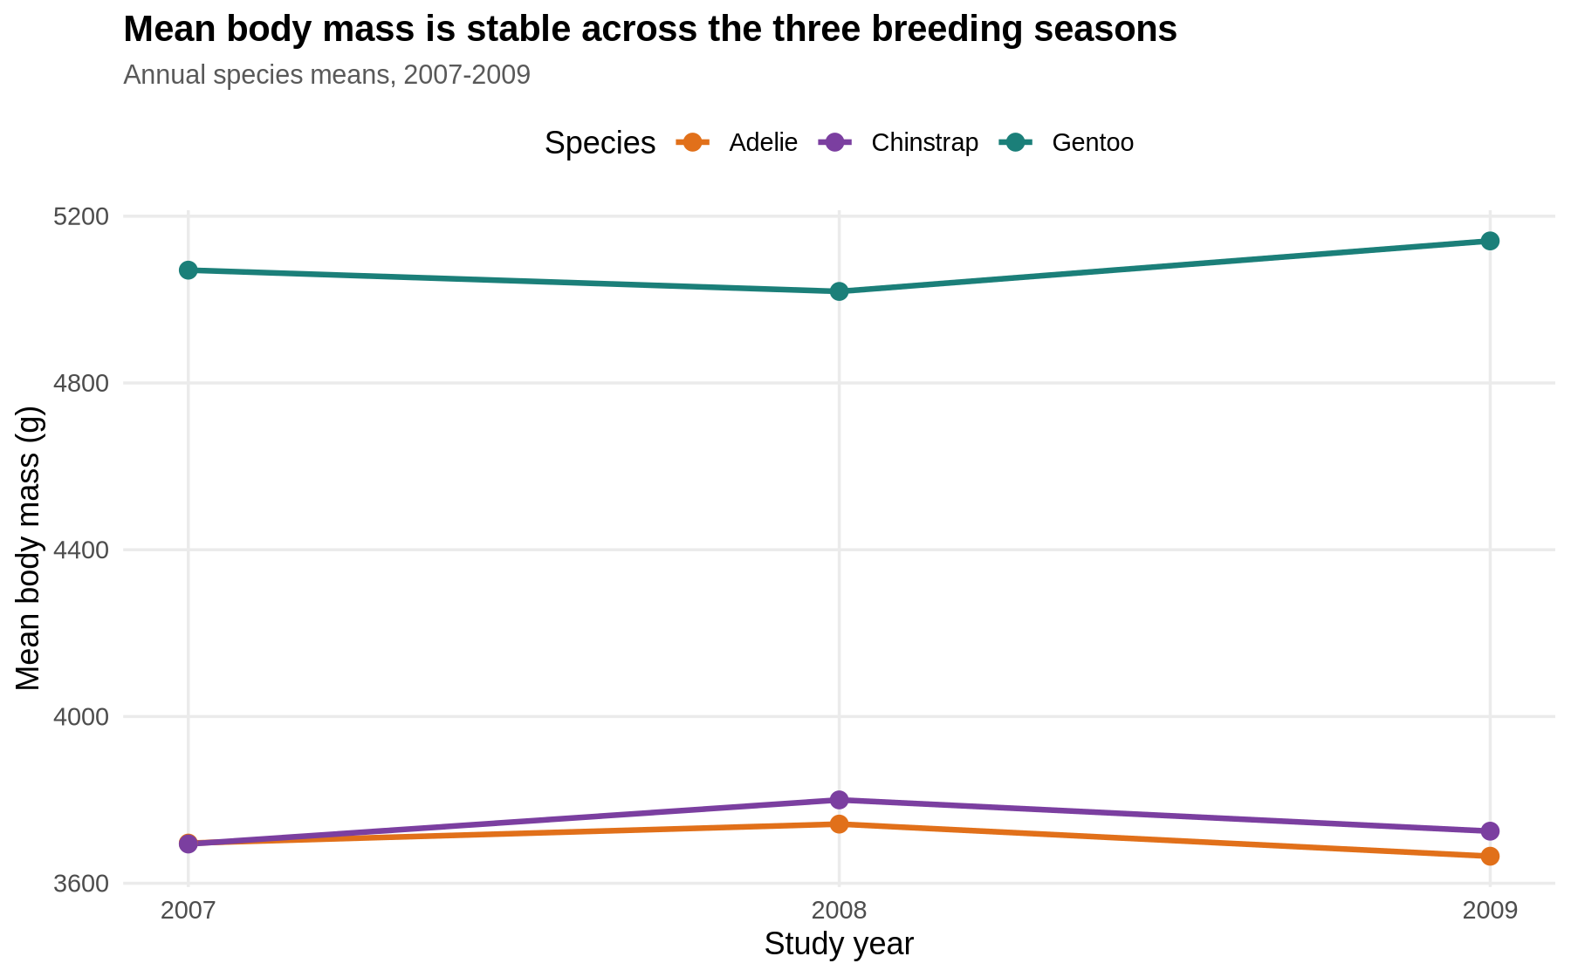
Figure 7 – Mean body mass per species across the three study years
R console output
species year body_mass_g flipper_length_mm bill_length_mm
1 Adelie 2007 3696 186.6 38.8
2 Chinstrap 2007 3694 192.4 48.7
3 Gentoo 2007 5071 215.1 47.0
4 Adelie 2008 3742 191.0 38.6
5 Chinstrap 2008 3800 197.7 48.7
6 Gentoo 2008 5020 217.6 46.9
7 Adelie 2009 3665 192.1 39.0
8 Chinstrap 2009 3725 198.1 49.1
9 Gentoo 2009 5141 218.4 48.5
How to read it: Each line follows one species; each point is that species' average body mass in that breeding season. Note that the vertical axis spans a wide range, so flat lines really do mean stability.
Insight: Nothing meaningful moves. Adelie varies by 77 g, Chinstrap by 106 g and Gentoo by 121 g across three years – small next to the 1,400 g gap between species and the 700 g gap between sexes. The practical consequence is that year can safely be pooled in later modelling, and this negative result is worth showing rather than hiding.

4.8 Figure 8 – Correlation heat map
A heat map compresses sixteen numbers into a picture that can be read in two seconds. Colour carries the sign and strength; the printed number keeps it precise for a technical reader.
R code
num <- df[, c("bill_length_mm", "bill_depth_mm", "flipper_length_mm", "body_mass_g")]
cm <- round(cor(num), 2)
cml <- data.frame(as.table(cm)); names(cml) <- c("v1", "v2", "r")

ggplot(cml, aes(v1, v2, fill = r)) +
geom_tile(colour = "white", linewidth = 1.2) +
geom_text(aes(label = sprintf("%.2f", r)), size = 4.4) +
scale_fill_gradient2(low = "#2166AC", mid = "white", high = "#B2182B",
midpoint = 0, limits = c(-1, 1)) +
coord_equal() +
labs(title = "Correlation structure of the four body measurements",
subtitle = "Pearson coefficients; bill depth is negatively correlated with the rest",
x = NULL, y = NULL, fill = "r") +
theme(axis.text.x = element_text(angle = 20, hjust = 1))
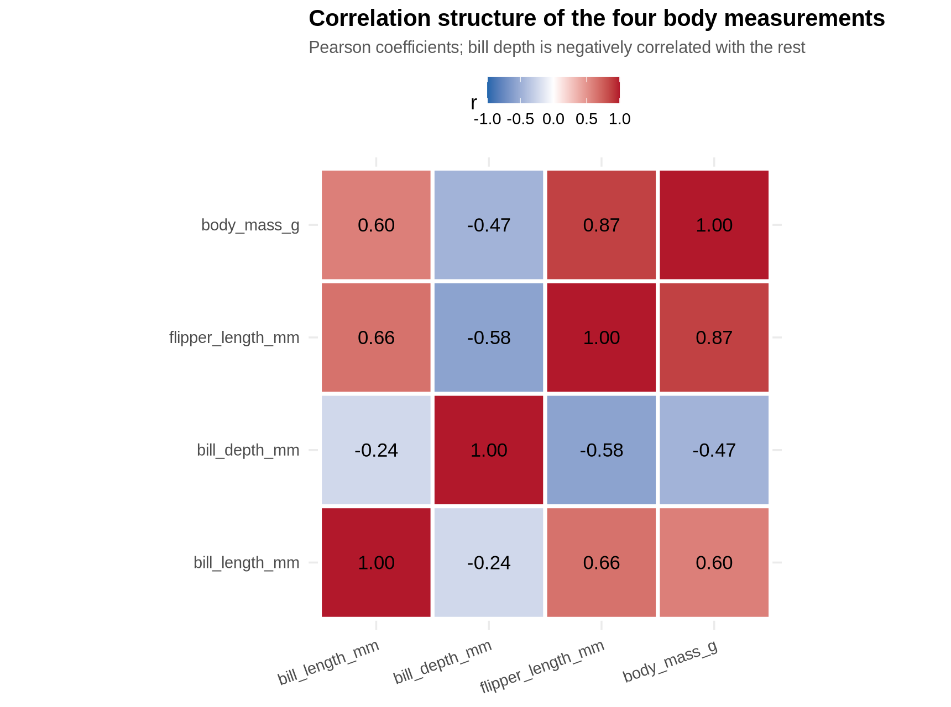
Figure 8 – Heat map of the Pearson correlation matrix of the four body measurements
R console output
bill_length_mm bill_depth_mm flipper_length_mm body_mass_g
bill_length_mm 1.00 -0.24 0.66 0.60
bill_depth_mm -0.24 1.00 -0.58 -0.47
flipper_length_mm 0.66 -0.58 1.00 0.87
body_mass_g 0.60 -0.47 0.87 1.00
How to read it: Red means the two measurements rise together, blue means one rises as the other falls, and white means no linear relationship. The diagonal is 1.00 by definition.
Insight: Flipper length and body mass form the strongest pair (r = 0.87), confirming Figure 5. Bill depth is the odd one out, correlating negatively with everything else – but Figure 6 has already shown that this negative block is an artefact of pooling species, which is precisely why the heat map should never be read on its own.

4.9 Figure 9 – Scatterplot matrix (lattice)
The lattice trellis system was used here because splom() produces a compact, publication-ready matrix of every pairwise relationship with one call. It is the visual counterpart of the heat map: the heat map gives the number, the matrix shows the shape behind the number.
R code
library(lattice)

splom(~ num, groups = df$species, pch = 19, cex = .45,
col = pal[levels(df$species)],
key = list(space = "top", columns = 3,
points = list(pch = 19, col = pal[levels(df$species)]),
text = list(levels(df$species))),
main = "Pairwise scatterplot matrix (lattice::splom)")
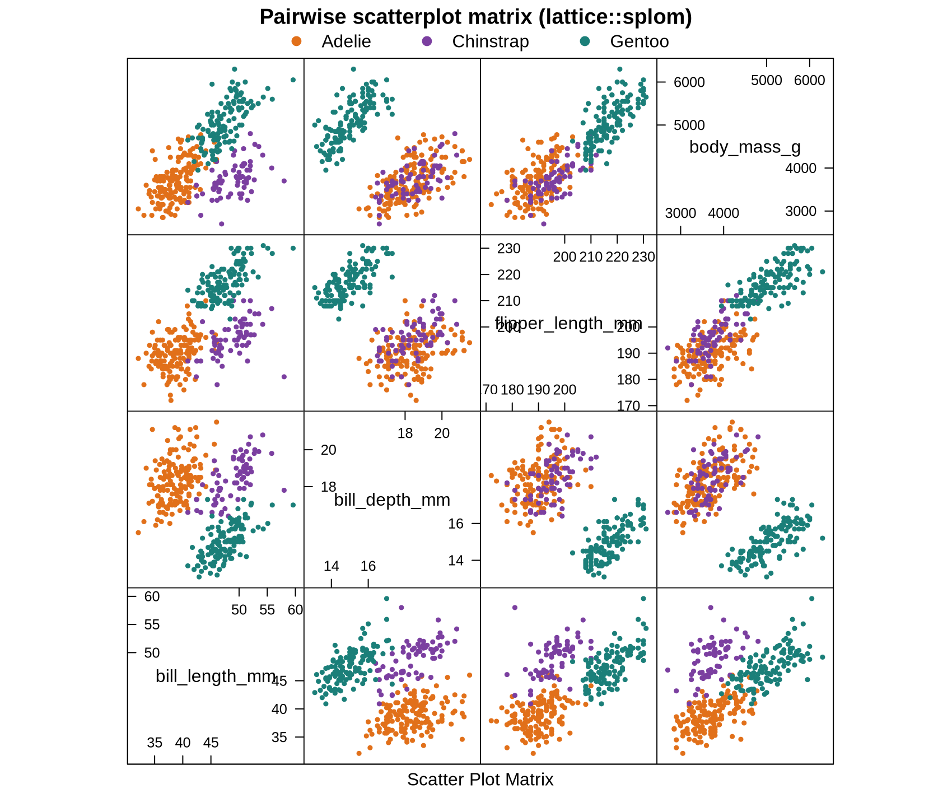
Figure 9 – Pairwise scatterplot matrix of all four measurements, grouped by species (lattice)
How to read it: Every off-diagonal panel is a scatter plot of the variable named in the row against the variable named in the column, with points coloured by species.
Insight: All six panels show three separable clouds rather than one, which is the single most important structural fact about this dataset: species is the dominant source of variation. The bill-length/bill-depth panel is where the paradox of Figure 6 is visible as three parallel clouds arranged along a downward diagonal.

4.10 Figure 10 – Mosaic plot (base R)
Base graphics were used for the final figure to demonstrate the third R plotting system. A mosaic plot is the natural choice for two categorical variables because area, not height, encodes the count – so both the size of each island's sample and its internal composition are readable at once.
R code
mosaicplot(table(df$island, df$species), color = pal, las = 1,
main = "Species composition of each island (base R mosaicplot)",
xlab = "Island", ylab = "Species")
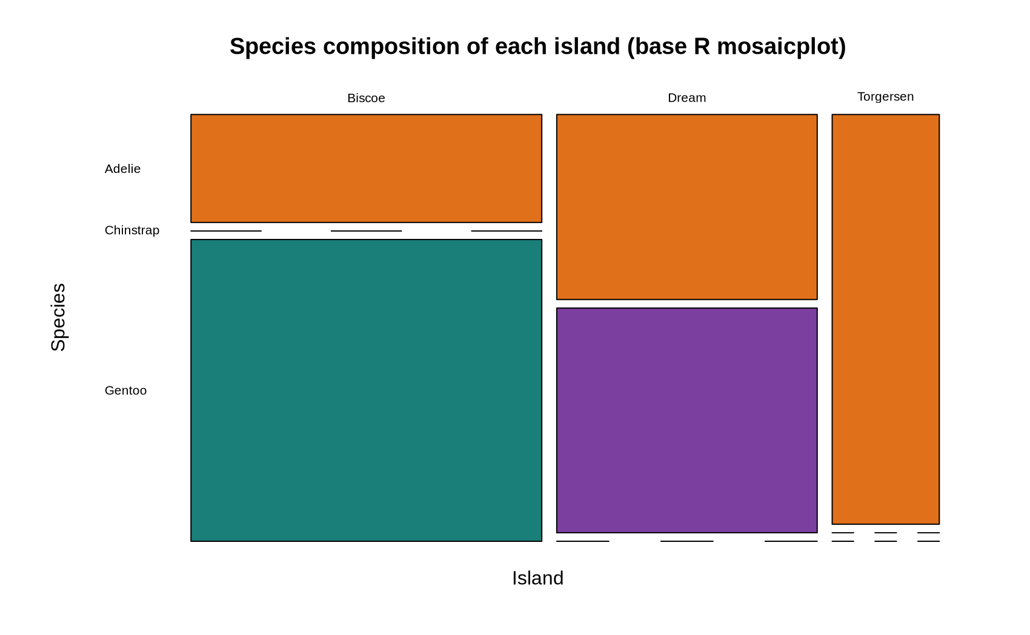
Figure 10 – Mosaic plot of the island-by-species contingency table (base graphics)
How to read it: The width of each column is proportional to how many penguins were observed on that island; the height of each block within a column is that species' share of the island.
Insight: Biscoe is the widest column (the largest sample) and is almost entirely Gentoo; Dream is mostly Chinstrap with a substantial Adelie share; Torgersen is narrow and purely Adelie. The empty cells make the confounding between island and species impossible to overlook.

5. Statistical Confirmation of the Visual Findings
A visualization suggests; a test confirms. Each of the three headline visual claims was checked formally so that the narrative rests on evidence rather than on the persuasiveness of a chart.
R code
summary(aov(body_mass_g ~ species, data = df))
summary(lm(body_mass_g ~ flipper_length_mm, data = df))
sapply(split(df, df$species), function(d) cor(d$bill_length_mm, d$bill_depth_mm))
cor(df$bill_length_mm, df$bill_depth_mm)
R console output
Df Sum Sq Mean Sq F value Pr(>F)
species 2 146864214 73432107 343.6 <2e-16 ***
Residuals 339 72443483 213698

Estimate Std. Error t value Pr(>|t|)
(Intercept) -5780.83136 305.814504 -18.90306 5.587301e-55
flipper_length_mm 49.68557 1.518404 32.72223 4.370681e-107

R-squared: 0.759

Adelie Chinstrap Gentoo
0.391 0.654 0.643

Pooled bill correlation: -0.235
- Figure 3/4 claim – species differ in body mass: one-way ANOVA gives F(2, 339) = 343.6, p < 2e-16. Confirmed.
- Figure 5 claim – flipper length predicts mass: each additional millimetre of flipper is worth 49.7 g (SE 1.5, p < 1e-100), and the model explains 75.9% of the variance. Confirmed.
- Figure 6 claim – the pooled bill correlation is an artefact: pooled r = −0.235 while all three within-species correlations are positive. Confirmed as a genuine Simpson's paradox.

6. Key Insights for a Non-Technical Reader
- There are effectively three different kinds of penguin in this data, and almost every pattern you can see is really the difference between those three kinds.
- Gentoo penguins are in a class of their own: about 1.4 kg heavier than the other two species, with longer flippers and noticeably shallower bills.
- Bigger flippers mean a heavier bird, reliably and in every species – it is the single most useful measurement if you could only take one.
- Males are heavier than females in all three species by roughly 400–800 g, so any comparison that ignores sex is comparing partly on sex.
- Where a penguin was found tells you which species it is, not something separate about the island: Gentoo were only seen on Biscoe and Chinstrap only on Dream.
- Nothing changed appreciably over the three years of the study, so the picture above describes a stable population rather than a trend.
- The most important warning in the whole report: looking at all the penguins together can point the opposite way to looking at each species separately (Figure 6). Always ask what groups are hidden inside a summary.

7. Reproducibility
The entire report is generated by one self-contained R script, week2_viz.R, which depends only on ggplot2 and lattice in addition to base R. Running it end to end regenerates every console output and all ten figures at 200 dpi.
Artefact | Description
week2_viz.R | Single script: load, prepare, plot, test
penguins.csv | Raw public dataset (344 rows, CC0)
fig01…fig10 (.png) | The ten figures embedded in this document
Environment | R 4.5.1 · ggplot2 3.5.2 · lattice 0.22.7
Random seed | set.seed(42) – fixes the jitter in Figure 4

The seed matters: geom_jitter() displaces points randomly, so without a fixed seed Figure 4 would differ slightly on every run and the document would not be exactly reproducible.

8. Conclusion
Ten visualizations, drawn with three different R graphics systems, were used to move from a cleaned table of 342 penguins to a defensible account of what the data contain. The composition charts established that island and species are confounded; the distribution charts revealed a bimodality that a single mean would have concealed; the comparison and relationship charts quantified the species, sex and flipper-length effects; the line chart established that time can be ignored; and the paradox figure demonstrated that pooling groups can reverse a conclusion outright.
Every visual claim was subsequently confirmed statistically, and every chart was chosen because it answered a question the previous chart raised. The result is not a gallery of plots but a narrative: species is the dominant structure in this dataset, flipper length is the best single predictor of body mass, sex adds a consistent secondary effect, and any analysis that ignores the species grouping risks reaching the wrong answer.

