**AGRIMARKET DDL STATEMENTS**

**MIS : 111803136**

**Name : Siddhika Santoshkumar Bejekar**

**College of Engineering, Pune**

**Agrimarket Database Tables:**

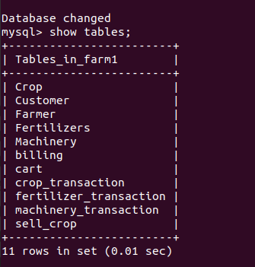

**1) Farmer Table**

create table Farmer

(Farmer_ID varchar(7),

Farmer_name varchar(20) not null,

Mobile_no numeric(10,0),

Email_ID varchar(20),

City varchar(10),

Password varchar(20),

primary key (Farmer_ID));

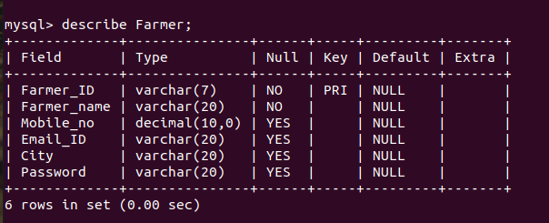

**2) Customer Table**

create table Customer

(Customer_ID varchar(7),

Customer_name varchar(20) not null,

Mobile_no numeric(10,0),

Email_ID varchar(20),

City varchar(10),

Password varchar(20),

primary key (Customer_ID));

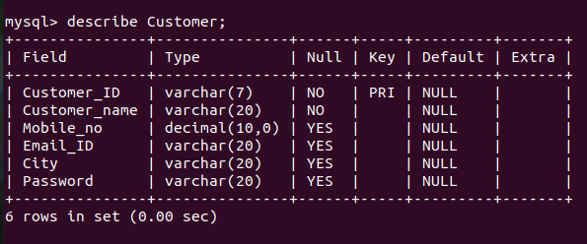

**3)Crops Table**

create table Crop

(Crop_ID varchar(7),

Crop_name varchar(20) not null,

Quantity numeric(3,2),

Primary key (Crop_ID));

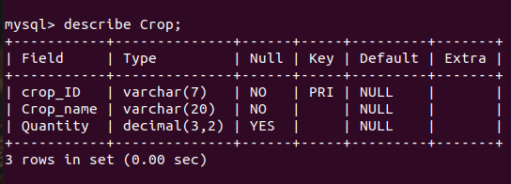

**4)Crop sell table**

create table sell_crop

(Crop_ID varchar(7),

Farmer_ID varchar(7),

Price numeric(5,2),

primary key (Crop_ID, Farmer_ID),

foreign key (Crop_ID) references Crop(Crop_ID) on delete cascade,

foreign key (Farmer_ID) references Farmer(Farmer_ID) on delete cascade);

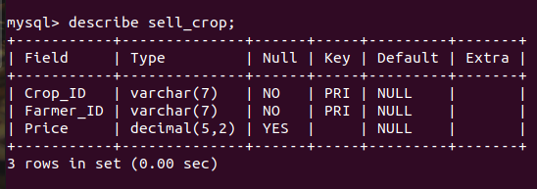

**5) Machinery Table**

create table Machinery

(Machine_ID varchar(7),

Machine_name varchar(10),

Company varchar(15),

Price numeric(7,2),

primary key (Machine_ID));

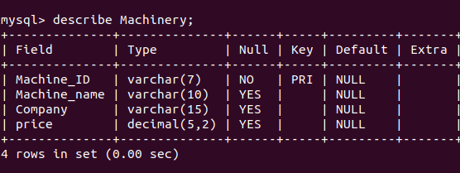

**6) Fertilizer table**

create table Fertilizer

(Fertilizer_ID varchar(7),

Fertilizer_name varchar(20) not null,

Component varchar(10),

Price numeric(7,2),

primary key (fertilizer_ID));

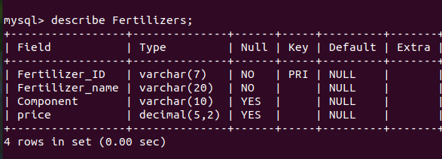

**7) Crop_Transaction table**

create table crop_transaction

(trans_IDc varchar(7),

Customer_ID varchar(7),

Crop_ID varchar(7),

Farmer_ID varchar(7),

primary key (trans_IDc),

foreign key (Customer_ID) references Customer(Customer_ID) on delete cascade,

foreign key (Crop_ID) references Crop(Crop_ID) on delete cascade,

foreign key (Farmer_ID) references Farmer(Farmer_ID) on delete cascade);

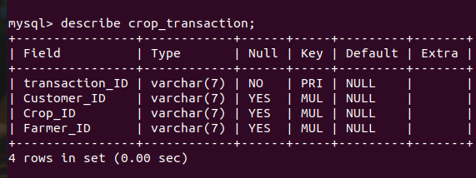

**7)Machinery_Transaction table**

create table machinery_transaction

(trans_Idm varchar(7),

Machine_ID varchar(7),

Customer_ID varchar(7),

primary key (trans_IDm),

foreign key(Machine_ID) references Machinery(Machine_ID) on delete cascade,

foreign key(Customer_ID) references Customer(Customer_ID) on delete cascade);

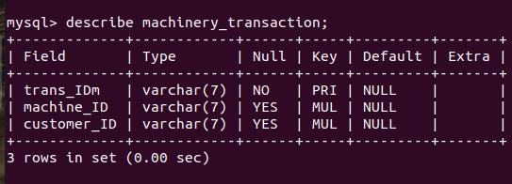

**8)Fertilizer_Transaction table**

create table fertilizer_transaction

(trans_Idf varchar(7),

Fertilizer_ID varchar(7),

Customer_ID varchar(7),

primary key (trans_IDf),

foreign key (Fertilizer_ID) references Fertilizer(Fertilizer_ID) on delete cascade,

foreign key(Customer_ID) references Customer(Customer_ID) on delete cascade);

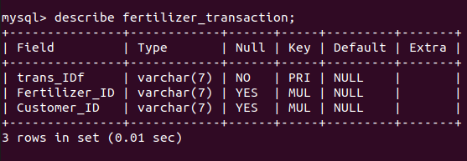

**9)Cart Table**

create table cart

(bill_ID varchar(7),

transaction_ID varchar(7),

amount numeric(5,2),

primary key (bill_ID, transaction_ID));

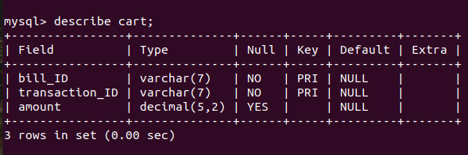

**10)Billing Table**

create table billing

(bill_ID varchar(7),

Customer_ID varchar(7),

Amount numeric(7,2),

Card_no int,

Card_name varchar(20),

Expiry int,

CVV numeric(3,0),

primary key(bill_ID),

foreign key(bill_ID) references cart(bill_ID) on delete cascade,

foreign key(Customer_ID) references Customer(Customer_ID) on delete cascade);

