- Student name:R.s.v.r.prasad
- Roll no:A24126552266
- Experiment No: [01]
- Date: [14/08/2026]
- Title: [ Design Static Webpage using Components]
🎯 Objective / Aim
- To design and implement a Static webpage using html components.
🛠️ System Requirements
- Hardware: Processor (e.g., Core i5), RAM (e.g., 8GB), Storage.
- Software: Operating System (e.g., Windows 11 / Linux), Code Editor (e.g., VS Code), Browser (e.g., Chrome), Runtime/Database (e.g., Node.js, MongoDB). [1, 2]
💻 Source Code
<!DOCTYPE html>
<html lang="en">
<head>
<meta charset="UTF-8">
<meta name="viewport" content="width=device-width, initial-scale=1.0">
<title>Html Web page</title>
</head>
<body>
<header>
<table width="100%" cellspacing="0" cellpadding="15">
<tr>
<td>
<h1 align="center">Welcome to my site!</h1>
</td>
<td align="right">
<nav>
<a href="#home">Home</a>&nbsp;|&nbsp;
<a href="#references">References</a>&nbsp;|&nbsp;
<a href="#about"></a>&nbsp;|&nbsp;
<a href="#form details">Fill Form</a>&nbsp;|&nbsp;
<a href="#site">Site Details</a>
</nav>
</td>
</tr>
</table>
</header>
<hr>
<section id="home">
<center>
<h2>Making Page Without CSS</h2>
<p>Lorem ipsum dolor sit, amet consectetur adipisicing elit. Delectus, aperiam.</p>
<p><a href="#references"><b>Read The Points Below &darr;</b></a></p>
</center>
</section>
<hr>
<td width="50%">
<main id="about">
<article>
<h2>1.Core Subjects of 3rd year</h2>
<p>Published: July 8,2026</p>
<p>Python</p>
<p>Java</p>
<p>C</p>
<p>Data structures</p>
<p>Operating systems</p>
<p>Theory of computation</p>
<p>Machine learning</p>
<p>Artificial intelligence</p>

</article>

<br><hr><br>
<article>
<h2>2. Important subjects</h2>
<p>Published: July 8, 2026</p>
<p>Browsers come equipped with excellent interactive elements by default. We can capture text inputs, provide multiple-choice configurations, and submit structured information to backend parsers using pure markup.</p>
</article>
<h3>Interactive Demonstration Forms</h3>
<form id="contact" action="#" method="post">
<fieldset>
<legend><b>Student Filling Form</b></legend>
<p>
<label for="name">Full Name:</label>
<input type="text" id="name" name="username" required placeholder="Satya Venkata">
</p>
<p>
<label for="email">Email Address: </label>
<input type="email" id="email" name="studentemail" required>
</p>
<p>
<label for="topic">Subject Topic:</label>
<select id="topic" name="studenttopic">
<option value="general">General Feedback</option>
<option value="technical">Technical Architecture</option>
<option value="academics">Academic Curriculum</option>
<option value="none">None of the above</option>
</select>
</p>
<p>
<label for="message">Message Details:</label><br>
<textarea id="message" name="studentmessage" rows="5" cols="40" placeholder="Type your questions here..."></textarea>
</p>
<p>
<input type="submit" value="Submit Form Data">
<input type="reset" value="Clear Entries">
</p>
</fieldset>
</form>
</article>
</main>
</td>
</main>
</td>
<td width="70%" bgcolor="skyblue">
<aside id="about">
<h3>Subject Topics</h3>
<p>Lorem ipsum dolor sit amet consectetur adipisicing elit. Odit cumque reiciendis excepturi rerum necessitatibus doloribus?</p>
<h4>Core Benefits:</h4>
<ul>
<li>Efficiency at scale</li>
<li>Optimization</li>
<li>High data compatibility</li>
<li>Data handling</li>
</ul>
<h4>Required Skills:</h4>
<ol>
<li>Python</li>
<li>SQL</li>
<li>JavaScript/HTML/CSS</li>
<li>Deep Learning</li>
<li>Machine Learning</li>
</ol>
</aside>
</td>
</tr>
</table>
<hr>
<footer>
<center>
<p>&copy; 2026 Created by R.Satya to describe student's study importance.&copy;</p>
</center>
</footer>
</body>
</html>
🧪 Execution Steps:
- Open vs code.
- Run the code by clicking the file name and reveal in file explorer and click the file.
- This runs the code in the web browser.
🖥️ Output:
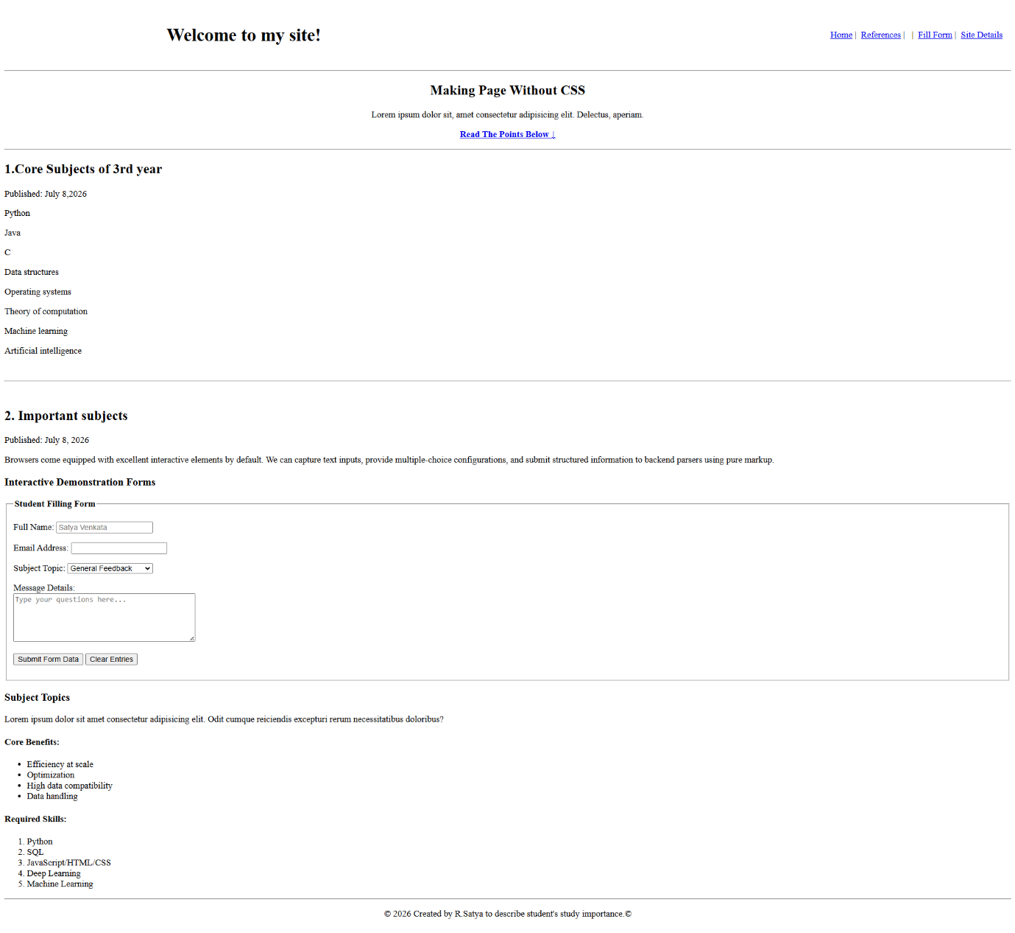
📝 Result / Conclusion
- The Static webpage is build using statuc html components.

