Kverra Infotech
Claude Implementation Change Request
Visual redesign + homepage restructuring
IMPORTANT
Read the existing PROJECT_OVERVIEW first. Preserve the current React/Vite + GSAP + Lenis architecture and apply the changes below. Do not rebuild the project from scratch or replace working architecture unnecessarily.

1. Existing Project Context
Kverra Infotech is a React/Vite marketing website for a real-estate photo-editing service. The existing project uses React 18, Vite 6, React Router, Tailwind CSS v4, GSAP/ScrollTrigger, Lenis, Phosphor Icons, Playfair Display and Plus Jakarta Sans. The project overview remains the source of truth for the existing component structure, routes, data layer and animation system.
- Keep the existing architecture and reusable components wherever possible.
- Do not remove GSAP, ScrollTrigger, Lenis, existing animation hooks, routing, service data architecture, or reduced-motion handling.
- Do not turn the site into a travel website. The screenshots are visual references only.
- The business remains Kverra Infotech and the website remains focused on real-estate photo editing.
- Keep WhatsApp as the primary conversion mechanism.

2. Reference Images
The three attached screenshots are the visual references for this redesign.

Reference 1: Blue + White visual language
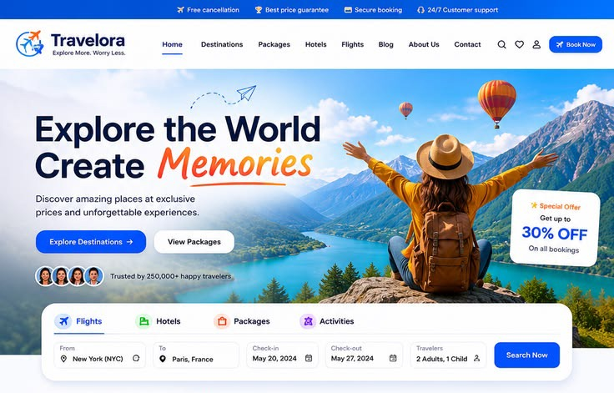
Use this primarily for the new blue-and-white brand atmosphere: bright white surfaces, strong blue accents, clean navigation, blue primary actions, refined cards and subtle shadows.

Reference 2: Homepage hero composition
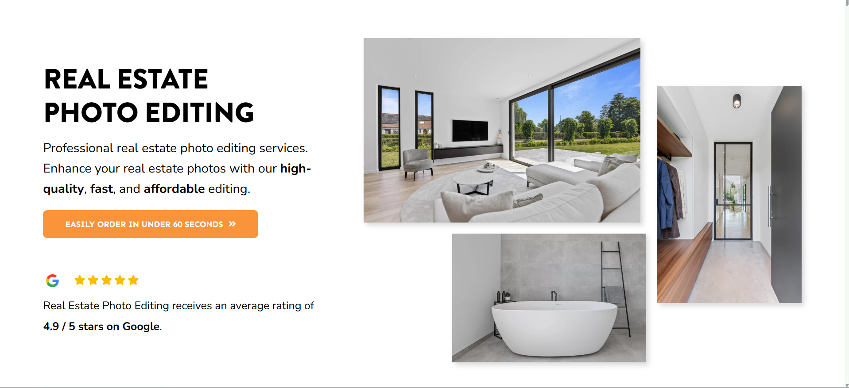
Use this primarily for the hero composition: large editorial headline and copy on the left, strong real-estate photography composition on the right, generous whitespace and a clear primary CTA.

Reference 3: 'This is what we do' service-card composition
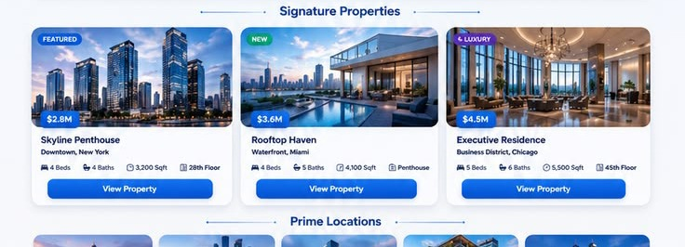
Use this primarily as the structural reference for the new services showcase: image-led premium cards, compact information hierarchy and strong blue CTA treatment.

3. CHANGE #1 — Replace the Entire Site Color Theme
Replace the current navy + gold visual system with a blue-and-white visual system inspired by Reference 1. This is a site-wide theme change, not just a homepage change.

Target visual direction
- White is the dominant page/surface color.
- Blue becomes the primary brand, action and accent color instead of gold.
- Use deep blue/navy for important text where strong contrast is needed.
- Use lighter blue tones for subtle backgrounds, badges, borders and hover states.
- Cards should generally use white surfaces with refined shadows and/or subtle blue-tinted borders.
- Primary CTA buttons should use the new blue brand color with white text.
- Remove the visual dependence on gold accents, gold gradients, gold buttons, gold rules and gold glass effects.
- The new site should feel premium, clean, modern and trustworthy rather than royal/gold.

Implementation requirements
- Update the Tailwind v4 @theme tokens in src/index.css rather than scattering new colors across components.
- Create a coherent blue scale plus white/neutral scale and make it the single source of truth.
- Update reusable visual utilities such as glass panels, navbar states, buttons, rules/dividers, overlays and theme-dependent effects.
- Audit Navbar, Footer, CTASection, LoadingScreen, Services, ServiceDetail, Portfolio, PrivacyPolicy, Terms and NotFound.
- Keep existing animation behavior, but make its visual treatment consistent with the new blue-and-white system.
Design rule
Think 'premium blue real-estate technology/service brand', not 'travel agency'. Use the screenshots for visual language only. Kverra's business identity and content remain unchanged.

4. CHANGE #2 — Redesign the Homepage Hero
Replace the current homepage hero composition with a layout inspired by Reference 2. Keep Kverra's actual business proposition and conversion flow, but change the visual composition substantially.

Desired desktop composition
- Use a clean white/light background.
- Create a strong two-column editorial hero.
- Left side: optional eyebrow/label, large headline, supporting paragraph and primary CTA.
- Right side: premium real-estate photography arranged as an intentional multi-image composition.
- Use one dominant large image plus smaller supporting images, similar to Reference 2.
- Use high-quality real-estate photography, rounded corners and subtle shadows where appropriate.
- Keep the headline as the first major visual focus.

Hero copy direction
- Keep the core Kverra proposition: professional real-estate photo editing that is high-quality, fast and affordable.
- The headline may be restructured to achieve the strong two-line editorial treatment of Reference 2, but do not copy the travel wording.
- Keep the primary conversion action tied to the existing WhatsApp/order flow.
- A secondary 'See it in action' / portfolio action may remain if it fits the composition.

REMOVE the Google review block
- Completely remove the Google logo/star-rating/review block currently beneath the hero CTA.
- Do not replace it with another review widget in this redesign.
- Do not leave awkward empty space where the review block was. Rebalance the hero naturally.
- Remove code/styles that exist only for that review block if they become unused.

Hero animation
- Keep the existing GSAP/ScrollTrigger philosophy and premium motion quality.
- The current parallax depth concept can be retained or adapted to the new image composition.
- Avoid aggressive movement that distracts from the headline.
- Preserve prefers-reduced-motion behavior.

5. CHANGE #3 — Redesign the Homepage Services Section
Replace the current bento-style ServicesGrid visual treatment with a service showcase inspired by Reference 3. The section should clearly communicate: 'This is what we do.'

Section concept
- Use a strong section heading such as 'This is what we do' or an equally appropriate Kverra heading.
- Make the section feel like a premium showcase of Kverra's actual editing capabilities.
- Use large, visually dominant service imagery.
- Use clean white cards with blue accents and strong information hierarchy.
- Show service name, concise value proposition and clear CTA/link.
- Continue using src/data/services.js as the source of truth.
- Keep each service linked to its existing /services/:slug ServiceDetail route.

Reference 3 structure to adapt
- Strong section heading above the cards.
- Premium image-led cards arranged in a clean grid/row.
- Optional small category/status badge where it makes sense.
- Service title with clear typography.
- Compact metadata such as turnaround or starting price only where useful and already available in the data.
- Clear blue CTA/action area.
- Subtle shadow, border, hover lift and/or image treatment.
- A second row/continuation may be used for the remaining services if needed, without making the section cluttered.
Do not copy the screenshot literally
Reference 3 contains travel/property-listing content such as property prices, bedrooms and locations. Do not use those concepts for Kverra. Translate only the CARD DESIGN LANGUAGE into real-estate photo-editing services. Actual service names, pricing, delivery and descriptions must continue to come from services.js.

Existing services to surface
- HDR Photo Editing
- Twilight / Day-to-Dusk
- Object Removal
- Sky, Grass & Pool Replacement
- Flambient Blending
- Drone / Aerial Image Enhancement
- 360° Panorama Stitching
- Day & Dusk Dual Delivery
These names are a presentation guide. Use the actual service records already present in services.js as the final source of truth.

6. What Must NOT Change
- Do not change the business from Kverra Infotech or the core real-estate photo-editing purpose.
- Do not introduce backend, database, accounts or payment functionality.
- Do not remove WhatsApp as the primary conversion mechanism.
- Do not replace the existing ServiceDetail route/data architecture.
- Do not remove React Router, Lenis or GSAP simply because the visual design is changing.
- Do not remove reduced-motion accessibility behavior.
- Do not break the existing mobile-first implementation.
- Do not invent new business claims, ratings, testimonials, guarantees or statistics.
- Do not copy travel-specific text, branding or content from the reference screenshots.

7. Animation & Interaction Direction
- Continue using useReveal, useStaggerReveal and useBlurReveal where appropriate.
- Continue using useTilt for suitable service cards if it supports the premium interaction.
- Continue using useMagnetic only for important CTAs.
- Keep subtle image blur-to-sharp reveals and parallax where appropriate.
- Service cards may use restrained image zoom, lift, overlay or blue accent transitions.
- Avoid excessive 3D, glow or gold-style luxury effects.
- Keep every animation compatible with prefers-reduced-motion.
- Do not introduce scroll hijacking or forced horizontal page scrolling.

8. Responsive Requirements
- Desktop should capture the hierarchy of the reference screenshots.
- Tablet should gracefully collapse the hero and service cards.
- Mobile should become a deliberate single-column experience, not a compressed desktop layout.
- The hero image composition must never overflow the viewport.
- Service cards must remain readable and tappable at 320px–430px widths.
- Primary CTA buttons need comfortable touch targets.
- Preserve the existing zero-horizontal-overflow requirement.

9. Implementation Strategy for Claude
- Read PROJECT_OVERVIEW completely before editing code.
- Audit src/index.css and identify every current navy/gold token and reusable visual utility affected by the theme change.
- Implement the new blue-and-white tokens first so components consume one coherent design system.
- Audit Navbar, Footer, CTASection, LoadingScreen and shared UI elements.
- Redesign Hero.jsx to match the composition described here and remove the Google review block completely.
- Redesign ServicesGrid.jsx into the new 'This is what we do' image-led showcase using services.js.
- Make only supporting homepage changes necessary for visual coherence.
- Update Services, ServiceDetail and Portfolio so the new theme is consistent site-wide.
- Run npm run build and fix all compile/import/style issues.
- Test responsive layouts at the project's target widths and verify no horizontal overflow.
- Verify reduced-motion behavior and route navigation.

10. Acceptance Checklist
- ☐ Entire website visibly uses a blue + white theme.
- ☐ Gold is no longer the dominant accent anywhere.
- ☐ The new theme is controlled by global design tokens in index.css.
- ☐ Homepage hero follows the second reference's editorial two-column composition.
- ☐ Google review/logo/star block is completely removed.
- ☐ Hero remains clearly about Kverra real-estate photo editing.
- ☐ Hero photography uses a deliberate premium multi-image composition.
- ☐ Homepage services section becomes a polished 'This is what we do' showcase inspired by Reference 3.
- ☐ Service cards use services.js and continue linking to ServiceDetail.
- ☐ No travel/property-listing content from the screenshots is copied into Kverra.
- ☐ GSAP + Lenis architecture remains intact.
- ☐ Reduced-motion behavior remains intact.
- ☐ Navbar, Footer, CTASection, Services, ServiceDetail and Portfolio are visually consistent with the new theme.
- ☐ Mobile layouts work without horizontal overflow.
- ☐ npm run build passes successfully.

11. Final Instruction to Claude
Implementation mindset
Treat this as a high-end visual redesign of an existing production-ready frontend, not a fresh project. Preserve engineering decisions that already work. The screenshots are references for color, composition, spacing, image treatment and card presentation. The final result must remain unmistakably Kverra Infotech: a premium real-estate photo-editing service website.

End of implementation brief

