🚲 Bike Dekho – Bike Sales Analysis Excel Project
Project Overview:
The Bike Dekho – Bike Sales Analysis is a hands-on data analysis project that explores sales trends in the biking industry using Microsoft Excel. This project demonstrates how Excel can be effectively utilized for data cleaning, transformation, analysis, and visualization to drive meaningful business insights.

🎯 Project Objectives:
- To clean and organize raw bike sales data for better usability.
- To perform exploratory data analysis (EDA) using Excel formulas and PivotTables.
- To uncover key patterns in customer demographics, bike preferences, and sales performance.
- To create an interactive and insightful dashboard for decision-makers.

📊 Key Tasks Performed:
- Data Cleaning & Preprocessing:
  - Removed duplicates, handled missing values
  - Standardized column formats (dates, currency, text)
  - Created calculated columns for metrics like Age, Profit Margin, etc.
- Exploratory Data Analysis:
  - Used PivotTables to analyze:
    - Sales by gender, region, and product category
    - Preferred bike models by customer demographics
    - Impact of income and occupation on bike purchasing behavior
  - Applied COUNTIFS, SUMIFS, VLOOKUP, IF, and DATE functions for derived insights.
- Data Visualization:
  - Created dynamic charts including:
    - Bar and column charts for sales comparisons
    - Pie charts for categorical breakdowns
    - Line charts for time-based trends
    - Slicers and filters for interactivity
- Dashboard Creation:
  - Built an executive-style Excel dashboard with:
    - KPIs: Total Sales, Units Sold, Avg. Income, Customer Count
    - Segmentation by region, gender, marital status, and product line
    - Clean layout and color-coded visuals for quick decision-making

📌 Tools & Features Used:
- Microsoft Excel (Formulas, PivotTables, PivotCharts)
- Conditional Formatting
- Slicers and Timelines
- Named Ranges and Data Validation
- Interactive Dashboard Design

📈 Business Insights Generated:
- 1. Gender vs Purchased Bike
- Males account for a significantly higher number of bike purchases compared to females.
- This suggests a gender skew in current marketing or social behavior.
- Targeted campaigns toward female riders could open a new market segment.

- 2. Marital Status vs Purchased Bike
- Married individuals are more likely to purchase bikes than single or divorced individuals.
- This may reflect combined household incomes, family commute needs, or lifestyle upgrades.
- Marketing messages focusing on family convenience and joint ownership can be effective.

- 3. Age Group vs Purchased Bike
- The majority of bike buyers fall in the 30–45 age group.
- This aligns with peak working-age individuals with commuting needs and disposable income.
- Promotional efforts can be concentrated around this core age range.
- 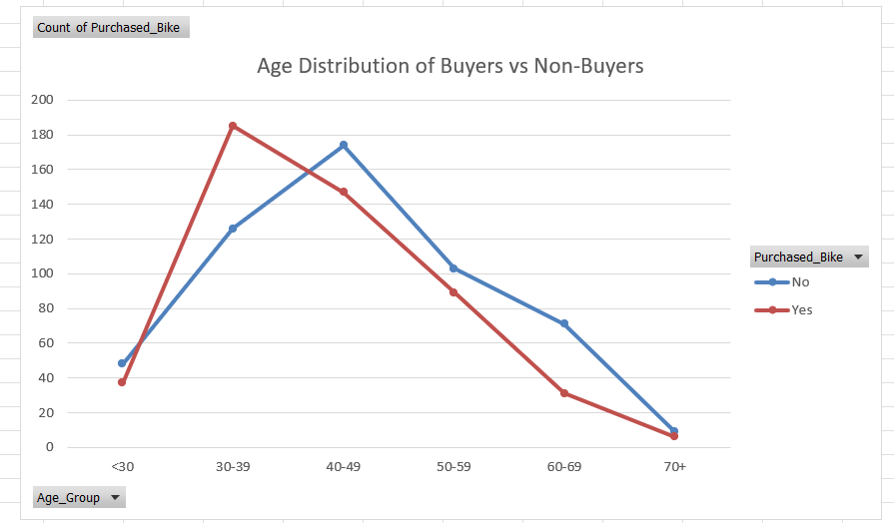

- 4. Income Band vs Purchased Bike
- Purchase activity increases with income, peaking between ₹40,000 to ₹80,000 monthly.
- High-income customers tend to prefer performance and feature-rich models.
- Entry-level models should be priced and promoted to appeal to lower-income segments.

- 5. Occupation vs Purchased Bike
- Professionals, engineers, and technical workers represent the majority of bike purchasers.
- Clerical and labor-class customers show limited purchase behavior, likely due to affordability.
- Tailored financing or installment options can help increase reach in these underrepresented groups.

- 6. Education vs Purchased Bike
- Individuals with Bachelor’s and Postgraduate degrees dominate the buyer demographic.
- Education appears correlated with better job opportunities and financial literacy.
- Marketing messages around fuel efficiency, eco-friendliness, and commuting benefits resonate well with this group.

- 7. Region vs Purchased Bike
- Western regions showed the highest concentration of purchases, followed by Central.
- These regions may have better roads, urban expansion, or reduced access to public transport.
- Inventory and advertising budgets should be prioritized based on regional trends.

- 8. Commute Distance vs Purchased Bike
- Buyers most commonly have commutes between 2–10 kilometers, which aligns with practical bike usage.
- Very short (<2 km) and long (>15 km) distances show lower bike ownership.
- Promotional messaging can focus on “the perfect ride for your daily 5 km.”

- 9. Cars Owned vs Purchased Bike
- Customers with 0–1 cars are more likely to purchase a bike.
- This reinforces the bike’s role as either a first vehicle or a fuel-efficient alternative for shorter distances.
- Bikes can be positioned as a backup or city vehicle for car-owning households.

- 10. Number of Children vs Purchased Bike
- People with 1 or 2 children are more likely to buy bikes compared to those with no or many children.
- Possibly due to school commutes or family errands.
- Family-focused bike models or bundled safety accessories could appeal to this demographic.

- 11. Home Ownership vs Purchased Bike
- Homeowners show slightly higher bike purchasing behavior compared to renters.
- This may indicate more financial stability or lifestyle permanency.
- Minor, but worth noting for combined targeting strategies (e.g., EMI offers).
- 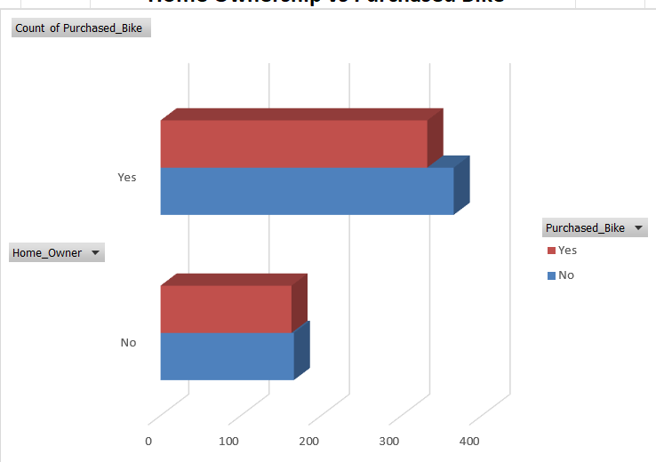
- 12. Buyer Heatmap: Age Group × Income Band
- The heatmap reveals that the highest concentration of buyers exists in the 30–40 age group earning ₹40,000–₹80,000 per month.
- This intersection is the core target for future campaigns.
- Any deviation from this cluster could highlight niche opportunities or underserved segments.
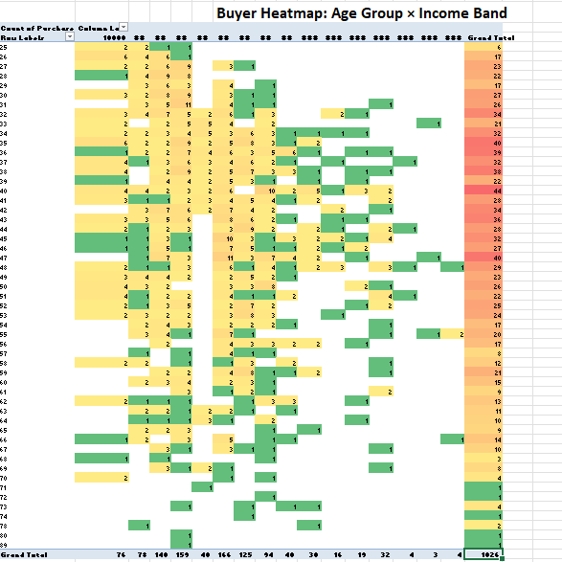

📁 Deliverables:
- Cleaned and structured Excel data file
- EDA worksheet with PivotTables and formula-based insights
- Interactive Sales Dashboard

🧠 Skills Demonstrated:
- Data Cleaning & Preparation
- Data Analysis & Interpretation
- Business Intelligence Reporting
- Dashboard Design in Excel

🧾 Conclusion
The Bike Dekho sales analysis highlights clear customer trends that can inform marketing, sales, and product decisions. Middle-aged, married males with moderate to high incomes form the core buyer segment. Factors like occupation, education, commute distance, and car ownership also play a significant role in influencing purchases.
Regional differences in demand suggest the need for localized strategies, while behavioral patterns confirm bikes are primarily used for short to mid-range commuting.
Excel-based dashboards made these insights accessible and actionable. Going forward, the findings can be used to refine product targeting, optimize pricing, and expand outreach to underrepresented groups such as female riders and students.
This project showcases how even basic tools like Excel can drive effective, data-driven business strategies.

