Title: Design and Implementation of a Zone-Based BLE Indoor Localization System Using ESP32
FIGURES
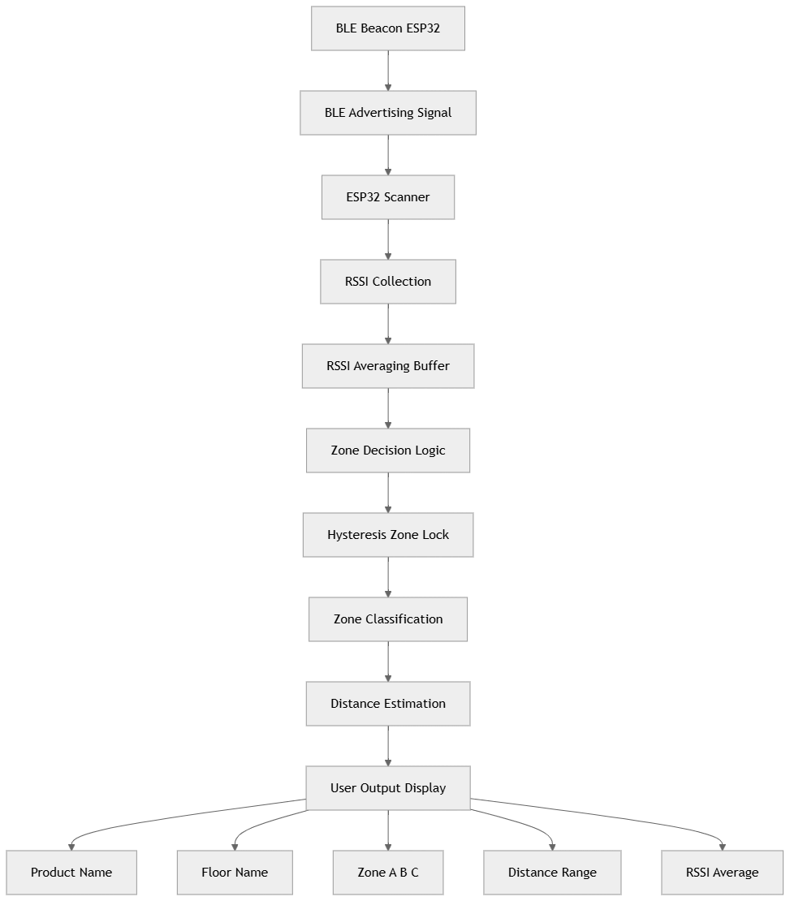
Figure 1 : Block diagram of the proposed zone-based BLE indoor localization system using ESP32

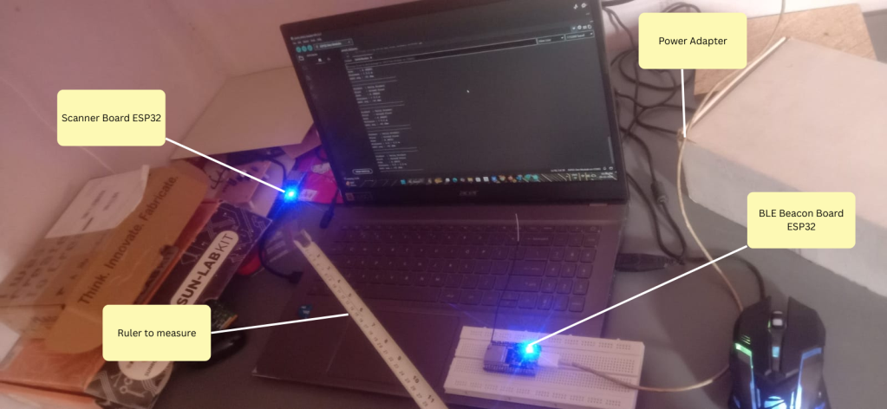

Figure 2 : Hardware Prototype of the BLE Indoor Localization System

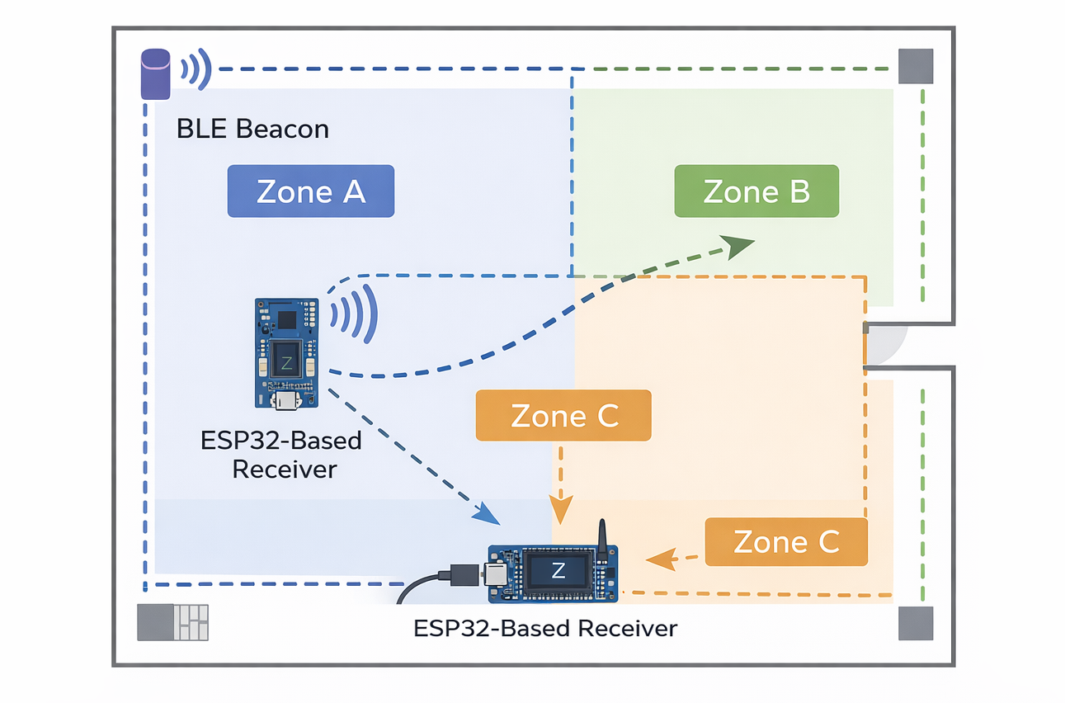
Figure 3 : Experimental zone layout for RSSI-based localization

