RSSI Signal Behaviour
The RSSI values were continuously recorded as the receiver device moved between different zones relative to the BLE beacon. The variation of RSSI with respect to time is shown in Figure 1.1.
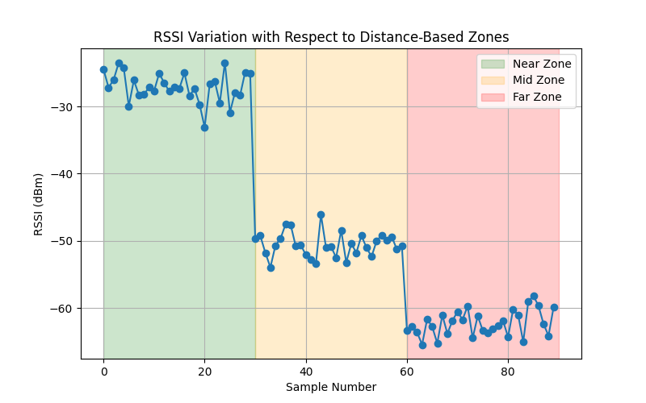

From the graph, it can be observed that when the receiver is close to the beacon, the RSSI values remain around −25 dBm to −30 dBm, representing the Near zone. As the receiver moves further away, the RSSI values decrease to around −50 dBm, indicating the Mid zone. When the receiver moves farther away, the RSSI drops below −60 dBm, corresponding to the Far zone.
RSSI Filtering Analysis
RSSI measurements are often affected by noise and signal fluctuations due to environmental factors such as obstacles and multipath reflections. To address this issue, a sliding window averaging filter was applied to stabilize the RSSI values.
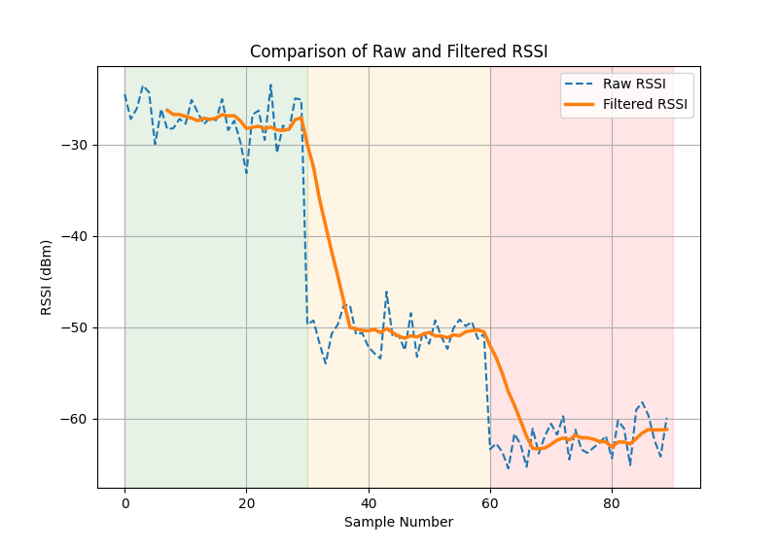
The figure compares the raw RSSI values with the filtered RSSI values. The filtered curve shows smoother transitions between zones, reducing fluctuations and improving the reliability of zone detection.
RSSI-Based Zone Classification
Based on the experimental RSSI observations, three proximity zones were defined as shown in Table 1.3
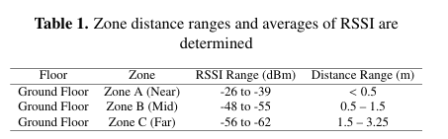
The zones were categorized as:
- Zone A (Near): RSSI range −26 to −39 dBm, distance less than 0.5 meters
- Zone B (Mid): RSSI range −48 to −55 dBm, distance between 0.5 and 1.5 meters
- Zone C (Far): RSSI range −56 to −62 dBm, distance between 1.5 and 3.25 meters
These thresholds were determined experimentally using multiple RSSI samples.
Zone Detection Accuracy
To evaluate the effectiveness of RSSI filtering, the zone detection accuracy was compared between unfiltered and filtered RSSI measurements.
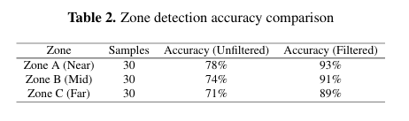
The results indicate that the filtering technique significantly improves zone detection accuracy. The Near zone accuracy increased from 78% to 93%, Mid zone accuracy improved from 74% to 91%, and Far zone accuracy improved from 71% to 89% after applying RSSI filtering.
Comparison with Existing Localization Methods

The proposed zone-based localization approach was compared with existing BLE localization techniques such as fingerprinting, trilateration, and cloud-based BLE systems.

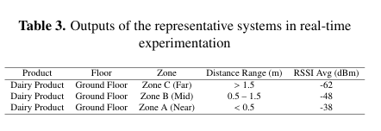
Unlike traditional approaches that require extensive calibration or cloud processing, the proposed system performs localization directly on the ESP32 edge device, reducing system complexity while maintaining reliable performance
Representative System Outputs
The real-time outputs generated by the system during experimentation are summarized in Table 5.4.
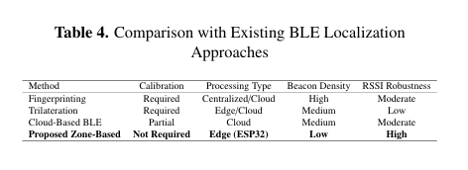

The system successfully reports the product type, floor location, detected zone, estimated distance range, and corresponding RSSI value.
Experimental Serial Monitor Outputs
The ESP32 receiver continuously scans BLE signals and calculates the average RSSI using a sliding window filtering algorithm. The following figures show the outputs obtained during the experiments.

System Initialization
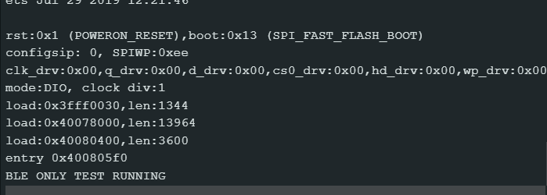
Near Zone Detection
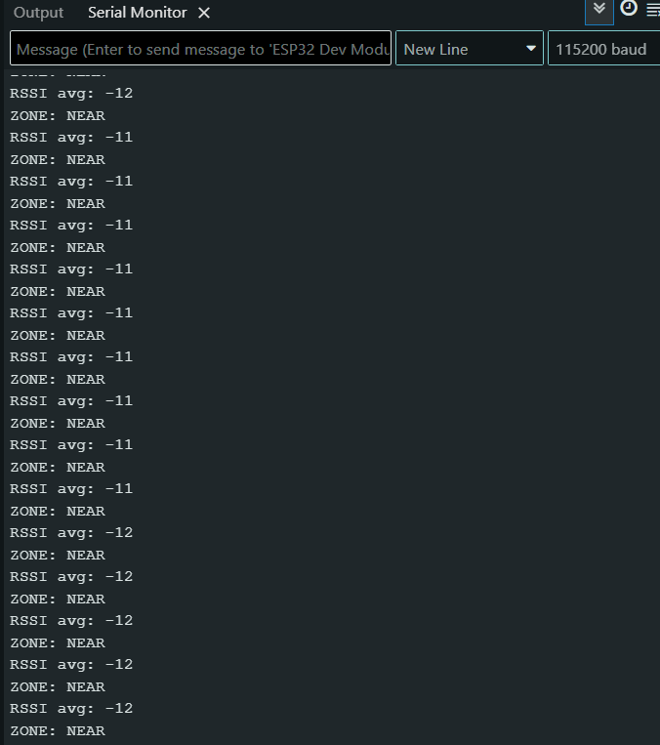
Mid Zone Detection
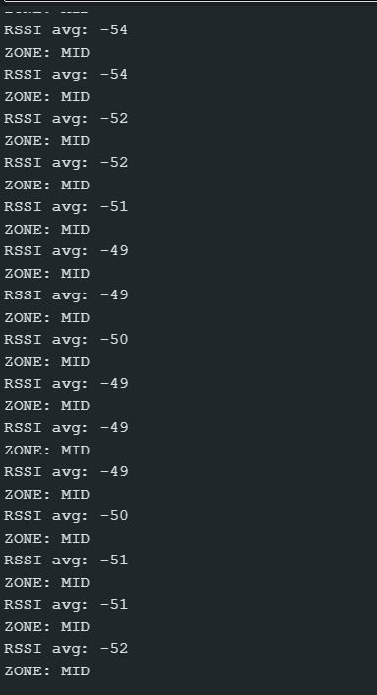

Far Zone Detection
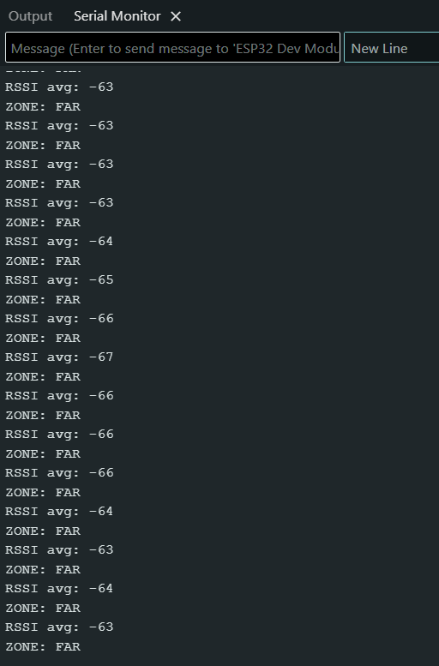

Zone Transition Detection
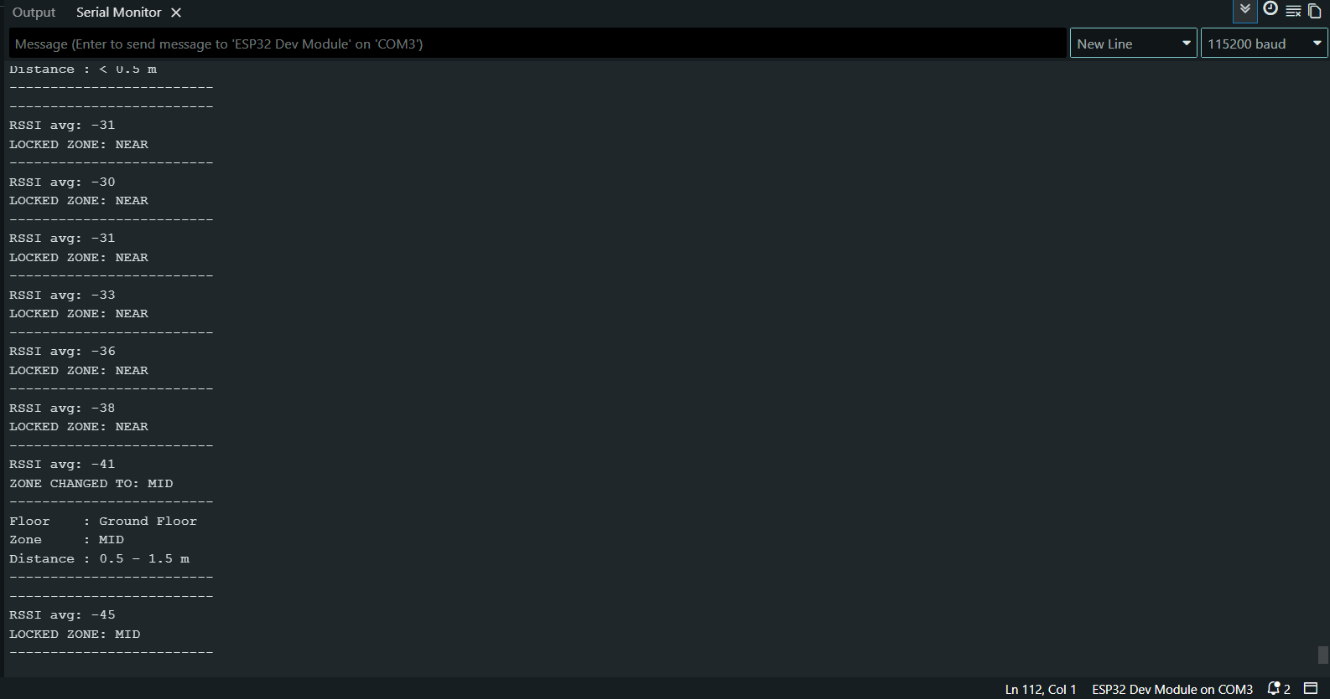

Mid to Far Zone Transition
