Title: Design and Implementation of a Zone-Based BLE Indoor Localization System Using ESP32

Tables
Table 1: Zone distance ranges and RSSI values
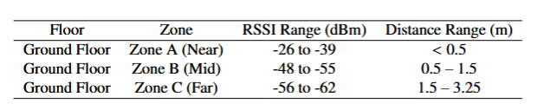
Table 2: Zone detection accuracy comparison
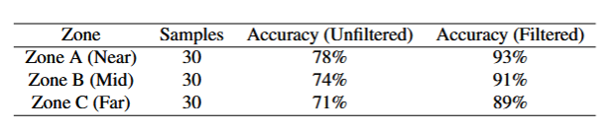
Table 3: Real-time experimental outputs
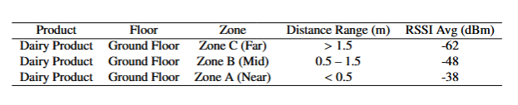
Table 4: Comparison with existing BLE localization approaches
