WebApplication – Analyse

Inhoud

1. FrontEnd - Website 3

1.1. Login Page 3

1.2. STORE Page 3

1.3. Product : 3

1.3.1. WebApp : 4

1.3.2. Ipad App : 4

1.3.3. API 4

1.4. Why App 4

1.5. Help : 4

1.5.1. Help : 4

1.5.2. Forums : 4

1.5.3. Videos : 4

# FrontEnd - Website

Top Menu :

Product | Why App | Help | Login | Store

Middle :

Pictures

Bottom :

Get newsletter



## Login Page

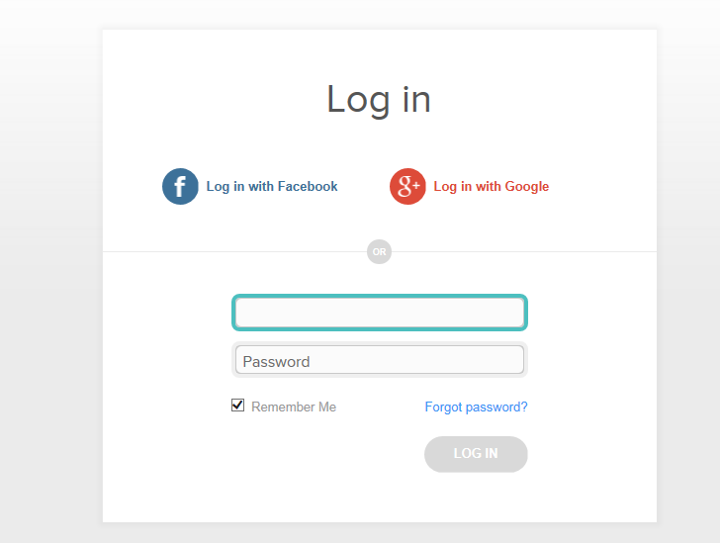

+ register (demo version)

## STORE Page

List of Products

* Free product (x features limited 1 month)
* Normal App (x features) License one year – six months
* Super App ( All features) License one year – six months
* Enter account or register during pay process

## Product :

WebApp | Ipad App | API

### WebApp :

Content : screenshots and commercial about WebApp: Features

### Ipad App :

Content : screentshots and commercial about Ipad App : Features

### API

Content : About API (export data to csv/excel/Webservice or other)

## Why App

content : Benefit of App Explained (Business Use Cases)

## Help :

Product Help | Forum | Videos

### Help :

Content : SearchBar / TOP articles / Contact Support

### Forums :

Content : forum (WebApp-App-API)

### Videos :

Content : how-to videos