WordPress – OVERVIEW

WordPress is an open source Content Management System (CMS), which allows the users to build dynamic websites and blogs. Wordpress is the most popular blogging system on the web and allows updating, customizing and managing the website from its back-end CMS and components.
What is Content Management System (CMS)? The Content Management System (CMS) is a software which stores all the data such as text, photos, music, documents, etc. and is made available on your website. It helps in editing, publishing and modifying the content of the website. WordPress was initially released on 27th May, 2003 by Matt Mullenweg and Mike Little. WordPress was announced as open source in October 2009.
Features
User Management:
It allows managing the user information such as changing the role of the users to (subscriber, contributor, author, editor or administrator), create or delete the user, change the password and user information. The main role of the user manager is Authentication.
Media Management:
It is the tool for managing the media files and folder, in which you can easily upload, organize and manage the media files on your website.
Theme System:
It allows modifying the site view and functionality. It includes images, stylesheet, template files and custom pages.

Extend with Plugins:
Several plugins are available which provides custom functions and features according to the users need.
Search Engine Optimization:
It provides several search engine optimization (SEO) tools which makes on-site SEO simple.
Multilingual:
It allows translating the entire content into the language preferred by the user.
Importers:
It allows importing data in the form of posts. It imports custom files, comments, post pages and tags.

Advantages
It is an open source platform and available for free.

CSS files can be modified according to the design as per users need.
There are many plugins and templates available for free. Users can customize the various plugins as per their need.
It is very easy to edit the content as it uses WYSIWYG editor (What You See Is What You Get is a user interface that allows the user to directly manipulate the layout of document without having a layout command).
Media files can be uploaded easily and quickly.
It offers several SEO tools which makes on-site SEO simple.
Customization is easy according to the user's needs.
It allows creating different roles for users for website such as admin, author, editor and contributor.
Disadvantages
Using several plugins can make the website heavy to load and run.
PHP knowledge is required to make modifications or changes in the WordPress website.
Sometimes software needs to be updated to keep the WordPress up-to-date with the current browsers and mobile devices. Updating WordPress version leads to loss of data, so it a backup copy of the website is required.
Modifying and formatting the graphic images and tables is difficult.

WordPress – INSTALLATION

System Requirements for WordPress
Database: MySQL 5.0+
Web Server:
WAMP (Windows)
LAMP (Linux)
XAMP (Multi-platform)
MAMP (Macintosh)
Operating System: Cross-platform
Browser Support: IE (Internet Explorer 8+), Firefox, Google chrome, Safari, Opera
PHP Compatibility: PHP 5.2+
Download WordPress
When you open the link : https://wordpress.org/download/, you will get to see a screen as the following snapshot:

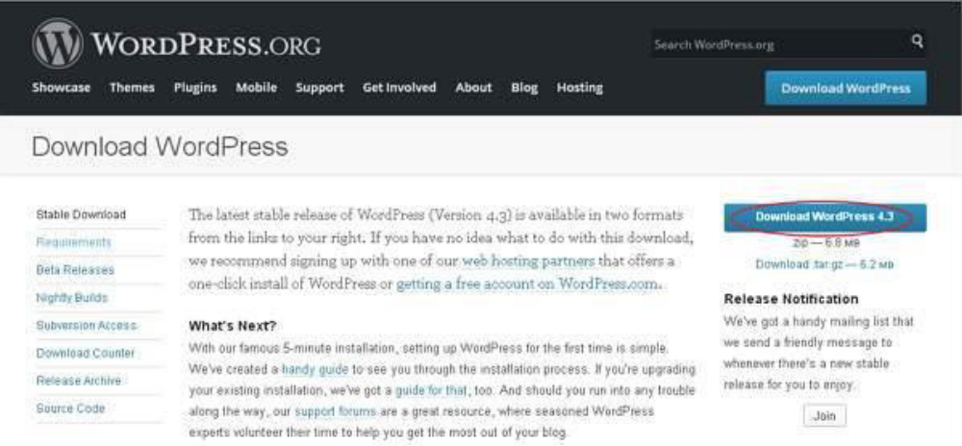

Create Store Database

WordPress requires MySQL database. So create a new empty database with user/password (for example, user as "root" and password as "root" or else you can set as per your convenience).

Then, you can continue with the installation process as discussed further.

Set Up Wizard

It's very easy to set up WordPress into your system. The following steps describe how to set up WordPress locally on your system.

Step (1): Extract the downloaded WordPress folder and upload it into your web server or localhost.
Step (2): Open your browser and navigate to your WordPress file path, then you will get the first screen of the WordPress installer as shown in the following screen. In our case, the path is localhost/< Your_WordPress_folder >.

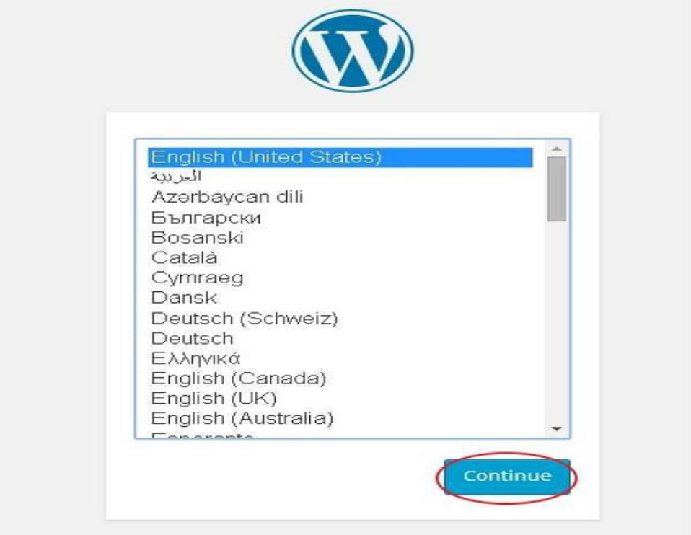

Select your language for the WordPress and click on Continue.
Step (3): In this step, you can view the information needed for the database before proceeding with WordPress installation.
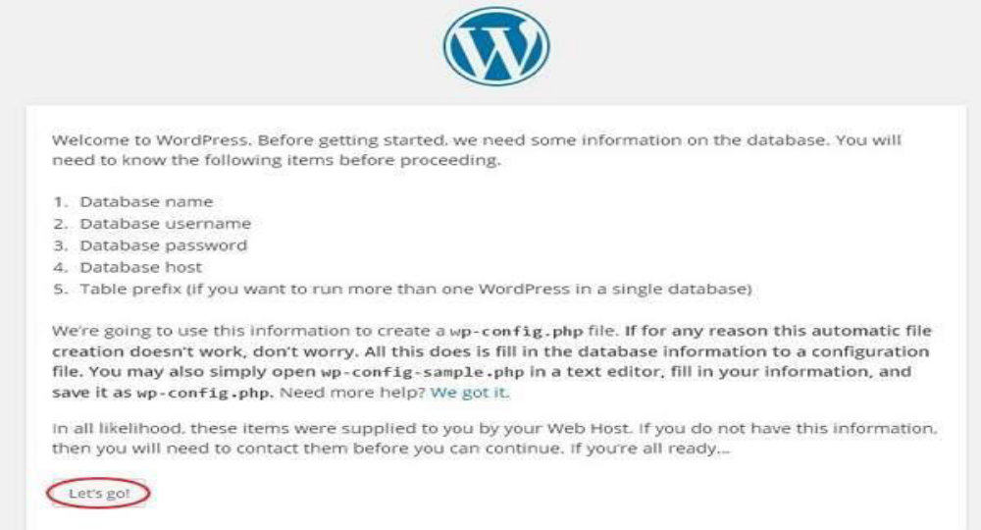

Click on Let's go!
Step (4): Here, you have to enter the information about the MySQL database as described in the following screen.
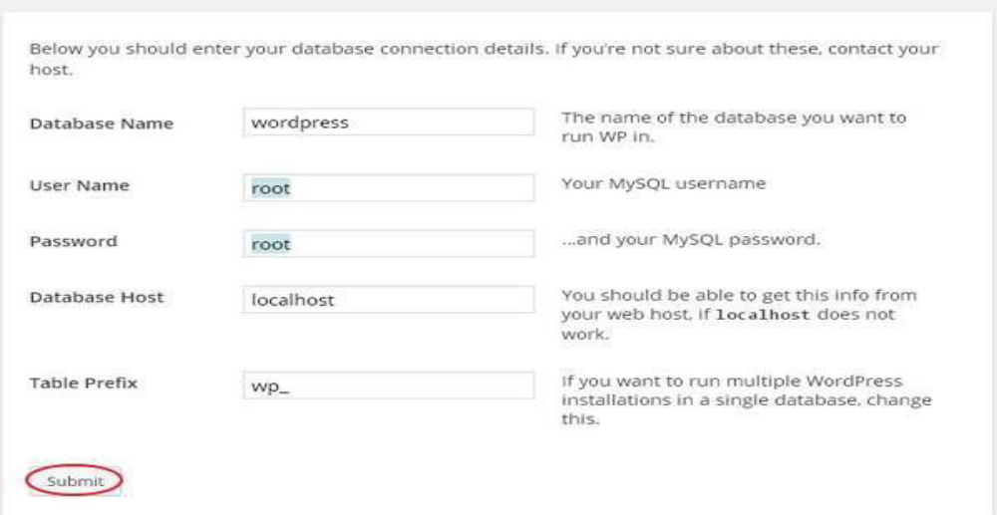

Database Name: Enter the database name which you have created in MySQL database for WordPress.

Username: Enter the user name of your MySQL database.

Password: Enter the password which you had set for MySQL database.

Database Host: Write the host name, by default it will be localhost.

Table Prefix: It is used to add prefix in the database tables which helps to run multiple sites on the same database. It takes the default value.
After filling all information, click on Submit button.

Step (5): WordPress checks the database setting and gives you the confirmation screen as shown in the following snapshot.

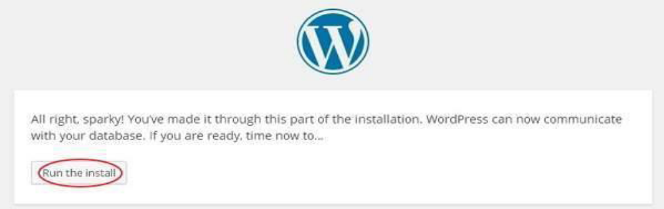

Click on Run the install

Step (6): Enter administrative information.

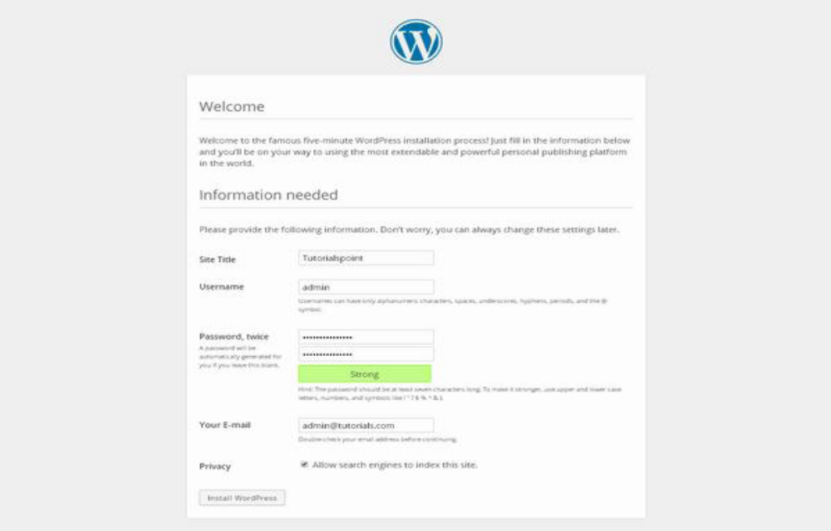

It contains the following fields:

Site Title: Enter the name of the site which you are going to create in WordPress.

Username: Enter the username as per your choice while logging in the WordPress.

Password twice: Enter password two times to protect your site.

Your E-mail: Enter your e-mail address which helps to recover the password or any update.

Privacy: It allows the search engine to index this site after checking the checkbox.

After filling all the information, click on the Install WordPress button.

Step (7): After installation being successful, you will get a screen of the stating success as seen in the following screen.
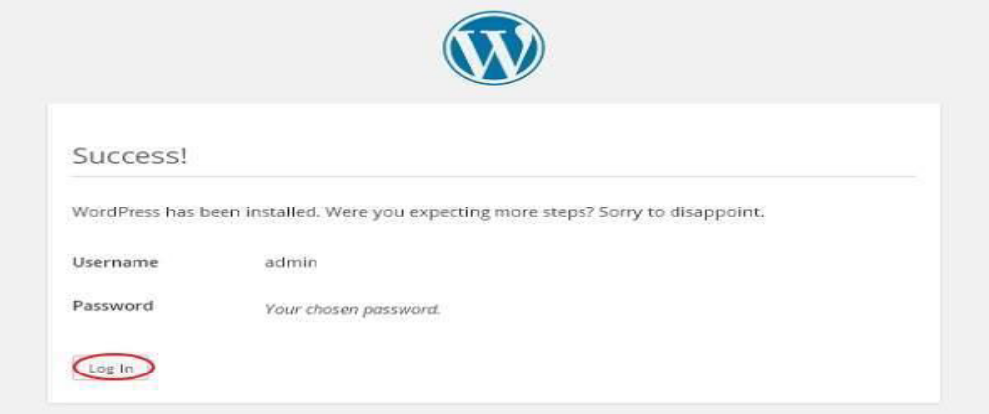
You can view your username and password detail added in WordPress
Click on Log In button.
Step (8): After clicking on login, you will get a WordPress Admin Panel as depicted in the following screen.
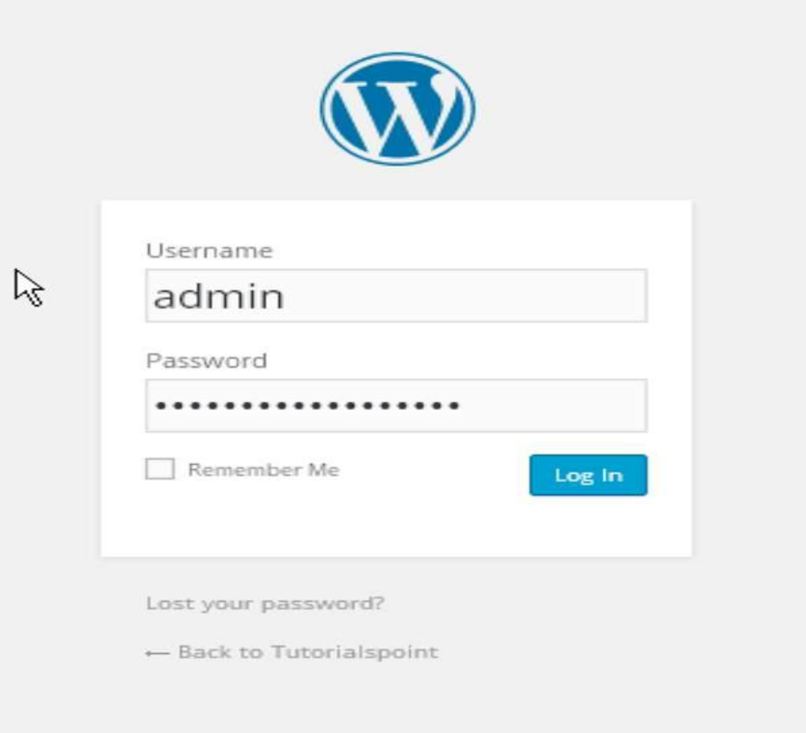

Enter the username and password which you had mentioned during installation as shown in step 6 and click on the Log In button.

