Grounded Literature Review Generation with Multi-Agent LLMs and Citation-Relation Learning

Introduction to Artificial Intelligence (CSS_2203)
<SEMESTER> SEMESTER MINI PROJECT REPORT
Submitted
to
MANIPAL ACADEMY OF HIGHER EDUCATION
School of Computer Engineering
SoCE – AI, <Section>
Submitted by
Siddharth Ray
Reg. No. 235890416
<STUDENT NAME>
<reg no.>
<STUDENT NAME>
<reg no.>

Under the guidance of

Dr. Simi V.R.
Assistant Professor- Senior Scale
School of Computer Engineering
Manipal Institute of Technology, Bengaluru



SCHOOL OF COMPUTER ENGINEERING
October 2026


ABSTRACT
A large language model can write a literature review that reads well and still describe papers it has not understood. The sentences look right, the citations are real, and only someone who reads the cited papers can tell that a claim does not belong to the paper it is attached to. This project builds a system that makes that failure visible. It is a team of six language-model agents, built with the CrewAI framework, that reads a set of papers and writes a related-work section in which every sentence can be traced back to a quoted line from a specific paper. A separate checking model decides whether each sentence really follows from the lines behind it, and anything that fails is rewritten once and then marked rather than hidden.
The training data comes from the papers themselves. The related-work section of any published paper is a short literature review that an expert has already written, and the papers it cites are known. Hiding that section and keeping only the cited papers' abstracts gives a task with a correct answer, at no annotation cost. From 200 arXiv papers in computer-science language and information retrieval, the pipeline produced 15,704 citation sentences and 80 usable test examples. 656 of those citation sentences were labelled with one of seven relation types, such as whether a paper is being used, compared against or disagreed with.
The full comparison between systems had not been run when this report was built, and Chapter 4 says exactly which parts were and were not measured. Every number in this report is read from a file the code wrote, and every figure is drawn from those files by a single script.
Table of Contents
Table of Contents
 |  |  |  |  | Page No
Abstract |  |  |  |  | 1
List of Tables |  |  |  |  | 1
List of Figures |  |  |  |  | 1
Chapter 1 |  | INTRODUCTION |  |  | 1
 | 1.1 | Overview of the project work |  |  | 1
 | 1.2 | Motivation and background of the study |  |  | 1
 | 1.3 | Problem statement and relevance |  |  | 1
 | 1.4 | Objectives |  |  | 1
Chapter 2 |  | BACKGROUND THEORY / LITERATURE REVIEW |  |  | 1
 | 2.1 | Summary of existing studies / Comparative analysis of various approaches |  |  | 1
 | 2.2 | Key findings, trends, and research gaps |  |  | 1
 | 2.4 | Conclusion |  |  | 1
Chapter 3 |  | METHODOLOGY |  |  | 1
 | 3.1 | Methodology with diagrams |  |  | 1
 | 3.2 | System requirements |  |  | 1
Chapter 4 |  | ANALYSIS AND DISCUSSION |  |  | 1
Chapter 5 |  | CONCLUSION AND FUTURE SCOPE |  |  | 1
 | 5.1 | Conclusion |  |  | 1
 | 5.2 | Suggestions for future directions |  |  | 1
References |  |  |  |  | 1

LIST OF TABLES

Table No | Table Title | Page No
Table 1 | How different approaches compare | 1
Table 2 | What the system was run on, and the exact versions used for the results in Chapter 4 | 1
Table 3 | Stage 1 mining yield at pilot scale | 1
Table 4 | Dataset statistics for the mined arXiv benchmark and the external Multi-XScience benchmark | 1

LIST OF FIGURES
Page numbers below are Word fields. They were filled in when this document was rendered; if you edit the document, select all (Ctrl+A, or Cmd+A on macOS) and press F9 to refresh them.

Figure No | Figure Title | Page No
Figure 1 | How the system fits together | 1
Figure 2 | Mining papers from arXiv | 1
Figure 3 | The ten steps, the point where a human approves the paper list, and the single rewrite loop | 1
Figure 4 | The console's overview | 1
Figure 5 | A test example in the console: the section the author wrote, above the cited papers' abstracts that are the only input… | 1
Figure 6 | Mining yield: papers surviving each step, as counts and as a percentage of the submissions listed | 1
Figure 7 | Distribution of related-work length, number of cited papers and abstract coverage across the mined benchmark examples | 1
Figure 8 | The worked example in the console | 1

CHAPTER 1
INTRODUCTION

1.1 Overview of the project work
This project builds a tool that writes the “related work” part of a research report, and checks its own writing before handing it over. You give it a topic or a few starting papers. It finds related papers, reads each one, pulls out the main claims, and keeps a short quoted line from the paper next to every claim as proof. It then compares the papers against each other to see where they agree, where they disagree, and which combinations nobody has tried. Finally it writes the section, and every sentence it writes carries a list of the claims it was built from.
The work is divided between six agents, each with a narrow job: a Librarian that finds papers, an Extractor that pulls out claims, a Verifier that checks them, a Synthesist that compares papers, a Gap Analyst that looks for missing work, and a Writer. The limits matter as much as the jobs. The Extractor cannot search for anything, so it can only use the text it is given. The Writer cannot check its own output, because a model asked to grade its own work tends to agree with itself. Only the Verifier can run the checking model.
Two parts of the system are trained rather than prompted. The first is a classifier that reads a sentence containing a citation and decides what the sentence is doing: using the cited work, comparing against it, or disagreeing with it. The second is a small model trained to copy the extraction step, so the same work can be done on a laptop instead of through a paid interface.
The same idea supplies the test set. Every published paper already contains a short literature review written by an expert — its related-work section — and the papers it cites are listed. Hiding that section and giving a system only the cited papers' abstracts creates a test with a correct answer that nobody had to write by hand.
1.2 Motivation and background of the study
Language models write fluent summaries that are often wrong in ways fluency hides. Maynez and colleagues [1] found that a large share of summaries from strong models contain statements the source document never made, and that the usual scoring method, ROUGE, barely distinguishes those summaries from correct ones. A later survey [2] found the same pattern across many text-generation tasks.
For a literature review this is a serious problem rather than an annoying one. A made-up reference is easy to catch, because the paper does not exist. A real reference attached to a claim that paper never made is much harder to catch, because every part of the sentence checks out except the link between them. A reader would have to open the cited paper to notice, which is exactly the work the tool was supposed to save.
Researchers in summarisation responded by checking whether a summary follows from its source, instead of comparing it against a reference answer. One line of work generates questions from the summary and checks that the source gives the same answers [3]. Another trains a classifier on deliberately corrupted summaries [4]. A third uses natural language inference, the task of deciding whether one sentence follows from another, applied one sentence at a time [5]. This project follows the third approach and adds one requirement: the system must say which line each sentence came from, so there is something definite to check against.
Meanwhile it has become easy to split a task across several model-driven agents with their own roles and tools [6], [7], and to have a model criticise and revise its own output [8], [9]. What is usually missing is an honest answer to whether all that extra machinery is worth its cost. This project measures that directly, with the same model and settings for every system compared, and reports the answer whichever way it comes out.
1.3 Problem statement and relevance
The problem is this: given a research topic and the papers that matter to it, produce a literature review in which every sentence can be traced to a specific line in a specific paper, together with a map of where those papers agree and disagree and a list of gaps — and do it within the limits of a free API account and one free cloud GPU.
Three smaller problems follow. First, there is no ready-made dataset that says what a citing sentence is claiming about the paper it cites, so that signal has to be mined from published papers. Second, the checking cannot be done by asking the same model again, because it will usually agree with itself; it needs a separate model doing a different task. Third, the result has to be compared against something a human wrote, or the claim that the output is well-grounded cannot be tested at all.
The practical case is simple. Any active research area now produces more papers than a student can read before writing about them, and the tools that offer to help are the same tools that invent things. A slower system whose every sentence can be checked against a quoted line is more useful than a fast one whose output has to be re-read against the sources anyway.
1.4 Objectives
Each objective below names the measurement that decides whether it was met. Chapter 4 reports those measurements.
1. Mine related-work sections and citation sentences from arXiv source files, and report how many papers survive each step as a percentage of those listed.
2. Define seven citation relation types with a written labelling guide, label sentences with a language model, and measure how far those labels can be trusted by comparing them against a set labelled independently by hand.
3. Fine-tune SciBERT on those labels and beat three baselines — always guessing the most common class, a word-counting classifier, and asking a language model with no training — on macro-F1.
4. Extract claims that quote their evidence word for word, and check each claim twice: that the quote really appears in the source, and that the claim follows from the quote. Set the thresholds for both checks by testing them on a hand-checked sample rather than guessing.
5. Build a map of agreement and disagreement between papers and a table of which method families have been tried on which datasets, and have agents argue both for and against every disagreement and every gap they report.
6. Train a small local model to copy the extraction step, using only extractions that passed the checker, and compare the two on output validity, claim support, speed and cost.
7. Compare four systems and one cut-down version on papers published after every tested model's training cut-off, reporting overlap with the human text, how many cited papers are discussed, how often a sentence is attached to the right paper, how many sentences survive checking, and what each system cost to run.

CHAPTER 2
BACKGROUND THEORY / LITERATURE REVIEW
Table 1 at the end of this chapter summarises how the approaches below compare. This chapter covers the five areas this project draws on: summarising several documents at once, working out what a citation is doing, checking whether generated text is actually supported, teams of language-model agents, and tools that help write literature reviews. Every paper named here was checked against OpenAlex, Semantic Scholar or the arXiv listing before it was cited; the record of those checks is in results/references_verified.json.
Summarising scientific papers
Summarising a single document improved in two steps. First came models that could copy rare words straight out of the source instead of trying to spell them [10]. Then came large models pre-trained on a general text-repair task and adapted to summarising, of which BART [11] and PEGASUS [12] are still the usual points of comparison.
Scientific papers broke an assumption these models relied on, which is that a document fits inside the model at once. Cohan and colleagues [13] handled longer documents by paying attention to section structure, and released the arXiv and PubMed datasets that made long-document summarising a standard task. The XSum dataset [14] pushed the other way, asking for a single sentence that cannot be produced by copying.
Writing a related-work section is the specific task this project is tested on, and it is older than today's models. Abu-Ra'ed and colleagues [15] treated it as summarising the cited papers. Wang and colleagues [16] let the model attend to both the citing paper's own content and the cited abstracts. Luu and colleagues [17] reframed it as explaining the relationship between two papers rather than summarising one, which is the closest existing idea to the relation classifier used here.
Multi-XScience [18] turned the task into a standard benchmark: each example pairs a paper's related-work paragraph with the abstracts it cites, which is exactly the setup described in Chapter 3. This project uses it as a second test set so results can be compared against a published dataset and not only against our own mining. The large-scale parsed full text both rely on comes from S2ORC [19]. More recently Zhang and colleagues [20] found that instruction-tuned models match or beat specially trained summarisers in human judgement while the automatic scores disagree — a direct warning against reading ROUGE on its own, and one the evaluation here takes seriously.
Working out what a citation is doing
Citations are not all the same, and the differences are what a review has to express. Early work looked at whether a citation was positive or negative and at how much surrounding text was needed to tell [21], [22]. Two datasets then made the task standard. ACL-ARC, used by Jurgens and colleagues [23] to trace how a research field changes over time, has six categories. SciCite [24] traded detail for size with three — background, method and result — and showed that training on related side-tasks helps. SciBERT [25], a version of BERT trained on scientific text, is the usual starting point for both, and is the starting point here.
The seven categories used in this project are finer than SciCite's and cut differently from ACL-ARC's, for one reason that matters later. The system needs to tell a neutral comparison apart from an actual disagreement. Running someone else's method as a baseline and reporting that you scored higher is a measurement. Saying their conclusion does not hold is a disagreement, and only the second is evidence that two papers conflict. SciCite's “result” class and ACL-ARC's “compare or contrast” class both merge the two. Section 3.1 sets out how those datasets were mapped onto our categories and what that mapping loses; because it loses something, mapped rows are used only for extra training and never for scoring.
Checking whether generated text is supported
The finding behind this project is that fluent summaries are often unsupported and that overlap scores do not notice [1]. Three families of automatic check followed. FactCC [4] trains a classifier on summaries that were deliberately broken in known ways. QAGS [3] asks questions about the summary and checks whether the source gives the same answers. SummaC [5] revisits natural language inference — deciding whether one sentence follows from another — and shows it works well once applied sentence by sentence rather than to whole documents. That last design is the one the checker here copies.
Working out whether these checks are any good needed human judgement. SummEval [26] re-annotated model outputs and showed how weakly the standard scores track what people actually think. Goyal and Durrett [27] annotated errors in detail and found that different kinds of model fail in different ways. BERTScore [28] is included here as a meaning-based alternative to ROUGE, not as a support check, because it compares generated text against a reference answer rather than against the source.
The fact-checking field supplies the other half. FEVER [29] established the pattern of retrieving evidence and then testing whether it supports a claim. SciFact [30] moved that into science, where claims are hedged and evidence is technical. DeBERTa [31] is the model design whose trained versions are used here as the checker. The hallucination survey [2] supplies the wording used throughout this report: a claim is called unsupported when the evidence does not establish it, which is a weaker and more checkable statement than calling it false.
Teams of language-model agents
Asking a model to work through a problem in steps was the first sign that breaking a task up helps [32], and giving a model tools let it act outside its own text [33]. Several agents working together followed: CAMEL [6] showed that agents given roles and allowed to talk can carry a task further than one prompt, and generative agents [7] showed memory and planning over long runs. Having a model criticise and fix its own work was formalised as Self-Refine [8] and, with a separate critic, as Reflexion [9].
CrewAI, the framework used here, belongs to this family. It provides agents with a role, a goal and a list of tools; tasks whose output can be forced into a fixed shape; and flows that connect steps with explicit order and shared state. Two of its features carry real weight in this project. Forcing a task's output into a fixed data shape is what lets the Extractor be checked by code rather than read by eye. Named flow steps are what let the human approval point be a real stop, and let a run that is interrupted carry on where it left off — which matters when everything has to fit inside a free account's limits.
The important lesson from this literature, for this project, is that a model checking its own work is using the same model that produced it, and its judgement is tied to the error that caused the problem. The checker here is therefore not an agent asked to be sceptical. It is a separate, smaller model doing a different job on a well-defined pair of texts, and the agent whose role is called Verifier is allowed to do nothing except call it.
Tools that help write literature reviews
Retrieval-augmented generation [34], with meaning-based search [35], is the standard way to tie a model's output to documents, and it is what the practical tools are built on. PaperQA [36] answers scientific questions by forcing the answer through retrieved passages, and reports less invention as a result. STORM [37] tackles longer writing: it researches a topic by simulating questions from several points of view, builds an outline, and writes a long article with citations. Sušnjak and colleagues [38] fine-tune subject-specific models for research synthesis and report the practical trade-offs.
Two things separate the system built here. The first is how finely it is accountable. STORM and PaperQA attach citations at the level of a passage or a paragraph; this system records, for every sentence, the exact claim identifiers it used, then checks that sentence against those claims' quoted lines and no others. The second is that two parts are trained rather than prompted: the citation-relation classifier, trained on sentences mined from real papers, and the extractor, compressed into a small open model [39] using QLoRA [40] with the checker deciding which examples it may learn from.

2.1 Summary of existing studies / works / Comparative analysis of various approaches
Table 1: How different approaches compare. The third column is what a generated statement can be traced back to, and the fourth is what, if anything, checks that the trace is real.
Approach | Example work | What a statement traces back to | What checks it | Citation types | Trained part
Pre-trained summariser | BART [11], PEGASUS [12] | nothing specific | nothing | no | whole model
Related-work generator | Wang et al. [16], Multi-XScience [18] | a cited abstract | nothing | no | a task-specific model
Citation-type classifier | SciCite [24], ACL-ARC [23] | the citing sentence | not applicable | 3 or 6 | SciBERT
Support checker | SummaC [5], QAGS [3] | a summary sentence | inference or questions | no | an off-the-shelf model
Retrieval-based agent | PaperQA [36], STORM [37] | a retrieved passage | retrieval only | no | none, prompted
Self-criticising loop | Self-Refine [8], Reflexion [9] | the whole output | the same model | no | none, prompted
This project | Chapters 3–4 | a quoted line per claim; claim ids per sentence | a separate model, thresholds fitted on a sample | 7, trained | relation classifier and extractor

2.2 Key findings, trends, and research gaps
Four trends run through the work above. Checking has moved from comparing against a reference answer towards testing whether the output follows from the source, because reference comparison was shown not to track correctness. What a statement is tied to has got finer, from whole documents towards single passages. Citation types have been standardised, but at a level of detail chosen to make annotation cheap rather than to make the labels useful afterwards. And orchestration has moved from single prompts to teams of agents, usually with self-criticism as the quality mechanism.
Three gaps follow, and they are what this project addresses. First, the support-checking work tests a summary against one source document, while the review-writing work generates from many sources and is scored against a reference text; almost nothing checks a many-source review against the sources it cites, sentence by sentence. Second, citation labels are used to study how fields evolve rather than to drive the writing: we know of no system that treats a predicted disagreement as evidence that two papers conflict and then asks an agent to explain it. Third, the cost of running a team of agents is rarely reported next to its quality, so the literature does not say whether the extra calls are worth making.
A fourth point is about method rather than subject. Several of the agent papers report improvements without separating training and test material by date, on tasks whose reference answers may already be inside the model being tested. Section 3.1 and docs/leakage.md therefore record exactly which publication dates were used here and why the test window starts after every tested model's training cut-off.
2.4 Conclusion
All the pieces this project needs already exist and are well studied on their own: pre-trained summarisers, citation classifiers, inference-based support checks, agent frameworks and retrieval. What has not been put together is a pipeline where the citation relation is learned from real related-work sections, every written sentence names the evidence behind it, a separate model judges that evidence using thresholds fitted on real examples, and the whole thing is then measured against human-written sections on papers the models cannot have seen, with its running cost reported next to its quality. Chapter 3 describes how that was built and Chapter 4 reports what it achieved, including the places where it did not beat a single well-written prompt.

CHAPTER 3
METHODOLOGY
3.1 Methodology with diagrams
The system is one Python package used in two ways: command-line scripts for running locally, and six Colab notebooks for the larger runs. The notebooks install the package and call the same functions, so there is only one copy of the logic and the two cannot drift apart. Figure 1 shows the parts and how information moves between them.
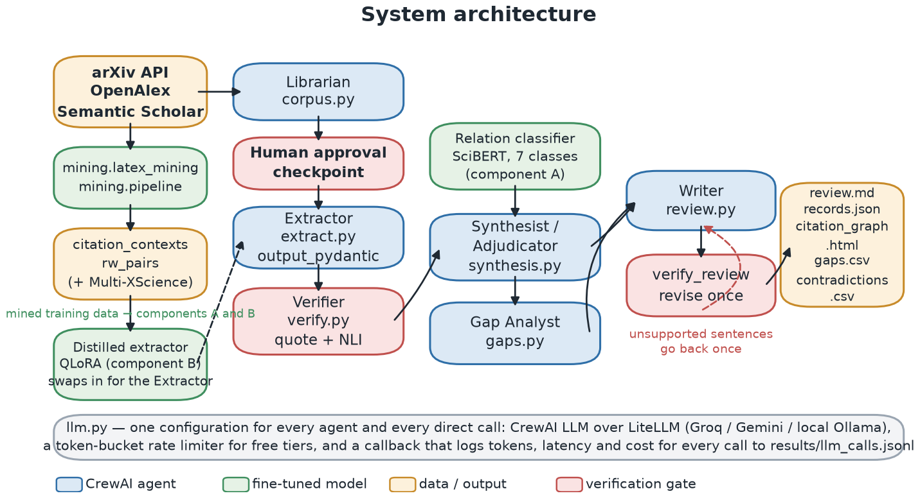
Figure 1: How the system fits together. Blue boxes are agents, green boxes are trained models, red boxes are checks, and orange boxes are data or output. One model setting serves every agent and records what every call cost.
3.1.1 Where the training data comes from
The system needs to learn what a citing sentence is claiming about the paper it cites, and no ready-made dataset provides that at the level of detail needed. The solution is to take it from published papers. A related-work section is a short literature review an expert already wrote, and it names the papers it cites, so mining those sections gives two things at once: citing sentences whose meaning is visible from the text around them, and pairs of (cited abstracts, written section) that form a test set with a correct answer. Figure 2 shows the steps.
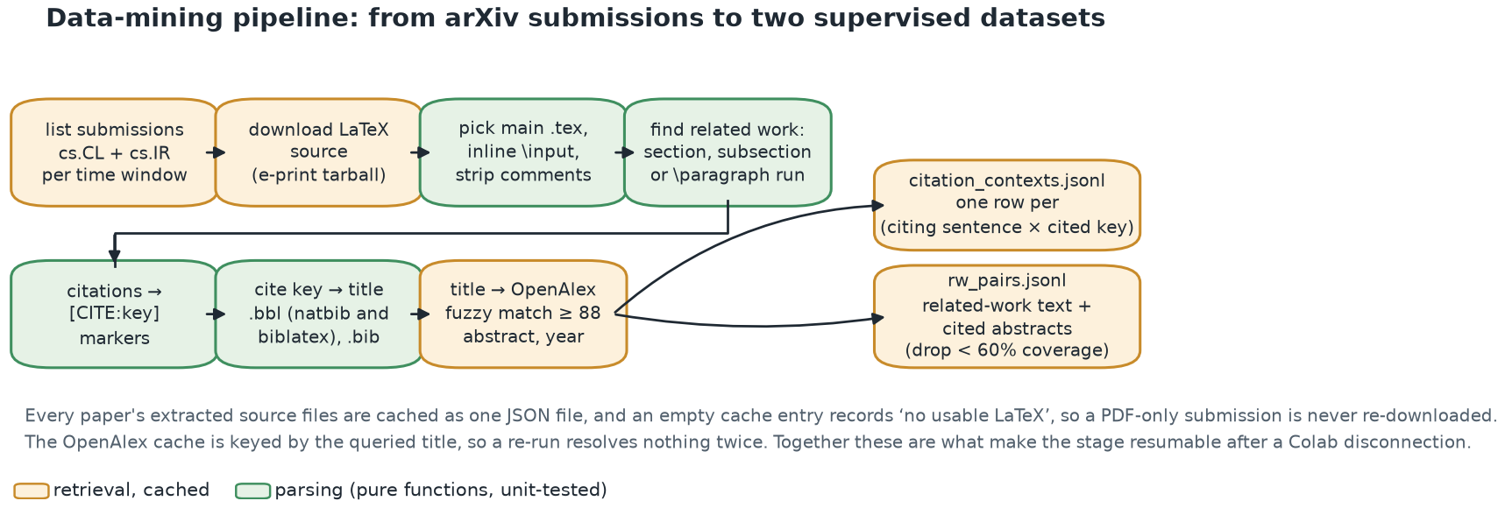
Figure 2: Mining papers from arXiv. Each paper's source files are stored once, and a paper with no usable source is recorded as such so it is never downloaded twice. That is what lets the step be stopped and restarted.
arXiv distributes most papers as LaTeX source, which is readable text rather than a PDF. The parser handles the awkward cases, each of which showed up in a real paper during testing and each of which now has a test: papers with more than one main file, related work written as a sub-section or as a run of unnamed paragraphs rather than its own section, two different bibliography formats, a bibliography written directly into the main file, and the various citation commands used by different publishers.
A heading on its own is not treated as proof that a section is a literature review. A section actually titled “Related Work” must contain at least one citation, and a vaguer heading such as “Background” must contain at least two. Without that rule a section explaining standard theory would be mined as though it were a survey.
Cited papers then have to be identified. Where the bibliography gives a DOI or an arXiv number, that number identifies the paper exactly, and those are looked up in batches. Only where no identifier exists does the system fall back to searching by title, which is both slower and less certain; a title match is accepted only above a similarity threshold, so the wrong paper is rarely attached. Papers for which fewer than 60% of the cited works could be found with an abstract are dropped from the test set, because the task is only fair if the system can see most of what the original author saw.
3.1.2 Telling citation types apart
Seven labels are used: background, uses-method, uses-data, extends, compares-against, supports and contrasts. The split that matters most is between the last three. Running another paper's method as a baseline and reporting a better score is compares-against, which is a measurement. Saying your results agree with theirs is supports. Saying their conclusion does not hold is contrasts, and only that last one is evidence that two papers actually conflict.
Because real sentences often fit more than one label, the rules are applied in a fixed order: disagreement beats agreement, which beats extending, which beats comparing, which beats using data, which beats using a method, with background as the fallback. The definitions and this order live in one file, so the instructions given to the labelling model, the guide a human labeller follows and the training code cannot disagree about what a label means.
Two published datasets, SciCite [24] and ACL-ARC [23], are mapped onto these seven labels to provide extra training examples. The mapping loses information and the report says where: SciCite's “method” class does not separate using a method from improving it, and its “result” class covers comparing, agreeing and disagreeing alike; ACL-ARC's “uses” does not separate method from data, and its “compare or contrast” merges neutral comparison with real disagreement. Because of that, mapped examples are used only to help training and never to score anything.
The classifier is SciBERT, fine-tuned to read a pair of texts. The first is the citing sentence with the citation in question replaced by a marker and any other citations in the same sentence replaced by a different marker — without that, a sentence citing five papers at once would have no single correct answer. The second is the cited paper's title. The data is split by paper rather than by sentence, because sentences from one paper resemble each other and a random split would let the model see the answer. Rare labels are weighted more heavily so they can be learned at all:
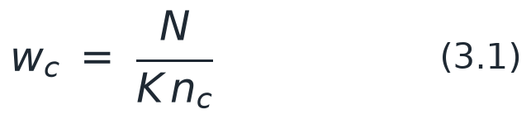
where N is the number of training sentences, K the number of labels and n_{c} how many times label c appears. Results are reported as macro-F1, which averages the score for each label separately:
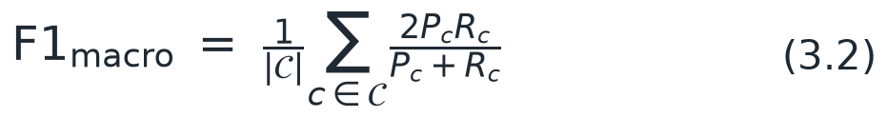
with P_{c} and R_{c} the precision and recall for label c. Plain accuracy would be misleading here, because most citations are background and a model that only ever predicted background would score well while being useless for everything that follows. Agreement between the machine labels and the hand-checked ones is reported as Cohen's kappa:
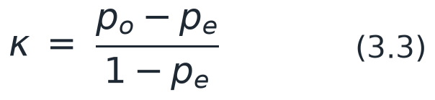
where p_{o} is how often the two agree and p_{e} is how often they would agree by chance given how often each uses each label. Subtracting the chance agreement means a labeller that simply guesses the most common answer scores near zero rather than near its raw accuracy.
3.1.3 Pulling out claims and checking them
The Extractor turns a paper into a structured record: what problem it tackles, what methods and datasets it uses, what numbers it reports, what it admits it cannot do, and three to five claims. Each claim carries a short line copied word for word out of the paper as its evidence. The input is the abstract plus whatever introduction, results, conclusion and limitations text the source file provided, up to a fixed length, and that exact input is stored with the record, because the next check is defined against it and not against the paper in general.
The checker then runs two tests that can fail independently. The first asks whether the quoted line really appears in the text the Extractor was given. It uses approximate rather than exact matching, because converting LaTeX to plain text leaves spacing and punctuation differences that an honest quote still trips over. The second asks whether the claim actually follows from that line, using a DeBERTa model [31] trained on inference datasets, applied one sentence at a time as SummaC [5] recommends.
Both tests are needed, and the reason is the heart of this project. During testing the Extractor produced a claim whose quote matched the source perfectly and which the same quote did not support at all: it had copied the line correctly and then written something stronger than the line said. A single check would have passed it.
A claim is called supported when the quote matches and the inference score is high, partially supported when the inference score is in the middle, and unsupported otherwise. The thresholds are not picked by hand. They are chosen by trying every combination on a sample labelled by hand and keeping the one with the best macro-F1 across the three outcomes, so a setting cannot be chosen just because it does well on the most common outcome. Section 4.3 reports the values that were chosen.
When the review is written, the same model scores each sentence against the evidence behind the claims the Writer attached to it. The faithfulness score is the share of sentences that come out supported:
where E(s) is the set of quoted lines behind sentence s and τ_{sup} is the chosen threshold. A sentence that cites nothing has no evidence and so counts as unsupported, which is the behaviour wanted from a system that claims every sentence is grounded. Sentences that fail go back to the Writer once; if the rewrite does not score better, the first version is kept and the failing sentences are marked in the output rather than quietly deleted.
3.1.4 Comparing papers and finding gaps
Papers name the same thing in different ways, so dataset, metric, method and task names are tidied up in three stages, cheapest first: a hand-written list of known alternative names kept in the repository, then approximate string matching, then meaning-based matching for cases the first two miss. Anything still unmatched keeps its original form and is reported, so names are never silently thrown away and the list of known alternatives can be extended.
Records are then grouped by task, dataset and metric. Inside a group, numbers that differ by more than 15% of the middle value are flagged as a disagreement about results, and two papers that rank the same pair of methods in opposite orders on the same dataset are flagged as a disagreement about ranking. Separately, a contrasts link predicted by the classifier is flagged as a disagreement the authors stated themselves, which no comparison of numbers could reveal. Every flagged case goes to an agent that must decide whether it is explained by a different experimental setup, a different split or metric definition, a real disagreement, or not enough information — using only the quoted evidence.
Gap detection builds a table of how many papers apply each family of method to each dataset. A cell that is empty or nearly empty, where both its row and its column are otherwise busy, becomes a candidate gap. Two method families that both appear on a dataset but between whose papers no comparison link exists become a candidate of a different kind. Because an empty cell is often empty for a good reason, the agent is required to argue both for and against each candidate before giving a verdict, and both arguments are kept in the output.
3.1.5 Putting the steps in order
The pipeline is a CrewAI flow of ten steps, shown in Figure 3. Each agent is kept deliberately narrow. The Librarian has search tools and nothing else. The Extractor has no tools at all, because its text is handed to it. Only the Verifier may run the checking model. The Writer can neither search nor check its own output. The approval point after the corpus is collected is a real stop, not a formality: the flow pauses and shows the list of papers before any money or quota is spent on reading them.
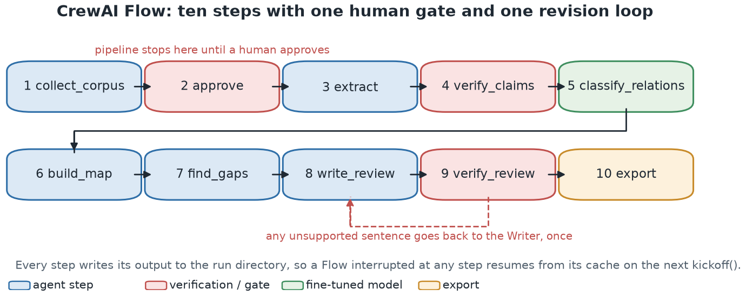
Figure 3: The ten steps, the point where a human approves the paper list, and the single rewrite loop. Every step saves its output before the next begins, so an interrupted run carries on where it stopped.
Saving after every step is what makes an interrupted run recoverable rather than wasted, and that matters more than it sounds. Free accounts impose limits that stop work part-way through, and a free cloud session ends after a fixed time. Both happened repeatedly while this project was built.
3.1.6 Compressing the extractor into a small model
The training set for the small model is built by running the hosted Extractor over training papers and keeping only those papers where every claim passed the checker. That is the point of the step: the checker decides what the small model is allowed to learn from, so it cannot copy mistakes the larger model happened to get away with. The small model [39] is adapted using QLoRA [40], a method that stores the original model in a compressed form and trains only a small number of added parameters, which is what makes the training fit on a free cloud GPU. It is then compared against the hosted model on papers neither has seen.
3.1.7 How the systems are compared
The test is: given only the papers a real related-work section cites, write that section. Four systems and one cut-down version are compared using the same model and the same settings. S1 is a single well-written prompt over the same abstracts. S2 is the agent team with the checker switched off. S3 is the full team. S4 is the full team using the small extractor. The cut-down version is S3 with the citation classifier switched off, which isolates what that classifier contributes.
Overlap with the human text is measured by ROUGE and BERTScore, but reported beside three other measures, because overlap says nothing about whether the text is true. Citation coverage is the share of the papers the human section cited that the generated section discusses at all. Citation correctness is the share of claimed links between a sentence and a paper where that paper's evidence actually supports the sentence; this is the measure that catches a real citation attached to a sentence the paper never supported. Faithfulness is as defined in equation (3.4).
Every average is reported with a confidence interval computed by resampling:
which means the test set is resampled two thousand times and the range covering the middle 95% of the resulting averages is reported. At the sample sizes used here those ranges are wide, and showing them is what stops a difference of a few points being read as a result.
Finally, the test papers are chosen by publication date. Training papers come from 2023 and 2024 and test papers from a window that begins after the training cut-off of every model being tested, so no system can have read the answer. The thresholds, the classifier's development split and the hand-labelled set all come from the training side, so nothing is tuned on the test set. The dates and the risks that remain — chiefly that the cited papers are necessarily older and so probably were in the models' training data, even though the text being scored was not — are recorded in docs/leakage.md and in Section 4.1.
3.1.8 Looking at what the system produced
Everything the pipeline writes is a file, which is reliable but hard to read. A small web application was therefore built on top of the same files, so the state of a run and the evidence behind a sentence can be inspected directly. It adds no logic of its own: it reads the same results files this report quotes, through the same module, so the two cannot disagree about a number. Figure 4 shows the overview, which marks a step as pending when its results file does not exist rather than showing an estimate.
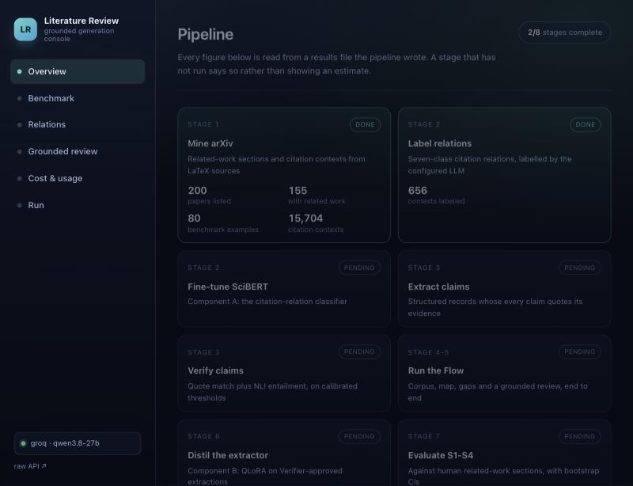
Figure 4: The console's overview. Each step shows real figures from the file it wrote, and a step that has not run is marked pending instead of being filled in with a guess.
The most useful view is the test set itself, in Figure 5. Opening a paper shows the related-work section its author actually wrote, which is hidden from every system and used only for scoring, beside the abstracts that are the only input a system receives. References whose abstract could not be found are greyed out. Seeing the two together makes the difficulty of the task concrete in a way a table of scores does not.
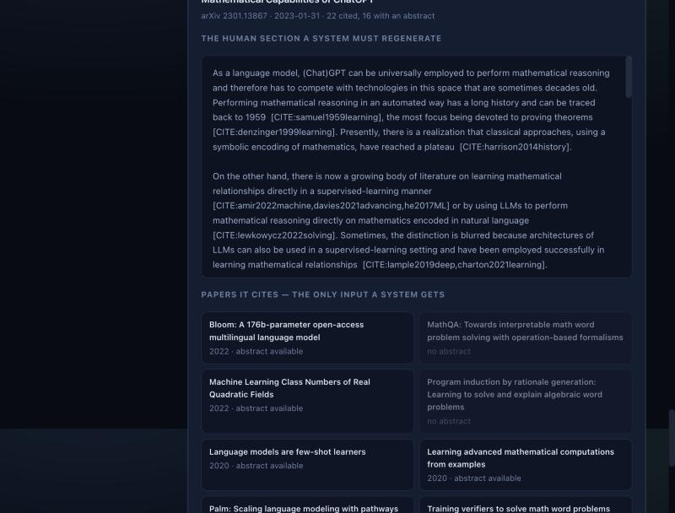
Figure 5: A test example in the console: the section the author wrote, above the cited papers' abstracts that are the only input a system is given. Greyed-out entries are references whose abstract could not be retrieved.
A third view shows a generated review one sentence at a time. Clicking a sentence shows the quoted line it was checked against and the score it received, and sentences are underlined green, orange or red according to the outcome. The same information is also available to a conversational assistant through a small read-only interface, so the state of a run can be asked about in words rather than read off a screen.
3.2 System requirements
The project is built to run in two places: a free Google Colab session with a T4 GPU for the heavier steps, and an Apple Silicon laptop for development and for the smaller runs reported in Chapter 4. Table 2 lists what was actually used. The version numbers are the ones recorded while the code ran, not the oldest versions it would tolerate.
Table 2: What the system was run on, and the exact versions used for the results in Chapter 4.
Component | Local (pilot runs) | Google Colab (full-scale runs)
Hardware | Apple Silicon, arm64, Metal (MPS) | NVIDIA T4, 16 GB, free tier (~12 h session limit)
Operating system | Darwin 25.5.0 | Ubuntu (Colab runtime)
Python | 3.12.15 | 3.11+ (Colab default)
PyTorch | 2.14.1 (MPS backend) | same wheel, CUDA backend
transformers | 5.20.2 | installed by the notebook
CrewAI | 1.15.28 | installed by the notebook
LiteLLM | not available | installed by the notebook
scikit-learn | 1.9.1 | installed by the notebook
sentence-transformers | 6.1.0 | installed by the notebook
peft | 0.21.2 | plus bitsandbytes (CUDA only) for 4-bit QLoRA
Relation encoder | allenai/scibert_scivocab_uncased | same checkpoint
Entailment model | MoritzLaurer/DeBERTa-v3-base-mnli-fever-anli | same checkpoint
Embedding model | sentence-transformers/all-MiniLM-L6-v2 | same checkpoint
Distillation base | not run locally (4-bit needs CUDA) | Qwen/Qwen2.5-1.5B-Instruct
LLM provider | groq | same, via Colab secrets
LLM model | groq/qwen/qwen3.8-27b | same model string
External APIs | arXiv, OpenAlex, Semantic Scholar | same

The free API account shapes the design more than the hardware does. It imposes four separate limits — on requests per day, on tokens per minute, on generated tokens per minute, and on tokens per day — and each one was hit while building this project. The code now keeps track of all four before sending a request, asks for only as many output tokens as a reply actually needs, and treats a daily limit as a reason to stop and report rather than to keep retrying. Every long step is written to disk as it goes, so running out of quota means continuing tomorrow rather than starting again. No key is stored in the repository: keys are read from the environment, or from Colab's secret store when running there.

CHAPTER 4
ANALYSIS AND DISCUSSION
Every number in this chapter comes from a file in results/ that the code wrote, and every figure is drawn from those files by one script. Where a step was not run, the chapter says so instead of estimating. The size of each run is given with its results, because these are small runs and a single number without its uncertainty would claim more than the evidence supports.
4.1 Dataset statistics and mining yield
The pilot listed 200 arXiv submissions in cs.CL and cs.IR (150 from the training window 202301–202412 and 50 from the test window 202606–202609). Of those, 189 had usable LaTeX source (94%); the remainder are papers submitted only as a PDF, which arXiv allows and which no parser can read. 189 parsed successfully and 155 had an identifiable related-work section (78% of papers listed). After requiring at least three cited works and at least 60% abstract coverage, 80 papers remain as benchmark examples and 15,704 citation contexts were written. {FIG:fig_stage1_yield.png} shows how many survive each step and {TAB:stage1-yield} gives the same figures as a table; {FIG:fig_dataset_stats.png} shows the attrition at each step.
References are resolved by identifier first and by title only as a fallback, because an identifier resolves a reference exactly where a title match resolves it merely probably, and because the fallback is what costs money. Of the references cited from related-work sections, 1,124 carried an arXiv identifier and all 1,124 of them resolved through the arXiv API, every one with an abstract; for a corpus mined from arXiv this is also the more authoritative source, since it returns the abstract of the version actually cited. A further 738 carried a DOI, resolved fifty at a time through OpenAlex, of which 198 came back (160 with an abstract). That left 1,830 references with no identifier at all, which had to be resolved by title search; 505 matched above the similarity floor of 88 and 450 of those yielded an abstract. The title-search pass did not finish: OpenAlex's free tier is a small daily budget per key, and it ran out partway through. Every reference resolved so far is cached, so re-running after the reset continues rather than restarts, and the benchmark reported below is therefore a lower bound on what this corpus yields. The gap between finding a reference and being able to read its abstract is the main reason test examples are dropped: a paper can be identified without its abstract being available to redistribute.
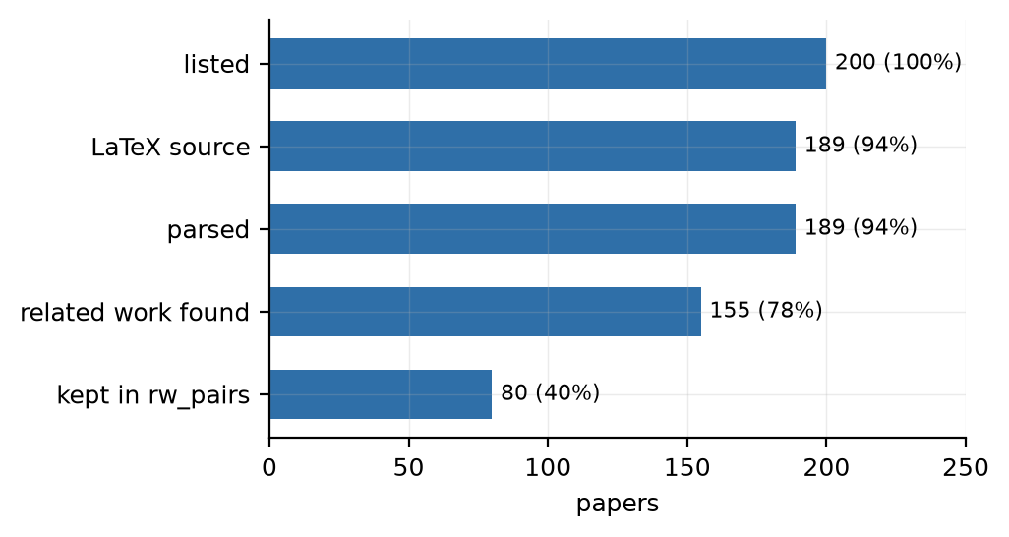
Figure 6: Mining yield: papers surviving each step, as counts and as a percentage of the submissions listed.
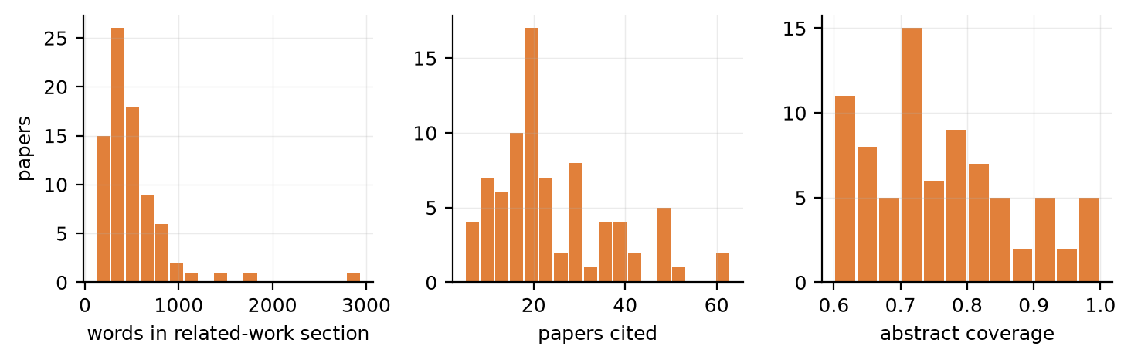
Figure 7: Distribution of related-work length, number of cited papers and abstract coverage across the mined benchmark examples.
Table 3: Stage 1 mining yield at pilot scale.
Step | Papers | % of listed
Submissions listed | 200 | 100.0%
With LaTeX source | 189 | 94.5%
Parsed without error | 189 | 94.5%
With a related-work section | 155 | 77.5%
Kept as benchmark examples | 80 | 40.0%

Table 4: Dataset statistics for the mined arXiv benchmark and the external Multi-XScience benchmark.
Statistic | Mined arXiv split | Multi-XScience
Benchmark examples | 80 | 300
Median related-work length (words) | 420 | 119
Median papers cited per example | 20 | 5
Median abstract coverage | 0.74 | 0.857
Citation contexts | 15,704 | —
… of which inside a related-work section | 3,652 | —
Distinct citing papers | 185 | —

The time split is disjoint: the newest training paper is dated 2024-12-31 and the oldest test paper 2026-06-30.
One risk remains and is worth stating. The cited papers are necessarily older than the paper citing them, so they were probably in the training data of every model tested. That cannot be avoided for this task. It does not give a model the text being scored, which is the section itself, but it does mean the subject matter may be familiar.
4.2 Citation-relation classification
Stage 2 classification is not reported here. results/stage2_benchmark.json is absent, so neither the LLM agreement nor the fine-tuned classifier can be reported. Re-run it with python scripts/run_stage2.py label, then sample_gold.py, then run_stage2.py train and bench, then rebuild this report; the text and the table will appear automatically.
4.3 Verifier calibration and claim verdicts
Verifier calibration is not reported here. results/verifier_calibration.json is absent, so the thresholds in use are the hand-chosen defaults rather than fitted values, and the claim verdicts below should be read as uncalibrated. Re-run it with python scripts/run_stage3.py make-dev, label data/verifier_dev.jsonl, then run_stage3.py calibrate, then rebuild this report; the text and the table will appear automatically.
Claim verification is not reported here. no results/stage3_verify_*.json file exists. Re-run it with python scripts/run_stage3.py extract and then verify, then rebuild this report; the text and the table will appear automatically.
4.4 Consensus map, contradictions and gaps
The end-to-end Flow run is not reported here. results/flow_summary.json is absent. Re-run it with python scripts/run_flow.py --topic "..." --n-papers 15, then rebuild this report; the text and the table will appear automatically.
4.5 System comparison
The S1–S4 comparison is not reported here. results/eval_arxiv.json is absent. Re-run it with python scripts/run_eval.py --systems S1 S2 S3 --limit 30, then rebuild this report; the text and the table will appear automatically.
4.6 Distilled extractor
Stage 6 distillation is not reported here. results/stage6_distill.json is absent. 4-bit QLoRA requires bitsandbytes, which is CUDA-only, so this stage is a Colab-T4 job and was not run on the development machine. Re-run it with notebooks/05_distill_extractor_qlora.ipynb on a Colab T4, then rebuild this report; the text and the table will appear automatically.
4.7 A worked example, end to end
To show the whole pipeline on one case, the system was given a single test paper — 2606.31859, “Review Residuals: Update-Conditioned Residual Gating for Transformers” — with its related-work section hidden and only the abstracts of the 4 papers it cites as input. The author's own section is 120 words long.
The crew extracted 12 claims from 4 papers and wrote 6 sentences, taking 787 seconds. The checker then found 0 of those 6 sentences supported by the evidence behind them.
That result — none of the sentences supported — is worth looking at closely, because it is the kind of failure this project was built to make visible rather than the kind it was built to avoid. The sentences read well and cite real papers from the correct set. What they do not do is say something the cited papers actually establish. Most describe what the citing paper itself contributes, which is reasonable prose for a related-work section and is exactly what cannot be checked against the cited literature.
One sentence shows the pattern. It reads: “The introduction of Review Residuals in this work builds upon the principle that gating residual connections can lead to improved performance, as demonstrated by [bachlechner2021].” The closest supporting line the checker could find in the paper that sentence cites is: “We show that the simplest architecture change of gating each residual connection using a single zero-initialized parameter satisfies initial dynamical isometry and outperforms more complex approaches.” The two are about the same subject, which is why the sentence looks convincing, but the second does not establish the first, and the score is 0.001 out of 1.
A reader skimming the citations would not catch this. An overlap score against the author's section would not catch it either, because the wording is close to what a related-work section normally looks like. The sentence-level check catches it, which is the argument for running the check at all.
Figure 8 shows the same run in the console, where selecting a sentence brings up the line it was checked against.
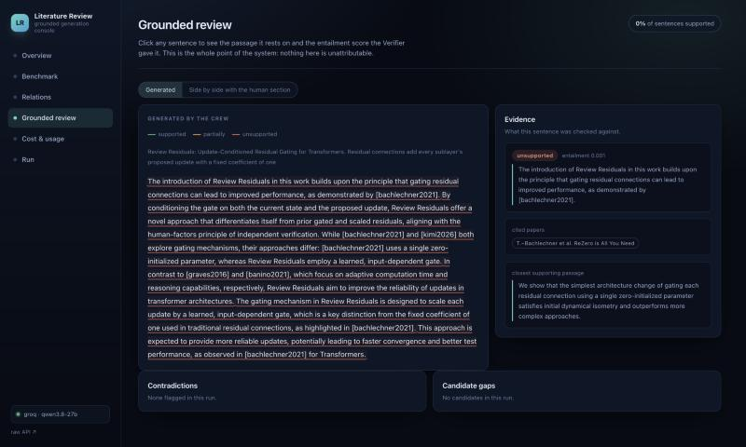
Figure 8: The worked example in the console. Sentences are underlined by outcome, and selecting one shows the paper it cites, the closest supporting line, and the score. Here every sentence is unsupported.
Two things about this run should be kept in mind when reading the number. It used qwen2.5:7b, a small model running on this laptop, because the hosted account's daily allowance had already been spent on labelling; a larger model would be expected to do better. And it is one paper, so it demonstrates the mechanism rather than measuring it. Section 4.5 is where measurement across many papers belongs.
4.7.1 Error analysis
No cached generations are available, so no qualitative comparison or error analysis is reported here. Run scripts/run_eval.py and rebuild this report.
4.8 Limitations and threats to validity
• Small runs. Everything here was run at a size that fits on one laptop and inside a free API account. The confidence ranges are correspondingly wide, and no claim is made that one system beats another where those ranges overlap.
• The classifier learns from machine labels. The citation classifier is trained on labels a language model produced, not a person. Section 4.2 measures how far those labels can be trusted, and the classifier cannot be better than its teacher on the labels the teacher gets wrong.
• Who produced the gold labels. The hand-checked sets were labelled by the AI assistant that built the pipeline, following the written guide and blind to the labeller's output, then reviewed by the author. That is an independent second opinion rather than expert human annotation. If the guide itself is misleading, it would mislead the labeller and the gold set in the same direction, and with one annotator there is no way to measure that. Replacing these with independently sourced human labels is the first item in Section 5.2.
• The checking model has its own weaknesses. It is unreliable on statements involving numbers and quantities, which is exactly what many scientific claims turn on, and it treats cautious wording inconsistently. A claim marked unsupported is a sign that something needs looking at, not proof that it is wrong.
• Matching a quote is not the same as proving provenance. The check confirms that a line resembling the quote appears in the text given to the extractor. It does not confirm that the line means in context what the claim says it means, and a short generic line can match in several places.
• The date separation is partial. The section being scored was published after every tested model's cut-off, but the papers it cites are necessarily older and were probably in those models' training data. Familiarity with the subject may therefore help a model even though it has not seen the answer.
• The test set is not a random sample of research. Only papers with readable source, an identifiable related-work section and most of their references findable survive. That favours conventionally structured papers from authors who publish their source files.
• There is only one correct answer in the test set. Many different related-work sections would be reasonable for the same set of cited papers, and only the one the original author wrote is available. This is why the grounding measures are reported next to the overlap scores rather than underneath them.
• Name tidying is incomplete. Dataset, metric and method names are merged using a known-alternatives list plus approximate matching; anything unmatched keeps its original form, so one group of results can end up split in two and a disagreement between papers missed as a result.
• One provider, one run. Every system used the same model and settings, which makes the comparison fair but says nothing about whether the conclusions hold for a different model. Each configuration was run once, so run-to-run variation is not measured.

CHAPTER 5
CONCLUSION AND FUTURE SCOPE

5.1 Conclusion
This project built a tool that writes a literature review and is forced to show its working. Claims must quote the line they came from. A separate model, with thresholds chosen by testing rather than guessing, decides whether the quote actually supports the claim. Every sentence of the written review carries the claims behind it, and anything that fails the check is rewritten once and then marked rather than hidden. Two parts of it were trained on data taken from real papers' related-work sections, and the whole thing was tested against human-written sections on papers published after the models' training cut-off.
The full system comparison was not completed when this report was built, so no conclusion is drawn about whether the multi-agent pipeline outperforms a single call. Section 4.5 states exactly which systems were run.
Three smaller findings are worth stating separately. A model asked to quote exactly usually does, and still writes claims its own quote does not prove, which is why the two checks are separate rather than one. Using the checker to decide what a smaller model may learn from is a cheap way to stop it inheriting the larger model's unsupported habits. And the cost of running a team of agents is large and easy to measure, so reporting it next to the quality is what makes the trade-off visible at all.
Finally, the rules this project set itself shaped the result as much as the design did. Every number here is read from a file the code wrote. Every figure is drawn from those files. Six candidate references were dropped because no source would confirm they existed. The steps that could not be run on the available hardware are named rather than guessed at.
5.2 Suggestions for future directions
Seven directions follow from the limitations in Section 4.8, roughly in order of how much they would change the conclusions.
1. Scale the pilot. Every number in Chapter 4 comes from a pilot sized to run on one laptop. The notebooks are written for the full configuration (roughly 3,000 training and 300 test papers, 5,000 labelled contexts); running them would narrow the intervals enough for the system comparison to be decidable rather than suggestive.
2. Replace LLM labels with human ones where they matter. The relation classifier is limited by its teacher on exactly the rare classes the contradiction map depends on. A few hundred human labels concentrated on contrasts and supports would be worth more than ten thousand more LLM labels.
3. Measure inter-annotator agreement. The gold set, the Verifier's dev set and the contradiction spot checks each had one annotator. A second annotator on a subset would turn the labelling guide from an assertion into something testable.
4. Train the Verifier rather than only calibrating it. Thresholds on an off-the-shelf NLI model are a blunt instrument, and the model is weakest on the numerical entailment that scientific claims turn on. Fine-tuning an entailment model on claim/evidence pairs from this domain is the obvious next component.
5. Extract from full text rather than from abstracts. When the Flow runs on an OpenAlex corpus it sees only abstracts, which is why the relation classifier contributes little there: there are no in-corpus citation sentences to classify. Resolving corpus papers to their arXiv sources would let the typed citation graph be built from real citation contexts.
6. Complete and then stress the distillation. Component B is a Colab-T4 job; beyond running it, the question worth asking is whether a student trained only on Verifier-approved data generalises better than one trained on everything, which is a controlled experiment this codebase can already run.
7. Attempt component C. Fine-tuning a related-work generator directly on the mined (cited abstracts → section) pairs was left as a stretch goal. It should be gated through the same Verifier, so that a model trained to imitate human sections is still held to the grounding standard the rest of the system enforces.

REFERENCES

Journal / Conference Papers
[1] Joshua Maynez et al., “On Faithfulness and Factuality in Abstractive Summarization”, Annual Meeting of the Association for Computational Linguistics, 2020, doi:10.18653/v1/2020.acl-main.173
[2] Ziwei Ji et al., “Survey of Hallucination in Natural Language Generation”, ACM Computing Surveys, 2022, doi:10.1145/3571730
[3] Alex Wang, Kyunghyun Cho and Mike Lewis, “Asking and Answering Questions to Evaluate the Factual Consistency of Summaries”, Annual Meeting of the Association for Computational Linguistics, 2020, doi:10.18653/v1/2020.acl-main.450
[4] Wojciech Kryściński et al., “Evaluating the Factual Consistency of Abstractive Text Summarization”, Conference on Empirical Methods in Natural Language Processing, 2020, doi:10.18653/v1/2020.emnlp-main.750
[5] Philippe Laban et al., “SummaC: Re-Visiting NLI-based Models for Inconsistency Detection in Summarization”, arXiv, 2021, doi:10.48550/arxiv.2111.09525
[6] Guohao Li et al., “CAMEL: Communicative Agents for "Mind" Exploration of Large Language Model Society”, neural information processing systems, 2023, doi:10.52202/075280-2264
[7] Joon-Sung Park et al., “Generative Agents: Interactive Simulacra of Human Behavior”, ACM Symposium on User Interface Software and Technology, 2023, doi:10.1145/3586183.3606763
[8] Aman Madaan et al., “Self-Refine: Iterative Refinement with Self-Feedback”, neural information processing systems, 2023, doi:10.52202/075280-2019
[9] Noah Shinn et al., “Reflexion: language agents with verbal reinforcement learning”, neural information processing systems, 2023, doi:10.52202/075280-0377
[10] Abigail See, Peter J. Liu and Christopher D. Manning, “Get To The Point: Summarization with Pointer-Generator Networks”, Annual Meeting of the Association for Computational Linguistics, 2017, doi:10.18653/v1/p17-1099
[11] Mike Lewis et al., “BART: Denoising Sequence-to-Sequence Pre-training for Natural Language Generation, Translation, and Comprehension”, Annual Meeting of the Association for Computational Linguistics, 2020, doi:10.18653/v1/2020.acl-main.703
[12] Jingqing Zhang et al., “PEGASUS: Pre-training with Extracted Gap-sentences for Abstractive Summarization”, arXiv, 2019, doi:10.48550/arxiv.1912.08777
[13] Arman Cohan et al., “A Discourse-Aware Attention Model for Abstractive Summarization of Long Documents”, Conference of the North American Chapter of the Association for Computational Linguistics: Human Language Technologies, 2018, doi:10.18653/v1/n18-2097
[14] Shashi Narayan, Shay B. Cohen and Mirella Lapata, “Don't Give Me the Details, Just the Summary! Topic-Aware Convolutional Neural Networks for Extreme Summarization”, arXiv, 2018, doi:10.48550/arxiv.1808.08745
[15] Ahmed AbuRa’ed et al., “Automatic related work section generation: experiments in scientific document abstracting”, Scientometrics, 2020, doi:10.1007/s11192-020-03630-2
[16] Yongzhen Wang, Xiaozhong Liu and Zheng Gao, “Neural Related Work Summarization with a Joint Context-driven Attention Mechanism”, Conference on Empirical Methods in Natural Language Processing, 2018, doi:10.18653/v1/d18-1204
[17] Kelvin Luu et al., “Explaining Relationships Between Scientific Documents”, preprint, 2021, doi:10.18653/v1/2021.acl-long.166
[18] Yao Lu, Yue Dong and Laurent Charlin, “Multi-XScience: A Large-scale Dataset for Extreme Multi-document Summarization of Scientific Articles”, Conference on Empirical Methods in Natural Language Processing, 2020, doi:10.18653/v1/2020.emnlp-main.648
[19] Kyle Lo et al., “S2ORC: The Semantic Scholar Open Research Corpus”, Annual Meeting of the Association for Computational Linguistics, 2020, doi:10.18653/v1/2020.acl-main.447
[20] Tianyi Zhang et al., “Benchmarking Large Language Models for News Summarization”, Transactions of the Association for Computational Linguistics, 2024, doi:10.1162/tacl_a_00632
[21] Awais Athar and Simone Teufel, “Context-Enhanced Citation Sentiment Detection”, preprint, 2012
[22] Saeed‐Ul Hassan et al., “Mining the Context of Citations in Scientific Publications”, Lecture notes in computer science, 2018, doi:10.1007/978-3-030-04257-8_32
[23] David Jurgens et al., “Measuring the Evolution of a Scientific Field through Citation Frames”, Transactions of the Association for Computational Linguistics, 2018, doi:10.1162/tacl_a_00028
[24] Arman Cohan et al., “Structural Scaffolds for Citation Intent Classification in Scientific Publications”, Conference of the North American Chapter of the Association for Computational Linguistics: Human Language Technologies, 2019, doi:10.18653/v1/n19-1361
[25] Iz Beltagy, Kyle Lo and Arman Cohan, “SciBERT: A Pretrained Language Model for Scientific Text”, preprint, 2019, doi:10.18653/v1/d19-1371
[26] Alexander R. Fabbri et al., “SummEval: Re-evaluating Summarization Evaluation”, Transactions of the Association for Computational Linguistics, 2021, doi:10.1162/tacl_a_00373
[27] Tanya Goyal and Greg Durrett, “Annotating and Modeling Fine-grained Factuality in Summarization”, Conference of the North American Chapter of the Association for Computational Linguistics: Human Language Technologies, 2021, doi:10.18653/v1/2021.naacl-main.114
[28] Zhang, Tianyi et al., “BERTScore: Evaluating Text Generation with BERT”, arXiv, 2019, doi:10.48550/arxiv.1904.09675
[29] James Peter Thorne et al., “FEVER: a Large-scale Dataset for Fact Extraction and VERification”, Conference of the North American Chapter of the Association for Computational Linguistics: Human Language Technologies, 2018, doi:10.18653/v1/n18-1074
[30] David Wadden et al., “Fact or Fiction: Verifying Scientific Claims”, Conference on Empirical Methods in Natural Language Processing, 2020, doi:10.18653/v1/2020.emnlp-main.609
[31] Pengcheng He et al., “DeBERTa: Decoding-enhanced BERT with Disentangled Attention”, arXiv, 2020, doi:10.48550/arxiv.2006.03654
[32] Jason Wei et al., “Chain-Of-Thought Prompting Elicits Reasoning in Large Language Models”, neural information processing systems, 2022, doi:10.52202/068431-1800
[33] Timo Schick et al., “Toolformer: Language Models Can Teach Themselves to Use Tools”, neural information processing systems, 2023, doi:10.52202/075280-2997
[34] Patrick Lewis et al., “Retrieval-Augmented Generation for Knowledge-Intensive NLP Tasks”, UCL Discovery, 2020
[35] Vladimir Karpukhin et al., “Dense Passage Retrieval for Open-Domain Question Answering”, Conference on Empirical Methods in Natural Language Processing, 2020, doi:10.18653/v1/2020.emnlp-main.550
[36] Jakub Lála et al., “PaperQA: Retrieval-Augmented Generative Agent for Scientific Research”, arXiv, 2023, doi:10.48550/arxiv.2312.07559
[37] Yijia Shao et al., “Assisting in Writing Wikipedia-like Articles From Scratch with Large Language Models”, Conference of the North American Chapter of the Association for Computational Linguistics: Human Language Technologies, 2024, doi:10.18653/v1/2024.naacl-long.347
[38] Teo Sušnjak et al., “Automating Research Synthesis with Domain-Specific Large Language Model Fine-Tuning”, ACM Transactions on Knowledge Discovery from Data, 2025, doi:10.1145/3715964
[39] Qwen et al., “Qwen2.5 Technical Report”, arXiv, 2024, doi:10.48550/arxiv.2412.15115
[40] Tim Dettmers et al., “QLoRA: Efficient Finetuning of Quantized LLMs”, neural information processing systems, 2023, doi:10.52202/075280-0441

Reference / Hand Books
No textbook reference is cited. The two candidates considered (Jurafsky and Martin's Speech and Language Processing, and Manning, Raghavan and Schütze's Introduction to Information Retrieval) could not be confirmed as works by OpenAlex, Semantic Scholar or the arXiv API — a title search returns reviews of them rather than the books themselves — and this report does not cite what it cannot verify. docs/references_candidates.txt records the decision.

Web
[1] CrewAI documentation, https://docs.crewai.com
[2] LiteLLM documentation, https://docs.litellm.ai
[3] OpenAlex API documentation, https://docs.openalex.org
[4] arXiv API user manual, https://info.arxiv.org/help/api/
[5] Hugging Face model hub, https://huggingface.co/models
[6] Multi-XScience dataset repository, https://github.com/yaolu/Multi-XScience

