SIF MONTHLY PERFORMANCE REPORT
{monthUpper}
Comprehensive analysis of India's Specialised Investment Fund universe — scheme count, AUM, fund flows, and NAV-based performance across Equity, Hybrid and Debt strategies. The values are as of {asOfLong} (Source: AMFI).

TOTAL SCHEMES  {universe.grandTotal.schemes}  active SIF schemes | TOTAL AUM  {snapshotAum}  as on {asOfShort} | NET INFLOWS  {snapshotNetFlow}  for {monthShort} | TOTAL FOLIOS  {universe.grandTotal.folios}  investor accounts

Contents
01 Market Snapshot
02 SIF Universe Overview
03 Equity Oriented Strategies — Categories, Allocations & Performance
04 Debt Oriented Strategies — Categories, Allocations & Performance
05 Hybrid Oriented Strategies — Categories, Allocations & Performance
06 Monthly Performance Highlights
07 Comprehensive Performance Table — All Schemes

SIFcase is India's dedicated research and analysis platform for Specialised Investment Funds, powered by Aureva Capital Private Limited.

01 MARKET SNAPSHOT

Performance across asset classes

Data source: NSE India

Category-wise net inflows into Indian Equities

Data sources: NSE India

02 SIF UNIVERSE OVERVIEW
{prose.universeOverview}

AUM by Category (₹ Cr) | Number of Schemes by Category

Category-wise Breakdown
Category | Schemes | AUM (₹ Cr) | Folios | Gross Inflow | Net Flow
{#universe.categories}{label} | {schemes} | {aumCr} | {folios} | {grossInflowCr} | {netFlowCr}{/universe.categories}
{universe.grandTotal.label} | {universe.grandTotal.schemes} | {universe.grandTotal.aumCr} | {universe.grandTotal.folios} | {universe.grandTotal.grossInflowCr} | {universe.grandTotal.netFlowCr}

Source: AMFI Monthly SIF Report — {monthLabel}. Data as published by AMFI on amfiindia.com.

New Scheme Registrations (NSR)
{universe.nsr.totalSchemes} new schemes launched in {monthLabel}, raising ₹{nsrMobilised} Cr. Source: AMFI NSR data.
Scheme Name | Category | Count | Mobilised (₹ Cr)
{#universe.nsr.rows}{schemeNames} | {category} | {count} | {mobilisedCr}{/universe.nsr.rows}

03 EQUITY ORIENTED STRATEGIES

A. SEBI-Permitted Equity Investment Strategies
Per SEBI Circular— Equity Oriented Investment Strategies

1. Equity Long-Short Fund
Minimum investment in equity and equity related instruments: 80%. Maximum short exposure through unhedged derivative positions in equity and equity related instruments: 25%. Structure: Open-ended or interval equity investment strategy investing in listed equity and equity related instruments, including limited short exposure through derivative instruments. Redemption: Daily or any lesser frequency as decided by the AMC.

2. Equity Ex-Top 100 Long-Short Fund
Minimum investment in equity and equity related instruments of stocks excluding top 100 stocks by market capitalisation: 65%. Maximum short exposure through unhedged derivative positions in equity and equity related instruments of stocks other than large cap stocks: 25%. Structure: Open-ended or interval strategy investing in equity (excluding large caps), with limited short exposure. Redemption: Daily or any lesser frequency as decided by the AMC.

3. Sector Rotation Long-Short Fund
Minimum investment in equity and equity related instruments across a maximum of 4 sectors: 80%. Maximum short exposure through unhedged derivative positions: 25%. Note: Short exposure applies at the sector level — if the fund takes a short position in a sector, all stocks of that sector held in the portfolio must be held as short positions. Structure: Open-ended or interval strategy across maximum four sectors. Redemption: Daily or any lesser frequency as decided by the AMC.

B. SEBI Allocation Ranges — Equity Strategies
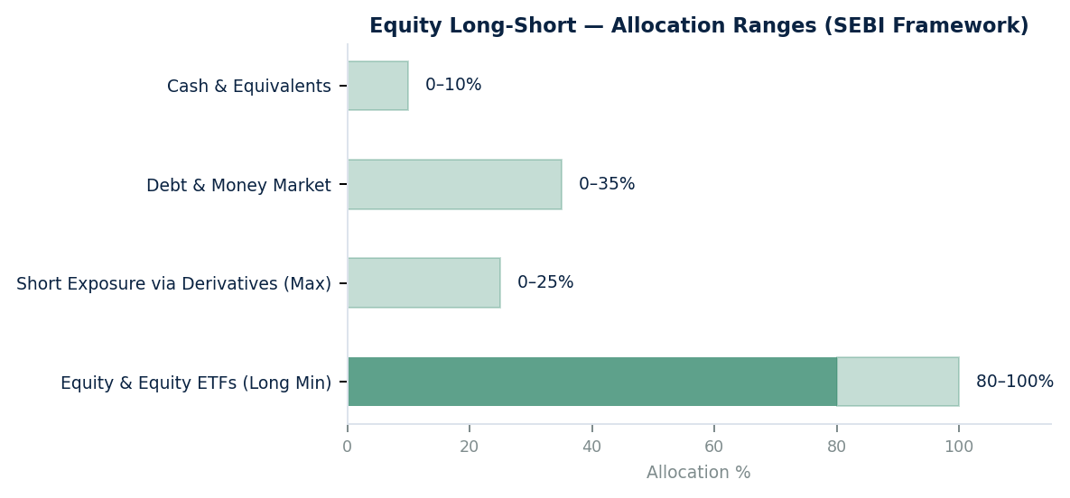
Equity Long-Short — Instrument Allocation Ranges (SEBI Framework)

Instrument / Asset Class | Min % | Max %
Equity & Equity ETFs / Instruments (Long) | Min 80% | Max 100%
Short via Unhedged Derivatives (Max) | 0% | Max 25%
Debt & Money Market Securities | 0% | Max 35%
Cash & Cash Equivalents | 0% | Max 10%
Single Stock Derivative Exposure | 0% | Max 10% of NAV
Cumulative Gross Exposure | — | Max 100% of NAV

C. Performance — Equity Oriented Schemes
Source: SIFcase NAV database. Returns are absolute. “-“ = insufficient history.

Scheme Name | Category | AMC | 1M % | 3M % | 6M % | 1Y % | SI % | Since
{#perf.equity}{schemeName} | {shortCategory} | {amc} | {r1m} | {r3m} | {r6m} | {r1y} | {si} | {since}{/perf.equity}

04 DEBT ORIENTED STRATEGIES

A. SEBI-Permitted Debt Investment Strategies
Per SEBI Circular— Debt Oriented Investment Strategies

1. Debt Long-Short Fund
Investment in debt instruments across duration, including unhedged short exposure through exchange traded debt derivative instruments. Structure: Interval investment strategy investing in debt instruments including limited short exposure in debt instruments. Redemption: Once in a week or any lesser frequency as decided by the AMC. Note: As of the current reporting period, no Debt Long-Short SIF schemes have been launched in India. This section will be populated when schemes go live.

2. Sectoral Debt Long-Short Fund
Investment in debt instruments of at least two sectors, with maximum investment of 75% in a single sector. Maximum short exposure through unhedged derivative positions in debt instruments: 25%. Short exposure applies across the sector — if short on a sector, all debt instruments of that sector held in the portfolio must be held as short positions. Structure: Interval strategy across minimum two sectors. Redemption: Once in a week or any lesser frequency as decided by the AMC.

B. SEBI Allocation Ranges — Debt Strategies
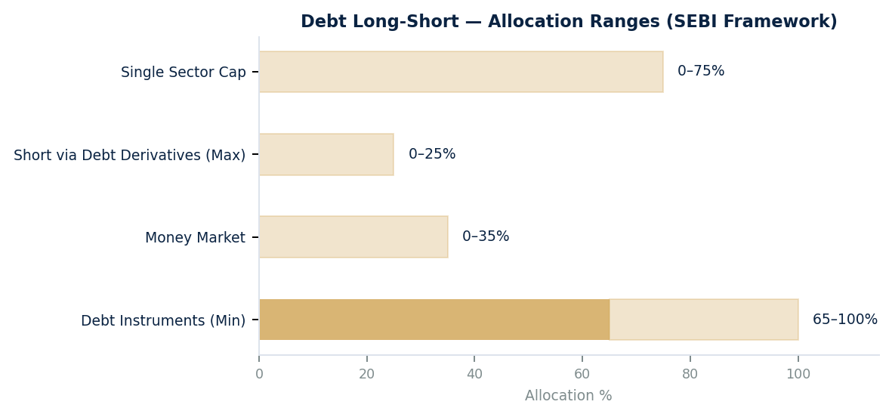
Debt Long-Short — Instrument Allocation Ranges (SEBI Framework)

Instrument / Asset Class | Min % | Max %
Debt Securities (G-Sec, SDL, Corporate Bonds) | Min 65% | Max 100%
Money Market Instruments | 0% | Max 35%
Short via Debt Derivatives (Unhedged Max) | 0% | Max 25%
Single Sector Maximum Exposure | — | Max 75%
Single Issuer (AAA-rated) | — | Max 20% of NAV
Cumulative Gross Exposure | — | Max 100% of NAV

Source: SEBI Circular

C. Performance — Debt Oriented Schemes
{prose.debtSectionNote}

05 HYBRID ORIENTED STRATEGIES

A. SEBI-Permitted Hybrid Investment Strategies
Per SEBI Circular— Hybrid Investment Strategies

1. Active Asset Allocator Long-Short Fund
Dynamic investment across equity, debt, equity and debt derivatives, REITs/InvITs, and commodity derivatives. Maximum short exposure through unhedged derivative positions in equity and debt instruments: 25%. Structure: Interval investment strategy dynamically investing across multiple asset classes, including limited short exposure through derivatives. Redemption: Twice in a week or any lesser frequency as decided by the AMC.

2. Hybrid Long-Short Fund
Minimum investment in equity and equity related instruments: 25%. Minimum investment in debt instruments: 25%. Maximum short exposure through unhedged derivative positions in equity and debt instruments: 25%. Structure: Interval investment strategy investing in both equity and debt securities, with limited short exposure through derivatives. Redemption: Twice in a week or any lesser frequency as decided by the AMC.

B. SEBI Allocation Ranges — Hybrid Strategies
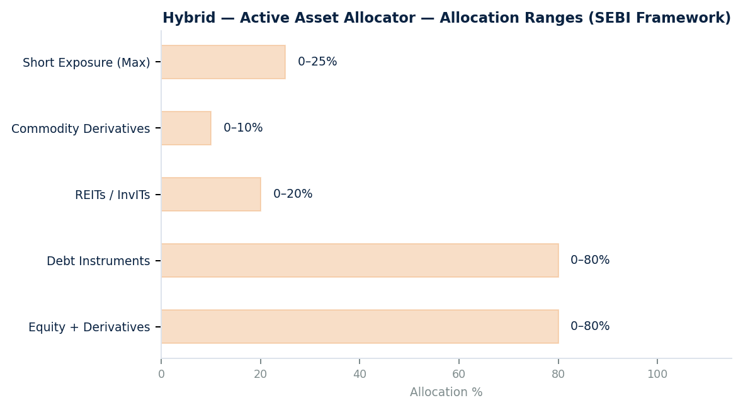  Active Asset Allocator L-S Ranges | 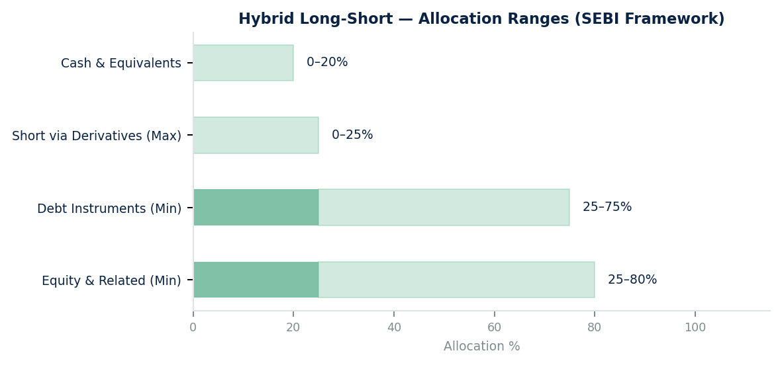  Hybrid Long-Short Ranges

Active Asset Allocator — Allocation Ranges
Instrument / Asset Class | Min % | Max %
Equity, Equity Derivatives (Long & Short) | 0% | Max 80%
Debt Instruments (Bonds, G-Sec, SDL) | 0% | Max 80%
REITs / InvITs | 0% | Max 20%
Commodity Derivatives | 0% | Max 10%
Short via Derivatives (Unhedged Max) | 0% | Max 25%
Cumulative Gross Exposure | — | Max 100% of NAV

Hybrid Long-Short — Allocation Ranges
Instrument / Asset Class | Min % | Max %
Equity & Related Instruments (Minimum) | Min 25% | Max 75%
Debt Instruments (Minimum) | Min 25% | Max 75%
Short via Derivatives in Eq + Debt (Max) | 0% | Max 25%
Cash & Cash Equivalents | 0% | Max 20%
Cumulative Gross Exposure | — | Max 100% of NAV

C. Performance — Hybrid Oriented Schemes
Source: SIFcase NAV database. Returns are absolute. “-“ = insufficient history.

Scheme Name | Category | AMC | 1M % | 3M % | 6M % | 1Y % | SI % | Since
{#perf.hybrid}{schemeName} | {shortCategory} | {amc} | {r1m} | {r3m} | {r6m} | {r1y} | {si} | {since}{/perf.hybrid}

06 MONTHLY PERFORMANCE HIGHLIGHTS
{prose.highlightsIntro}

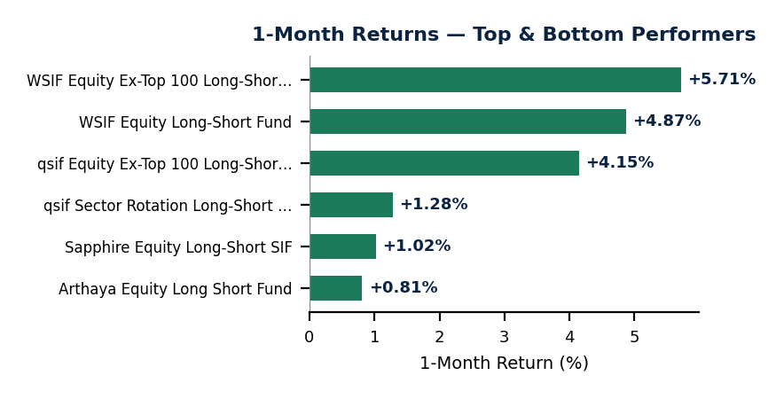
1-Month Returns — Top & Bottom Performers

Top 3 Performers — 1-Month Return
Scheme Name | Category | AMC | 1M Return | Since Inception
{#perf.top3}{schemeName} | {shortCategory} | {amc} | {r1m} | {si}{/perf.top3}

Bottom 3 Performers — 1-Month Return
Scheme Name | Category | AMC | 1M Return | Since Inception
{#perf.bottom3}{schemeName} | {shortCategory} | {amc} | {r1m} | {si}{/perf.bottom3}

07 COMPREHENSIVE PERFORMANCE TABLE — ALL ACTIVE SCHEMES
Source: SIFcase NAV database. Returns: Absolute. “-“ = insufficient history.

Scheme Name | Category | AMC | 1M % | 3M % | 6M % | 1Y % | SI % | Since
{#perf.comprehensive}{schemeName} | {shortCategory} | {amc} | {r1m} | {r3m} | {r6m} | {r1y} | {si} | {since}{/perf.comprehensive}

■ Positive (0 to +3%) | ■ Strong (> +3%) | ■ Mild negative (-2% to 0) | ■ Negative (< -2%)

DISCLAIMER
SEBI Mandatory Standard Disclaimer: Investments in Specialized Investment Fund involves relatively higher risk including potential loss of capital, liquidity risk and market volatility. Please read all investment strategy related documents carefully before making the investment decision
This report is prepared by SIFcase, a research and analysis platform operated by Aureva Capital Private Limited ("Aureva Capital"), for informational and research purposes only. It does not constitute investment advice, a solicitation, an offer to buy or sell, or a recommendation of any security, financial product, or SIF scheme mentioned herein. This report is for informational purposes only and does not constitute investment advice.
Mutual Fund / SIF investments are subject to market risks. Please read the Scheme Information Document (SID), Key Information Memorandum (KIM), and Statement of Additional Information (SAI) carefully before investing. Past performance does not guarantee future results. NAV may go up or down.
Performance data is sourced from NAV records on the SIFcase research platform. Universe data is from AMFI monthly reports. SIFcase and Aureva Capital do not guarantee completeness or accuracy. Verify independently with AMCs or AMFI (www.amfiindia.com).

Aureva Capital Private Limited

AMFI Registered MF & SIF distributor | ARN- 346247 | www.aurevawealth.com | SIFcase: https://www.sifcase.com

2026. All rights reserved. Reproduction without prior written consent is prohibited.

