Part 4

Service Providers should just be a list of users with a set role. Same with Tenants, in the “Manage Account” you have Tenant / Service Providers, these are not the same, and users will not want to add a role to each Tenant.

The role should be available when creating the tenant, and same for creating a Service Provider.

Tenant is a person that leases the property

Service Provider is someone that provides a utility service for the Agent

It seems that Tenants and Service providers are both created in “Tenants/Service Providers” and you can only enter Username and Email, this is not correct, as you will need to go and edit the role (Tenant / Service Provider) then you need to go to Tenant to edit the profile to create all the additional data.  
  
Creating Tenants should be done from “Tenants” menu option, and include all the fields to create a tenant.

Same for Service Provider, there should be a menu option for Service Providers, where you can create, edit and delete service providers.

Roles for both Tenants and Service providers should be available in the Create process.

The buttons on the new roles / permissions say “See Stuffs” and “Create Stuff”, as these take you to the Staff / Users I assume it should read staff.

Although I would have assumed the Users / Staff view option to be available from the side menu under Role and Permissions

Solved

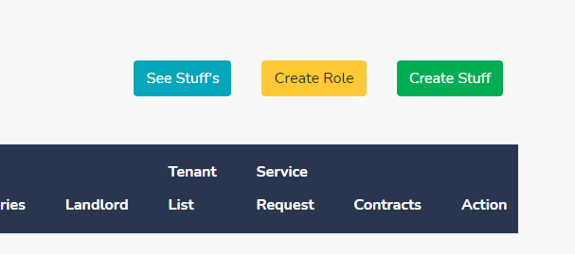

In Landlords you can create landlords, but in Tenants you cannot create Tenants

Added

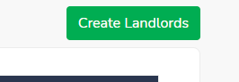

There is no search option in landlords or tenants pages

Added

When you create a User (in agent) it takes you to agencies/inbox and the search says “Search Properties”

Fixed

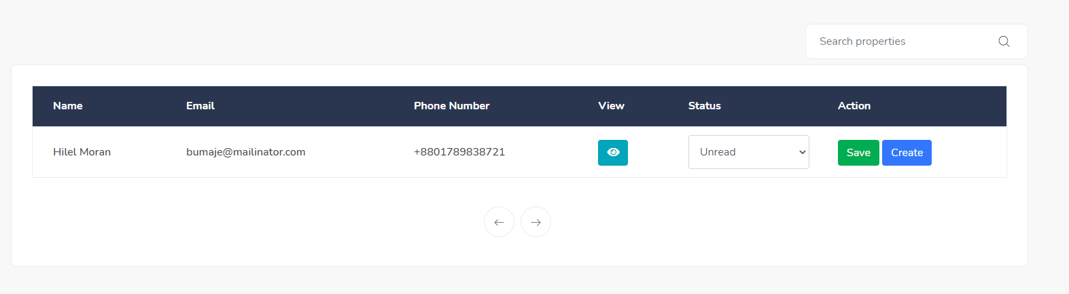

When you create a User you cannot set the password, then you have to change the password for the user and it will not let you as you have not set an old password.

This password will automatically generate and send to the end user through the email. So that they can login with that password and after that they will be able to change password.

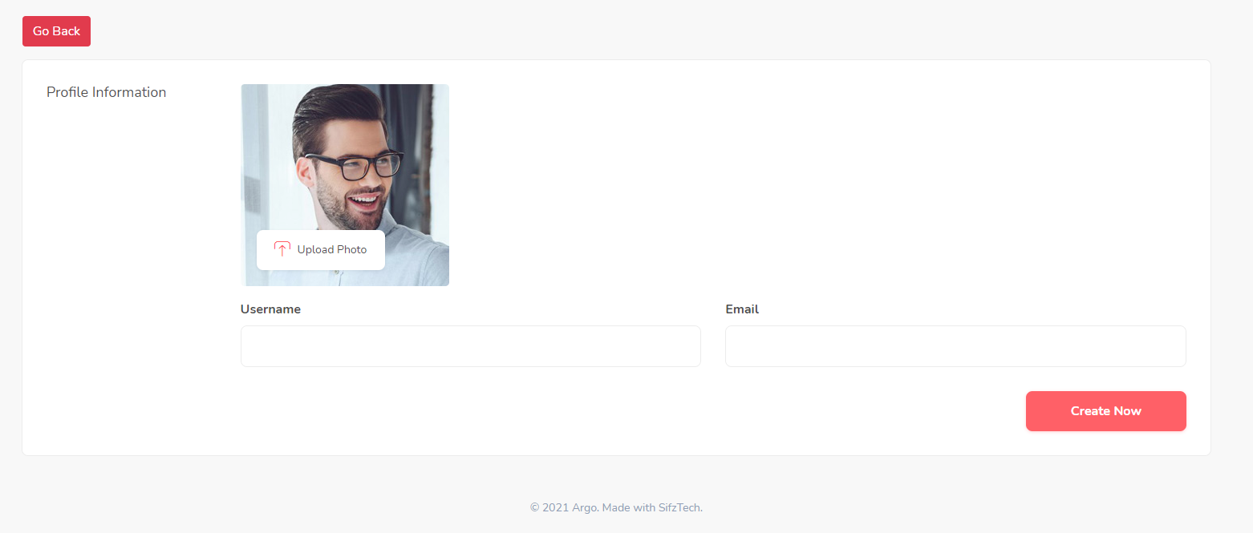

Attempting to change user password shows “agent-profile-password/11” and you get a 404 error.

Most of the pages have a welcome message, as this is not needed (and not an all pages) this should not be there and just the title of the page should be there as you do not know what page you are on.

Ok it will on dashboard only.

We are still missing parts of the requirements :

**Agent Area**

* User management (for organisation users, add edit, delete, profile)
* User roles and permissions for above
* Menu Management for website menu and CMS Pages
* Properties (Add, Edit, Delete)
* Projects (Add, Edit, Delete)
* Features (Add, Edit, Delete)
* Facilities (Add, Edit, Delete)
* Categories (Add, Edit, Delete)
* Tenants (Add, Edit, Delete)
* Landlords (Add, Edit, Delete)
* Contracts (Add, Edit, Delete)
* Service Requests (Add, Edit, Delete)
* Payments (from Stripe / Paypal)
* Calendar and Appointments
* Reports
* Additional CMS Pages (Add, Edit, Delete)
* Document Templates
* Tasks (Add, Edit, Delete)
* Settings

**Tenant Area**

* Dashboard (Payment History Done
* , Outstanding Payments Done
* , outstanding Service Requests,
* Current Contract Done
* , Messages Done
* Contract View
* Property Details
* Make Payment (to organisations stripe / paypal account) done
* View Payment History
* View Tenant Documents Done
* Service Request (Add, Edit)
* Message Organisation (Add, Edit, Delete)
* Tenant Profile (Edit)

This is the contracts where you can see documents also by visiting the contracts. Click on the eye buttons. Same as Agent they will be able to see their contract details.

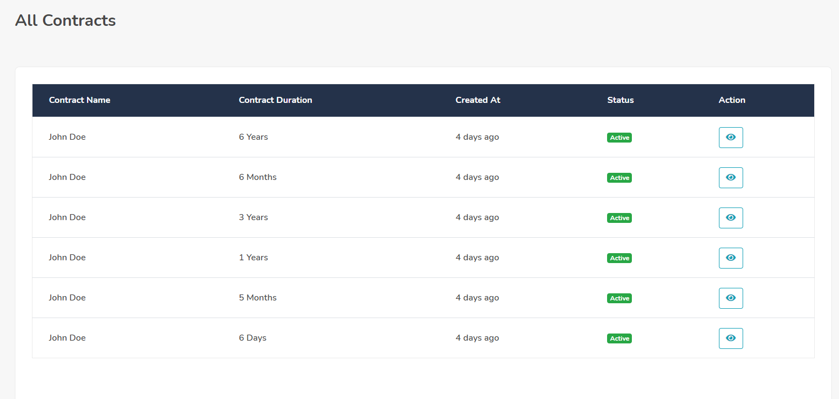

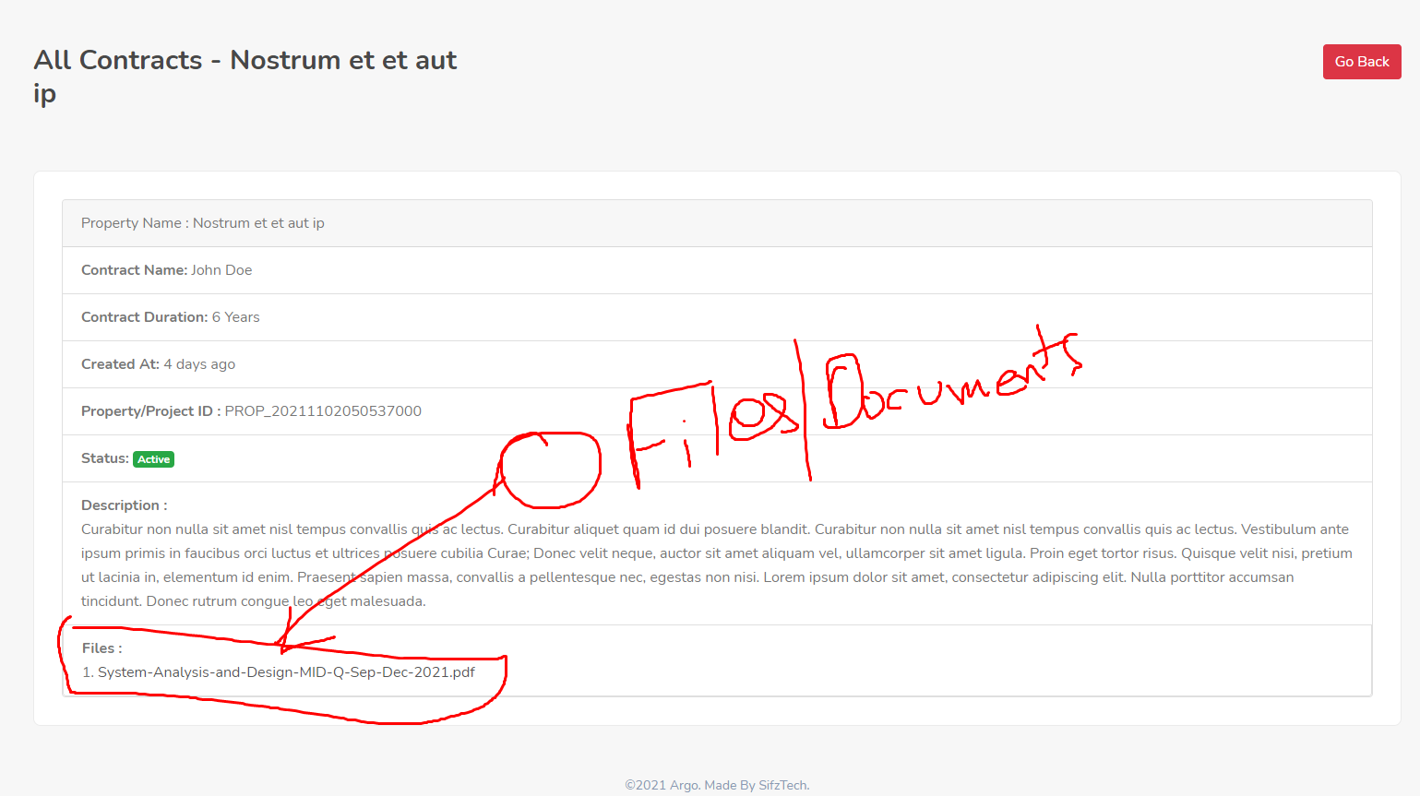

Click on the My Payment option you will be able to see all the payment history.

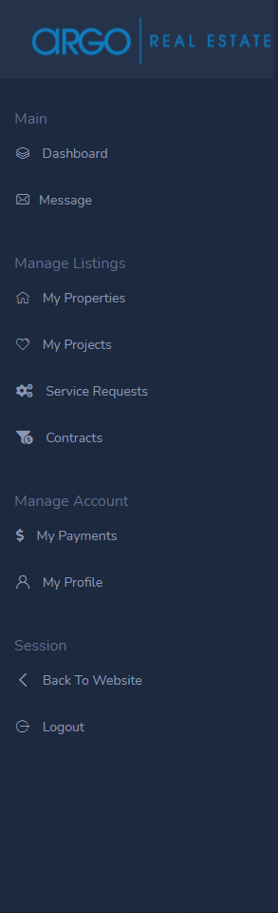This is the menus from the tenant.