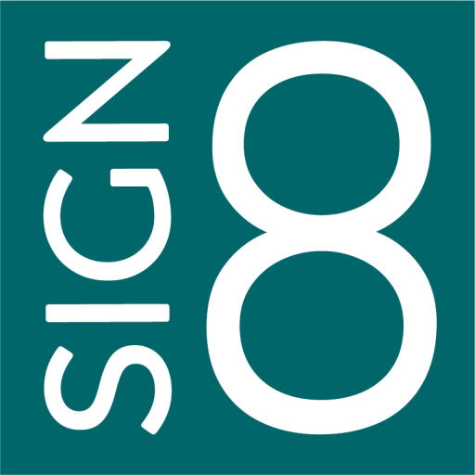

SIPO User Documentation
Complete Guide to the SIPO Document Signing Platform
11. März 2026

Table of Contents
Authentication
Dashboard
Documents
Templates
Signing Process
Personal Settings
Team Settings
Organisation Settings
Administration

Authentication
Before you can use SIPO, you need to authenticate. The following pages handle account access: signing in, creating a new account, and resetting a forgotten password.
If your organisation has already created an account for you, you will receive an email with your login credentials. Otherwise, you can register a new account yourself.
To sign in, open the SIPO URL in your web browser. Enter your email address and password, then click "Sign In". If you have two-factor authentication enabled, you will be prompted to enter your verification code on the next screen.
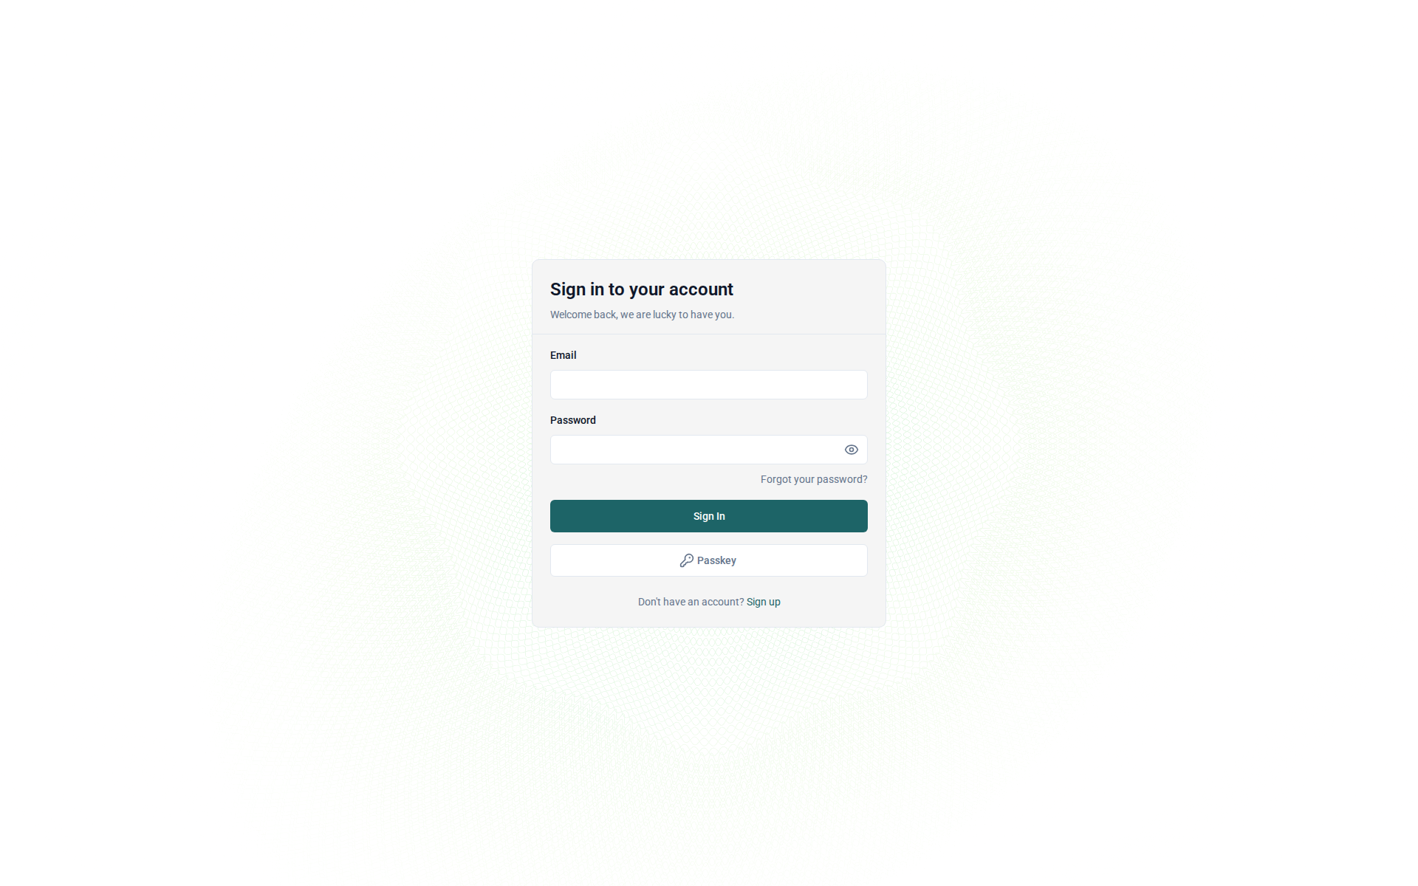
Figure: The SIPO sign-in page
If you do not yet have an account, click "Create Account" on the sign-in page. Fill in your name, email address, and choose a secure password. After submitting, you may need to verify your email address before you can sign in.
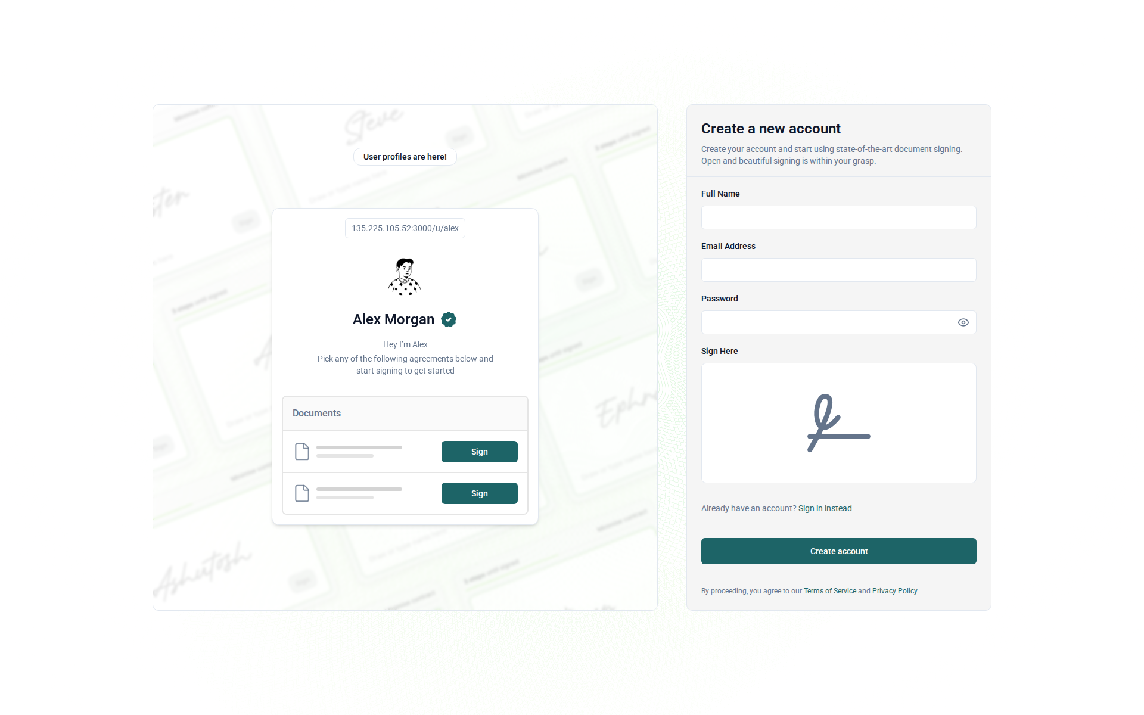
Figure: The account registration page
If you have forgotten your password, click "Forgot your password?" on the sign-in page. Enter your email address and click "Reset Password". You will receive an email with a link to set a new password. The link is valid for a limited time.
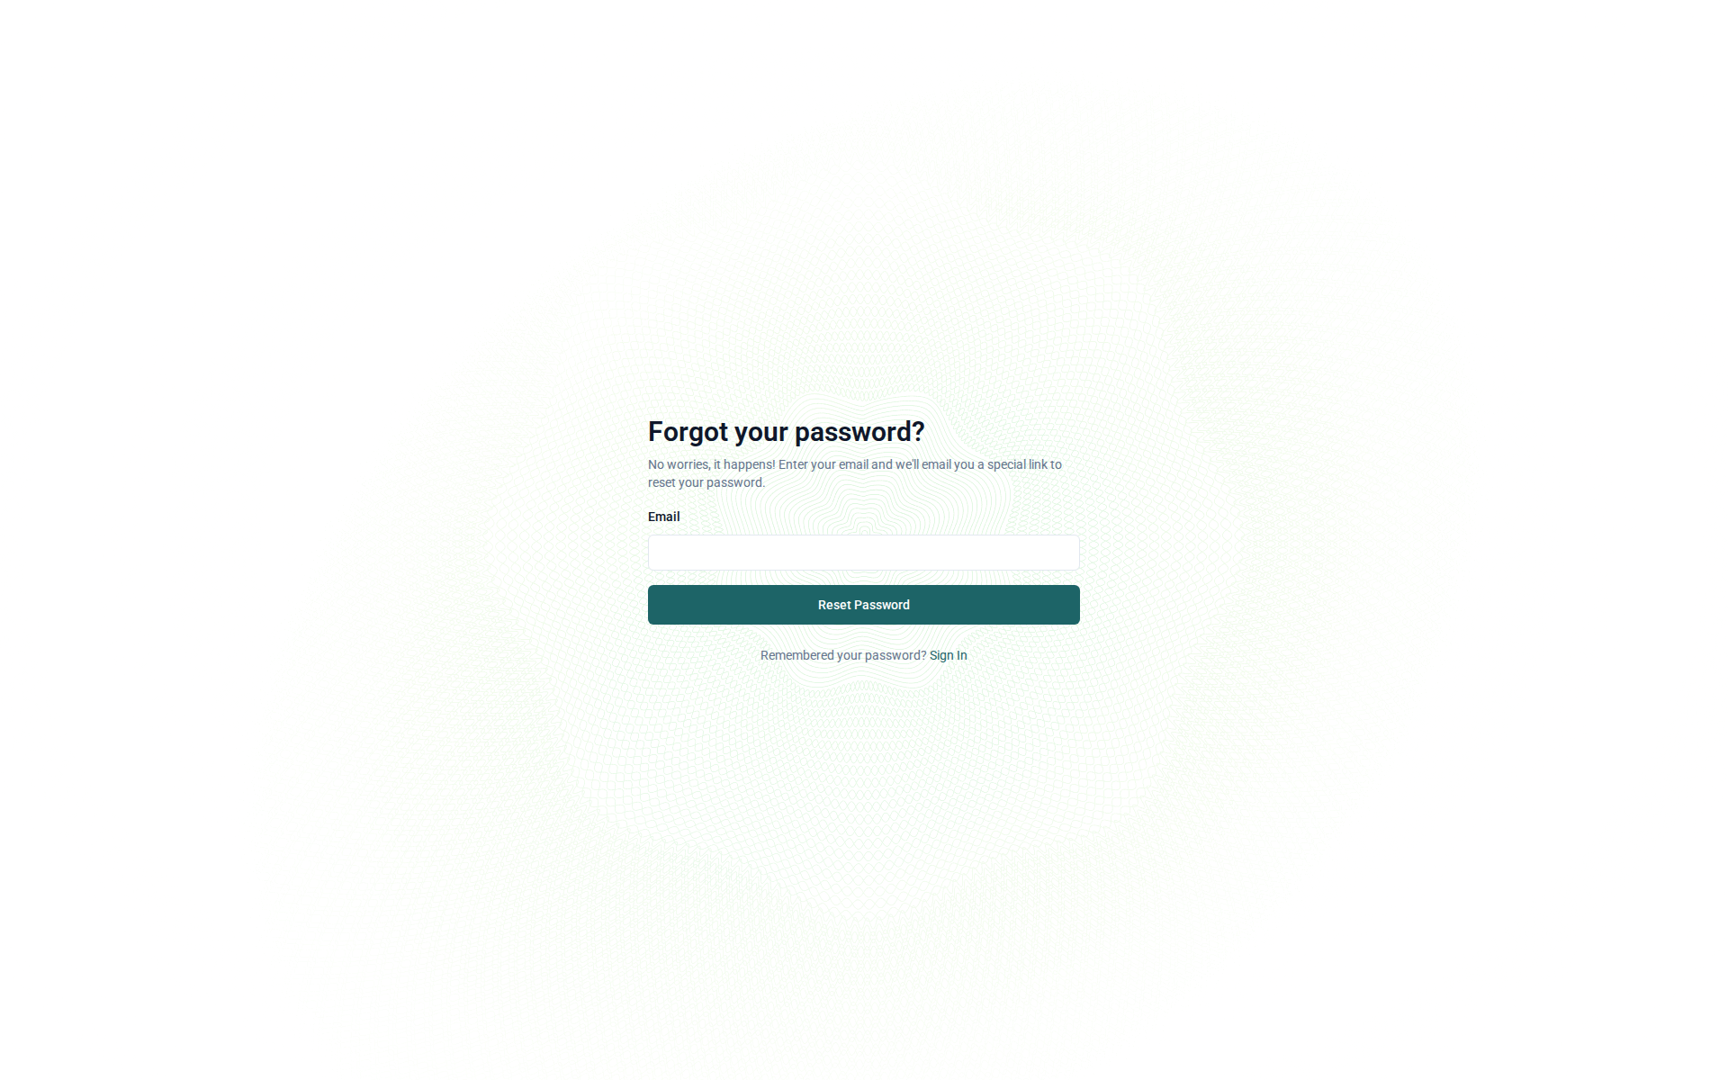
Figure: The password reset page

Dashboard
After signing in, you land on the Dashboard. This is your central starting point in SIPO. It shows all your documents at a glance and provides quick access to your inbox, where documents that require your action are listed.
Use the top navigation bar to switch between Documents, Templates, and other areas. The team selector in the upper-right corner allows you to switch between your personal workspace and any teams you belong to.
The dashboard displays all your documents sorted by most recent activity. You can see the document title, status (Draft, Pending, Completed), recipients, and the date of last change. Click on any document to open it. Use the "New Document" button in the upper area to start creating a new document.
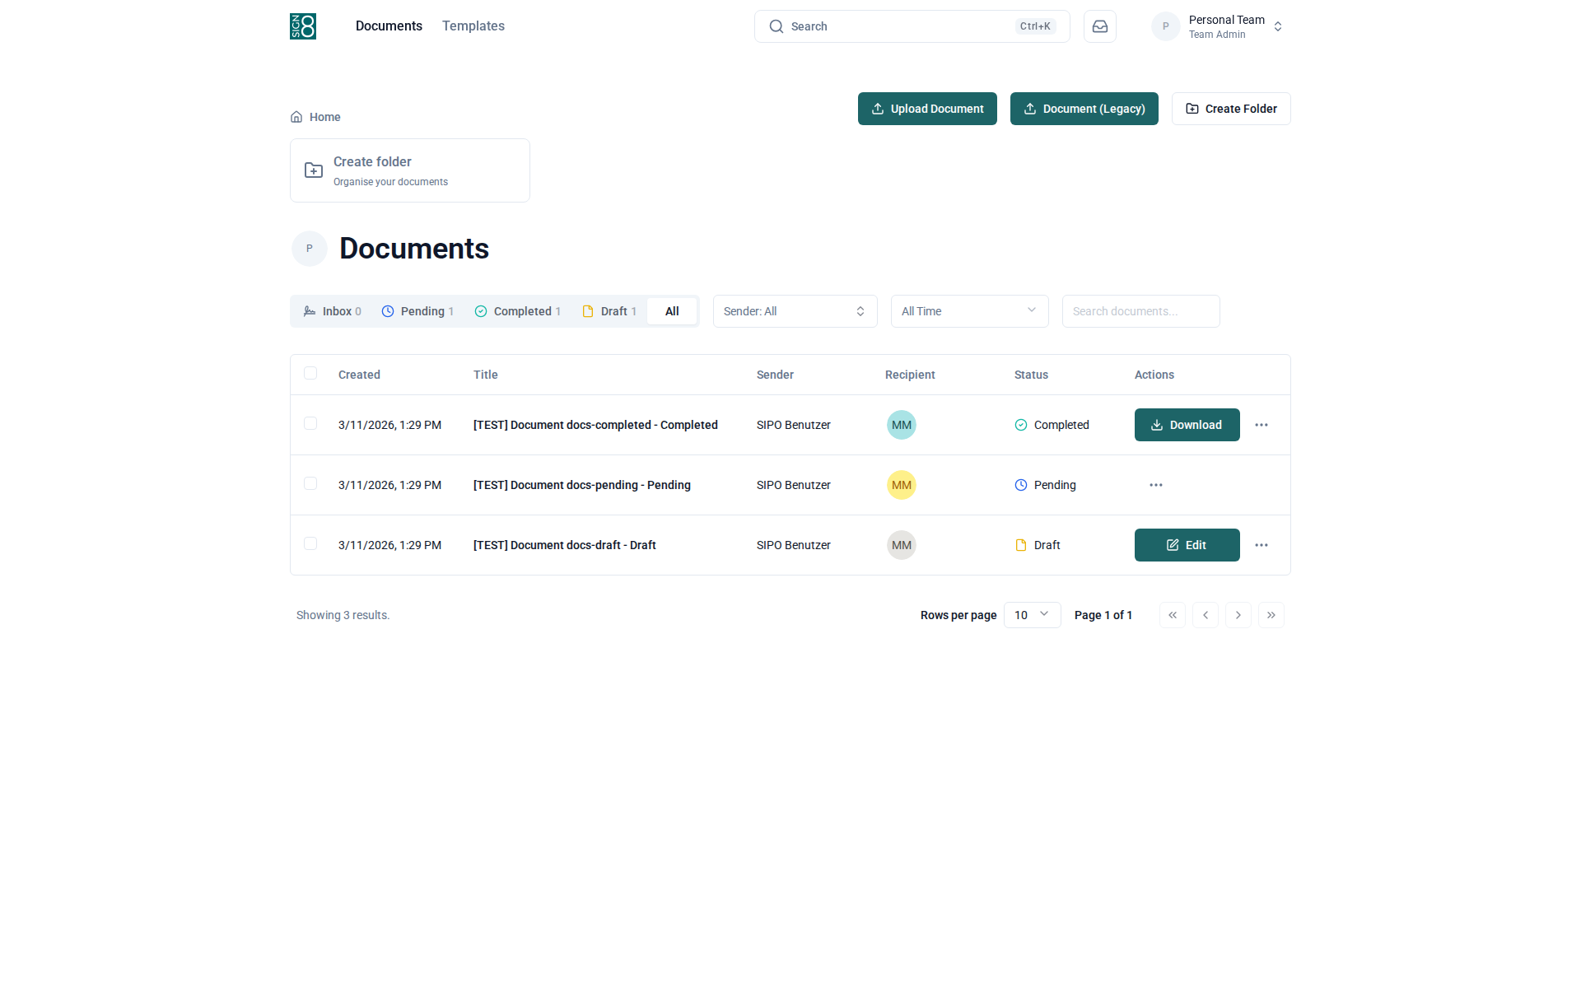
Figure: The main dashboard showing your documents
The Inbox shows documents that are waiting for your action — for example, documents you need to sign or review. Click on a document to open the signing view directly. Once you have completed the required action, the document will disappear from your inbox.
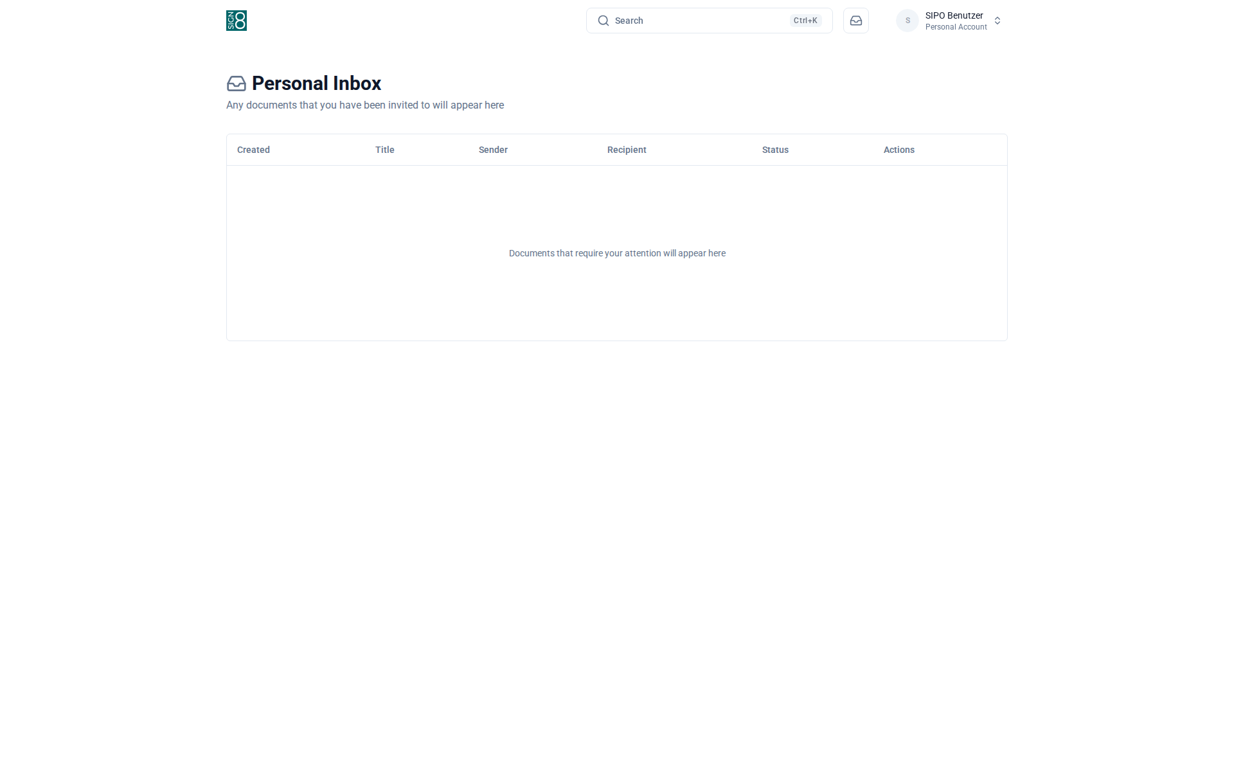
Figure: The inbox showing documents that need your action

Documents
The Documents section is the core of SIPO. Here you create, send, track, and manage all your documents. Documents go through several states: Draft (being prepared), Pending (waiting for signatures), and Completed (all signatures collected).
You can filter documents by status, search by title, and organise them into folders for better overview. Each document can be opened to view its details, download the PDF, or resend signature requests.
The document list provides a complete overview of all documents in your team. Use the status tabs at the top (All, Draft, Pending, Completed) to filter documents. The search bar allows you to find documents by title. You can also sort documents by date or title.
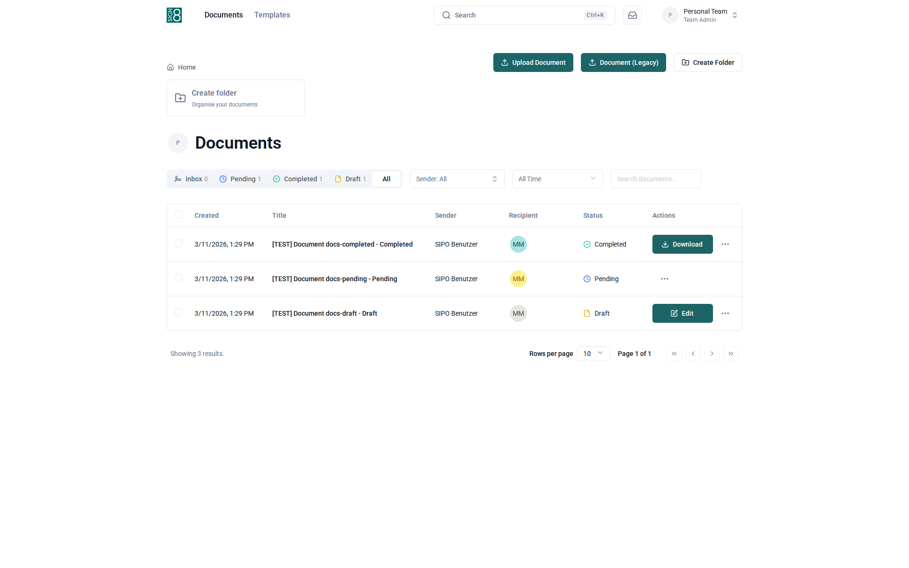
Figure: The document list with status filters and search
Click on any document to open its detail view. Here you can see the full document information: title, status, all recipients and their signing status, and the document history. You can download the PDF, resend email invitations to recipients who have not yet signed, or delete the document if it is still in Draft status.
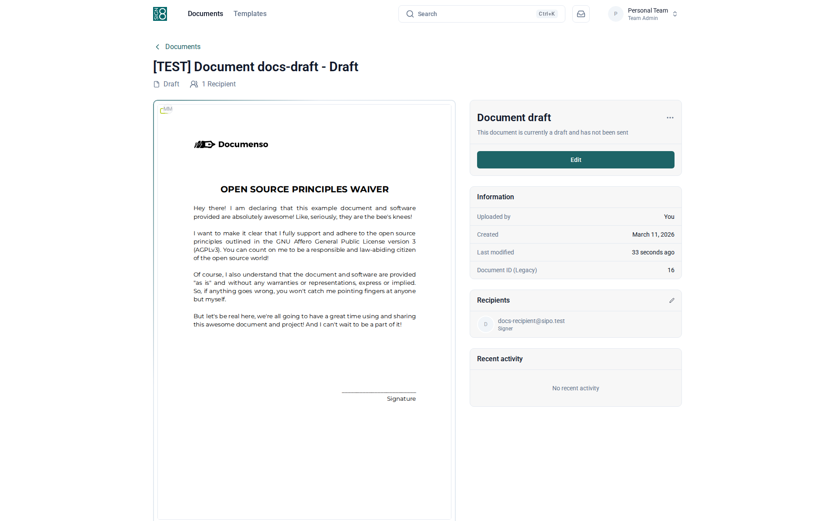
Figure: Detailed view of a single document
To create a new document, click "New Document". The document editor guides you through 4 steps:
Step 1 — General: Set the document title, language, access method, and visibility. You can also expand "Advanced Options" for additional settings.
Step 2 — Recipients: Add the email addresses of all people who need to sign or receive the document. You can assign different roles (Signer, Approver, CC, Viewer).
Step 3 — Fields: Place signature fields, date fields, text fields, and other form elements on the PDF. Drag and drop fields onto the document and assign them to the appropriate recipient.
Step 4 — Review & Send: Review all settings and click "Send" to distribute the document to all recipients via email.
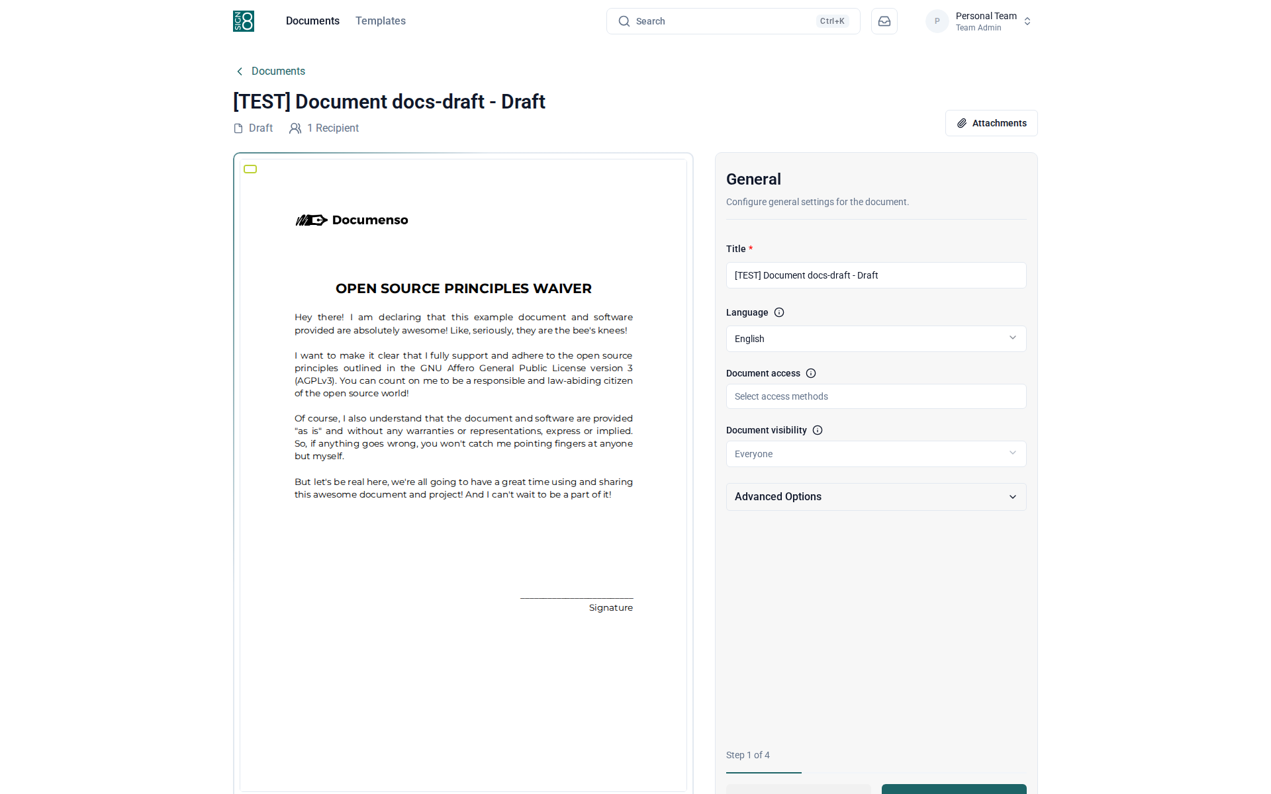
Figure: The document editor wizard (Step 1 of 4 — General Settings)
Folders help you organise your documents. Click "Folders" in the navigation to view and manage your folder structure. You can create new folders, rename existing ones, and move documents between folders by selecting them in the document list.
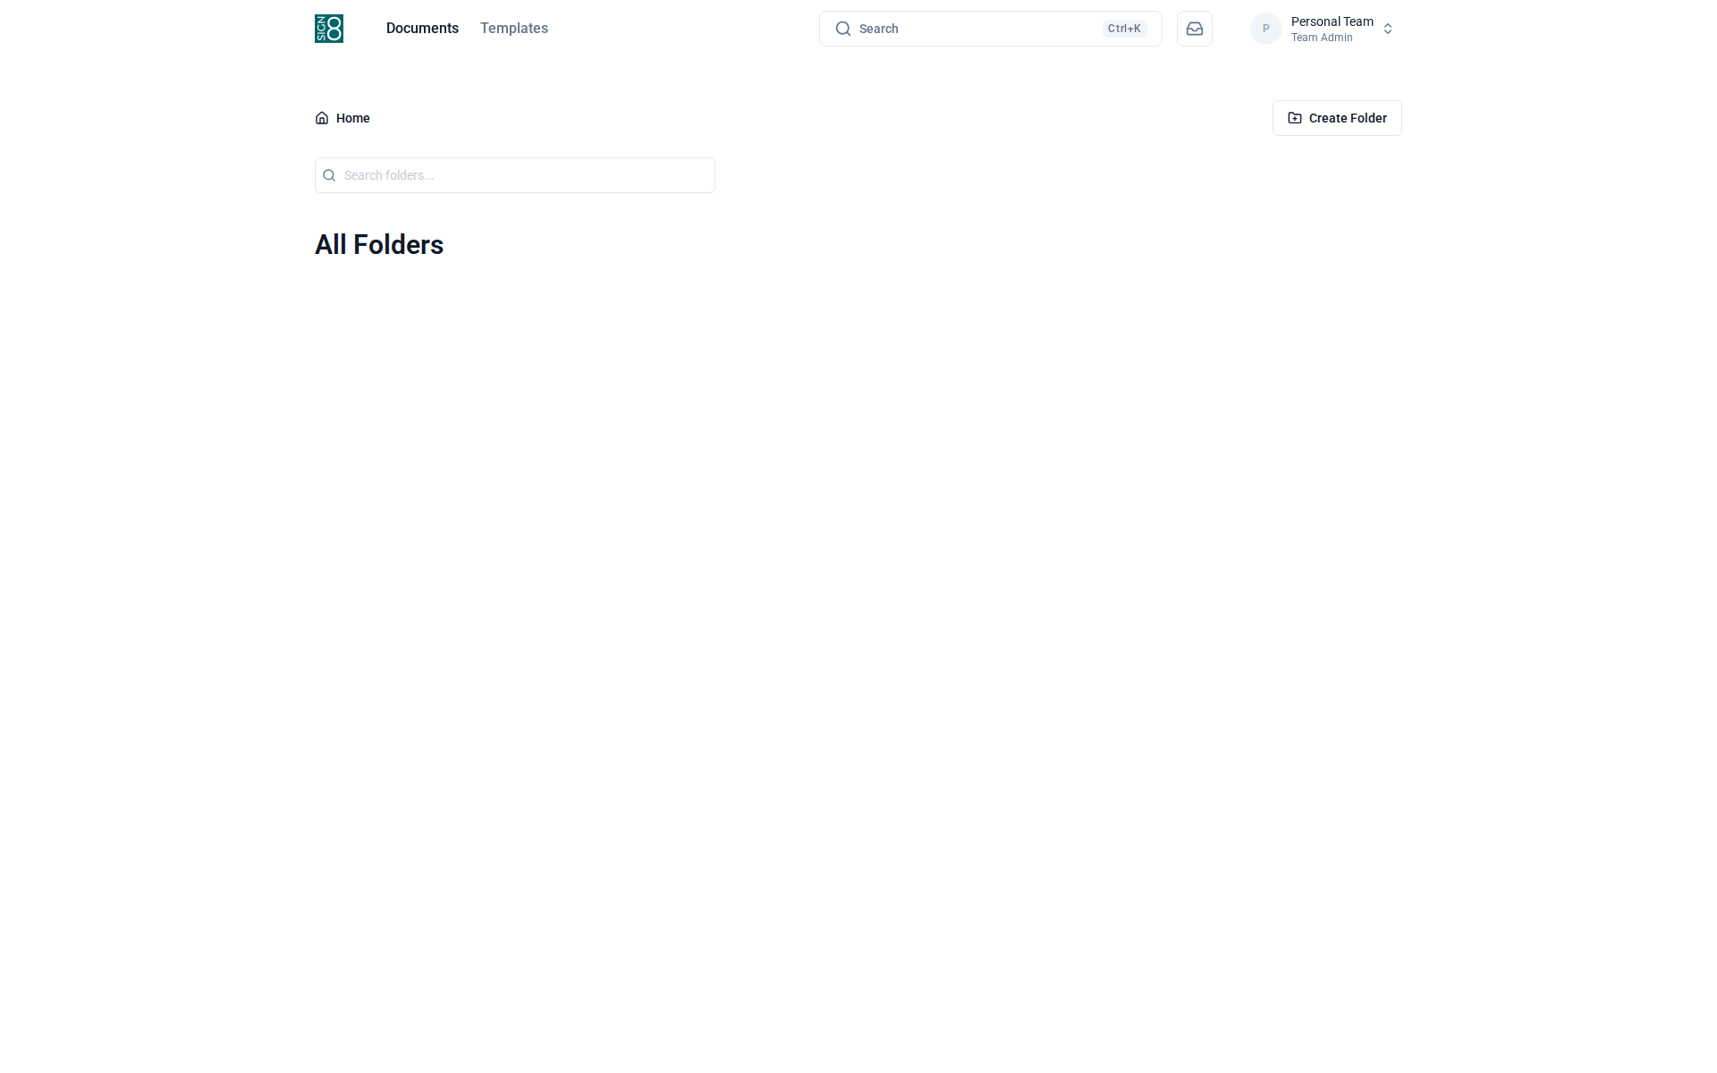
Figure: Organising documents into folders

Templates
Templates save you time when you frequently send the same type of document. A template stores the PDF, the recipient roles, and the field placements so you can reuse them with a single click.
To use a template, open it and click "Use Template". SIPO will create a new document pre-filled with the template settings. You only need to fill in the actual recipient email addresses and send it.
The template library shows all available templates. Templates are reusable document configurations that include a PDF, predefined recipient roles, and pre-placed fields. Click on a template to view its details, or click "New Template" to create one.
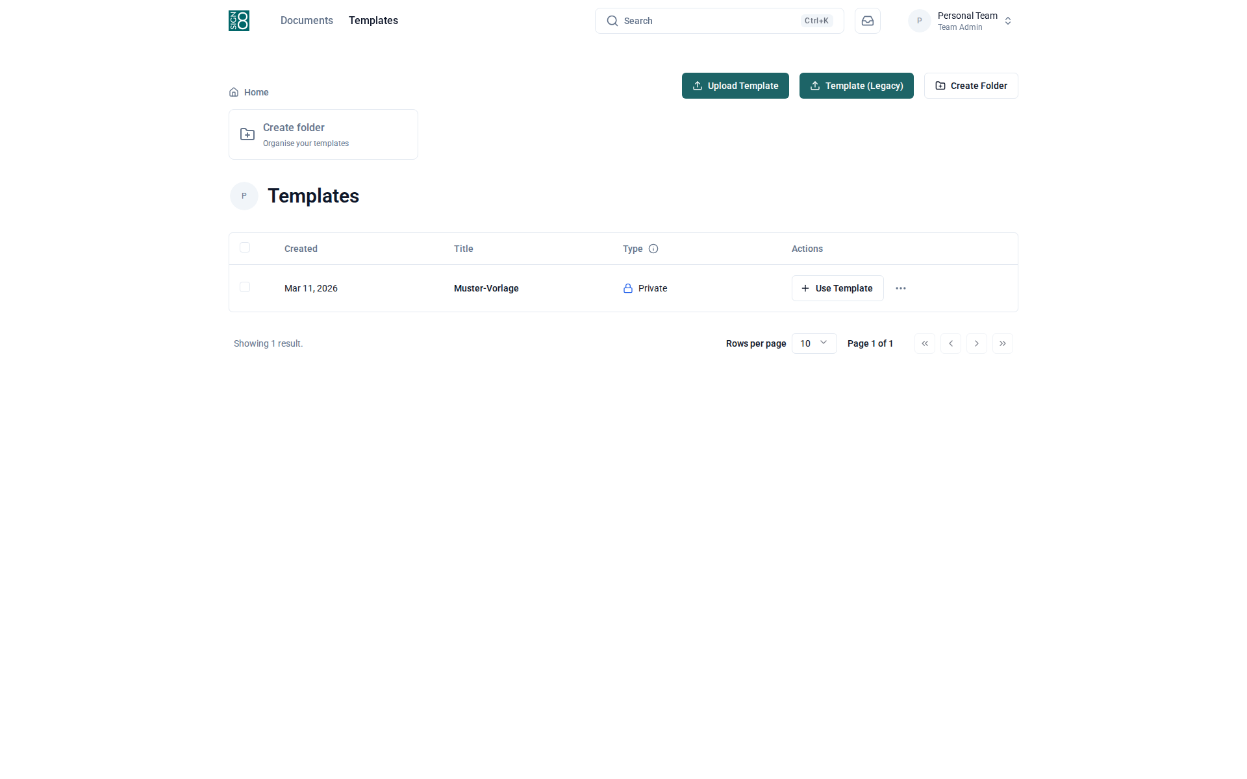
Figure: The template library
The template detail view shows the template configuration including the PDF preview, recipient roles, and field placements. To create a new document from this template, click "Use Template". You can also edit the template to update its fields or recipient configuration.
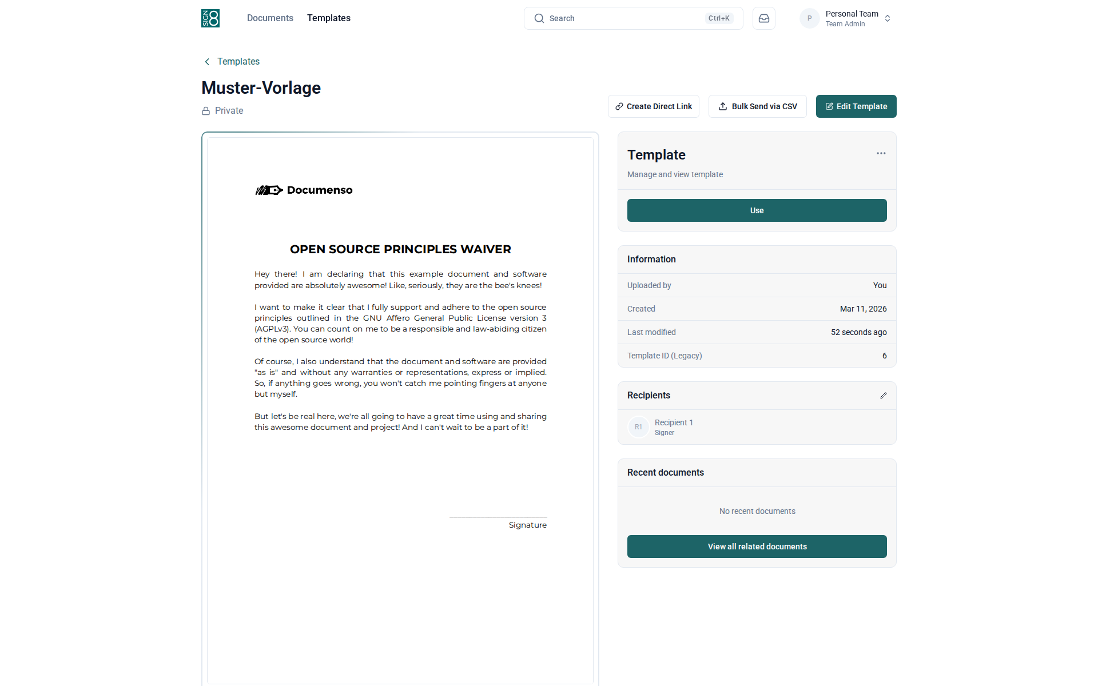
Figure: Template configuration and preview

Signing Process
When someone sends you a document for signing, you will receive an email with a link. Clicking this link opens the signing view, where you can review the document and complete the required fields.
Depending on the document configuration, you may need to provide a signature, initials, a date, or fill in text fields. Once you have completed all required fields, click the "Complete" button to submit your signature. You will receive a copy of the fully signed document by email.
This is what recipients see when they open a document link from their email. The document is displayed on the left side. Required fields are highlighted and marked with the recipient's colour. Click on each field to fill it in — for signature fields, you can draw, type, or upload your signature. Once all required fields are completed, the "Complete" button at the bottom becomes active. Click it to submit your signature.
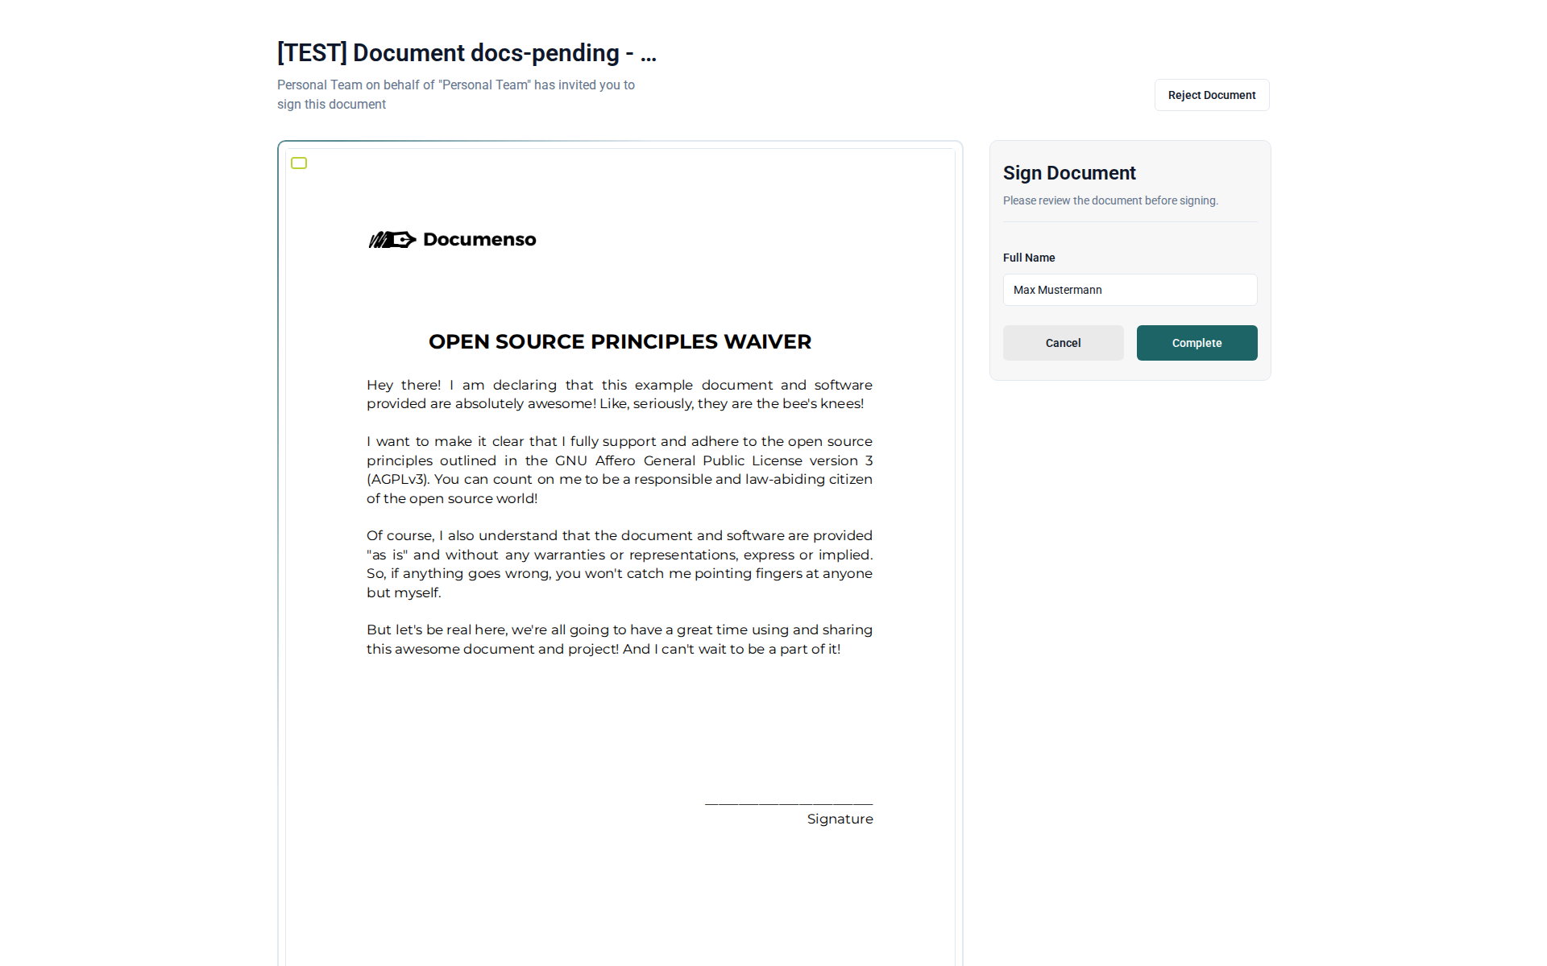
Figure: The signing view as seen by a document recipient

Personal Settings
Your personal settings control your account and preferences. You can access them by clicking on your avatar in the top-right corner and selecting "Settings".
Here you can update your name, manage your password and two-factor authentication, configure API tokens for integrations, set up webhooks, customise your branding, and adjust default document preferences.
In Profile settings, you can change your display name and upload a profile picture. Your email address is shown here but can only be changed by an administrator. You can also select your preferred language for the SIPO interface.
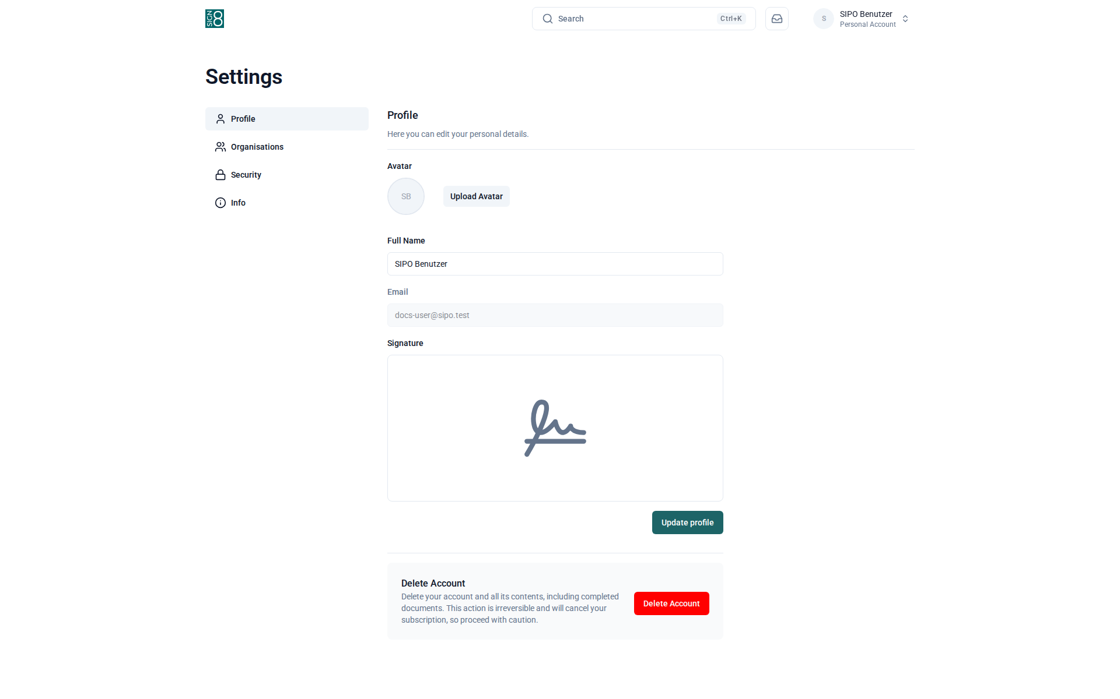
Figure: Profile settings — name, avatar, and language
Security settings let you change your password and manage two-factor authentication (2FA). To enable 2FA, click "Enable Two-Factor Authentication" and scan the QR code with your authenticator app (e.g. Google Authenticator or Authy). This adds an extra layer of security to your account.
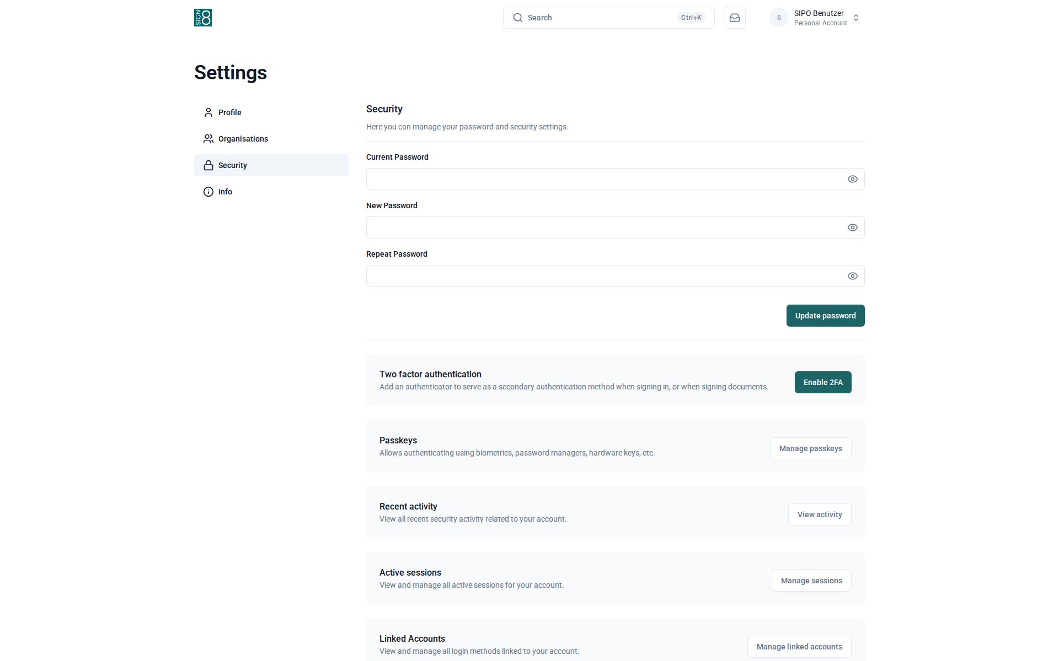
Figure: Security settings — password and two-factor authentication
The Info page shows technical information about the SIPO installation, including the application version, build information, and open-source licence details. This information may be helpful when reporting issues to your administrator.
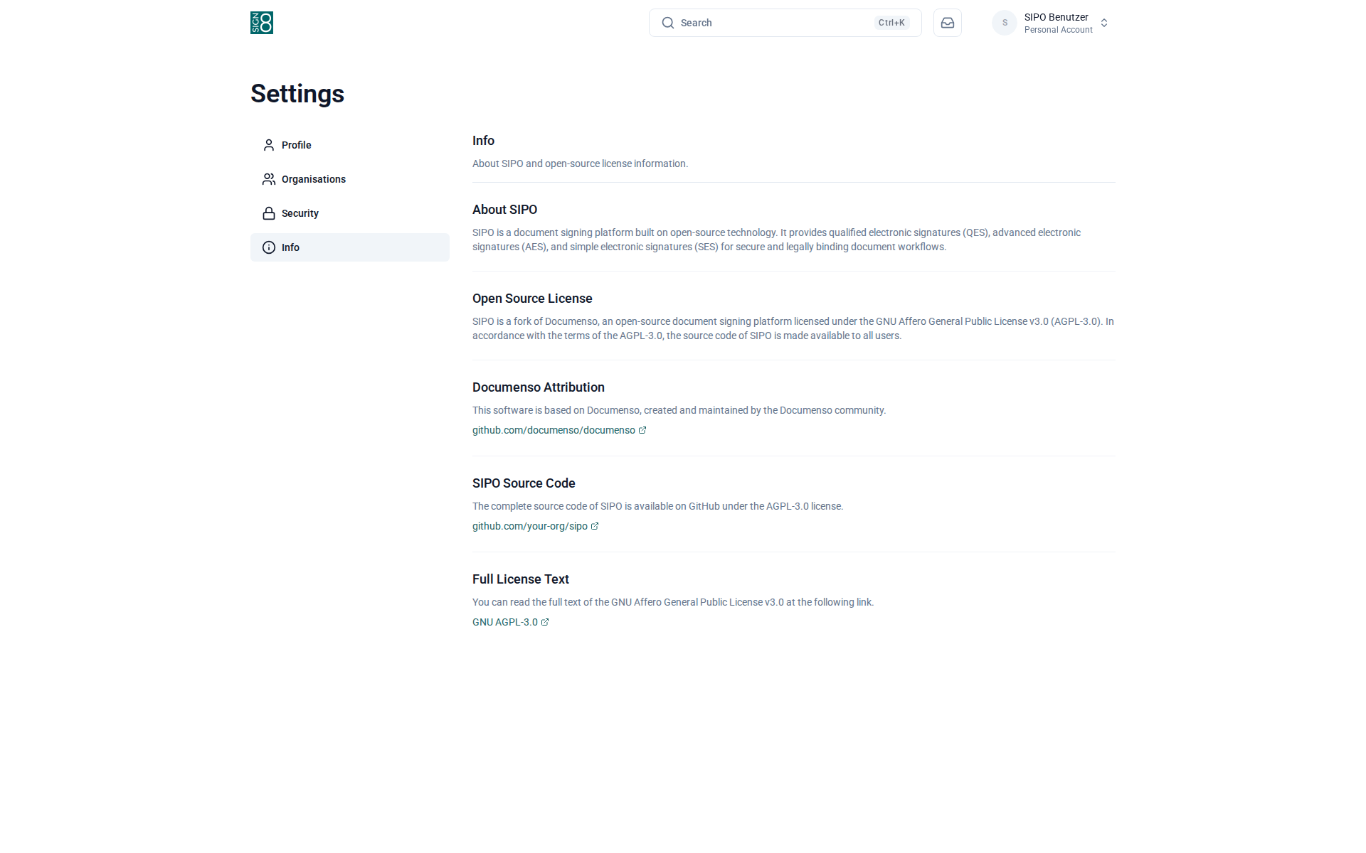
Figure: Application information and version details
API tokens allow external applications to access SIPO on your behalf. Click "Create Token" to generate a new token. Give it a descriptive name so you can identify its purpose later. Important: Copy the token immediately after creation — it will not be shown again. You can revoke tokens at any time by clicking the delete icon.
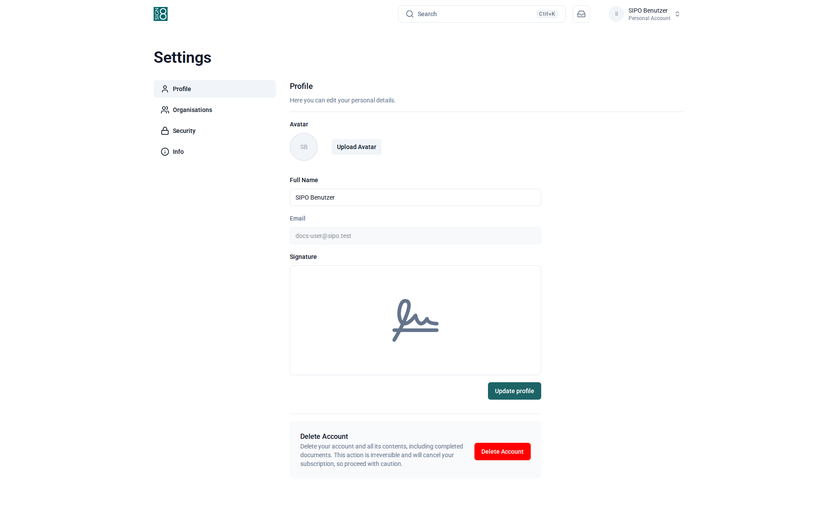
Figure: API token management for integrations
Webhooks send automatic notifications to external URLs when events occur in SIPO (e.g. when a document is signed or completed). Click "Create Webhook" to add a new endpoint. You can select which events should trigger the webhook and test the connection.

Figure: Webhook configuration for event notifications
Branding settings allow you to customise the appearance of emails and documents sent from your account. You can upload your logo, set brand colours, and add a custom email footer. These settings apply to all documents you send from your personal workspace.

Figure: Custom branding settings for your documents
Document preferences set the default values for new documents. You can configure the default language, document access method, and other options. These defaults can always be overridden when creating individual documents.

Figure: Default document preferences
This page shows all organisations you are a member of. You can see your role in each organisation and navigate to the organisation settings if you are an administrator. To leave an organisation, click the corresponding option next to the organisation name.
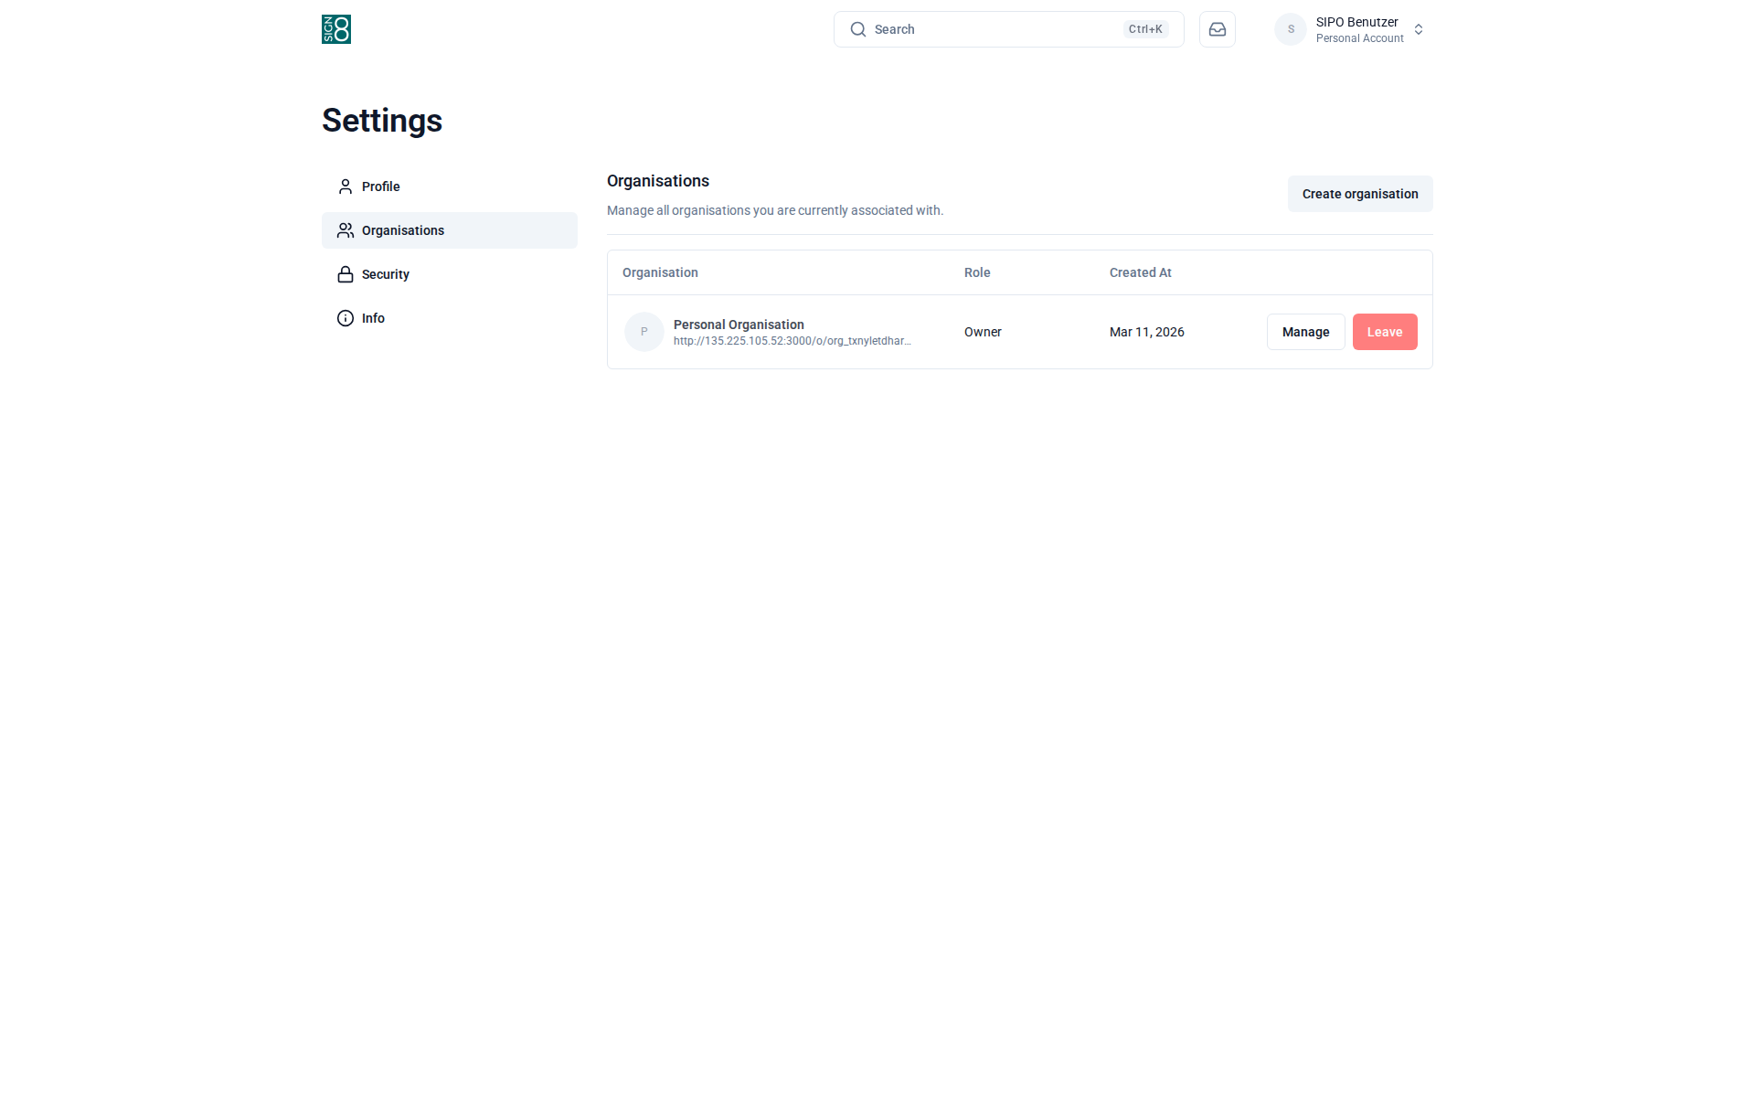
Figure: Your organisation memberships

Team Settings
Team settings are available to team administrators and control how the team operates. To access them, first switch to the team using the team selector in the top-right corner, then navigate to Settings.
Here you can rename the team, manage team members and their roles, set team-wide document preferences, and configure custom branding that will appear on documents sent from this team.
General team settings allow you to change the team name and other basic configuration. Only team administrators can access these settings. Changes here affect how the team appears to all its members.
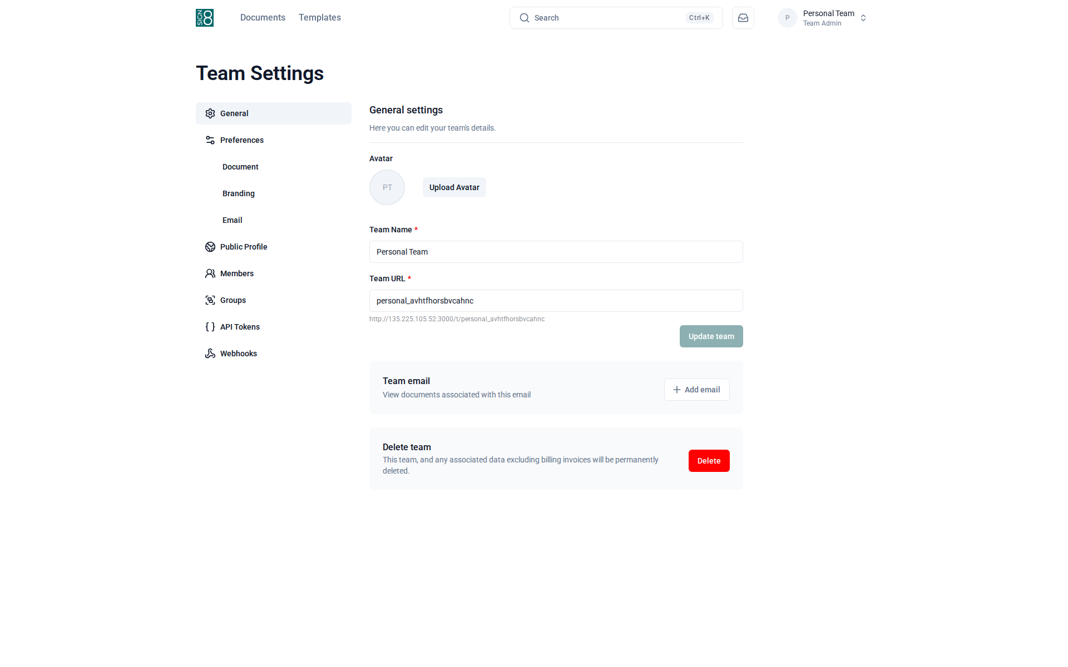
Figure: General team settings
Team member management allows administrators to invite new members, change member roles, and remove members from the team. Available roles are: Admin (full access), Manager (can manage documents and templates), and Member (can create and sign documents).
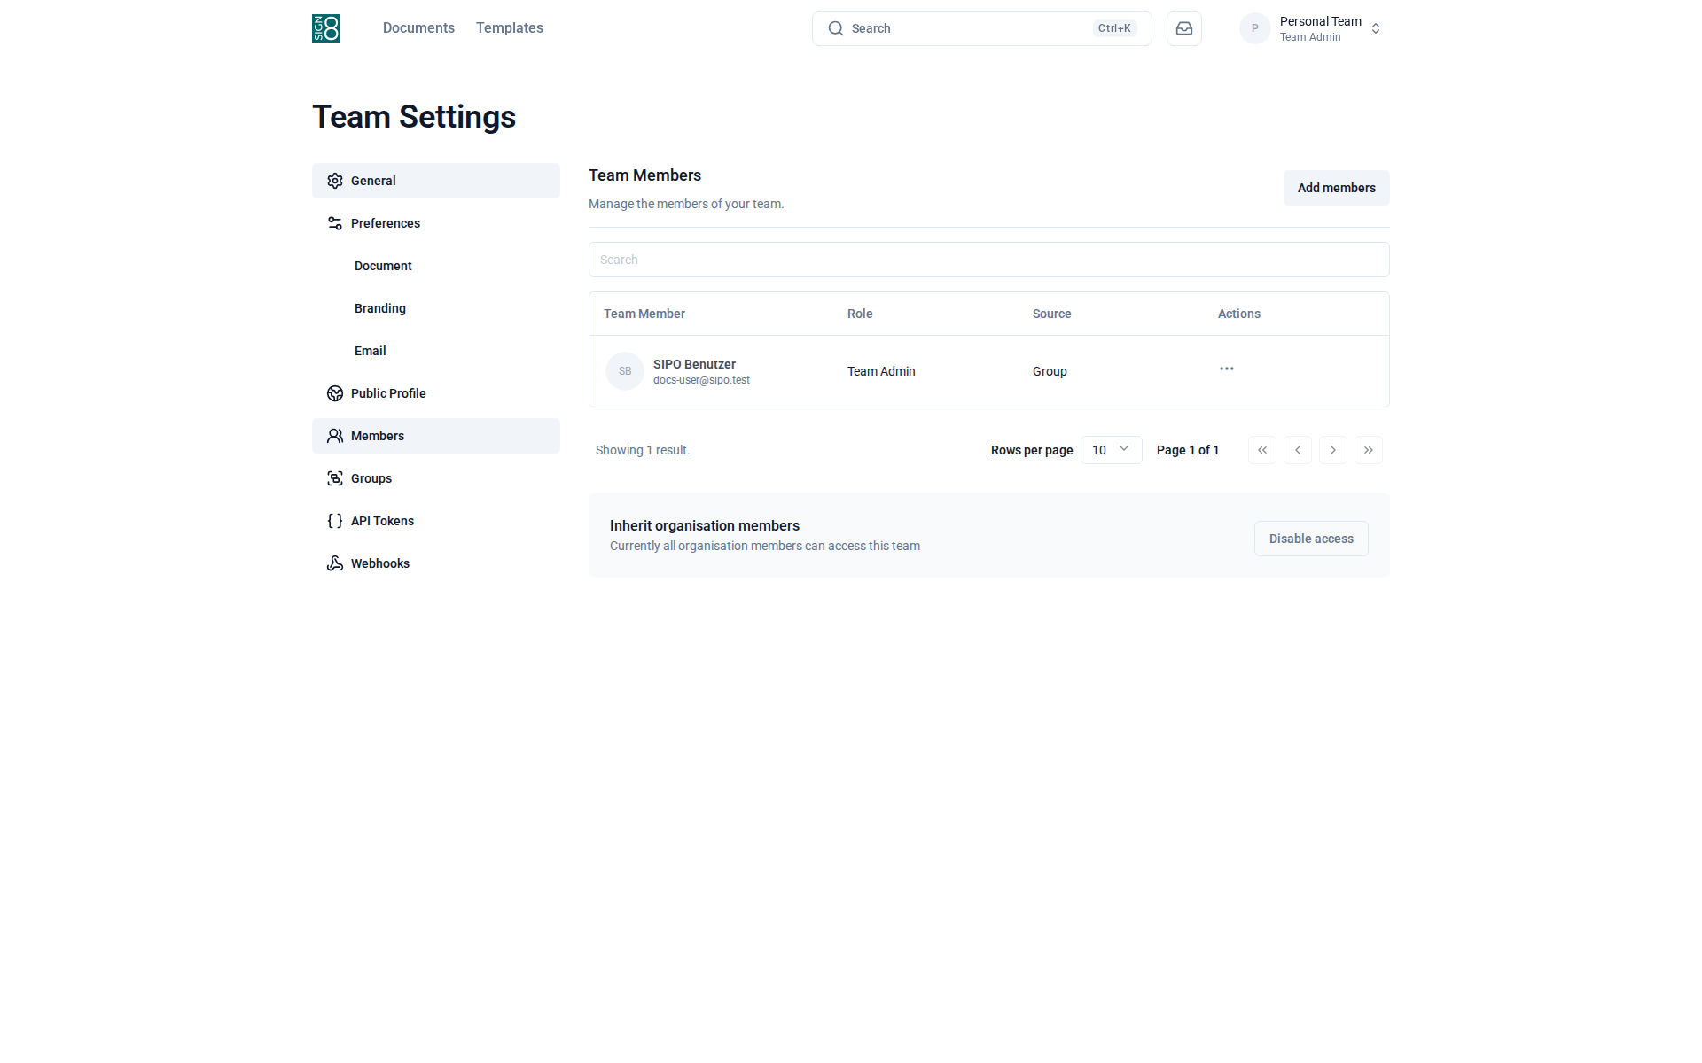
Figure: Team member management and role assignment
Team document preferences override the personal document settings for all documents created within this team. This ensures consistency across the team — for example, you can set a default language or signing method for all team documents.
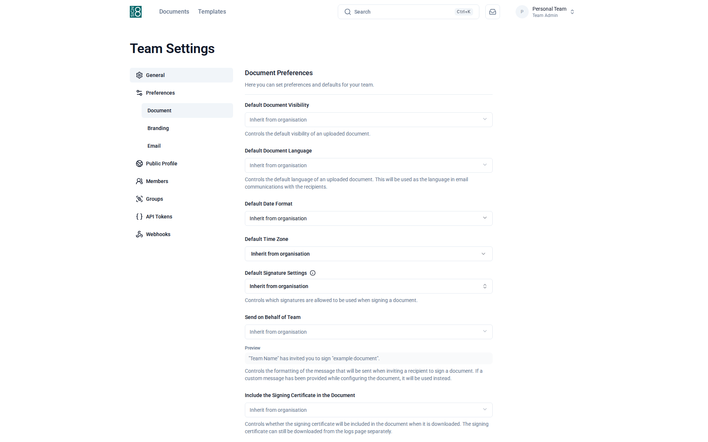
Figure: Team-wide document preferences
Team branding allows you to set a team-specific logo, colours, and email footer. This branding will appear on all documents and emails sent from this team, ensuring a consistent appearance for your recipients.
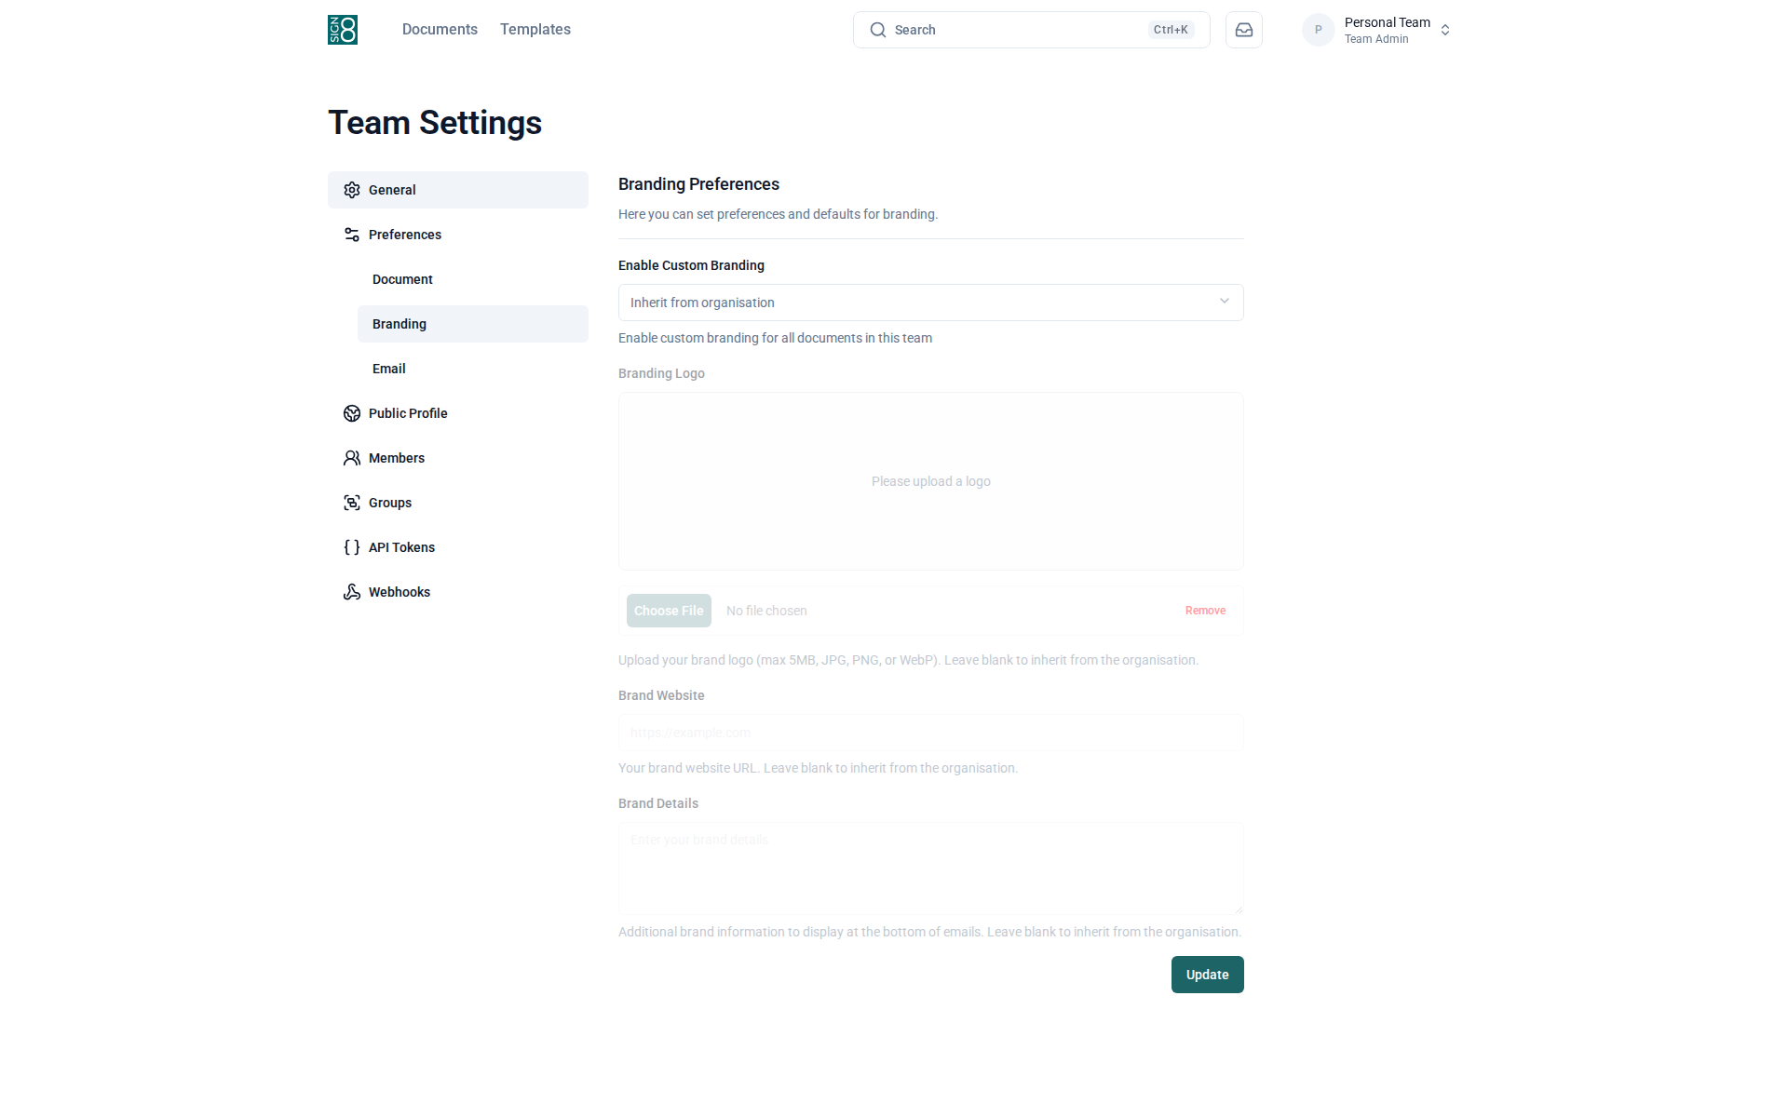
Figure: Team branding customisation

Organisation Settings
Organisation settings provide top-level control over your entire organisation. Access them by clicking on your organisation name in the sidebar.
Organisation administrators can manage members, create and organise teams, and view billing information. Changes made at the organisation level may affect all teams within it.
Organisation general settings allow you to configure the organisation name and basic properties. Only organisation owners and administrators can access these settings.
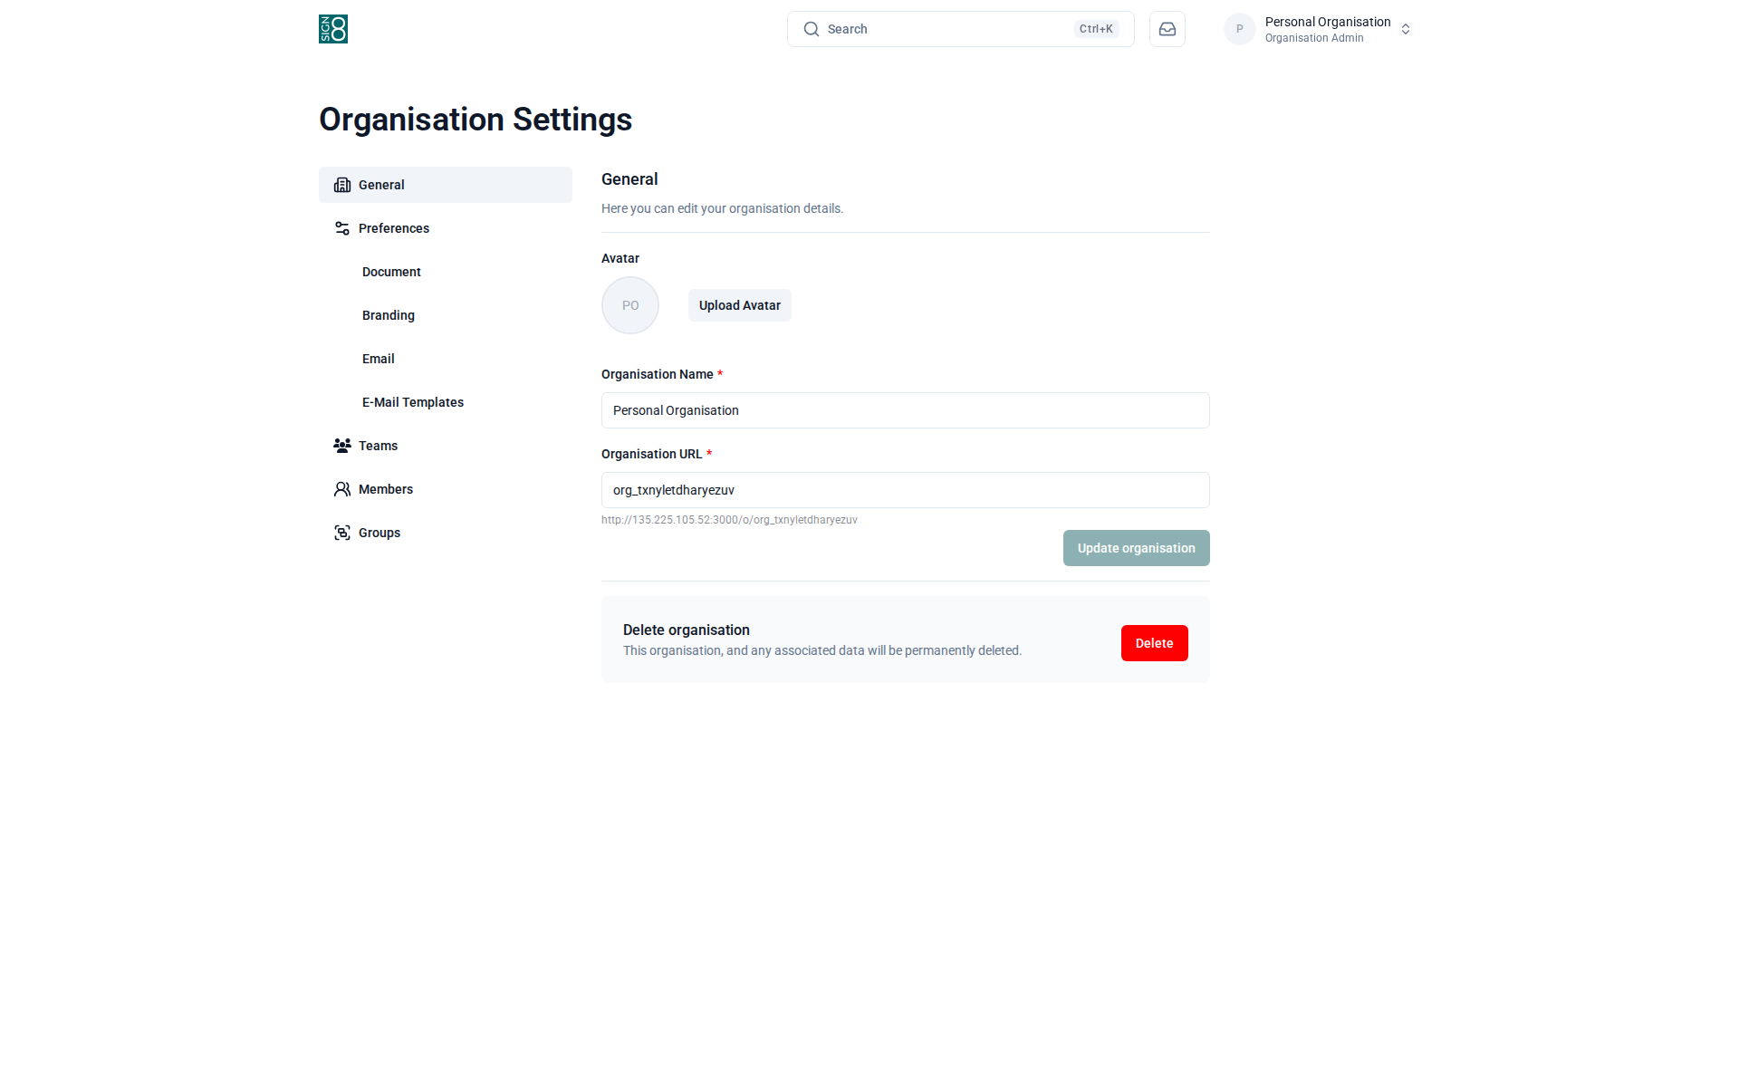
Figure: Organisation general settings
Organisation member management shows all members across the entire organisation. You can invite new members, change their roles, and remove them. Members added at the organisation level can be assigned to any team within the organisation.
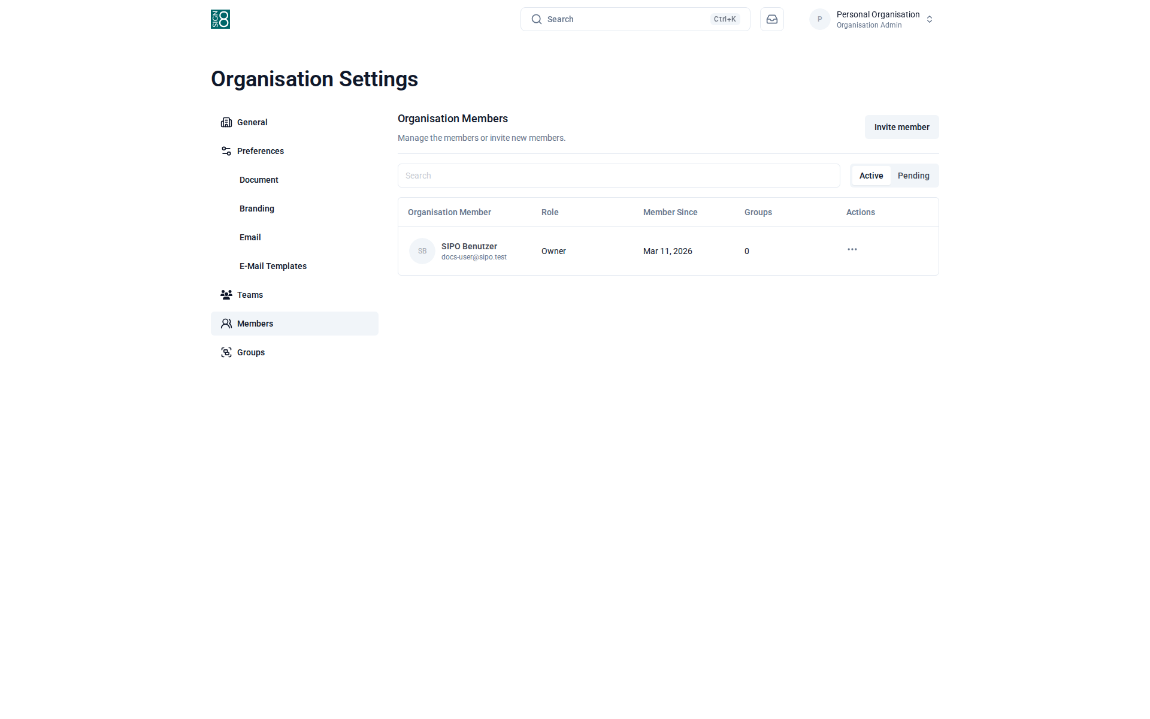
Figure: Organisation member management
The Teams page shows all teams within the organisation. You can create new teams, rename existing ones, and manage team membership. Teams help you organise your users and documents by department, project, or any other grouping.
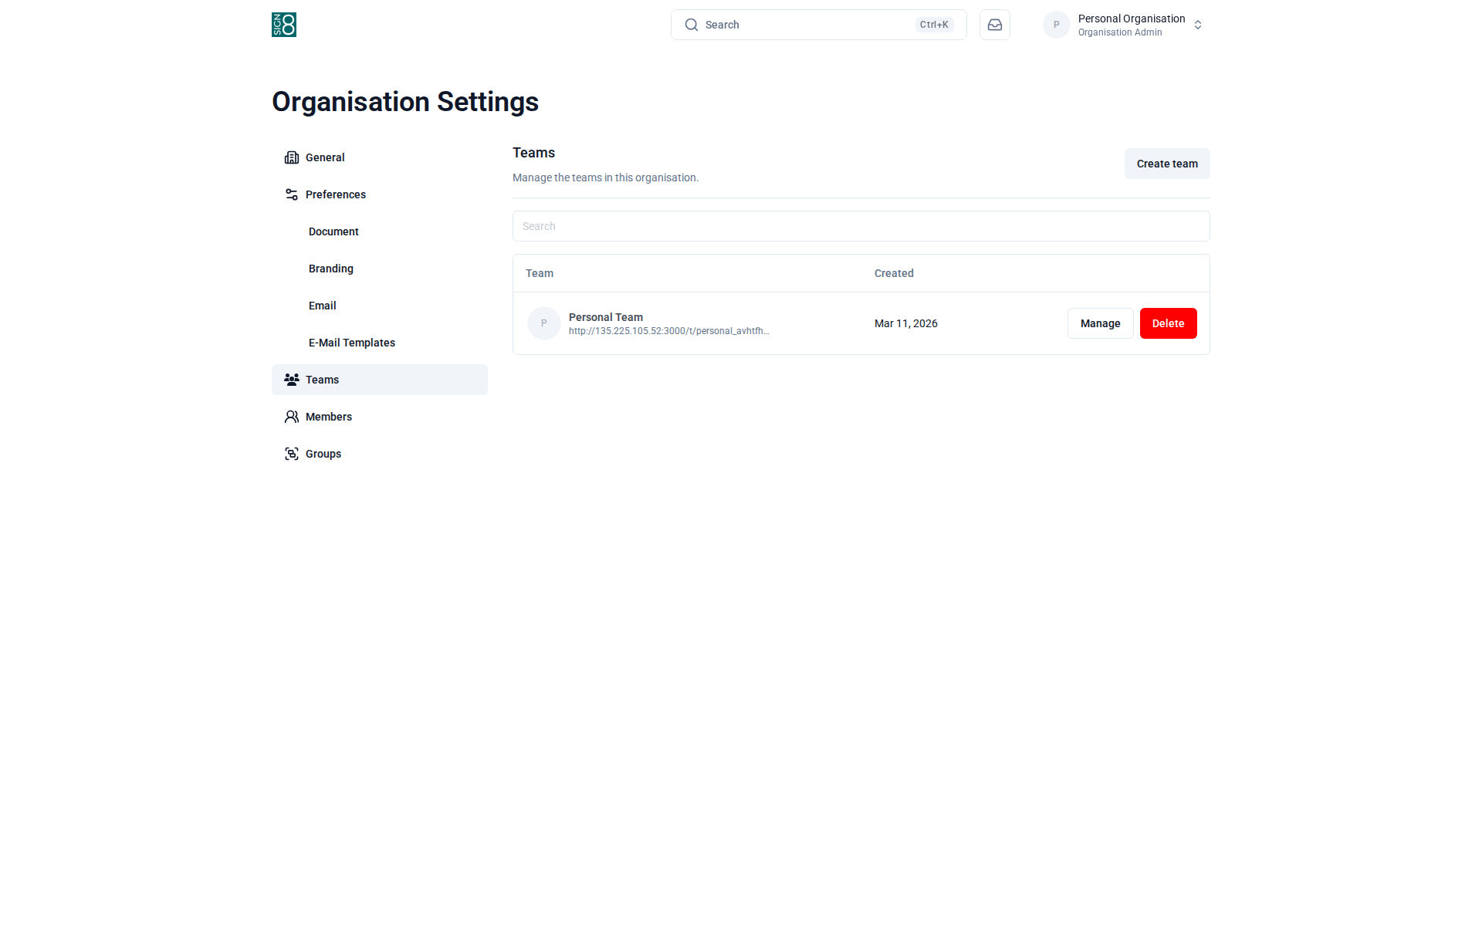
Figure: Teams within the organisation
The Billing page shows your current subscription plan, usage statistics, and payment information. Here you can upgrade or downgrade your plan, update payment methods, and download invoices.
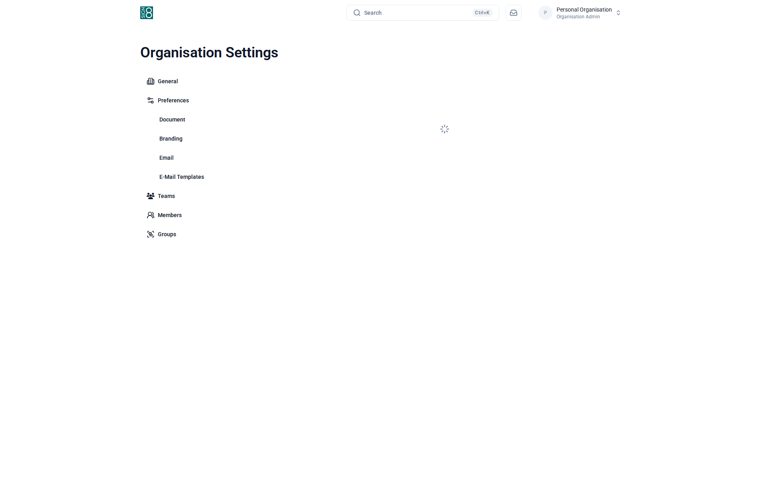
Figure: Billing and subscription overview

Administration
The administration panel is only available to users with the Administrator role. It provides system-wide oversight and configuration capabilities.
Administrators can view platform statistics, manage all users, review all documents across the system, manage organisations, and configure site-wide settings such as branding and feature flags.
The statistics dashboard provides an overview of platform usage including total users, documents, and signatures. Use these metrics to monitor platform adoption and identify trends.
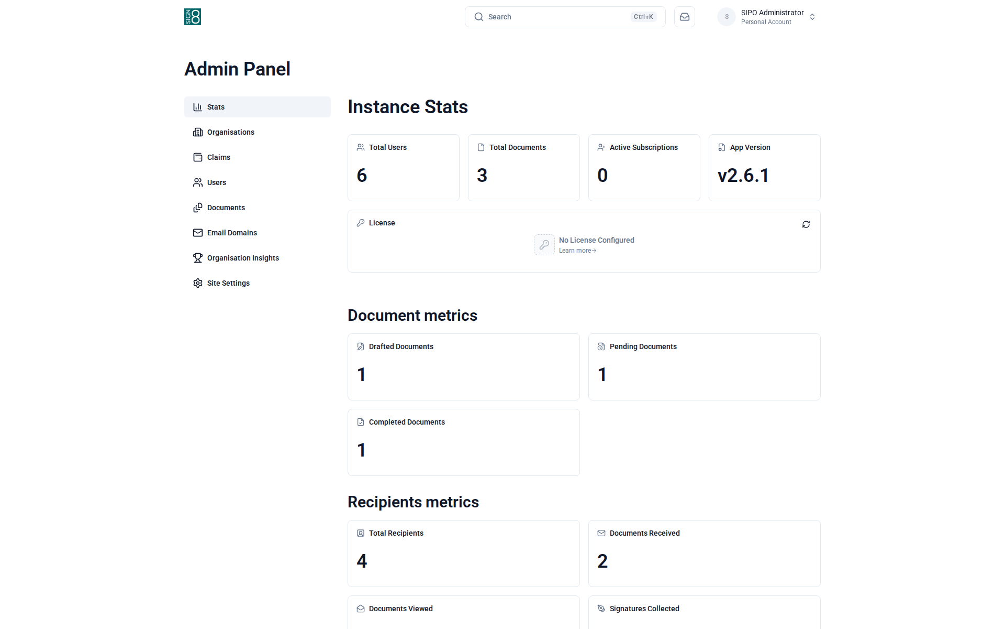
Figure: System statistics and usage dashboard
The user management panel lists all registered users. Administrators can search for users, view their details, change roles, disable accounts, or delete users. Click on a user to see their full profile and activity history.
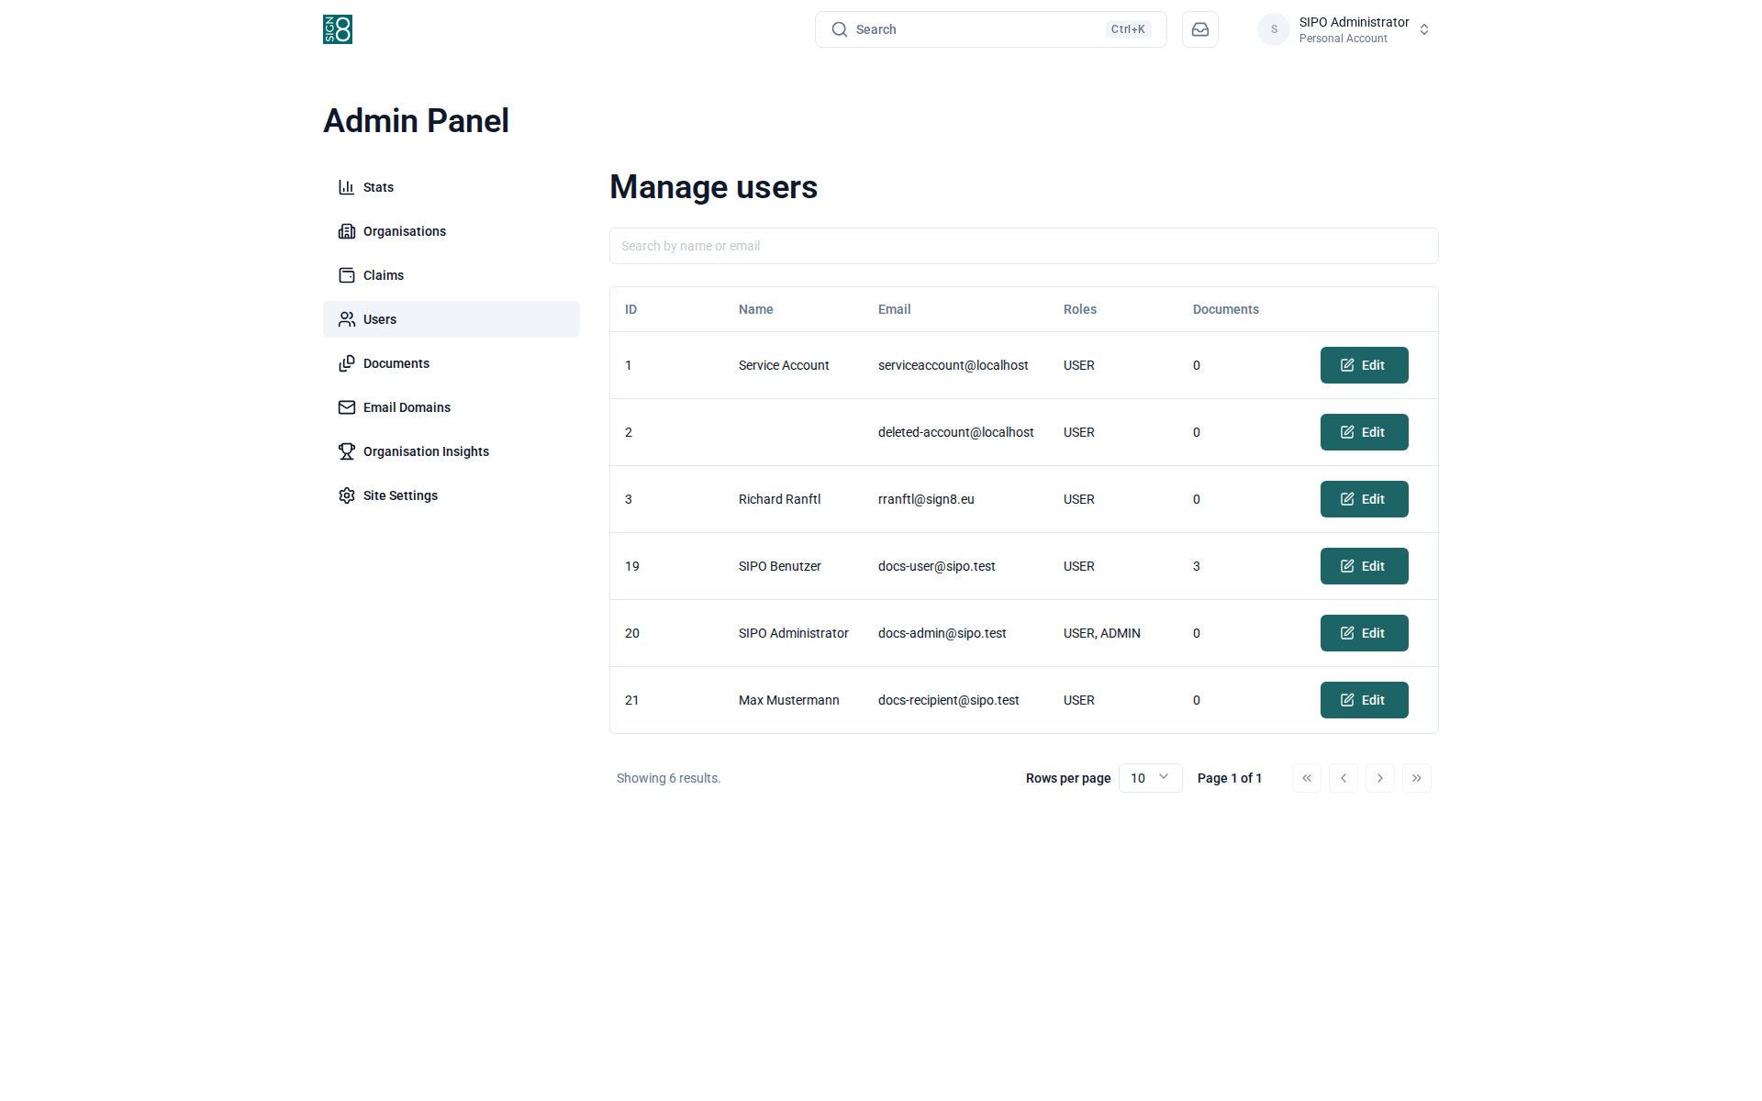
Figure: User management panel
The document management view shows all documents across the entire platform. Administrators can search, filter, and review any document regardless of team or user ownership. This is useful for compliance and audit purposes.
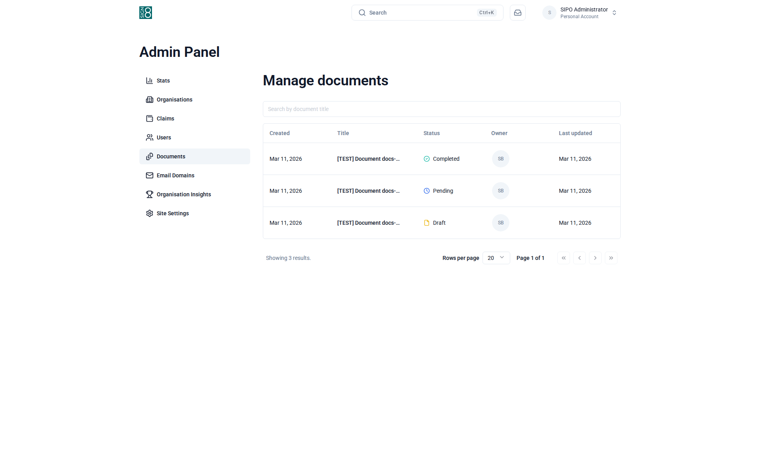
Figure: System-wide document management
Organisation management lists all organisations on the platform. Administrators can view organisation details, manage their members, and adjust organisation-level settings.
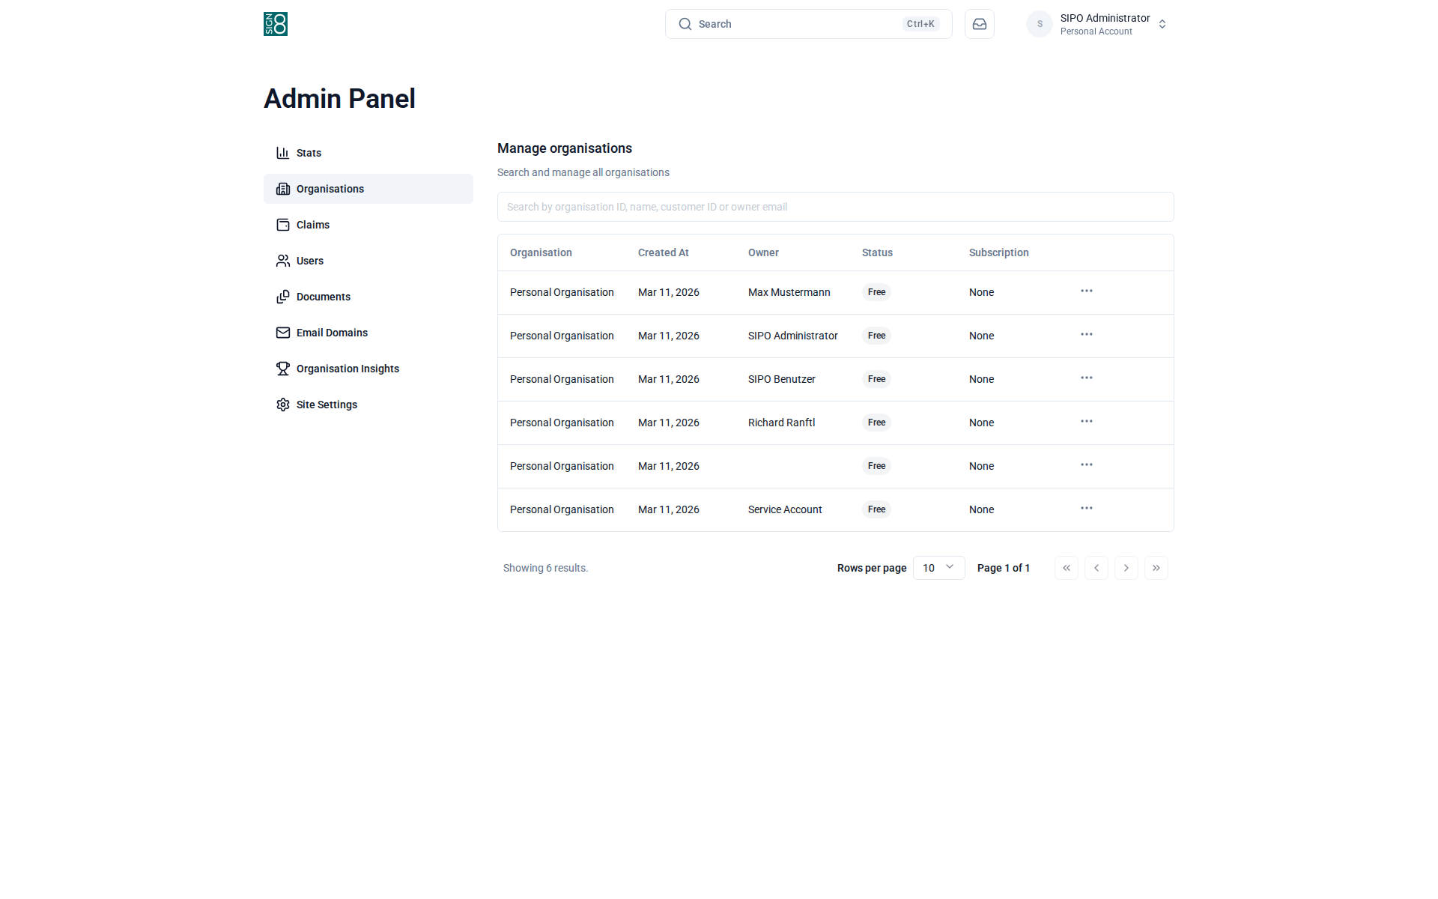
Figure: Organisation management
Site-wide settings control platform-level configuration such as default branding, feature flags, email settings, and security policies. Changes here affect all users and organisations on the platform.
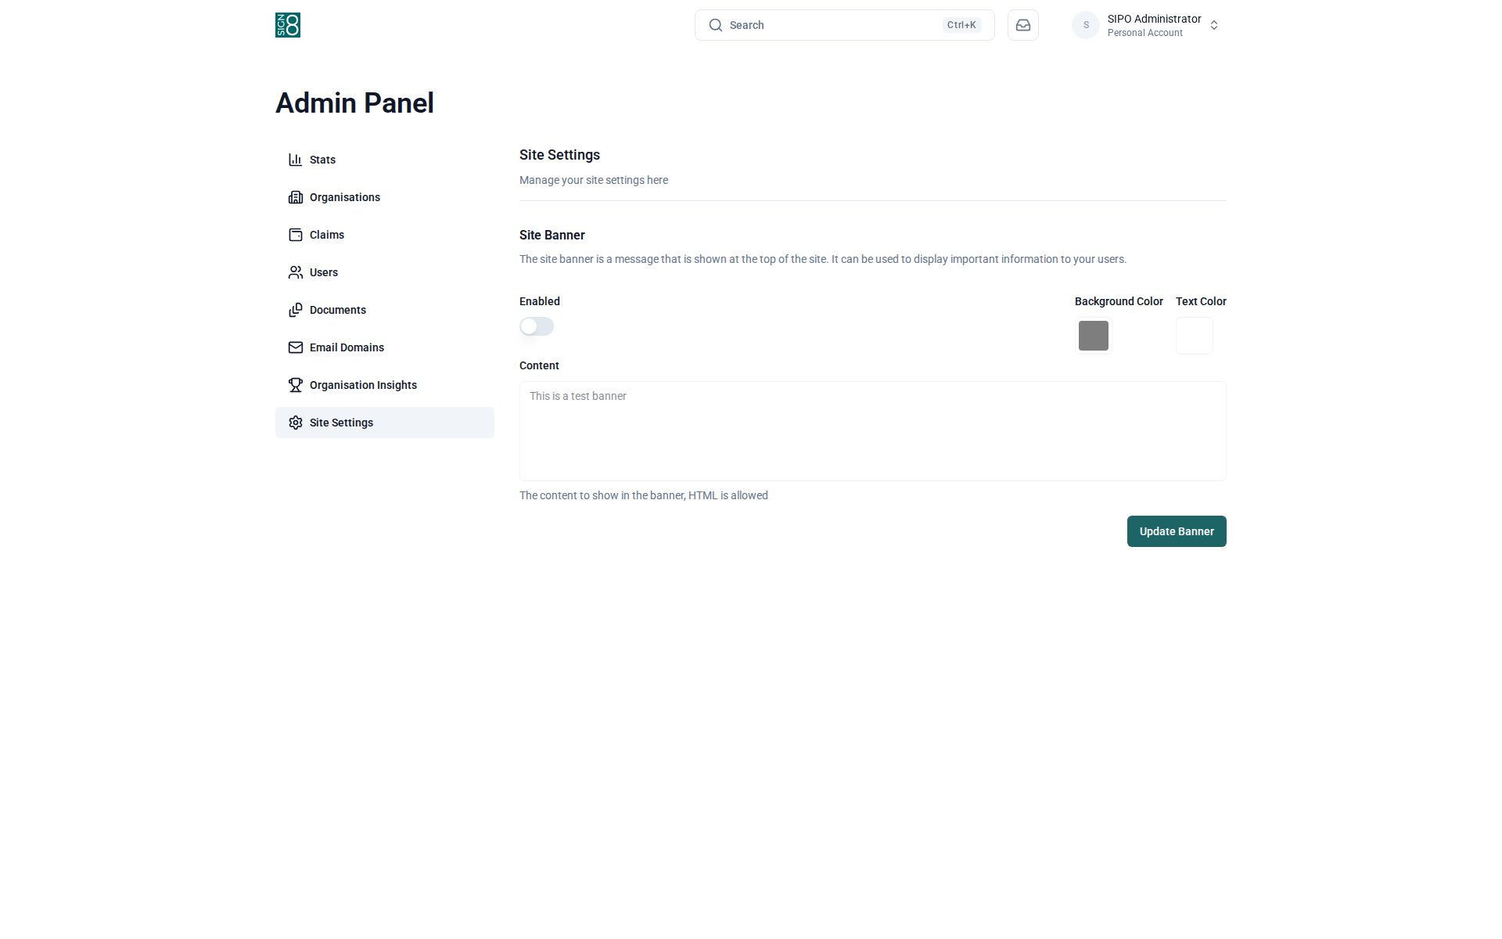
Figure: Site-wide configuration and feature flags

