Objective 2.2: Multiple Linear Regression for Match Goals Scored
Role 3 Contribution | Dataset: lr22_team_match_208.csv (N = 208) | Target: goals_scored
1. Model Specification & Best-Subset Selection
To model the total goals scored by a team in an individual World Cup match (goals_scored, mean=1.48, var=1.94, zero-rate=26.4%), we evaluated 8 strictly pre-kick-off explanatory variables across all 255 candidate subsets. The global full model (k=8) achieved R²=0.306 and Adj. R²=0.278. Model comparison using information criteria demonstrated that eliminating redundant noise features (is_knockout, p=0.658; opp_gf_pg, p=0.580) minimised predictive penalty. The optimal model (k=6) yielded the lowest Akaike Information Criterion (AIC=665.75 vs. 669.33 full) and superior 10-fold cross-validation root mean squared error (CV RMSE=1.191 vs. 1.203). Variance Inflation Factors (VIF) for all retained features remain strictly below 3.03, confirming absence of damaging multicollinearity.
Predictor | Coef (β̂) | Std. Error | t-stat | p-value | VIF
Intercept (const) | -0.747 | 0.979 | -0.76 | 0.446 | —
team_log_value | +0.386 | 0.117 | +3.30 | 0.001 | 3.03
opp_log_rank | +0.269 | 0.083 | +3.26 | 0.001 | 1.70
is_host_home | +0.802 | 0.346 | +2.32 | 0.022 | 1.05
team_gf_pg | -0.397 | 0.215 | -1.85 | 0.066 | 1.65
opp_ga_pg | +0.401 | 0.216 | +1.86 | 0.064 | 1.36
team_log_rank | -0.226 | 0.120 | -1.88 | 0.062 | 2.84
2. Substantive Football Analytics Interpretations
1) Baseline Squad Quality: Team market value is the premier offensive driver (β̂=+0.386, p=0.001); a doubling of squad valuation increases expected goals by ~0.27 (ln(2)×0.386). Concurrently, facing lower-ranked opponents (higher ln rank) substantially boosts goal expectancy (β̂=+0.269, p=0.001).
2) True Host Nation Edge: Controlling for underlying talent, playing on domestic soil yields a statistically significant premium of +0.802 goals per match (p=0.022), reflecting home crowds and familiarity.
3) Tactical Form Dynamics: Prior form displays nuanced effects: opponent goals conceded earlier (opp_ga_pg) increases goal yield (β̂=+0.401, p=0.064), while team prior scoring displays a slight negative rebound (β̂=-0.397, p=0.066), reflecting tactical adaptation by subsequent rivals.
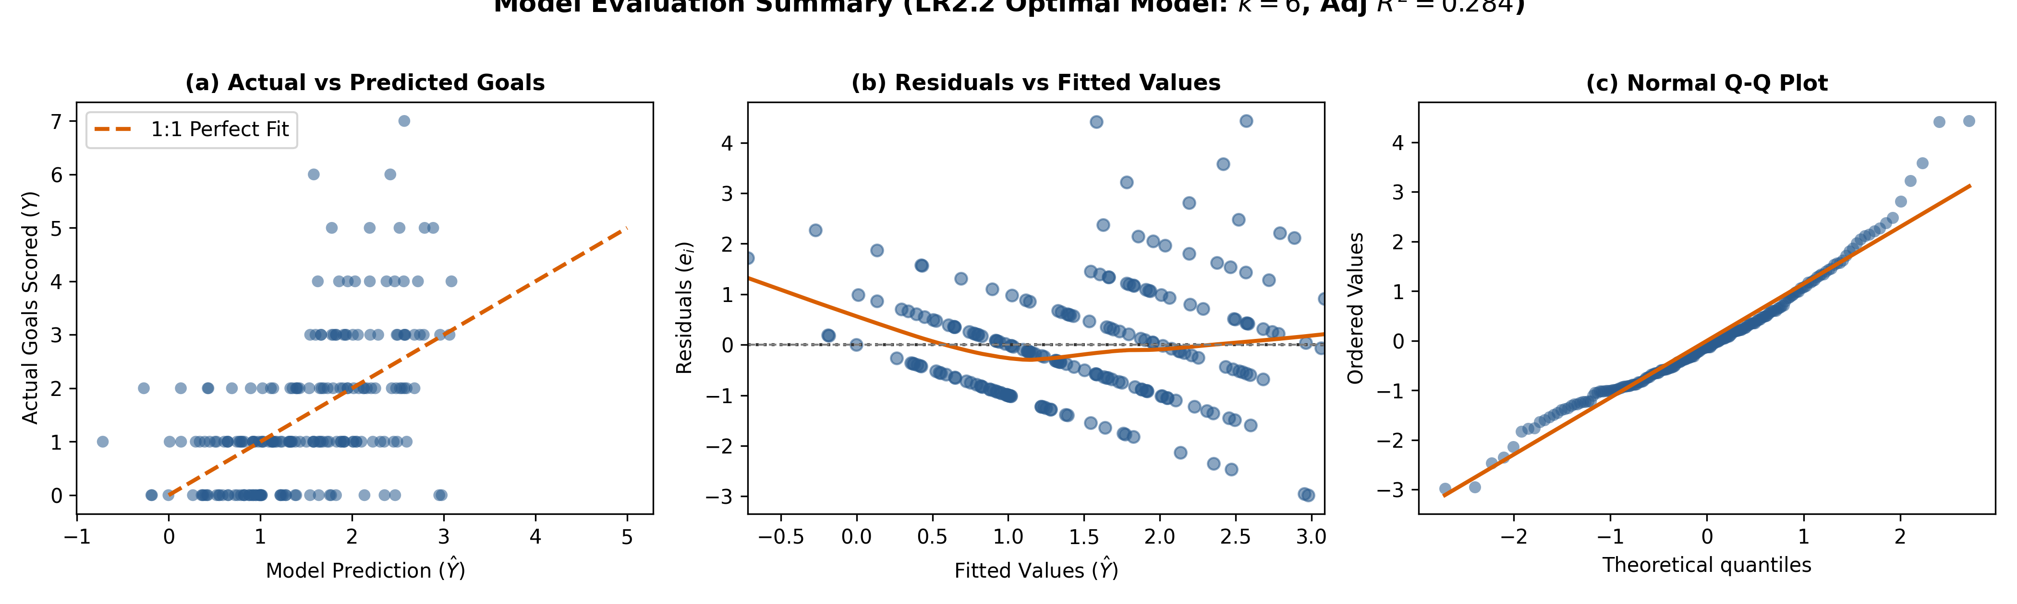
Figure 1. Diagnostics of the optimal LR2.2 model: (a) Predicted vs Actual goals; (b) Residuals vs Fitted; (c) Normal Q-Q plot.
3. Residual Diagnostics & Methodological Robustness
Classical diagnostic testing identifies inherent count-data traits: the Breusch-Pagan test indicates mild heteroscedasticity (LM=20.30, p=0.0024), while Jarque-Bera rejects strict Gaussian residuals (JB=45.84, p<0.001, skewness=0.78) driven by zero-inflation (26.4%). To ensure defensive rigor, MacKinnon-White HC3 robust standard errors were re-estimated (Table 1); squad value (p=0.0007), opponent rank (p=0.0022), and host edge (p=0.0477) remain strictly significant. Durbin-Watson (DW=1.82) confirms absence of severe residual autocorrelation. Maximum Cook's distance is 0.137, well below critical cutoffs (D < 0.5), demonstrating that findings are not driven by outlier blowouts.

