Predicting FIFA World Cup 2026 Match Outcomes from Pre-Match Information
HIT140 Foundations of Data Science · Assessment 3 · Darwin Group 26
Abel Qin (s________) · Luke Ren (s________) · Peng Song (s________) · Sihao Cui (s399370)
1 Introduction
The FIFA World Cup 2026 produced 104 matches and a detailed public record of how each was played. Almost all of that record, however, describes what happened during a match and is therefore useless for anticipating it. This report asks a deliberately harder question: how much of a match can be explained using only information that already existed when the referee blew the first whistle?
We build and evaluate two multiple linear regression models. Model 2.1 predicts the goal difference between the two teams in a match (104 rows, one per match). Model 2.2 predicts the number of goals a single team scores in a match (208 rows, one per team per match). Each uses exactly eight explanatory variables, every one of them available before kick-off, and the two models share four variables at concept level, the maximum permitted. All data preparation, analysis and visualisation were done in Python.
2 Data and feature engineering
Match results for all 104 fixtures come from the OpenFootball worldcup.json dataset (CC0). Pre-tournament team strength comes from two sources outside the three listed in the project brief, which the unit coordinator confirmed is acceptable when cited: the FIFA World Ranking released on 11 June 2026, and Transfermarkt squad market valuations. Confederation membership is standard FIFA classification. Goals are counted after extra time and exclude penalty shoot-outs; five matches went to extra time and four to penalties.
Avoiding leakage. The dataset builder walks the fixture list grouped by date. A team's running tournament record is updated only after every match on that date has been read, so the explanatory variables for any match draw only on (a) pre-tournament inputs or (b) results of matches played on strictly earlier dates. Matches played on the same day never inform one another, and nothing from the match being predicted is used.
Handling the opening round. In-tournament form is undefined before a team has played. Rather than dropping rows, which the fixed row counts forbid, form variables are shrunk towards a prior: (sum + 2 x prior) / (games + 2), with priors of 1.3 goals scored and conceded and 1.0 points per game. Every team therefore begins its first match at the prior, and all 104 and 208 rows are complete without imputation. The builder asserts its own output: row counts, exactly eight explanatory variables per model, no missing values, concept-level overlap of at most four, and goal totals matching the source results.
Concept | Model 2.1 (104 rows, all team1 − team2) | Model 2.2 (208 rows)
FIFA ranking * | log_rank_diff | team_log_rank, opp_log_rank
Squad value * | log_value_diff | team_log_value
Host at home * | host_home_diff | is_host_home
Stage * | stage_ord | is_knockout
Form — points | ppg_diff | —
Form — goal difference | gd_pg_diff | —
Rest days | rest_days_diff | —
Confederation | same_confed | —
Form — goals for | — | team_gf_pg
Form — goals against | — | opp_ga_pg
Form — opponent goals for | — | opp_gf_pg
Table 1. The eight explanatory variables of each model. Four concepts marked * are shared between the two models, which is the maximum the brief allows; no column name is identical, because model 2.1 expresses each as a team1-minus-team2 difference while model 2.2 uses levels for the team and its opponent.
3 Model 2.1 — goal difference between the two teams
Exploratory analysis. Goal difference is roughly symmetric (mean +0.48, SD 2.02). Ranking and squad value each correlate with it (r = 0.63 and 0.66) but also with each other (r = 0.79): they carry one signal, not two. Form correlates at r = 0.32, yet its partial correlation given strength collapses to -0.06 (p > 0.5), so form is largely strength in disguise. A third finding is a scheduling artefact: the fixture list names the better-ranked team first in some stages and second in others, which makes the intercept and stage term appear significant (p = 0.046 and 0.035). A relabelling test, randomly swapping the two teams and refitting the full model 2,000 times, shows those two terms reach significance in only 7% and 6% of relabellings, the chance rate, while ranking and value survive in 99-100%.
Modelling and optimisation. Models were scored on identical folds by repeated 10-fold cross-validation (30 repeats) and by a walk-forward test that forecasts each stage from earlier ones. The full eight-variable OLS (adjusted R2 0.48) reaches a cross-validated RMSE of 1.55 but 1.82 walk-forward, worse than a ranking-only regression, because it learns the listing artefact. Two changes driven by the exploratory analysis fixed this: a strength index, the mean of the two log differences (equal weights not rejected, p = 0.59), and a symmetric specification without an intercept. Of the remaining variables only host advantage lowered both errors. Twenty competing models, including ridge, lasso, elastic net, Huber, principal component and partial least squares regression, best-subset selection and tree ensembles, all lost to the two-term model on both tests.
Final model. goal_diff = 0.90 x strength + 0.82 x host_home_diff, where strength = (log_rank_diff + log_value_diff) / 2. The index combines two of the eight original variables with equal weights and is not a ninth variable, so the final model draws on three of the eight. Cross-validated RMSE falls 3.7% to 1.49 and walk-forward RMSE 21% to 1.43 (bootstrap 95% CI of the gain -0.59 to -0.18). Doubling a team's combined ranking and value advantage is worth 0.63 goals. The strength coefficient is precise (95% CI 0.72-1.09) and stays within 0.83-0.99 under four robustness checks; the host effect rests on 13 matches and is uncertain (HC3 p = 0.12). Residuals pass normality, constant-variance and linearity tests (Shapiro-Wilk p = 0.48, Breusch-Pagan p = 0.17, RESET p = 0.35).
Week 9 hold-out protocol. Fitted with scikit-learn on an 80/20 random split, the full eight-variable model returns MAE 1.205, MSE 2.249, RMSE 1.500, normalised RMSE 0.150 and R2 0.416, against 1.644, 3.871, 1.967, 0.197 and -0.004 for a baseline that predicts the mean of the training set. The model therefore beats the naive baseline comfortably on a random split; Table 2 shows why that is not the whole story.
Model | Terms | CV RMSE | Walk-forward RMSE | Hold-out RMSE
Mean baseline | 0 | 2.03 | 2.10 | 1.97
Full OLS, eight variables | 8 | 1.55 | 1.82 | 1.91
Weighted symmetric ridge | 8 | 1.51 | 1.45 | 1.52
Final: strength + host | 2 | 1.49 | 1.43 | 1.52
Table 2. Out-of-sample error for model 2.1, in goals. Hold-out = last 16 matches, fitted on the first 88.
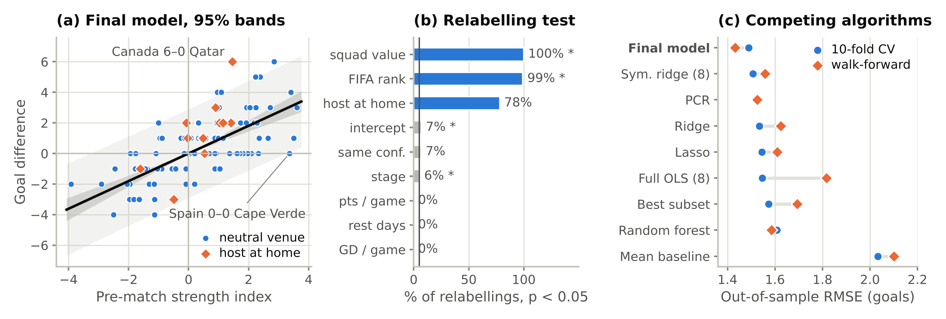
Figure 1. Model 2.1. (a) Fitted model with 95% confidence and prediction bands. (b) Share of 2,000 random relabellings in which each term of the full model is significant. (c) Out-of-sample RMSE of the competing models.
4 Model 2.2 — goals scored by a team in a match
Exploratory analysis. Goals scored average 1.48 per team-match with a variance of 1.94 and a 26.4% zero rate. Correlations with the response rank the eight variables clearly: squad value (+0.40), own FIFA ranking (-0.37) and opponent ranking (+0.32) lead, followed by the opponent's goals conceded per game (+0.21) and host advantage (+0.14). The team's own scoring form is weak (+0.10), and two variables are effectively noise: the opponent's goals-for form (-0.06) and the knockout flag (-0.01).
Modelling and optimisation. The full eight-variable OLS gives R2 = 0.306 and adjusted R2 = 0.278 (AIC 669.33). An exhaustive search over all 255 subsets confirmed what the correlations suggested: removing opp_gf_pg (p = 0.580) and is_knockout (p = 0.658) lowers AIC to 665.75 and improves 10-fold cross-validated RMSE from 1.203 to 1.191. Variance inflation factors stay below 3.03 throughout, so the retained variables are not damagingly collinear.
Final model. goals_scored = -0.747 + 0.386 x team_log_value + 0.269 x opp_log_rank + 0.802 x is_host_home - 0.397 x team_gf_pg + 0.401 x opp_ga_pg - 0.226 x team_log_rank. Doubling squad valuation raises expected goals by about 0.27; playing at home as a host nation is worth +0.80 goals. Diagnostics show the count-data character of the response: Breusch-Pagan detects mild heteroscedasticity (p = 0.0024) and Jarque-Bera rejects normal residuals (p < 0.001, skewness 0.78), driven by the zero inflation. Re-estimating with HC3 robust standard errors leaves squad value (p = 0.0007), opponent ranking (p = 0.0022) and host advantage (p = 0.0477) significant. Durbin-Watson is 1.82 and the largest Cook's distance 0.137, so neither autocorrelation nor single outliers drive the result.
Competing algorithms. Six alternatives were fitted on the same 80/20 split (Table 3). Every non-linear and ensemble method performed worse than ordinary linear regression, and gradient boosting was worse than predicting the training mean. Only the regularised linear models improved on OLS, and only marginally (R2 0.175 to 0.196). With 208 rows and eight variables, flexible models overfit; we therefore recommend retaining linear regression, which is both the more interpretable and, in practice, the more accurate choice, with elastic net as a defensible alternative.
Model | MAE | RMSE | Normalised RMSE | R2
Training-set mean (naive baseline) | 1.070 | 1.418 | 0.203 | -0.002
Linear regression | 0.923 | 1.287 | 0.184 | 0.175
Elastic net | 0.914 | 1.270 | 0.181 | 0.196
Polynomial (degree 2) | 1.008 | 1.352 | 0.193 | 0.089
Random forest | 1.002 | 1.361 | 0.194 | 0.077
Gradient boosting | 1.055 | 1.498 | 0.214 | -0.118
Table 3. Model 2.2 against competing regression algorithms on the same 80/20 hold-out (random_state = 42). Ridge and lasso, omitted for space, fall between linear regression and elastic net.
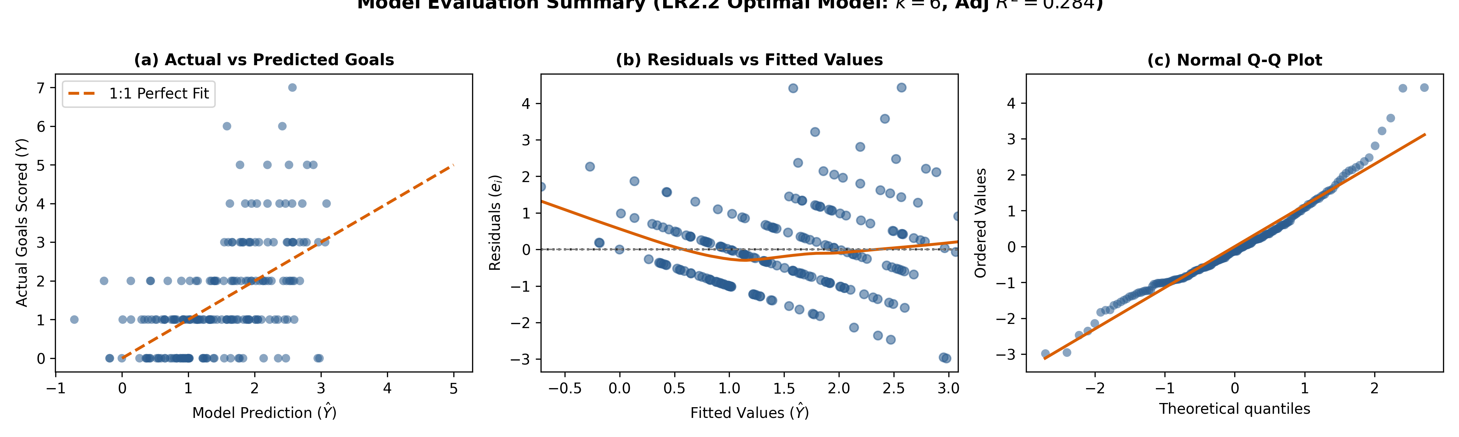
Figure 2. Model 2.2 diagnostics. (a) Predicted against actual goals. (b) Residuals against fitted values. (c) Normal Q-Q plot, showing the departure from normality caused by the 26.4% of team-matches with no goals.
5 Comparison, limitations and conclusions
The two models agree on what matters. Pre-tournament strength, measured by FIFA ranking and squad value, dominates both; playing at home as a host nation is the only other variable that earns its place in either. They also agree on what does not matter, and this is the more interesting result. Model 2.1 finds that in-tournament form has a partial correlation of -0.06 once strength is controlled for; model 2.2 finds the same variables weakly correlated (+0.10) and carrying a counter-intuitive negative coefficient. Read separately, that negative sign invites a tactical story. Read together with model 2.1, the simpler explanation is collinearity against ranking and value: form in a seven-match tournament is mostly a noisy restatement of strength the teams already had.
Both models explain under half the variance, and model 2.2 under a fifth. Model 2.1 produces a 95% prediction interval of plus or minus 2.9 goals, so it ranks fixtures far better than it forecasts them. Three limitations bound the work. Seven matches per team is a short history, which is why form variables had to be shrunk towards a prior and why flexible models overfit. The host effect rests on 13 matches. And a methodological warning carries beyond this dataset: random cross-validation rated the full eight-variable model of 2.1 as adequate, and only chronological validation exposed that it had learned a scheduling artefact rather than football. Where observations are ordered in time, random folds are not enough.
For prediction we recommend the symmetric two-term model for goal difference and the six-variable linear regression for goals scored. For interpretation the lesson is blunter: most of what decides a World Cup match is settled before the tournament starts, and the rest is largely not forecastable from data available beforehand.

