2. Linear Regression 2.1: predicting goal difference
Data. Each of the 104 matches has eight pre-match variables, all team 1 minus team 2: FIFA rank and squad value (log scale), host at home, form (points and goal difference per game), rest days, stage and same confederation. Nothing is missing and nothing leaks: form and rest are zero in all 24 opening matches.
EDA. Goal difference is roughly symmetric (mean +0.48, SD 2.02). (i) Rank and squad value correlate with the target (r = 0.63 and 0.66) and with each other (r = 0.79): one signal. (ii) Form correlates with the target (r ≈ 0.32), but its partial correlation given strength is −0.06 (p > 0.5): form is strength in disguise. (iii) The mean exceeds zero (p = 0.017) only because the schedule lists the better-ranked team first in some stages and second in others. A relabelling test (randomly swapping the two teams and refitting the full OLS 2,000 times, Figure 2.1b) shows that the intercept and stage, both significant as scheduled (p = 0.046 and 0.035), are significant in only 7% and 6% of relabellings, the chance rate; rank and value remain significant in 99–100%.
Modelling and optimisation. All models were scored on identical folds by repeated 10-fold cross-validation (30 repeats, nested tuning) and by a walk-forward test that forecasts each stage from earlier ones (80 forecasts). The full 8-variable OLS (adjusted R² 0.48) has a CV RMSE of 1.55 but 1.82 in walk-forward, worse than a rank-only regression (1.55), because it learns the listing artefact. Two EDA-driven changes fixed this: a strength index, the mean of the two log differences (equal weights not rejected, p = 0.59), and a symmetric specification with no intercept. Of the other variables only host advantage lowered both errors. All twenty competing models (Table 2.1, Figure 2.1c), including ridge, lasso, elastic net, Huber, PCR, PLS, best subset and tree ensembles, lost to the two-term model on both tests.
Final model. goal_diff = 0.90 × strength + 0.82 × host_home_diff, where strength = (log_rank_diff + log_value_diff)/2: two of the original variables combined with equal weights, not a ninth variable, so the model uses three of the eight. CV RMSE falls 3.7% to 1.49 and walk-forward RMSE 21% to 1.43 (bootstrap 95% CI of the gain −0.59 to −0.18). Doubling a team’s rank and value advantage is worth 0.63 goals. The strength coefficient is precise (95% CI 0.72–1.09) and stays within 0.83–0.99 under four robustness checks, including a refit on matches after squad values were published; the host effect rests on 13 matches and is uncertain (HC3 p = 0.12, date-clustered p = 0.06). Residuals pass normality, equal-variance and linearity tests (Shapiro–Wilk p = 0.48, Breusch–Pagan p = 0.17, RESET p = 0.35).
Limits and recommendation. With the last 16 matches held out, every conventional eight-variable model did worse than an always-draw forecast (1.64) and the symmetric models better; the host term did not help there. The 95% prediction interval is ±2.9 goals (90% coverage): pre-match data explain under half of the variance. We recommend the symmetric two-term model, with the weighted symmetric ridge as the fallback if all eight variables must stay. Random CV alone hid the full model’s weakness; validate chronologically too.
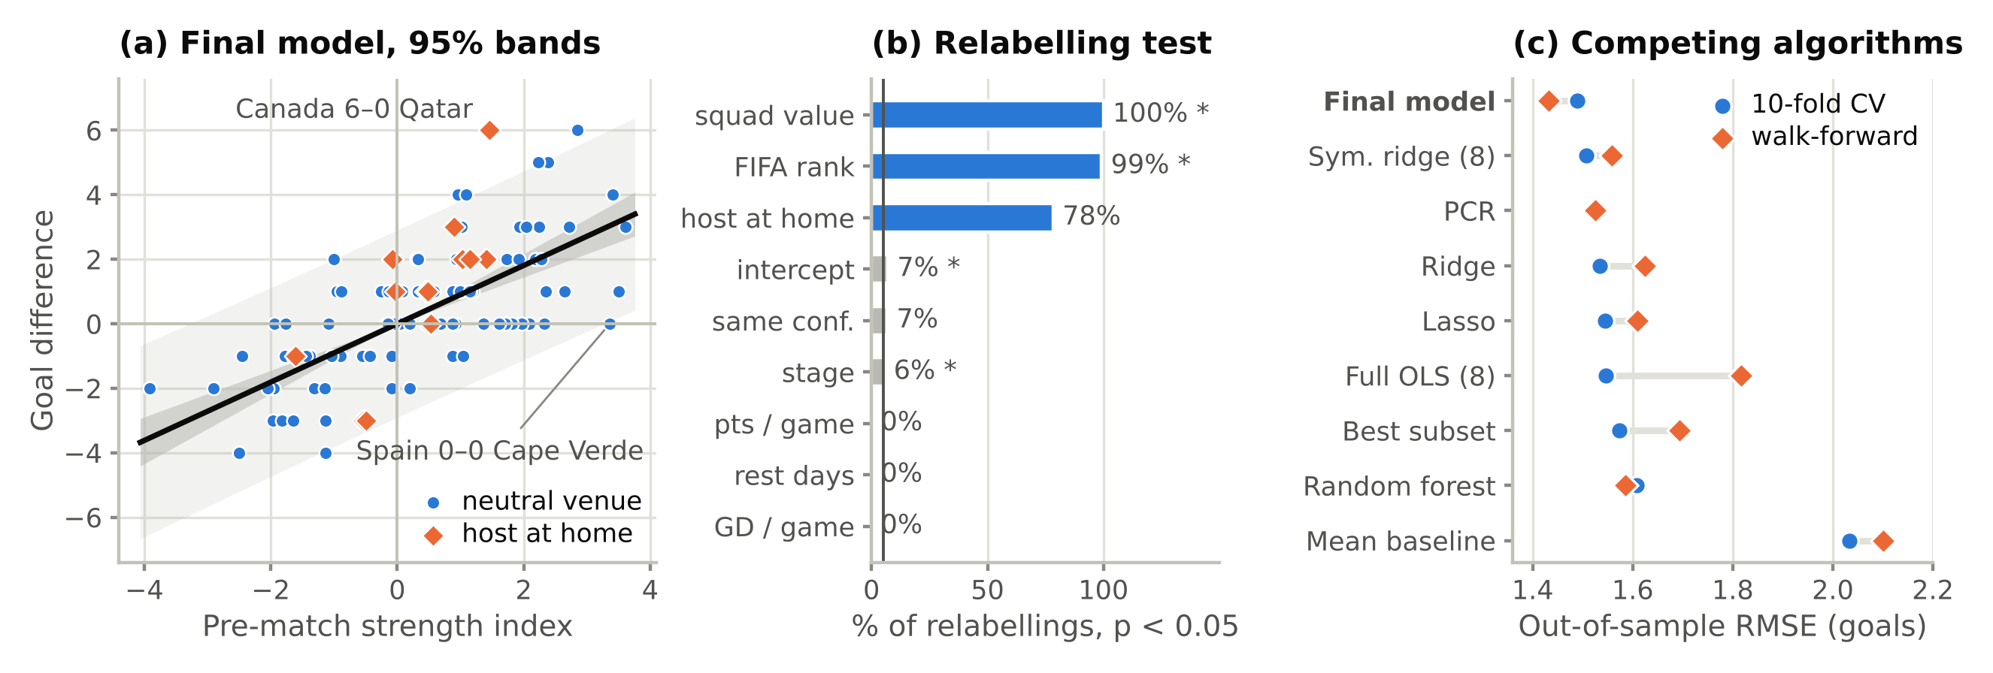
Figure 2.1. (a) Final model with 95% confidence and prediction bands. (b) Share of 2,000 random relabellings in which each full-OLS term is significant (* = as scheduled). (c) Out-of-sample RMSE of competing models.
Table 2.1. Out-of-sample RMSE in goals (WF = walk-forward; hold-out = last 16 matches, fitted on the first 88).
Model | Terms | CV RMSE | CV R² | WF RMSE | Hold-out RMSE
Mean baseline | 0 | 2.03 | −0.02 | 2.10 | 1.97
Full OLS, 8 variables | 8 | 1.55 | 0.41 | 1.82 | 1.91
Ridge, 8 variables | 8 | 1.53 | 0.42 | 1.62 | 1.83
Weighted symmetric ridge, 8 variables | 8 | 1.51 | 0.44 | 1.45 | 1.52
Symmetric OLS: strength | 1 | 1.50 | 0.45 | 1.44 | 1.37
Final: strength + host | 2 | 1.49 | 0.45 | 1.43 | 1.52

