**<S I I F>**

**Data Specification**

Version <2.0>

# Revision History

|  |  |  |  |
| --- | --- | --- | --- |
| Date | Versión | Descripción | Autor |
| 2019/06/01 | 1.0 | Base de datos SIIF | Sebastián López Camilo Quintero  Jeisson Silva |
| 2019/10/18 | 2.0 | SISTEMA DE INFORMACIÓN DE INVENTARIOS FARMACEUTICOS | Sebastián López Camilo Quintero  Jeisson Silva |
|  |  |  |  |

# Table of Contents

Revision History 2

Table of Contents 3

Introduction 4

Purpose 4

Scope 4

Definition, Acronyms and Abbreviations 4

References 4

Database Design 4

Data Dictionary 4

Appendices 4

# Diseño de base de datos

## Entidad relación

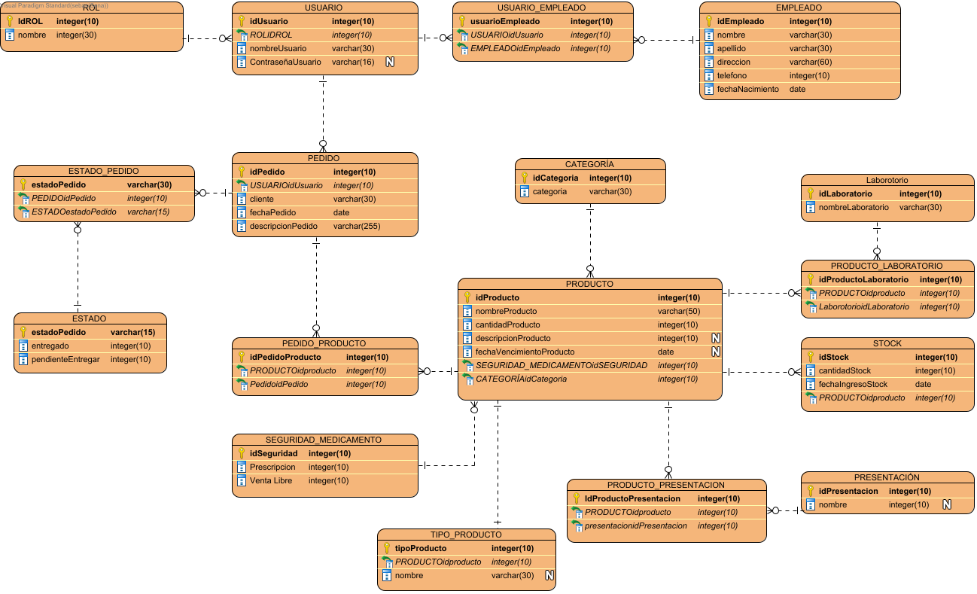

# Data Dictionary

## Data Dictionary

|  |  |  |  |  |  |  |  |  |  |
| --- | --- | --- | --- | --- | --- | --- | --- | --- | --- |
| Entity Name | Entity Description | |  |  |  |  |  |  |  | | --- | --- | --- | --- | --- | --- | --- | | Column Name | Column Description | Data Type | Length | Primary Key | Nullable | Unique | |
| CATEGORÍA | Dependiendo del medicamento la categoría cambia | | categoria |  | varchar | 30 | false | false | false | | --- | --- | --- | --- | --- | --- | --- | | idCategoria |  | integer | 10 | true | false | false | |
| EMPLEADO | El empleado el cual va a usar el software | | apellido |  | varchar | 30 | false | false | false | | --- | --- | --- | --- | --- | --- | --- | | direccion |  | varchar | 60 | false | false | false | | fechaNacimiento |  | date | 0 | false | false | false | | idEmpleado |  | integer | 10 | true | false | false | | nombre |  | varchar | 30 | false | false | false | | telefono |  | integer | 10 | false | false | false | |
| ESTADO | El estado del pedido si esta por entregar o si ya se entrego | | entregado |  | integer | 10 | false | false | false | | --- | --- | --- | --- | --- | --- | --- | | estadoPedido |  | varchar | 15 | true | false | false | | pendienteEntregar |  | integer | 10 | false | false | false | |
| ESTADO_PEDIDO | Relación | | ESTADOestadoPedido |  | varchar | 15 | false | false | false | | --- | --- | --- | --- | --- | --- | --- | | estadoPedido |  | varchar | 30 | true | false | false | | PEDIDOidPedido |  | integer | 10 | false | false | false | |
| Laborotorio | Dependiendo del medicamento el laboratorio cambiara | | idLaboratorio |  | integer | 10 | true | false | false | | --- | --- | --- | --- | --- | --- | --- | | nombreLaboratorio |  | varchar | 30 | false | false | false | |
| PEDIDO | El proceso finaliza con el pedido | | cliente |  | varchar | 30 | false | false | false | | --- | --- | --- | --- | --- | --- | --- | | descripcionPedido |  | varchar | 255 | false | false | false | | fechaPedido |  | date | 0 | false | false | false | | idPedido |  | integer | 10 | true | false | false | | USUARIOidUsuario |  | integer | 10 | false | false | false | |
| PEDIDO_PRODUCTO | Relación | | idPedidoProducto |  | integer | 10 | true | false | false | | --- | --- | --- | --- | --- | --- | --- | | PedidoidPedido |  | integer | 10 | false | false | false | | PRODUCTOidproducto |  | integer | 10 | false | false | false | |
| PRESENTACIÓN | Depende si es ejemplo frasco, tableta, crema etc | | idPresentacion |  | integer | 10 | true | false | false | | --- | --- | --- | --- | --- | --- | --- | | nombre |  | integer | 10 | false | true | false | |
| PRODUCTO | El producto tiene su cantidad su descripción y su fecha de vencimiento | | cantidadProducto |  | integer | 10 | false | false | false | | --- | --- | --- | --- | --- | --- | --- | | CATEGORÍAidCategoria |  | integer | 10 | false | false | false | | descripcionProducto |  | integer | 10 | false | true | false | | fechaVencimientoProducto |  | date | 0 | false | true | false | | idProducto |  | integer | 10 | true | false | false | | nombreProducto |  | varchar | 50 | false | false | false | | SEGURIDAD_MEDICAMENTOidSEGURIDAD |  | integer | 10 | false | false | false | |
| PRODUCTO_LABORATORIO | Relación | | idProductoLaboratorio |  | integer | 10 | true | false | false | | --- | --- | --- | --- | --- | --- | --- | | LaborotorioidLaboratorio |  | integer | 10 | false | false | false | | PRODUCTOidproducto |  | integer | 10 | false | false | false | |
| PRODUCTO_PRESENTACION | Relación | | IdProductoPresentacion |  | integer | 10 | true | false | false | | --- | --- | --- | --- | --- | --- | --- | | presentacionidPresentacion |  | integer | 10 | false | false | false | | PRODUCTOidproducto |  | integer | 10 | false | false | false | |
| ROL | Administrador  Tecnico  Auxiliar administrativo | | IdROL |  | integer | 10 | true | false | false | | --- | --- | --- | --- | --- | --- | --- | | nombre |  | integer | 30 | false | false | false | |
| SEGURIDAD_MEDICAMENTO | Relación | | idSeguridad |  | integer | 10 | true | false | false | | --- | --- | --- | --- | --- | --- | --- | | Prescripcion |  | integer | 10 | false | false | false | | Venta Libre |  | integer | 10 | false | false | false | |
| STOCK | Donde sebe que productos tiene a la fecha | | cantidadStock |  | integer | 10 | false | false | false | | --- | --- | --- | --- | --- | --- | --- | | fechaIngresoStock |  | date | 0 | false | false | false | | idStock |  | integer | 10 | true | false | false | | PRODUCTOidproducto |  | integer | 10 | false | false | false | |
| TIPO_PRODUCTO | Relación | | nombre |  | varchar | 30 | false | true | false | | --- | --- | --- | --- | --- | --- | --- | | PRODUCTOidproducto |  | integer | 10 | false | false | false | | tipoProducto |  | integer | 10 | true | false | false | |
| USUARIO | Para ingresar al sistema | | ContraseñaUsuario |  | varchar | 16 | false | true | false | | --- | --- | --- | --- | --- | --- | --- | | idUsuario |  | integer | 10 | true | false | false | | nombreUsuario |  | varchar | 30 | false | false | false | | ROLIDROL |  | integer | 10 | false | false | false | |
| USUARIO_EMPLEADO | Relación | | EMPLEADOidEmpleado |  | integer | 10 | false | false | false | | --- | --- | --- | --- | --- | --- | --- | | usuarioEmpleado |  | integer | 10 | true | false | false | | USUARIOidUsuario |  | integer | 10 | false | false | false | |