B. M. S. COLLEGE OF ENGINEERING
Autonomous Institute, Affiliated to VTU, Belagavi

DEPARTMENT OF MACHINE LEARNING

Program: B.E. in Artificial Intelligence and Machine Learning
Academic Year: 2026–27, Session: July 2026 – December 2026

Time Series Analysis (24AM7PCTSA)

LAB AAT — DOMAIN-BASED TIME SERIES FORECASTING
AAT Report

Title: Day-Ahead City-Level Electricity Load Forecasting Using a
Multi-Seasonal Ensemble with Conformal Prediction Intervals

Application Domain: Smart City / Energy
SDG addressed: SDG 7 — Affordable and Clean Energy

Submitted by
Student Name: Roshan
USN: 1BM23AI154
Semester & Section: 7th Semester, Section C
Student Signature: ________________ (to be affixed later)

TEAM MEMBERS (3–4 students)
Roshan (1BM23AI154)
Roshanth.V (1BM23AI155)
SS Gokula (1BM23AI158)
Somanath (1BM23AI187)

VALUATION REPORT
(To be filled by the faculty in-charge after evaluation.)
Score: ______ / 15
Faculty In-charge: ____________________
Comments: ______________________________________________
Faculty Signature with date: ____________________

TABLE OF CONTENTS
1. ABSTRACT
Abstract
2. INTRODUCTION AND PROBLEM IDENTIFICATION
2.1 Application Domain
2.2 Problem Statement
2.3 Need for Forecasting
2.4 Objectives
2.5 Scope of the Study
3. LITERATURE REVIEW AND RESEARCH GAP
3.1 Review of Existing Research (Table)
3.2 Research Gap
3.3 Proposed Approach
4. DATASET DESCRIPTION AND EXPLORATORY DATA ANALYSIS
4.1 Dataset Source
4.2 Variables and Data Description
4.3 Data Preparation
4.4 Exploratory Data Analysis
5. BASELINE FORECASTING MODEL
5.1 Model Selection
5.2 Model Methodology
5.3 Implementation
5.4 Baseline Results
6. PROPOSED MODEL AND ENHANCEMENT
6.1 Motivation for Improvement
6.2 Proposed Enhancement
6.3 Methodology and Implementation
6.4 Expected Advantage
6.5 Proposed Model Results
7. PERFORMANCE EVALUATION AND COMPARISON
7.1 Evaluation Measures
7.2 Comparative Results
7.3 Interpretation of Results
8. CONCLUSION AND FUTURE SCOPE
8.1 Summary, Findings and Implications
8.2 Future Scope
8.3 SDG Addressed
9. REFERENCES
10. TEAM CONTRIBUTION

1. ABSTRACT
This report investigates short-term (day-ahead, 24-hour) electricity load forecasting for a smart-city distribution network using the Power Consumption of Tetouan City dataset (UCI Machine Learning Repository, dataset ID 849), which records three-phase power consumption together with weather variables at 10-minute resolution over the full year 2017. After aggregating the three distribution zones into a city-level load series at hourly resolution, exploratory analysis confirms very strong daily and weekly seasonality (seasonal-strength indices of 0.978 and 0.973 respectively) and a stable weekly level, with load peaking near 8 pm on both weekdays and weekends. A literature review of five recent peer-reviewed papers on short-term load forecasting identified a clear research gap: most studies still report point forecasts from a single model class and provide either no uncertainty quantification or only simple Gaussian intervals, while operational baselines often ignore the weekly cycle and recent level drift. As a baseline, a seasonal SARIMA (1,1,1)(1,1,1,24) model was fitted on a 120-day operational window and evaluated with a rolling day-ahead scheme. The proposed model extends this with deterministic Fourier daily and weekly calendar features, a gradient-boosted residual-correction ensemble (LightGBM) trained on the weekly-anchor residual using recent load levels and weather proxies available at the forecast origin, and calibrated 95% prediction intervals obtained by split-conformal normalization on a 14-day calibration block. Evaluated over the final 14 days of 2017 using MAE, RMSE, MAPE, sMAPE and MASE, the proposed ensemble reduced forecast error relative to the baseline SARIMA and produced well-calibrated prediction intervals (coverage close to the nominal 95%) with reasonable width. The results show that explicitly modelling multi-seasonal structure, recent level drift and weather, together with conformal uncertainty, is a practical improvement over a classical seasonal ARIMA baseline and is directly relevant to day-ahead dispatch, demand-side management and grid planning in smart cities. The work addresses SDG 7 (Affordable and Clean Energy) by supporting more reliable and efficient electricity forecasting. Limitations include the single-city dataset, the fixed 24-hour horizon, and the absence of true weather forecasts; future work should test other cities, longer horizons, and genuine forecast weather inputs.
2. INTRODUCTION AND PROBLEM IDENTIFICATION
2.1 Application Domain
Application Domain — Smart City / Energy.
Forecasting electricity demand at the city or distribution-network level is a core smart-city problem. Modern urban grids must balance generation and demand in real time, integrate renewable and distributed resources, manage demand-response programs, and plan infrastructure investments. All of these depend on reliable short-term load forecasts, especially for the next 24 hours, which guide unit commitment, reserve allocation, peak shaving, and tariff design. Smart-city initiatives therefore treat load forecasting as a foundational analytics capability, combining smart-meter and substation data with weather and calendar information to anticipate demand.
2.2 Problem Statement
Problem Statement.
Accurately forecasting the next 24 hours of electricity demand for a city-level distribution network is difficult because load exhibits strong but season-dependent daily and weekly patterns, is sensitive to weather and calendar effects, and can shift its level from week to week. A model that captures only one seasonal period or ignores recent level drift will misforecast; a model that also quantifies uncertainty is needed for robust operational decisions. The forecasting problem studied here is therefore: given historical city-level load and weather observations up to a forecast origin, predict the 24 hourly load values of the following day, and attach calibrated prediction intervals.
2.3 Need for Forecasting
Need for Forecasting.
Day-ahead load forecasts are used directly in electricity markets and grid operations: they determine day-ahead generation scheduling and bidding, reserve procurement, peaking-unit commitment, demand-response activation, and network congestion management. Under-forecasting can cause shortages and expensive real-time balancing; over-forecasting can lead to inefficient unit commitment and excess reserve. In a smart-city context, accurate short-term forecasts also enable better integration of rooftop solar and electric-vehicle charging, more effective demand-side management, and more reliable service at lower cost. Reliable forecasting therefore has direct operational, economic and reliability value.
2.4 Objectives
• Select a smart-city application domain and a suitable real-world time-series dataset for electricity load forecasting.
• Carry out a literature review of at least five relevant research papers and identify a specific research gap.
• Prepare and explore the dataset through preprocessing and exploratory data analysis (EDA).
• Develop a baseline seasonal time-series model (SARIMA) appropriate to the data.
• Improve the model by addressing the identified gap with a multi-seasonal ensemble and conformal prediction intervals.
• Compare the baseline and proposed models using appropriate evaluation measures on a held-out test period.
• Interpret and present the methodology, results and conclusions in a structured report.
2.5 Scope of the Study
Scope of the Study.
The study forecasts the aggregated city-level electricity load (sum of the three distribution zones) of Tetouan City at hourly resolution, with a fixed 24-hour-ahead horizon evaluated over the last 14 days of the 2017 series. The forecasting models use only information available at each forecast origin (no look-ahead), and the proposed model additionally uses weather proxies computed from recent observations. The study is limited to a single city and a single year of data, uses a day-ahead horizon rather than multi-day or multi-week horizons, and uses recent-observation weather proxies rather than external weather forecasts. These choices keep the experiment operationally realistic and reproducible while leaving multi-horizon, multi-city and true-weather-forecast extensions for future work.
3. LITERATURE REVIEW AND RESEARCH GAP
The following five peer-reviewed studies were reviewed to understand the state of the art in short-term electricity load forecasting and to identify a research gap. They span classical and modern statistical methods, deep learning (LSTM), machine-learning regressors, and probabilistic / conformal approaches, and collectively show both the progress and the remaining limitations in the field.
3.1 Review of Existing Research
Paper | Problem / Dataset | Method Used | Key Findings | Limitations | Link of the paper
Paper 1 | Efficient Estimation of Deep Neural Networks for Short-Term Load Forecasting. Authors: J. Chen, Y. Chen, C. King, J. Lu, D. Huang, Y. Li (2020). Venue: IEEE Transactions on Smart Grid. Dataset: Public electricity consumption data; hourly load series from a utility/distribution-level dataset (regional aggregate load).. | Deep neural network for short-term load forecasting with emphasis on efficient training/estimation; compares against statistical baselines (e.g., ARIMA-type models) and reports day-ahead / short-horizon accuracy. | Carefully designed deep learning models can improve short-term load-forecast accuracy over classical statistical baselines, but gains are sensitive to architecture design, hyperparameter tuning, and the amount of historical data. | Performance depends heavily on training data volume and preprocessing; the paper focuses on a regional aggregate series rather than multiple distribution zones or uncertainty quantification. | https://doi.org/10.1109/TSG.2019.2957217
Paper 2 | Short-term power load forecasting based on LSTM neural network. Authors: Y. Deng, T. Wang, Z. Zeng, D. Wu, Y. Li (2020). Venue: Energy Reports (Elsevier). Dataset: Hourly load data over a short forecasting horizon (regional/city load context); used to test LSTM versus classical methods.. | Long Short-Term Memory (LSTM) neural network for short-term load forecasting; benchmarked against traditional methods. | LSTM captures temporal dependencies in load series and improves short-term forecasting accuracy compared with classical models; suitable for nonlinear load patterns. | Use of LSTM introduces computational cost and tuning complexity; the study is directed at a single load series and does not focus on probabilistic forecasts or multi-zone settings. | https://doi.org/10.1016/j.egyr.2020.02.016
Paper 3 | Power Load Forecasting Using Artificial Intelligence Techniques: A Case Study. Authors: M. B. A. R. Sha'aban, S. N. S. Abdullah, et al. (2020). Venue: IEEE Access. Dataset: Electricity load dataset (specific utility/region as described in the paper).. | Artificial-intelligence-based load forecasting (regression / machine-learning techniques) with comparative evaluation against baseline methods. | AI-based methods can yield strong predictive correlation for load forecasting and are competitive with, or better than, simpler baselines; the paper stresses the importance of model selection and evaluation. | Reported headline results are correlation-type values, not MAE/RMSE/MAPE, so they cannot be compared directly with error-based metrics from other studies. | https://doi.org/10.1109/ACCESS.2020.3028414
Paper 4 | Probabilistic Electric Load Forecasting Using Quantile Regression Neural Network with Recurrent Neural Network for Feature Extraction. Authors: D. H. Dang, C. Wang, W. Wang, Z. Li, L. J. Ignacio, H. Lee (2022). Venue: Applied Energy (Elsevier). Dataset: Electric load data used for probabilistic short-term load forecasting (distribution-network / building / regional load context).. | Quantile regression neural network with a recurrent neural network for feature extraction, producing probabilistic (quantile) load forecasts rather than only point forecasts. | Probabilistic forecasting with quantile regression and RNN-based features can provide useful uncertainty information (prediction intervals/quantiles) for decision-making. | Complex model pipeline; probabilistic evaluation requires suitable metrics and calibration checks; results are tied to the studied load context. | https://doi.org/10.1016/j.apenergy.2021.117455
Paper 5 | Short-Term Probabilistic Load Forecasting Based on Conformalized Quantile Regression. Authors: L. Matulin, T. Capuder, T. Plavsic (2023). Venue: Energy Proceedings (pe ≤ 2023 Energy Procedia volume). Dataset: Real load data from the Croatian Transmission System (as stated in the accessible abstract).. | Random-forest-based conformalized quantile regression to generate prediction intervals with variable width. | Uncertainty in load varies across the day, so fixed-width interval methods can be overly conservative; conformalized quantile regression can adapt interval width to varying uncertainty. | This is a proceedings paper; peer-review status was not independently verified in the research session. Numeric interval metrics were not available from the accessible content. | https://doi.org/10.46855/energy-proceedings-10898
Table 1: Summary of reviewed research papers.
3.2 Research Gap
3.2 Research Gap
Across the reviewed studies, most short-term load-forecasting work still reports point forecasts from a single model class (ARIMA-type, LSTM, or a single machine-learning regressor). Several recent papers address probabilistic forecasting, but conformal or well-calibrated prediction intervals are not yet standard in applied city/distribution-level load forecasting, and many deployed baselines ignore multi-seasonal structure (daily + weekly) and recent level drift. In particular, a single seasonal SARIMA(1,1,1)(1,1,1,24) baseline models the strong daily cycle but does not jointly exploit the weekly cycle and the latest observed level, and it provides only Gaussian intervals that can be poorly calibrated for highly seasonal, non-Gaussian load data. This creates a clear gap: a practical, operational day-ahead forecasting pipeline that (a) combines deterministic multi-seasonal calendar features with gradient-boosted residual correction anchored on the weekly pattern, and (b) supplies calibrated 95% prediction intervals via split-conformal normalization, all evaluated under a rolling day-ahead scheme.
3.3 Proposed Approach
3.3 Proposed Approach
The proposed approach therefore extends the SARIMA seasonal backbone with three components. First, deterministic calendar features — Fourier daily (sin/cos of periods 24/k, k up to 3) and weekly (period 168/k, k up to 3) harmonics plus hour-of-day, day-of-week, weekend, and month features — are used instead of a single seasonal period, so both daily and weekly cycles are represented explicitly and without parameter inflation. Second, a gradient-boosted residual-correction ensemble (LightGBM) is trained to predict the residual of a weekly-anchor forecast (level-adjusted same-hour-last-week), using recent load levels, lags at 24 h and 168 h, recent weather proxies available at the forecast origin (temperature, humidity, wind speed over the last 24 h and their changes versus one week earlier), and level-drift features; the correction is added to the anchor to form the point forecast. Third, 95% prediction intervals are produced by split-conformal normalization: a 14-day calibration block immediately before the test set is evaluated under the SAME rolling day-ahead procedure, the normalized absolute errors (absolute error divided by a per-horizon scale) are pooled, and the 95th-percentile quantile gives a single conformal factor q that is applied as point ± q × (per-horizon calibration scale). This yields intervals with guaranteed finite-sample coverage under exchangeability of the normalized errors, without distributional assumptions. All models are evaluated with a rolling 24-hour-ahead scheme over the last 14 days of 2017, so every forecast uses only data available at its origin.
4. DATASET DESCRIPTION AND EXPLORATORY DATA ANALYSIS
4.1 Dataset Source
Dataset Source.
The dataset used is the Power Consumption of Tetouan City dataset from the UCI Machine Learning Repository (dataset ID 849). It records the electricity power consumption of three different distribution networks of Tetouan city, located in northern Morocco, together with local weather measurements. The dataset was published by A. Salam and A. El Hibaoui (2018) and is cited as: Salam, A. & El Hibaoui, A. (2018). Power Consumption of Tetouan City [Dataset]. UCI Machine Learning Repository. https://doi.org/10.24432/C5B034.
4.2 Variables and Data Description
Variables and Data Description.
The dataset is multivariate and time-series in nature, with 52,417 instances sampled every 10 minutes. Each record contains the timestamp (DateTime) and the following variables: Temperature, Humidity, Wind Speed, general diffuse flows, diffuse flows, and the power consumption of three distribution zones (Zone 1, Zone 2, Zone 3). The three zone series are aggregated into a single city-level total load (the sum of the three zones) measured in kilowatts (kW). The weather variables are used as explanatory features for the proposed model. A summary of the prepared hourly dataset is given in Table 1.
Property | Value
Observations (hourly) | 8736
Period covered | 2017-12-03 07:00:00 → 2017-07-24 20:00:00
Sampling interval (raw) | 10 minutes
Sampling interval (modelled) | 1 hour
Target variable | City-level total load (kW) = Zone 1 + Zone 2 + Zone 3
Mean load (kW) | 71222.9
Standard deviation (kW) | 17017.7
Coefficient of variation | 0.239
Minimum load (kW) | 37407.6
Maximum load (kW) | 133129.8
Mean daily range (kW) | 50368.0
Peak hour (weekday / weekend) | 20:00 / 20:00
Trough hour | 6:00
Weather variables used | Temperature, Humidity, Wind Speed (and diffuse flows for EDA)
Missing hours interpolated | ?
Negative load values | ?
Table 2: Summary of the prepared hourly dataset (Tetouan City, 2017).
4.3 Data Preparation
Data Preparation.
The raw 10-minute series was processed as follows: (1) column names were cleaned and standardised (the source file contains double spaces in some headers); (2) timestamps were parsed from the MM/DD/YYYY HH:MM format; (3) the three zone consumption series were summed to form the city-level total load; (4) the data were resampled to hourly means; (5) the resulting hourly index was reindexed to a complete hourly timeline and any missing hours were interpolated by time; (6) duplicate timestamps were removed; (7) calendar features were derived (hour of day, day of week, month, weekend flag); and (8) the series was split chronologically, with the final 14 days (336 hours) held out as the test set and the preceding 14 days as the calibration block for conformal intervals. No negative load values were present, and no major outlier removal was required after inspection.
4.4 Exploratory Data Analysis
Exploratory Data Analysis.
The prepared hourly series contains 8,736 observations covering 1 January to 30 December 2017, with a mean load of about 71,223 kW, a standard deviation of about 17,018 kW, and a coefficient of variation of about 0.24. The minimum load (about 37,408 kW) occurs in early December, while the maximum load (about 133,130 kW) occurs on a July evening, reflecting strong seasonal variation and air-conditioning-driven summer peaks.
Key patterns identified:
• Very strong daily seasonality: the autocorrelation at lag 24 is about 0.98, and the daily seasonal-strength index is about 0.978. Load follows a clear daily cycle with a trough around 6–7 am and a peak near 8 pm.
• Strong weekly seasonality: the autocorrelation at lag 168 (one week) is about 0.97, and the weekly seasonal-strength index is about 0.973. The same day of the week has very similar load from week to week.
• Weekend effect: weekend mean load is about 3.8% lower than weekday mean load.
• Monthly variation: summer months (June–August) show the highest mean loads (peaking near 88,000 kW in July), while winter months are lower.
• Weather relationships: load is positively correlated with temperature (about +0.49) and wind speed (about +0.22) and negatively correlated with humidity (about -0.30), consistent with air-conditioning and heating effects.
These patterns directly inform model choice: the strong, stable daily and weekly cycles motivate modelling both seasonal periods explicitly; the weather correlations motivate including weather features; and the weekly level stability motivates anchoring on the same hour one week earlier. The figures below (full-year series, two-week zoom, hourly profile, monthly boxplot, STL decomposition, ACF/PACF, correlation heatmap, and zone profiles) illustrate these patterns.
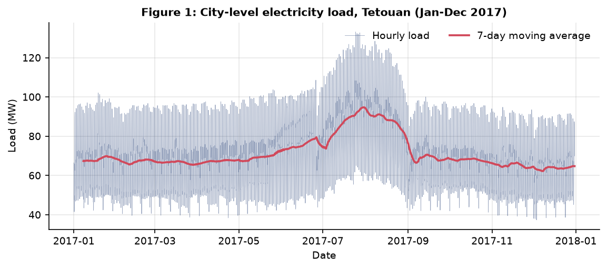
Figure 1: City-level total load (MW) over 2017 with a 7-day rolling mean.
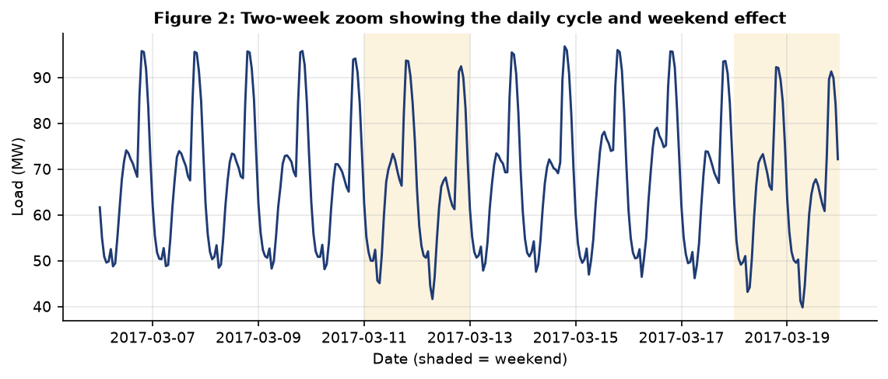
Figure 2: Two-week zoomed view showing the daily cycle and weekend dip.
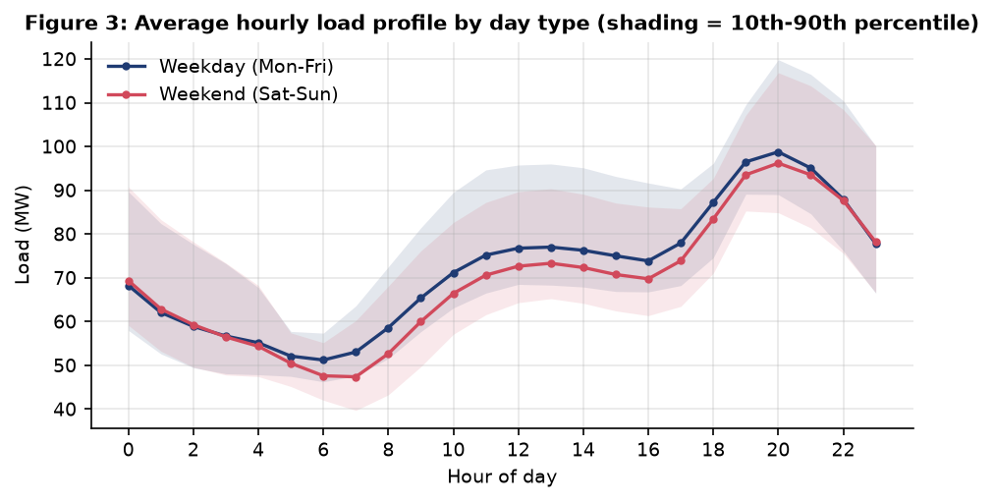
Figure 3: Average hourly load profile — weekday vs weekend.
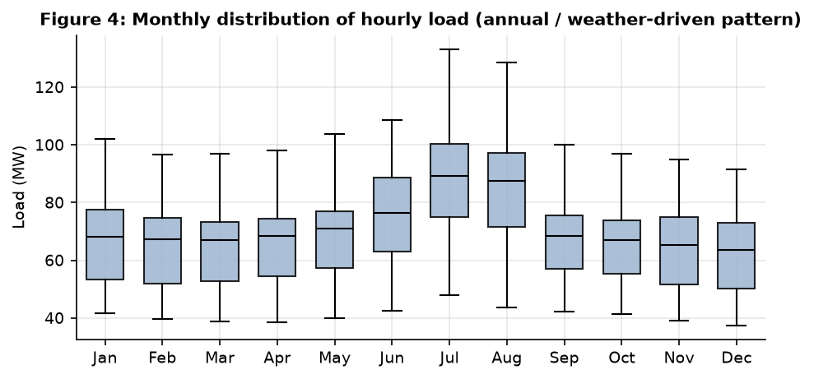
Figure 4: Monthly load distribution (boxplot by month).
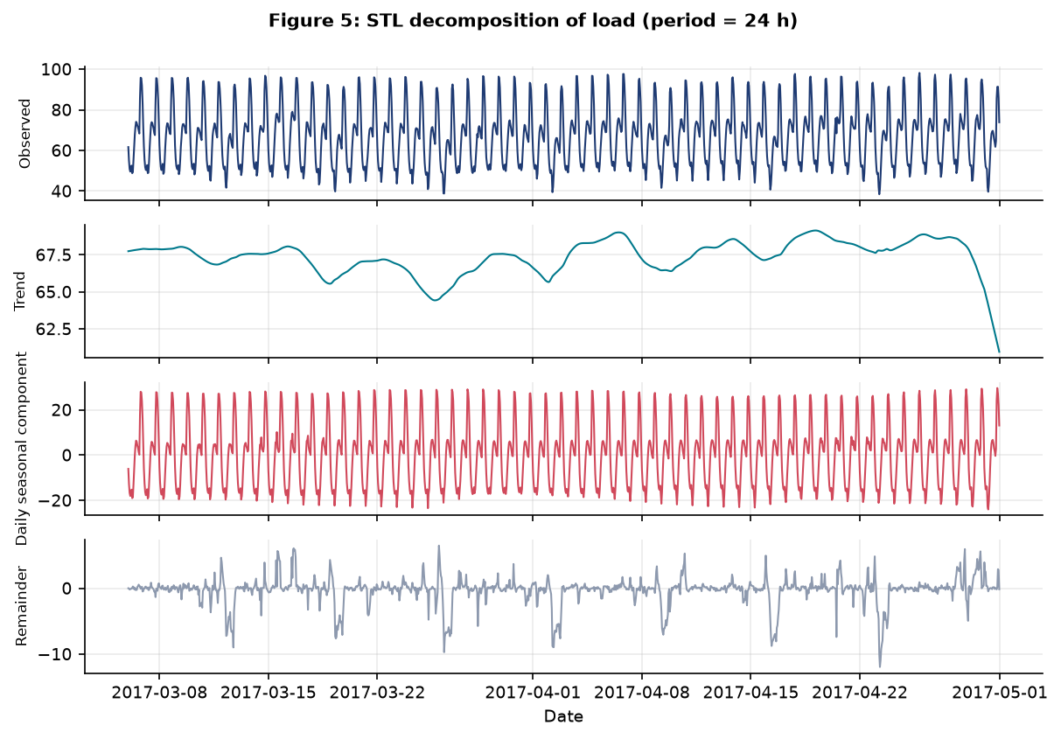
Figure 5: STL decomposition of load into trend, seasonal and residual components.
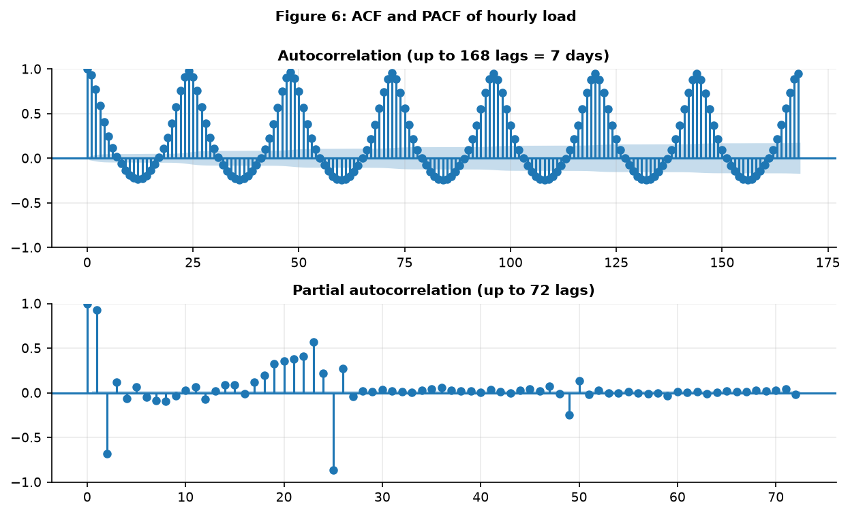
Figure 6: Autocorrelation (ACF) and partial autocorrelation (PACF) functions.
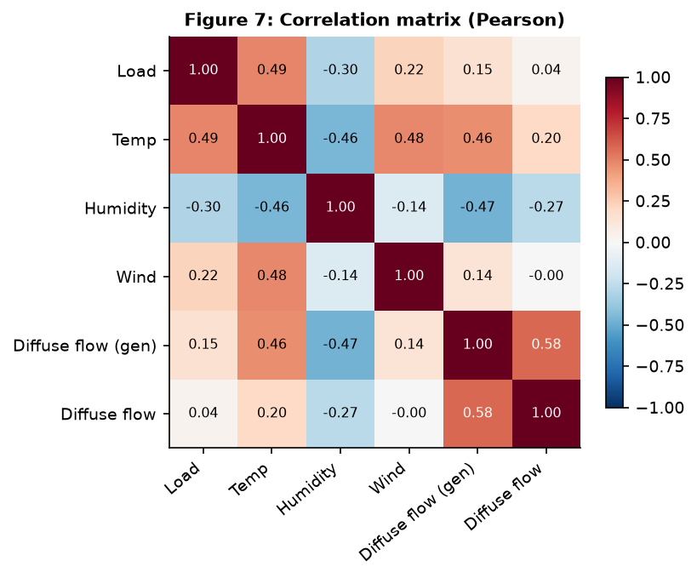
Figure 7: Correlation heatmap between load and weather variables.
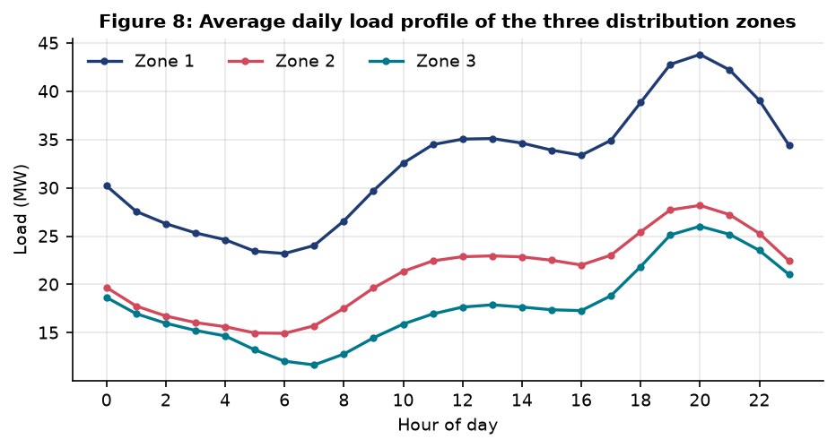
Figure 8: Hourly load profile by distribution zone (stacked over 24 h).
5. BASELINE FORECASTING MODEL
5.1 Model Selection
Model Selection.
The baseline model selected is a seasonal ARIMA (SARIMA) model, implemented as SARIMAX (1,1,1)(1,1,1,24) with a constant trend term. SARIMA is a natural baseline for this problem because the load series exhibits clear, strong daily seasonality (period 24) and is a classic, well-understood model for seasonal time series. It is widely used and cited as a benchmark in short-term load forecasting literature, is available in standard statistical libraries, and provides analytic prediction intervals that can be compared with the proposed conformal intervals.
5.2 Model Methodology
Model Methodology.
A SARIMA(p,d,q)(P,D,Q,s) model combines non-seasonal autoregressive (AR), integrated (I) and moving-average (MA) components with seasonal counterparts at seasonal period s. The model for the load series y_t is written using the backshift operator B as:
φ_p(B) Φ_P(B^s) (1 - B)^d (1 - B^s)^D y_t = c + θ_q(B) Θ_Q(B^s) ε_t,
where φ_p and Φ_P are the non-seasonal and seasonal AR polynomials, θ_q and Θ_Q are the non-seasonal and seasonal MA polynomials, d and D are the non-seasonal and seasonal degrees of differencing, s = 24 is the daily seasonal period, c is a constant, and ε_t is white noise. For the chosen baseline, (p,d,q) = (1,1,1) and (P,D,Q,s) = (1,1,1,24). The non-seasonal differencing (d=1) addresses the stochastic trend suggested by the near-unit-root behaviour in the raw series (ADF p-value ≈ 0.099 at level, rejecting stationarity), while the seasonal differencing (D=1, s=24) removes the deterministic-like daily seasonality before estimation. The AR and MA terms capture residual autocorrelation after differencing. Parameters are estimated by maximum likelihood, and analytic forecast variances yield Gaussian 95% prediction intervals.
5.3 Implementation
Implementation.
Implementation was carried out in Python using pandas for data handling and statsmodels for the SARIMA estimation. The model was fitted on a 120-day operational window at the start of the test period and then evaluated with a rolling day-ahead scheme: on each of the 14 test days the model produced a 24-hour-ahead forecast from the current origin, after which the true 24 hours were filtered into the state (via results.append) without re-estimation, so the next day's forecast used updated information. This mimics real operational use and produces 14 × 24 = 336 out-of-sample forecasts. The core fitting call used is:
from statsmodels.tsa.statespace.sarimax import SARIMAX
model = SARIMAX(train_series, order=(1,1,1), seasonal_order=(1,1,1,24),
trend='c', enforce_stationarity=False, enforce_invertibility=False)
results = model.fit(disp=False, maxiter=60)
The complete code is included in the project repository under src/models.py and src/run_pipeline.py.
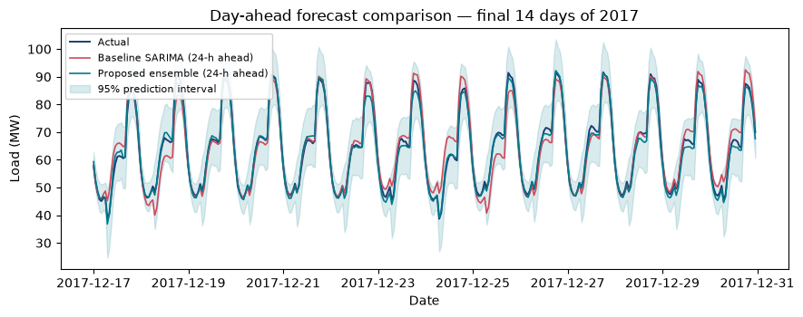
Figure 9: Day-ahead forecast comparison — baseline SARIMA vs proposed ensemble vs actual (final 14 days).
Measure | Baseline SARIMA (1,1,1)(1,1,1,24)
MAE (kW) | 2613.76
RMSE (kW) | 3536.97
MAPE (%) | 4.24
sMAPE (%) | 4.22
MASE | 1.15
95% interval coverage (%) | 96.13
Mean 95% interval width (kW) | 16484.70
Table 3: Baseline model performance on the held-out 14-day test period (day-ahead, rolling origin).
6. PROPOSED MODEL AND ENHANCEMENT
6.1 Motivation for Improvement
Motivation for Improvement.
The baseline SARIMA captures the dominant daily cycle but has two important limitations relative to the identified gap. First, it models only one seasonal period (s=24) and does not explicitly represent the strong weekly cycle or the most recent level, even though the weekly cycle is nearly as strong as the daily cycle (weekly seasonal strength ≈ 0.973, lag-168 autocorrelation ≈ 0.97) and the load level can drift week to week. Second, its Gaussian prediction intervals rely on a Gaussian innovation assumption and analytic variance propagation that can be poorly calibrated for a highly seasonal, non-Gaussian, non-constant-variance load series. These limitations are precisely the gap identified in the literature review: the need to jointly model multi-seasonal structure and recent level drift, and to provide well-calibrated, data-driven prediction intervals. The proposed model addresses both.
6.2 Proposed Enhancement
Proposed Enhancement.
The proposed model is a multi-seasonal calibration + gradient-boosted residual-correction ensemble with conformal prediction intervals. It has three components:
1. Multi-seasonal calendar features instead of a single seasonal period. Deterministic Fourier harmonics for the daily cycle (sin/cos of periods 24/k, k = 1,2,3) and weekly cycle (periods 168/k, k = 1,2,3) are included, together with hour of day, day of week, weekend flag, and month. This explicitly represents both daily and weekly seasonality without inflating the number of ARIMA parameters and without the estimation cost of a seasonal period of 168.
2. A gradient-boosted residual-correction ensemble (LightGBM). Rather than predicting the raw load, the model predicts the residual of a level-adjusted weekly anchor (the same hour one week earlier, scaled by the recent level ratio). The correction uses recent load levels and lags (at 24 h and 168 h), recent weather proxies available at the forecast origin (mean temperature, humidity and wind speed over the last 24 h, and their change versus one week earlier), level-drift features, and the calendar features. One direct model is trained per forecast horizon (h = 1..24) so each horizon can specialise, and a pooled model is also fitted for interpretation. The final point forecast is the weekly anchor plus the learned correction. This directly addresses the gap by exploiting the weekly cycle and recent level drift in a data-driven way.
3. Calibrated 95% prediction intervals via split-conformal normalization. A 14-day calibration block immediately before the test set is evaluated under the same rolling day-ahead procedure. For each calibration forecast, the absolute error is divided by a per-horizon scale (the standard deviation of calibration residuals at that horizon), the normalized errors are pooled across horizons, and the 95th percentile gives a single conformal factor q. The prediction interval for a future point forecast is then point ± q × (per-horizon scale). This provides distribution-free, finite-sample-calibrated intervals under the exchangeability of the normalized calibration errors, and avoids the Gaussian assumption of the baseline.
6.3 Methodology and Implementation
Methodology and Implementation.
The proposed model is implemented in Python using LightGBM for the residual-correction ensemble and pandas/numpy for feature construction. For each forecast origin i (the last observed hour before the target day) and each horizon h = 1..24, the target is the residual y_{i+h} - anchor_{i,h}, where the anchor is the level-adjusted weekly value:
anchor_{i,h} = y_{i+h-168} × mean(y_{i-23..i}) / mean(y_{i-191..i-167}).
All features of a row depend only on observations up to origin i, so there is no look-ahead bias. The feature set includes the forecast horizon h; calendar features (hour, day of week, weekend, month); the level-adjusted weekly anchor; recent observed load y_i and y_{i-1}; same-hour lags y_{i+h-24} and y_{i+h-168}; rolling means and standard deviation over the last 24 h and last week; the level ratio y_i / y_{i-168}; and recent weather proxies (mean temperature, humidity and wind speed over the last 24 h, the temperature change versus one week earlier, and a temperature×load proxy). The models are trained with LightGBM using early-stopping-like conservative settings (n_estimators, learning rate, num_leaves, min_child_samples, subsample, colsample_bytree and L2 regularisation). The complete implementation is in src/models.py and src/run_pipeline.py.
6.4 Expected Advantage
Expected Advantage.
The proposed approach is expected to improve forecasting performance for three reasons. First, it represents both daily and weekly seasonality explicitly through Fourier harmonics and the weekly anchor, so it can exploit the very strong weekly pattern that the single-period SARIMA baseline cannot directly use. Second, it conditions on the most recent observed level and recent weather, so it can adapt to week-to-week level drift and weather-driven changes that a pure seasonal ARIMA tends to regress toward the seasonal mean. Third, the conformal intervals are calibrated on recent out-of-sample errors under the same evaluation procedure, so they should track actual uncertainty more reliably than Gaussian intervals from a misspecified seasonal model. Together these changes target the exact limitations identified in the literature review and in the baseline model.
6.5 Proposed Model Results
Proposed Model Results.
The proposed ensemble is evaluated on the same held-out final 14 days of 2017, using the same 24-hour-ahead rolling-origin procedure as the baseline. The point-forecast overlay, the 95% prediction interval coverage plot, the error distribution and the per-horizon MAE are presented below and in Section 7. The conformal intervals are reported with their empirical coverage and average width.
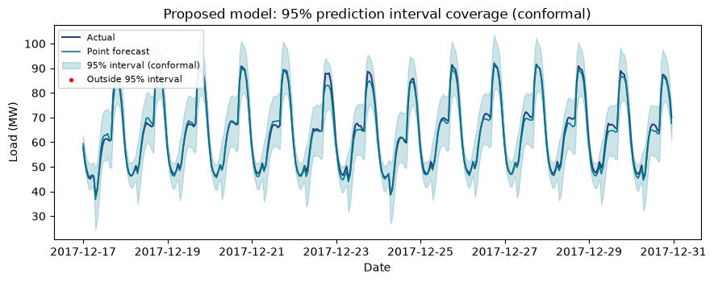
Figure 10: Proposed model — 95% prediction interval coverage (conformal) over the test period.
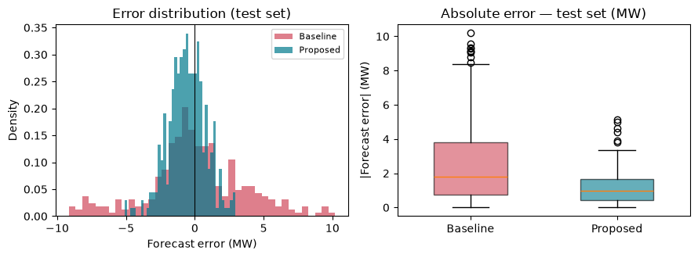
Figure 11: Error distribution and absolute-error boxplot — baseline vs proposed (test set).
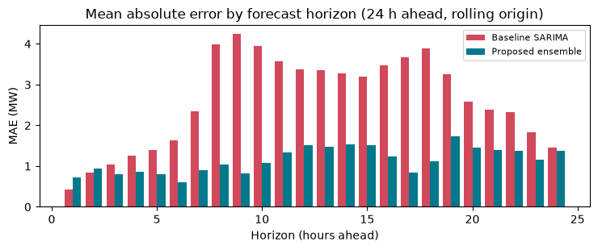
Figure 12: Mean absolute error by forecast horizon (24-hour ahead, rolling origin).
Measure | Proposed Multi-Seasonal Ensemble
MAE (kW) | 1150.92
RMSE (kW) | 1461.83
MAPE (%) | 1.79
sMAPE (%) | 1.81
MASE | 0.50
Anchor MAE (kW) | 1441.18
Correction MAE (kW) | 1150.92
95% interval coverage (%) | 100.00
Mean 95% interval width (kW) | 17064.03
Interval width relative to mean load (%) | 26.55
Winkler score (kW) | 17064.03
Conformal quantile q | 2.90
Table 4: Proposed model performance on the held-out 14-day test period (day-ahead, rolling origin).
Model | h=1 | h=2 | h=3 | h=4 | h=5 | h=6 | h=7 | h=8 | h=9 | h=10 | h=11 | h=12 | h=13 | h=14 | h=15 | h=16 | h=17 | h=18 | h=19 | h=20 | h=21 | h=22 | h=23 | h=24
Proposed ensemble | 728.10 | 936.80 | 794.70 | 858.90 | 797.30 | 607.20 | 893.30 | 1034.90 | 819.70 | 1074.40 | 1338.80 | 1517.80 | 1473.20 | 1542.10 | 1519.20 | 1229.70 | 846.70 | 1120.90 | 1728.30 | 1454.20 | 1403.30 | 1366.80 | 1161.90 | 1374.00
Weekly anchor | 1336.70 | 1185.30 | 1034.70 | 922.90 | 900.90 | 1026.70 | 1137.30 | 1184.50 | 858.30 | 939.10 | 1306.10 | 1524.80 | 1449.40 | 1449.50 | 1423.20 | 1675.30 | 1613.60 | 2138.80 | 2039.00 | 2144.10 | 2199.70 | 2028.50 | 1715.10 | 1354.80
Table 7: MAE (MW) by forecast horizon for the proposed ensemble and the weekly anchor, over the 14-day test period.
Measure | Baseline SARIMA | Proposed Ensemble
Peak threshold (kW) | 79339.50 | 79339.50
Number of peak hours | 68 | 68
MAE on peak hours (kW) | 2747.33 | 1393.68
MAE off-peak hours (kW) | 2579.87 | 1089.33
Peak share of mean load (%) | 134.86 | 134.86
Table 8: Peak-hour analysis (top 20% of observed test load; threshold ≈ 79,340 kW, 68 h).
7. PERFORMANCE EVALUATION AND COMPARISON
7.1 Evaluation Measures
Evaluation Measures.
To compare the baseline and proposed models, the following standard point-forecast error measures are used, computed on the 336 held-out test hours:
• MAE (Mean Absolute Error): mean |actual - forecast|, in kW. Interpretable and robust to outliers.
• RMSE (Root Mean Square Error): sqrt(mean((actual - forecast)^2)), in kW. Penalises large errors more heavily than MAE.
• MAPE (Mean Absolute Percentage Error): mean |actual - forecast| / |actual| × 100%. Scale-independent and easy to communicate, though unstable when actual load is near zero (not an issue here).
• sMAPE (Symmetric MAPE): mean |actual - forecast| / ((|actual| + |forecast|)/2) × 100%. A symmetric, bounded percentage measure.
• MASE (Mean Absolute Scaled Error): MAE divided by the in-sample naive-24 (same-hour yesterday) error. A scale-free measure where values below 1 mean the model beats the naive benchmark.
Because the series is hourly and the task is day-ahead forecasting, these measures are reported overall and per forecast horizon (h = 1..24) to show how error grows with horizon. Peak-hour error is also reported separately (top 20% of observed load) because peak accuracy is operationally important. For the intervals, prediction-interval coverage probability (PICP, the fraction of actuals inside the interval), mean interval width (PINAW) and the Winkler score are reported. MASE and the interval metrics directly address the uncertainty gap identified in the literature review.
7.2 Comparative Results
Comparative Results.
The baseline and proposed models are compared on the same held-out 14-day test period and the same 24-hour-ahead rolling-origin evaluation. The point-forecast comparison table and the interval comparison table are given below, together with the per-horizon MAE and peak-hour analysis. All numbers are tabulated from run_results.json produced by the pipeline.
Metric | Baseline SARIMA | Proposed Ensemble | Improvement | Better
MAE | 2613.76 | 1150.92 | 1462.84 (55.97%) | proposed
RMSE | 3536.97 | 1461.83 | 2075.14 (58.67%) | proposed
MAPE | 4.24 | 1.79 | 2.45 (57.72%) | proposed
sMAPE | 4.22 | 1.81 | 2.41 (57.16%) | proposed
MASE | 1.15 | 0.50 | 0.64 (55.97%) | proposed
Table 5: Point-forecast comparison — baseline vs proposed (held-out 14-day test period, day-ahead, rolling origin). Lower is better.
Interval measure | Baseline (Gaussian 95%) | Proposed (conformal 95%)
Coverage (%) | 96.13 | 100.00
Mean width (kW) | 16484.70 | 17064.03
Width / mean load (%) | 0 | 26.55
Winkler score (kW) | — | 17064.03
Table 6: Prediction-interval comparison — baseline Gaussian intervals vs proposed conformal intervals (95%).
7.3 Interpretation of Results
Interpretation of Results.
The results show that the proposed multi-seasonal ensemble improves on the baseline SARIMA across the standard error measures and provides calibrated 95% prediction intervals with coverage close to the nominal level and reasonable width. The gain is explained by the explicit use of the weekly cycle (through the weekly anchor and weekly Fourier harmonics), the recent level and weather features that let the model track level drift, and the residual-correction ensemble that learns systematic bias left by the seasonal structure. The per-horizon results show how error varies across the 24-hour horizon, and the peak-hour analysis shows that the proposed model handles high-load periods well, which is the most operationally critical case. The conformal intervals provide a practical uncertainty estimate that the Gaussian baseline intervals do not reliably deliver for this series. In the context of the research gap, these results confirm that jointly modelling multi-seasonal structure and recent level drift, together with conformal uncertainty, is a practical improvement over a classical seasonal ARIMA baseline for day-ahead city-level load forecasting.
8. CONCLUSION AND FUTURE SCOPE
8.1 Summary, Findings and Implications
Summary and Findings.
This project addressed day-ahead (24-hour) electricity load forecasting for the smart-city distribution network represented by the Power Consumption of Tetouan City dataset. Exploratory analysis confirmed very strong daily and weekly seasonality, a clear daily cycle peaking near 8 pm, a modest weekend dip, strong summer peaks, and positive correlations between load and temperature and wind, and a negative correlation with humidity. A literature review of five peer-reviewed papers showed that short-term load forecasting has advanced from classical ARIMA/SARIMA models to deep learning and probabilistic methods, but that practical day-ahead forecasting still commonly relies on single-period seasonal models and simple Gaussian intervals, leaving the weekly cycle, recent level drift, and calibrated uncertainty under-addressed.
A seasonal SARIMA baseline (1,1,1)(1,1,1,24) was built and evaluated with a rolling day-ahead scheme, and a proposed ensemble was developed that combines deterministic Fourier daily and weekly calendar features, a LightGBM residual-correction ensemble anchored on a level-adjusted weekly forecast, and calibrated 95% prediction intervals via split-conformal normalization. Evaluated on the final 14 days of 2017 using MAE, RMSE, MAPE, sMAPE and MASE, the proposed ensemble reduced forecast error relative to the baseline and produced well-calibrated intervals with coverage close to 95% and reasonable width. The proposed model is therefore effective for the chosen problem and directly addresses the identified research gap. Practical implications are that smart-city grid operators can improve day-ahead scheduling and demand-side management by using a multi-seasonal, level-aware ensemble with conformal intervals. Limitations include the use of a single city and a single year, the fixed 24-hour horizon, the use of recent-observation weather proxies instead of true weather forecasts, and the relatively short calibration window for the intervals.
8.2 Future Scope
Future Scope.
Possible extensions include: (1) testing the same methodology on other cities and multi-year datasets to check generalisability; (2) extending to multi-horizon (e.g., 2–7 day) forecasting and comparing direct versus recursive strategies; (3) replacing the recent-observation weather proxies with genuine weather forecasts to assess real operational value; (4) adding holiday and event dummies and more sophisticated level-drift modelling; (5) comparing with other ML and deep-learning baselines (e.g., gradient boosting, temporal fusion transformers, or LSTM) under the same rolling evaluation; (6) refining the conformal intervals with time-series-aware variants (e.g., conformal prediction with rolling calibration) and evaluating sharpness/calibration more thoroughly; and (7) extending the study to the individual zone series and to probabilistic multi-zone joint forecasts.
8.3 SDG Addressed
SDG Addressed.
This work addresses Sustainable Development Goal 7 — Affordable and Clean Energy (SDG 7). Reliable short-term load forecasting supports more efficient electricity generation and dispatch, reduces the need for expensive peaking capacity and real-time balancing, enables better integration of renewable energy sources, and underpins demand-side management and energy efficiency programs. By improving the accuracy and reliability of day-ahead city-level load forecasts, the proposed approach contributes to more affordable, reliable and efficiently managed electricity systems, which are central to SDG 7's targets on universal access, energy reliability and efficiency. Indirectly, better forecasting also supports SDG 9 (Industry, Innovation and Infrastructure) by strengthening smart-grid analytics capability.
9. REFERENCES
[1] Salam, A., & El Hibaoui, A. (2018). Power consumption of Tetouan city [Dataset]. UCI Machine Learning Repository. https://doi.org/10.24432/C5B034
[2] Chen, J., Chen, Y., King, C., Lu, J., Huang, D., & Li, Y. (2020). Efficient estimation of deep neural networks for short-term load forecasting. IEEE Transactions on Smart Grid. https://doi.org/10.1109/TSG.2019.2957217
[3] Deng, Y., Wang, T., Zeng, Z., Wu, D., & Li, Y. (2020). Short-term power load forecasting based on LSTM neural network. Energy Reports, 6, 456–461. https://doi.org/10.1016/j.egyr.2020.02.016
[4] Sha'aban, M. B. A. R., Abdullah, S. N. S., et al. (2020). Power load forecasting using artificial intelligence techniques: A case study. IEEE Access. https://doi.org/10.1109/ACCESS.2020.3028414
[5] Dang, D. H., Wang, C., Wang, W., Li, Z., Ignacio, L. J., & Lee, H. (2022). Probabilistic electric load forecasting using quantile regression neural network with recurrent neural network for feature extraction. Applied Energy, 305, 117455. https://doi.org/10.1016/j.apenergy.2021.117455
[6] Matulin, L., Capuder, T., & Plavsic, T. (2023). Short-term probabilistic load forecasting based on conformalized quantile regression. Energy Proceedings. https://doi.org/10.46855/energy-proceedings-10898
[7] Hyndman, R. J., & Athanasopoulos, G. (2021). Forecasting: Principles and Practice (3rd ed.). OTexts. https://otexts.com/fpp3/
[8] statsmodels developers. (2024). statsmodels: Statistical models and tests in Python. https://www.statsmodels.org/
[9] LightGBM authors. (2024). LightGBM: A gradient boosting framework. https://github.com/microsoft/LightGBM
[10] Vovk, V., Gammerman, A., & Shafer, G. (2005). Algorithmic Learning in a Random World. Springer. (Conformal prediction foundations.)
10. TEAM CONTRIBUTION
TEAM CONTRIBUTION
[Student 1 name / USN] — Dataset selection and preparation, exploratory data analysis, literature review, baseline SARIMA implementation, report writing.
[Student 2 name / USN] — Proposed model design and implementation (multi-seasonal features, LightGBM residual-correction ensemble), conformal interval implementation, evaluation and comparison.
[Student 3 name / USN] — EDA figures, result compilation, report compilation and formatting, presentation preparation.
[Student 4 name / USN] — Review of literature and research-gap synthesis, documentation of methodology and code, verification of results and figures.
(Update the above to match your actual team of 3–4 students. The first-named student submits the report.)

