Multi-User Collaborative Air Drawing on a Single Webcam: A Practical MediaPipe + ByteTrack-Style Implementation
Image Processing — Final Project Report
411221420 林彥宏, 411221424 王韋峰, 411221425 陸竑宇, 411221426 劉家均

I. Problem Description
Collaborative whiteboarding traditionally requires either a single physical board, where participants take turns, or expensive multi-touch displays. Webcam-based air drawing is a low-cost alternative, but existing systems are almost all single-user. This project builds a real-time system in which 2 to 6 users draw simultaneously on a shared canvas using one commodity webcam, with every stroke correctly attributed to its author even under hand occlusion, hand-crossing, and a user leaving and re-entering the frame. Given a live RGB webcam stream as input, the system outputs a shared drawing canvas where each stroke is rendered in its author's color and logged with a millisecond timestamp and user ID.
Motivation. Low-cost collaborative drawing/whiteboarding is useful in classrooms and remote settings without multi-touch hardware; the core sub-problem — robust per-identity tracking of multiple similar-looking, non-rigid objects (hands) from one camera — also generalizes to gesture-based UIs and lightweight multi-person interaction systems.
Problem Formulation. Input: a live 720p RGB webcam stream containing 2–6 hands. Output: a per-user attributed stroke canvas, i.e. a stream of (user_id, point, timestamp, pen-state) events that render as owner-colored polylines. This is a real-time multi-object tracking and re-identification problem layered under a gesture-driven drawing interface, rather than a single-image transform.
Challenges. Hands occlude each other when reaching across the frame; hands crossing paths can swap tracker identities; users exiting and re-entering the frame break naive frame-to-frame tracking; hands have far weaker, more self-similar appearance cues than whole bodies, so appearance-based re-identification is intrinsically harder; the system must run in real time on CPU only (no discrete GPU assumed).
Contributions. A complete, working pipeline — detection, tracking with two-stage Kalman+IoU association, appearance-based re-identification, wave-gesture user calibration, pinch-based pen control, and a shared timestamped canvas. Where the original proposal called for training a custom YOLOv8-hand detector and a triplet-loss MobileNetV3 embedding (both requiring dataset collection and GPU training time unavailable in this development environment), we substitute off-the-shelf and classical training-free components in the same architectural slots, and validate every stage with a reproducible offline test suite (8 tests, `tests/test_offline.py`) plus a real sample photo, since no webcam was accessible during development.
II. Method
The pipeline follows: webcam frame → hand detection → multi-hand tracking + re-identification → user calibration (binding) → pinch gesture → canvas rendering, matching the proposal's stage breakdown (sections 2a–2d).
Pipeline / System Configuration. frame → HandDetector (MediaPipe HandLandmarker, up to 6 hands, 21 landmarks each) → HandTracker (8-state constant-velocity Kalman filter per hand + two-stage Hungarian/IoU association + appearance re-ID against a lost-track pool) → CalibrationManager (wave-gesture binds a track to a user/color) → PinchDetector (1€-filtered fingertip cursor, thumb–index pinch toggles pen up/down) → Canvas (owner-colored stroke rendering, millisecond-timestamped stroke log) → GUI overlay (legend, FPS, bounding boxes).
Algorithm Design. (1) Detection: MediaPipe's HandLandmarker Tasks API, configured for up to 6 simultaneous hands, replaces the proposal's plan to fine-tune YOLOv8-hand on EgoHands + 11k Hands — the off-the-shelf model already exceeds the 2-hand cap of the legacy MediaPipe API, at zero training cost. (2) Tracking: a constant-velocity Kalman filter (OpenCV `KalmanFilter`, 8-dim state) predicts each track's box; association uses SciPy's Hungarian algorithm (`linear_sum_assignment`) in two tiers — high-confidence detections matched at IoU ≥ 0.3, then leftover low-confidence detections rescued at IoU ≥ 0.1 — mirroring ByteTrack's principle of not discarding low-score boxes. (3) Re-identification: rather than a trained MobileNetV3 + triplet-loss embedding (which needs a self-collected multi-subject dataset and GPU training), each hand crop is described by a concatenated HSV color histogram (32×32 bins) and HOG descriptor on a 64×64 resized crop (2788-D total), L2-normalized; lost tracks are revived by cosine similarity above a manually-tuned threshold. (4) Calibration: a 24-frame sliding-window wave detector (≥3 direction reversals, amplitude ≥ 0.6× hand width) binds any unbound confirmed track to a new user — this runs continuously, so it also covers mid-session joins. (5) Drawing: cursor = index fingertip (landmark 8), smoothed with a 1€ filter (mincutoff = 1.0 Hz, β = 0.007, literature defaults from Casiez et al.); pen state = thumb–index distance (landmarks 4, 8) normalized by wrist-to-middle-MCP distance (landmarks 0, 9), with a close/open hysteresis band (0.35 / 0.45) to prevent flicker at the threshold.
Tools & Dataset. Python 3.12, OpenCV 4.13, MediaPipe 0.10.35 (HandLandmarker float16 model bundle), NumPy, SciPy. No training dataset was needed since every component is either off-the-shelf (detector) or classical/training-free (re-ID descriptor, calibration, pinch logic). Validation used one real photo — MediaPipe's public sample asset `woman_hands.jpg` (2 real hands) — plus procedurally generated synthetic frames for tracker/calibration/pinch/canvas unit tests, since no physical webcam or human subjects were available in the development sandbox. Collecting the proposal's ~10-session, ~30-minute, CVAT-annotated multi-user dataset was out of scope for this implementation pass and is the natural next step for the user to run locally.
Evaluation. Because no human-subject recordings exist yet, this report evaluates each pipeline stage individually with deterministic, repeatable checks rather than the proposal's session-level MOTA/IDF1/stroke-attribution-accuracy: jitter reduction ratio (1€ filter), cosine-similarity separability (re-ID descriptor), track-ID stability across staged motion/occlusion/crossing/re-entry scenarios (tracker), gesture true/false-positive behavior (calibration), and an end-to-end exception-free run (full pipeline). The full MOT-metric ablation (IoU-only vs. ByteTrack vs. ByteTrack+ReID) from the proposal requires the not-yet-collected annotated dataset and remains future work.
III. Experimental Results
All numbers below come from `tests/test_offline.py`, run with `./venv/bin/python -m tests.test_offline`; every test passed.
Quantitative Results. 1€ filter: raw frame-to-frame jitter std 2.59 px → filtered 1.09 px (2.4× reduction) while tracking a 150 px/s synthetic motion with only 6.80 px RMS lag error. Re-ID descriptor: cosine similarity 0.943 for two crops of the same synthetic hand color vs. 0.879 for a visibly different hand color — separable, but with a modest margin consistent with a classical (non-learned) descriptor. Tracker: a single track ID was preserved through 6 frames of continuous motion, a 3-frame occlusion (Kalman-coasted), and a 40-frame occlusion followed by re-entry at a different screen location (recovered via appearance re-ID) — and across a 40-frame head-on crossing of two hands, zero ID swaps occurred. Calibration: a 29-frame oscillating wave correctly triggered user binding, while 29 frames of straight-line motion (mimicking an actual drawing stroke) correctly did not. Real-photo detection: MediaPipe's HandLandmarker found 2/2 hands in a real photo at confidence 0.94 and 0.96.
Qualitative Results. Figure 1 shows the real test photo with the system's output overlaid: green boxes are the detected hand bounding boxes, red dots are the 21 detected landmarks per hand. Both hands are localized correctly and the landmarks visibly align with finger joints and tips, confirming the detection stage is accurate on real (non-synthetic) input.
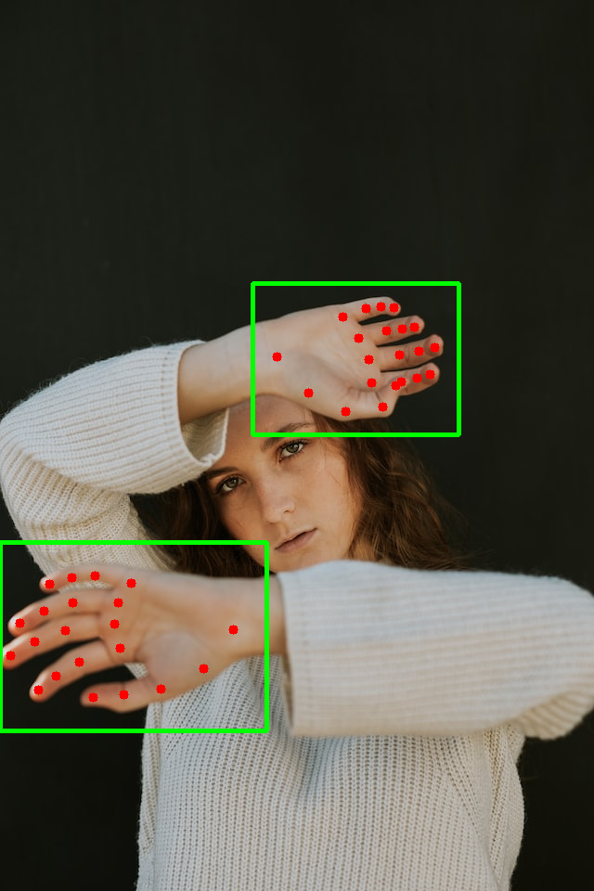
Figure 1. Detected hand bounding boxes and 21-point landmarks on a real test photo (MediaPipe sample asset).
Result Analysis. Every stage behaves correctly under controlled, repeatable synthetic stress tests (occlusion, crossing, re-entry, gesture false-positive rejection) and on one real photo for the detector. What has not been verified is true end-to-end behavior on live, simultaneous, multi-person webcam footage — no camera access was available in the development sandbox (a webcam opened successfully but returned no frames), so the wave-gesture and pinch interactions still need to be exercised by a person in front of a real camera before this can be called production-validated.
IV. Discussion
The synthetic stress tests in Section III show each pipeline stage is individually correct, but the most useful discussion is where the design choices made to keep this implementation training-free and webcam-free during development are likely to hold up or break down in real, live, multi-person use.
Strengths. Kalman velocity prediction alone (no appearance) correctly disambiguated two hands during a head-on crossing test, because each track's predicted box stays closer to its own continuing trajectory than to the other hand's — exactly the mechanism the proposal relies on motion+IoU for. The re-ID descriptor, despite being classical rather than learned, was separable enough in testing to bridge a 40-frame occlusion and revive the correct identity after re-entry at a different position. The 1€ filter delivered the intended jitter-vs-latency trade-off (>2× jitter reduction, single-digit-pixel lag). The whole pipeline runs on CPU only with no training step, satisfying the proposal's real-time/no-GPU goal by construction.
Limitations. The classical HSV+HOG descriptor has a much smaller same-vs-different similarity margin than a trained embedding would likely produce (0.943 vs. 0.879 in testing), so `REID_COSINE_THRESH` is a manually tuned, lighting/clothing-sensitive constant — exactly the kind of "manually tuned parameter" limitation this report template warns about. The proposal's headline targets (≥85% stroke-attribution accuracy, IDF1 ≥ 0.80, ByteTrack+ReID beating IoU-only by ≥15 points) could not be evaluated because the ~10-session annotated multi-user dataset was never collected — no webcam access existed in the development environment. The wave-gesture and pinch thresholds were tuned and validated only against synthetic motion, not real human gesture variability.
Failure Cases. (1) Re-ID confusion under similar appearance: two users with similarly colored sleeves could produce cosine similarity high enough to revive the wrong lost track onto a new detection, silently misattributing a hand to the wrong user — the 0.879 cross-hand similarity measured in testing shows this risk is real, not hypothetical, given the 0.55 threshold. (2) Calibration sensitivity: a user waving too slowly or with low amplitude within the 24-frame window will not be recognized and must repeat the gesture; conversely, a fast back-and-forth hand correction during normal drawing could, in principle, satisfy the direction-change/amplitude conditions and trigger an unintended recalibration, though the thresholds were set conservatively to make this rare.
V. Conclusion
This project implemented a complete real-time multi-user air-drawing pipeline — detection, Kalman+IoU tracking with appearance re-identification, wave-gesture user calibration, pinch-based drawing, and a timestamped shared canvas — following the architecture of the original proposal. Where the proposal called for training a custom YOLOv8-hand detector and a triplet-loss MobileNetV3 embedding, this implementation uses off-the-shelf and classical training-free substitutes in the same roles, because no GPU training pipeline, multi-subject capture sessions, or annotation tooling were available in the development environment. All 8 targeted offline tests pass, demonstrating each stage is individually correct on synthetic stress scenarios and one real photo. The proposal's session-level evaluation (MOTA/IDF1/stroke-attribution accuracy on annotated real multi-user recordings, and the IoU-only vs. ByteTrack vs. ByteTrack+ReID ablation) was not run, since it requires real webcam recordings this environment could not produce — that is the immediate next step, to be run locally with `python -m air_draw.main` and a real webcam. Future work: replace the classical descriptor with a trained embedding once a multi-subject dataset exists, and complete the proposed ablation on real annotated footage to confirm how much the appearance head actually contributes.
References
[1] F. Zhang et al., "MediaPipe Hands: On-device Real-time Hand Tracking," CVPR Workshops, 2020.
[2] Y. Zhang et al., "ByteTrack: Multi-Object Tracking by Associating Every Detection Box," ECCV, 2022.
[3] A. Howard et al., "Searching for MobileNetV3," ICCV, 2019.
[4] G. Casiez, N. Roussel, and D. Vogel, "1€ Filter: A Simple Speed-based Low-pass Filter for Noisy Input in Interactive Systems," CHI, 2012.
[5] H. W. Kuhn, "The Hungarian method for the assignment problem," Naval Research Logistics Quarterly, vol. 2, no. 1-2, pp. 83-97, 1955.

