Chest Disease Detection using CNN AI Algorithm

In this project as per your request we have employed CNN and traditional machine learning algorithms like Random Forest and Decision tree to detect various viral chest disease infections. Each algorithm performance is evaluated in terms of precision, recall, accuracy, confusion matrix and FSCORE. Among all algorithms CNN is giving best detection accuracy. To train above algorithms we have used NIH Chest X-ray dataset which consists of 15 various diseases but we took 4 classes such as Fibrosis, Normal, Inflammation and Pneumonia and this dataset can be downloaded from below URL

<https://www.kaggle.com/datasets/nih-chest-xrays/data>



In above screen can see possible classes found in dataset and above dataset we have one more class as ‘No Findings’ which consider as normal. We took above classes chest X-ray images and then saved in dataset folder like below screen

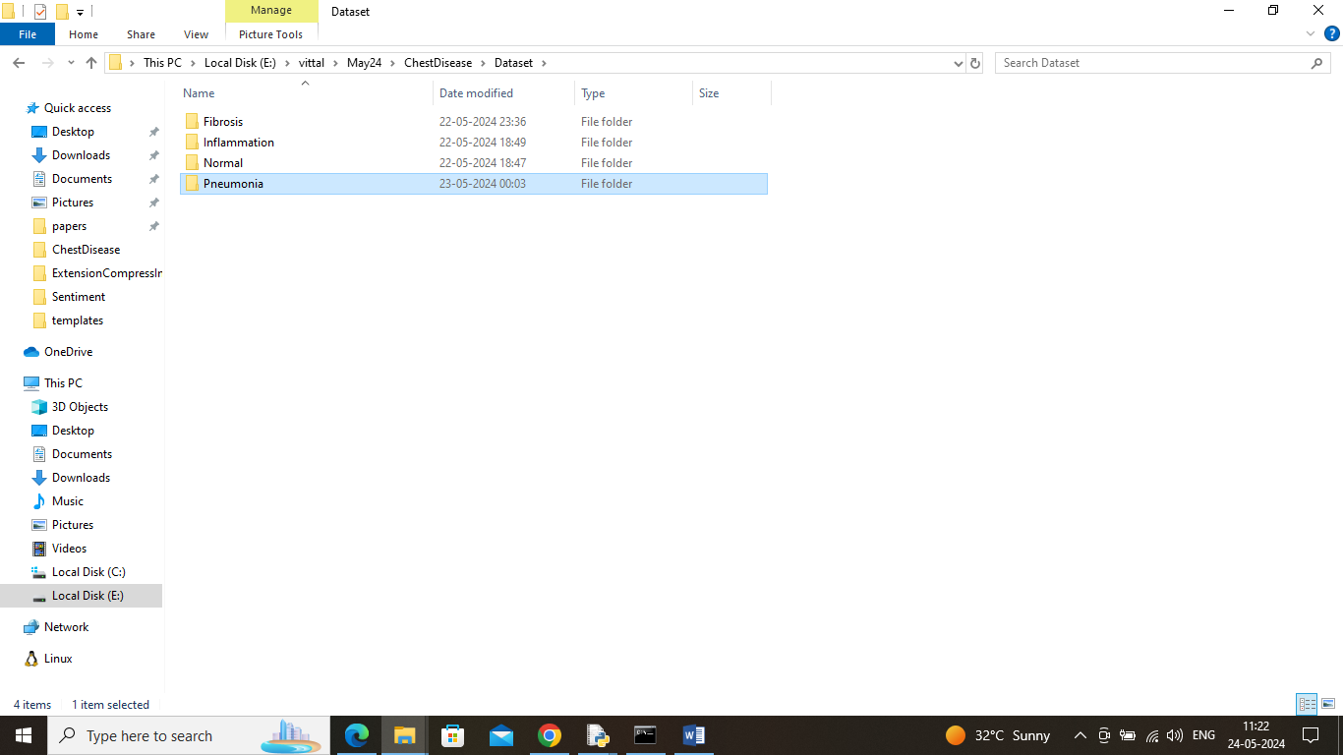

In above screen can see dataset contains 4 folders and go inside any folder to view related images like below screen

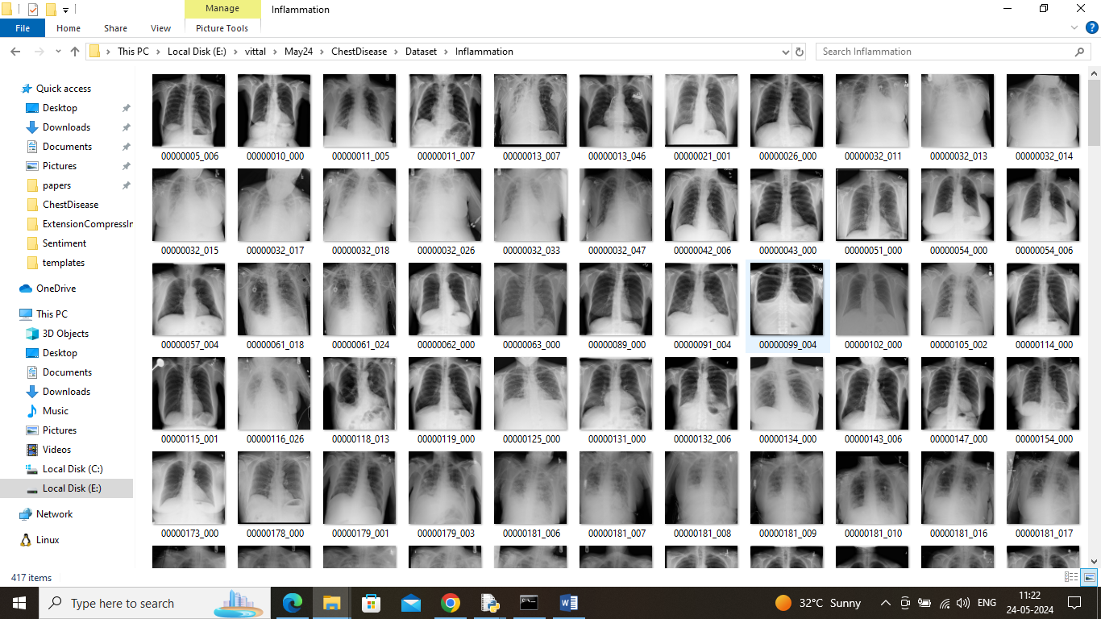

So by using above chest X-ray imaging will train AI algorithms to detect type of chest disease.

SCREEN SHOTS

To run the project double click on run.bat file

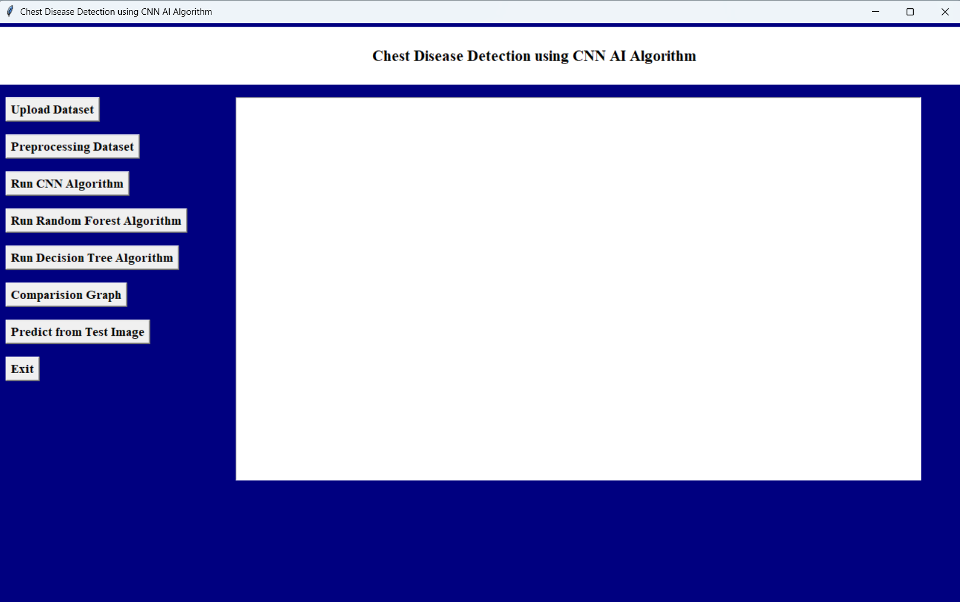

In above screen connecting to dataset folder and then looping and reading all images and then resizing to equal size and then creating X and Y training array where X will contains image features and Y will contains labels and then in blue color text can see total number of images loaded

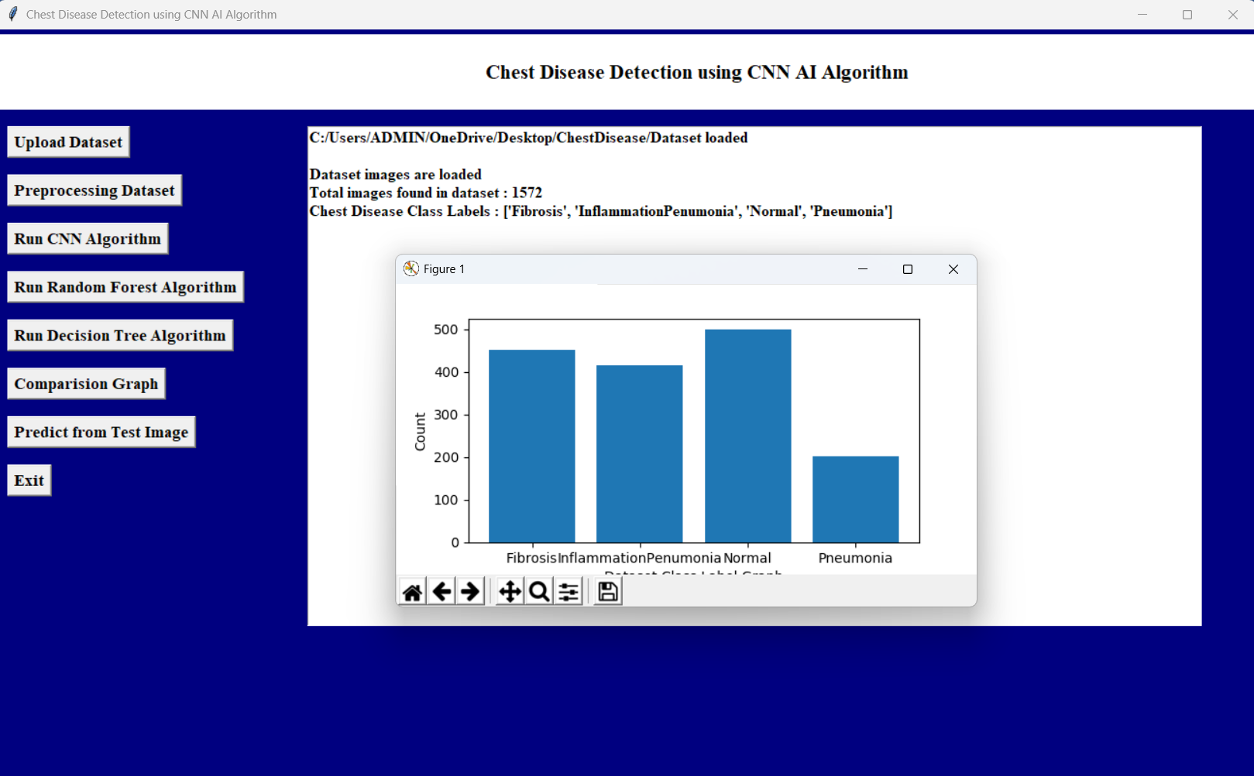

In above screen displaying graph with different class labels and there image counts and in above graph x-axis represents Class label and y-axis represents image count found in that class label

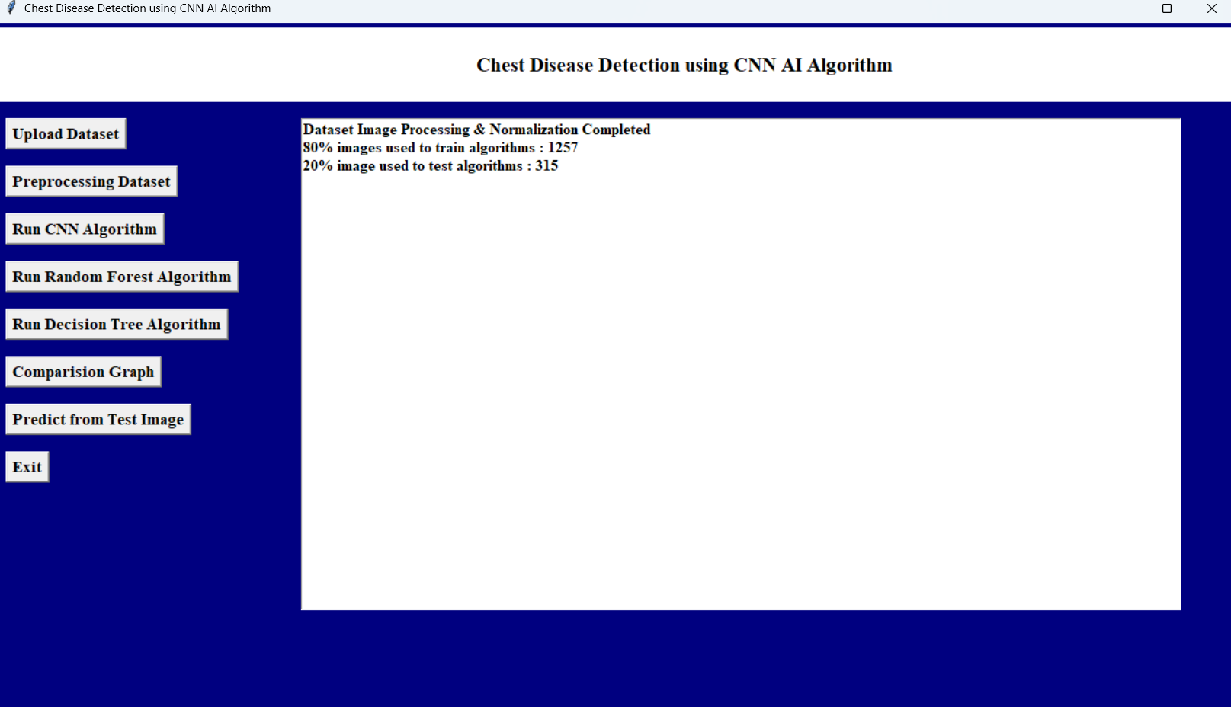

In above screen applying image processing techniques like shuffling, normalizing and then splitting all images into train and test where application using 80% images for training and 20% for testing and then can see train and test size

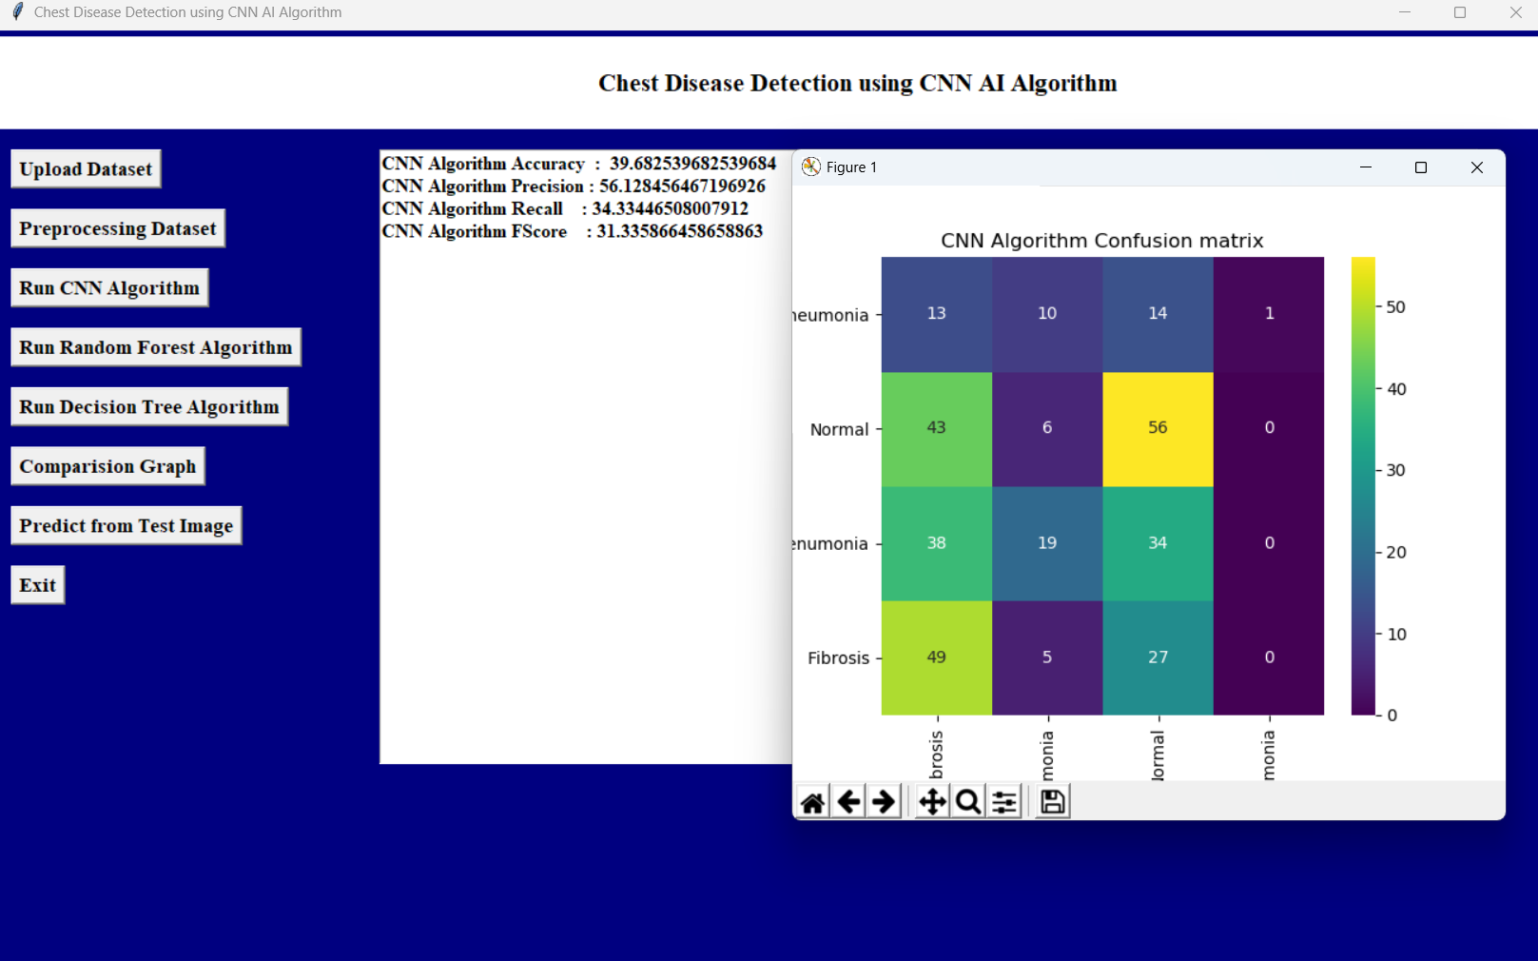

In above screen defining CNN algorithm layers for features filtration and training and then generate a train model and this model will be applied on test data to get below output In above confusion matrix graph x-axis represents ‘Predicted Labels’ and y-axis represents true labels and then all different color boxes in diagnol represents correct prediction count and remaining blue boxes represents incorrect prediction count which are very few

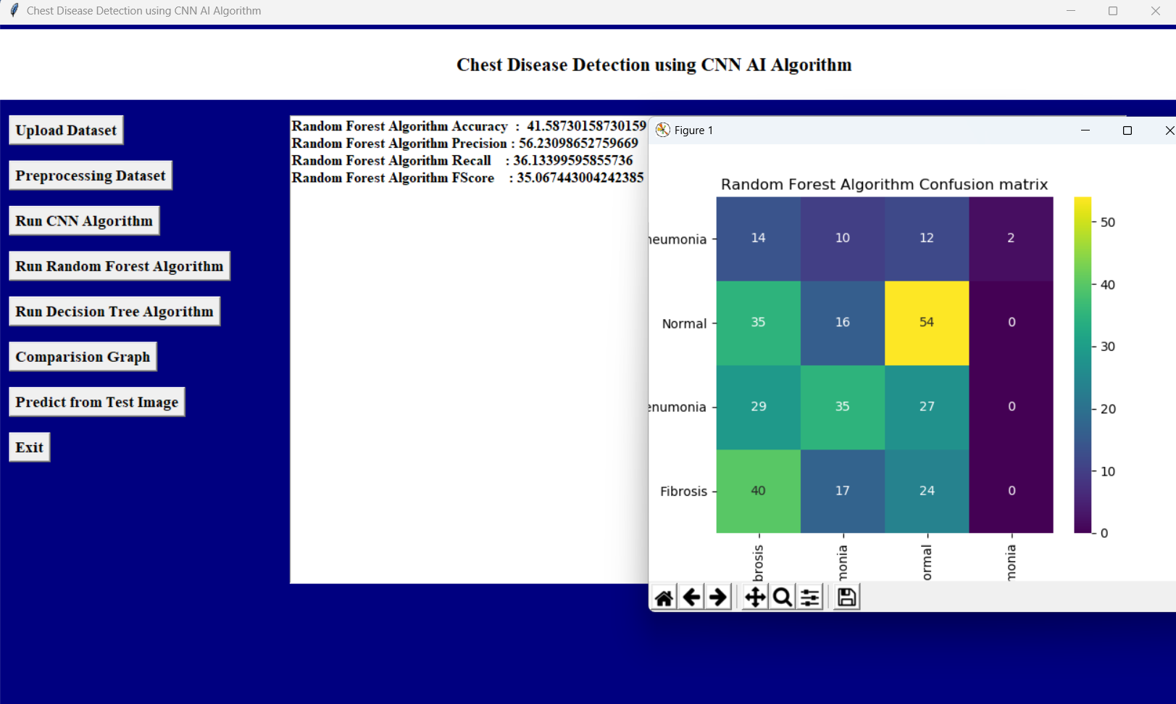

In above screen Random Forest got 40% accuracy and can se other metrics also

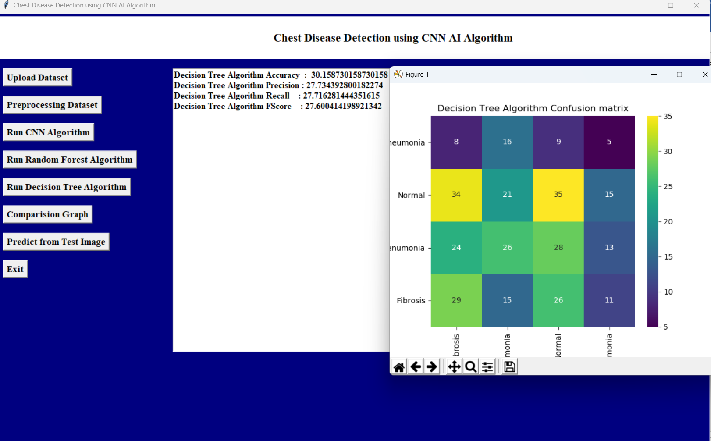

In above screen decision tree got 32% accuracy and can see other metrics also

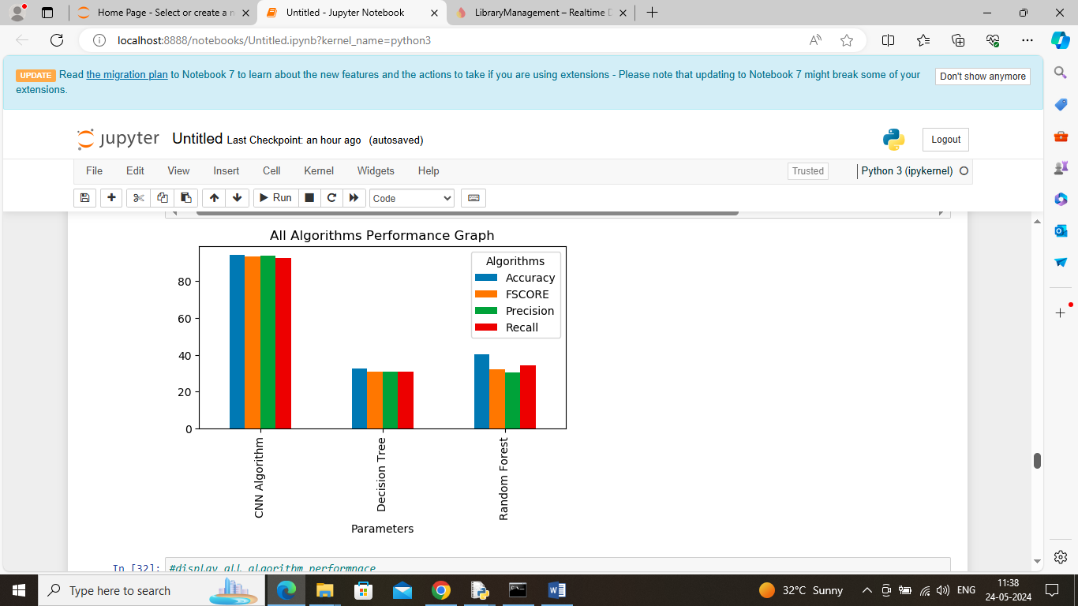in above graph showing comparison between all algorithms where x-axis represents algorithm names and y-axis represents accuracy and other metrics in different color bars and in all algorithms CNN got best performance

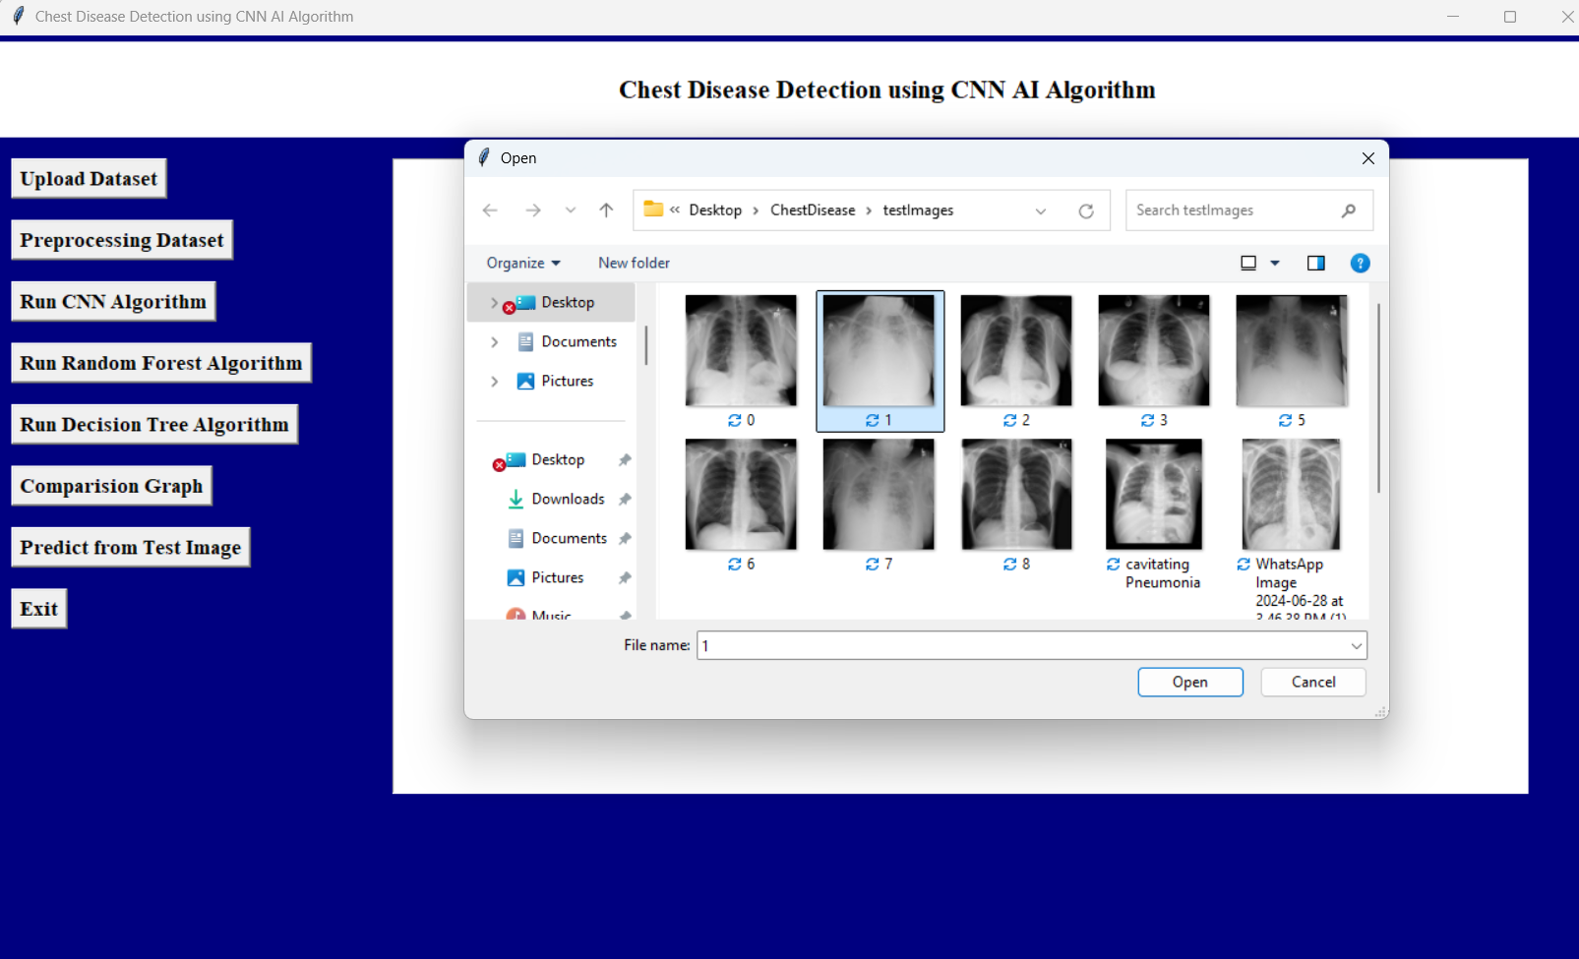

In above screen defining predict function which will take image path as input and then extract features and then apply CNN model to predict type of chest infection from x-ray image

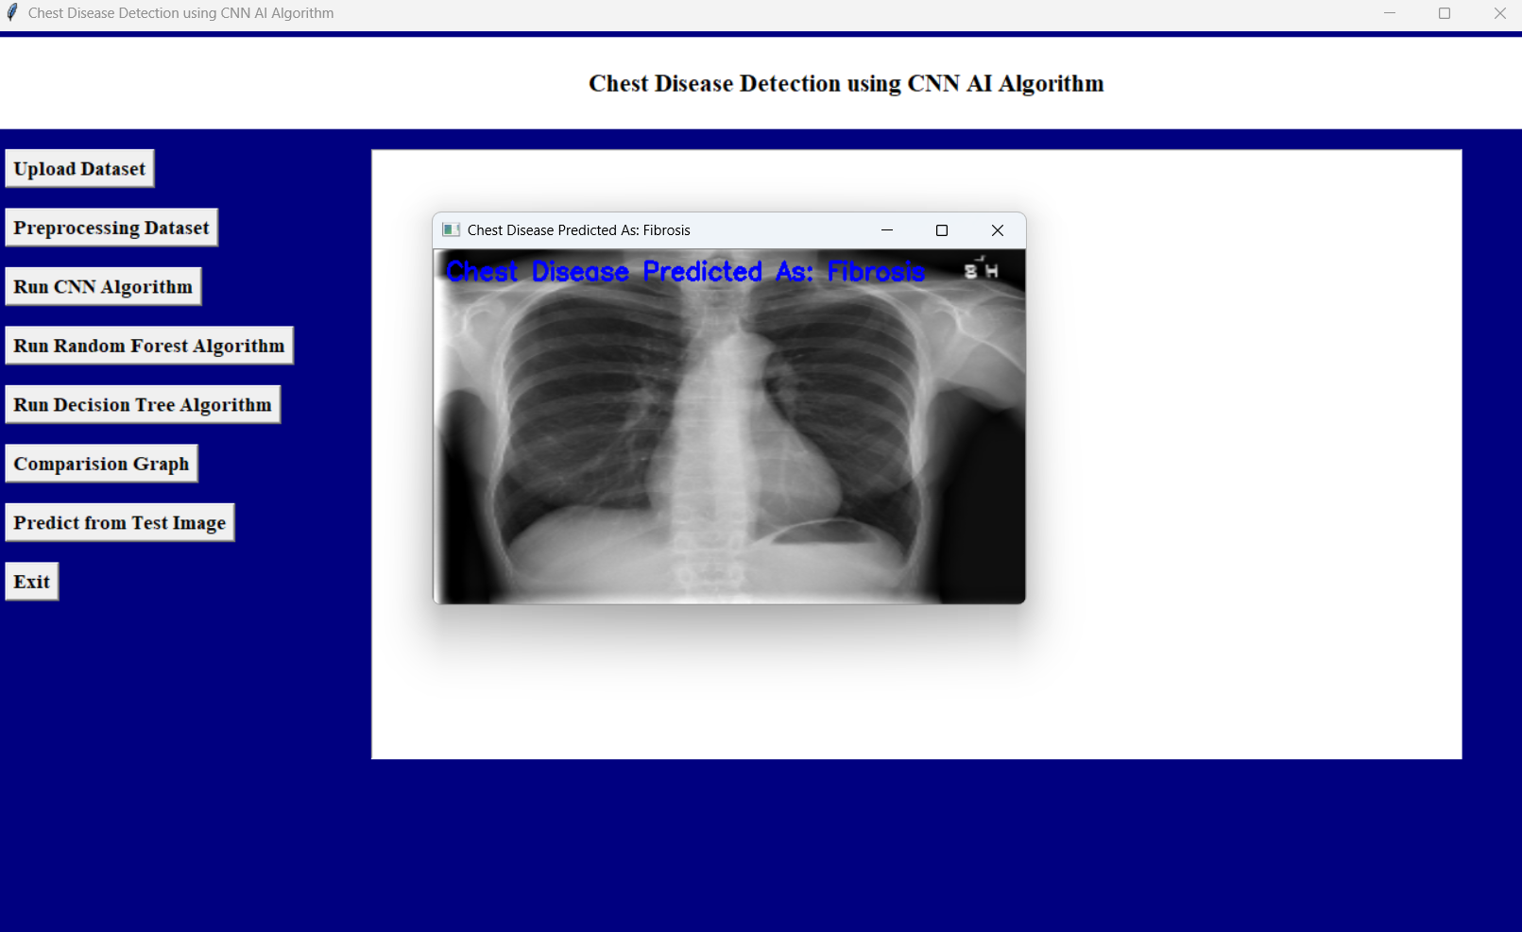

In above screen calling predict function with image path and then CNN detected ‘Fibrosis’ from given image

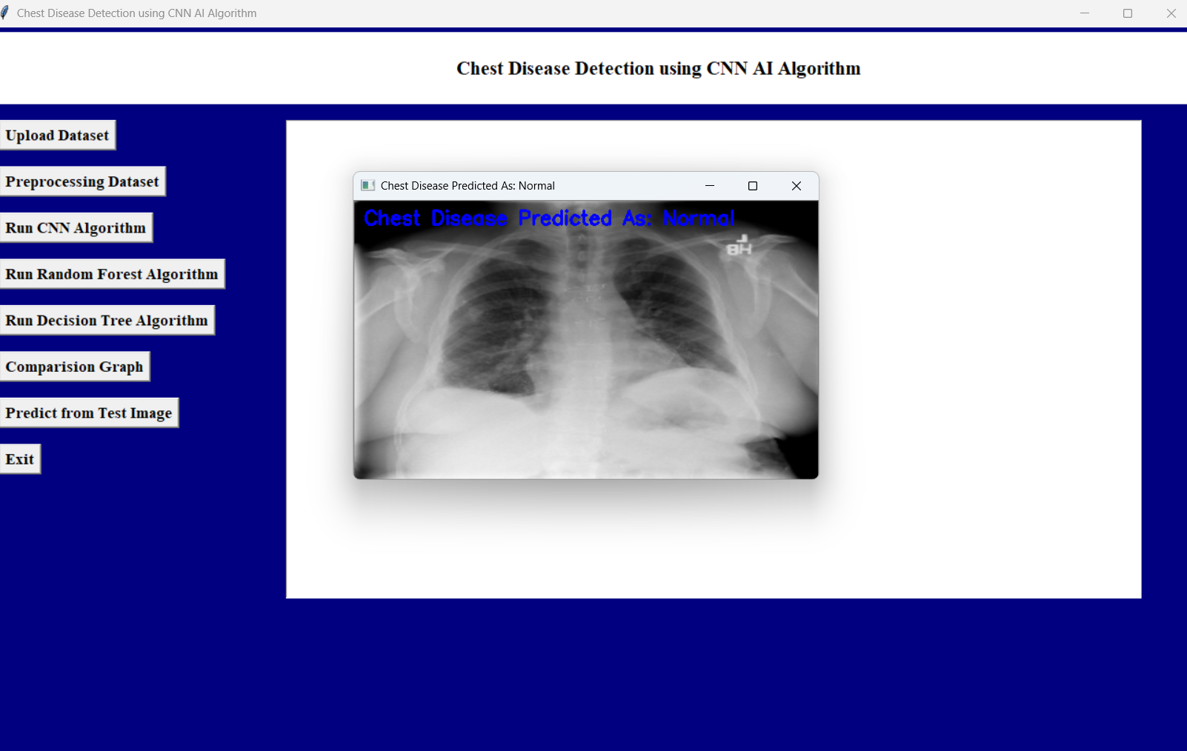

above screen normal detected

Similarly by giving input image path CNN model can detect type of chest infection