Integrated Gradients (IG) Summary Tables & Figures
This document is auto-generated from ig_one_demo.csv and ig_global_top.csv.

Table 1. Single-case IG Top-10 (normalized)
feature | ig_abs | ig_norm
pathology_fig | 2.608515 | 0.255809
cytology_grade | 2.142649 | 0.210123
HPV_overall | 1.095433 | 0.107426
HPV16 | 0.722094 | 0.070814
atypical_vessels | 0.669578 | 0.065664
HPV_other_hr | 0.593330 | 0.058186
child_alive | 0.496913 | 0.048731
iodine_negative | 0.470708 | 0.046161
menopausal_status | 0.449009 | 0.044033
parity | 0.367291 | 0.036019

Figure 1. Single-case IG (Top features).
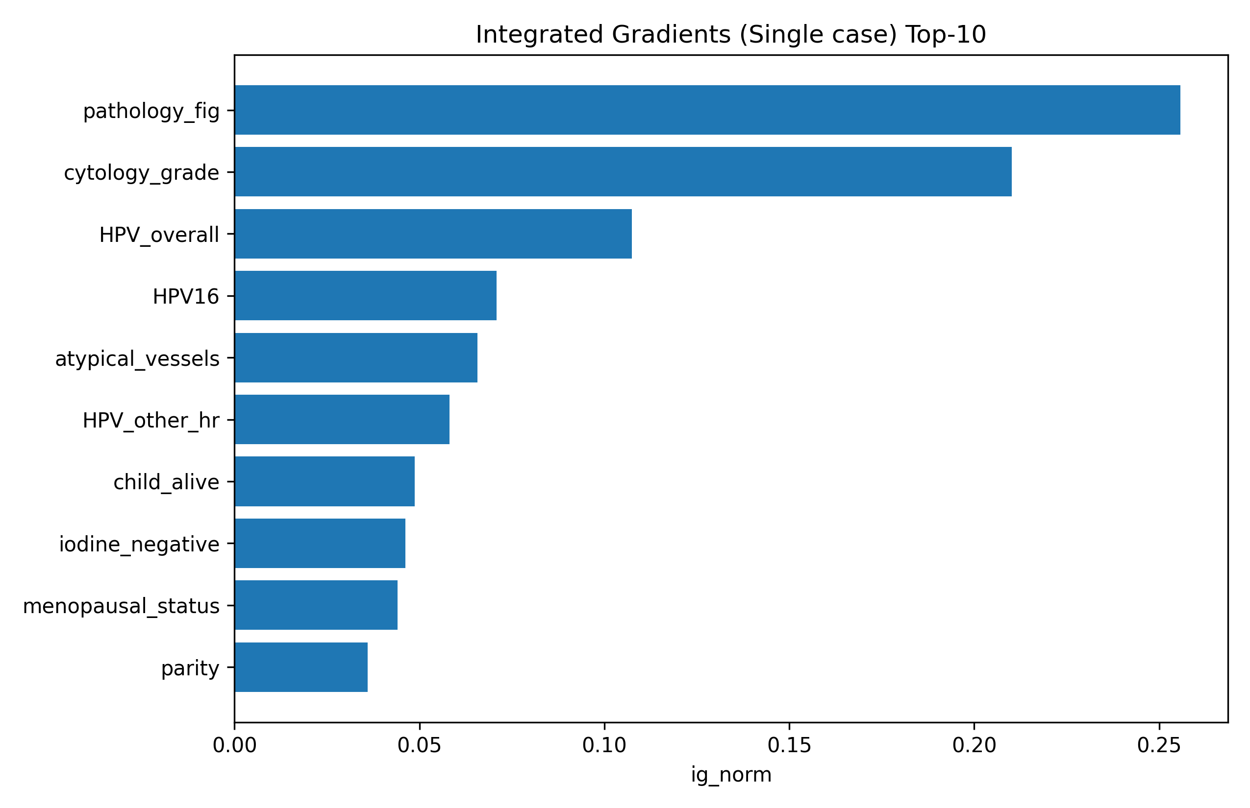

Table 2. Global IG Top-15 (mean normalized)
feature | mean_ig_abs | mean_ig_norm
HPV_overall | 1.515611 | 0.128040
HPV16 | 1.306994 | 0.110416
child_alive | 1.276928 | 0.107876
iodine_negative | 1.028309 | 0.086872
menopausal_status | 0.900790 | 0.076099
TZ_type | 0.860023 | 0.072655
cytology_grade | 0.825462 | 0.069736
parity | 0.653393 | 0.055199
age | 0.649110 | 0.054837
atypical_vessels | 0.631025 | 0.053309
HPV_other_hr | 0.548027 | 0.046298
pathology_fig | 0.541492 | 0.045746
colpo_impression | 0.434511 | 0.036708
HPV18 | 0.380057 | 0.032107
gravidity | 0.285292 | 0.024102

Figure 2. Global IG (Top features).
