西安交通大学实验报告
课程_ 计算机程序设计 实验名称 继承(类的派生) 第 1 页
系 别______钱学森学院_____ 实 验 日 期 2019 年5月 9 日
专业班级__ 钱学森班83班 _ 组别_____________
实 验 报 告 日 期 2019 年 5月9日
姓 名___李庆尧___学号__2160506114____ 报 告 退 发 ( 订正 、 重做 )
同 组 人_________________________________ 教 师 审 批 签 字

- 实验目的
（1）掌握不同继承方式下对基类的成员的访问的控制。
二.实验内容
（－）实验题目一：
（必做题）从类Person中派生出一个教师类，新增的属性有：专业，职称和主讲课程（一门），并为这些属性定义相应的方法。
1.程序源代码
#include<iostream>
#include<cstring>
using namespace std;
class Person{
protected:
char Name[20];
char Sex;
int Age;
public:
Person(char *name,int age,char sex){
Register(name,age,sex);
}
void Register(char *name,int age, char sex){
strcpy(Name,name);
Age=age;
Sex=(sex=='m'?'m':'f');
}
void ShowMe(){
cout<<Name<<'\t'<<Age<<'\t'<<Sex<<endl;
}
~Person(){}
};
class Teacher:public Person{
char major[20];
char pro[20];
char course[20];
public:
Teacher(char *name,int age, char sex,char *major,char *pro,char *course):Person(name,age,sex){
strcpy(this->major,major);
strcpy(this->pro,pro);
strcpy(this->course,course);
}
void change_data(char *name,int age, char sex,char *major,char *pro,char *course);
void show_data();
~Teacher(){}
};
void Teacher::change_data(char *name="wu",int age=1, char sex='m',char *major="math",char *pro="math",char *course="math"){
Register(name,age,sex);
strcpy(this->major,major);
strcpy(this->pro,pro);
strcpy(this->course,course);
}
void Teacher::show_data(){
ShowMe();
cout<<"专业："<<major<<endl;
cout<<"职称："<<pro<<endl;
cout<<"主讲课程："<<course<<endl;
}
int main(){
Teacher t("Simon",24,'m',"math","professor","math");
cout<<"初始值："<<endl;
t.show_data();
t.change_data("Simon",30,'m',"math","professor","math");
cout<<"修改之后："<<endl;
t.show_data();
}2.实验结果
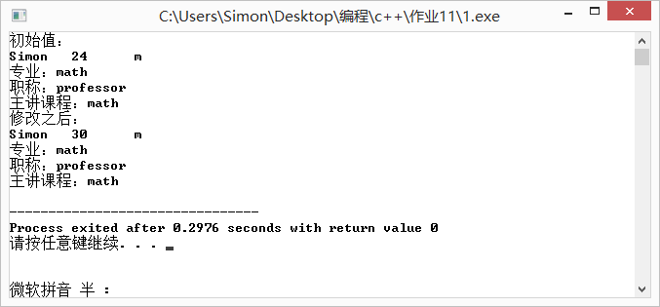
（二）实验题目二：
许多研究生既有学生的属性，又有教师的属性。试通过多重继承说明一个研究生类。
1.程序源代码：
#include<iostream>
#include<cstring>
using namespace std;
class Person{ // 人
protected:
char Name[20];
char Sex;
int Age;
public:
Person(char *name,int age,char sex){
Register(name,age,sex);
}
void Register(char *name,int age, char sex){
strcpy(Name,name);
Age=age;
Sex=(sex=='m'?'m':'f');
}
void ShowMe(){
cout<<Name<<'\t'<<Age<<'\t'<<Sex<<endl;
}
~Person(){}
};
class Teacher:public Person{ // 老师
protected:
char major[20];
char pro[20];
char course[20];
public:
Teacher(char *name,int age, char sex,char *major,char *pro,char *course):Person(name,age,sex){
strcpy(this->major,major);
strcpy(this->pro,pro);
strcpy(this->course,course);
}
void change_data(char *name,int age, char sex,char *major,char *pro,char *course);
void show_data();
~Teacher(){}
};
void Teacher::change_data(char *name=(char*)"wu",int age=1, char sex='m',char *major=(char*)"math",char *pro=(char*)"math",char *course=(char*)"math"){
Register(name,age,sex);
strcpy(this->major,major);
strcpy(this->pro,pro);
strcpy(this->course,course);
}
void Teacher::show_data(){
ShowMe();
cout<<"专业："<<major<<endl;
cout<<"职称："<<pro<<endl;
cout<<"主讲课程："<<course<<endl;
}
class Student:public Person{ // 学生
protected:
char Id[12];
char Class[12];
public:
Student(char *name,int age,char sex,char *id,char *Class);
void show_sdata();
~Student(){}
};
Student::Student(char *name=(char*)"simon",int age=1,char sex='m',char *id=(char*)"12345678912",char *Class="class 2"):Person(name,age,sex){
strcpy(Id,id);
strcpy(this->Class,Class);
}
void Student::show_sdata(){
ShowMe();
cout<<"ID:"<<Id<<endl;
cout<<"Class:"<<Class<<endl;
}
class Graduates:public Student,public Teacher{
private:
char subject[10];
public:
Graduates(char *name,int age,char sex,char *id,char *Class,char *major,char *pro,char *course,char *subject)
:Student(name,age,sex,id,Class),Teacher(name,age,sex,major,pro,course){
strcpy(this->subject,subject);
}
void show();
~Graduates(){}
};
void Graduates::show(){
show_sdata();
cout<<"专业："<<major<<endl;
cout<<"职称："<<pro<<endl;
cout<<"主讲课程："<<course<<endl;
cout<<"研究课题："<<subject<<endl;
}
int main(){
Graduates g("Simon",25,'m',"123456","class 2","math","talker","math","high level math");
g.show();
return 0;
}2.实验结果
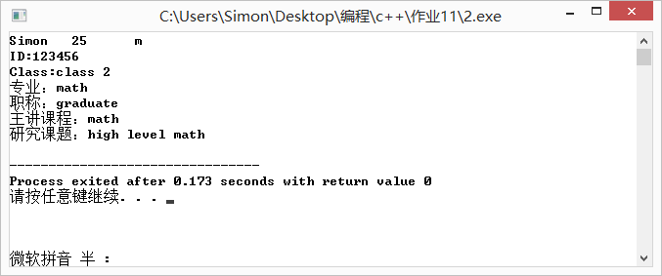
（三）实验题目三：修改例7-8，从point类中派生出以恶Line类，Line类增加一个数据成员Endpoint 计算线的长度，试比较一下与直接使用Point类来构造Line类的不同之处。
1.程序源代码
#include<iostream>
#include<cmath>
using namespace std;
class Point{
double x,y;
public:
Point(double x,double y);
void setPoint(double,double);
double getX(){
return x;
}
double getY(){
return y;
}
void print();
~Point(){}
};
void Point::setPoint(double a,double b){
x=a;
y=b;
}
Point::Point(double x=0.0,double y=0.0){
this->x=x;
this->y=y;
}
void Point::print(){
cout<<'['<<x<<","<<y<<']'<<endl;
}
class Line:public Point{
private:
Point startPoint;
Point endPoint;
double length;
public:
Line(double x1,double y1,double x2,double y2){
setLine(x1,y1,x2,y2);
};
void setLine(double,double,double,double);
void EndPoint();
void show();
~Line(){}
};
void Line::setLine(double x1,double y1,double x2,double y2){
startPoint.setPoint(x1,y1);
endPoint.setPoint(x2,y2);
}
void Line::EndPoint(){
double x1=startPoint.getX();
double x2=endPoint.getX();
double y1=startPoint.getY();
double y2=endPoint.getY();
length=sqrt((x2-x1)*(x2-x1)+(y2-y1)*(y2-y1));
}
void Line::show(){
cout<<"起点为：";
startPoint.print();
cout<<"终点为：";
endPoint.print();
cout<<"长度为："<<length;
}
int main(){
Line l(2,3,4,5);
l.show();
}3.实验结果
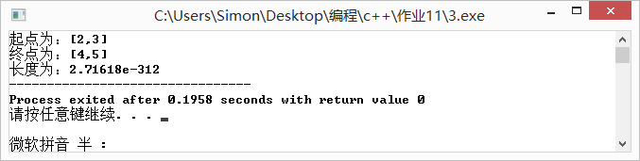
（四）实验题目四：从Date类和Time类派生一个DateAndTime类，修改相应的成员函数，当时间递增到新的一天时，应能修改日期值。
1.程序源代码：
#include<iostream>//取消构造函数
#include<time.h>
#include<windows.h>
using namespace std;
class Time{
protected:
int hour;
int minute;
int second;
public:
Time(int hour=0,int minute=0,int second=0){
this->hour=hour;
this->minute=minute;
this->second=second;
}
void show(){
cout<<hour<<":"<<minute<<":"<<second;
}
~Time(){}
};
class Date
{
protected:
int year,month,day;
void SetSystemDate(); //取得系统日期
public:
Date(int y=1900,int m=1,int d=1) //构造函数
{
year = y; month = m; day = d;
}
void init(int,int,int ); //设置年月日数据
void print_ymd(); //显示年月日
void print_mdy(); //显示月日年
int get_year() { return year; } //得到年份值
int get_month() { return month; } //得到月份值
int get_day() { return day; } //得到日值
bool IsLeapYear(); //判断是否为闰年
};
void Date::SetSystemDate()
{
//取得系统日期
tm *gm;
time_t t=time(NULL);
gm = gmtime(&t);
year = 1900 + gm->tm_year;
month = gm->tm_mon +1;
day = gm->tm_mday;
}
void Date::init(int yy,int mm,int dd)
{
if (yy>=1900&&yy<=9999)
year = yy;
else
{
SetSystemDate();
return;
}
if (mm>=1&&mm<=12)
month = mm;
else
{
SetSystemDate();
return;
}
if (dd>=1&&dd<=31)
day = dd;
else
{
SetSystemDate();
return;
}
};
void Date::print_ymd()
{ cout<<year<<"-"<<month<<"-"<<day;}
void Date::print_mdy()
{ cout<<month<<"-"<<day<<"-"<<year;}
bool Date::IsLeapYear()
{
if ( year % 400 == 0 || ( year % 100 != 0 && year % 4 == 0 ) )
return true;
return false;
}

class DateAndTime:public Date,public Time{
public:
DateAndTime(int y,int m,int d,int h,int mi,int s);
void init(int,int,int,int,int,int);
void showDateAndTime();
void timeUp();
~DateAndTime(){}
};
DateAndTime::DateAndTime(int y,int m,int d,int h,int mi,int s):Date(y,m,d),Time(h,mi,s){
timeUp();
}
void DateAndTime::init(int yy,int mm,int dd,int h,int mi,int s){
if (yy>=1900&&yy<=9999)
year = yy;
else
{
SetSystemDate();
return;
}
if (mm>=1&&mm<=12)
month = mm;
else
{
SetSystemDate();
return;
}
if (dd>=1&&dd<=31)
day = dd;
else
{
SetSystemDate();
return;
}
this->hour=hour;
this->minute=minute;
this->second=second;
timeUp();
}
void DateAndTime::timeUp(){
for(int i=0;;i++){
Sleep(1000);
second++;
if(second==60){
second=0;
minute++;
if(minute==60){
minute=0;
hour++;
if(hour==24){
hour=0;
day++;
if(day==31){
month++;
if(month==12){
year++;
}
}
}
}
}
showDateAndTime();
}

}
void DateAndTime::showDateAndTime(){
print_ymd();
cout<<" ";
show();
cout<<endl;
}
int main()
{
DateAndTime t(1999,10,10,23,59,50);
t.timeUp();
return 0;
}3.实验结果
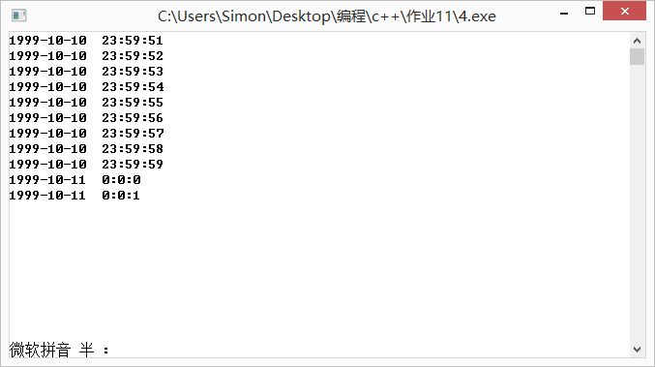
（五）实验题目五：定义一个一元三次方程类，类中至少包含构造函数、求根函数、输出方程根的函数，相加函数，输出方程函数等5个函数，并编写主函数测试各成员函数。提示：①两个一元三次方程对应相加仍然是一个一元三次方程。②求根方法采用迭代方法，迭代公式为： Xn+1=Xn－F(Xn)/F’(Xn) ，结束迭代的条件|F(Xn+1)|<10-7与 |Xn+1-Xn|<10-7 。③ 一元三次方程的一般形式如下： dX3+cX2+bX+a=0 。将一元三次方程类作为基类，派生出一元四次方程类，派生类的成员函数与基类相同，大致也有5个函数，编写主函数加以测试。例如方程2X3-4X2+3x-6＝0在1.5附近的根。又例如方程X3+12X2+48X+64=0在-4.5附近的根。例如方程X4-10X3+35X2-50x+24＝0在4.5附近的根。又例如方程X4+12X3+54X2+108X+81=0在-1.5附近的根。
1.程序源代码
#include<iostream>
#include<cmath>
using namespace std;
class three{
protected:
double d,c,b,a;
double qiuzhi(double t);
double dao(double t);
public:
three(double d,double c,double b,double a);
void scfc();
double qiugen(double t);
void scgen(double t);
void xj(three t);
~three(){}
};
three::three(double d=1,double c=1,double b=1,double a=1){
this->a=a;
this->b=b;
this->c=c;
this->d=d;
}
void three::scfc(){
if(d!=0&&d!=1&&d!=-1){
cout<<d;
cout<<"x^3";
}else if(d==1){
cout<<"x^3";
}else if(d==-1){
cout<<"-x^3";
}
if(c!=0&&c!=1&&c!=-1){
if(c<0){
cout<<c;
}else{
cout<<"+"<<c;
}
cout<<"x^2";
}else if(c==1){
cout<<"+x^2";
}else if(c==-1){
cout<<"-x^2";
}
if(b!=0&&b!=1&&b!=-1){
if(b<0){
cout<<b;
}else{
cout<<"+"<<b;
}
cout<<"x";
}else if(b==1){
cout<<"+x";
}else if(b==-1){
cout<<"-x";
}
if(a>0){
cout<<"+"<<a;
}else if(a<0){
cout<<a;
}
cout<<"="<<"0";
cout<<endl;
}
double three::qiuzhi(double t){
double result=d*pow(t,3)+c*pow(t,2)+b*t+a;
return result;
}
double three::dao(double t){
double result=3*d*pow(t,2)+2*c*t+b;
return result;
}
double three::qiugen(double t){
double gen;
gen=t-qiuzhi(t)/dao(t);
if(fabs(qiuzhi(gen))>=pow(10,-7)&&fabs(gen-t)>=pow(10,-7)){
gen=qiugen(gen);
}
return gen;
}
void three::scgen(double t){
cout<<"方程在"<<t<<"附近的根为"<<qiugen(t)<<endl;
}
void three::xj(three t){
d+=t.d;
c+=t.c;
b+=t.b;
a+=t.a;
}
class four:public three{
protected:
double e;
double qiuzhi(double t);
double dao(double t);
public:
four(double,double,double,double,double);
void scfc();
void xj(four t);
void scgen(double t);
double qiugen(double t);
~four(){}
};
four::four(double e,double d,double c,double b,double a):three(d,c,b,a){
this->e=e;
}
double four::qiugen(double t){
double gen;
gen=t-qiuzhi(t)/dao(t);
if(fabs(qiuzhi(gen))>=pow(10,-7)&&fabs(gen-t)>=pow(10,-7)){
gen=qiugen(gen);
}
return gen;
}
void four::scgen(double t){
cout<<"方程在"<<t<<"附近的根为"<<qiugen(t)<<endl;
}
double four::qiuzhi(double t){
double result=e*pow(t,4)+d*pow(t,3)+c*pow(t,2)+b*t+a;
return result;
}
double four::dao(double t){
double result=4*e*pow(t,3)+3*d*pow(t,2)+2*c*t+b;
return result;
}
void four::scfc(){
if(e!=0&&e!=1&&e!=-1){
cout<<e<<"x^4";
}else if(e==1){
cout<<"x^4";
}else if(e==-1){
cout<<"-x^4";
}
if(d!=0&&d!=1&&d!=-1){
if(d<0){
cout<<d;
}else{
cout<<"+"<<d;
}
cout<<"x^3";
}else if(d==1){
cout<<"+x^3";
}else if(d==-1){
cout<<"-x^3";
}
if(c!=0&&c!=1&&c!=-1){
if(c<0){
cout<<c;
}else{
cout<<"+"<<c;
}
cout<<"x^2";
}else if(c==1){
cout<<"+x^2";
}else if(c==-1){
cout<<"-x^2";
}
if(b!=0&&b!=1&&b!=-1){
if(b<0){
cout<<b;
}else{
cout<<"+"<<b;
}
cout<<"x";
}else if(b==1){
cout<<"+x";
}else if(b==-1){
cout<<"-x";
}
if(a>0){
cout<<"+"<<a;
}else if(a<0){
cout<<a;
}
cout<<"="<<"0";
cout<<endl;
}
void four::xj(four t){
e+=t.e;
d+=t.d;
c+=t.c;
b+=t.b;
a+=t.a;
}
int main(){
three m(1,12,48,64);
m.scfc();
m.scgen(-4.5);
four m1(1,-10,35,-50,24);
m1.scfc();
m1.scgen(4.5);
}3.实验结果
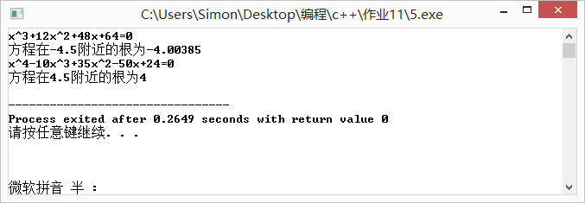
（六）实验题目六：采用继承方式 定义一个三层生日蛋糕类，不论基类还是派生类都至少包含 5 个函数：构造函数、设置数据成员函数、求蛋糕体积、运算符 > 重载函数、输出生日祝词与蛋糕形状函数。并编写主函数测试各成员函数。继承方式如下：首先定义圆柱体形状蛋糕类，只有 3 个数据成员，半径、高、生日祝词。然后派生出圆柱体 _ 方柱体蛋糕类，即在圆柱体形状上增加方柱体形状。假定方柱体的正方形面积小于圆柱体的圆形面积，注意方柱体的高与正方形的边长不一定相等。再用圆柱体 _ 方柱体蛋糕类派生出圆柱体 _ 方柱体 _ 菱形体蛋糕类，即在方柱体形状上增加菱形柱体形状。假定菱形柱体的菱形面积小于方柱体的正方形面积。提示： ① 运算符 > 重载指两个蛋糕对象的体积大小。 ②基类和派生类数据成员不能定义为 public 。③ 设置数据成员函数、求蛋糕体积、求蛋糕表面积函数、输出生日祝词与蛋糕形状函数均为同名重载函数，例如分别采用函数名为 init() 、 volume() 、 area() 、 output() 。程序运行参考图如下：（红颜色的功能下一章实验完成）
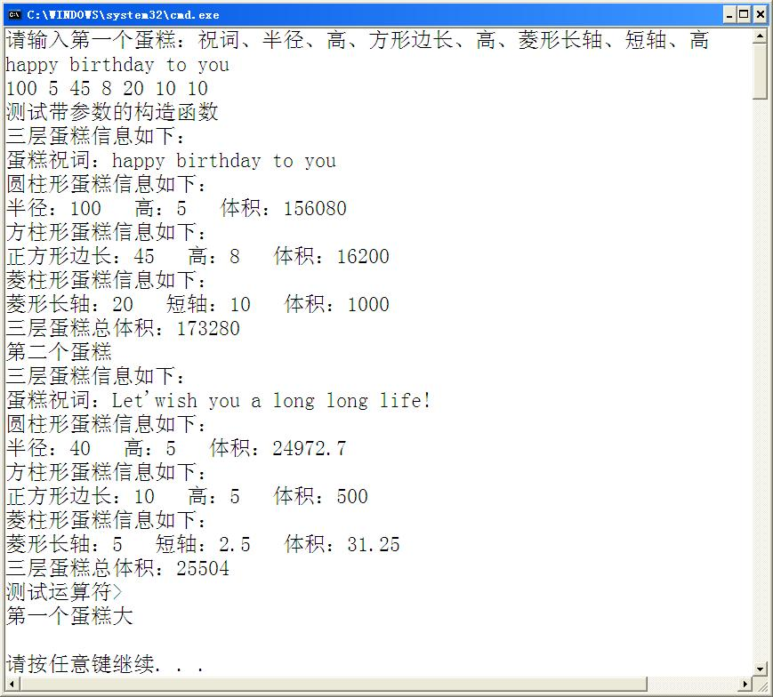
1.程序源代码
#include<iostream>
#include<cmath>
#include<cstring>
using namespace std;
class yzdg{
protected:
double r1;
double h1;
double v1;
double s1;
char words[50];
void volume();
void area();
public:
yzdg(char *words,double r1,double h1);
void init(char *words,double r1,double h1);
void output();
~yzdg(){}
};
yzdg::yzdg(char *words=(char*)"happy birthday",double r1=1,double h1=1){
init(words,r1,h1);
}
void yzdg::init(char *words=(char*)"happy birthday",double r1=1,double h1=1){
this->r1=r1;
this->h1=h1;
strcpy(this->words,words);
volume();
area();
}
void yzdg::volume(){
v1=M_PI*r1*r1*h1;
}
void yzdg::area(){
s1=2*M_PI*r1*h1+2*M_PI*r1*r1;
}
void yzdg::output(){
cout<<"蛋糕信息如下："<<endl;
cout<<"蛋糕祝词："<<words<<endl;
cout<<"圆柱形蛋糕信息如下："<<endl;
cout<<"半径："<<r1<<" "<<"高："<<h1<<" "<<"体积"<<v1<<endl;
}
class doubleLayer:public yzdg{
protected:
double r2,h2,v2,s2,v,s;
void volume();
void area();
public:
doubleLayer(char *words=(char*)"happy",double r1=1,double h1=1,double r2=1,double h2=1){
init(words,r1,h1,r2,h2);
}
void init(char *words,double r1,double h1,double r2,double h2);
void output();
~doubleLayer(){}
};
void doubleLayer::init(char *words,double r1,double h1,double r2=1,double h2=1){
this->r1=r1;
this->h1=h1;
strcpy(this->words,words);
this->r2=r2;
this->h2=h2;
volume();
area();
}
void doubleLayer::volume(){
v1=M_PI*r1*r1*h1;
v2=r2*r2*h2;
v=v1+v2;
}
void doubleLayer::area(){
s1=2*M_PI*r1*h1+2*M_PI*r1*r1;
s2=2*r2*r2+4*r2*h2;
s=s1+s2-r2*r2;
}
void doubleLayer::output(){
cout<<"二层蛋糕信息如下："<<endl;
cout<<"蛋糕祝词："<<words<<endl;
cout<<"圆柱形蛋糕信息如下："<<endl;
cout<<"半径："<<r1<<" "<<"高："<<h1<<" "<<"体积："<<v1<<endl;
cout<<"方柱形蛋糕信息如下："<<endl;
cout<<"正方形边长："<<r2<<" "<<"高："<<h2<<" "<<"体积："<<v2<<endl;
cout<<"总体积："<<v;
}
class three:public doubleLayer{
protected:
double cz,dz,h3,v3,s3;
void volume();
void area();
public:
three(char *words=(char*)"happy",double r1=1,double h1=1,double r2=1,double h2=1,double cz=1,double dz=1,double h3=1){
init(words,r1,h1,r2,h2,cz,dz,h3);
}
void init(char *words,double r1,double h1,double r2,double h2,double cz,double dz,double h3);
void output();
~three(){}
};
void three::init(char *words,double r1,double h1,double r2,double h2,double cz=4,double dz=2,double h3=1)
{
this->r1=r1;
this->h1=h1;
strcpy(this->words,words);
this->r2=r2;
this->h2=h2;
this->cz=cz;
this->dz=dz;
this->h3=h3;
volume();
area();
}
void three::volume(){
v1=M_PI*r1*r1*h1;
v2=r2*r2*h2;
v3=cz*dz/2.0*h3;
v=v1+v2+v3;
}
void three::area(){
s1=2*M_PI*r1*h1+2*M_PI*r1*r1;
s2=2*r2*r2+4*r2*h2;
s3=cz*dz+4*sqrt((cz/2)*(cz/2)+(dz/2)*(dz/2))*h3;
s=s1+s2+s3-r2*r2-cz*dz/2;
}
void three::output(){
cout<<"三层蛋糕信息如下："<<endl;
cout<<"蛋糕祝词："<<words<<endl;
cout<<"圆柱形蛋糕信息如下："<<endl;
cout<<"半径："<<r1<<" "<<"高："<<h1<<" "<<"体积："<<v1<<endl;
cout<<"方柱形蛋糕信息如下："<<endl;
cout<<"正方形边长："<<r2<<" "<<"高："<<h2<<" "<<"体积："<<v2<<endl;
cout<<"菱形蛋糕信息如下："<<endl;
cout<<"长轴："<<cz<<" "<<"短轴："<<dz<<" "<<"体积：" <<v3<<endl;
cout<<"总体积："<<v;
}
int main(){
three t;
cout<<"请输入蛋糕：祝词，半径，高，正方形边长，高，菱形长轴，短轴，高:"<<endl;
char happy[50];
cin.get(happy,49);
cin.get();
double a[7];
for(int i=0;i<7;i++){
cin>>a[i];
}
t.init(happy,a[0],a[1],a[2],a[3],a[4],a[5],a[6]);
t.output();
}3.实验结果
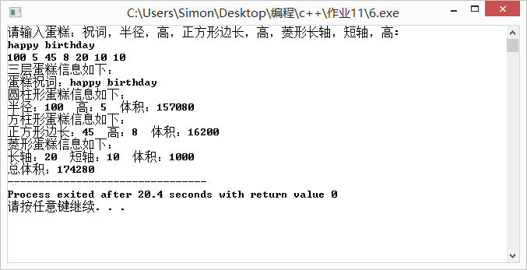

（七）实验题目七：（必做题）参照第9章PPT课件普通人类person定义，在person中增加念数字函数，其原型如下：
char *speek_n(int n);
该函数功能：给定一个整数，形成汉语读数字符串。例如n=2019，则形成“Er Ling Yi Jiu”；又如n=-32768，则形成“Fu San Er Qi Liu Ba”。再继承定义密码专家类cryptographist，增加明文指针成员和密文指针成员及整数秘钥Key，加密函数和解密函数，其原型如下：
char *cipher(char *Plaintext);
char *decipher(char *ciphertext);
加密解密采用凯撒加密法，大小写字母和数字都要用后移Key位字母或数字替代，整数秘钥Key只能是3~9的整数，构造时>9的秘钥设为9，<3的秘钥设为3，如32010则为9，-168则为3。注意无论加密或解密都要将明文字符串存入明文指针指向空间，密文字符串存入存入密文指针指向空间。注意加密专家类中的构造与析构函数的定义。编写主函数加以测试。
1.程序源代码
#include<iostream>
#include<windows.h>
#include<string.h>
#include<cmath>
using namespace std;
struct dictionary
{
int number;
char eng[50];
char han[25];
char spell[30];
};
dictionary my_[]={
{0,"zero","零","Ling"},
{1,"one","一","Yi"},
{2,"two","二","Er"},
{3,"three","三","San"},
{4,"four","四","Si"},
{5,"five","五","Wu"},
{6,"six","六","Liu"},
{7,"seven","七","Qi"},
{8,"eight","八","Ba"},
{9,"nine","九","Jiu"},
{10,"ten","十","Shi"},
{11,"eleven","十一","Shi Yi"},
{12,"twelve","十二","Shi Er"},
{20,"twenty","二十","Er Shi"},
{100,"hundred","一百","Yi Bai"},
{1000,"thousand","一千","Yi Qian"},
{1000000,"million","一百万","Yi Bai Wan"},
{1000000000,"billion","十亿","Shi Yi"},
{1,"january","一月","Yi Yue"},
{12,"december","十二月","Shi Er Yue"},
{1,"monday","星期一","Xing Qi Yi"},
{7,"sunday","星期日","Xing Qi Ri"}};
//定义两个全局字符指针数组，存取所需的单词
//num1中为1到19，空出了0，所以可以直接用num1 [n]调用，得到n对应单词
static const char *num1[]=
{
"","one ","two ","three ","four ","five ","six ","seven ","eight ","nine ","ten ","eleven ","twelve ",
"thirteen ","fourteen ","fifteen ","sixteen ","seventeen ","eighteen ","nineteen "
};
//num10中为20-90，空出了0和1，所以可以直接用num10[n/10]调用，得到n对应单词
static const char *num10[]=
{
"","","twenty ","thirty ","forty ","fifty ","sixty ","seventy ","eighty ","ninety "
};
class person
{
protected:
char *name; //人名
char sex; //性别
char pid[19]; //身份证号码
dictionary *mymem; //人脑记忆空间指针
int sum; //人脑记忆单词数量
char *speekn;
public:
person(); //无参构造函数
person(char *n,char s,char *p,dictionary *my,int k); //有参构造函数
void change_data(char *n,char s,char *p,dictionary *my,int k); //修改数据
void walking(int k,int v); //以v速度行走k步
void hearing(char *sentence); //将句子字符串小写变大写，大写变小写输出
void speek(int n); //说出整数n的英文
void speek(char *han_p); //说出汉字拼音
void reading(char *eng_p); //阅读单词、短语、句子，写出相关汉字，说出相关拼音
void writing(char *han_p); //写出汉字
void showme(); //输出人的属性值
void out(int a); //翻译小于1000的整数
char* speek_n(int n);
~person(); //析构函数
};
char* person::speek_n(int n){
int k=0,i=fabs(n);
int l[20];
while(i){
l[k]=i%10;
i/=10;
k++;
}
char *p=new char[5*k+10];
if(n<0){
p[0]='F';
p[1]='u';
p[2]=' ';
p[3]='\0';
}else{
p[0]='\0';
}
for(int j=0;j<k;j++){
strcat(p,my_[l[k-1-j]].spell);
strcat(p," ");
}
speekn=p;
return p;
}
person::person()
{
name = NULL;
mymem = NULL;
pid[0] = sex = sum = '\0';
speekn=NULL;
}
person::person(char *n,char s,char *p,dictionary *my,int k)
{
name=new char[strlen(n)+1];
strcpy(name,n);
strcpy(pid,p);
sex=s;
sum=k;
mymem=new dictionary[sum];
for(int i=0;i<sum;i++) *(mymem+i)=*(my+i);
}
void person::change_data(char *n,char s,char *p,dictionary *my,int k)
{
if(name!=NULL) delete []name;
name=new char[strlen(n)];
strcpy(name,n);
strcpy(pid,p);
sex=s;
sum=k;
if (mymem!=NULL) delete []mymem;
mymem=new dictionary[sum];
for(int i=0;i<sum;i++) *(mymem+i)=*(my+i);
}
void person::out(int a)
{
int b=a%100;
//若百位不为零，输出百位数加hundred，若此时十位个位均为0，不加and
if(a/100!=0)
{
cout<<num1[a/100]<<"hundred ";
if(b!=0)
cout<<"and ";
}
//当后两位在20以内时，直接调用num1[n]，输出
if(b<20)
cout<<num1[b];
//当后两位大于20时
else
{
//先调用num10，输出十位数
cout<<num10[b/10];
//个位不为0时应输出"-"个位数
if(b%10!=0)
cout<<"\b-"<<num1[b%10];
}
}
void person::walking(int k,int v)
{
cout<<"\n"<<name<<"水平直线行走"<<k<<"步"<<endl;
for(int i=0;i<k;i++)
{
cout<<' '<<"o_o";
Sleep(1000/v);
cout<<"\b\b\b";
}
}
void person::hearing(char *sentence)
{
cout<<endl<<sentence<<endl;
char *p=new char[strlen(sentence)+1];
strcpy(p,sentence);
char *pp=p;
while(*p)
{
if(*p>='a' && *p<='z')
*p='A'+(*p-'a'+0);
else if(*p>='A' && *p<='Z')
*p='a'+(*p-'A');

p++;
}
cout<<pp<<endl;
delete pp;
}
void person::speek(char *han_p)
{
cout<<han_p;
}
void person::speek(int n)
{
cout<<n<<" --> ";
if(n>1999999999)
cout<<"dev C++平台无法处理大于1999999999位的数！"<<endl;
else
{
//三位三位取出，存入abcd中
int a=n/1000000000,b=(n%1000000000)/1000000,c=(n%1000000)/1000,d=n%1000;
//不等于0时，输出并加上million或thousand
if(a!=0)
{
out(a);
cout<<"billion ";
}

if(b!=0)
{
out(b);
cout<<"million ";
}
if(c!=0)
{
out(c);
cout<<"thousand ";
}
if(d!=0)
{
//据英文语法规则，最后两位前一定有and
if(d<100&&(a!=0||b!=0||c!=0))
cout<<"and ";
out(d);
}
cout<<endl;
}
}
void person::reading(char *eng_p)
{
int i;
cout<<endl<<eng_p<<" --> ";
for(i=0;i<sum;i++)
if (strcmp(eng_p,mymem[i].eng)==0)
{
writing(mymem[i].han);
cout<<" --> ";
speek(mymem[i].spell);
if (mymem[i].number!=-1)
{
cout<<" --> ";
speek(mymem[i].number);
}
break;
}
if (i==sum) cout<<" not understanding!\n";
}
void person::writing(char *han_p)
{
cout<<han_p;
}
void person::showme()
{
cout<<endl<<"姓名："<<name<<' '<<"性别：";
if (sex=='m')
cout<<"男"<<' ';
else
cout<<"女"<<' ';
cout<<"身份证号码："<<pid<<' ';
cout<<"词汇量："<<sum<<endl;
}
person::~person() //析构函数
{
if (name!=NULL) delete []name;
if (mymem!=NULL) delete []mymem;
if(speekn!=NULL) delete []speekn;
}
class cryptographist:public person{
char *mingwen;
char *miwen;
int key;
public:
char *cipher(char *Plaintext);
char *decipher(char *ciphertext);
void change_data(char *n,char s,char *p,dictionary *my,int k,int key);
cryptographist(char *n,char s,char *p,dictionary *my,int k,int key);
cryptographist():person(){
mingwen=NULL;
miwen=NULL;
key=0;
}
~cryptographist(){
if (name!=NULL) delete []name;
if (mymem!=NULL) delete []mymem;
if(speekn!=NULL) delete []speekn;
if(mingwen!=NULL) delete []mingwen;
if(miwen!=NULL) delete []miwen;
};
};
cryptographist::cryptographist(char *n,char s,char *p,dictionary *my,int k,int key)
:person(n,s,p,my,k){
if(key>9){
this->key=9;
}else if(key<3){
this->key=3;
}else{
this->key=key;
}
mingwen=NULL;
miwen=NULL;
}
void cryptographist::change_data(char *n,char s,char *p,dictionary *my,int k,int key){
if(name!=NULL) delete []name;
name=new char[strlen(n)];
strcpy(name,n);
strcpy(pid,p);
sex=s;
sum=k;
if (mymem!=NULL) delete []mymem;
mymem=new dictionary[sum];
for(int i=0;i<sum;i++) *(mymem+i)=*(my+i);
this->key=key;
}
char*cryptographist::cipher(char *Plaintext){
if(miwen!=NULL){
delete []miwen;
}
if(mingwen!=NULL){
delete []mingwen;
}
int n=strlen(Plaintext);
miwen=new char[n];
mingwen=new char[n];
strcpy(mingwen,Plaintext);
strcpy(miwen,Plaintext);
for(int i=0;i<n;i++){
if(miwen[i]>='a'&&miwen[i]<='z'-key){
miwen[i]+=key;
}else if(miwen[i]>'z'-key&&miwen[i]<='z'){
miwen[i]='a'+key-('z'-miwen[i]);
}
if(miwen[i]>='0'&&miwen[i]<='9'-key){
miwen[i]+=key;
}else if(miwen[i]>'9'-key&&miwen[i]<='9'){
miwen[i]='a'+key-('9'-miwen[i]);
}
if(miwen[i]>='A'&&miwen[i]<='Z'-key){
miwen[i]+=key;
}else if(miwen[i]>'Z'-key&&miwen[i]<='Z'){
miwen[i]='A'+key-('Z'-miwen[i]);
}
}
return miwen;
}
char *cryptographist::decipher(char *ciphertext){
if(miwen!=NULL){
delete []miwen;
}
if(mingwen!=NULL){
delete []mingwen;
}
int n=strlen(ciphertext);
miwen=new char[n];
mingwen=new char[n];
strcpy(mingwen,ciphertext);
strcpy(miwen,ciphertext);
for(int i=0;i<n;i++){
if(mingwen[i]>='a'+key&&miwen[i]<='z'){
mingwen[i]-=key;
}else if(mingwen[i]>='a'&&miwen[i]<'a'+key){
mingwen[i]='z'-(key-(mingwen[i]-'a'));
}
if(mingwen[i]>='0'+key&&mingwen[i]<='9'){
mingwen[i]-=key;
}else if(mingwen[i]>='0'&&mingwen[i]<'0'+key){
miwen[i]='9'-(key-(mingwen[i]-'0'));
}
if(mingwen[i]>='A'+key&&mingwen[i]<='Z'){
mingwen[i]-=key;
}else if(mingwen[i]>='A'&&mingwen[i]<'A'+key){
miwen[i]='Z'-(key-(mingwen[i]-'Z'));
}
}
return mingwen;
}
int main()
{
char name_[20],sex_,PID_[19];
cout<<"input name,sex,PID: ";
cin>>name_>>sex_>>PID_;
cin.get();
cryptographist Jack(name_,sex_,PID_,my_,12,3); //创建对象杰克
Jack.showme(); //输出人的属性值
// Jack.hearing((char *)"Hi! You are simple!"); //听英文句子
// Jack.speek(1006); //说出整数num的英文句子
// Jack.reading((char *)"eleven");
int l;
cout<<"请输入你想让他读的数：";
cin>>l;
cin.get();
cout<<Jack.speek_n(l)<<endl;
cout<<"请输入明文："<<endl;
char mingwen[20];
cin.get(mingwen,19);
cin.get();
cout<<"密文是："<<Jack.cipher(mingwen)<<endl;
cout<<"请输入密文："<<endl;
char miwen[20];
cin.get(miwen,19);
cin.get();
cout<<"明文是："<<Jack.decipher(miwen);
return 0;
}3.实验结果
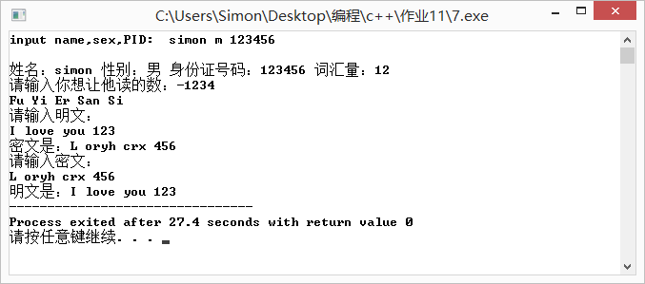
二 .个人小结
实验内容小结：
通过本次实验，我认识到了类的构造函数和析构函数在类的派生过程中的结合的紧密性，但是想要熟练地掌握运用类派生去解决问题却不是一件很容易的事情，主要问题在于派生过程中对于构造函数有一些不易掌握的地方，例如父类应当有无参数的构造函数或者构造函数的各项数值有初始值，继承过程中的权限问题也比较复杂，需要多方考虑数据成员的访问。
对比分析内容：
我阅读了高年级同学 的优秀实验报告并和我的进行了对比，差距确实很大主要分为以下几个方面：首先是word文档编辑的优美性学长的报告程序内容用彩色字体标识，结果也无空白，对于不同的部分，他用彩色方框标注了题目，使得结构一目了然，word文档读起来令人愉悦。 其次，他还注上了实验所用时间，这让我们对这次实验的具体信息有了更多的了解。其次是要点分析部分虽然不做要求，但是优秀报告中的要点分析不但写了，而且还对自己的思考过程和没有解决的问题有描述，报告中的要点分析十分详细甚至有指导意义，对题目的算法有较为详细的分析和叙述，这对将来复习和再理解和思考题目有着极大的帮助，着实收获颇丰。说来惭愧，我总是以没有时间为由没有去写实验的要点分析，认为只要编程出来就行了，久而久之确实和别人有差距，今后如果其他科目课业不繁忙，我一定尽量写。

