Description for assignment3 open-ended task

This task aims to implement a loading saved game function.

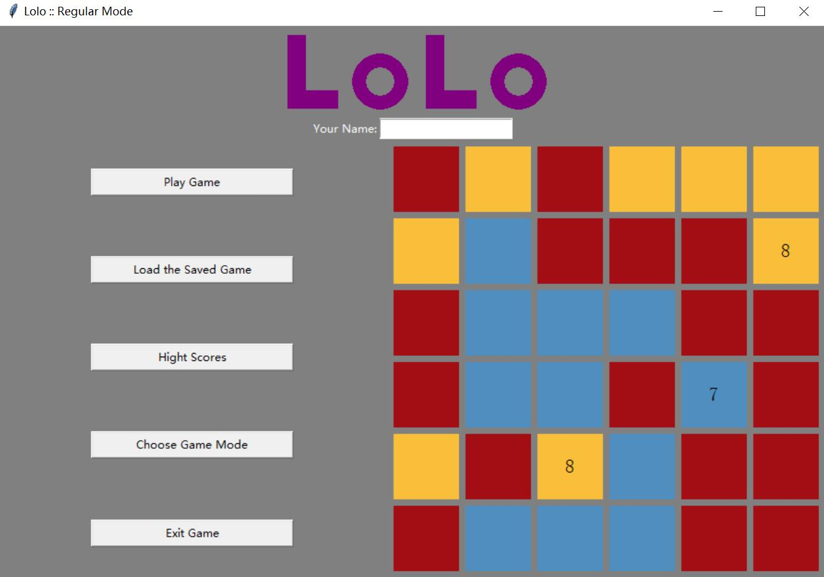

The button Load the Saved Game is designed for loading a mostly recently saved game of the current game mode. For example, if the game mode selected is unlimited game and press Load the Saved Game button, player will be able to continue the saved with the saved name and saved score.

Figure1

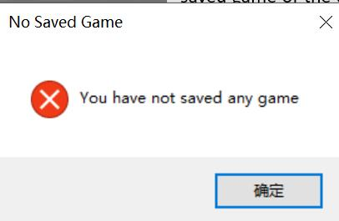

When there is no saved game, a popup window will jump out to tell player that no saved game.

Figure2

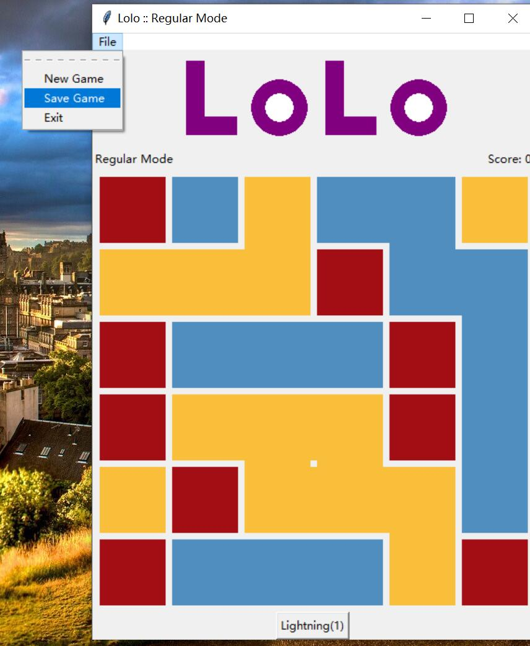The button Save Game is designed for saving the current game together with score and player’s name.

To play the saved game, player need go back to loading screen and select corresponding game mode, then click Load the Saved Game.

Figure3

The saving and loading functions are implemented by some supporting codes from highscores.py.

HignScoreManager class is used for processing saved game data from a self-created json file.

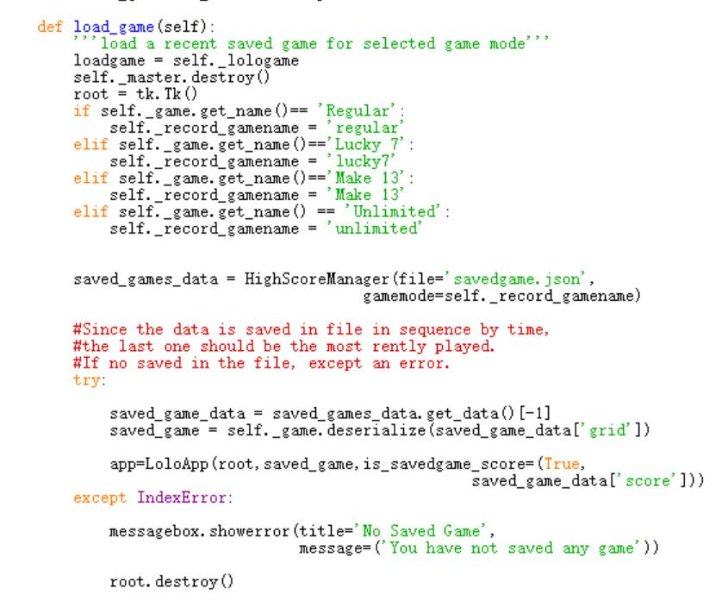

Figure4