ABC Retail Solutions
Retail Sales Data Processing & Business Insights
Data Engineering Pipeline – Project Documentation

1. Executive Summary
ABC Retail Solutions operates across multiple cities through online and offline channels. This document describes the end-to-end data engineering pipeline built to ingest, cleanse, transform, and visualise retail transaction data from two source systems, enabling reliable business intelligence and KPI reporting.
The pipeline processes 8,494 raw records from two transactional source systems, producing a clean, analytics-ready dataset of 7,914 validated transactions after deduplication, imputation, standardisation, and PII masking.
Note on Cloud Infrastructure: While the use case recommends Microsoft Azure for cloud-based pipeline deployment, this solution has been implemented locally using Python. The Microsoft Azure student subscription used during development has expired and renewal or purchase was not feasible at the time of submission. The pipeline is fully functional end-to-end in a local environment and is designed to be cloud-portable

2. Dataset Description

2.1 Source Tables
Table | Rows | Description
product_details | 10 | Dimension / reference table: product_id, product_name, category, standard price
retail_data1 | 4,243 | Transactional data from source system 1
retail_data2 | 4,251 | Transactional data from source system 2

2.2 Retail Transaction Schema
Column | Type | Description
transaction_id | Integer | Unique transaction identifier
customer_id | Integer | Customer identifier
customer_name | String | Full name of customer
product_id | Integer | FK to product_details
price | Float | Unit price of product (may be missing)
product_name | String | Raw product name (inconsistent casing)
category | String | Product category (abbreviated or inconsistent)
purchase_location | String | online / offline
city | String | City of transaction
transaction_date | Mixed | Date as Excel serial, datetime, or string
quantity | Integer | Units purchased (may be 0 or negative)
payment_method | String | Card / UPI / Cash / NetBanking
discount | Float | Discount fraction 0–1
email | String | Customer email (PII)
phone | String/Int | Customer phone (PII)
payment_status | String | successful / failed

3. Architecture & Data Flow

3.1 Pipeline Architecture
The solution follows a local Python-based ELT architecture with the following layers:
- Source Layer – Excel workbook (USECASE - Data_Engineering.xlsx) containing three sheets.
- Ingestion Layer – Pandas read_excel with schema validation.
- Transformation Layer – Deduplication, date parsing, category normalisation, PII masking, and revenue calculation.
- Aggregation Layer – KPI computation grouped by category, city, product, month, payment method, and channel.
- Output Layer – Cleaned CSV (retail_cleaned.csv) and 9 KPI CSV files consumed by Power BI.
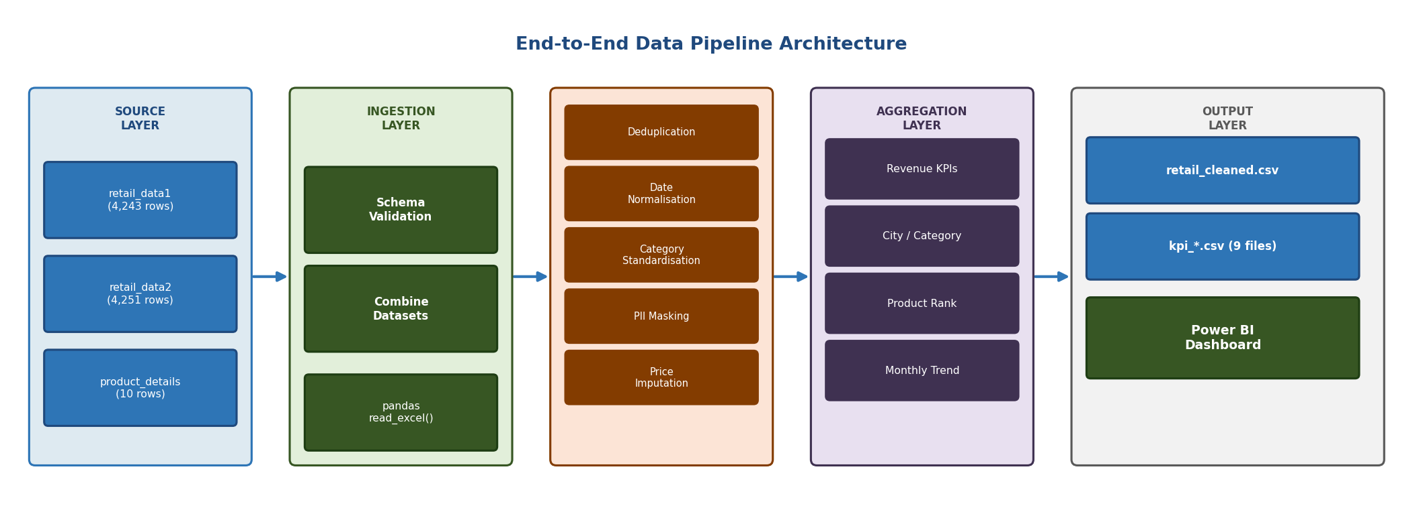
Figure 1: End-to-End Pipeline Architecture

3.2 Data Flow Diagram
The high-level data flow is as follows:
Excel Source (retail_data1 + retail_data2 + product_details) → [Ingestion & Validation] → [Combine & Deduplicate] → [Clean & Standardise] → [PII Masking] → [Feature Engineering] → [Aggregation / KPIs] → CSV Outputs → Power BI Dashboard
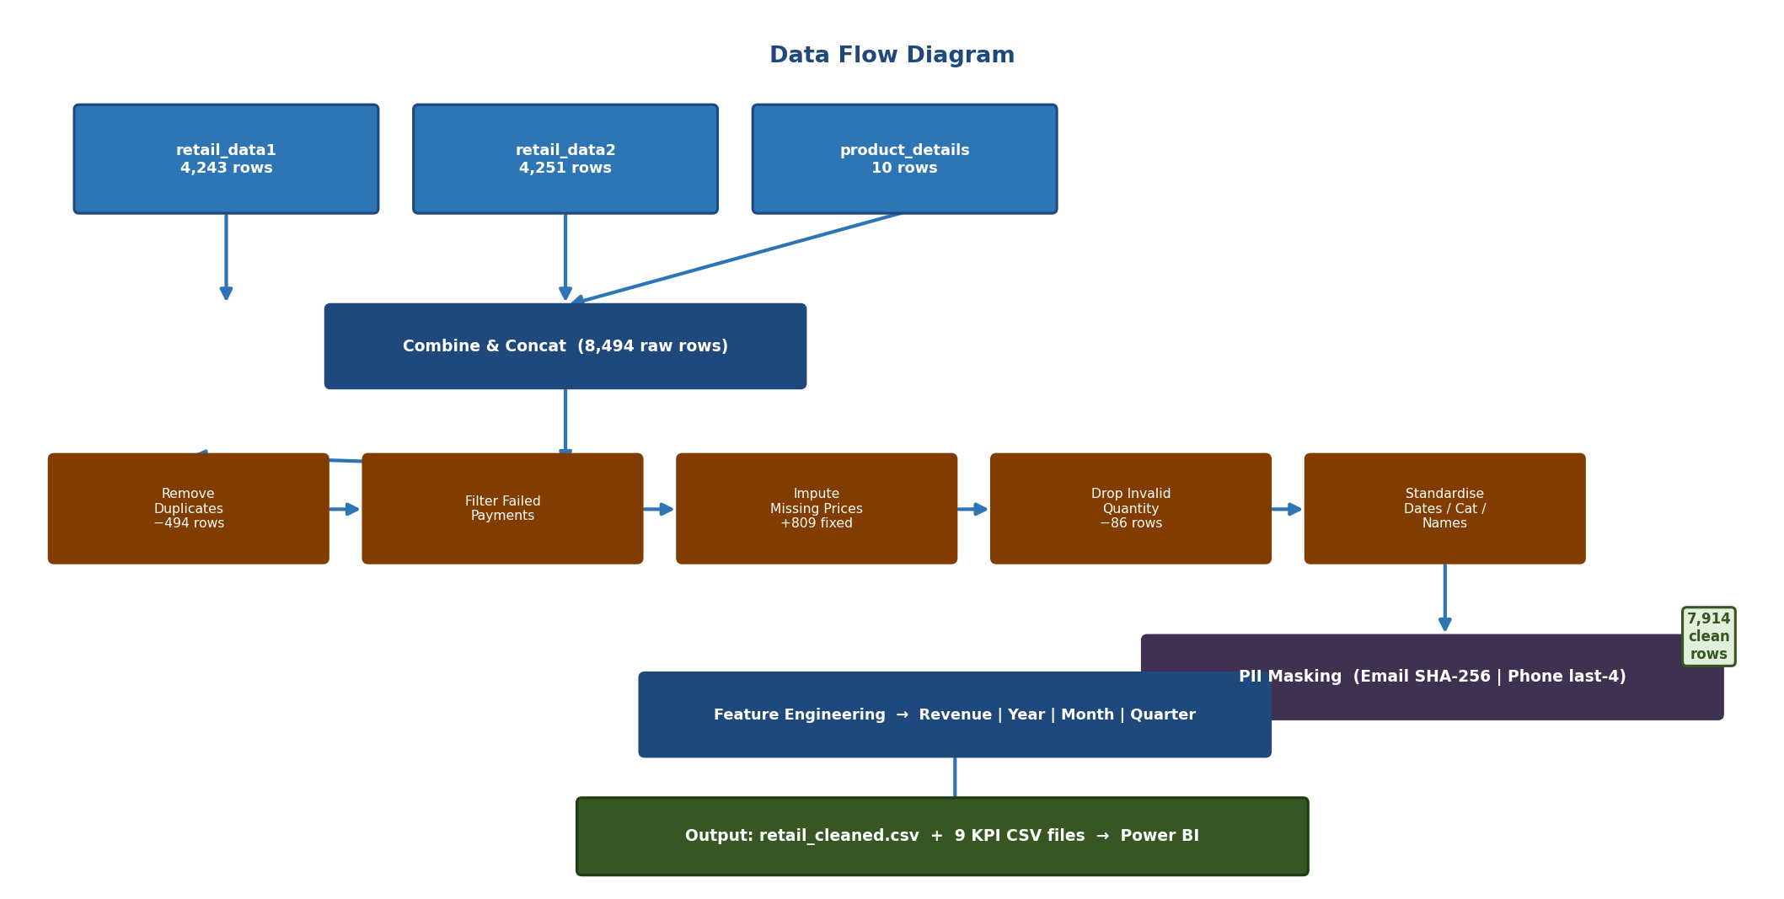
Figure 2: Data Flow Diagram

3.3 Data Model
The data model is a simple star schema. The fact table (retail_cleaned.csv) contains one row per successful transaction and joins to the product dimension (product_details) on product_id. All KPI aggregation tables are derived from the fact table.
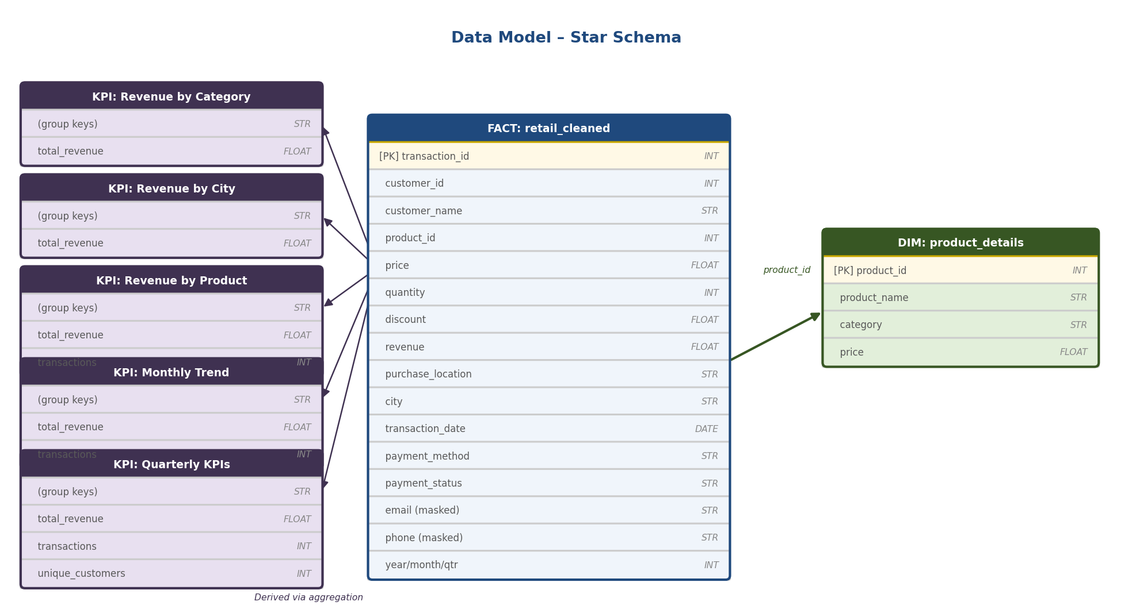
Figure 3: Data Model – Star Schema

Table | Role | Key
retail_cleaned | Fact table – transactions | transaction_id
product_details | Dimension – product reference | product_id
kpi_revenue_by_* | Aggregated KPI tables | (group keys)

4. Assumptions
- A transaction marked 'successful' is the authoritative version where a duplicate exists with status 'failed'.
- Missing prices are recoverable from product_details using product_id; rows with no matching product_id and no price are dropped.
- Quantity values of 0 or negative are invalid and represent data entry errors; these rows are excluded.
- The discount column represents a fraction (0.10 = 10%); values outside [0, 1] are clipped to bounds.
- Excel date serial numbers are offset from 1899-12-30 (Windows Excel epoch).
- Category abbreviations (ELEC, CLOTH, FURN, HOME) map deterministically to their full names.
- Only the five cities present in the data (Bangalore, Chennai, Delhi, Hyderabad, Mumbai) are considered valid.
- Revenue formula: Revenue = Price × Quantity × (1 – Discount).

5. Data Cleaning Strategy

5.1 Issue Inventory
Issue | Description | Resolution
Duplicate transactions | Same transaction_id with 'successful' and 'failed' statuses | Keep 'successful' row; drop 'failed'
Missing price | 809 rows with null price | Impute from product_details via product_id
Invalid quantity | 86 rows with quantity ≤ 0 | Drop rows
Inconsistent category | Abbreviations: ELEC, CLOTH, FURN, HOME, etc. | Map via alias dictionary to canonical names
Inconsistent product name | Mixed case: 'laptop', 'LAPTOP', 'Laptop' | Overwrite from product_details name map
Inconsistent dates | Excel serial integers, datetime objects, and MM-DD-YYYY strings | parse_date() function normalises all to datetime
PII in email & phone | Plain-text customer contacts | SHA-256 hash of email local part; last-4-digit masking for phone
Discount out of range | Potential values outside [0, 1] | clip(0, 1)

5.2 Cleaning Statistics
Metric | Value
Raw rows (combined) | 8,494
Duplicate transactions removed | 494
Failed-payment rows removed | 0 (handled in deduplication step)
Missing prices imputed | 809
Invalid quantity rows removed | 86
Clean rows for analysis | 7,914

6. Transformation Logic

6.1 Date Normalisation
Transaction dates arrive in three formats: Excel date serial numbers (integers), Python datetime objects produced by openpyxl, and MM-DD-YYYY strings. A custom parse_date() function handles all three branches. Excel serials are converted using the offset Timestamp('1899-12-30') + Timedelta(days=serial).

6.2 Category Standardisation
A CATEGORY_ALIAS dictionary maps all variants (case-insensitive) to one of four canonical categories: Electronics, Clothing, Furniture, Home Appliances. For rows still unmapped after the alias lookup, the product_details dimension provides the authoritative category via a product_id join.

6.3 PII Masking
Email addresses: the local part (before @) is replaced with the first 8 hex characters of its SHA-256 hash. The domain is preserved for regional analysis. Example:
TroyMitchell@gmail.com → a3f9c12b@gmail.com
Phone numbers: the first 6 digits are replaced with 'XXXXXX'; the last 4 digits are retained for partial identification. Example:
8385276968 → XXXXXX6968

6.4 Revenue Calculation
Revenue per transaction = Unit Price × Quantity × (1 – Discount Rate)
Derived date features: year, month, month_name, quarter extracted from transaction_date.

7. KPIs & Business Insights

7.1 Headline KPIs
KPI | Value
Total Revenue | ₹1,163,993,285
Total Transactions | 7,914
Unique Customers | 1,960
Average Order Value | ₹1,47,080
Average Discount | 22.4%

7.2 KPI Definitions
KPI / Metric | Formula / Source | Power BI File
Total Revenue | SUM(revenue) | DAX: SUM(retail_cleaned[revenue])
Revenue by Category | GROUP BY category → SUM(revenue) | DAX: SUM(retail_cleaned[revenue]) grouped by category
Revenue by City | GROUP BY city → SUM(revenue) | DAX: SUM(retail_cleaned[revenue]) grouped by city
Revenue by Product | GROUP BY product → SUM(revenue) | DAX: SUM(retail_cleaned[revenue]) grouped by product
Monthly Revenue Trend | GROUP BY year, month → SUM(revenue) | DAX: SUM(retail_cleaned[revenue]) grouped by month_name
Revenue by Channel | GROUP BY purchase_location → SUM(revenue) | DAX: SUM(retail_cleaned[revenue]) grouped by purchase_location
Revenue by Payment | GROUP BY payment_method → SUM(revenue) | DAX: SUM(retail_cleaned[revenue]) grouped by payment_method
Quarterly KPIs | GROUP BY year, quarter → multiple metrics | DAX: SUM(retail_cleaned[revenue]) grouped by quarter
City × Category Heat | GROUP BY city, category → count, revenue | DAX: COUNTROWS / SUM grouped by city and category
Top Customers | GROUP BY customer_id → SUM(revenue) TOP 20 | DAX: SUM(retail_cleaned[revenue]) grouped by customer, TOP N filter

8. Power BI Dashboard Guide

8.1 Data Sources
Connect Power BI Desktop to retail_cleaned.csv as the single data source. All KPIs are calculated using DAX measures directly from this table, ensuring slicers and filters apply consistently across all visuals and pages.
- retail_cleaned.csv — single master data source for all visuals
- DAX Measure: Total Revenue = SUM(retail_cleaned[revenue])
- DAX Measure: Total Transactions = COUNTROWS(retail_cleaned)
- DAX Measure: Unique Customers = DISTINCTCOUNT(retail_cleaned[customer_id])
- DAX Measure: Avg Order Value = AVERAGE(retail_cleaned[revenue])
- DAX Measure: Avg Discount % = AVERAGE(retail_cleaned[discount]) * 100

8.2 Recommended Dashboard Pages
Page | Visuals
Overview / Summary | 5 DAX KPI cards (Total Revenue, Total Transactions, Avg Order Value, Unique Customers, Avg Discount %); Donut chart: Online vs Offline revenue split; Slicers: City, Category, Year
Revenue Analysis | Line/Bar chart: monthly revenue trend by month_name; horizontal bar: quarterly revenue; horizontal bar: revenue by payment method (Card, Cash, UPI, NetBanking); Slicers: City, Channel, Category, Year
Product Performance | Horizontal bar chart: revenue by product_name (Laptop #1); Table: product_name, category, Sum of revenue with grand total (₹1,16,39,93,285); Slicers: City, Year, Category, Channel
Category Trends | Bar chart: revenue by category (Electronics leads); Stacked bar: revenue by city and category; Stacked bar: Monthly Revenue Trend by Category; Slicers: Category, City, Year, Channel
Regional Insights | Horizontal bar chart: revenue by city; Matrix table: City x Category revenue with grand totals (rows: 5 cities, cols: 4 categories + Total); Slicers: City, Channel, Year, Category
Customer Intelligence | Not implemented as a separate page; customer revenue data is accessible via filters on the Product Performance and Regional Insights pages

8.3 Suggested Slicers & Filters
- Year range slicer (2025–2026) present on all pages
- City multi-select slicer (Bangalore, Chennai, Delhi, Hyderabad, Mumbai)
- Category slicer (Clothing, Electronics, Furniture, Home Appliances)
- Purchase location slicer (Online / Offline) present on Revenue Analysis, Product Performance, Category Trends, and Regional Insights pages
- All slicers cross-filter all visuals on the same page; selecting Chennai updates all charts and KPI cards simultaneously

9. Scalability Considerations
- The pipeline is built on pandas for local execution. For datasets exceeding available RAM, the same logic can be migrated to PySpark or chunked pandas processing using pd.read_csv(chunksize=) without changing the transformation logic.
- The SOURCE_FILE variable in the pipeline is parameterised, allowing the script to ingest from any file path — local directory, network share, or cloud storage — without changing the pipeline code.
- Output CSV files are timestamped and overwritten on each pipeline run. For production use, this can be extended to append-only loading with date-partitioned output folders (output/year=2025/month=01/) to support incremental processing.
- The cleaned dataset (retail_cleaned.csv) is connected to Power BI via Import mode. For larger datasets, this can be switched to DirectQuery mode by loading the CSV into a local SQL database (SQLite / PostgreSQL) and connecting Power BI directly to that.
- The pipeline uses Python’s logging module throughout for structured runtime logs. All critical steps (ingestion, deduplication, imputation, PII masking, export) emit INFO or WARNING messages, making it easy to audit pipeline runs and catch data quality issues early.
- The modular structure of the pipeline (separate steps for ingestion, cleaning, PII masking, aggregation, export) makes it straightforward to add unit tests using pytest for each function to ensure regression safety as the dataset grows.

10. GitHub Repository Structure
Path | Contents
retail_pipeline.py | Full data engineering pipeline (Python)
Documentation/documentation.docx | This document
Retail_sales_dashboard.pbix | Power BI report with all dashboards and measures

Note on Output Files: The cleaned dataset (retail_cleaned.csv) and all KPI CSV files are not stored in the GitHub repository. They are generated automatically by running the pipeline. When retail_pipeline.py (or the Jupyter Notebook) is executed, all output files are saved locally to an output/ folder in the same directory as the script. These output files serve as the data source for the Power BI dashboard.

11. Appendix – Category Alias Mapping
Raw Value (lower-case) | Canonical Category
elec | Electronics
electronics | Electronics
cloth | Clothing
clothing | Clothing
furn | Furniture
furniture | Furniture
home | Home Appliances
home appliances | Home Appliances

