Step 1: Create Angular application

Step 2: 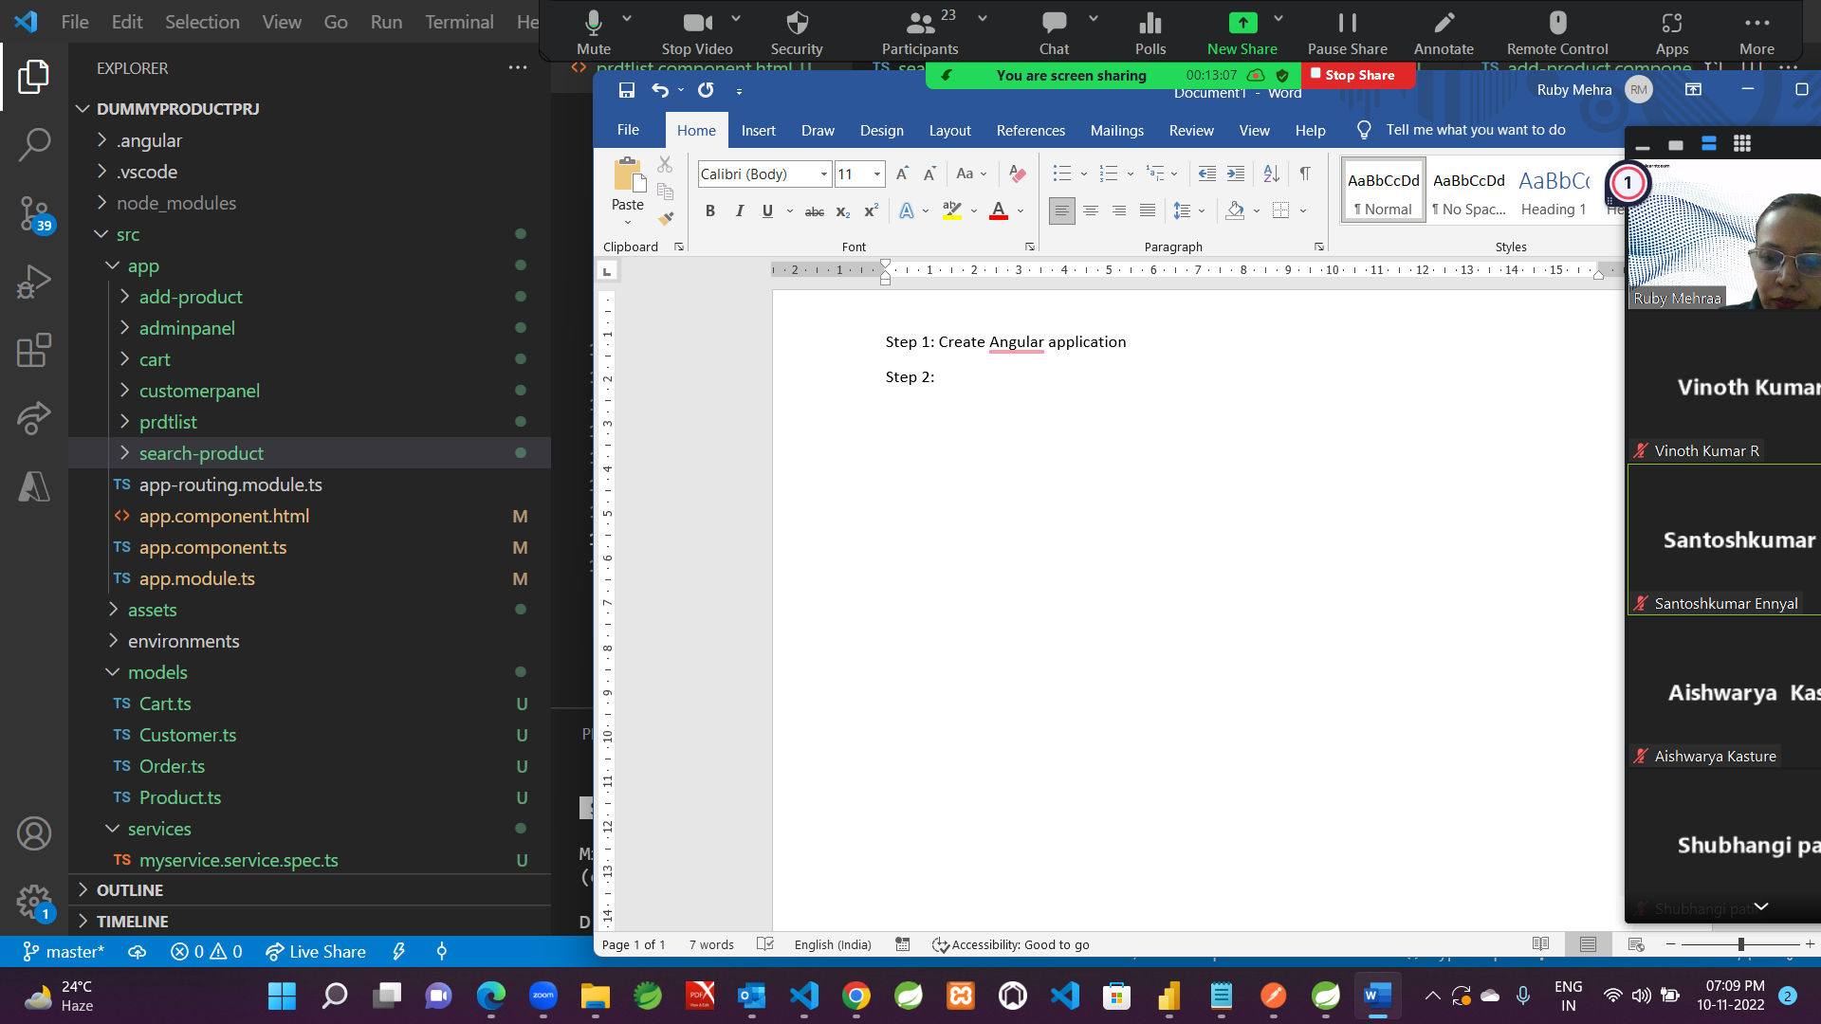

Create all these above mentioned components

Step 3: app.module.ts

import { NgModule } from '@angular/core';

import { BrowserModule } from '@angular/platform-browser';

import { FormsModule,ReactiveFormsModule} from '@angular/forms';

import { AppRoutingModule } from './app-routing.module';

import { AppComponent } from './app.component';

import { AdminpanelComponent } from './adminpanel/adminpanel.component';

import { RouterModule } from '@angular/router';

import { CustomerpanelComponent } from './customerpanel/customerpanel.component';

import { CartComponent } from './cart/cart.component';

import { PrdtlistComponent } from './prdtlist/prdtlist.component';

import { SearchProductComponent } from './search-product/search-product.component';

import { AddProductComponent } from './add-product/add-product.component';

@NgModule({

  declarations: [

    AppComponent,

    AdminpanelComponent,

    CustomerpanelComponent,

    CartComponent,

    PrdtlistComponent,

    SearchProductComponent,

    AddProductComponent,

  ],

  imports: [

    BrowserModule,

    AppRoutingModule,FormsModule,ReactiveFormsModule,RouterModule,

    RouterModule.forRoot([

      {path: 'admin', component:AdminpanelComponent},

      {path: 'customer', component:CustomerpanelComponent },

      {path: '', redirectTo: '/customer', pathMatch: 'full'},

      {path: 'viewcart', component:CartComponent},

      {path: 'productlist', component: PrdtlistComponent },

      {path: 'addproduct', component: AddProductComponent },

      {path: 'searchprdt/:id', component:SearchProductComponent }

    ])

  ],

  providers: [],

  bootstrap: [AppComponent]

})

export class AppModule { }

Step4:

App.component.ts

import { Component } from '@angular/core';

@Component({

  selector: 'app-root',

  templateUrl: './app.component.html',

  styles:[ 'body{margin: 20px 20px 20px 20px; padding:20px 20px 20px 20px}']

})

export class AppComponent {

  title = 'DummyProductPrj';

}

App.component.html

<header>

      <div class="container bg-primary">

            <img src="https://www.designhill.com/resize_img.php?atyp=page_file&pth=ft_ca_ct||117||contestfile_1&flp=1554116576-13511971185ca1efe0bcd5a0-26602492.jpg"

            height="100" width="100" />

      </div>

</header>

<router-outlet></router-outlet>

Step 5: create service and model

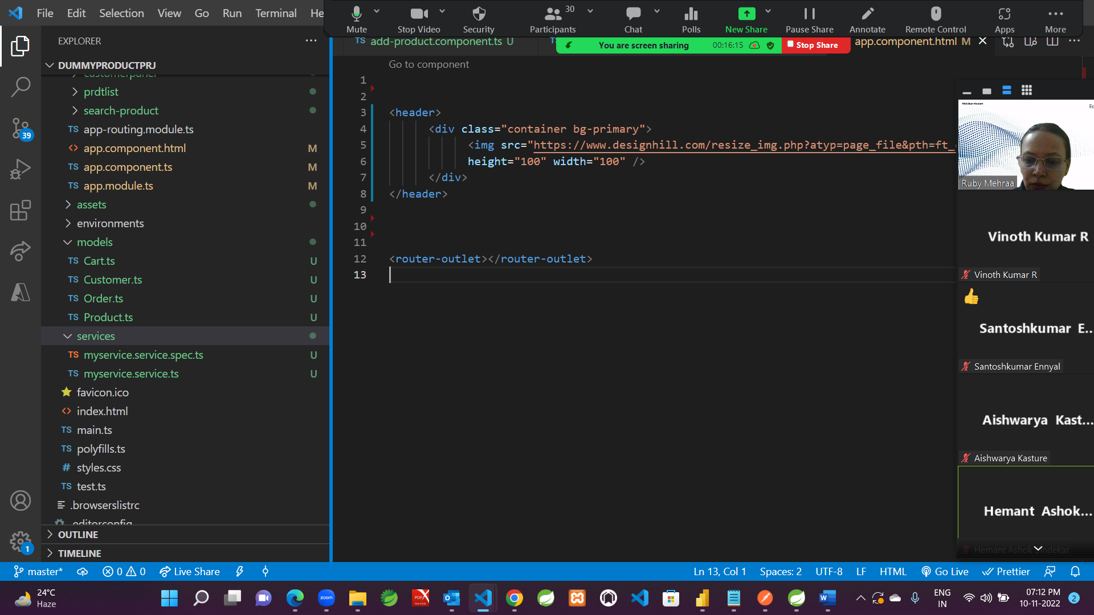

My.service.ts

import { Injectable } from '@angular/core';

import { Product } from 'src/models/Product';

@Injectable({

  providedIn: 'root'

})

export class MyserviceService {

  prdt?:Product[] // multiple records

  constructor()

  {

  }

  createProduct():Product[]

  {

    this.prdt = [{prid:101,prnm:"Laptop 1",qty:10,price:100000,pic:"../assets/laptop1.jpg",description:"In laptops, the age of the CPU (Central processing unit) is known as the 'generation'. The newer generation of laptops is more developed, has more features, and is more power-efficient than the older ones."},

                  {prid:102,prnm:"Laptop 2",qty:5,price:90000,pic:"../assets/laptop2.jpg",description:"In laptops, the age of the CPU (Central processing unit) is known as the 'generation'. The newer generation of laptops is more developed, has more features, and is more power-efficient than the older ones."},

                  {prid:103,prnm:"Laptop 3",qty:3,price:980000,pic:"../assets/laptop3.jpg",description:"In laptops, the age of the CPU (Central processing unit) is known as the 'generation'. The newer generation of laptops is more developed, has more features, and is more power-efficient than the older ones."},

                  {prid:104,prnm:"Laptop 4",qty:7,price:760000,pic:"../assets/laptop4.jpg",description:"In laptops, the age of the CPU (Central processing unit) is known as the 'generation'. The newer generation of laptops is more developed, has more features, and is more power-efficient than the older ones."},

                  {prid:105,prnm:"Laptop 5",qty:5,price:50000,pic:"../assets/Laptop5.png",description:"In laptops, the age of the CPU (Central processing unit) is known as the 'generation'. The newer generation of laptops is more developed, has more features, and is more power-efficient than the older ones."},

                  {prid:106,prnm:"Laptop 6",qty:3,price:480000,pic:"../assets/Laptop6.png",description:"In laptops, the age of the CPU (Central processing unit) is known as the 'generation'. The newer generation of laptops is more developed, has more features, and is more power-efficient than the older ones."},

                  {prid:107,prnm:"Laptop 7",qty:7,price:960000,pic:"../assets/Laptop7.png",description:"In laptops, the age of the CPU (Central processing unit) is known as the 'generation'. The newer generation of laptops is more developed, has more features, and is more power-efficient than the older ones."}

                ]

    return this.prdt

  }

  searchproduct(id:number):Product |any

  {

  return this.prdt?.filter(

                    (m)=>m.prid == id)

  }

}

Product.ts

export class Product

{

  public prid?:number

  public prnm?:string

  public qty?:number;

  public price?:number

  public description?:string

  public pic?:string

}

Step6: Store few images in assets folder

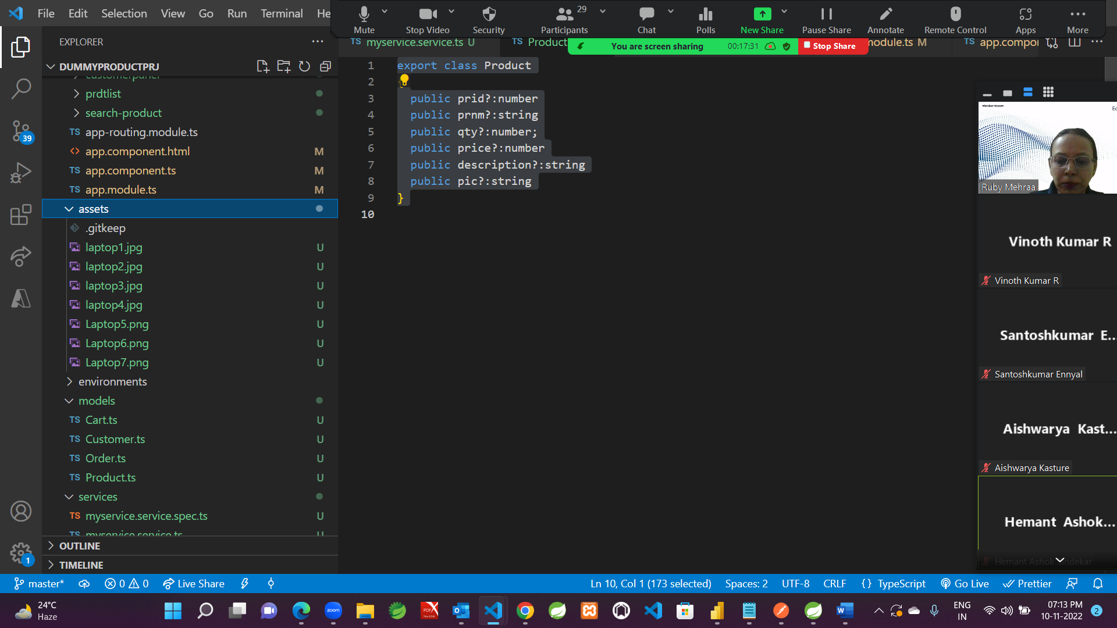

Step 7:

Add bootstrap and jquery library in project and map in angular.json file

 "styles": [

              "src/styles.css","node_modules/bootstrap/dist/css/bootstrap.min.css"

            ],

            "scripts": ["node_modules/jquery/dist/jquery.min.js",

              "node_modules/bootstrap/dist/js/bootstrap.min.js"]

Step 8: For rest of the component level coding refer to github file:

https://github.com/MehraRuby/CoreJavaCodes