Brain Hemorrhage Detection based on Heat Maps, Autoencoder and CNN Architecture

In this paper author is using combination of deep learning (ALEXNET) and machine learning (SVM) algorithm to predict brain Hemorrhage. First author is applying Autoencoder algorithm to increase image samples and we already applied this technique using KERAS Image Augmentation to increase dataset images to 250.

Heatmap features extraction technique is applied on all Increased images samples and then this features will get trained with ALEXNET algorithm. Trained features will be extracted from ALEXNET and then retrain with SVM to perform classification of Hemorrhage availability and non-availability.

To trained above algorithms we are using below brain dataset

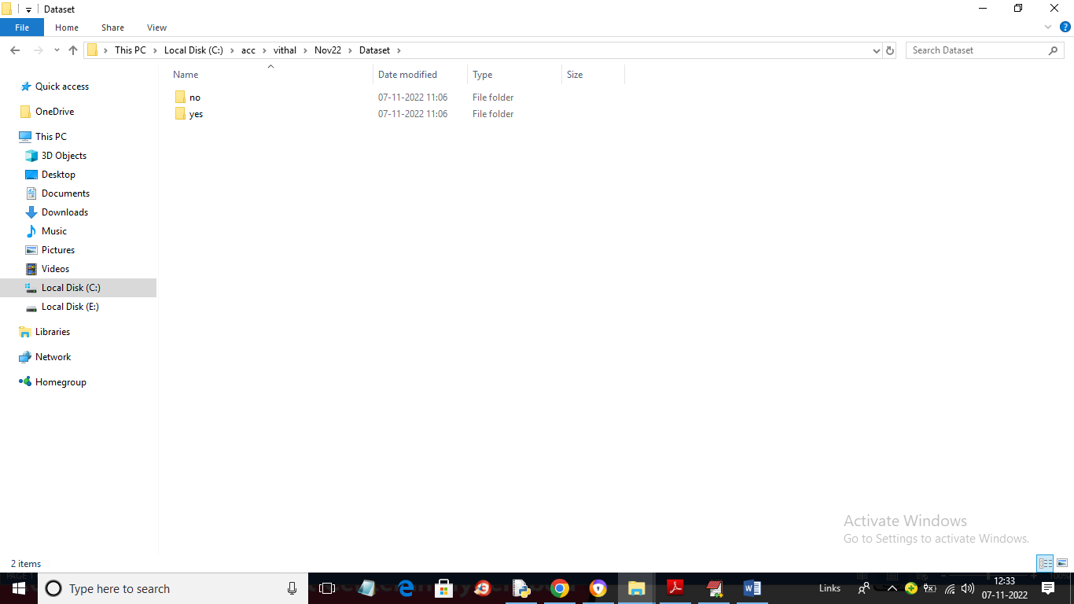

In above screen we have 2 folders called ‘yes or no’ and then go inside any folder to view brain images where ‘yes’ folder contains Hemorrhage images and ‘no’ folder contains ‘Normal’ images

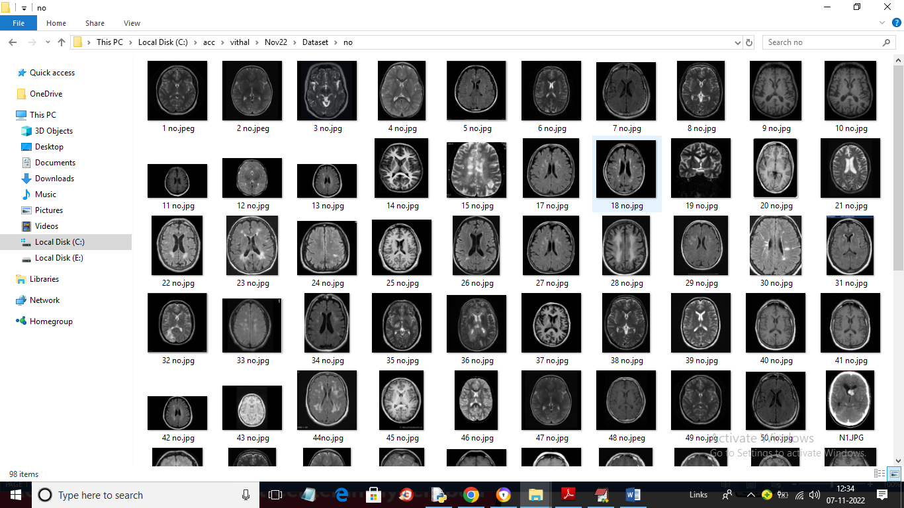

In above screen we can see dataset images and by using above image we will train ALEXNET and SVM algorithms

To implement this project we have designed following modules

1. Upload Brain Hemorrhage Dataset: using this module we will upload dataset images to application
2. Dataset Preprocessing & Heatmap Features: using this module we will read each image and then apply Heatmap to extract features and then normalized all pixel values to 0 and 1. All processed images will be split into train and test where application used 80% images for training and 20% for testing
3. Run Alexnet Features Extraction Algorithm: 80% training data will be input to Alexnet algorithm to trained a model and this trained model will be applied on 20% test data to calculate prediction accuracy
4. Train SVM Classifier on Alexnet Features: using this module we will extract features from Alexnet and then retrain with SVM to build a classification model
5. Predict Brain Hemorrhage from test Images: using this module we will upload test image and then SVM classifier will predict presence of Hemorrhage or not
6. Alexnet Training Graph: using this module we will plot Alexnet training accuracy and loss graph

SCREEN SHOTS

To run project double click on ‘run.bat’ file to get below output

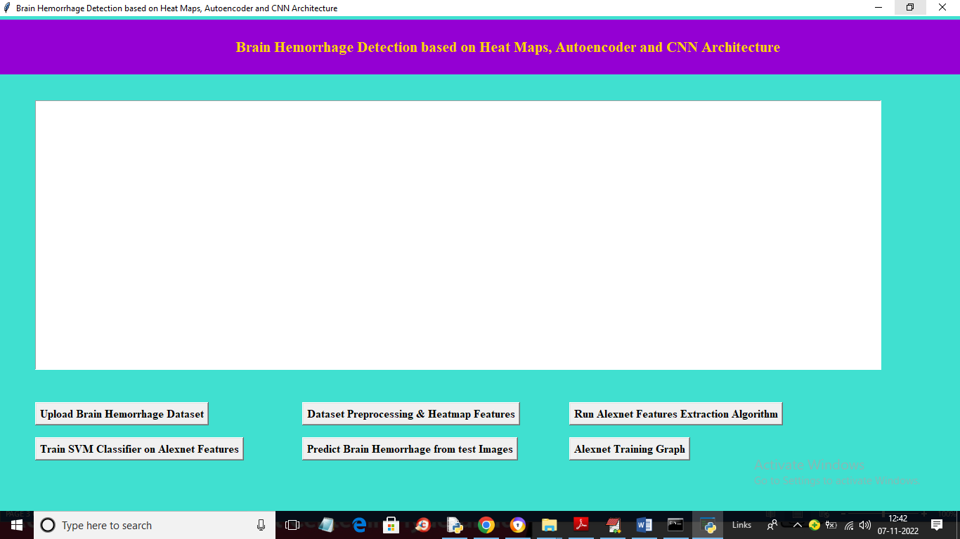

In above screen click on ‘Upload Brain Hemorrhage Dataset’ button to upload dataset and get below output

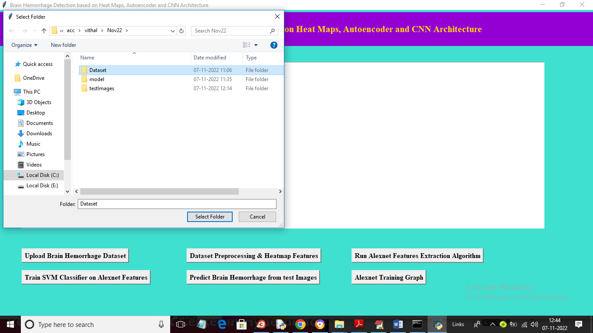

In above screen selecting and uploading entire dataset folder and then click on ‘Select Folder’ button to load dataset and get below output

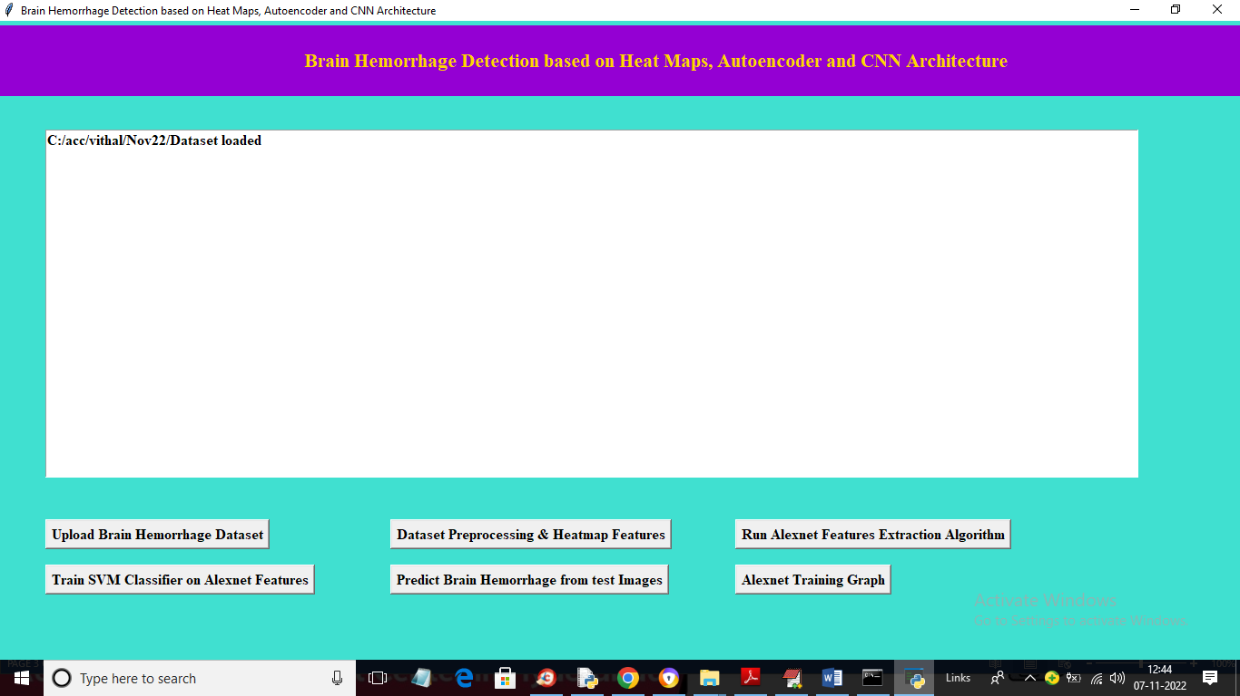

In above screen dataset loaded and now click on ‘Dataset Preprocessing & Heatmap Features’ button to read each image and then calculate Heatmap and then normalize pixel values and then split dataset into train and test

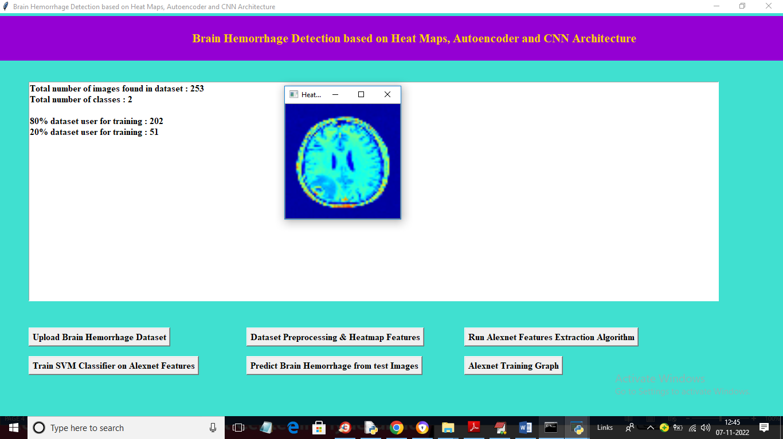

In above screen we can see dataset contains 253 images and application using 202 images for training and 52 for testing and we can see processed Heatmap image and now close above image and then click on ‘Run Alexnet Features Extraction Algorithm’ to train Alexnet and get below output

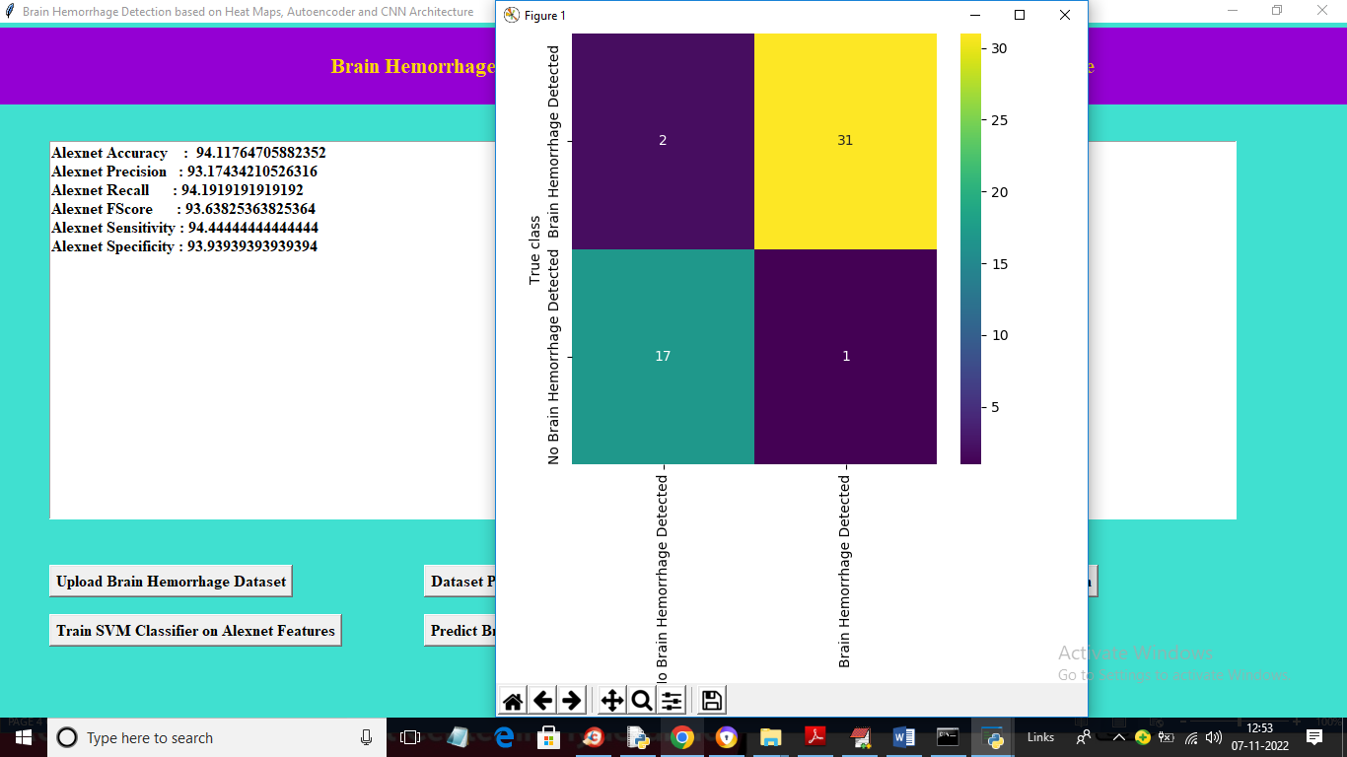

In above screen with Alexnet we got 94% accuracy and in confusion matrix graph x-axis represents Predicted classes and y-axis represents TRUE classes and blue colour boxes contains INCORRECT prediction count and different colour boxes contains CORRECT prediction count and we can see there is very few incorrect count in confusion matrix graph and now close above graph and then click on ‘Train SVM Classifier on Alexnet Features’ button to train SVM and get below output

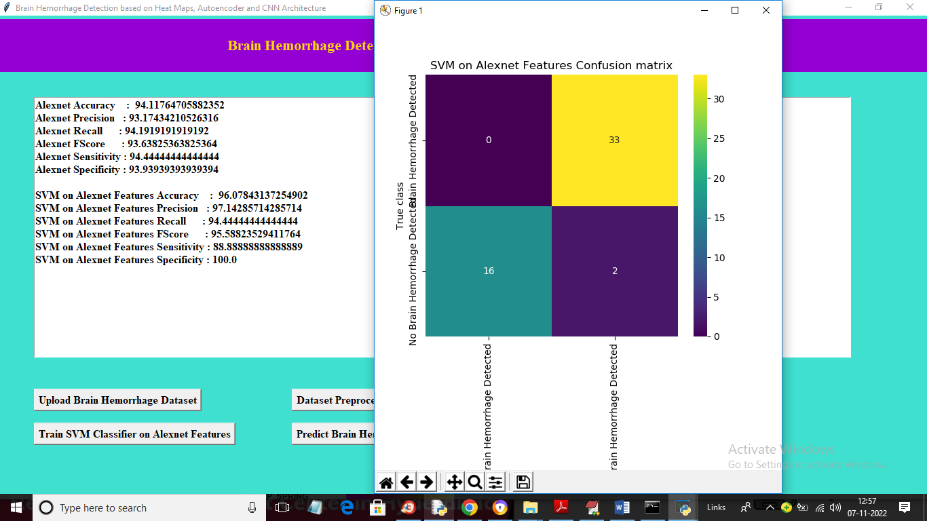

In above screen with SVM we got 96% accuracy and in confusion matrix graph we can see SVM predicted only 2 records or images as wrong prediction and now close above graph and then click on ‘Predict Brain Hemorrhage from test Images’ button to upload test image and get classification result

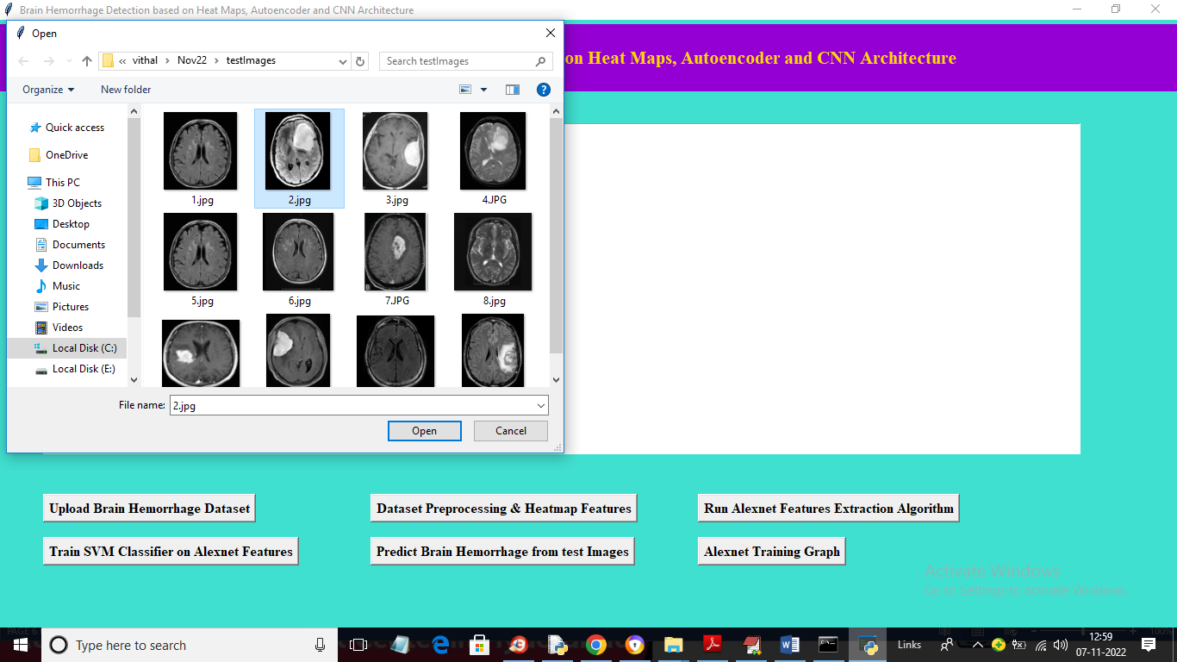

In above screen selecting and uploading ‘2.jpg’ file and then click on ‘Open’ button to get below classification result

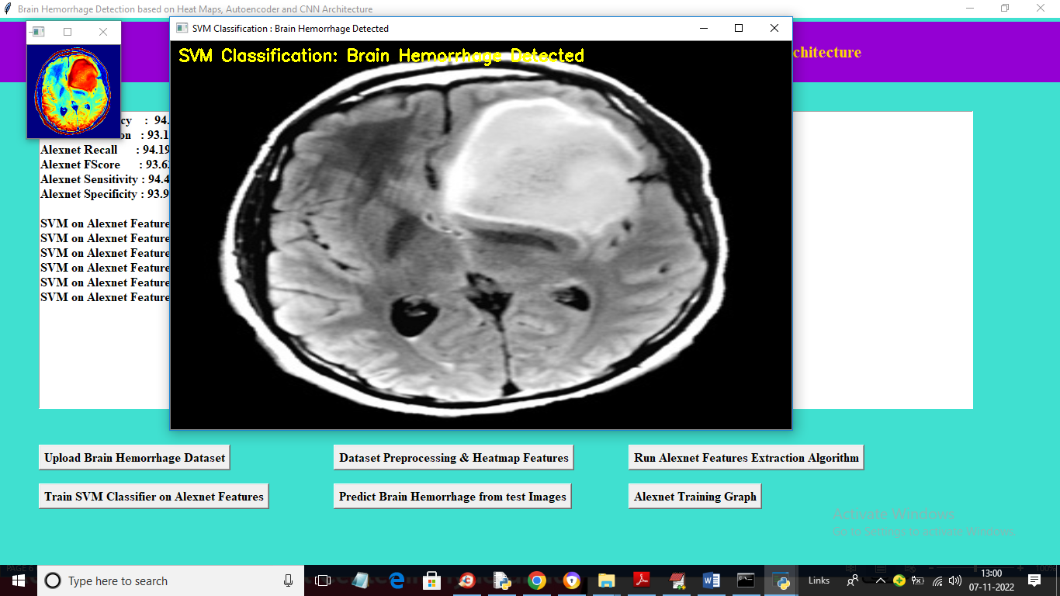

In above screen first we can see Heatmap image and then we can see SVM classification result as ‘Brain Hemorrhage detected’ and now close above image and then test another image

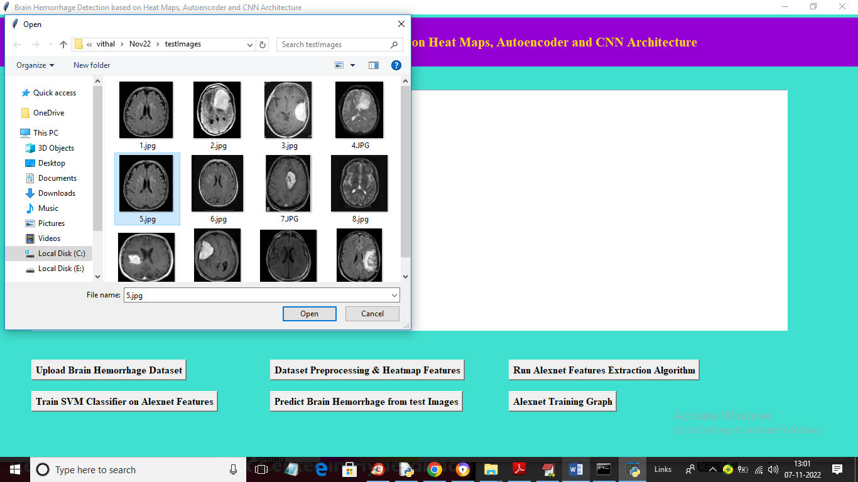

In above screen selecting and uploading ‘5.jpg’ file and then click on ‘Open’ button to get below output

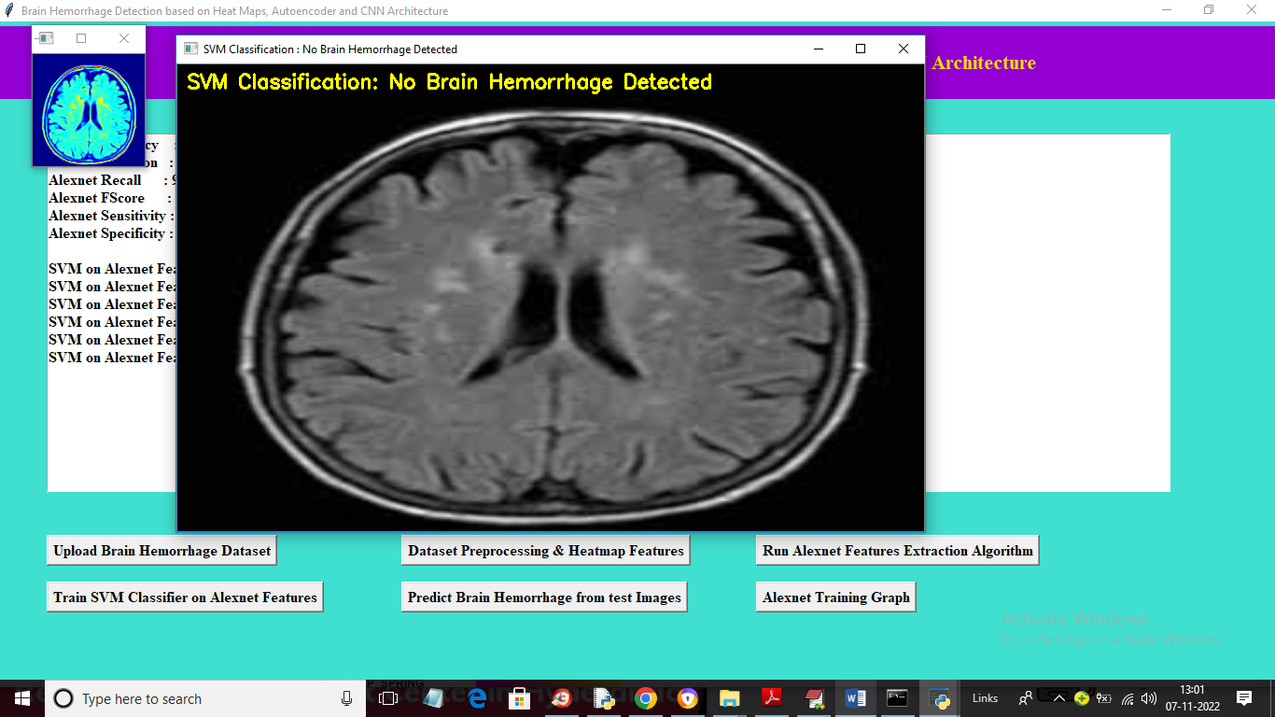

In above screen we can see ‘No Hemorrhage Detected’ and similarly you can upload and test other images. Now click on ‘Alexnet Training Graph’ button to get below Alexnet training graph

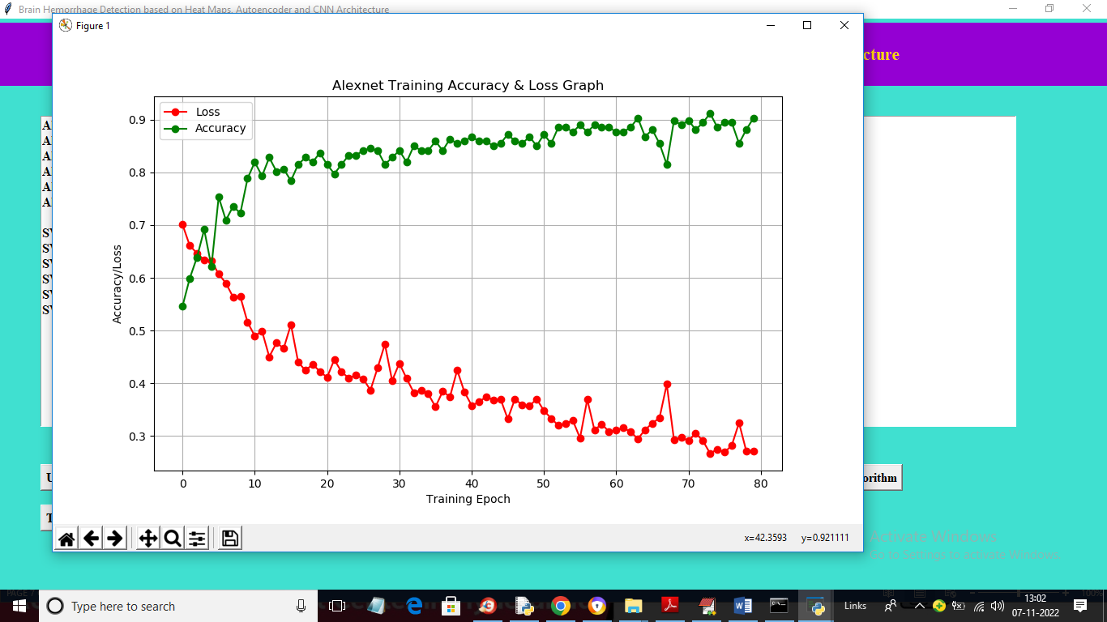

In above graph x-axis represents Training Epoch/Iterations and y-axis represents accuracy and loss values and in above graph green line represents ACCURACY and red line represents LOSS values and we can see with each increasing epoch accuracy got increased and LOSS got decreased. In above graph we can see Training accuracy reached closer to 1 and loss reached closer to 0