E&G Resource Allocation Tool
A management view of partner outreach, deployment, approvals, and results
Pitch message: The tool turns scattered outreach activity into one visible operating picture, so E&G leadership can approve, deploy, monitor, and learn from field work with less delay and less manual follow-up.

What the tool does
The E&G Resource Allocation Tool is a practical deployment ledger for Enterprise & Growth. It connects partner sourcing, outreach planning, staff assignment, approval workflows, field-time monitoring, and results in one place.
It is designed to help Senior Management answer four questions quickly:
- What outreach activity is planned, pending, or awaiting approval?
- Which partners and regions are producing the strongest onboarding results?
- Are the right staff available and assigned to the work?
- Where are per diem or field-time exceptions requiring action?

Management value
- Faster decisions: approval queues and urgent items are visible at a glance.
- Better accountability: each outreach has a partner, region, date, team, status, and outcome trail.
- Smarter deployment: staff skills and availability support more deliberate team matching.
- Stronger cost control: per diem approval is linked to the outreach before departure.
- Evidence-led improvement: partner conversion and outreach results show where effort is working.

Suggested 3-minute pitch flow
1. Start with the dashboard: Show the approval queue, urgent per diem item, field-time exceptions, and staff availability.
2. Move to the partner registry: Show how active partners are ranked by onboarding conversion and how pipeline leads can be tracked.
3. Open outreach planning: Show the register of planned, pending, approved, and completed field activity.
4. Finish with Per Diem: Show pre-departure approval and the field-time tracker that flags trips running beyond plan.
5. Close on governance: Emphasise role-based access: Senior Management can manage approvals and users, while Field Staff see the work relevant to them.

Screens in the tool
The following screens are representative views from the working application and can be used as visual prompts during the pitch.
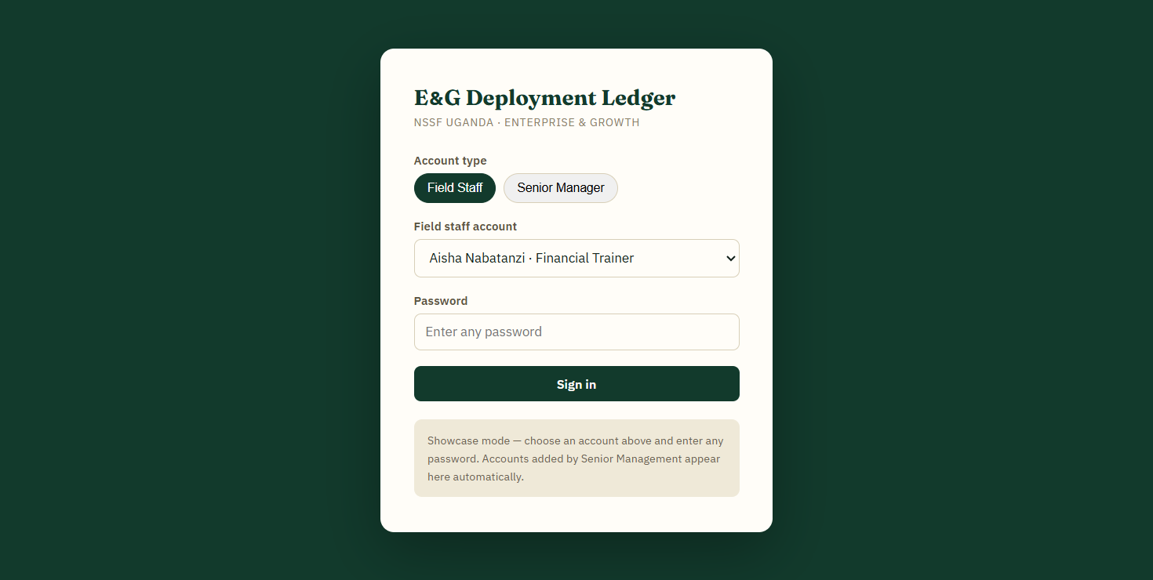
1. Role-based access: Senior Manager and Field Staff entry points.
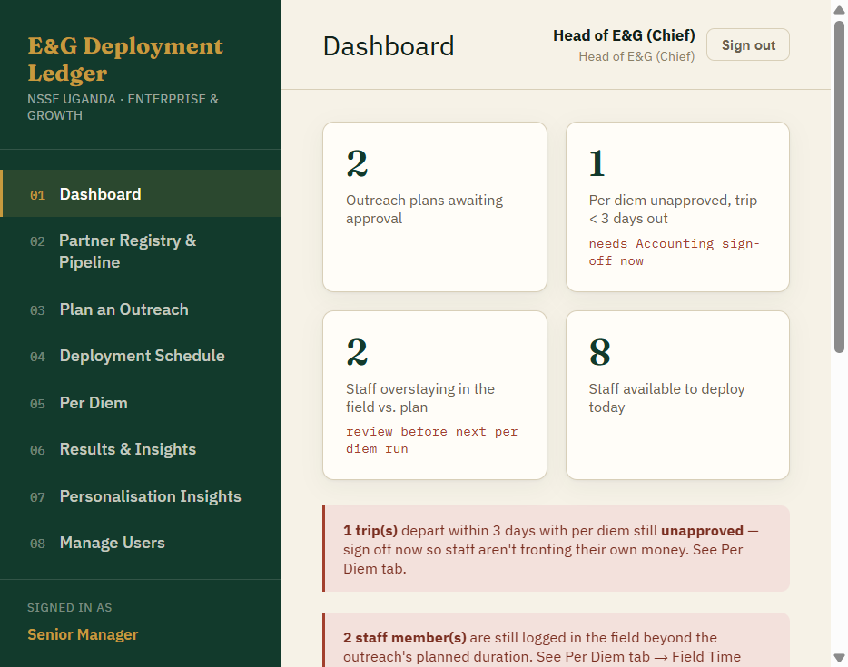
2. Executive dashboard: approvals, urgent exceptions, staff availability, and sign-out control.

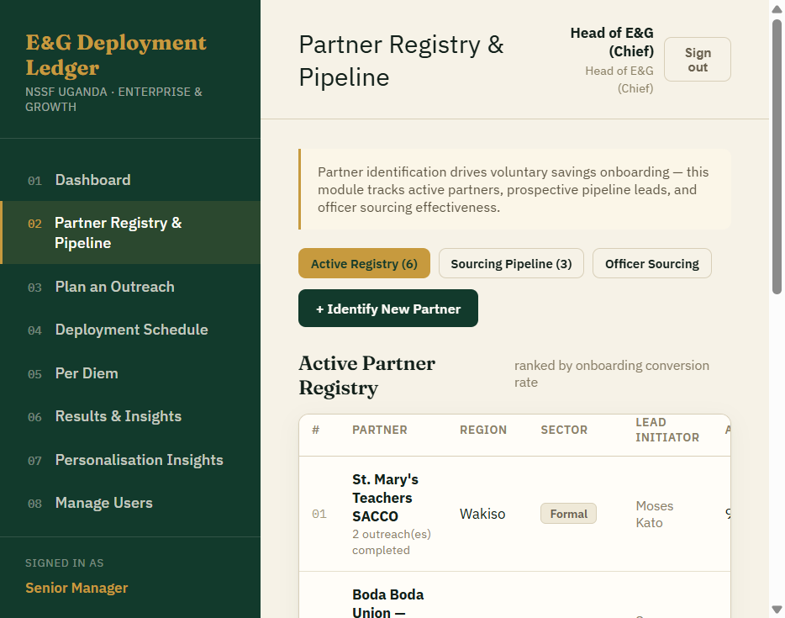
3. Partner Registry & Pipeline: active partners, conversion rates, regions, sectors, and sourcing leads.
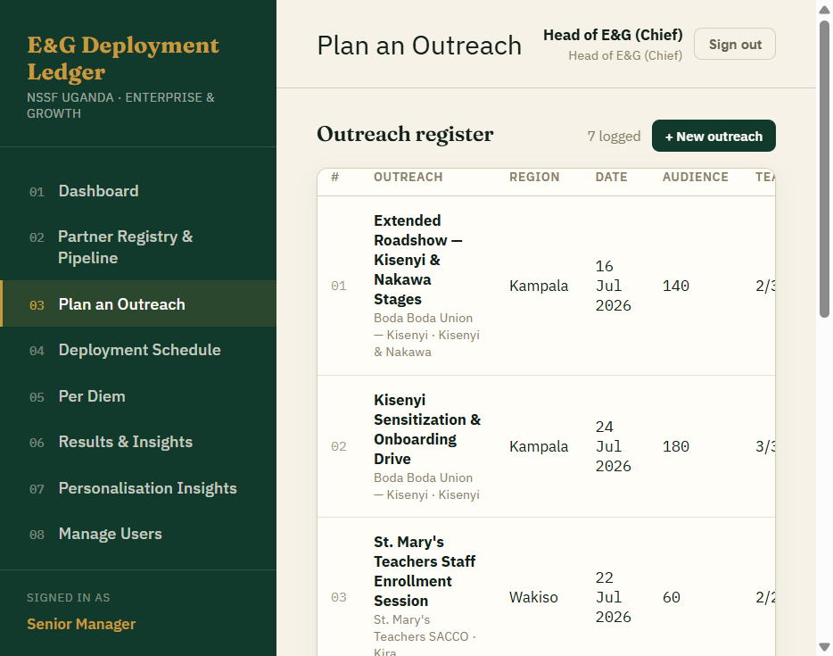
4. Plan an Outreach: one register for dates, audience, team assignment, status, and per diem state.

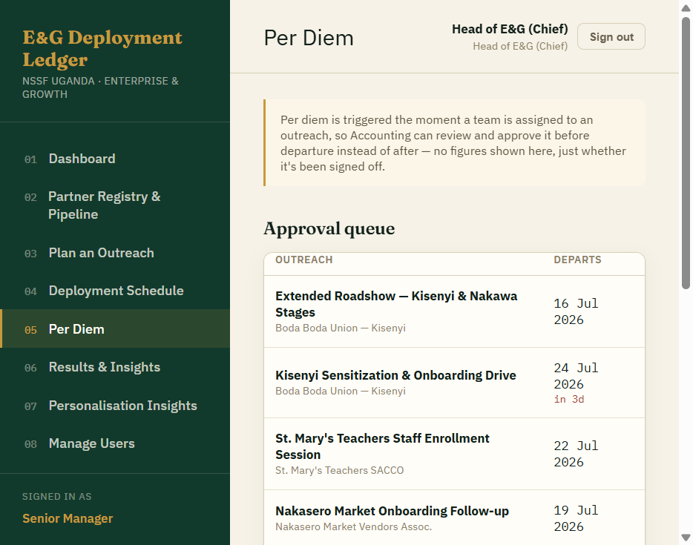
5. Per Diem: approval queue before departure and field-time tracking for trips beyond plan.

Suggested closing statement
This tool gives E&G a shared operational picture without adding another complicated reporting layer. It makes the next action visible: approve the trip, assign the team, follow up with the partner, or investigate an exception. The result is a more controlled deployment cycle and a clearer link between field activity and onboarding outcomes.

Current scope
The hosted version is a working prototype for demonstration and internal validation. It currently uses seeded data and browser/local API storage; a production rollout would add shared database hosting, organisation authentication, and server-side permissions.

