Specification of the Sequence Structure
The sequence structure together with Memory Management Control Operation (MMCO) and Reference Picture List Reordering (RPLR) commands is specified in the encoder configuration file via a formatted string.

Syntax of the formatted string specifying the sequence structure
The general syntax of the sequence structure string is given by

sequence structure: GSP

where GSP is a string that specifies a general sequence part. It generally consists of an arbitrary combination of frame sequence parts (FSP) and/or further general sequence parts (GSP) that can be optionally enclosed in curly brackets preceded by an asterisk and a syntax element REP specifying the number of repetitions of the sub-sequence structure inside the curly brackets:

GSP: [*REP{]GSP|FSP[GSP|FSP]…[GSP|FSP][}]

The syntax element REP specifies the number of repetitions of the sub-sequences enclosed in curly brackets, it can be either a decimal number or the character ‘n’, which specifies that the sub-sequence structure encloses in curly brackets in repeated forever:

REP: [(decimal number)|n]

A frame sequence part (FSP) consists of a combination of frame descriptions (FDES) that can be optionally enclosed in curly brackets preceded by an asterisk and the syntax element REP specifying the number of repetitions of the sub-sequence structure enclosed inside the curly brackets in the same manner as for the general sequence part (GPS):

FSP: [*REP{]FDES[FDES]…[FDES][}]

A frame description (FDES) specifies all parameters needed by the encoder for encoding a given frame of a video sequence and updating the decoded picture buffer (DPB). A frame specification (FDES) consists of a frame coding type (TYPE) specifying the slice coding type and whether the frame is marked as “used for reference”, a frame index offset (OFFSET) specifying the difference of the frame indices of the frame to encode and the first frame (in input order) of the current frame sequence part (FSP) inside the input video sequence, and optionally up to two lists of reference picture reordering commands and/or a list of memory management control operation commands:

FSPEC: (TYPE)(OFFSET)[RPLR-List0[RPLR-List1]][MMCO-List]

The frame coding type (TYPE) specifies the slice coding type for the frame and it further determines whether the frame is marked as “used for reference” after storing in the decoded picture buffer. The following values are possible:

TYPE: A|I|P|B|i|p|b

A: The first picture of the frame is coded as IDR picture (the second picture is coded as P picture and marked as “used for reference”).
I: The picture(s) is/are coded as I picture(s) and marked as “used for reference”.
P: The picture(s) is/are coded as P picture(s) and marked as “used for reference”.
B: The picture(s) is/are coded as B picture(s) and marked as “used for reference”.
i: The picture(s) is/are coded as I picture(s) and marked as “unused for reference”.
p: The picture(s) is/are coded as P picture(s) and marked as “unused for reference”.
b: The picture(s) is/are coded as B picture(s) and marked as “unused for reference”.

The frame index offset (OFFSET) is a decimal number, which specifies the frame index of the given frame inside the given input video sequence:

OFFSET: (decimal number)

This frame index is not given as absolute number, but as difference between the frame index of the current frame and the frame index of the first frame (in input order) of the current frame sequence part (FSP). If a frame sequence part consists of N frames, each frame index offset (OFFSET) must greater or equal to 0 and less than N, and all frame index offsets inside the frame sequence part must be different.

The lists of reference picture list reordering commands start with the character ‘R’ followed by an optional ordered list of re-ordering commands.

RPLR-List0: R[–DIFF|+DIFF|L(LTI)]…[–DIFF|+DIFF|L(LTI)]
RPLR-List1: R[–DIFF|+DIFF|L(LTI)]…[–DIFF|+DIFF|L(LTI)]

The reference list re-ordering commands are specified in the following way.

–DIFF: specifies the reference picture list reordering command reordering_of_pic_nums_idc = 0, the associated syntax element abs_diff_pic_num_minus1 is set equal to the given decimal number DIFF.
+DIFF: specifies the reference picture list reordering command reordering_of_pic_nums_idc = 1, the associated syntax element abs_diff_pic_num_minus1 is set equal to the given decimal number DIFF.
L(LTI): specifies the reference picture list reordering command reordering_of_pic_nums_idc = 2, the associated syntax element long_term_pic_num is set equal to the given decimal number LTI. [Currently not supported by the encoder]

The reference picture list reordering command reordering_of_pic_nums_idc = 3 (end of list) is not specified, but automatically appended if the specified list of reordering commands is not empty. For B frames, two lists of reordering commands can be specified, the first list is related to reference picture list 0 and the second list is related to reference picture list 1. If reference picture list reordering commands should only be specified for reference picture list 1, this can be done by specifying an empty list for reference picture list 0: RR[–DIFF|+DIFF|L(LTI)]…[–DIFF|+DIFF|L(LTI)].

The list of memory management control operation (MMCO) commands starts with the character ‘M’ followed by an optional ordered list of MMCO commands.

MMCO-List: M[N(DIFF)|L(LTI)–|L(LTI):(DIFF)|L(NUM)$|E|L(LTI)+]…[…]

The MMCO commands are specified in the following way.

N(DIFF): specifies the memory management control operation command memory_management_control_operation = 1 (mark a short-term picture as “unused for reference”), the associated syntax element difference_of_pic_nums_minus1 is set equal to the given decimal number DIFF.
L(LTI)–: specifies the memory management control operation command memory_management_control_operation = 2 (mark a long-term picture as “unused for reference”), the associated syntax element long_term_pic_num is set equal to the given decimal number LTI. [Currently not supported by the encoder]
L(LTI):(DIFF):specifies the memory management control operation command memory_management_control_operation = 3 (assign a long-term index to a short-term picture), the associated syntax elements long_term_frame_idx and difference_of_pic_nums_minus1 are set equal to the given decimal numbers LTI and DIFF, respectively. [Currently not supported by the encoder]
L(NUM)$: specifies the memory management control operation command memory_management_control_operation = 4 (specify maximum long-term frame index), the associated syntax element max_long_term_frame_idx_plus1 is set equal to the given decimal number NUM. [Currently not supported by the encoder]
E: specifies the memory management control operation command memory_management_control_operation = 5 (mark all reference pictures as “unused for reference” and set the MaxLongTermFrameIdx variable to “no long-term frames indices”). [Currently not supported by the encoder]
L(LTI)+: For non-IDR pictures, it specifies the MMCO command memory_management_control_operation = 6 (assign a long-term frame index to the current decoded picture), the associated syntax element long_term_frame_idx is set equal to the given decimal number LTI. [Currently not supported by the encoder]
For IDR pictures, it sets the flag long_term_reference_flag equal to 1 and the given decimal number LTI is ignored. [Currently not supported by the encoder]

Examples for using the sequence structure string
In the following various examples are given for the usage of the sequence structure format string specified above.

Examples without MMCO and reordering commands

Example 1:
Format string: A0*n{P0}
Coding Types: IDR P P P P P P …
Stored as reference: 1 1 1 1 1 1 1 …
Coding Order: 0 1 2 3 4 5 6 …

Example 2:
Format string: A0*n{P2b0b1}
Coding Types: IDR B B P B B P …
Stored as reference: 1 0 0 1 0 0 1 …
Coding Order: 0 2 3 1 5 6 4 …

Example 3:
Format string: A0*2{P3B1b0b2}
Coding Types: IDR B B B P B B B P IDR B B B P …
Stored as reference: 1 0 1 0 1 0 1 0 1 1 0 1 0 1 …
Coding Order: 0 3 2 4 1 7 6 8 5 9 12 11 13 10…

Example 4:
Format string: A0*2{P1p0}*n{I0*2{P1p0}}
Coding Types: IDR P P P P I P P P P I P P P P …
Stored as reference: 1 0 1 0 1 1 0 1 0 1 1 0 1 0 1 …
Coding Order: 0 2 1 4 3 5 7 6 9 8 10 12 11 14 13…

Example with MMCO commands

Example 5:
Reference frames: 5
Format string: A0P1ML2$L0+P2ML1:1P3ML0-N0P4P5P6MEP7P8P9
Coding Types: IDR P P P P P P P P P IDR …
Stored as reference: 1 1 1 1 1 1 1 1 1 1 1 …
Coding Order: 0 1 2 3 4 5 6 7 8 9 10 …

Current Frame Index (coding order) | Ordered set of short-term reference pictures (specified by the frame indices) after decoding and storing the current frame | Ordered set of long-term reference pictures (specified by the frame indices) after decoding and storing the current frame
0 (0) | 0
1 (1) | 0 | 1
2 (2) | 2 | 1 0
3 (3) | 3 | 0
4 (4) | 4 3 | 0
5 (5) | 5 4 3 | 0
6 (6) | 6
7 (7) | 7 6
8 (8) | 8 7 6
9 (9) | 9 8 7 6
10 (10) | 10
… | … | …

Example with Reordering Commands

Example 6:
Reference frames: 4
Format string: A0P4B1B3b2R-0-0-0R-1+0-2
Coding Types: IDR B B B P IDR B B B P …
Stored as reference: 1 1 0 1 1 1 1 0 1 1 …
Coding Order: 0 2 4 3 1 5 7 9 8 6 …

Current Frame Index (coding order) | Reference index list 0 (specified by the frame indices); in brackets: list 0 without reordering if it is different | Reference index list 1 (specified by the frame indices); in brackets: list 1 without reordering if it is different
0 (0)
4 (1) | 0
1 (2) | 0 4 | 4 0
3 (3) | 1 0 4 | 4 1 0
2 (4) | 3 1 4 0 (1 0 3 4) | 1 3 0 4 (3 4 1 0)
5 (5)
9 (6) | 5
6 (7) | 5 9 | 9 5
8 (8) | 6 5 9 | 9 6 5
7 (9) | 8 6 9 5 (6 5 8 9) | 6 8 5 9 (8 9 6 5)
… | … | …

Further examples for the application of MMCO and reference picture list reordering command

Example 7:
Consider the following encoder configuration:

Reference frames: 3
Format string (version 1): A0P4B1B3b2*n{P3B0B1b2}

When coding the first B picture ‘B0’ of a sub-sequence part “{P3B0B1b2}”, the temporal preceding P picture, which has the smallest temporal distance to the current B picture ‘B0’ of all previously encoded pictures, has already been marked as “unused for reference” by the sliding window algorithm. The coding efficiency can easily be enhanced if this picture is kept and instead one of the previously encoded B pictures is marked as “unused for reference”. This can be done by using the sequence structure:

Format string (version 2): A0P4B1B3b2*n{P3MN1B0B1b2}

In the Figure 1, the rate-distortion efficiency of both of these methods is compared for the sequence “Mobile & Calendar” in CIF resolution with a frame rate of 30Hz.

Example 9:
Consider the following encoder configuration:

Reference frames: 3
Format string (version 1): A0P5P1P4P2P3P6P11P7P10P8P9
Coding Types: IDR P P P P P P P P P P P …
Stored as reference: 1 1 1 1 1 1 1 1 1 1 1 1 …
Coding Order: 0 2 4 5 3 1 7 9 10 11 8 6 …

When coding the P picture ‘P6’, the temporal closest preceding picture ‘P5’ has already been marked as “unused for reference” by the sliding window algorithm. Furthermore, the default order of the reference picture lists is not optimal. The coding efficiency for low bit-rates can be enhanced by storing picture ‘P5’ as long-term reference picture and reordering the reference picture lists in a way that the temporally closest reference picture have the lowest reference indices. As an example, the following sequence format can be used:

Format string (version 2):
A0P5ML1#L0+P1P4RL0P2R-1P3P6RL0P11R-0L0P7R-1L0ML0-P10R-1P8R-1P9

In the Figure 2, the rate-distortion efficiency of both of these methods is compared for the sequence “Mobile & Calendar” in CIF resolution with a frame rate of 30Hz.
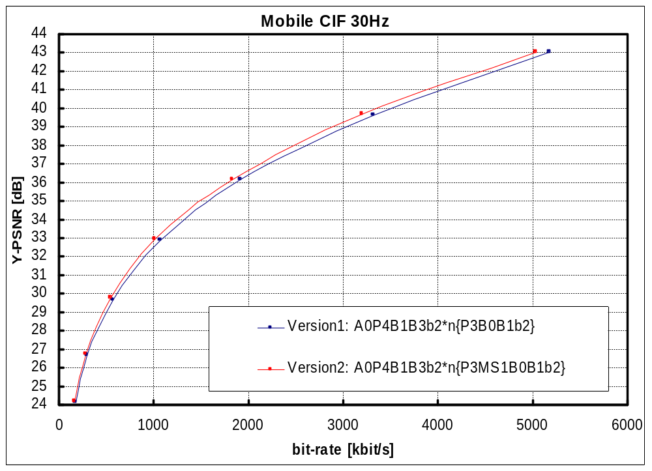
Figure 1: Rate-distortion performance for example 8.
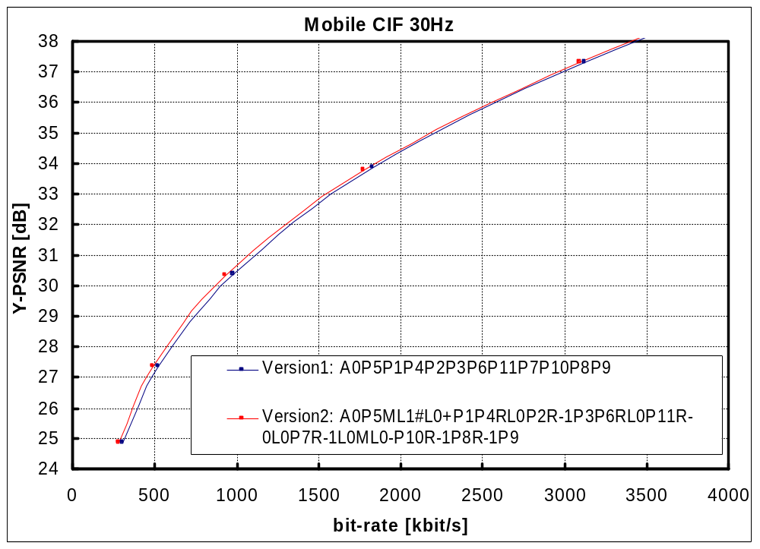
Figure 2: Rate-distortion performance for example 9.

